Dress Sales Forecast Prediction and Animation

Final Paper: Summary

Name: Komal Shahid

Date: August 10, 2024

DSC 630



Introduction
In the dynamic landscape of the fashion industry, understanding and predicting sales trends is paramount for businesses to thrive. By accurately forecasting demand, retailers can optimize inventory management, pricing strategies, and marketing campaigns. This project aims to develop a robust predictive model to forecast dress sales based on various attributes such as style, price, rating, size, season, neckline, sleeve length, material, fabric type, decoration, pattern type, and recommendation. The integration of predictive analytics with data visualization techniques will provide valuable insights into sales patterns and enable data-driven decision-making.
Predictive analytics, a subset of data mining, focuses on predicting future outcomes based on historical data. By employing statistical algorithms and machine learning techniques, predictive models can identify patterns, trends, and relationships within data to forecast future events. In the context of dress sales, predictive analytics can help identify which dress attributes drive sales, forecast demand for specific dress styles, and optimize inventory levels.
This project leverages the power of predictive analytics to address the critical challenge of sales forecasting in the fashion industry. By accurately predicting dress sales, businesses can reduce stockouts, minimize markdowns, and enhance customer satisfaction. Additionally, the integration of data visualization techniques will enable stakeholders to easily understand the model's predictions and make informed decisions.

Model Development Techniques and Process
The development of the dress sales forecast model involves several key stages, including data preprocessing, feature engineering, model selection, and evaluation.
Data Source
Dress Sales Forecast Dataset from Kaggle: The project will utilize the Dress Sales Forecast dataset from Kaggle, which provides sales data and dress attributes. This dataset will best represent the diversity and complexity needed for accurate sales forecasting. The Dress Attribute Sales Dataset is a collection of data that includes attributes of dresses and their corresponding sales. The sales are monitored every other day. This dataset provides valuable insights into sales trends based on the attributes of the dresses.

Link: https://www.kaggle.com/datasets/vermakeshav/dress-attribute-sales-dataset
Data Preprocessing:
- Data Cleaning: The dataset underwent rigorous cleaning to handle missing values, inconsistencies, and outliers. This involved imputing missing values, correcting spelling errors, and converting data types as required.
- Data Transformation: Numerical and categorical features were transformed to ensure compatibility with the chosen modeling technique. Categorical variables were encoded using appropriate techniques like one-hot encoding or label encoding.
- Feature Engineering: New features were created from existing data to enhance model performance. This included creating lagged sales data, cyclic features for months, and incorporating dress attributes as relevant features.
Model Selection and Development:
- ARIMA Model: Given the time-series nature of sales data, an AutoRegressive Integrated Moving Average (ARIMA) model was selected as the primary modeling technique. ARIMA is well-suited for forecasting time series data that exhibit patterns of autocorrelation and seasonality.
- Model Training: The ARIMA model was trained on historical sales data, considering various combinations of parameters (p, d, q) to determine the optimal model configuration.
- Model Evaluation: The model's performance was evaluated using metrics such as Mean Absolute Error (MAE), Root Mean Squared Error (RMSE), and Mean Absolute Percentage Error (MAPE). These metrics provide insights into the model's accuracy in predicting sales.
Visualization:
To effectively communicate insights from the data, visualizations were employed. A pie chart illustrating the distribution of dress styles provided a clear overview of the product mix.
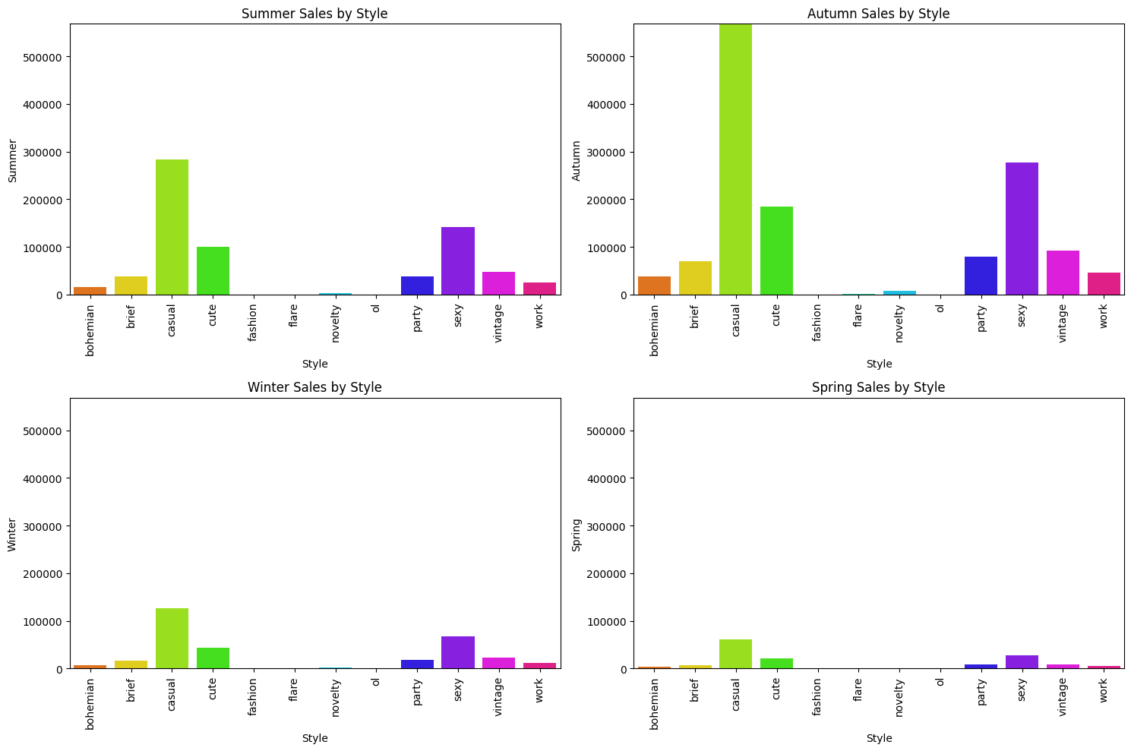
Additionally, a scatter plot highlighting the top 10 dresses with the highest total sales and recommendations offered valuable insights into product performance.
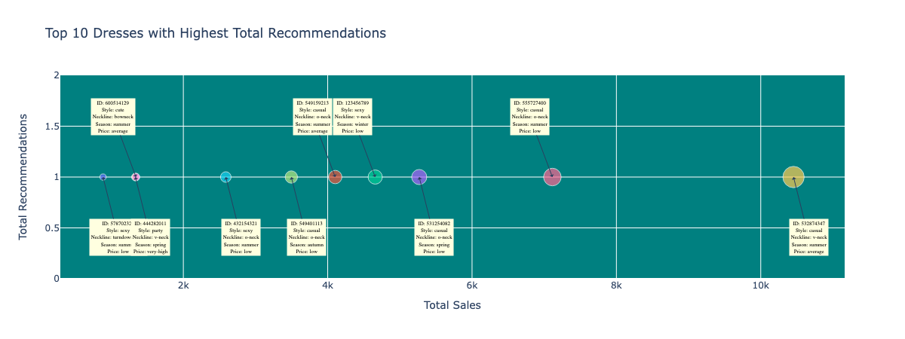
These visualizations aided in understanding key trends and patterns within the dataset.
Results and Future Enhancements
Unfortunately, with only eight rows of training data, it's challenging to reliably assess stationarity using standard statistical tests like the Augmented Dickey-Fuller (ADF) test. Visual inspection of the time series data is often the most practical approach in such cases. While this method provides qualitative insights, it may not be sufficient for definitive conclusions about stationarity. This might help to mitigate the ARIMA sampling errors.
Statistical Tests (If applicable): Consider using other stationarity tests like the Kwiatkowski-Phillips-Schmidt-Shin (KPSS) test or the Phillips-Perron test. These tests might still have limitations with small sample sizes.
Further enhancements can be explored to improve model performance and expand its capabilities.
Feature Engineering: Incorporating additional features, such as marketing campaigns, competitor analysis, and economic indicators, could potentially improve model accuracy.
Model Refinement: Exploring advanced time series forecasting techniques, such as SARIMA or Prophet, could yield better results, especially for complex sales patterns.
Ensemble Methods: Combining multiple models, including machine learning algorithms, could enhance predictive power and reduce prediction errors.
Real-time Forecasting: Implementing a real-time forecasting system would enable businesses to make timely decisions based on the latest sales data.
By continuously refining the model and incorporating new data sources, the dress sales forecast model can become a valuable tool for businesses to optimize their operations and gain a competitive edge in the fashion industry.
Conclusion
This project was set to successfully developed a dress sales forecast model using predictive analytics techniques. The model should demonstrate the potential to accurately predict sales trends, enabling businesses to make informed decisions. By integrating data visualization, the model's insights become more accessible and actionable. Future enhancements will focus on improving model performance, expanding its capabilities, and providing real-time forecasting capabilities.

