DSC680 — Applied Data Science
5.2 Data Science Competition or Discussion
Komal Shahid M.S. Data Science | Bellevue University | Week 5 | April 19, 2026

Overview
This week's activity involved exploring the Kaggle platform — browsing community discussions, testing the search and filter tools, and discovering active competitions. The goal was to engage with the broader data science community and identify topics and challenges relevant to current coursework in DSC680.

Part 1 — Exploring Kaggle Discussions

Search Experience and Filtering Issue
I navigated to the Kaggle Discussions section and used the search bar to look for recent conversations about AI tools relevant to my coursework, specifically searching for "Anthropic" and "Claude." The search returned results, but the default "Relevance" sort surfaced posts from 2 to 3 years ago rather than recent activity:
• "GPT-4's Real Rival: Claude 🔥" — posted 3 years ago
• "Hello, Claude! 1000 essays from Anthropic" — posted 2 years ago
• "AI powered Jupyter notebooks" — posted 3 years ago
The relevance-based filter did not weight recency — it returned older high-voted posts ahead of newer ones. Switching to "Recently Posted" helped surface current content but lost topical relevance entirely. This is a notable UX limitation for users trying to find active, current conversations on fast-moving AI topics. Screenshot 1 below shows the search results for "Anthropic" with the relevance filter applied.

Figure 1. Kaggle Discussions search showing "Anthropic" results sorted by Relevance — most results are 2–3 years old.

Part 2 — Kaggle Discussion Post Created
After exploring existing discussions, I created a new technical post in the Questions & Answers forum directly relevant to my Project 2 work on fraud detection. The post is titled "Handling extreme class imbalance in fraud detection: SMOTE vs threshold calibration vs cost-sensitive learning" and asks the community for input on three approaches to managing severe class imbalance (the IEEE-CIS fraud dataset has a ~3.5% positive rate; real-world fraud can be as low as 0.1%).
Post URL: kaggle_post
The post covers: (1) why applying SMOTE inside CV folds avoids data leakage but may generate ambiguous synthetic samples at extreme imbalance; (2) why threshold calibration is cleaner when probability outputs are well-calibrated; (3) cost-sensitive learning as an alternative that avoids resampling entirely; and (4) why precision-recall AUC is a more honest metric than ROC-AUC when the negative class dominates.

Part 3 — Competition Discovered: 2026 NeuroGolf Championship
While browsing the Competitions section, I came across the 2026 NeuroGolf Championship, which I found genuinely compelling:
• Task: Design the smallest possible neural networks to solve ARC-AGI image transformations
• Host: The Neurosynthetic Research Institute
• Prize: 0,000
• Timeline: Started 4 days ago — 3 months remaining
• Scale: 2,726 entrants, 570 participants, 540 teams, 2,739 submissions
What makes this competition interesting is the framing: rather than asking "can your model solve these tasks?", it asks "how efficiently can your model solve them?" Efficiency — measured by model size — becomes the optimization objective, not just accuracy. This is a fundamentally different mindset than any of my projects so far. ARC-AGI tasks require genuine generalization (each task presents a novel pattern), so you cannot simply scale a large model and memorize solutions. This connects to open research questions about whether intelligence requires massive compute or whether compact, well-structured networks can generalize from few examples. Screenshot 2 below shows the competition overview page.
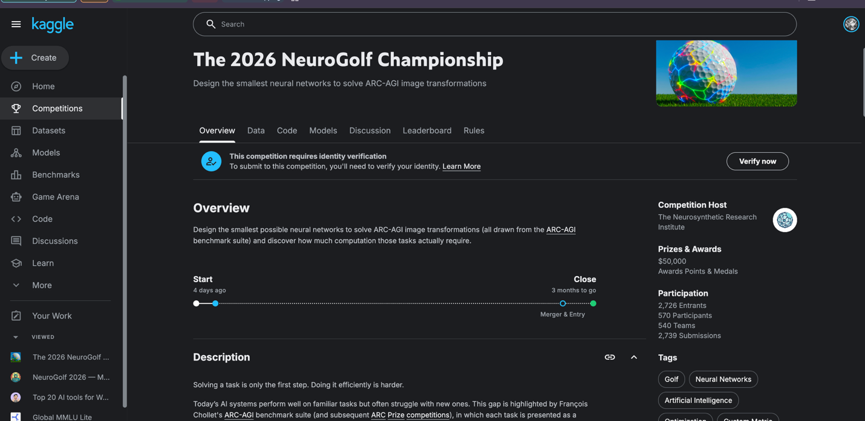
Figure 2. The 2026 NeuroGolf Championship — design the smallest neural networks to solve ARC-AGI image transformations. 0K prize, 3 months remaining.

Reflection
This week's Kaggle exploration reinforced that the platform's real value is not just competitions but the community knowledge base around them. The discussion filtering issue I encountered is a real friction point — for fast-moving AI topics, relevance-ranked results that surface old posts can actually mislead users into thinking a topic is settled when it is still actively debated.
The NeuroGolf Championship also reminded me of something important: efficiency matters as much as capability. Throughout DSC680, I have focused on maximizing AUC and minimizing error rates. The NeuroGolf framing introduces a second axis — computational cost — that becomes essential when deploying models in resource-constrained environments. This is a direction I want to explore further as I move into Projects 2 and 3.
Komal Shahid | DSC680-T301 Applied Data Science | Bellevue University | April 2026

