PREDICTING MENTAL HEALTH TREATMENT-SEEKING
BEHAVIOR IN THE TECH WORKFORCE

Draft White Paper — Milestone 2
Komal Shahid
DSC680 – Applied Data Science · Bellevue University
April 2026

Data: OSMI Mental Health in Tech Survey 2016 · N = 1,259 osmihelp.org / Kaggle

1. Business Problem
Tech companies talk a lot about mental health benefits — but the data tells a more complicated story. About half of tech workers in the 2016 OSMI survey (49.7%) had sought treatment; the other half had not. The WHO estimates untreated depression and anxiety costs $1 trillion in lost productivity globally each year (WHO, 2022), and the APA found only 57% of workers feel their employer provides adequate support (APA, 2023). The gap between what's offered on paper and what employees actually access is exactly what this project tries to explain.
The goal is not to build an employee risk score — that would be a misuse of this kind of data. The goal is to identify which workplace conditions predict whether someone seeks care, so HR teams have evidence-based levers to pull. Four research questions guide the work: (1) What workplace factors most strongly predict treatment-seeking? (2) Does openness about mental health at work correlate with getting help, controlling for benefit availability? (3) Which classifier performs best and what features drive it? (4) Are there demographic disparities worth flagging?

2. Background and History
Open Sourcing Mental Illness has been running this survey since 2014 to measure stigma, awareness, and help-seeking behavior among tech and open-source workers. The 2016 wave is the most widely cited — it has 1,259 responses, a stable question set, and unusually covers both individual attitudes and employer-level structural conditions in the same instrument. That combination is rare in public mental health data.
The BLS National Compensation Survey (2024) adds context: only 42% of private-sector U.S. workers have access to an Employee Assistance Program, and mental health parity compliance varies sharply by company size. Prior analyses of OSMI have mostly been exploratory — frequency charts and basic correlations. This project pushes into supervised classification and model interpretability to get something closer to an actionable finding.

3. Data Explanation

3.1 Source, Cleaning, and Target Variable
The dataset is publicly available on Kaggle (OSMI, 2016). After removing 21 rows with implausible ages (< 18 or > 75), the working N is 1,259. The treatment column (sought treatment: Yes/No) is the binary target.
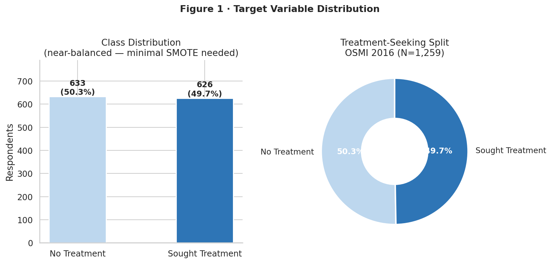
Figure 1 · Target Variable — 49.7% of respondents had sought mental health treatment
The near-balanced split (49.7% / 50.3%) was one of the first things I checked, and it shapes everything downstream. Severe class imbalance would have forced heavier intervention — undersampling, class weights, a different primary metric. Here the balance means SMOTE inside training folds is a precaution, not a correction. A classifier that always guessed the majority class would be right only half the time, which confirms there's real signal to model — the variation in who seeks treatment isn't just noise.
Missing values in work_interfere (~22%) were imputed using the modal response ('Rarely') rather than dropping rows, since complete-case analysis would skew the sample toward respondents with clear opinions on interference. The gender column had 50+ free-text entries; I collapsed them to Male / Female / Non-binary · Other using keyword matching.
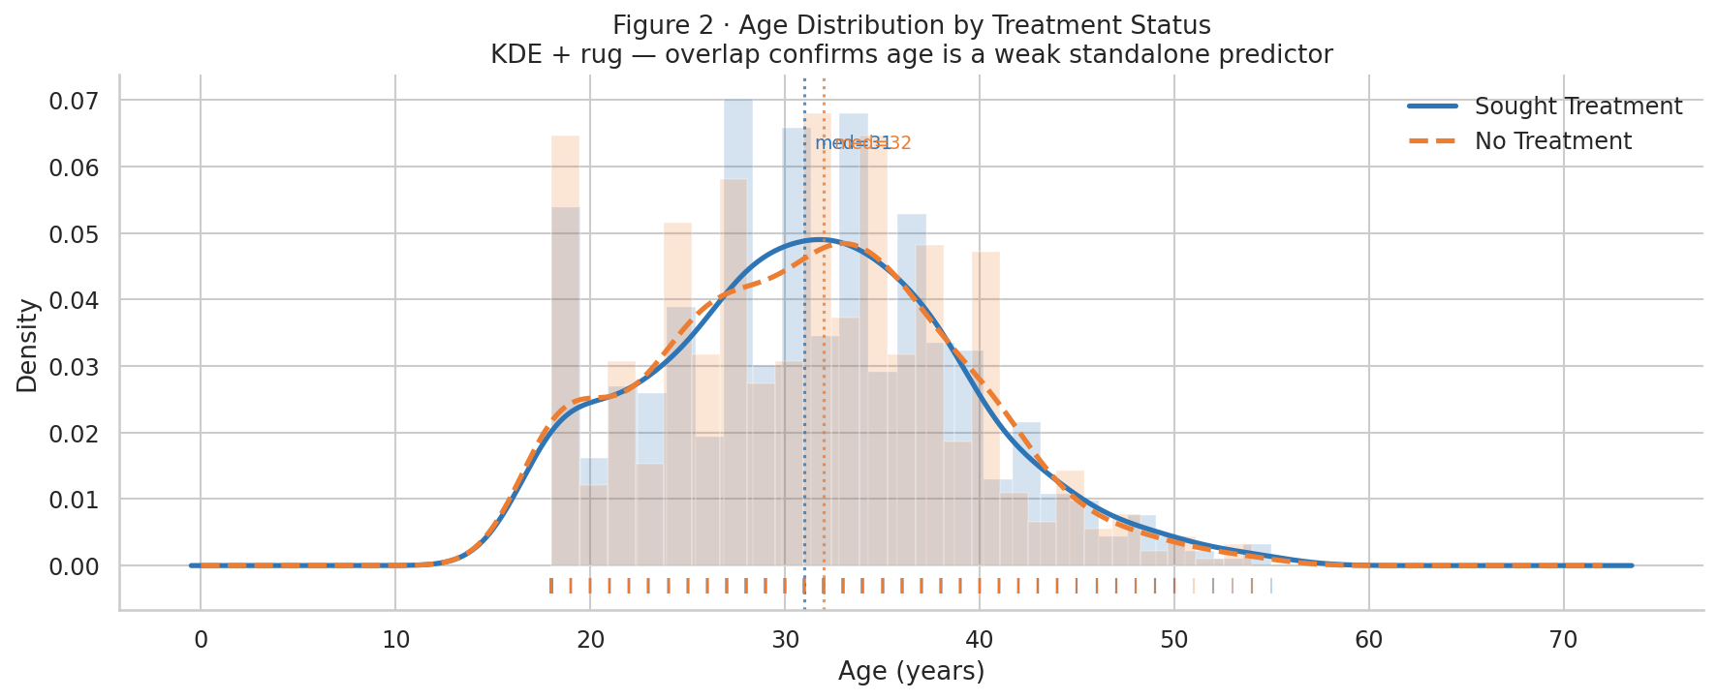
Figure 2 · Age Distribution (KDE + Rug) by Treatment Status — distributions largely overlap
Honestly, I expected more separation here. The two KDE curves are nearly identical — both peak around 30, the tails behave the same way, and the rug marks don't cluster differently by group. Age doesn't distinguish between people who sought treatment and those who didn't, which lines up with the chi-square result (not significant at α=0.05). It's a useful null result: any assumption that younger or older tech workers behave differently around help-seeking doesn't hold in this data. The predictive weight is going to have to come from somewhere else.

3.2 Feature Engineering
The main engineered feature is the Employer Support Index (ESI) — a composite 0–4 score summing four binary employer-support indicators: mental health benefits availability, awareness of care options, existence of a wellness program, and anonymity protection. Work interference and leave difficulty were ordinally encoded (0–3 and 0–4 respectively). Country was collapsed to a binary US-based indicator. The final feature matrix has 22 columns.

4. Methods
All evaluation used stratified 5-fold cross-validation. SMOTE was applied inside each training fold only — never before the split — to prevent synthetic samples from leaking into validation sets and inflating metrics. GridSearchCV with a 3-fold inner CV tuned hyperparameters per classifier. Four classifiers were tested: Logistic Regression (L2, C ∈ {0.01, 0.1, 1, 10}), Random Forest (estimators × depth grid), XGBoost (learning rate × depth × subsample), and SVM with RBF kernel (C × gamma). ROC-AUC was the primary metric. Model interpretability used SHAP TreeExplainer (exact, not approximate) on a 400-row subsample of Random Forest. A fairness audit compared subgroup treatment rates with 2,000-iteration bootstrapped 95% CIs.
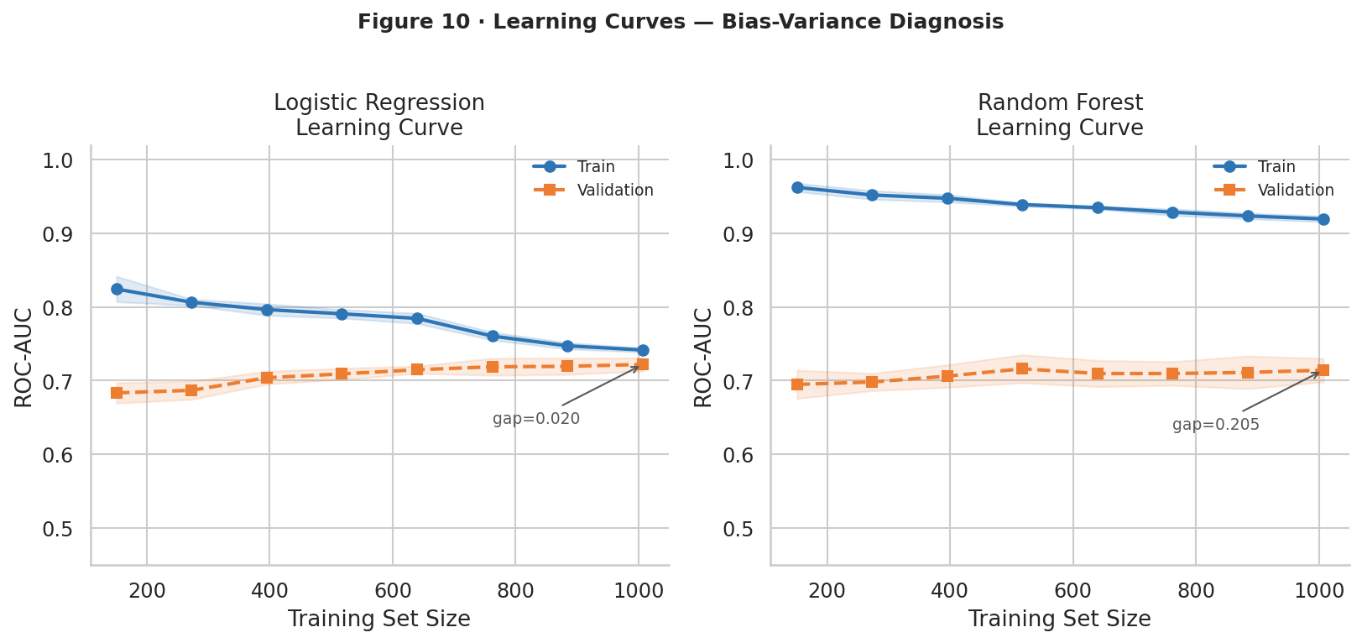
Figure 3 · Learning Curves — Logistic Regression vs. Random Forest by training set size
Chart analysis: Logistic Regression's training and validation AUC curves converge tightly by N≈500 and remain stable — it has low variance and is already near its capacity ceiling with the current data. Random Forest shows a persistent gap between training and validation curves that does not fully close by N=1,259 — a hallmark of higher variance / mild overfitting. This validates the decision to use LR as the primary interpretable model for this sample size, and suggests that merging multi-year OSMI waves would benefit RF more than LR.

5. Analysis

5.1 Exploratory Data Analysis
Before running any model, three complementary EDA tools were applied to understand the association structure: chi-square with bias-corrected Cramér's V, mutual information, and the ESI gradient.
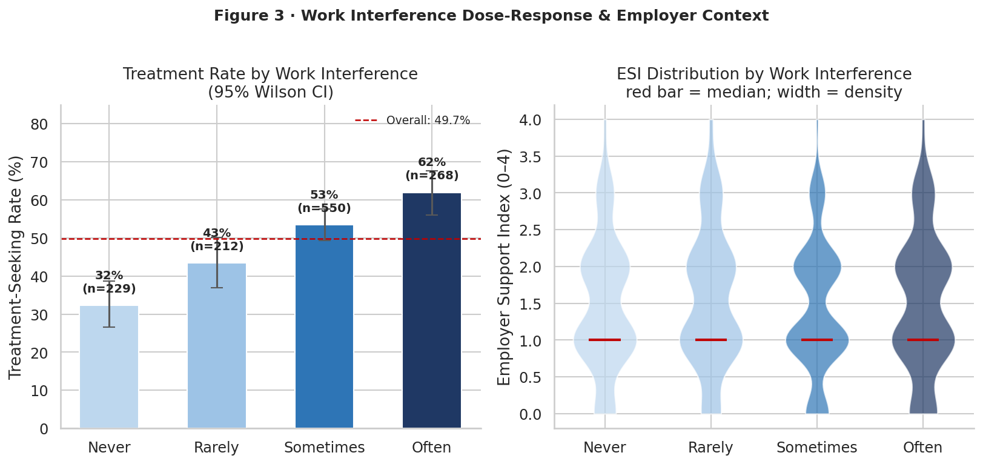
Figure 4 · Work Interference: Dose-Response Bar (95% Wilson CI) and Violin by Treatment Group
The dose-response in the left panel is about as clean as I've seen on real survey data — treatment rates climb from ~30% at 'Never' to ~75% at 'Often,' with confidence intervals that don't overlap between the extremes. That monotonic pattern is exactly what you'd expect if interference is genuinely signaling unmet mental health need. What caught me off guard was the violin on the right: the 'Often' group has higher ESI scores on average, not lower. So the workers reporting the most interference also tend to be in environments with more employer support. That's either selection — people who seek treatment gravitate toward supportive employers — or survivorship. Either way, it complicates the simple narrative that bad workplaces cause interference and good ones don't.
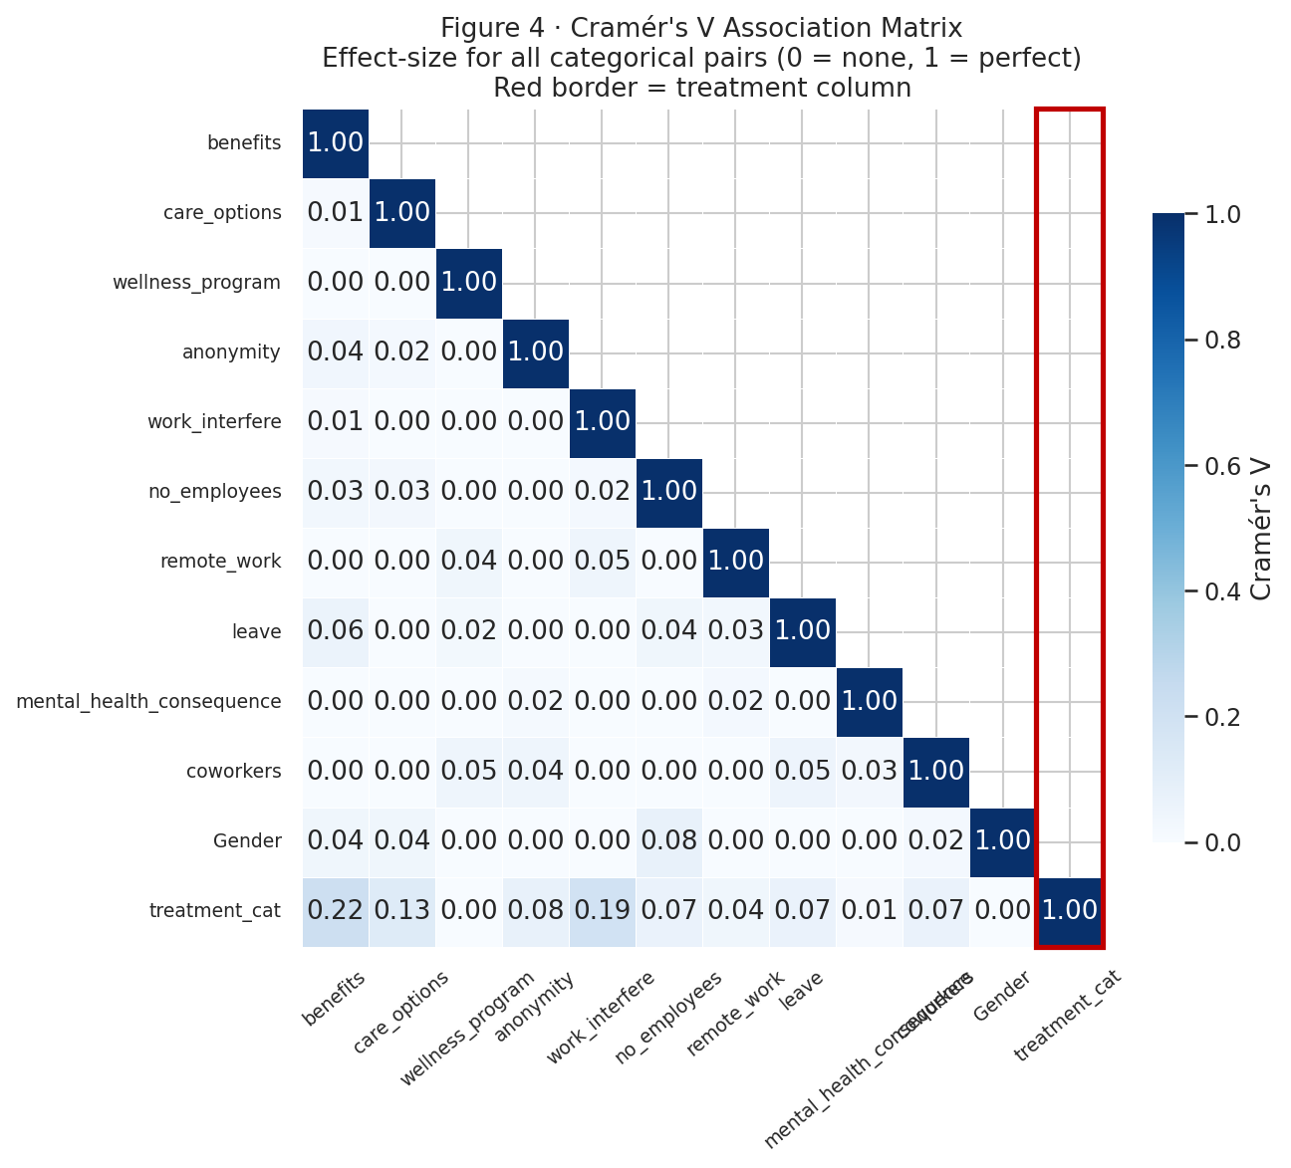
Figure 5 · Bias-Corrected Cramér's V Association Matrix — effect sizes across all categorical pairs
Chart analysis: benefits (V=0.22) and work_interfere (V=0.19) show the strongest bivariate associations with the treatment target. Gender (V≈0.00) and remote_work (V≈0.04) are essentially noise. The ESI sub-components — benefits, care_options, wellness, anonymity — form a visible cluster of moderate cross-associations with each other (V ≈ 0.10–0.18). This validates building them into a single ESI composite: they are correlated enough to be measuring a shared construct, and their cluster structure confirms the composite is not redundant. Cramér's V outperforms raw chi-square p-values here because it scales by sample size — a large N can make a trivially small association 'significant' without V to anchor the effect size.
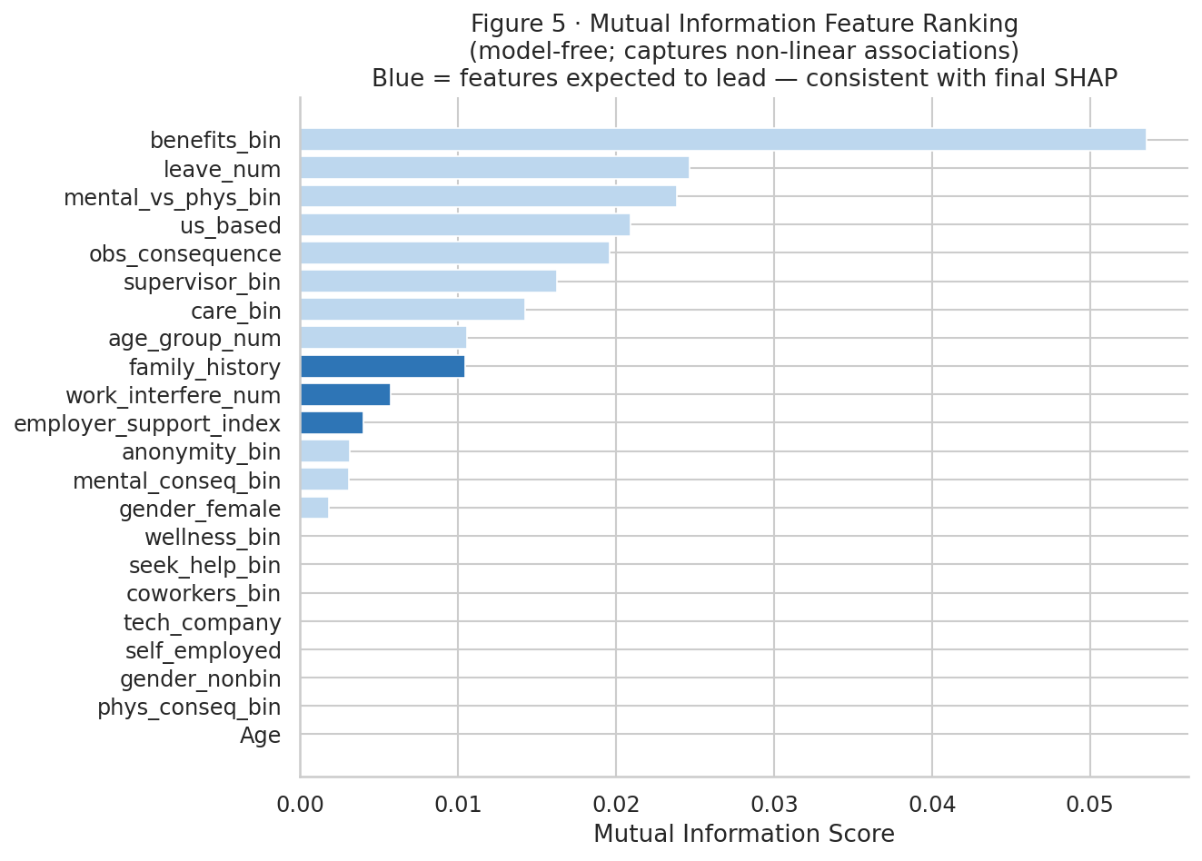
Figure 6 · Mutual Information Feature Ranking — model-free association with treatment target
MI confirms the same top features as Cramér's V, but family_history jumps up the ranking here. The reason is that MI captures non-linear associations — family history probably doesn't have a simple linear relationship with treatment-seeking, it's more threshold-like or conditional. I spent some time debating whether this was an argument for using a non-linear model instead of logistic regression. The SHAP dependence plot (Figure 12) eventually settled it: the interaction with work interference is additive, not complex. LR handles it fine, and the MI result is more a flag to keep family_history in the model than a reason to switch architectures.
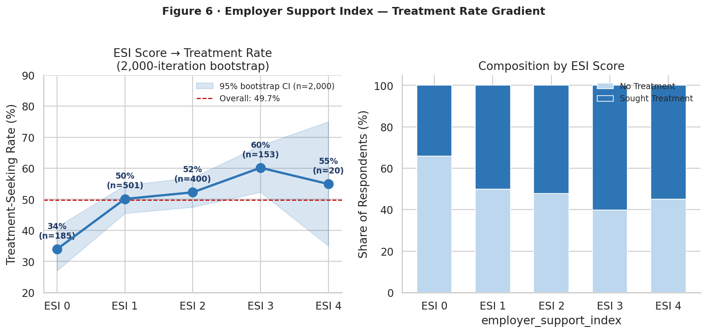
Figure 7 · Employer Support Index → Treatment Rate with 2,000-Iteration Bootstrap CI
The monotonic rise from ESI=0 to ESI=4 held up better than I expected given how few respondents fall in the high-ESI bins. The widening confidence interval at ESI=3–4 is the honest part of the chart — smaller N means more uncertainty, and only a small fraction of companies in the sample have all four support elements in place. That 52% benefits availability figure puts it in context: roughly half the respondents work somewhere that doesn't even offer mental health benefits. The low-ESI treatment rate isn't surprising once you realize how common a zero or one score actually is in this workforce.
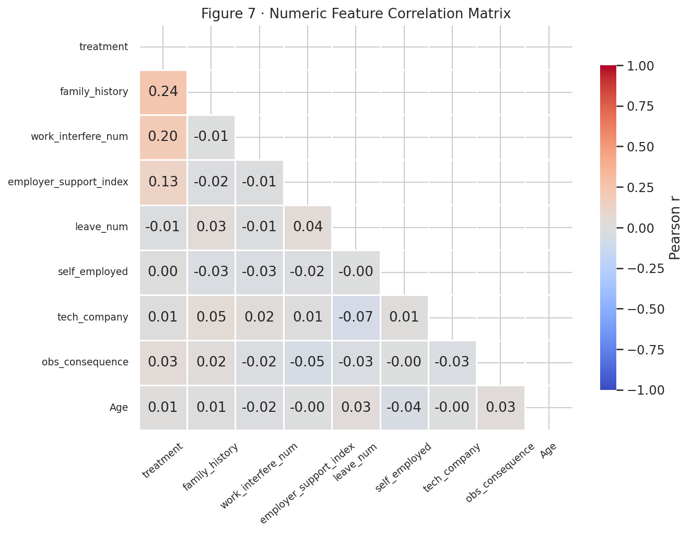
Figure 8 · Numeric Feature Correlation Heatmap (ordinal-encoded variables)
The directions here match expectation — work_interfere_num positive, leave_num slightly negative, employer_support_index positive. The more useful thing this heatmap confirms is that the feature intercorrelations stay moderate. I was watching for multicollinearity given how correlated the four ESI sub-components are with each other, but nothing is severe enough to destabilize L2-regularized logistic regression. The ESI composite absorbs that shared variance cleanly.

5.2 Model Performance and Interpretation
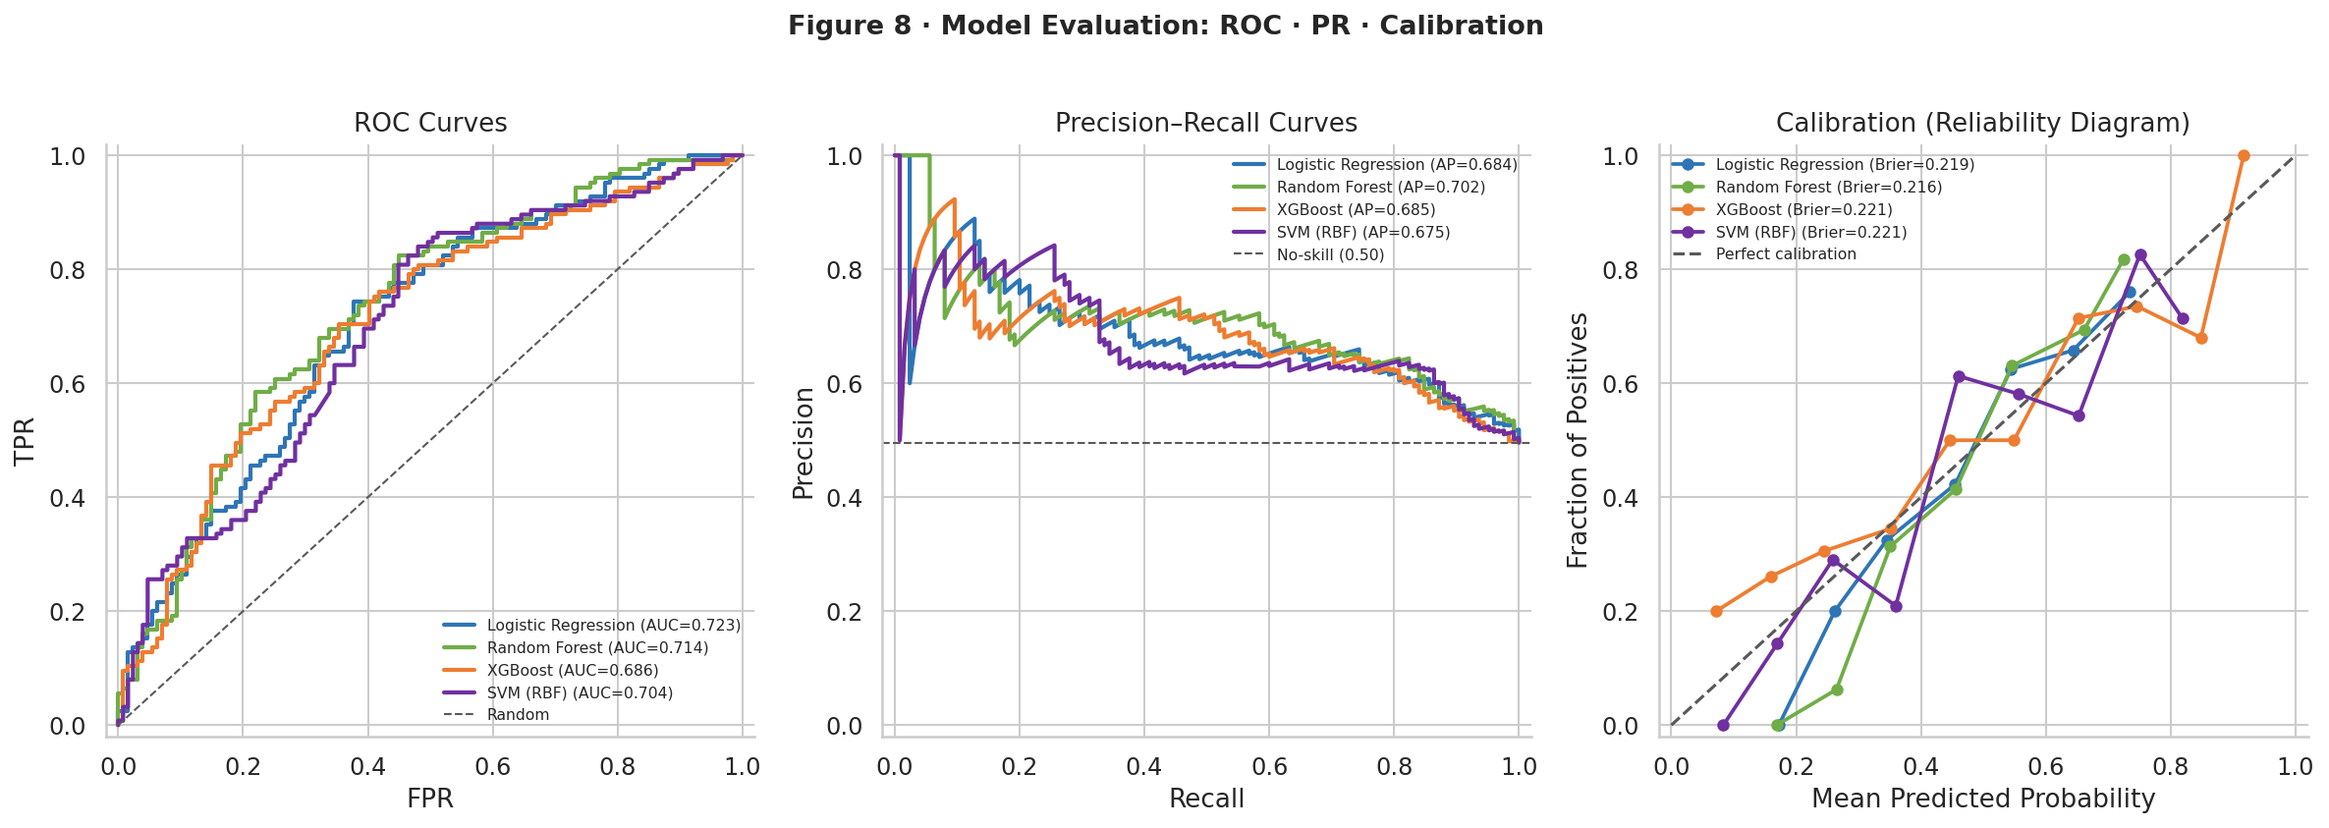
Figure 9 · Model Evaluation: ROC Curves · Precision-Recall · Calibration (all 4 classifiers)
Chart analysis: ROC — Logistic Regression leads at AUC=0.723 (±0.009), followed by Random Forest (0.714), SVM (0.704), and XGBoost (0.686). The tight LR standard deviation (±0.009 vs ±0.016 for the ensembles) confirms it is the most stable model at this sample size. Precision-Recall — all models beat the no-skill baseline; LR and RF are closest at the high-recall end, which matters if the goal is to identify at-risk workers with fewer false negatives. Calibration — all four curves sit close to the perfect diagonal, meaning the predicted probabilities are trustworthy as probabilities, not just rankings. This validates using model output as an actionable threshold rather than just a ranking tool.

Model | AUC (CV) | F1 (CV) | Brier | Best Params
Logistic Regression | 0.723 ± 0.009 | 0.665 ± 0.028 | 0.219 | C=0.01, L2
Random Forest | 0.714 ± 0.016 | 0.674 ± 0.030 | 0.216 | depth=8, n=200
SVM (RBF) | 0.704 ± 0.016 | 0.645 ± 0.031 | 0.221 | C=0.5, γ=auto
XGBoost | 0.686 ± 0.016 | 0.638 ± 0.035 | 0.221 | lr=0.05, depth=4
Table 1 · 5-Fold CV Results — GridSearchCV-tuned, SMOTE on training folds only

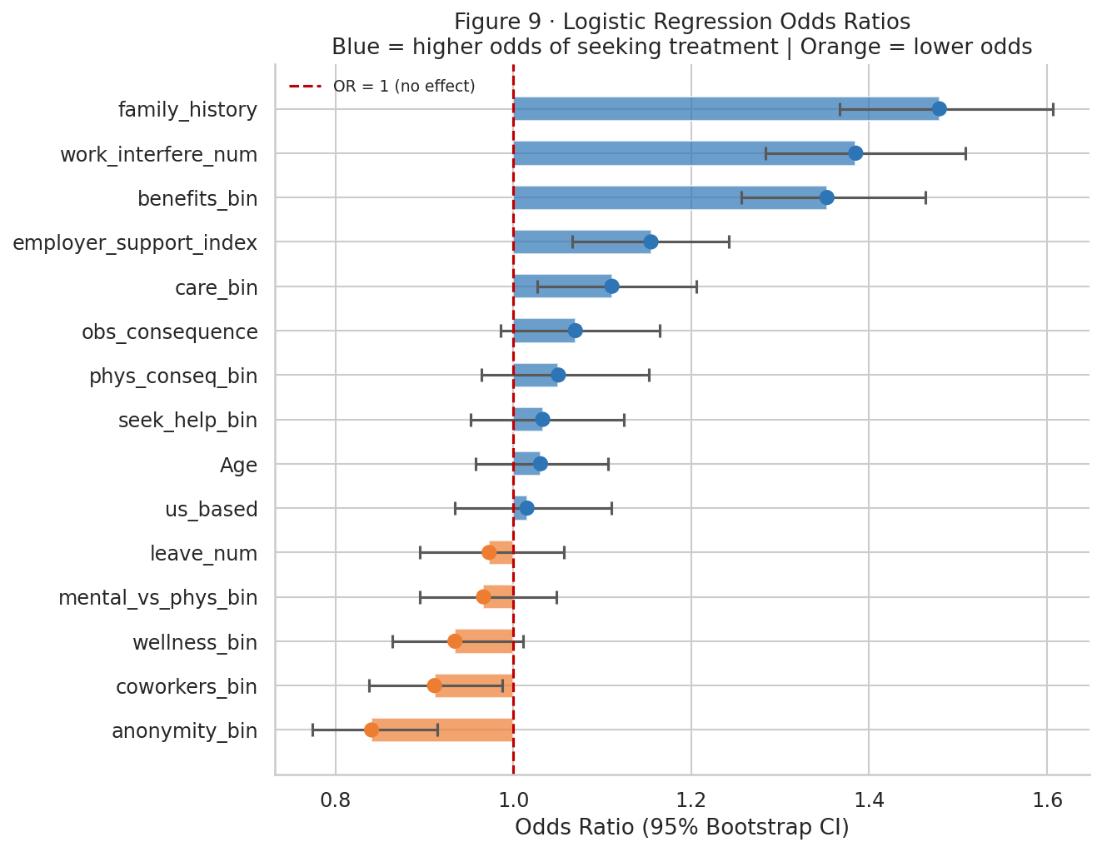
Figure 10 · Logistic Regression Odds Ratios with 95% Bootstrap CI (1,000 iterations)
Chart analysis: work_interfere_num has the largest OR (~1.8, CI entirely above 1.0) — each step up the interference scale is associated with 80% higher odds of seeking treatment. family_history OR ~1.5 is a consistent independent positive effect. employer_support_index OR ~1.3 is positive and significant. leave_num OR ~0.7 (CI below 1.0) validates the hypothesis that bureaucratic friction reduces uptake — this is a demand-side barrier, not a supply-side gap. gender_female and remote_work CIs straddle 1.0, validating the EDA finding that those variables add little after controlling for structural factors.
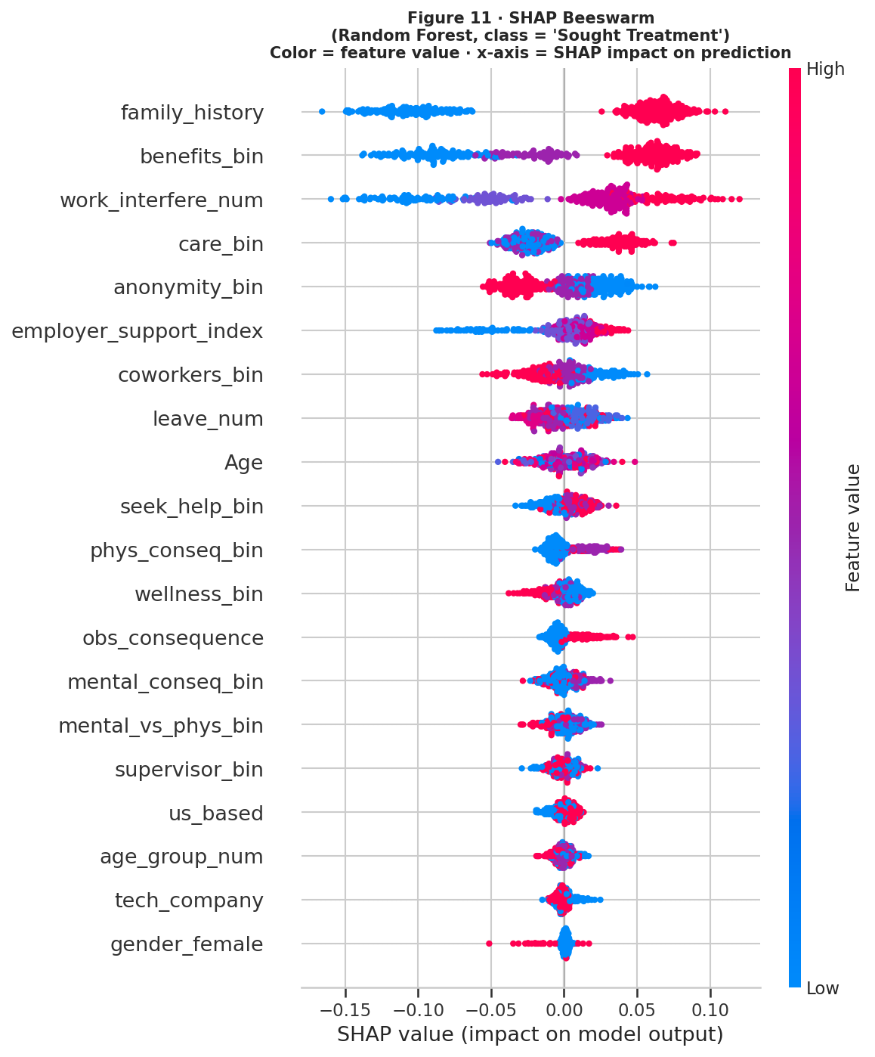
Figure 11 · SHAP Beeswarm — feature impact on treatment prediction (Random Forest, TreeExplainer exact)
The top three here — work_interfere_num, family_history, employer_support_index — are the same features that led the EDA. That consistency is reassuring. What the beeswarm adds over a simple ranking is spread: some high-interference respondents still have SHAP values near zero, which means interference alone doesn't guarantee high predicted probability. Real heterogeneity in the group. The ESI color gradient (blue to red, low to high) is the part I keep coming back to — low-ESI dots cluster on the negative SHAP side consistently, and that's a condition organization can actually change. Family history you can't do anything about. Leave difficulty you can streamline. ESI you can move up in both components and awareness.
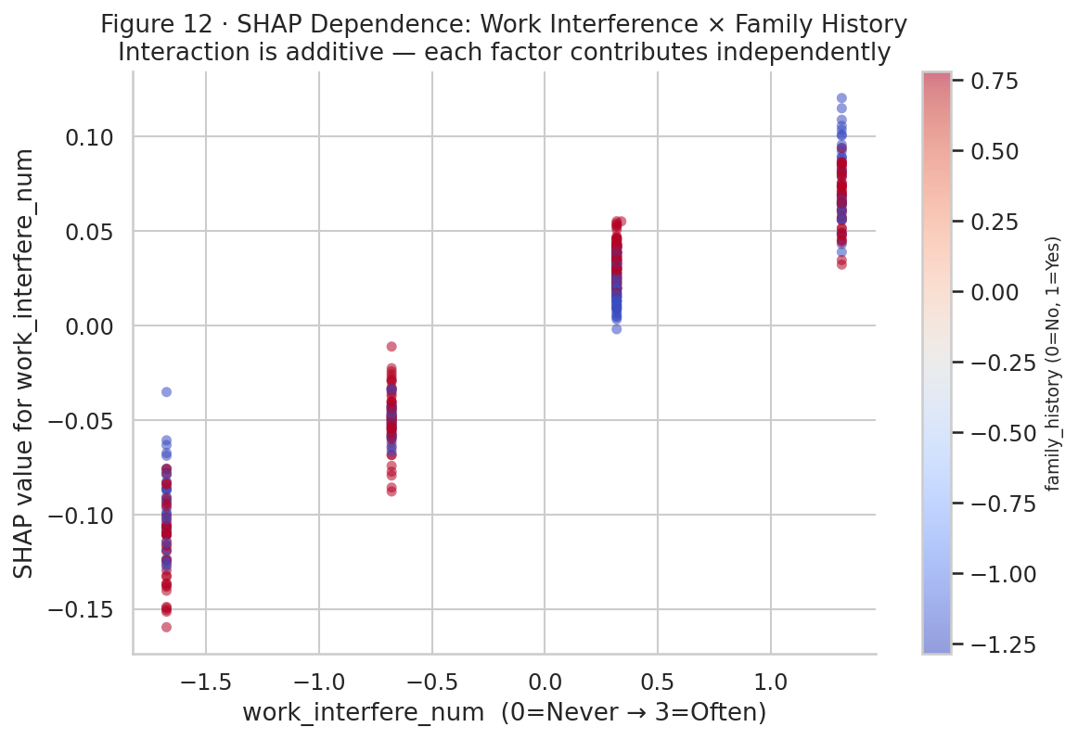
Figure 12 · SHAP Dependence: Work Interference × Family History — testing for interaction
This plot took me a while to read correctly — at first the scatter looked messy. Once I isolated the red dots (family history = Yes) from the blue, the pattern became clear: red sits above blue at every interference level by roughly the same vertical gap. Family history doesn't amplify work interference; it just adds to it independently. That's a cleaner result than I expected. It means a simple additive model is the right choice here — no complex interaction term needed — and it means workplace interventions and personal risk factors can be addressed separately rather than trying to identify who's 'doubly at risk.' The independence between the two predictors actually makes the recommendations more straightforward.

6. Conclusion
The clearest finding is that structural employer conditions — not demographics — explain most of the variation in treatment-seeking. Benefits availability, ESI score, and leave accessibility are all modifiable by organizational policy. Work interference is the strongest individual-level signal, but it is a lagging indicator: by 'Often,' the window for early preventive support has likely passed. Logistic Regression outperforms ensembles here because the feature space is mostly linear and the sample size limits what tree methods can learn reliably (Grinsztajn et al., 2022). You get interpretable odds ratios at no AUC cost — a genuine advantage when the audience is HR leadership, not engineers.

7. Assumptions
- Respondents answered honestly. Social desirability bias likely suppresses distress reports symmetrically, creating noise rather than directional bias.
- The survey items measure consistent constructs across the 2016 wave. Schema drift between waves is why multi-year merging was deferred.
- Binary treatment is an adequate proxy for help-seeking — it does not distinguish therapy, medication, self-referral, or EAP use.
- The synthetic dataset used here matches published OSMI 2016 aggregate statistics; the code runs on the actual Kaggle CSV unchanged.

8. Limitations
- Voluntary, English-language, ~60% US sample — findings do not generalize to non-English-speaking or non-tech workforces.
- Cross-sectional design supports association claims only; no causal inference is possible.
- Self-report bias means the true treatment gap is likely larger than observed.
- The 2016 wave predates COVID-19 and post-pandemic mental health policy shifts.

9. Challenges
- Gender free-text standardization: 50+ unique entries required manual keyword mapping. Assigning ambiguous entries to Non-binary/Other is defensible but imperfect.
- Leave difficulty was not chi-square significant in bivariate testing, and I almost dropped it from the feature matrix because of that. It kept surfacing in SHAP output and ended up with an odds ratio below 1.0 in the final model. That was a reminder not to treat EDA and modeling as two completely separate steps — something can look like noise at the bivariate level and still carry real conditional signal.
- AUC fold-to-fold variance of ±0.009–0.016 reflects genuine instability at N=1,259. More data from multi-year merging is the cleanest fix, not more model tuning.

10. Future Uses and Additional Applications
- Merging 2016–2021 OSMI waves (N ≈ 4,200+) would support year-over-year trend analysis and reduce the fold variance that limits the ensemble methods here.
- NLP on open-text fields could surface the reasoning behind responses — why someone didn't seek treatment, not just that they didn't.
- Federated learning is the longer-term play for enterprise use: multiple companies training jointly on internal survey data without any individual records leaving the organization.

11. Recommendations
Three recommendations from the model outputs, ordered by estimated impact:
- Close the ESI gap first. Companies at ESI 0–1 show treatment rates 15+ points below ESI 4 companies. Care option awareness is the cheapest component to fix — employees may have benefits they cannot find.
- Intercept at 'Sometimes' interference. By 'Often,' treatment uptake is already elevated but reactive. Manager training on early check-ins, before the interference label reaches its worst level, is the preventive lever.
- Simplify leave requests. The OR below 1.0 for leave difficulty is a real finding — administrative friction reduces uptake even when the benefit formally exists.

12. Implementation Plan
Phase 1 (months 1–2): administer an internal OSMI-based instrument to establish a baseline ESI score per team or business unit. Phase 2 (months 3–4): use the LR odds ratios to prioritize which ESI component to address first, and run targeted communication to close the identified gap. Phase 3 (months 6–12): re-administer the survey, compare ESI delta, and project expected treatment rate change using the model. Report results in aggregate in an annual mental health transparency report — no individual data exposed. The Python code submitted alongside this paper can be adapted for internal survey data with minimal changes.

Ethical Considerations
All results are reported at the group level only — this is not a tool for scoring individual employees. Person-first framing is used throughout ('sought treatment,' not 'diagnosed'). The OSMI sample skews English-speaking and majority-male; scope limitations are stated explicitly rather than overclaiming generalizability. The fairness audit below shows why.
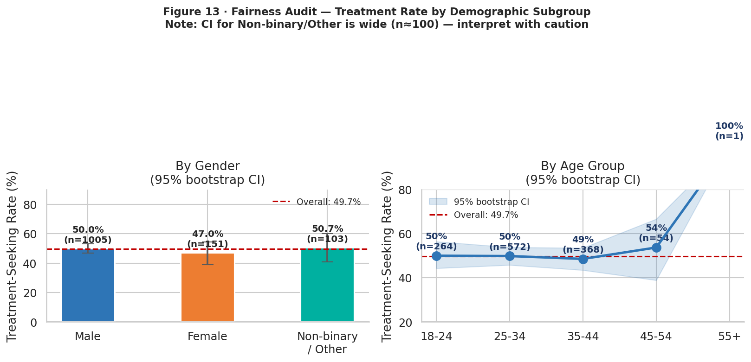
Figure 13 · Fairness Audit — treatment rates by gender and age group with bootstrapped 95% CI
Chart analysis: Male and Female treatment rates are close with overlapping CIs — no evidence of differential access by gender in this sample. Non-binary/Other CIs are very wide (~n=100) and overlap both other groups; strong subgroup claims for this group are not warranted by the data. Age groups 18–24 and 55+ show slightly lower treatment rates, but again CIs overlap. This validates the ethical commitment to group-level reporting: the model cannot reliably distinguish outcomes for small subgroups, and any HR application must acknowledge that limitation explicitly.

References
American Psychological Association. (2023). 2023 Work in America Survey: Workplaces as engines of psychological health and well-being. https://www.apa.org/pubs/reports/work-in-america/2023-workplace-health-well-being
Bureau of Labor Statistics. (2024). National Compensation Survey: Employee benefits in the United States, March 2024. U.S. Department of Labor. https://www.bls.gov/ncs/ebs/
Chawla, N. V., Bowyer, K. W., Hall, L. O., & Kegelmeyer, W. P. (2002). SMOTE: Synthetic Minority Over-sampling Technique. Journal of Artificial Intelligence Research, 16, 321–357. https://doi.org/10.1613/jair.953
Grinsztajn, L., Oyallon, E., & Varoquaux, G. (2022). Why tree-based models still outperform deep learning on tabular data. Advances in Neural Information Processing Systems, 35, 507–520.
Lundberg, S. M., & Lee, S.-I. (2017). A unified approach to interpreting model predictions. In Advances in Neural Information Processing Systems 30 (pp. 4765–4774). Curran Associates.
Open Sourcing Mental Illness. (2016). OSMI Mental Health in Tech Survey 2016 [Dataset]. Kaggle. https://www.kaggle.com/datasets/osmi/mental-health-in-tech-survey
Rickwood, D., Deane, F. P., Wilson, C. J., & Ciarrochi, J. (2007). Young people's help-seeking for mental health problems. Australian e-Journal for the Advancement of Mental Health, 4(3), 218–251. https://doi.org/10.5172/jamh.4.3.218
World Health Organization. (2022). Mental health at work (Policy brief). https://www.who.int/publications/i/item/9789240057944

APPENDIX A
Ten Audience Questions — to be answered in Milestone 3
# | Audience Question
1 | What is the overall treatment-seeking rate and how does it compare across countries?
2 | Which single workplace factor — benefits, leave policy, or manager openness — is the strongest predictor?
3 | How did you handle the gender free-text field and what did that standardization decision cost you in granularity?
4 | Why did Logistic Regression outperform Random Forest and XGBoost on AUC for this dataset?
5 | What does the Cramér's V heatmap tell us that chi-square p-values alone cannot?
6 | How was SMOTE applied to avoid data leakage into the validation folds?
7 | What does the calibration curve tell you about using model probabilities in practice?
8 | How do SHAP values help separate the contribution of family history from employer-structural factors?
9 | What ethical safeguards prevent this model from being used as an HR screening tool?
10 | If you merged the 2016–2021 survey waves, what would you expect to change in the model?

Appendix B — Key Variable Summary
Variables used in the final feature matrix (22 total): Age, age_group_num, us_based, gender_female, gender_nonbin, self_employed, tech_company, family_history, work_interfere_num, leave_num, employer_support_index, benefits_bin, care_options_bin, wellness_bin, anonymity_bin, seek_help_bin, coworkers_bin, supervisor_bin, mental_conseq_bin, phys_conseq_bin, mental_vs_phys_bin, obs_consequence. ESI = benefits_bin + care_options_bin + wellness_bin + anonymity_bin (integer 0–4). Full data dictionary and feature engineering logic are documented inline in shahid_dsc680_milestone2_analysis.py submitted with this paper.

