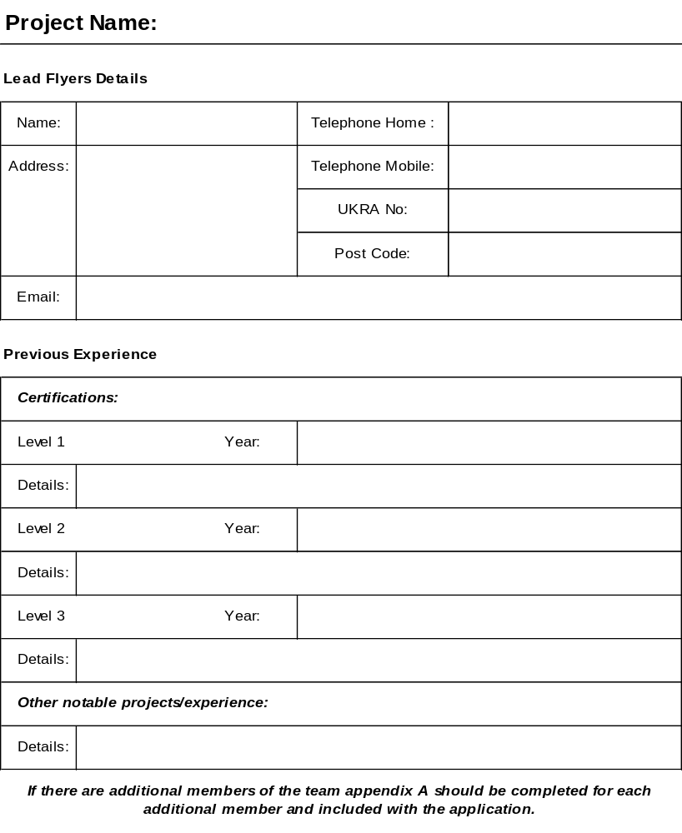

Procedure for Obtaining Approval to Fly Large Projects
Under BMFA Insurance

This application is intended to be used by existing UKRA members, of good standing, with level 3 certification, seeking authorization to fly certain high impulse projects (>10240Ns) under existing BMFA insurance. Whilst such projects may not routinely be covered by their level three certification, it is possible that with approval from the Safety and Technical Committee (STC) at an early stage and mentorship through the construction process, cover can be granted. This is similar to a scheme operated by the BMFA for particularly large model aircraft projects.

The flyer is seeking to gain two signatures before the flight can commence. Both of these signatures will be from members of the STC. One signature shall be from the project advisor (see below) and the other will be obtained from a different member of the STC upon a full inspection of the completed and assembled vehicle (without motor), at any time prior to launch.

At the inception of the project, the flyer should approach a member of the STC to discuss the project’s parameters. This person will then be the project advisor. He or she will then follow the project through to its completion offering any help, encouragement and advice as he or she sees fit. Prior to beginning building the flyer should submit a detailed report to the project advisor and STC

This report must contain all the following elements;

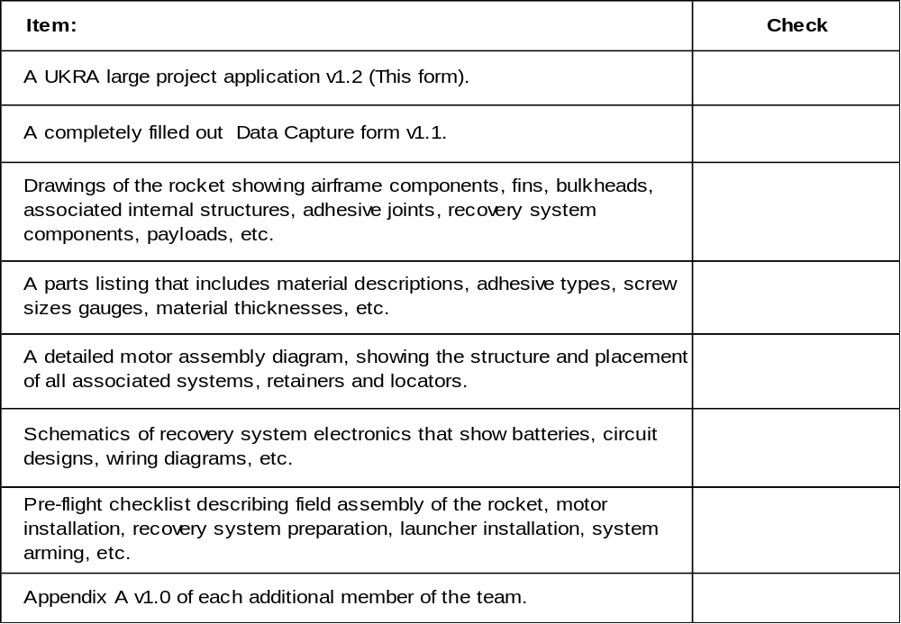

STC will examine the report for problems and complete a risk assessment on the project. The project advisor, with advice from STC, will then feedback to the flyer any problems that can be foreseen before building commences. The flyer will then make any necessary changes and modifications to comply with the STC's recommendations and the risk assessment. Further reports will, if necessary be completed for the project advisor as required by STC. At this early stage the insurance company will be approached for agreement in principle to cover the launch.

On completion of the build a final version of the report containing all the elements described above will be presented to the advisor and STC. Once satisfied with the report and following a suitable inspection of the project by the advisor, the advisor and the head of STC (or their deputy if they are the advisor) will sign off the project as flight ready. Confirmation of insurance cover must be obtained prior to flight.

At this point, the flyer should obtain all necessary exemptions and apply for any NOTAMs required.

It is the STC’s right to refuse to sign off on any project if, at any time, it is decided that the flight cannot be safely made or the individual/s concerned demonstrate a lack of responsibility with regard to any matters pertaining to Health and Safety. The Chair of the STC shall have the final say as to the suitability of any project.

One of the two STC signatories must be at the launch site to witness the flight, liaise with the flyer and site Range Safety Officer (RSO) (who must also be Cert Level III) and ensure compliance with the previously carried out risk assessment. It shall be the duty of the member of the STC in co-operation with the RSO to stop the launch if, at any time, it is decided that the flight cannot be safely made or the individual/s concerned break any conditions imposed by the STC’s risk assessment.

