Application Automation Task:
- For this assignment, we request that you prepare test Automation scripts regarding to scenarios explained at “User stories for Automation” section.
- Please ensure that test names match the documentation, such as "Scenario 1," "Scenario 2," etc.
- We expect adherence to best practices.
- Using delays directly will not be accepted as best practice.
- The provided solution should build successfully and run without errors. Zip solution files and upload once completed. Txt files will not be accepted.
Scenario 1:
Launch Url navigate to main screen without registration.
www.booking.com
Select language as English US  Select 2 adults and 1 children , select age as 8  Enter Your Destination:Stockholm  Checkin date : Today + 5  Checkout date : Today + 9  Click Search | 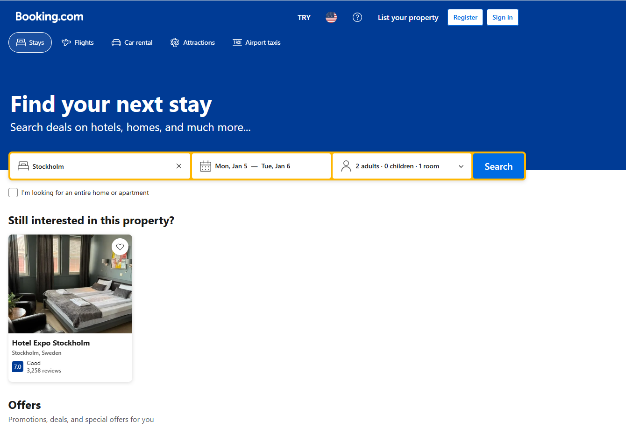

Scenario 2:

From avabile filter options  Set “Bugdet per night” Min 2000 SEK - Max 10000 SEK  Use “Meals” filter box and select “Breakfast included” checkbox  Click show results | 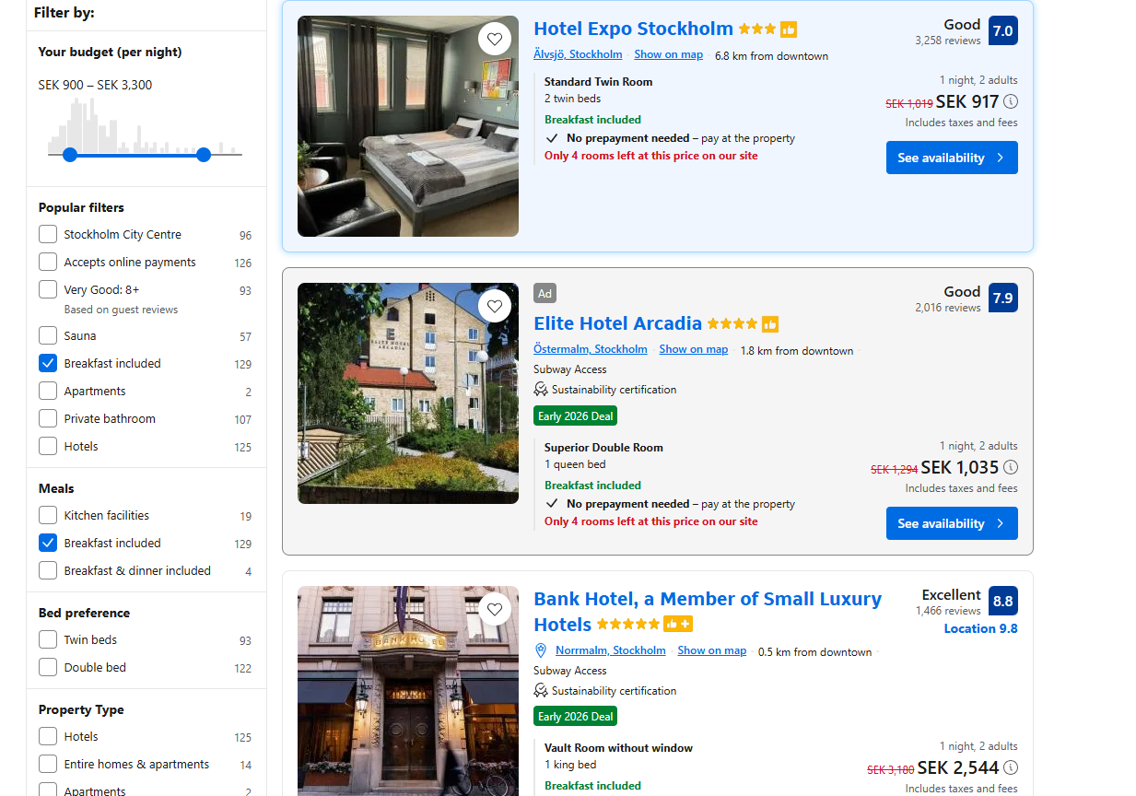

Scenario 3:
1-) Find the lowest rating property found at Scenario 2
(Do not use “property rating sort by” dropdown , find by algorithm )

Scenario 4:
Select the lowest rating property found at Scenario 3,then
Scroll down to guest reviews part,

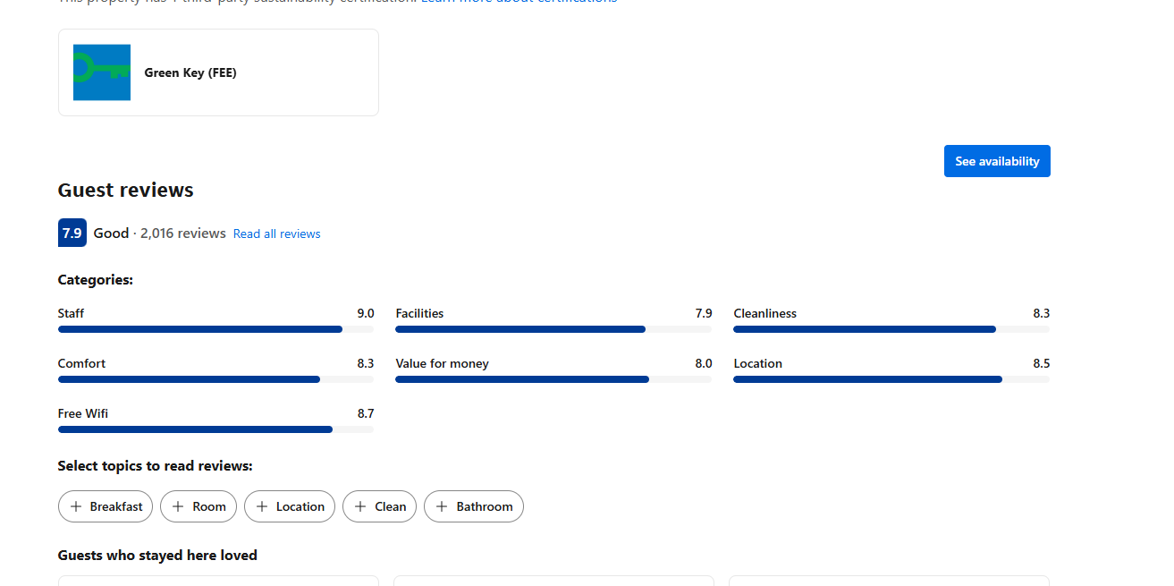 ​

- Validate that “Comfort” rating is more than 6.3
- Validate that “Cleanliness” rating is equal to 5.7
- Take Screenshot

