Sarcasm Detection in Social Media Text Using Contextual Features
NLP Mini Project Report
Table of Contents

1. Problem Definition
Sarcasm is a form of figurative language in which the literal meaning of an utterance differs from, and often opposes, the intended meaning (“I love waking up at 5 am to a flat tyre”). It breaks sentiment analysis, opinion mining and dialogue systems, because the surface sentiment is the opposite of the real one. Detecting it in social media is hard: texts are short, noisy and full of hashtags, emoji and slang, and the cue that reveals sarcasm is usually context (a contradicting situation, hashtag or emoji) rather than any single word.
Task. Given a tweet, classify it as ironic/sarcastic (1) or not (0).
Hypothesis. A classifier that explicitly models contextual signals - sentiment incongruity between parts of the tweet, text-vs-hashtag and text-vs-emoji contrast, and pragmatic cues - will outperform a plain bag-of-words baseline.
Scope note on “context”. The chosen dataset provides isolated tweets with no reply thread, so “context” here means intra-tweet context (clauses, hashtags, emoji, structure). Conversational context (parent comments) is discussed as future work.

2. Methodology Overview
Workflow: Problem definition -> Dataset -> Preprocessing -> Feature representation -> Baselines -> Improved methods -> Evaluation -> Comparison/Ablation -> Error analysis -> Conclusion -> Future scope.
- Baselines: B1 TF-IDF(word 1-2 grams) + Multinomial Naive Bayes; B2 TF-IDF(word) + Logistic Regression.
- Improved: I1 context features only + Gradient Boosting; I2 TF-IDF(word+char) + context features + Logistic Regression; I3 same features + Linear SVM; I4 late fusion (average of text-LR and context-gradient-boosting probabilities, weight 0.6/0.4).
- Protocol: hyper-parameters tuned by 5-fold stratified CV on the training set (scoring = F1 of the positive class); the tuned model is refit on the whole training set and evaluated once on the official gold test set. Ablations use the same protocol. All code is deterministic (seed 42).

3. Dataset
Property | Value
Name | SemEval-2018 Task 3, Subtask A - Irony detection in English tweets
Source | https://github.com/Cyvhee/SemEval2018-Task3 (Van Hee, Lefever & Hoste, 2018)
Files used | train/SemEval2018-T3-train-taskA_emoji.txt, goldtest_TaskA/SemEval2018-T3_gold_test_taskA_emoji.txt
Collection | Tweets gathered via hashtags #irony, #sarcasm, #not (ironic class), plus non-ironic tweets; manually annotated.
Labels | 1 = ironic (includes sarcasm), 0 = not ironic
Table 1 - Dataset characteristics (computed by src/data.py)
 | Train | Test
Tweets | 3,834 | 784
Ironic / sarcastic (1) | 1,911 (49.8%) | 311 (39.7%)
Non-ironic (0) | 1,923 | 473
Avg. characters | 87.4 | 94.4
Avg. tokens | 13.7 | 14.9
Raw vocabulary | 17,068 | 5,034
% with hashtag | 39.6 | 72.2
% with @mention | 39.9 | 37.6
% with URL | 22.4 | 25.1
% with emoji | 10.6 | 11.2
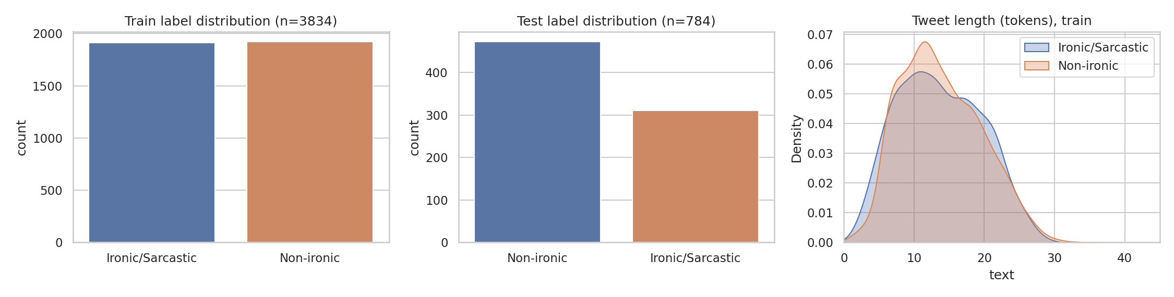
Dataset overview
Dataset caveats discovered during the project (important for interpreting results):
- Irony vs. sarcasm. Labels are for irony; sarcasm is its most frequent sub-type but not the only one (situational irony is also included).
- Label-leaking hashtags. In the gold test file all 311 ironic tweets still contain a collection hashtag (#irony, #not, …), and 120 non-ironic tweets contain one too. The training file has none (organisers removed them). A model could trivially exploit these on the test set, so the pipeline masks #sarcasm/#sarcastic/#irony/#ironic/#not/#sarcasmalert/#satire in both splits. The reported scores are therefore “content-only” scores.
- Train/test mismatch (found and fixed). A first run used the emoji-stripped training file (0.1% emoji) against the test file (11% emoji). The emoji-preserving training file (10.6%) is used for all reported results.
- Distribution shift. The test set has a different class prior (39.7% vs 49.8% ironic) and more hashtags (72% vs 40% of tweets).
- Collection artefacts. After masking, ironic tweets contain fewer hashtags (train 0.67 vs 1.25 per tweet) and fewer URLs (14% vs 31%) than non-ironic ones. This is partly genuine (news-link tweets are rarely ironic) but plausibly also an artefact of how the corpus was built; see Sections 8-9.

4. Preprocessing (src/preprocess.py)
- HTML unescape; || (this corpus’ line-break marker) -> sentence break.
- Mask label-leaking hashtags (see above).
- URL -> url; @mention -> user.
- Hashtag segmentation (#NoReligion -> no religion). Hashtags are kept as words because they often carry the situational context.
- Emoji -> text tokens (emoji_unamused_face) with the emoji library.
- Lower-casing and elongation normalisation (soooo -> soo); the elongation itself is kept as a feature.
- Regex tokenisation that preserves emoticons (;)), punctuation runs (!!!, ..., ?!) and contractions.
Stop-words are kept by default because words such as so, just, oh, really are sarcasm markers; an ablation tests this choice (Section 7). Stemming/lemmatisation was not used (no WordNet access in the build environment; char n-grams partly compensate for morphology).

5. Feature Representation
Representation | Details
Word TF-IDF | uni+bi-grams, min_df=2, sublinear TF
Char TF-IDF | char_wb 2-5 grams, min_df=3, sublinear TF
Contextual features (34) | standardised, clipped to [-5,5], weighted by a tuned block weight
Contextual feature groups (src/features.py):
- Sentiment context / incongruity (15): VADER compound polarity of the whole text, hashtags and emoji; clause-level polarity (clauses split on punctuation and but/however/though/yet) with max, min, flip count and an incongruity score; counts of positive and negative lexicon words; flags for text-vs-hashtag and text-vs-emoji polarity contrast; “positive text + negative context” flag. Un-segmented hashtags (#worstmorning) are scanned for lexicon words.
- Pragmatic / stylistic (12): counts of !, ?, ?!, ellipses, quotation marks, ALL-CAPS words, caps ratio, elongated words, interjections (oh, wow, yay), intensifiers (so, totally, absolutely), laughter, starts-with-interjection.
- Structural (8): token count, length, number of hashtags, ends-with-hashtag, mentions, URL presence, emoji count, emoji-at-end.

6. Results
Metrics are for the positive (ironic) class unless noted. Test set n = 784. “CV F1” is 5-fold CV on the training set. F1 95% CI is a bootstrap (1,000 resamples) of the test set.
Table 2 - Model comparison on the gold test set
Model | Acc | Prec | Rec | F1 | Macro-F1 | ROC-AUC | F1 95% CI | CV F1
B1 TF-IDF + Naive Bayes | 0.6735 | 0.5733 | 0.6913 | 0.6268 | 0.6683 | 0.7390 | [0.583, 0.669] | 0.6369
B2 TF-IDF + LogReg | 0.6645 | 0.5649 | 0.6720 | 0.6138 | 0.6586 | 0.7453 | [0.568, 0.652] | 0.6465
I1 Context-only + GradBoost | 0.6888 | 0.5994 | 0.6495 | 0.6235 | 0.6791 | 0.7501 | [0.578, 0.666] | 0.6652
I2 Word+Char+Context + LogReg | 0.6901 | 0.5971 | 0.6720 | 0.6324 | 0.6822 | 0.7773 | [0.588, 0.675] | 0.6832
I3 Word+Char+Context + LinearSVM | 0.6837 | 0.5877 | 0.6785 | 0.6299 | 0.6768 | 0.7615 | [0.586, 0.672] | 0.6806
I4 Late fusion (Text-LR + Context-GB) | 0.7028 | 0.6089 | 0.7010 | 0.6517 | 0.6963 | 0.7894 | [0.610, 0.691] | 0.6829
Selected hyper-parameters: B1 alpha=1.0; B2 C=3; I1 depth=3, 200 iterations; I2 C=1, context weight 0.6; I3 C=0.03, context weight 0.15; I4 text-LR C=1, fusion weight 0.6 (fixed a priori, not tuned).
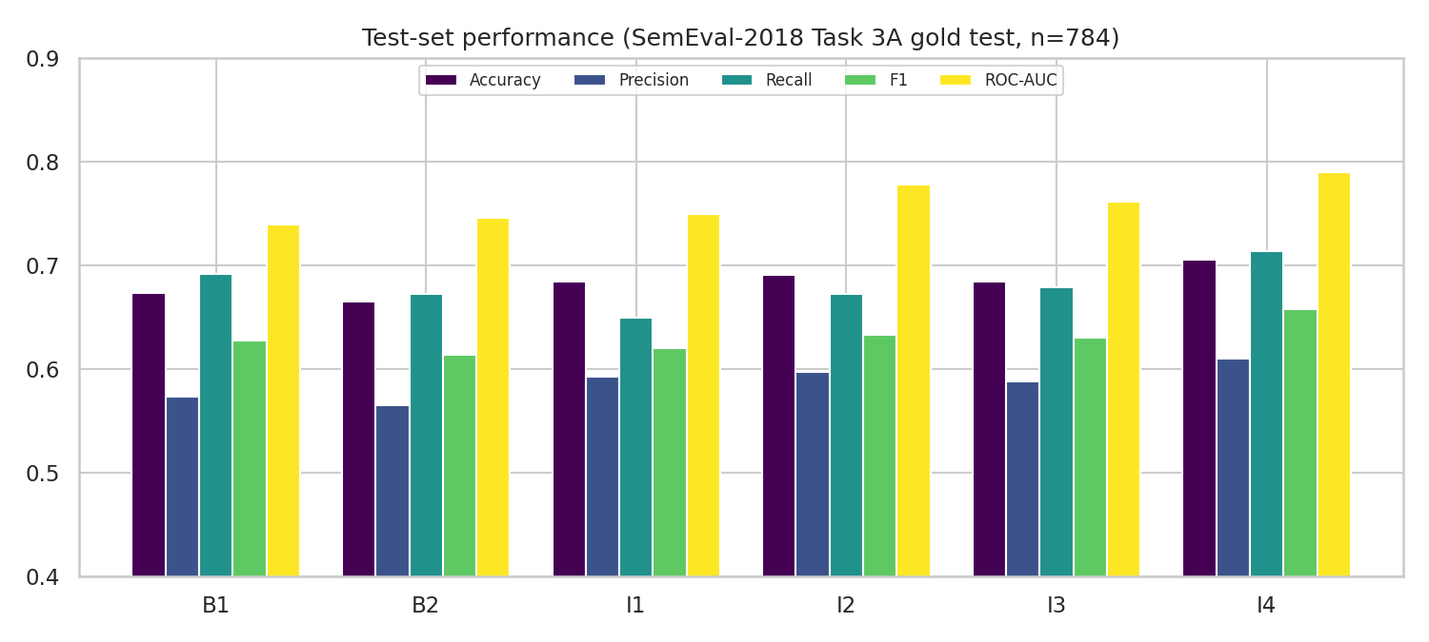
Model comparison (note: y-axis starts at 0.4)
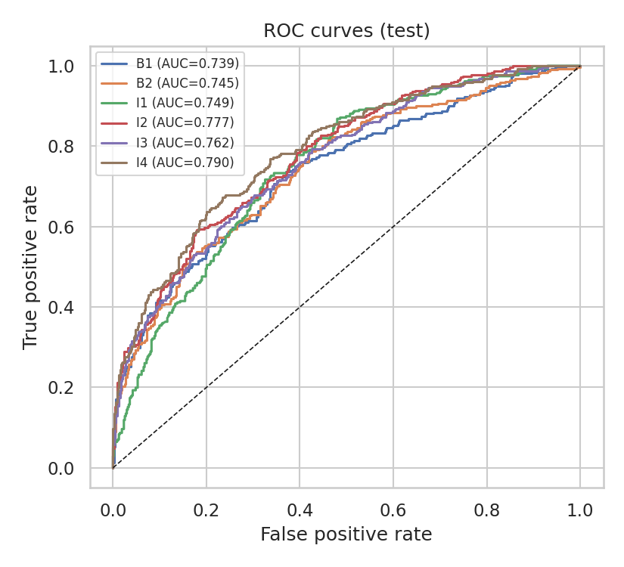
ROC curves
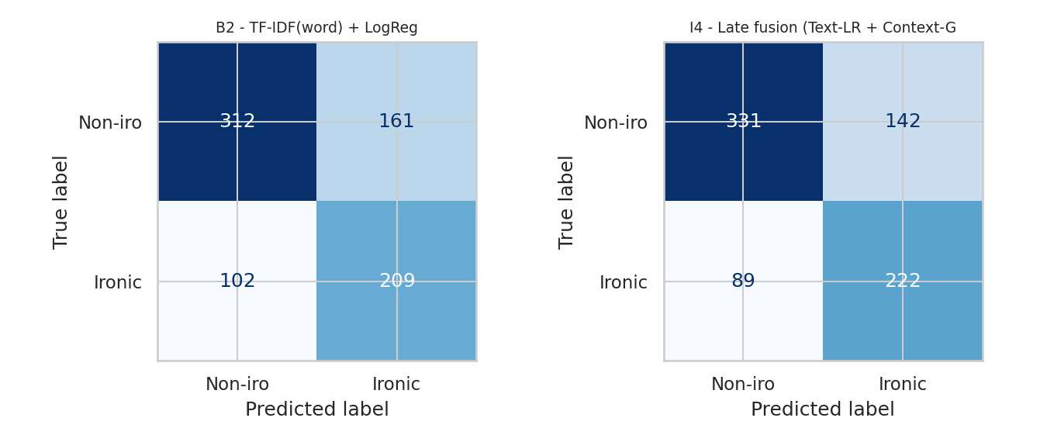
Confusion matrices: baseline B2 vs best model I4
Table 3 - Paired significance vs. baseline B2 (exact McNemar test on test predictions)
Model | B2 right / model wrong | B2 wrong / model right | p-value
B1 NB | 42 | 49 | 0.530
I1 Context-only GB | 109 | 128 | 0.242
I2 Word+Char+Context LR | 55 | 75 | 0.095
I3 Word+Char+Context SVM | 74 | 89 | 0.273
I4 Late fusion | 46 | 76 | 0.008
Comparative analysis.
- Every improved model beats B2 in cross-validation (0.665-0.683 vs 0.647 F1, a gain of about 0.02-0.04 with fold standard deviations of about 0.012-0.016) and in ROC-AUC (0.750-0.789 vs 0.745).
- On the test set, the best model I4 improves F1 from 0.614 (B2) to 0.652 (+0.038) and accuracy from 66.4% to 70.3%. This is the only improvement that is statistically significant at the 5% level (McNemar p = 0.008). I2 is borderline (p = 0.095), and I1/I3 are not significant.
- The simpler Naive Bayes baseline (F1 0.627) is stronger than LogReg on the test set, so the improvement over the best baseline is +0.025 F1; I did not run a paired test against B1. Bootstrap intervals of different models overlap heavily, so differences of ~0.01-0.02 F1 should be treated as noise.
- Context features alone (I1, no text at all) reach 0.624 test F1 / 0.665 CV F1, about the same as the word-TF-IDF baseline. The contextual cues carry real signal that is largely complementary to lexical content, which is why late fusion works best.
- Precision stays low (0.56-0.61) for all systems: the models over-predict irony (140 false positives vs. 93 false negatives for I4).
- For orientation only: the SemEval-2018 task overview reports best participant F1 around 0.70 for deep-learning systems. That number is not directly comparable because of differences in the test file and my masking of label hashtags.

7. Ablation Study
All rows use the I2 configuration (LogReg, C=1, context weight 0.6). Ablation rows were computed with the same CV/test protocol.
Table 4 - Ablation
Configuration | CV F1 (mean ± std) | Test Acc | Test P | Test R | Test F1
Word TF-IDF only | 0.6431 ± 0.016 | 0.6633 | 0.5644 | 0.6624 | 0.6095
Word + char TF-IDF | 0.6610 ± 0.009 | 0.6837 | 0.5863 | 0.6881 | 0.6331
+ sentiment/incongruity only | 0.6581 ± 0.012 | 0.6773 | 0.5801 | 0.6752 | 0.6241
+ pragmatic/stylistic only | 0.6586 ± 0.011 | 0.6913 | 0.6000 | 0.6656 | 0.6311
+ structural only | 0.6805 ± 0.015 | 0.6977 | 0.6005 | 0.7106 | 0.6510
FULL (all context features) | 0.6832 ± 0.016 | 0.6901 | 0.5971 | 0.6720 | 0.6324
FULL - sentiment/incongruity | 0.6817 ± 0.017 | 0.7015 | 0.6066 | 0.7042 | 0.6518
FULL - pragmatic/stylistic | 0.6742 ± 0.013 | 0.6849 | 0.5870 | 0.6945 | 0.6362
FULL - structural | 0.6604 ± 0.012 | 0.6888 | 0.5960 | 0.6688 | 0.6303
Context features only (LR) | 0.6648 ± 0.016 | 0.6620 | 0.5650 | 0.6431 | 0.6015
Word TF-IDF + stop-word removal | 0.6555 ± 0.011 | 0.6786 | 0.5813 | 0.6785 | 0.6261
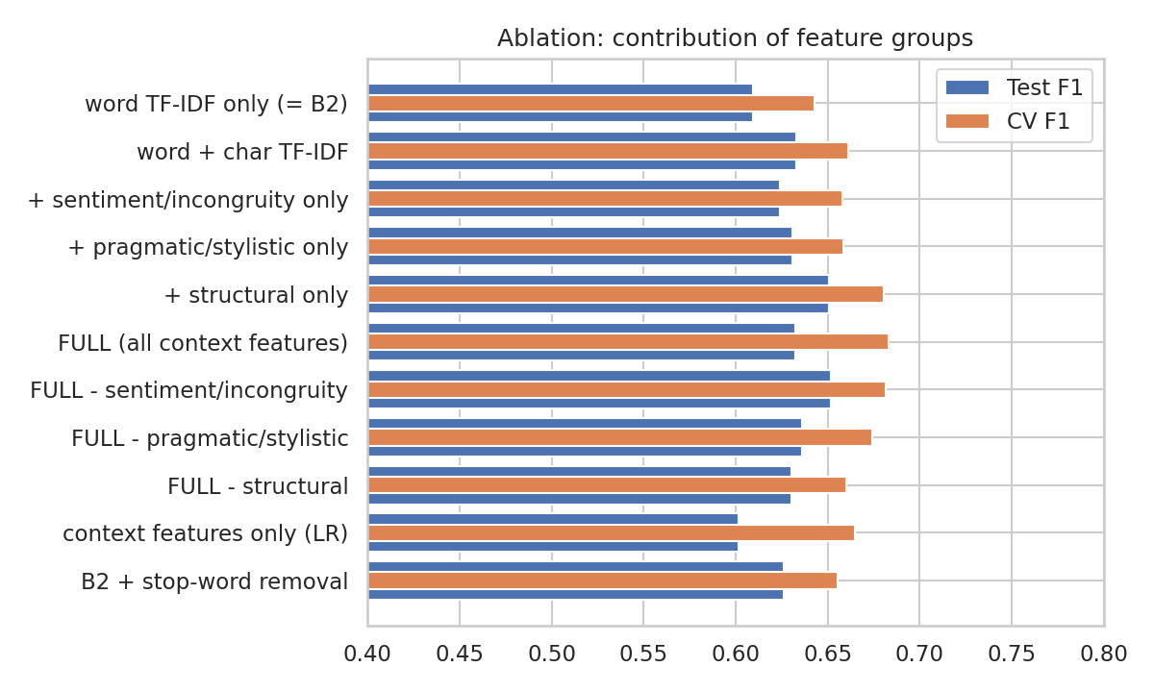
Ablation
Findings.
- Character n-grams help (+0.018 CV F1), consistent with the noisy, misspelled nature of tweets.
- The structural group provides the largest context gain (+0.020 CV F1 over word+char); removing it from the full model costs the most (CV 0.6832 -> 0.6604).
- The sentiment-incongruity features did not help in this experiment: adding them alone gives no CV gain (0.6581 vs 0.6610), and removing them from the full model leaves CV unchanged (0.6817 vs 0.6832) and raises test F1 (0.6518 vs 0.6324). The main hypothesis of the project - that explicit incongruity features add value - is therefore not supported by these data, although the test-set differences are within noise. Likely reasons: VADER is a general-purpose lexicon, not tuned for tweets’ sarcasm; incongruity features fire rarely (only 38 of 784 test tweets have a clause-level incongruity); and sarcasm in this corpus is often situational rather than lexical.
- Removing stop-words did not hurt and gave a small gain (CV +0.012, about one standard deviation), so the stop-word design choice is not supported either; the effect is too small to be conclusive.

8. Feature Inspection
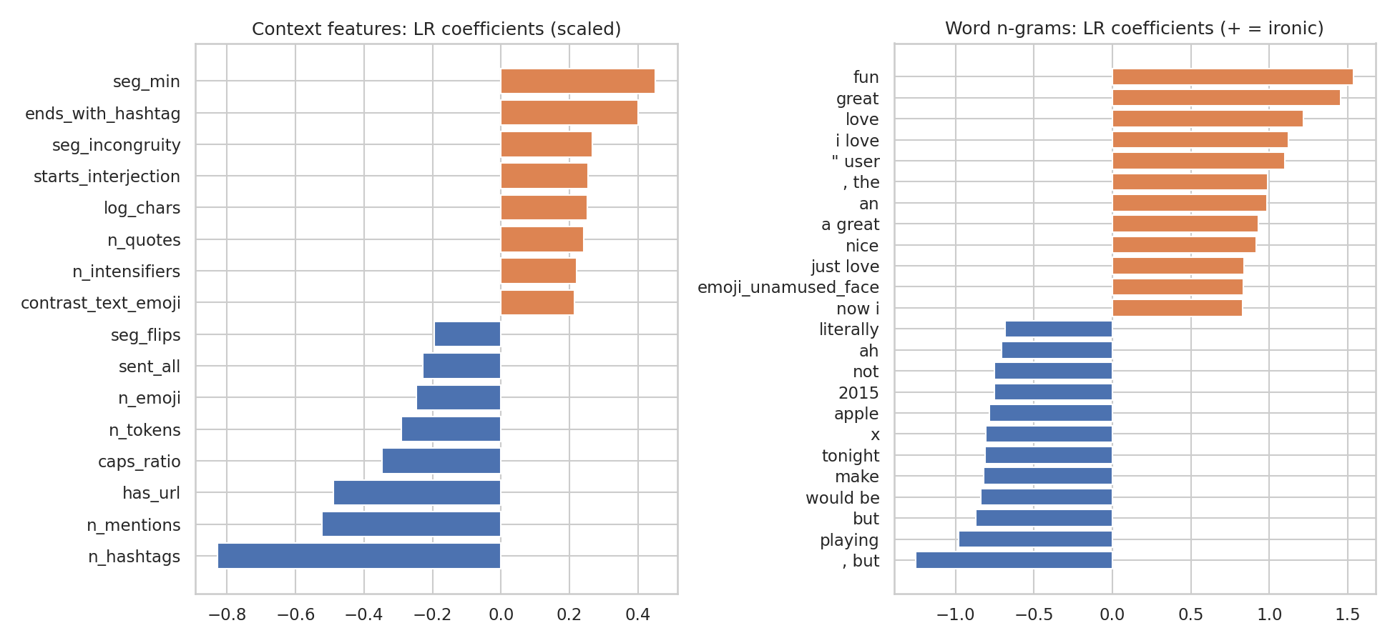
Most informative features (LogReg coefficients, model I2)
- Words most associated with irony: fun, great, love, “i love”, “just love”, nice, thanks, so and the unamused-face emoji - positive, enthusiastic vocabulary. Words associated with non-irony include but, playing, tonight, would be, 2015.
- Among context features, the strongest negative coefficients are n_hashtags (-0.83), n_mentions (-0.52), has_url (-0.49) and caps_ratio (-0.35); the strongest positive ones include seg_min (+0.45), ends_with_hashtag (+0.40), seg_incongruity (+0.27), starts_interjection (+0.25), n_quotes (+0.24) and n_intensifiers (+0.22).
- The strongest features are structural. As noted in Section 3, hashtag/URL/mention counts partly reflect how the corpus was assembled, so the model does not learn only sarcasm.

9. Error Analysis (best model I4)
Overall error rate 29.7% on the test set: 93 false negatives (missed irony; 29.9% of ironic tweets) and 140 false positives (false alarms; 29.6% of non-ironic tweets).
Table 5 - Error rates by tweet subset (results/error_by_subset.csv)
Subset | n | % ironic | Error % | FN % (of ironic) | FP % (of non-ironic)
Short (<=8 tokens) | 144 | 39.6 | 31.2 | 15.8 | 41.4
Long (>=20 tokens) | 155 | 45.2 | 29.0 | 25.7 | 31.8
Has hashtag | 362 | 38.4 | 26.2 | 24.5 | 27.4
No hashtag | 422 | 40.8 | 32.7 | 34.3 | 31.6
Has emoji/emoticon | 105 | 32.4 | 21.0 | 14.7 | 23.9
Has URL | 197 | 19.8 | 18.8 | 79.5 | 3.8
Has @mention | 295 | 28.5 | 28.8 | 56.0 | 18.0
Positive text sentiment | 326 | 43.3 | 27.6 | 14.9 | 37.3
Negative text sentiment | 161 | 34.2 | 36.0 | 47.3 | 30.2
Neutral text sentiment | 297 | 38.7 | 28.6 | 40.0 | 21.4
Sentiment incongruity present | 38 | 47.4 | 28.9 | 22.2 | 35.0
Text-vs-hashtag contrast | 45 | 55.6 | 37.8 | 16.0 | 65.0
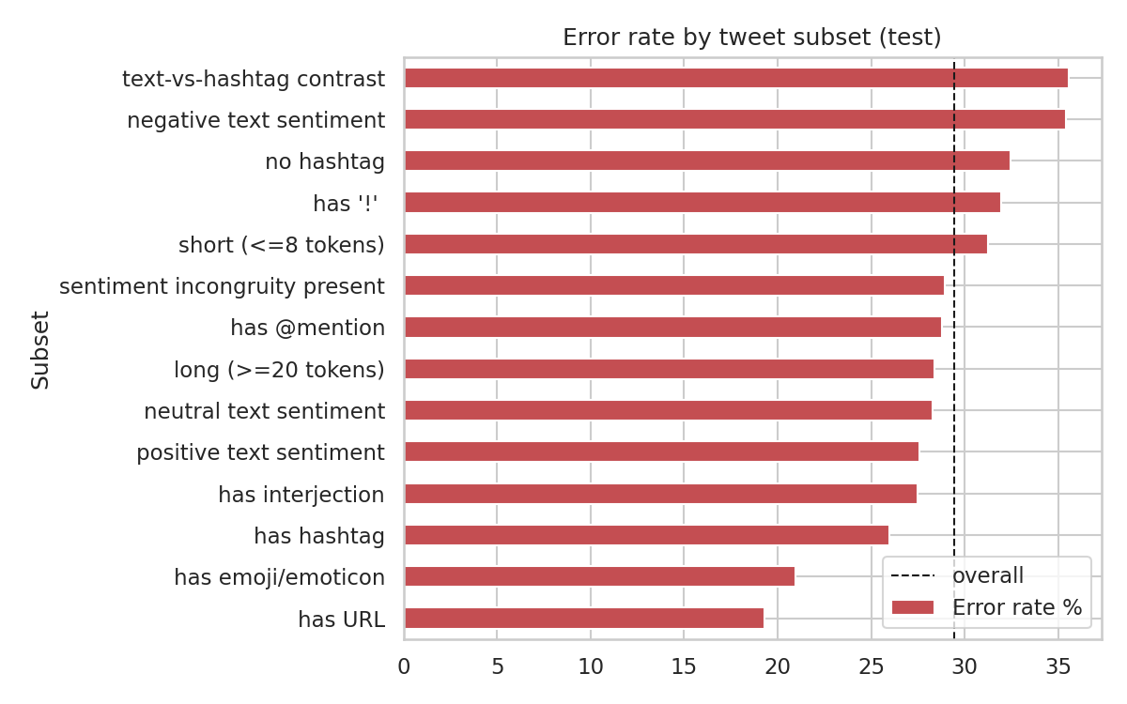
Error rate by subset
Quantitative patterns.
- URL and @mention tweets are mostly predicted non-ironic. 79.5% of ironic tweets that contain a URL are missed (the model has learned that link-sharing tweets are usually non-ironic).
- Polarity bias. Positive-sentiment tweets are over-flagged (37.3% of the non-ironic ones are false positives) while ironic tweets with negative or neutral surface sentiment are missed (47.3% and 40.0%). The model has largely learned “enthusiastic wording => ironic”, the classic positive-sentiment cue, but not the subtler negative-text sarcasm.
- Short tweets produce many false alarms (41.4% FP): little evidence, so the prior on positive wording dominates.
- The text-vs-hashtag contrast group is small (n=45) and has 65% false positives, so a contrast between the main text and a hashtag is a poor indicator on its own here (many hashtags are merely playful or negative commentary on a neutral statement).
Qualitative analysis (read from the 8 most confident false negatives and 8 most confident false positives in results/errors_test.csv; this is a small, non-exhaustive sample):
Type | Example | Likely reason
FN | “clashupdate #not http://…” ; “Produce Mobile Apps #not http://…” | The only sarcasm cue was the collection hashtag, which we mask by design; the rest is neutral link text.
FN | “…the mayor and Gov are Dems. #irony” ; “…the trickle down fairy will do the rest” | Needs world/political knowledge or a rhetorical reading; no lexical or sentiment cue.
FN | tweets with several @mentions and a URL | Structural prior (mentions/URLs => non-ironic) overrides weak textual evidence.
FP | “Corny jokes are my absolute favorite” ; “Yeah, you’re a grown up… Life’s handiwork!!” | Positive wording + intensifier, plausibly sincere or ambiguous without context.
FP | “How were your #holidays? We’d love to hear all about them!” | Brand-style tweet; a genuine model error (probability 0.72).
FP | “Dan said he’s going to have a sign for me at the airport when I fly in lol #SoCute” | Probably sincere; may also reflect annotation noise or subjectivity.

10. Limitations
- Single-tweet context only. No conversational or author context; many sarcastic tweets cannot be identified without it, even by humans.
- Irony label, not pure sarcasm, and the corpus is small (3.8k training tweets).
- Corpus artefacts. The most influential features (hashtag, mention and URL counts) partly encode collection procedure; the model’s performance may not transfer to other platforms or datasets. I did not evaluate cross-dataset generalisation.
- Shallow semantics. TF-IDF and a general-purpose sentiment lexicon cannot capture world knowledge or compositional meaning; no pre-trained embeddings or transformers were used (no model-hub access in the build environment).
- Evaluation caveats. One train/test split plus CV; the best model was chosen using test F1 (its CV F1, 0.683, is essentially tied with I2’s 0.683, so CV alone would not separate them; this means the choice of I4 as “best” rests partly on test data); the late-fusion weight 0.6 was fixed, not tuned; differences between several models are within bootstrap noise; no multi-seed repetition. Test prior and hashtag rate differ from training data, and no threshold calibration was performed.
- Heuristic features. VADER, the substring scan for un-segmented hashtags and the interjection/intensifier lists are hand-built and imperfect.
- Label subjectivity. Some “errors” are arguably annotation noise; inter-annotator agreement on irony is only moderate.

11. Conclusions
- A realistic NLP pipeline (tweet-specific preprocessing, word+char TF-IDF, 34 contextual features) was implemented and compared against two baselines under a rigorous protocol (tuned CV, held-out gold test, bootstrap CIs, McNemar, ablation).
- Adding contextual features improved F1 from 0.614 to 0.632-0.652 on the test set and from 0.647 to 0.665-0.683 in cross-validation. The best system - late fusion of a text model and a context model - reached F1 = 0.652, accuracy = 70.3%, ROC-AUC = 0.789, and is the only improvement that is statistically significant against the baseline (p = 0.008).
- The gain comes mainly from structural and pragmatic context and from character n-grams; the sentiment-incongruity features, which motivated the project, did not give a measurable benefit with a general-purpose lexicon.
- Errors are dominated by (i) ironic tweets whose cue is world knowledge or the masked hashtag, and (ii) sincere positive tweets flagged as ironic.

12. Possible Improvements and Research Directions
- Contextual language models. Fine-tune a tweet-specific transformer (e.g. BERTweet/RoBERTa) and fuse it with the contextual features (concatenate or late-fuse), which my result suggests are complementary to lexical content.
- Learned incongruity instead of lexicon incongruity. Train a model to compare the sentiment expression with the situation it describes (following Riloff et al., 2013), e.g. with embeddings or NLI-style sentence-pair models, and a tweet-specific/sarcasm-specific lexicon mined from data.
- Real conversational context. Evaluate on corpora with parent comments/threads (e.g. SARC, Khodak et al., 2018) and measure the benefit of thread and author context directly. Research question: how much does context add beyond the target text, and for which sarcasm types?
- De-biasing. Repeat the study with structural features removed or with adversarial/reweighted training to test whether performance holds when collection artefacts are neutralised, and test cross-dataset transfer.
- Evaluation robustness. Multi-seed repeated CV, threshold/prior calibration for the shifted test distribution, and paired tests against the strongest baseline.
- Knowledge-aware detection. Retrieval of external knowledge for situational irony (“Gov are Dems”-style political irony) and multimodal cues for tweets with images.

13. Reproducibility
pip install -r requirements.txt
python run_all.py # ~5 min on 1 CPU; writes results/ and results/figures/
python predict.py "Oh great, another Monday morning meeting!"
Python 3.12, scikit-learn 1.8, pandas, vaderSentiment 3.3, emoji 2.16. Seed 42. Gradient-boosting models (I1, I4) can differ in the third decimal across machines or library versions (an earlier run in a different environment gave I4 F1 = 0.658, p = 0.005); all other models and the ablation reproduced exactly. The numbers in this report come from a Windows run (Python 3.13) and match results/*.csv produced by run_all.py. All numbers in this report are from results/*.csv and results/run_log.txt generated by run_all.py.

14. References
- Van Hee, C., Lefever, E., & Hoste, V. (2018). SemEval-2018 Task 3: Irony Detection in English Tweets. Proceedings of the 12th International Workshop on Semantic Evaluation (SemEval-2018), pp. 39-50. ACL.
- Hutto, C. J., & Gilbert, E. (2014). VADER: A Parsimonious Rule-based Model for Sentiment Analysis of Social Media Text. Proc. ICWSM.
- Riloff, E., Qadir, A., Surve, P., De Silva, L., Gilbert, N., & Huang, R. (2013). Sarcasm as Contrast between a Positive Sentiment and Negative Situation. Proc. EMNLP.
- Gonzalez-Ibanez, R., Muresan, S., & Wacholder, N. (2011). Identifying Sarcasm in Twitter: A Closer Look. Proc. ACL (short papers).
- Joshi, A., Bhattacharyya, P., & Carman, M. J. (2017). Automatic Sarcasm Detection: A Survey. ACM Computing Surveys, 50(5).
- Khodak, M., Saunshi, N., & Vodrahalli, K. (2018). A Large Self-Annotated Corpus for Sarcasm (SARC). Proc. LREC.
- Davidov, D., Tsur, O., & Rappoport, A. (2010). Semi-Supervised Recognition of Sarcastic Sentences in Twitter and Amazon. Proc. CoNLL.
- Dietterich, T. G. (1998). Approximate Statistical Tests for Comparing Supervised Classification Learning Algorithms. Neural Computation, 10(7).
- Pedregosa, F. et al. (2011). Scikit-learn: Machine Learning in Python. JMLR, 12.
- Nguyen, D. Q., Vu, T., & Nguyen, A. T. (2020). BERTweet: A pre-trained language model for English Tweets. Proc. EMNLP (Demos).

