Requirements

* ~~Mobile first build.~~
* ~~Demonstrate the use of a task runner such as Gulp, Grunt, or Webpack.~~

Used Gulp to install a SASS converter to automatically convert all my SASS into CSS.

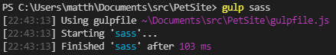

* ~~Demonstrate the use of precompiled styles e.g. SASS or LESS.~~

Used Gulp to install a SASS converter to automatically convert all my SASS into CSS

.

* ~~A naming convention such as BEM, for easy to follow css classes and structure.~~



* ~~Implement the slide out cart functionality using JavaScript.~~

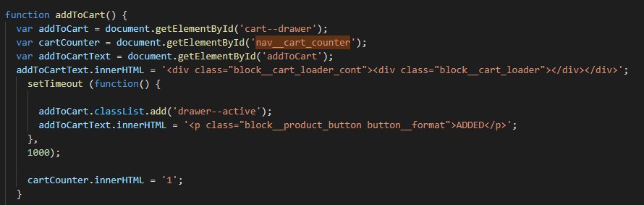

* ~~Create a 1 second loading animation before the slide out cart opens.~~

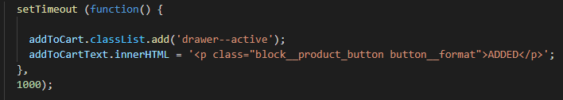

* ~~Use animations for opening/closing the cart.~~

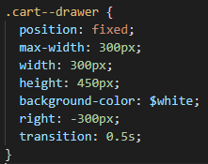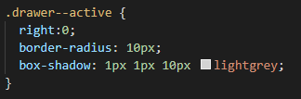

* ~~Ensure the slide out cart is scrollable on mobiles and tablets.~~

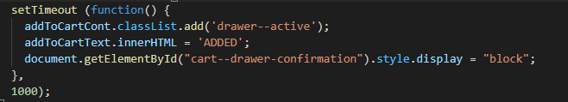

* ~~Ensure the implementation is cross-browser friendly.~~
* ~~Build reusable components that could be used on other areas of the website~~

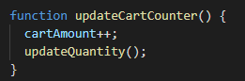

* ~~Use Roboto and Open Sans fonts – which are available via Google Fonts.~~

