Interface Specification
Open source 6LoWPAN implementation for ULE FP and PP

Contents

1 Introduction 3
1.1 Scope 3
1.2 History 3
1.3 References 3
1.4 Terms & Abbreviations 3
2 System Overview 5
2.1 Scope of the of the 6LoWPAN Library 5
2.2 Limitations of the 6LoWPAN library 5
2.3 General Implementation Considerations 6
2.4 Test Interface 6
3 6LBR Interface 7
3.1 6LBR Specific API Functions 7
3.2 6LBR Specific Type Definitions 12
4 6LN Interface 14
4.1 6LN Specific API Functions 14
4.2 6LN Specific Type Definitions 23
5 Example on how the 6LoWPAN Library is interfaced 26

Introduction

Scope
The scope of this document is to define the interfaces for the 6LoWPAN library implementation for DECT ULE for both FP and PP.

History
Revision | Author | Issue Date | Comments
0.1 | THK | 1-JUL-15 | Initial Revision
0.2 | THK | 10-Jul-15 | Reviewed internally by RTX (JTP and CM)
1.0 | THK | 13-Jul-15 | Released to ULE Alliance
1.1 | THK | 24-Jul-15 | Reviewed by HSO
1.2 | THK | 10-Aug-15 | Remarks from ULE Alliance
1.3 | JJO | 06-Jan-16 | Changes made during development at RTX
1.4 | SFC | 01-Mar-16 | Updated interfaces.

References

[1] | Title: | SoW - Open source 6LoWPAN implementation for ULE FP and PP
 | Author: | Rasmus Fossa
 | Location: | q:\Projects\UleAlliance\Simone\Specifications\  ProductRequirements\StatementOfWork\SoW-6LoWPAN26may2015.pdf
[2] | Title: | Transmission of IPv6 Packets over DECT Ultra Low Energy draft-ietf-6lo-dect-ule
 | Author: | P. Mariager et al.
 | Location: | https://tools.ietf.org/wg/6lo/draft-ietf-6lo-dect-ule/
[3] | Title: | HAN-FUN library implementation
 | Author: | Bithium S.A.
 | Location: | https://github.com/ULE-Alliance/hanfun.git

[4] | Title: | Testing framework for a 6LoPWAN implementation  over DECT ULE networks
 | Author: | Offenburg University of Applied Sciences
 | Location: | q:\Projects\UleAlliance\Simone\Specifications\ProductRequirements \StatementOfWork\FromOffenburg\SoW_ule_6lotest_v06.pdf

Terms & Abbreviations
6LoWPAN  6LBR  6LN  API | IPv6 over Low power Wireless Personal Area Networks  6LoWPAN Board Router (In DECT known as FP)  6LoWPAN Node (In DECT known as PP)  Application Interface
DECT | Digital Enhanced Cordless Telephone
FP | DECT Fixed Part (Base)
HS | DECT Handset
MMI | Man Machine Interface / User interface
PP | DECT Portable Part (Handset)
DNS | Domain Name System
ULE | DECT Ultra Low Energy
RTX | RTX A/S
SW | Software
HW | Hardware
FP | Fixed Part
PP | Portable Part
ME | Management Entity
MM | Mobility Management
HSO | Hochschule Offenburg (Offenburg University of Applied Sciences)
UA | ULE Alliance
LL | Link Layer, in this case the DECT ULE layer. (In some documents the DECT ULE layer is referred as Transport Layer, TL, which contradicts both the OSI and Internet model where the ULE layer would be Physical/Data Link layer and network layer respectively )

System Overview
The complete system consists of a DECT ULE Board Router (6LBR) with possible internet access and a number of DECT ULE nodes (6LN) using 6LowPAN as communication protocol, and DECT ULE as Phy/Data Link layer.

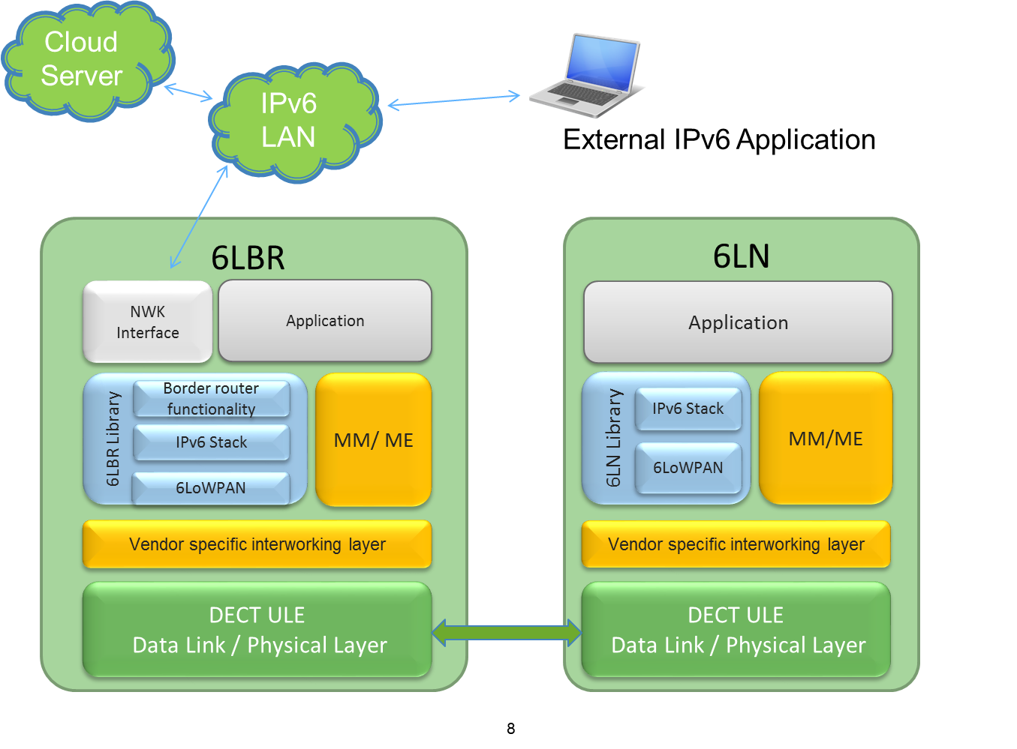

Scope of the of the 6LoWPAN Library
The library implements the procedures defined in [2]. The library can be configured either as for the node or for the gateway, respectively 6LN and 6LBR. It is based on the open source Contiki implementation of 6LoWPAN for 802.15.4, but with adaption for DECT-ULE as Link Layer.

The features implemented in the protocol stack are:
IPv6 header compression HC01. Supporting IPv6 only, UDP, TCP and ICMP. Supporting messages: RS, RA, NS, NA, context registration, SLAAC (based on IEEE MAC48), DNS resolver, addressing: global routable via registered context. Supported IP options: SLLAO, 6CO, ABRO, ARO, RDNSSO
Neighbor registration cache
Unicast / multicast (relay via 6LBR)

Limitations of the 6LoWPAN library
The 6LoWPAN library only handles the IPv6 configuration and packet transmission, thus all DECT ULE MM/Registration has to be handled elsewhere. Also power management such as sleep/wakeup handling is outside the scope of the 6LoWPAN library.

As specified in [2] the DECT ULE 6LoWPAN library will only support star topology network due to the nature of DECT ULE. Thus, multi-hop network is not supported and 6LN cannot be part of the routing.

Due to DECT ULE star topology, each branch of the star is considered an individual link and thus the 6LNs cannot directly hear one another and cannot talk to one another with link-local addresses, however communications directly between 6LN and 6LBR can use IPv6 link-local methodology.

General Implementation Considerations
The 6LoWPAN library is implemented in ANSI C, and will be provided as an open source library under the 3-clause BSD-style license. The 6LoWPAN library is based on the Contiki 6LowPAN implementation for 802.15.4, and will use the uIP stack and socket API from Contiki.

All the messages, parameters and data types defined in this document as in the 6LoWPAN implementation have little endian byte ordering and all the messages and data types with multiple members are byte aligned (packed).

All functions defined in this document are implemented as non-blocking. Pointers parsed as argument or given as return value must be considered as volatile, and responsibility of the caller to copy data.

Random generation of iid
Since the iid is based on random generation it is important that the random init function is seeded with a truly random number. random_init() must be called after ule6loGI_init(..) at the LBR and after lla_init(..) at the node.

Test Interface
In order to provide a reliable software library testing of functionalities and interfaces are crucial. Therefore a test interface is implemented providing the necessary functions for both doing White-box and black-box testing. The test interface conforms to the requirement setup in [4], thereby enabling HSO to perform system test and final Acceptance testing.

6LBR Interface

6LBR Specific API Functions
The 6LBR interfaces upwards to an external network and a possible application and downwards to the DECT-ULE layer. Furthermore the 6LBR 6LoWPAN library also provides a test interface, which interacts directly into the library. Potentially the 6LoWPAN library could also provide a socket interface to the application. However this not included on the 6LBR side in the current version, for more option see, Socket Interface for the 6LN.

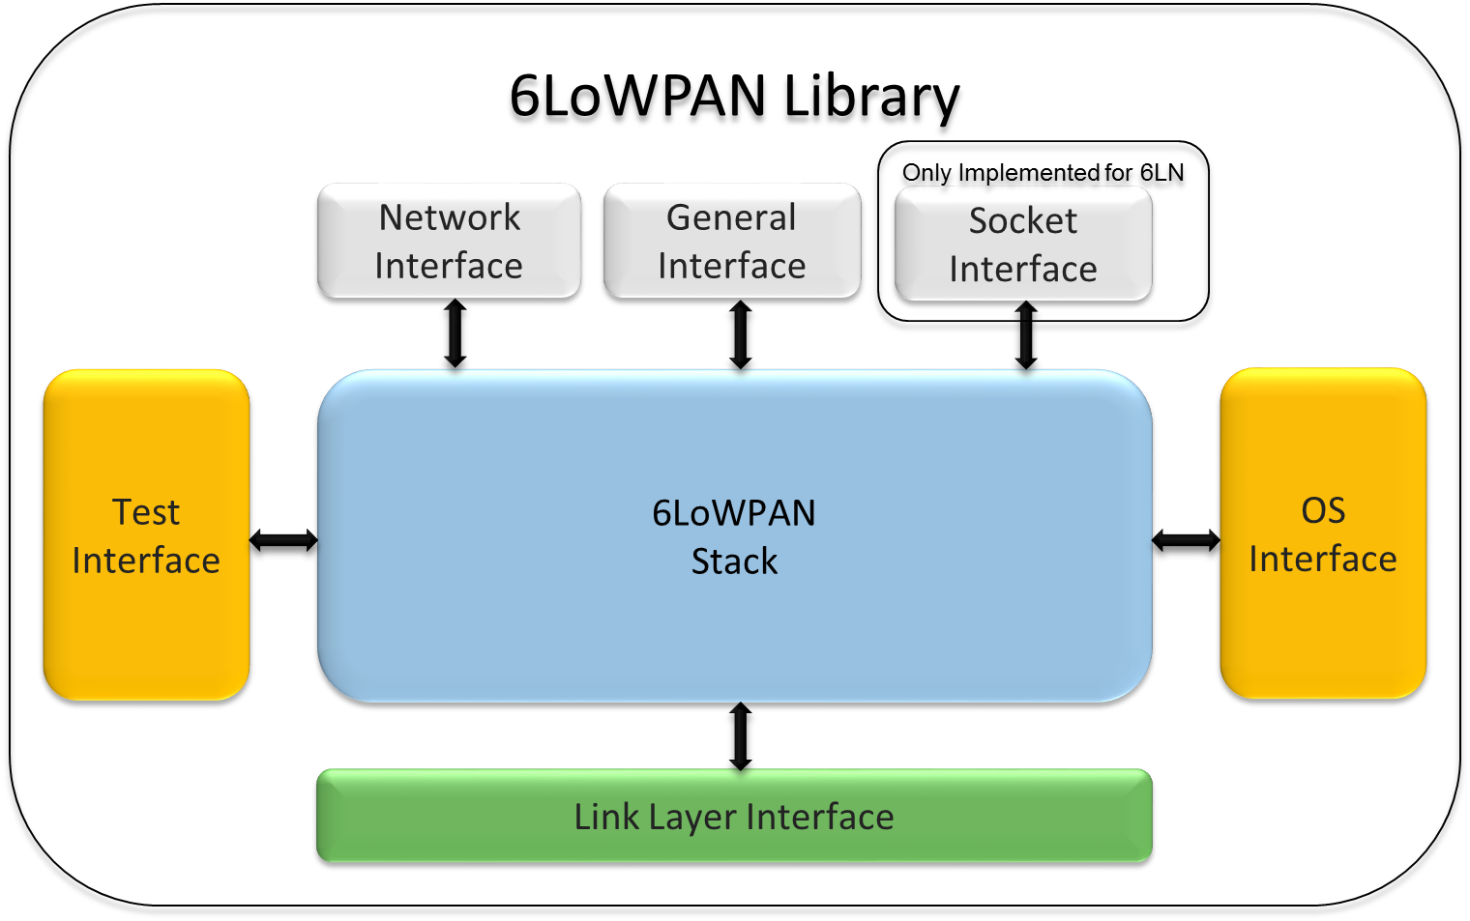

General Interface
The 6LoWPAN library provides a set of general interface functions for initializing the library and to get various parameters.

ule6loGI_init
Description: | This function is called by the application/OS to initialize the 6LoWPAN library
Returns: | ule6lo_status_t
Parameters:
  Type | Name | Description
  const ule6lo_IPEI_t * | ULEAddr | Pointer to IPEI of ULE device

ule6loGI_getStatus
Description: | Returns status of 6LoWPAN library, STATUS_SUCCESS for working, otherwise not working
Returns: | ule6lo_status_t
Parameters: | None

ule6loGI_getIp6addr
Description: | Function for getting IP address
Returns: | ule6lo_status_t
Parameters:
Type | Name | Description
ule6lo_ipType_t | ipType | Type of IP address
ule6lo_ip6addr_t*  ule6lo_ipMode_t | ipAddr  mode | Pointer to IP address  Mode of IP address requested

ule6loGI_addContext
Description: | Function called from the application to add a context address for compression.
Returns: | ule6lo_status_t
Parameters:
Type | Name | Description
uint8_t[] | prefix | Array of bytes for the prefix
uint8_t | prefixlength | Length of prefix in bytes

ule6loGI_addMulticastAddr
Description: | Function called from the application to add a multicast address to listen at.
Returns: | ule6lo_status_t
Parameters:
Type | Name | Description
ule6lo_ip6addr_t* | ipaddress | Pointer to multicast address

ule6loGI_removeMulticastAddr
Description: | Function called from the application to remove a multicast address we are currently listen at.
Returns: | ule6lo_status_t
Parameters:
Type | Name | Description
ule6lo_ip6addr_t* | ipaddress | Pointer to multicast address

ule6loGI_setMacAddress
Description: | Function to add the mac address for the LBR
Returns: | none
Parameters:
Type | Name | Description
ule6lo_macAddr_t* | macaddress | Pointer to the mac address

ule6loGI_getDomain
Description: | Returns a pointer to zero-terminated string with the domain name
Returns: | ule6lo_status_t
Parameters:
Type | Name | Description
ule6lo_ip6addr_t* | ipAddr | Pointer to IP address
char * | domain | Pointer to zero terminated string

Network Interface
The 6LoWPAN library on the 6LBR interfaces upwards to the network. This interface provide the following functions:

ule6loNI_receive
Description: | This function is called by the network interface to deliver an incoming IPv6 packet to the 6LoWPAN library. The packet is on layer 2, including mac header.
Returns: | ule6lo_status_t
Parameters:
  Type | Name | Description
  const uint8_t * | Data | Pointer to IPv6 packet
  uint16_t | dataLength | Length of IPv6 packet

ule6loNI_send
Description: | This function is called by 6LoWPAN library to deliver an outgoing IPv6 packet to the network. The packet is on layer 2, including mac header.
Returns: | ule6lo_status_t
Parameters:
  Type | Name | Description
  const uint8_t * | data | Pointer to IPv6 packet
  uint16_t | dataLength | Length of IPv6 packet

ule6loNI_echoRequest
Description: | This function sends out an echo request(ICMP 128) to the network.
Returns: | None
Parameters: | None

ULE Link Layer Interface
The 6LoWPAN library aligns the interface towards the LL with the interface used in the Han-Fun library [3], in order to obtain best possible interoperability. The Han-Fun defines following functions, where similar functions will be used for the 6LoWPAN library:

- Transport::initialize()
- Transport::receive()
- Transport::connected()
- Transport::delivered()
- Transport::send()

ule6loLLI_init
Description: | Called after location registration to inform the 6LoWPAN library a new ULE link is connected
Returns: | Status
Parameters:
  Type | Name | Description
  const ule6lo_IPEI_t * | ULEAddr | Pointer to IPEI of ULE device

ule6loLLI_receive
Description: | Called from LL when LL receives a data indication and forwards data to the 6LoWPAN library.
Returns: | status_t
Parameters:
  Type | Name | Description
  const uint8_t * | data | Pointer to ULE packet
  uint16_t | dataLength | Length of ULE packet
  const ule6lo_IPEI_t * | ULEAddr | Pointer to IPEI of ULE device

      - ule6loLLI_send
Description: | Called from within 6LoWPAN library when sending a ULE packages to the LL layer
Returns: | None
Parameters:
  Type | Name | Description
  const uint8_t * | data | Pointer to ULE packet
  uint16_t | dataLength | Length of ULE packet
  const ule6lo_IPEI_t * | ULEAddr | Pointer to IPEI of ULE device

ule6loLLI_delivered
Description: | Called from LL after transmission to indicate status.
Returns: | None
Parameters:
  Type | Name | Description
  ule6lo_status_t | status | Status of previous transmission
  const ule6lo_IPEI_t * | ULEAddr | Pointer to IPEI of ULE device

OS Interface

ule6loOS_processRun
Description: | This function should be called repeatedly from the main() program / OS to actually run the 6LoWPAN library.
Returns: | None
Parameters: | None

ule6loOS_getMACAddr
Description: | Returns the 6LBRs MAC address. This function is hardware/ OS depended and needs to be implemented correspondingly
Returns: | ule6lo_macAddr_t *
Parameters: | None

ule6loOS_getTimerTick
Description: | Function called by the 6LoWPAN library to get the system timer tick. The function expects a tick increment corresponding to10 ms. The function is hardware/ OS depended and needs to be implemented correspondingly.
Returns: | uint32_t
Parameters: | None

Test Interface
The following defines the test interface for the 6LBR 6LoWPAN library.

ule6loTestIn_init
Description: | Initialize test interface (allocates buffers, resets packet counts and status ) and returns status
Returns: | ule6lo_status_t
Parameters: | None

ule6loTestIn_deinit
Description: | Terminates test interface, including cleanup of buffer handling and deregister call backs, returns status
Returns: | ule6lo_status_t
Parameters: | None

ule6loTestIn_reset
Description: | Performs soft reset which emulates a hardware reset, everything is cleared including IPs and NB lists. Returns status
Returns: | ule6lo_status_t
Parameters: | None

ule6loTestIn_getNbListSize
Description: | Returns the length of Neighbor list.
Returns: | uint16_t
Parameters: | None

ule6loTestIn_getNbList
Description: | Copies specified index of the Neighbor list to specified destination
Returns: | ule6lo_status_t
Parameters:
  Type | Name | Description
  uint16_t | index | Index in the neighbor list to be copied
  ule6lo_nbr_t* | nBListItem | Item in neighbor list

ule6loTestIn_getnofSentPacket
Description: | Returns amount of sent packets on DECT interface
Returns: | uint32_t
Parameters: | None

ule6loTestIn_getnofReceivedPacket
Description: | Returns amount of received packets on DECT interface
Returns: | uint32_t
Parameters: | None

ule6loTestIn_regRxHook
Description: | Register a hook function to be called every time an packet is received on the wireless interface, with the raw packet as argument
Returns: | None
Parameters:
  Type | Name | Description
  ule6lo_hock_t | rxHook | Pointer callback function. This function is called every time a packet is received, with a pointer to the packet and length of the packet

ule6loTestIn_regTxHook
Description: | Register a hook function to be called every time an packet is transmitted on the wireless interface, with the raw packet as argument
Returns: | None
Parameters:
  Type | Name | Description
  ule6lo_hock_t | txHook | Pointer callback function. This function is called every time a packet is received, with a pointer to the packet and length of the packet

ule6loTestIn_regBorderRouterRxHook
Description: | Register a hook function to be called every time an packet is received on the border router interface, with the raw packet as argument
Returns: | None
Parameters:
  Type | Name | Description
  ule6lo_hock_t | rxHook | Pointer callback function. This function is called every time a packet is received, with a pointer to the packet and length of the packet

ule6loTestIn_regBorderRouterTxHook
Description: | Register a hook function to be called every time an packet is transmitted on the border router interface, with the raw packet as argument
Returns: | None
Parameters:
  Type | Name | Description
  ule6lo_hock_t | txHook | Pointer callback function. This function is called every time a packet is received, with a pointer to the packet and length of the packet

ule6loTestIn_getnofBorderRouterSentPacket
Description: | Returns amount of sent packets on border router interface
Returns: | uint32_t
Parameters: | None

ule6loTestIn_getnofBorderRouterReceivedPacket
Description: | Returns amount of received packets on border router interface
Returns: | uint32_t
Parameters: | None

6LBR Specific Type Definitions

ule6lo_status_t
Description: |  | General status type
C-syntax:
typedef enum ule6lo_status_t
{
 | STATUS_SUCCESS |  | = 0x00, | The request completed successfully.
 | STATUS_NOT_CONNENCTED |  | = 0x01, | Connected
 | STATUS_ERROR |  | = 0x02, | Error
 | STATUS_NO_DEVICE |  | = 0x03, | No such device
 | STATUS_NO_DATA |  | = 0x04, | No data is available.
 | STATUS_NOT_READY |  | = 0x05, | The device is not ready.
 | STATUS_MAX |  | = 0xFF
} ule6lo_ststaus_t;

ule6lo_ipType_t
Description: |  | IP address type. More migth be added
C-syntax:
typedef enum ule6lo_ipType_t
{
 | IP_ADDRESS_LINK_LOCAL |  | = 0x00, | Link local IP address
 | IP_ADDRESS_GLOBAL |  | = 0x01, | Global IP address
 | IP_ADDRESS_MAX |  | = 0xFF
} ule6lo_ipType_t;

ule6lo_macAddr_t
Description: |  | MAC address type
C-syntax:
typedef union {
{
 | uint8_t |  | u8[6];
} ule6lo_macAddr_t;

ule6lo_ip6addr_t
Description: |  | IPv6 address type
C-syntax:
typedef union ule6lo_ip6addr_t {
{
 | uint8_t |  | u8[16];
 | uint16_t |  | u16[8];
} ule6lo_ip6addr_t;

ule6lo_IPEI_t
Description: |  | IPEI address type
C-syntax:
typedef union {
{
 | uint8_t |  | id[5];
} ule6lo_IPEI_t;

ule6lo_nbr_t
Description: |  | An entry in the neighbor cache
C-syntax:
typedef struct ule6lo_ds6_nbr {
{
 | ule6lo_ipaddr_t |  | ipaddr;
 | ule6lo_IPEI_t |  | lladdr;
} ule6lo_nbr_t;

ule6lo_hook_t
Description: | Hock function pointer type
C-syntax:
typedef void (*ule6lo_hook_t)(uint8_t *data, uint16_t dataLength)

ule6lo_ipMode_t
Description: |  | IP address mode.
C-syntax:
typedef enum ule6lo_ipMode_t
{
 | IP_ADDRESS_ANY |  | = -1, | ANY
 | IP_ADDRESS_TENTATIVE |  | = 0, | Tentative
 | IP_ADDRESS_PREFERRED  IP_ADDRESS_DEPRECATED |  | = 1,  = 2 | Preferred  Deprecated
} ule6lo_ipMode_t;

6LN Interface
The 6LoWPAN library on the ULE node interface upwards to the application with a BSD like socket interface, a DNS interface and a more general application interface and downwards to the DECT ULE layer. Also for the node a test interface is defined together with an OS abstraction interface.

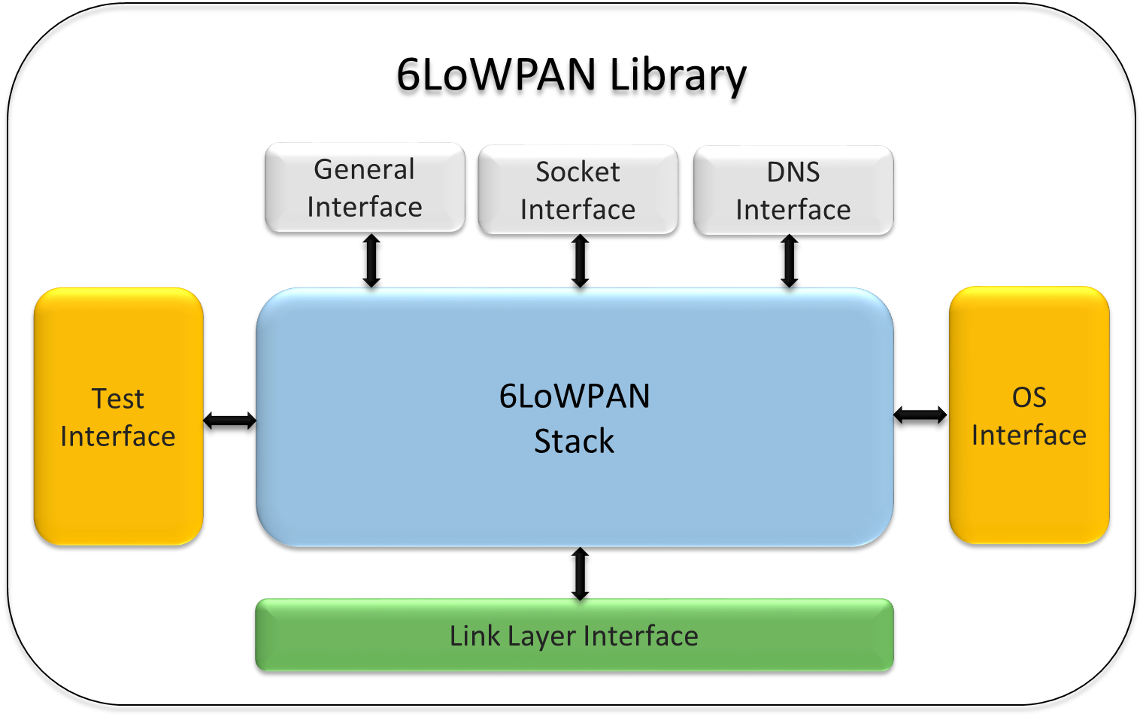

6LN Specific API Functions

General Interface
The 6LoWPAN library provides a set of general interface functions for initializing the library and for getting various parameters.

ule6loGI_init
Description: | This function is called by the application/OS to initialize the 6LoWPAN library
Returns: | ule6lo_status_t
Parameters: | None

ule6loGI_getStatus
Description: | Returns status of 6LoWPAN library, STATUS_SUCCESS for working, otherwise not working
Returns: | ule6lo_status_t
Parameters: | None

ule6lo_getIp6addr
Description: | Function for getting IP address
Returns: | ule6lo_status_t
Parameters:
Type | Name | Description
ule6lo_ipType_t | ipType | Type of IP address
ule6lo_ip6addr_t*  ule6lo_ipMode_t | ipAddr  mode | Pointer to IP address  Mode of IP address requested

ule6loGI_addMulticastAddr
Description: | Function to add a multicast address to listen at.
Returns: | ule6lo_status_t
Parameters:
Type | Name | Description
ule6lo_ip6addr_t* | ipaddress | Pointer to multicast address

ule6loGI_removeMulticastAddr
Description: | Function to remove a multicast address we are currently listen at.
Returns: | ule6lo_status_t
Parameters:
Type | Name | Description
ule6lo_ip6addr_t* | ipaddress | Pointer to multicast address

ule6loGI_setMacAddress
Description: | Function to add the mac address for the node
Returns: | none
Parameters:
Type | Name | Description
ule6lo_macAddr_t* | macaddress | Pointer to the mac address

ule6loGI_getDomain
Description: | Returns a pointer to zero-terminated string with the domain name
Returns: | ule6lo_status_t
Parameters:
Type | Name | Description
ule6lo_ip6addr_t* | ipAddr | Pointer to IP address
char * | domain | Pointer to zero terminated string

Socket Interface
The socket interface upwards the application uses the BSD like implementation from Contiki, which provides both a TCP and UDP socket API. Therefore types and function definitions corresponds to the ones used in Contiki.

tcp_socket_register
Description: | This function registers a TCP socket. The function sets  up the output and input buffers for the socket and  callback pointers
Returns: | Int
Parameters:
  Type | Name | Description
  struct tcp_socket * | S
  void * | Ptr
  uint8_t | input_databuf
  int | input_databuf_len
  uint8_t | output_databuf
  int | output_databuf_len
  tcp_socket_data_callback_t | input_callback
  tcp_socket_data_callback_t | event_callback

tcp_socket_connect
Description: | Connects a TCP socket to an IP address and port number, returns -1 for failure.
Returns: | int
Parameters:
  Type | Name | Description
  struct tcp_socket* | S | Pointer to TCP socket
  const uip_ipaddr_t* | Ipaddr | Destination IP
  uint16_t port | port | Destination port

tcp_socket_listen
Description: | Listen to a TCP socket on specified port number, returns -1 for failure.
Returns: | int
Parameters:
Type | Name | Description
struct tcp_socket* | S | Pointer to TCP socket
uint16_t port | port | Port number

tcp_socket_unlisten
Description: | Stops listing to specified TCP socket, returns -1 for failure.
Returns: | int
Parameters:
  Type | Name | Description
  struct tcp_socket* | S | Pointer to TCP socket

tcp_socket_send
Description: | Sends data on specified TCP socket, returns -1 for failure.
Returns: | int
Parameters:
  Type | Name | Description
  struct tcp_socket* | S | Pointer to TCP socket
  const uint8_t * | data | Pointer to data to send
  int | datalen | Length of data

tcp_socket_send_str
Description: | Sends a string on specified TCP socket, string needs to be NULL terminated, returns -1 for failure.
Returns: | int
Parameters:
  Type | Name | Description
  struct tcp_socket* | S | Pointer to TCP socket
  const char * | Str | string to send

tcp_socket_close
Description: | Closes connection on specified TCP socket.
Returns: | int
Parameters:
  Type | Name | Description
  struct tcp_socket* | S | Pointer to TCP socket

tcp_socket_unregister
Description: | Clean up TCP socket.
Returns: | int
Parameters:
  Type | Name | Description
  struct tcp_socket* | S | Pointer to TCP socket

udp_socket_register
Description: | This function registers the UDP socket with the system. A UDP socket must be registered before any data can be sent or received over the socket.
Returns: | int
Parameters:
  Type | Name | Description
  struct udp_socket * | S
  void * | Ptr
  udp_socket_data_callback_t | input_callback

udp_socket_close
Description: | Closes and removes UDP socket
Returns: | int
Parameters:
  Type | Name | Description
  struct udp_socket* | c | Pointer to UDP socket

udp_socket_bind
Description: | Binds UDP socket to specified port number
Returns: | int
Parameters:
  Type | Name | Description
  struct udp_socket* | c | Pointer to UDP socket
  uint16_t | Local_port | Port number

udp_socket_connect
Description: | Connects UDP socket (this is optional in UDP)
Returns: | int
Parameters:
  Type | Name | Description
  struct udp_socket* | c | Pointer to UDP socket
  uip_ipaddr_t * | remote_addr | Pointer to remote IP address
  uint16_t | Local_port | Port number

udp_socket_send
Description: | Sends data packet on specified UDP socket, needs to be in a “connected state” in order to know the recipient
Returns: | int
Parameters:
  Type | Name | Description
  struct udp_socket* | c | Pointer to UDP socket
  const void * | data | Pointer to data to send
  uint16_t | datalen | Length of data

udp_socket_sendto
Description: | Sends data packet on specified UDP socket, to specified IP address and port number
Returns: | int
Parameters:
  Type | Name | Description
  struct udp_socket* | c | Pointer to UDP socket
  const void * | data | Pointer to data to send
  uint16_t | datalen | Length of data
  uip_ipaddr_t * | remote_addr | Pointer to remote IP address
  uint16_t | Local_port | Port number

DNS Interface
The 6LoWPAN library provides a set of DNS resolver functions used to lookup a hostname and map it to a numerical IP address. These functions are directly based on Contiki, thus types and function definitions corresponds to the ones used in Contiki.

resolv_query
Description: | Queues a name so that a question for the name will be sent out.
Returns: | None
Parameters:
  Type | Name | Description
  const char * | name | The hostname that is to be queried

resolv_lookup
Description: | Look up a hostname in the array of known hostnames.
Returns: | resolv_status_t
Parameters:
  Type | Name | Description
  const char * | name | The hostname that is to be queried
  uip_ipaddr_t ** | ipaddr | IP address corresponding to the hostname

ULE Link Layer Interface
The 6LoWPAN library aligns the interface towards the LL with the interface used in the Han-Fun library [3], in order to obtain best possible interoperability. The Han-Fun defines following functions, where similar function will be used for the 6LoWPAN library:

- Transport::initialize()
- Transport::receive()
- Transport::connected()
- Transport::check()
- Transport::delivered()
- Transport::send()

ule6loLLI_init
Description: | Called after location registration to inform the 6LoWPAN library that the 6LN is now connected to 6LBR
Returns: | ule6lo_status_t
Parameters:
  Type | Name | Description
  const ule6lo_IPEI_t * | ULEAddr | Pointer to IPEI of ULE device

ule6loLLI_receive
Description: | Called from LL when LL receives a data indication and forwards data to the 6LoWPAN library.
Returns: | ule6lo_status_t
Parameters:
  Type | Name | Description
  const uint8_t * | data | Pointer to ULE packet
  uint16_t | dataLength | Length of ULE packet
  Const ule6lo_IPEI_t | *ULEAddr | Ipei of the sending LBR

ule6loLLI_connected
Description: | Called from LL to indicate status of connection, if ready to receive/transmit data, or disconnected/offline
Returns: | None
Parameters:
  Type | Name | Description
  ule6lo_status_t | status | Status of the connection

ule6loLLI_check
Description: | Called from LL before receiving data. It sends an empty string.
Returns: | None
Parameters: | None
      - ule6loLLI_send
Description: | Called from the 6LoWPAN library when sending a ULE packages to the LL layer
Returns: | None
Parameters:
  Type | Name | Description
  const uint8_t * | data | Pointer to ULE packet
  uint16_t | dataLength | Length of ULE packet

ule6loLLI_delivered
Description: | Called from LL after transmission to indicate status.
Returns: | None
Parameters:
  Type | Name | Description
  ule6lo_status_t | status | Status of previous transmission

OS Interface

ule6loOS_processRun
Description: | This function should be called repeatedly from the main() program / OS to actually run the 6LoWPAN library.
Returns: | None
Parameters: | None

ule6loOS_getMACAddr
Description: | Returns the 6LNs MAC address. This function is hardware/ OS depended and needs to be implemented correspondingly
Returns: | ule6lo_macaddr_t *
Parameters: | None

ule6loOS_getTimerTick
Description: | Function called by the 6LoWPAN library to get the system timer tick. The function expects a tick increment corresponding to10 ms. The function is hardware/ OS depended and needs to be implemented correspondingly.
Returns: | uint32_t
Parameters: | None

Test Interface
The following defines the test interface for the 6LN 6LoWPAN library:

ule6loTestIn_init
Description: | Initialize test interface, returns status
Returns: | ule6lo_status_t
Parameters: | None

ule6loTestIn_deinit
Description: | Terminates test interface, including cleanup of buffer handling and deregister call backs, returns status
Returns: | ule6lo_status_t
Parameters: | None

ule6loTestIn_reset
Description: | Performs soft reset which emulates a hardware reset, everything is cleared including IPs and NB lists. Returns status
Returns: | ule6lo_status_t
Parameters: | None

ule6loTestIn_getNbListSize
Description: | Returns the length of Neighbor list.
Returns: | uint16_t
Parameters: | None

ule6loTestIn_getNbList
Description: | Copies specified index of the Neighbor list to specified destination
Returns: | ule6lo_status_t
Parameters:
  Type | Name | Description
  uint16_t | index | Index of the neighbor list to be copied
  ule6lo_nbr_t* | nBListItem | Item in neighbor list

ule6loTestIn_getnofSentPacket
Description: | Returns amount of sent packets
Returns: | uint32_t
Parameters: | None

ule6loTestIn_getnofReceivedPacket
Description: | Returns amount of received packets
Returns: | uint32_t
Parameters: | None

ule6loTestIn_regRxHook
Description: | Register a hook function to be called, every time an packet is received, with the raw packet and length as argument
Returns: | None
Parameters:
  Type | Name | Description
  ule6lo_hock_t | rxHook | Pointer callback function. This function is called every time a packet is received, with a pointer to the packet and length of the packet

ule6loTestIn_regTxHook
Description: | Register a hook function to be called every time an packet is transmitted, with the raw packet as argument
Returns: | None
Parameters:
  Type | Name | Description
  ule6lo_hock_t | txHook | Pointer callback function. This function is called every time a packet is received, with a pointer to the packet and length of the packet

6LN Specific Type Definitions

ule6lo_status_t
Description: |  | General status type
C-syntax:
typedef enum ule6lo_status_t
{
 | STATUS_SUCCESS |  | = 0x00, | The request completed successfully.
 | STATUS_NOT_CONNENCTED |  | = 0x01, | Connected
 | STATUS_ERROR |  | = 0x02, | Error
 | STATUS_NO_DEVICE |  | = 0x03, | No such device
 | STATUS_NO_DATA |  | = 0x04, | No data is available.
 | STATUS_NOT_READY |  | = 0x05, | The device is not ready.
 | STATUS_MAX |  | = 0xFF
} ule6lo_ststaus_t;

ule6lo_ipType_t
Description: |  | IP address type. More migth be added
C-syntax:
typedef enum ule6lo_ipType_t
{
 | IP_ADDRESS_LINK_LOCAL |  | = 0x00, | Link local IP address
 | IP_ADDRESS_GLOBAL |  | = 0x01, | Global IP address
 | IP_ADDRESS_MAX |  | = 0xFF
} ule6lo_ipType_t;

ule6lo_macAddr_t
Description: |  | MAC address type
C-syntax:
typedef union {
{
 | uint8_t |  | u8[6];
} ule6lo_macAddr_t;

ule6lo_ip6addr_t
Description: |  | IPv6 address type
C-syntax:
typedef union ule6lo_ip6addr_t {
{
 | uint8_t |  | u8[16];
 | uint16_t |  | u16[8];
} ule6lo_ip6addr_t;

ule6lo_IPEI_t
Description: |  | IPEI address type
C-syntax:
typedef union {
{
 | uint8_t |  | id[5];
} ule6lo_IPEI_t;

ule6lo_hook_t
Description: | Hook function pointer type
C-syntax:
typedef void (*ule6lo_hook_t)(uint8_t *data, uint16_t dataLength)

tcp_socket_event_callback_t
Description: |  | TCP event callback function
C-syntax:
typedef enum {
TCP_SOCKET_CONNECTED,
TCP_SOCKET_CLOSED,
TCP_SOCKET_TIMEDOUT,
TCP_SOCKET_ABORTED,
TCP_SOCKET_DATA_SENT
} tcp_socket_event_t;

Typedef void (* tcp_socket_event_callback_t)
(
 | struct tcp_socket * |  | S,
 | void * |  | Ptr,
 | tcp_socket_event_t |  | Event,
);

udp_socket
Description: |  | UDP socket type
C-syntax:
struct udp_socket
{
 | udp_socket_input_callback_t |  | input_callback;
 | void * |  | ptr
 | struct process * |  | p
 | Struct uip_conn * |  | C
};

udp_socket_input_callback_t
Description: |  | A UDP socket callback function
C-syntax:
typedef void (* udp_socket_input_callback_t)
[
 | struct udp_socket * |  | C,
 | void * |  | Ptr,
 | const uip_ipaddr_t * |  | source_addr,
 | uint16_t |  | source_port,
 | const uip_ipaddr_t * |  | dest_addr,
 | uint16_t |  | dest_port,
 | const uint8_t * |  | input_data_ptr,
 | int |  | input_data_len,
);

resolv_status_t
Description: |  | resolv status type
C-syntax:
typedef uint8_t resolv_status_t;
enum
{
 | RESOLV_STATUS_CACHED |  | = 0x00, | Hostname is fresh and usable. This response is cached and will eventually expire to RESOLV_STATUS_EXPIRED.
 | RESOLV_STATUS_UNCACHED |  | , | Hostname was not found in the cache. Use resolv_query() to look it up.
 | RESOLV_STATUS_EXPIRED |  | , | Hostname was found, but it's status has expired. The address returned should not be used. Use resolv_query() to freshen it up.
 | RESOLV_STATUS_NOT_FOUND |  | , | The server has returned a not-found response for this domain name. This response is cached for the period described in the server. You may issue a new query at any time using resolv_query(), but you will generally want to wait until this domain's status becomes RESOLV_STATUS_EXPIRED.
 | RESOLV_STATUS_RESOLVING |  | , | This hostname is in the process of being resolved. Try again soon.
 | RESOLV_STATUS_ERROR |  | , | Some sort of server error was encountered while trying to look up this record. This response is cached and will eventually expire to RESOLV_STATUS_EXPIRED.
};

ule6lo_ipMode_t
Description: |  | IP address mode.
C-syntax:
typedef enum ule6lo_ipMode_t
{
 | IP_ADDRESS_ANY |  | = -1, | ANY
 | IP_ADDRESS_TENTATIVE |  | = 0, | Tentative
 | IP_ADDRESS_PREFERRED  IP_ADDRESS_DEPRECATED |  | = 1,  = 2 | Preferred  Deprecated
} ule6lo_ipMode_t;

Example on how the 6LoWPAN Library is interfaced

