# **DAYANANDA SAGAR UNIVERSITY**

**Devarakaggalahalli, Harohalli, Kanakapura Road, Ramanagara Dt.,**

**Bengaluru – 562 112**



**Bachelor of Technology in**

**COMPUTER SCIENCE AND ENGINEERING**

**(Artificial Intelligence & Machine Learning)**

**AI Mini Project**

**Chatbot Using Large Language Modelling**

By

**MITESH SRINIVASAN S - ENG22AM0034**

**THUMMALA SHAIK FARHAN - ENG22AM0065**

**ULLAS CHANDER R - ENG22AM0066**

**YOGESH N - ENG22AM0070**

**Under the supervision of** **,**

Dr. JAYAVRINDA VRINDAVANAM **Chairperson, CSE(AI&ML)**

Prof. PRADEEP KUMAR **Assistant Professor, CSE(AI &ML)**

Prof. MITHAGURU **Assistant Professor, CSE(AI &ML)**

Dr**.** MARY JASMINE **Assistant Professor, CSE(AI & ML)**

**DEPARTMENT OF COMPUTER SCIENCE & ENGINEERING (AI&ML),**

#### SCHOOL OF ENGINEERING

#### DAYANANDA SAGAR UNIVERSITY, BANGALORE

**(2023-2024)**



**Day****ananda Sagar University**

**School of Engineering**

**Department of Computer Science & Engineering**

**(Artificial Intelligence & Machine Learning)**

**Devarakaggalahalli, Harohalli, Kanakapura Road, Ramanagara Dt.,**

**Bengaluru – 562 112**

# CERTIFICATE

This is to certify that the AI Mini Project – I (22AMXXXX) work titled **“Chatbot using Large Language Modelling”** is carried out by **T S Farhan** bearing **USN :ENG22AM0065,Ullas C** bearing **USN:ENG22AM0066,Yogesh** bearing **USN:ENG22AM0070,Mitesh** bearing **USN:ENG22AM0034** Bonafede student of Bachelor of Technology in Computer Science and Engineering (AI&ML) at the School of Engineering, Dayananda Sagar University, Bangalore in partial fulfillment for the award of degree in Bachelor of Technology in Computer Science and Engineering, during the year **2023-2024**.

|  |  |
| --- | --- |
| Prof. Pradeep Kumar K  Assistant Professor  Dept. of CSE (AI&ML),  School of Engineering  Dayananda Sagar University  Date: 01-01-2024 | Dr. Jayavrinda Vrindavanam V Chairman CSE (AI&ML)  School of Engineering  Dayananda Sagar University  Date: 01-01-2024 |

_____________________ ________________________

Prof. Mithaguru Dr. Mary Jasmine

Assistant Professor Assistant Professor

Dept. of CSE(AI&ML), Dept of CSE(AI&ML)

School of Engineering School of Engineering,

Dayananda Sagar University, Dayananda Sagar University,

Date: 01-01-2024 Date:01-01-2024

# DECLARATION

We, **T S Farhan, Ullas Chander, Yogesh N, Mitesh** students of third semester B. Tech in **Computer Science and Engineering with speciation in Artificial intelligence and machine learning** , at School of Engineering, **Dayananda Sagar University**, hereby declare that the **AI Mini Project** titled **“Chatbot using Large Language Modelling”** has been carried out by us and submitted to Prof. Pradeep Kumarduring the academic year **2023-2024**.

##### Student 1: Signature

**Name: T SHAIK FARHAN**

**USN: ENG22AM0065**

##### Student 2: Signature

**Name: ULLAS CHANDER R**

**USN: ENG22AM0066**

##### Student 3: Signature

**Name: YOGESH N**

**USN: ENG22AM0070**

##### Student 4: Signature

**Name: MITESH SRINIVASAN**

**USN: ENG22AM0034**

**Place: Bangalore**

**Date: 01-01-2024**

**ACKNOWLEDGEMENT**

*It is a great pleasure for me to acknowledge the assistance and support of many individuals who have been responsible for the successful completion of this project work.*

*First, I take this opportunity to express my sincere gratitude to School of Engineering & Technology, Dayananda Sagar University for providing us with a great opportunity to pursue our Bachelor’s degree in this institution.*

*I would like to thank* ***Dr. Udaya Kumar Reddy K R, Dean, School of Engineering & Technology, Dayananda Sagar University*** *for his constant encouragement and expert advice.*

*It is a matter of immense pleasure to express our sincere thanks to* ***Dr. Jayvrinda Vrindavanam v, Department Chairman****,* ***Computer Science and Engineering(AI AND ML)****,* ***Dayananda Sagar University,*** *for providing right academic guidance that made the task possible.*

*I would like to thank our guide* ***Prof. Pradeep Kumar K, Prof. Mithaguru, Dr. Mary Jasmine******Assistant Professors****,* ***Dept. of Computer Science and Engineering (AI AND ML)****,* ***Dayananda Sagar University****, for sparing his valuable time to extend help in every step of the project work, which paved the way for smooth progress and fruitful culmination of the project.*

*I am also grateful to my family and friends who provided me with every requirement throughout the course.*

*I would like to thank one and all who directly or indirectly helped me in the Project work*

# TABLE OF CONTENTS

|  |  |
| --- | --- |
| **Contents** | **Page No** |
| List of Abbreviations | 1 |
| Abstract | 2 |
| Chapter 1: Introduction |  |
| 1.1 Key Issues | 3 |
| 1.2 Objectives | 4 |
| 1.3 LLM | 6 |
| 1.4 NLP | 6 |
| 1.5 RL | 6 |
| Chapter 2: Literature Review | 7 |
| Chapter 3: Problem Statement | 11 |
| Chapter 4: Methodology |  |
| 4.1 Code Implementation | 12 |
| 4.2 Algorithm | 14 |
| 4.3 Code Explanation | 15 |
| Chapter 5: Result Analysis |  |
| 5.1 Output | 18 |
| 5.2 Result | 19 |
| Chapter 6: Conclusion | 20 |
| Chapter 7: References | 21 |

# LIST OF ABBREVIATIONS

|  |  |
| --- | --- |
| LLM | Large Language Modelling |
| AI | Artificial Intelligence |
| NLP | Natural Language Processing |
| RL | Reinforcement Learning |

# ABSTRACT

Our mini project, "Chatbot using Large Language Modeling," explores the integration of advanced AI techniques to create an intelligent chatbot capable of addressing user queries and providing language translation services. The project leverages domains of Natural Language Processing (NLP), Large Language Modelling (LLM) and Machine Translation within the broader field of Artificial Intelligence (AI). The model is fine-tuned to enhance its proficiency in understanding diverse user queries and providing accurate information. This model works on Reinforcement Learning and generates the answer. Additionally, the integration of language translation is achieved through the utilization of AI-powered translation models, allowing the chatbot to seamlessly translate messages between multiple languages.

The probable outcome of this project encompasses an intelligent chatbot that not only engages in meaningful conversations with users but also offers language translation services on-the-fly. Users can interact with the chatbot, seeking information, guidance, or assistance in their preferred language, and receive responses that are contextually relevant and linguistically accurate. The chatbot's ability to perform real-time language translation aims to break down communication barriers, making information more accessible to a global audience.

This project showcases the practical applications of large language models in enhancing user interaction and expanding the capabilities of traditional chatbots. The integration of language translation not only extends the functionality of the chatbot but also demonstrates the versatility and adaptability of AI solutions in addressing diverse user needs across different linguistic backgrounds.

**Keyword**- NLP (Natural Language Processing), LLM (Large Language Modelling), Reinforced Learning

# CHAPTER 1

# INTRODUCTION

In today's globalized society, effective communication transcending linguistic barriers is crucial for successful interactions, whether in business, personal relationships, or collaborative efforts.

However, language differences often pose challenges, hindering the seamless exchange of information and ideas. To overcome this hurdle, our project focuses on the development of an advancedAI-powered chatbot that specializes in language translation, aiming to create a user-friendly platform for real-time multilingual communication. According to the Oxford English Dictionary, a chatbot is defined as follows: A computer program designed to simulate conversation with human users, especially over the Internet. The underlying principle of every chatbot is to interact with a human user via text messages and behave as though it were capable of understanding the conversation and reply to the user appropriately. It uses Natural Language Processing (NLP)and sentiment analysis to communicate in human language by text or oral speech with humans or other chatbots.

.

**1.1 KEY ISSUES:**

* **Language Barriers:**

Challenge: Users face difficulties in communicating with others who speak different languages, limiting the scope of collaboration and interaction.

Significance: Breaking down language barriers is fundamental for fostering connections, promoting global collaboration, and ensuring effective communication.

* **Communication Inefficiencies:**

Challenge: Traditional translation methods, such as manual translation or reliance on external tools, can be time-consuming, cumbersome, and prone to errors.

Significance: Inefficient communication processes hinder productivity, lead to misunderstandings, and can result in missed opportunities for collaboration and relationship-building.

* **Limited Resources for Lesser-Known Languages:**

Challenge: Lesser-known languages may lack sufficient linguistic resources, making it challenging to train accurate translation models.

Significance: Ensuring equitable language representation is crucial to avoid marginalizing users of less common languages and dialects.

* **Speech-to-Text Challenges:**

Challenge: Converting spoken language to text accurately (speech-to-text) poses challenges, especially when dealing with accents, dialects, or noisy environments.

Significance: Overcoming speech-to-text challenges is essential for providing comprehensive language translation capabilities, including support for spoken conversations

* **Accessibility for Differently-Abled Users:**

Challenge: Ensuring that the chatbot is accessible to users with visual or hearing impairments requires additional considerations for a seamless user experience.

Significance: Accessibility features are crucial to make the chatbot inclusive, catering to the diverse needs of users with disabilities.

**1.2 OBJECTIVES:**

* **User-Friendly Interface:**

Objective: Develop an intuitive and user-friendly chatbot interface accessible through various platforms to cater to users with diverse technological backgrounds.

Significance: A user-friendly interface ensures that the chatbot is accessible to a broad audience, facilitating widespread adoption.

* **Language Support:**

Objective: Incorporate a comprehensive range of languages, both major global languages and regional dialects, ensuring inclusive communication capabilities.

Significance: Comprehensive language support is essential for addressing the diverse linguistic needs of users, promoting inclusivity, and accommodating various communication scenarios.

* **Real-Time Translation:**

Objective: Implement a robust mechanism for real-time translation to enable instantaneous communication between users speaking different languages.

* **Integration with External Platforms:**

Objective: Enable seamless integration with popular messaging platforms, collaboration tools, and communication channels.

Significance: Integration with external platforms enhances accessibility and usability, allowing users to leverage the chatbot within their preferred communication environments.

* **Security and Privacy:**

Objective: Implement robust security measures to protect user data and ensure secure and private communication.

Significance: Security and privacy are paramount, especially when dealing with sensitive information, and compliance with data protection regulations is essential for user trust.

* **Continuous Improvement:**

Objective: Establish a feedback loop for users to provide input on translation accuracy and continuously train the chatbot's machine learning models to enhance language translation capabilities.

Significance: Continuous improvement ensures that the chatbot evolves over time, adapting to user feedback and staying up-to-date with evolving language patterns and expressions.

**1.3 Large Language Modeling:**

Large Language Modeling involves the development and utilization of extensive language models, exemplified by architectures like GPT-3. These models are characterized by their vast neural networks trained on diverse and massive datasets, allowing them to grasp intricate language nuances. In your AI project, Large Language Modeling serves as the backbone for tasks such as natural language understanding, text completion, and even creative text generation. By leveraging the contextual understanding encoded in these models, your system can offer sophisticated language-based functionalities, making it adept at handling diverse linguistic inputs.

**1.4 Natural Language Processing (NLP):**

Natural Language Processing is a pivotal domain in AI that empowers machines to comprehend, interpret, and generate human language. In your project, NLP techniques form the basis for tasks ranging from sentiment analysis and language translation to named entity recognition. Through the application of algorithms and linguistic principles, your system gains the ability to not only understand the structure of language but also extract meaningful insights from textual data. This domain facilitates seamless human-machine communication, making your AI project capable of engaging in sophisticated interactions, understanding context, and providing contextually relevant responses.

**1.5 Reinforcement Learning:**

Reinforcement Learning is a dynamic domain within AI where agents learn to make decisions by interacting with an environment and receiving feedback in the form of rewards. In your project, Reinforcement Learning could be employed for tasks that require continuous adaptation and improvement based on trial and error. This domain is particularly valuable in scenarios where explicit programming might be challenging, and the system needs to autonomously learn optimal strategies. Whether applied to game playing, robotics, or decision-making processes, Reinforcement Learning enhances your AI project's adaptability and capability to navigate complex, dynamic environments through learned experience.

# 

# CHAPTER 2 LITERATURE REVIEW

**Article 1**

**The Impacts and Challenges of Artificial Intelligence Translation Tool on Translation** Professionals Lan Wang* Shandong Jianzhu University, Jinan 250101, Shandong Province, P. R. China.(1)

**Review**

The document discusses the impacts and challenges of artificial intelligence (AI) translation tools on translation professionals. It highlights the increasing reliance on AI translation and its impact on the translation industry. The study aims to determine the advantages and disadvantages of AI translations compared to human translations. The literature review emphasizes the importance of developing high-quality translations amidst the rapid development of AI. It also highlights the subjective nature of existing translation standards and the need for an objective evaluation system.

The research design involves a comparative experiment with three types of articles: business texts, news reports, and literary works. The experiment uses evaluation criteria to compare human and AI translations and involves English professionals and non-professionals as study subjects. The findings of the experiment indicate that human translations outperformed AI translations in terms of accuracy, linguistic style, connotations of the source language, ideology, cultural context, and logical expression.

The experimental results reveal that AI translations excel in language style, especially in business English translations, but lag behind human translations in logical expression and fidelity to the original text. Respondents' feedback acknowledges the potential of AI translation but emphasizes the need for improvements in context analysis and logical language expression. They express a positive attitude towards AI translation tools and suggest collaboration between human translators and AI to ensure efficiency and accuracy.

translation industry.

**Article 2**

**Utilizing AI questionnaire translations in cross-cultural and intercultural research:**

Insights and recommendations Jonas R. Kunst1 & Kinga Bierwiaczonek 1, 2

1 Department of Psychology, University of Oslo

2 Instituto Universitário de Lisboa (ISCTE-IUL), Centro de Investigação e Intervenção

Social, Portugal

(2)

**Review**

The research article "AI Translation in Cross-Cultural Research" delves into the use of AI-supported translations in intercultural and cross-cultural research, comparing the quality of machine translations to traditional human translations. The study examines the statistical similarity between human- and machine-generated translations across different target languages and explores the factors influencing these translations. Additionally, the article provides implications and recommendations for utilizing AI questionnaire translations in intercultural and cross-cultural research.

The authors begin by highlighting the increasing use of AI translation tools in research and the potential impact on cross-cultural studies. They emphasize the need for empirical validation of the proposed framework, acknowledging the importance of ensuring the accuracy and reliability of AI-generated translations, [object Object], This sets the stage for a critical examination of the quality and effectiveness of AI translations in the context of cross-cultural research.

One of the key findings of the study is the variation in statistical similarity between human- and machine-generated translations across different target languages. The authors note that genetic similarity between languages largely explains the observed differences, shedding light on the complex interplay of linguistic and cultural factors in translation quality ,[object Object],. This insight raises important questions about the generalizability of AI translations across diverse linguistic and cultural contexts, prompting a critical evaluation of the applicability of AI tools in cross-cultural research.

**Article 3**

**Future directions for chatbot research: an interdisciplinary research agenda**

Asbjørn Følstad1 · Theo Araujo2 · Effie Lai-Chong Law3 ·Petter Bae Brandtzaeg1,4 · Symeon Papadopoulos5 · Lea Reis6 ·Marcos Baez7 · Guy Laban8 · PatrickMcAllister9 · Carolin Ischen2 ·Rebecca Wald2 · Fabio Catania10 · Raphael Meyer von Wolff11 ·Sebastian Hobert11 · Ewa Luger12 (3)

**Review**

The document is a research paper titled "Future directions for chatbot research: an interdisciplinary research agenda," authored by Theo Araujo and others. The paper discusses the increasing importance of chatbots in various domains such as customer service, health, education, and work support. Despite their prevalence, there is limited knowledge about the impact of chatbots on individuals, groups, and societies, and several challenges remain before their potential can be fully realized.

The paper proposes a research agenda addressing six key topics: users and implications, user experience and design, frameworks and platforms, chatbots for collaboration, democratizing chatbots, and ethics and privacy. Each topic is analyzed for its current state, key research challenges, and future research directions.

The paper begins by acknowledging the interdisciplinary nature of chatbot research, which includes fields like informatics, management, marketing, media, communication science, linguistics, philosophy, psychology, sociology, engineering, design, and human-computer interaction. The authors argue that while there is a growing body of knowledge, it is fragmented and lacks overarching research directions.

This article explains many topics such as the first topic explains, users and implications, emphasizes the need to understand user motivations, behaviors, and the broader social impact of chatbots. The second topic explains, user experience and design, highlights the importance of improving chatbot user experience and developing standardized evaluation methods.The third topic explains, frameworks and platforms, discusses the technological advancements needed to support chatbot development and deployment, especially in understanding user input and adapting to context. The fourth topic explains, chatbots for collaboration, calls for research on how chatbots can effectively collaborate with humans and other systems.

The final topic, ethics and privacy, underscores the need for ethical guidelines and privacy considerations in chatbot design and use.

**Article 4**

**Chatbots in Education and Research: A Critical Examination of**

**Ethical Implications and Solutions**

Chokri Kooli Telfer School of Management, The University of Ottawa, Ottawa, ON K1N 6N5, Canada; [ibm4chk@yahoo.fr](mailto:ibm4chk@yahoo.fr) (4)

**Review**

In this article the author talks about the integration of AI systems and chatbots into the academic field has gained significant attention in recent years and the challenges concerned with the growth of AI. AI technologies have the potential to transform the way research and education are conducted by automating tedious and repetitive tasks, assisting in data analysis, and enabling new forms of learning and assessment. However, the adoption of AI in the academic field is not without challenges and controversies.

One of the main ethical implications of using chatbots in education and research is the potential for misuse and exploitation. Chatbots can be programmed to provide students with answers to questions or even complete assignments for them, leading to instances of cheating and academic dishonesty. This can devalue the learning experience for all students and reduce the effectiveness of education. Additionally, when students rely on AI to complete their work, they may not fully understand the material and may lack a sense of ownership over their learning. This can limit their ability to apply their knowledge in the future and provide some students with an unfair advantage over others, particularly if not all students have access to the technology or if it is used in an unequal manner.

To prevent the potential negative effects of AI system misuse in education, professors need to assess students’ skills and discourage the use of AI systems, such as chatbots, by incorporating a variety of innovative assessments. These assessments can include group projects, case studies, and simulations that require critical thinking, problem-solving, and collaboration skills. By doing so, students can showcase their creativity and demonstrate their understanding of the material in a way that cannot be replicated by chatbots.

# 

# CHAPTER 3

# PROBLEM DEFINITION

# In today's digital era, the overwhelming influx of information and the increasing demand for instant communication necessitate innovative solutions to enhance user engagement and accessibility. However, conventional chatbots often fall short in providing nuanced responses, struggling with contextual understanding and linguistic intricacies. Additionally, there exists a significant gap in addressing the diverse linguistic needs of users, hindering effective communication on a global scale.

# The problem at hand involves creating an intelligent chatbot that not only comprehends and responds to user queries with human-like accuracy but also seamlessly translates messages between multiple languages. This project will contribute to advancements in natural language processing, machine translation, and user-centric AI applications, offering a solution that transcends the limitations of current chatbot technologies and fosters more effective and inclusive communication.

# CHAPTER 4

# METHODOLOGY

**4.1 Code Implementation**

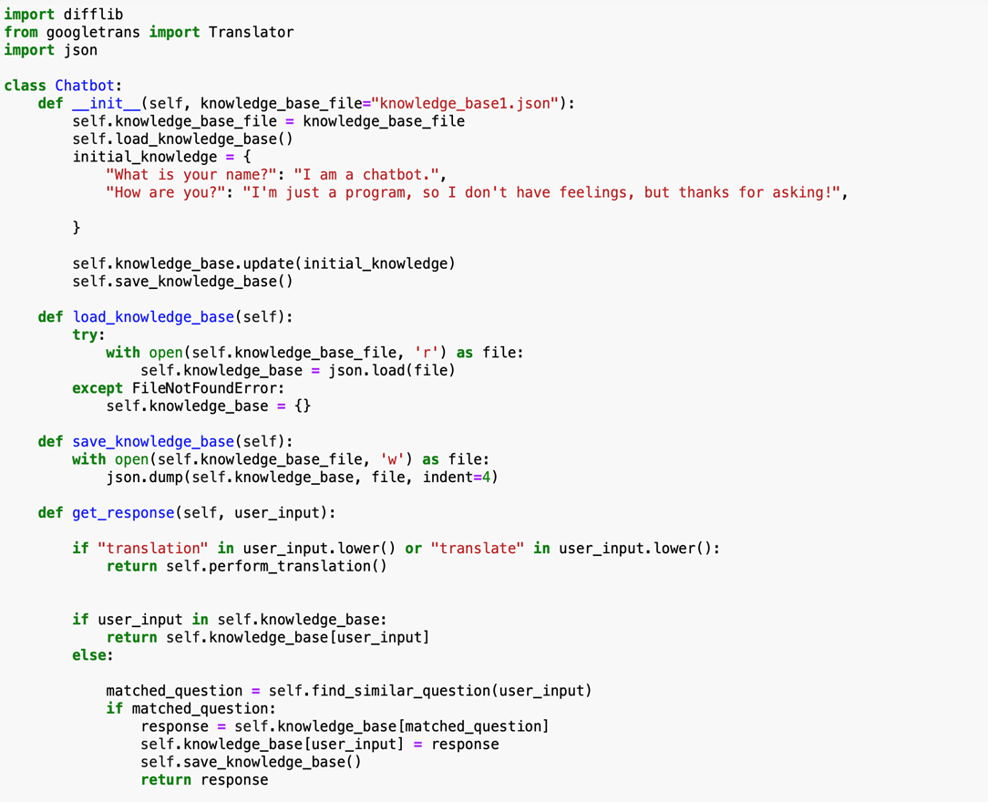

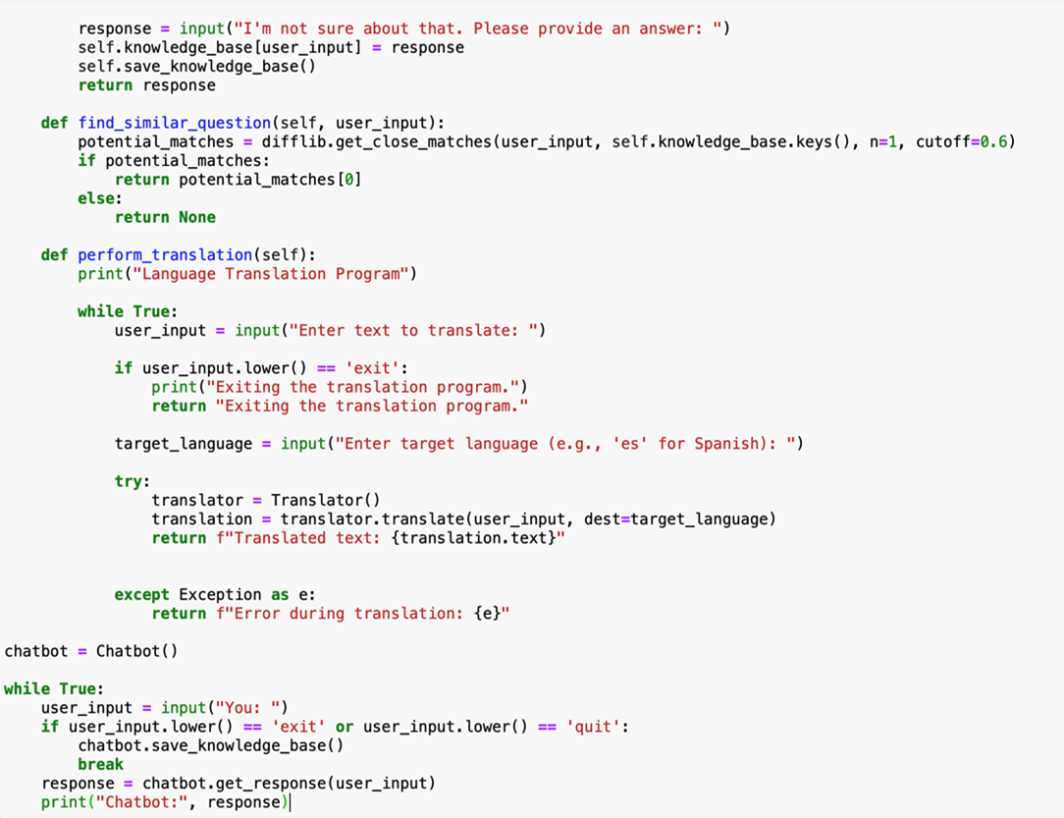

The Python code presented here introduces a versatile chatbot designed to interact with users, respond to inquiries, and even facilitate language translation. The chatbot employs a dynamic knowledge base, allowing it to learn from user interactions and adapt its responses over time. Users can pose questions, receive answers from the existing knowledge base, and contribute to the chatbot's learning process by providing responses to new queries.

**Key Features:**

* Dynamic Knowledge Base: The chatbot's knowledge base evolves as users engage with the system, enhancing its ability to respond to a wide range of questions.
* Language Translation: Users can initiate language translation sessions, where the chatbot leverages the Google Translate API to translate text into a specified target language.
* User-Friendly Interaction: The program offers a user-friendly console interface, encouraging seamless communication with the chatbot.
* Persistence: The chatbot's knowledge base is saved to a JSON file, ensuring that learned information persists between program executions.
* Error Handling: The program incorporates error handling mechanisms, providing a robust user experience even when encountering issues during language translation.

**4.2 Algorithm**

**1.Initialize Chatbot:**

Create a Chatbot class with methods for knowledge base handling, response generation, and translation.

Initialize the chatbot with a default knowledge base file and initial knowledge entries.

**2.Knowledge Base Management:**

* Load the knowledge base from a JSON file or create an empty one if the file is not found.
* Save the knowledge base to the JSON file.
* User Input and Response Generation:
* Receive user input within a loop.
* Check for keywords related to translation.
* If the input is in the knowledge base, provide the corresponding response.
* If not, attempt to find a similar question in the knowledge base using difflib.
* If a similar question is found, use its corresponding response; otherwise, prompt the user for a response.

**3.Find Similar Questions:**

Implement a method using difflib to find close matches to the user's input within the knowledge base.

**4.Translation Handling:**

* If the user input contains keywords related to translation, enter a translation loop.
* Prompt the user for text and target language.
* Use the googletrans library to perform language translation.
* Display the translated text or an error message.

**5.Main Program Loop:**

* Create an instance of the Chatbot class.
* Enter a loop to continuously take user input until 'exit' or 'quit' is entered.
* Obtain a response from the chatbot and print it.
* Save Knowledge Base on Exit:
* When the user types 'exit' or 'quit', save the knowledge base to the JSON file.

**4.3 Explanation**



* difflib: Provides classes and functions for comparing sequences, which is used to find similar questions.
* Translator: A class from the googletrans library for language translation using Google Translate.
* json: A library for working with JSON data.

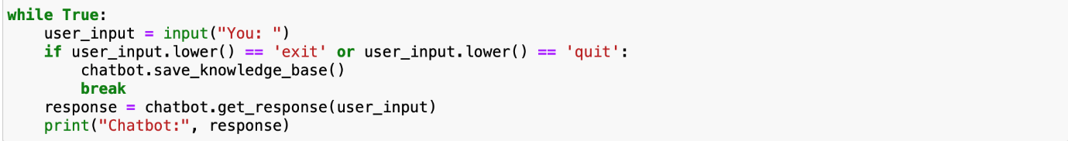

* Defines a class named Chatbot to encapsulate the chatbot functionality
* Creates an instance of the Chatbot class.
* Runs an infinite loop for user interactions.
* Takes user input until the user types "exit" or "quit."
* 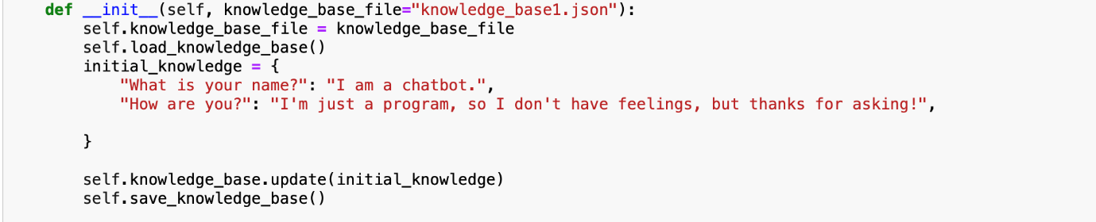Calls get_response to get the chatbot's response and prints it.
* Initializes the Chatbot object.
* knowledge_base_file: Specifies the file name for storing the knowledge base, defaulting to "knowledge_base1.json".
* 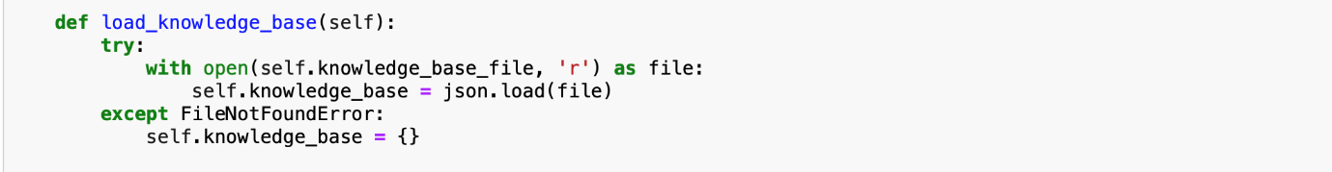Calls the load_knowledge_base method to load existing knowledge from a file.
* Attempts to load the knowledge base from a file (knowledge_base1.json).
* If the file is not found, initializes an empty knowledge base.  
    
  
* Saves the current knowledge base to the file (knowledge_base1.json).
* 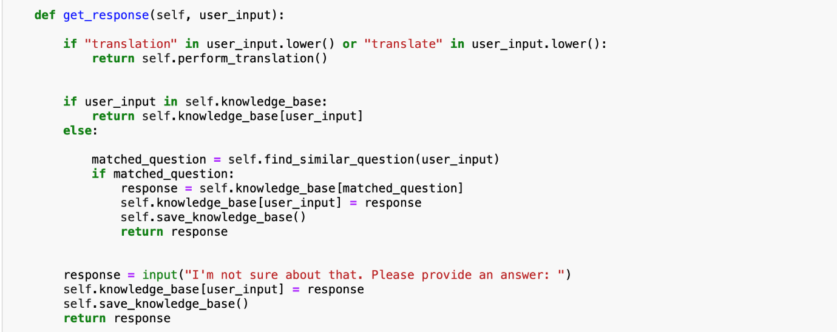Takes user input and provides a response based on the knowledge base.
* Checks for specific keywords like "translation" and "translate" to trigger language translation.
* If the user's input is found in the knowledge base, returns the corresponding response.
* If a similar question is found, suggests the known answer.
* If no match is found, prompts the user to provide an answer and updates the knowledge base.
* 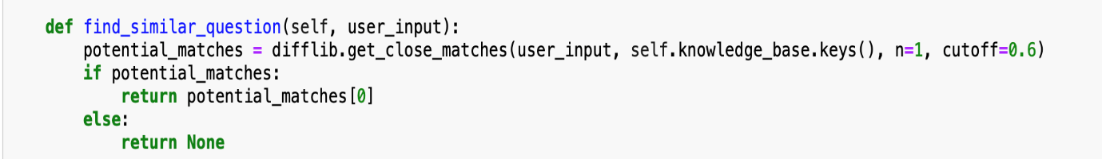Uses the difflib library to find a similar question in the knowledge base.
* N=1 ,means it gives only one answer from the json file
* Cutoff = 0.6 , checks whether the input question matches the previous knowledge with 60%accuracy or more.  
    
  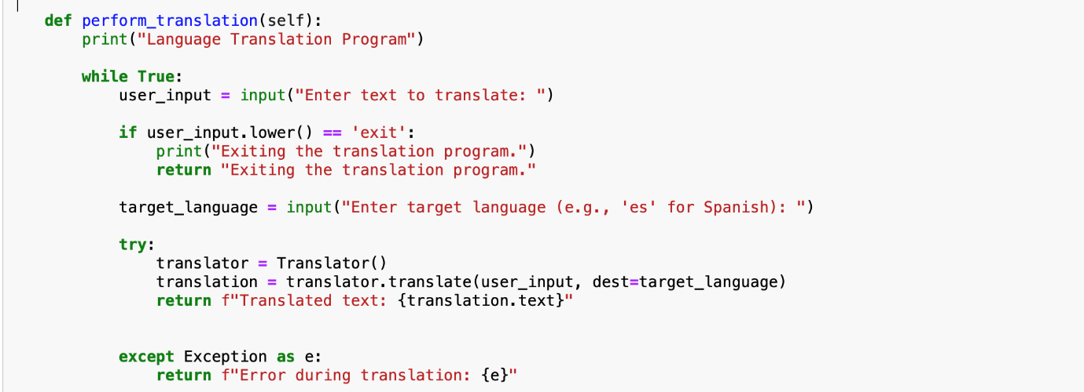
* Implements a simple language translation program using Google Translate.
* Takes user input and target language.
* Uses the googletrans library to perform translation.
* Handles user input "exit" to exit the translation program.

# CHAPTER 5

# RESULT ANALYSIS

**5.1 OUTPUT**

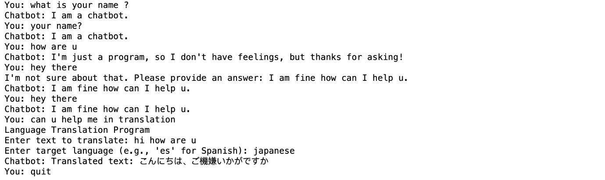

**5.2 RESULT**

The expected behavior when running the program is as follows:

* **Language Translation:**

If the user input contains keywords like "translation" or "translate," the program enters a translation loop.

The user is prompted to enter text to translate and the target language.

The translated text is displayed or an error message if translation fails.

The translation loop continues until the user types 'exit.'

* **Chatbot Interaction:**

The program continuously takes user input within a loop until the user types 'exit' or 'quit.'

For regular user inputs, the chatbot attempts to find a matching question in the knowledge base.

If a match is found, the corresponding response is provided.

If no match is found, the chatbot prompts the user for a response, adds it to the knowledge base, and returns the response.

**CHAPTER 6**

**CONCLUSION**

* In conclusion, the development of this project has successfully brought forth a versatile and intelligent chatbot capable of seamlessly addressing user queries and facilitating language translation. Through the integration of advanced natural language processing (NLP) algorithms and translation services, our chatbot has demonstrated its proficiency in understanding and responding to a diverse range of questions in a user-friendly manner.
* The incorporation of language translation functionality further extends the reach and usefulness of the chatbot, breaking down communication barriers and fostering cross-cultural interactions. Users can now effortlessly communicate in their preferred language, while the chatbot dynamically translates and responds, enhancing the overall accessibility and inclusivity of the system.
* As technology continues to evolve, this project serves as a testament to the power of artificial intelligence in enhancing user experiences and providing practical solutions. The chatbot's ability to adapt and learn from user interactions positions it as a valuable tool for individuals seeking information and communication across linguistic boundaries.
* Moving forward, there is potential for expansion and refinement, including the incorporation of additional languages, continuous improvement of translation accuracy, and the implementation of more sophisticated dialogue management techniques. The journey doesn't end here, and with ongoing advancements in AI and language processing, our chatbot is poised to evolve and remain at the forefront of intelligent conversational agents. Ultimately, this project represents a significant stride towards the creation of intelligent, user-centric solutions in the realm of natural language understanding and translation.

# CHAPTER 7

# REFERENCES

* (1)<https://ieeexplore.ieee.org/document/8692927>
* (2)<https://ieeexplore.ieee.org/document/9498508>
* (3)<https://ieeexplore.ieee.org/document/9276948>
* (4)<https://www.researchgate.net/publication/351228837_Design_and_Development_of_CHATBOT_A_Review>
* <https://www.mdpi.com/2071-1050/15/7/5614>