Endocrine Screening Analysis for ROCKS
Katie Paul Friedman
2026-09-07
Table of contents

Purpose
Here, the analysis to understand how ROCKS can be employed to identify potential screening candidates for ER and AR is provided. This is in Figure 7 of Weitekamp et al.
Read in Rdata from source.
load(file = "./source/er_ar_summary_input_06sept26.RData")

Using Predicted Properties to Determine Screening Candidates
The concept is to provide a rapid means of narrowing down the screening candidate list to fill specific gaps in endocrine screening and identify the chemicals that are easiest to screen.

OPERA v2.9 Coverage
Using OPERA v2.9, express coverage of important properties for amenability. Visualization: create a bar chart of property coverage in rocks_amenability
First, how many chemicals have no defined molecular formula?
# how many rows in rocks_amenability are chemicals without structures?
## quantify by counting the number of cichem with no mol_formula in rocks_chemistry
length(unique(rocks_chemistry[is.na(mol_formula), cichem]))
[1] 69749
Next, prepare data for making a bar chart of property coverage in rocks_amenability. For each property, count the number of chemicals that have a defined value for that property.
# create a data.table with the counts of cichem where the logp, logp_ad, vp, vp_ad, hl, hl_ad, ws, ws_ad, are TRUE, FALSE, or NA, using rocks_amenability table
# Select only the columns you want to check
cols_to_check <- names(rocks_amenability)[names(rocks_amenability) %like% "_ad"]
ad_counts <- rbindlist(lapply(cols_to_check, function(col) {
tbl <- table(rocks_amenability[[col]], useNA = "always")
data.table(
column = col,
value = names(tbl),
count = as.integer(tbl)
)
}))
# order ad_counts so that TRUE, FALSE, and then NA using factors
ad_counts[, value := factor(value, levels = c("TRUE", "FALSE", NA), exclude = NULL)]
ad_counts[, text_color := fcase(
value == "TRUE", "white",
value == "FALSE", "black",
is.na(value), "black"
)]
Make a bar chart of ad_counts using ggplot2.
# Note that ULRI has special colors
ULcolors <- c(
"#122C49", #1
"#000095", #2
"#0A32FF", #3
"#00689C", #4
"#577E9E", #5
"#00CAFB", #6
"#BCE4F7", #7
"#123A28", #8
"#00948F", #9
"#00A451", #10
"#58595B", #11
"#B38874", #12
"#E5DDCA", #13
"#5B0428", #14
"#98443D", #15
"#CA0123", #16
"#FF6255", #17
"#FF9D55" #18
)
# Remove the NAs because ggplot2 didn't like it when I tried to change the legend from NA to No Prediction
ad_counts <- ad_counts %>%
mutate(value = factor(
ifelse(is.na(value), "No Prediction", as.character(value)),
levels = c("TRUE", "FALSE", "No Prediction")
))
# make a bar chart of ad_counts using ggplot2
fig_property_coverage <- ggplot(ad_counts, aes(x = column, y = count, fill = value)) +
geom_bar(stat = "identity", position = "stack") +
labs(
title = "",
x = "Predicted Physicochemical Properties",
y = "Chemical Count"
) +
theme_minimal() +
theme(axis.text.x = element_text(angle = 45, hjust = 1)) +
scale_fill_manual(
values = c("TRUE" = ULcolors[2], "FALSE" = ULcolors[7], "No Prediction" = "grey"),
labels = c("TRUE" = "Inside AD", "FALSE" = "Outside AD", "No Prediction" = "No Prediction"),
name = "Applicability Domain (AD)"
) +
geom_text(
stat = "identity",
position = position_stack(vjust = 0.5),
aes(label = count, color = value),
size = 3,
fontface = "bold"
) +
scale_color_manual(
values = c("TRUE" = "white", "FALSE" = "black", "No Prediction" = "black"),
guide = "none"
) +
scale_x_discrete(labels = c(
"logp_ad" = "LogP",
"vp_ad" = "VP",
"hl_ad" = "HLC",
"ws_ad" = "Water Sol"
))
fig_property_coverage
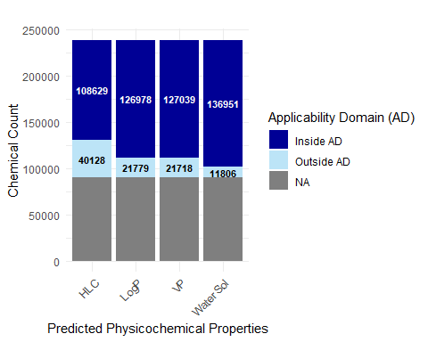

Of these, how many are amenable to screening?
Write the basic function to give a definition of in vitro screening amenability and put into rocks_amenability table.

Screening Amenability
A little exploration on water solubility. how many chemicals have water solubility value less than 10uM, assuming OPERA units in log10-M?
# how many chemicals have water solubility value less than 10uM, assuming OPERA units in log10-M
# calculate how many chemicals in rocks_amenability have water solubility less than water_sol_limit
water_sol_limit <- log10(0.000010)
ws_limit <- rocks_amenability[!is.na(ws) & ws < water_sol_limit]
nrow(ws_limit)
[1] 30155
Write the basic function to give a definition of in vitro screening amenability and put into rocks_amenability table. This is a coarse grain filter to identify the most screenable candidates, and could be further refined for a true implementation of picking screening candidates that also incorporates essential data streams such as exposure. This is a fairly permissive definition of screening amenability.
# "Screening amenable" when:
# when average mass is not NA and greater than 100 and less than 600
# logP is not NA and between -3 and 6,
# vapor pressure is not NA and greater than 1e-5, and half-life is not NA and less than 1000, then the chemical is amenable to in vitro screening. Otherwise, it is not amenable to in vitro screening.
rocks_amenability[, in_vitro_screening_amenable := fcase(
# All three are NA - cannot determine
is.na(logp) & is.na(vp) & is.na(hl),
"UNKNOWN",
# All three AD flags are FALSE - cannot determine
!is.na(logp_ad) & logp_ad == FALSE &
!is.na(vp_ad) & vp_ad == FALSE &
!is.na(hl_ad) & hl_ad == FALSE,
"UNKNOWN",
# logP and VP are both NA - use HLC only
is.na(logp) & is.na(vp) & !is.na(hl),
fifelse(!is.na(hl_ad) & hl_ad == TRUE & hl > -3.0, "FALSE", "TRUE"),
# Standard case - logP and VP available, VP AD is valid
!is.na(average_mass) & average_mass > 100 &
!is.na(logp) & logp < 7 & !is.na(logp_ad) & logp_ad == TRUE &
!is.na(vp) & vp < 2 & !is.na(vp_ad) & vp_ad == TRUE,
"TRUE",
# Mass > 100, logP < 7, logP AD valid - ignore VP when VP AD is not valid
!is.na(average_mass) & average_mass > 100 &
!is.na(logp) & logp < 7 & !is.na(logp_ad) & logp_ad == TRUE &
(is.na(vp_ad) | vp_ad == FALSE),
"TRUE",
# Default - conditions not met
default = "FALSE"
)]

Create upset plot of chemicals that are amenable to screening, have in silico predictions, and have in vitro models
# simplify data
combined_endo_summary_classy[, any_positive := as.integer(any(c(agonist, antagonist, binding) == 1, na.rm = TRUE)), by = .(cichem_id, model)]
combined_toxcast_summary[, any_positive := as.integer(any(c(agonist, antagonist) >= 0.1, na.rm = TRUE)), by = .(cichem_id, model)]
# collapse to one row per cichem - any positive across all models
endo_collapsed <- combined_endo_summary_classy[, .(
endo_any_positive = as.integer(any(any_positive == 1, na.rm = TRUE)),
endo_model_available = as.integer(any(!is.na(agonist) | !is.na(antagonist) | !is.na(binding)))
), by = cichem_id]
toxcast_collapsed <- combined_toxcast_summary[, .(
toxcast_any_positive = as.integer(any(any_positive >= 0.1, na.rm = TRUE)),
toxcast_model_available = as.integer(any(!is.na(agonist) | !is.na(antagonist)))
), by = cichem_id]
# merge
upset_data <- merge(
rocks_amenability[, .(cichem, in_vitro_screening_amenable)],
endo_collapsed,
by.x = "cichem",
by.y = "cichem_id",
all.x = TRUE
)
upset_data <- merge(
upset_data,
toxcast_collapsed,
by.x = "cichem",
by.y = "cichem_id",
all.x = TRUE
)
Reshape the data for plotting
upset_data[, datasets := mapply(function(endo, toxcast, endo_avail, toxcast_avail, amenable) {
sets <- c()
# amenability
if (!is.na(amenable) & amenable == "TRUE") sets <- c(sets, "Predicted Screening Amenable")
if (!is.na(amenable) & amenable == "cannot determine") sets <- c(sets, "Cannot Determine Amenability")
# endo
if (!is.na(endo) & endo == 1) sets <- c(sets, "In Silico Model Positive")
else if (!is.na(endo_avail) & endo_avail == 1) sets <- c(sets, "In Silico Model Negative")
else sets <- c(sets, "In Silico Model Not Available")
# toxcast
if (!is.na(toxcast) & toxcast == 1) sets <- c(sets, "ToxCast Model Positive")
else if (!is.na(toxcast_avail) & toxcast_avail == 1) sets <- c(sets, "ToxCast Model Negative")
list(sets)
}, endo_any_positive, toxcast_any_positive, endo_model_available, toxcast_model_available, in_vitro_screening_amenable)]
upset_data[, `Screening Candidates` := fifelse(
sapply(datasets, function(x) {
"Predicted Screening Amenable" %in% x &
"In Silico Model Positive" %in% x &
!("Cannot Determine Amenability" %in% x) &
!("In Silico Model Negative" %in% x) &
!("ToxCast Model Positive" %in% x) &
!("ToxCast Model Negative" %in% x)
}),
"Screening Candidates",
"Other"
)]
Decided just to indicate that ToxCast model is available, and that will reduce number of bars.
# make ToxCast Model Positive and ToxCast Model Negative equal "ToxCast Model Available"
upset_data2 <- upset_data[, datasets := lapply(datasets, function(x) {
if ("ToxCast Model Positive" %in% x | "ToxCast Model Negative" %in% x) {
x <- setdiff(x, c("ToxCast Model Positive", "ToxCast Model Negative"))
x <- c(x, "ToxCast Model Available")
}
return(x)
})]
Need to inspect the data to see the chemicals that are not screening amenable but have ToxCast Model Positive or ToxCast Model Available (278 total)
In general, the behaviors we see are: + substances with no structure + low MW or high logP substances + substances with OPERA AD failures is the predominant case
inspect <- upset_data2[!sapply(datasets, function(x) {
"Predicted Screening Amenable" %in% x
}) & sapply(datasets, function(x) {
"ToxCast Model Available" %in% x
}), .(cichem, datasets)]
inspect <- rocks_chemistry[inspect, on = "cichem", .(cichem, primary_name, datasets)]
inspect_full <- rocks_amenability[inspect, on = "cichem", .(
cichem,
primary_name,
datasets,
in_vitro_screening_amenable,
average_mass,
logp, logp_ad,
vp, vp_ad,
hl, hl_ad
)]
inspect_full
Key: <cichem>
cichem
<char>
1: CICHEM000200055
2: CICHEM000200279
3: CICHEM000200295
4: CICHEM000200444
5: CICHEM000200477
---
274: CICHEM000477968
275: CICHEM000481226
276: CICHEM000481812
277: CICHEM000481937
278: CICHEM014026330
primary_name
<char>
1: Acetamide
2: Acrylamide
3: Acrylonitrile
4: Allyl alcohol
5: Allyl isothiocyanate
---
274: Formalin
275: Benzyl-C8-18-alkyldimethylammonium chlorides
276: 4-tert-Butylaniline
277: 4,4'-Di-tert-butylbiphenyl
278: Cobaltate(5-), bis[4-[[6-[[4-chloro-6-[(2-hydroxyethyl)amino]-1,3,5-triazin-2-yl]amino]-1-hydroxy-3-sulfo-2-naphthalenyl]azo]-3-hydroxy-7-nitro-1-naphthalenesulfonato(4-)]-, pentasodium
datasets
<list>
1: In Silico Model Negative,ToxCast Model Available
2: In Silico Model Negative,ToxCast Model Available
3: In Silico Model Negative,ToxCast Model Available
4: In Silico Model Negative,ToxCast Model Available
5: In Silico Model Negative,ToxCast Model Available
---
274: In Silico Model Not Available,ToxCast Model Available
275: In Silico Model Not Available,ToxCast Model Available
276: In Silico Model Negative,ToxCast Model Available
277: In Silico Model Positive,ToxCast Model Available
278: In Silico Model Not Available,ToxCast Model Available
in_vitro_screening_amenable average_mass logp logp_ad vp vp_ad hl
<char> <num> <num> <lgcl> <num> <lgcl> <num>
1: FALSE 59.068 -1.17 TRUE -1.40 TRUE -8.45
2: FALSE 71.079 -0.67 TRUE -2.15 TRUE -8.84
3: FALSE 53.064 0.25 TRUE 2.03 TRUE -3.86
4: FALSE 58.080 0.17 TRUE 1.41 TRUE -5.30
5: FALSE 99.150 1.14 TRUE 0.57 TRUE -3.62
---
274: UNKNOWN NA NA NA NA NA NA
275: UNKNOWN NA NA NA NA NA NA
276: FALSE 149.237 NA FALSE -0.93 TRUE -5.44
277: FALSE 266.428 7.98 TRUE -3.57 TRUE -3.49
278: UNKNOWN 1487.938 NA NA NA NA NA
hl_ad
<lgcl>
1: TRUE
2: TRUE
3: TRUE
4: TRUE
5: TRUE
---
274: NA
275: NA
276: TRUE
277: TRUE
278: NA
# count how many have in_vitro_screening_amenable=="FALSE" or "UNKNOWN" because of monoisotopic mass less than 100 or logP > 6
# count the number of TRUE from this subset
rocks_amenability[cichem %in% inspect$cichem & in_vitro_screening_amenable %in% c("FALSE", "UNKNOWN"), .(
mass_under_100 = sum(average_mass < 100, na.rm = TRUE),
logp_over_6 = sum(logp > 6, na.rm = TRUE),
logp_ad_fail = sum(is.na(logp_ad) | logp_ad == FALSE, na.rm = TRUE),
vp_ad_fail = sum(is.na(vp_ad) | vp_ad == FALSE, na.rm = TRUE),
hl_ad_fail = sum(is.na(hl_ad) | hl_ad == FALSE, na.rm = TRUE),
all_ad_fail = sum((is.na(logp_ad) | logp_ad == FALSE) &
(is.na(vp_ad) | vp_ad == FALSE) &
(is.na(hl_ad) | hl_ad == FALSE), na.rm = TRUE),
# Overlaps between mass/logp and AD failures
mass_and_logp = sum(average_mass < 100 & logp > 6, na.rm = TRUE),
mass_and_logp_ad_fail = sum(average_mass < 100 & (is.na(logp_ad) | logp_ad == FALSE), na.rm = TRUE),
mass_and_vp_ad_fail = sum(average_mass < 100 & (is.na(vp_ad) | vp_ad == FALSE), na.rm = TRUE),
mass_and_hl_ad_fail = sum(average_mass < 100 & (is.na(hl_ad) | hl_ad == FALSE), na.rm = TRUE),
mass_and_all_ad_fail = sum(average_mass < 100 & (is.na(logp_ad) | logp_ad == FALSE) &
(is.na(vp_ad) | vp_ad == FALSE) &
(is.na(hl_ad) | hl_ad == FALSE), na.rm = TRUE),
logp_and_logp_ad_fail = sum(logp > 6 & (is.na(logp_ad) | logp_ad == FALSE), na.rm = TRUE),
logp_and_vp_ad_fail = sum(logp > 6 & (is.na(vp_ad) | vp_ad == FALSE), na.rm = TRUE),
logp_and_hl_ad_fail = sum(logp > 6 & (is.na(hl_ad) | hl_ad == FALSE), na.rm = TRUE),
logp_and_all_ad_fail = sum(logp > 6 & (is.na(logp_ad) | logp_ad == FALSE) &
(is.na(vp_ad) | vp_ad == FALSE) &
(is.na(hl_ad) | hl_ad == FALSE), na.rm = TRUE)
)]
mass_under_100 logp_over_6 logp_ad_fail vp_ad_fail hl_ad_fail all_ad_fail
<int> <int> <int> <int> <int> <int>
1: 91 35 164 133 144 131
mass_and_logp mass_and_logp_ad_fail mass_and_vp_ad_fail mass_and_hl_ad_fail
<int> <int> <int> <int>
1: 0 10 7 7
mass_and_all_ad_fail logp_and_logp_ad_fail logp_and_vp_ad_fail
<int> <int> <int>
1: 7 2 2
logp_and_hl_ad_fail logp_and_all_ad_fail
<int> <int>
1: 9 1
fig_upset <- ggplot(upset_data2, aes(x = datasets, fill = `Screening Candidates`)) +
geom_bar() +
geom_text(stat = "count", aes(label = after_stat(count)),
vjust = -0.5, hjust = -0.1, angle = 45, size = 3) +
scale_x_upset() +
scale_y_log10(
breaks = c(1, 5, 10, 50, 100, 500, 1000, 5000, 10000, 50000, 100000),
labels = scales::comma,
expand = expansion(mult = c(0, 0.3))
) +
scale_fill_manual(
values = c("Screening Candidates" = ULcolors[2], "Other" = ULcolors[7]),
name = NULL
) +
labs(
title = "",
x = "Dataset Intersection",
y = "Chemical Count"
) +
theme_minimal() +
theme_combmatrix(combmatrix.label.text = element_text(size = 10))
fig_upset
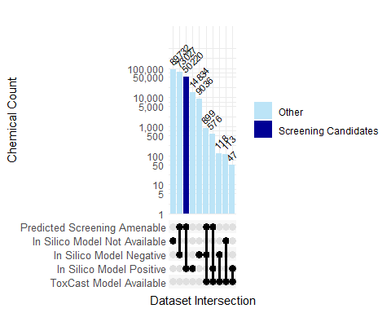
Make a version for Supplement that splits In Silico Model Negative and Positive into CERAPP and COMPARA (any mode). This addresses questions about how much COMPARA positives vs. CERAPP positives may drive the screening candidate list. This is a more complex upset plot, but it is informative - just too detailed for the main text of the paper which is not endocrine-focused per se.
# collapse endo to one row per cichem PER MODEL (CERAPP vs COMPARA)
endo_collapsed_by_model <- combined_endo_summary_classy[, .(
endo_any_positive = as.integer(any(any_positive == 1, na.rm = TRUE)),
endo_model_available = as.integer(any(!is.na(agonist) | !is.na(antagonist) | !is.na(binding)))
), by = .(cichem_id, model)]
# reshape wide so each model becomes its own set of columns
endo_wide <- dcast(
endo_collapsed_by_model,
cichem_id ~ model,
value.var = c("endo_any_positive", "endo_model_available"),
fill = NA
)
# this yields columns like:
# endo_any_positive_CERAPP, endo_any_positive_COMPARA,
# endo_model_available_CERAPP, endo_model_available_COMPARA
# merge
upset_data3 <- merge(
rocks_amenability[, .(cichem, in_vitro_screening_amenable)],
endo_wide,
by.x = "cichem",
by.y = "cichem_id",
all.x = TRUE
)
upset_data3 <- merge(
upset_data3,
toxcast_collapsed,
by.x = "cichem",
by.y = "cichem_id",
all.x = TRUE
)
Reshape the data for plotting
upset_data3[, datasets := mapply(function(cerapp, compara, toxcast,
cerapp_avail, compara_avail, toxcast_avail,
amenable) {
sets <- c()
# amenability
if (!is.na(amenable) & amenable == "TRUE") sets <- c(sets, "Predicted Screening Amenable")
if (!is.na(amenable) & amenable == "cannot determine") sets <- c(sets, "Cannot Determine Amenability")
# endo - CERAPP
if (!is.na(cerapp) & cerapp == 1) sets <- c(sets, "CERAPP Positive")
else if (!is.na(cerapp_avail) & cerapp_avail == 1) sets <- c(sets, "CERAPP Negative")
# endo - COMPARA
if (!is.na(compara) & compara == 1) sets <- c(sets, "COMPARA Positive")
else if (!is.na(compara_avail) & compara_avail == 1) sets <- c(sets, "COMPARA Negative")
# toxcast
if (!is.na(toxcast) & toxcast == 1) sets <- c(sets, "ToxCast Model Positive")
else if (!is.na(toxcast_avail) & toxcast_avail == 1) sets <- c(sets, "ToxCast Model Negative")
list(sets)
}, endo_any_positive_CERAPP, endo_any_positive_COMPARA, toxcast_any_positive,
endo_model_available_CERAPP, endo_model_available_COMPARA, toxcast_model_available,
in_vitro_screening_amenable)]
# collapse ToxCast sets for plotting
upset_data3[, datasets := lapply(datasets, function(x) {
if (any(c("ToxCast Model Positive", "ToxCast Model Negative") %in% x)) {
x <- c(setdiff(x, c("ToxCast Model Positive", "ToxCast Model Negative")),
"ToxCast Model Available")
}
x
})]
# candidate logic works regardless (checks both original and collapsed labels)
upset_data3[, `Screening Candidates` := fifelse(
sapply(datasets, function(x) {
"Predicted Screening Amenable" %in% x &
("CERAPP Positive" %in% x | "COMPARA Positive" %in% x) &
!any(c("ToxCast Model Positive", "ToxCast Model Negative", "ToxCast Model Available") %in% x)
}),
"Screening Candidates",
"Other"
)]
fig_upset3 <- ggplot(upset_data3, aes(x = datasets, fill = `Screening Candidates`)) +
geom_bar() +
geom_text(stat = "count", aes(label = after_stat(count)),
vjust = -0.5, hjust = -0.1, angle = 45, size = 3) +
scale_x_upset() +
scale_y_log10(
breaks = c(1, 5, 10, 50, 100, 500, 1000, 5000, 10000, 50000, 100000),
labels = scales::comma,
expand = expansion(mult = c(0, 0.3))
) +
scale_fill_manual(
values = c("Screening Candidates" = ULcolors[2], "Other" = ULcolors[7]),
name = NULL
) +
labs(
title = "",
x = "Dataset Intersection",
y = "Chemical Count"
) +
theme_minimal() +
theme_combmatrix(combmatrix.label.text = element_text(size = 10))
fig_upset3
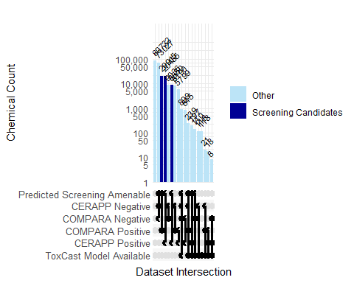
Combine fig_upset and fig_property_coverage into a single figure with two panels, A and B, then save as a tif.
fig_combined <- grid.arrange(
arrangeGrob(fig_property_coverage, top = textGrob("A", x = 0, hjust = -0.5, gp = gpar(fontsize = 16, fontface = "bold"))),
arrangeGrob(fig_upset, top = textGrob("B", x = 0, hjust = -0.5, gp = gpar(fontsize = 16, fontface = "bold"))),
ncol = 1
)
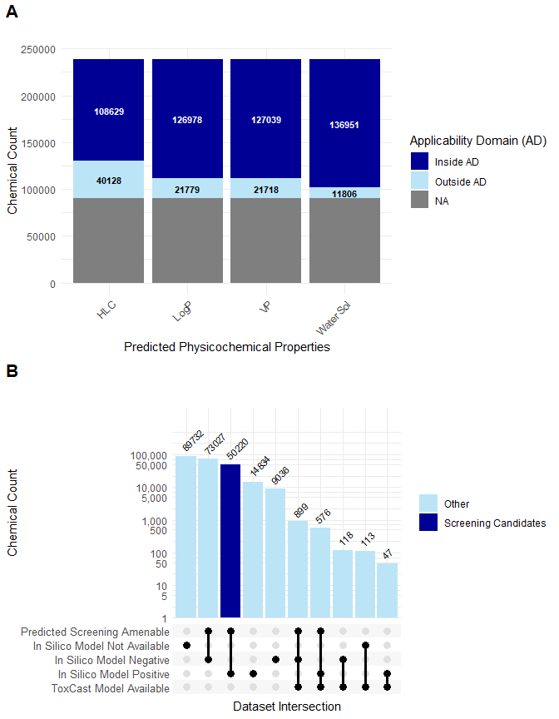
# now save to ./output as tif at 300 dpi
tiff("./output/fig7_06sept2026.tif", width = 7, height = 9, units = "in", res = 300)
grid.draw(fig_combined)
dev.off()
png
2
# save supplemental version of the more complex upset plot (fig_upset3)
tiff("./output/supp_fig_extended_upset_06sept2026.tif", width = 7, height = 7, units = "in", res = 300)
grid.draw(fig_upset3)
dev.off()
png
2
Get the screening candidates based on the dataset intersection created above. + No ToxCast Model Available + In Silico Positive (CERAPP or COMPARA) + Predicted Screening Amenable
screening_candidates <- upset_data2[
sapply(datasets, function(x) {
"Predicted Screening Amenable" %in% x &
"In Silico Model Positive" %in% x &
#!"ToxCast Model Positive" %in% x &
#!"ToxCast Model Negative" %in% x
!"ToxCast Model Available" %in% x
})
]
screening_candidates_cichem <- screening_candidates$cichem
# save the screening_candidates table to a csv
fwrite(screening_candidates, "./output/screening_candidates_06sept2026.csv")

Representative Subset of Screening Candidates
Here we go through an exercise to demonstrate how to cluster the screening candidates based on their Morgan fingerprints. This is a demonstration of how to use the fingerprints to pick a subset of representative screening candidates.

Morgan Fingerprint clustering of this population of chemicals
First make a fingerprint matrix - this is really big (50220 x 2048)
# Subset rocks_morganfp to screening candidates only
rocks_screening <- rocks_morganfp[cichem %in% screening_candidates_cichem]
rocks_screening <- rocks_screening[!is.na(fp) & fp != ""]
cat("Screening candidates with fingerprints:", nrow(rocks_screening), "\n")
Screening candidates with fingerprints: 50220
# Build matrix from the subset
fp_strings <- rocks_screening$fp
fp_matrix <- do.call(rbind, lapply(fp_strings, function(x) {
as.integer(strsplit(x, "")[[1]])
}))
rownames(fp_matrix) <- rocks_screening$cichem
# Confirm
cat("fp_matrix dimensions:", nrow(fp_matrix), "x", ncol(fp_matrix), "\n")
fp_matrix dimensions: 50220 x 2048
Build sparse matrix of Jaccard similarity. This is too intensive to run at rendering, so have saved the result for loading later.
# Consider restarting R to clear memory
# --- Subset to only the screening-candidate compounds --
rocks_screening <- rocks_morganfp[cichem %in% screening_candidates_cichem]
# Drop any compounds with a missing or empty fingerprint string, since those can't be converted into bit positions.
rocks_screening <- rocks_screening[!is.na(fp) & fp != ""]
# --- Set up the dimensions of the fingerprint matrix ---
fp_strings <- rocks_screening$fp # vector of fingerprint strings, one per compound
n_compounds <- length(fp_strings) # number of rows in the final matrix (compounds)
n_bits <- 2048 # number of columns (Morgan fingerprint bit length)
cat("Building sparse matrix directly from fingerprint strings...\n")
# Progress bar
pb <- txtProgressBar(min = 0, max = n_compounds, style = 3)
# --- Prepare storage for non-zero (i.e., "on") bit positions ---
# A sparse matrix only stores the coordinates of the 1s. Instead of growing
# vectors each iteration (slow, quadratic), we preallocate one list slot per
# compound and fill it in, then combine everything once at the end (fast, linear).
row_list <- vector("list", n_compounds) # each slot: the row indices for one compound's on-bits
col_list <- vector("list", n_compounds) # each slot: the column indices for one compound's on-bits
# --- Loop over every compound and extract its "on" bits ---
for (i in seq_along(fp_strings)) {
# Split the fingerprint string into individual characters ("0"/"1")
# and convert them to integers -> a vector of 0s and 1s of length n_bits.
bits <- as.integer(strsplit(fp_strings[[i]], "")[[1]])
# Find the positions where the bit is 1 (the "on" bits for this compound).
on_bits <- which(bits == 1L)
row_list[[i]] <- rep(i, length(on_bits)) # same row i for all of its on-bits
col_list[[i]] <- on_bits # the column position of each on-bit
setTxtProgressBar(pb, i) # advance the progress bar
}
close(pb)
# --- Flatten the per-compound lists into single coordinate vectors ---
# unlist() concatenates all slots at once, which is far faster than repeatedly
# growing a vector inside the loop.
row_idx <- unlist(row_list) # row coordinate for every on-bit across all compounds
col_idx <- unlist(col_list) # column coordinate for every on-bit across all compounds
# --- Assemble the sparse matrix from the collected coordinates ---
# sparseMatrix places a value of 1 at every (row_idx, col_idx) pair;
# all other cells are implicitly 0 (and never stored -> memory efficient).
sparse_M <- sparseMatrix(
i = row_idx, # row coordinates of the 1s
j = col_idx, # column coordinates of the 1s
x = 1, # value to place at each coordinate
dims = c(n_compounds, n_bits), # full matrix shape (compounds x 2048 bits)
dimnames = list(rocks_screening$cichem, NULL) # label rows by compound ID; columns unnamed
)
# --- Report the result ---
cat("Sparse matrix dimensions:", dim(sparse_M), "\n") # rows (compounds) x cols (bits)
cat("Memory used:", round(object.size(sparse_M) / 1e6, 1), "MB\n") # footprint in megabytes
n_compounds <- nrow(sparse_M)
n_bits <- ncol(sparse_M)
k <- 30
# Build an Annoy index using Hamming space on the binary fingerprints.
# (Annoy has no native Jaccard; we get approximate candidates via Hamming,
# then RE-RANK them with exact Jaccard distance below.)
ann <- new(AnnoyHamming, n_bits)
dense_fp <- as.matrix(sparse_M)
for (i in seq_len(n_compounds)) ann$addItem(i - 1, dense_fp[i, ])
ann$build(50) # 50 trees; more = more accurate, slower
# Exact Jaccard (Tanimoto) distance between two binary vectors
jaccard_dist <- function(a, b) {
inter <- sum(a & b)
uni <- sum(a | b)
if (uni == 0) 0 else 1 - inter / uni
}
nn_idx <- matrix(0L, nrow = n_compounds, ncol = k)
nn_dist <- matrix(0, nrow = n_compounds, ncol = k)
pb <- txtProgressBar(min = 0, max = n_compounds, style = 3)
for (i in seq_len(n_compounds)) {
# get a generous candidate pool from Annoy, then re-rank by exact Jaccard
cand <- ann$getNNsByItem(i - 1, k * 5) + 1 # +1 back to R indexing
cand <- cand[cand != i] # drop self
d <- vapply(cand, function(j) jaccard_dist(dense_fp[i, ], dense_fp[j, ]), numeric(1))
ord <- order(d)[1:k]
nn_idx[i, ] <- cand[ord]
nn_dist[i, ] <- d[ord]
setTxtProgressBar(pb, i)
}
close(pb)
umap_result <- uwot::umap(
X = NULL,
nn_method = list(idx = nn_idx, dist = nn_dist),
n_components = 2,
min_dist = 0.3,
spread = 1.5,
seed = 42,
verbose = TRUE
)
# save umap_result to file
saveRDS(umap_result, "./output/umap_result_06sept2026.rds")
# load umap_result from file
umap_result <- readRDS("./output/umap_result_06sept2026.rds")
dim(umap_result)
[1] 50220 2
umap_coords <- umap_result
# confirm
cat("UMAP coords dimensions:", nrow(umap_coords), "x", ncol(umap_coords), "\n")
UMAP coords dimensions: 50220 x 2
# Expected: 50220 x 2
# build data.table with UMAP coordinates and metadata
umap_dt <- data.table(
cichem = rocks_screening$cichem,
primary_name = rocks_screening$primary_name,
UMAP1 = umap_coords[, 1],
UMAP2 = umap_coords[, 2]
)
# merge sector info
umap_dt <- merge(
umap_dt,
combined_toxcast_summary[, .(
cichem = cichem_id, sector = sector_class
)],
by = "cichem", all.x = TRUE
)
# deprecated this to use the sector_class
#umap_dt[, sector := fcase(
# pharmaceutical == TRUE, "pharmaceutical",
# agricultural == TRUE, "agricultural",
# industrial == TRUE, "industrial",
# consumer == TRUE, "consumer",
# default = "unknown"
#)]
Here we apply k-means.
# Preparing for kmeans on UMAP coordinates
umap_matrix <- as.matrix(umap_dt[, .(UMAP1, UMAP2)])
rownames(umap_matrix) <- umap_dt$cichem
gc() # free memory before distance computation
used (Mb) gc trigger (Mb) max used (Mb)
Ncells 5184669 276.9 8838172 472.1 8838172 472.1
Vcells 137852941 1051.8 228315780 1742.0 193159873 1473.7
umap_dist <- dist(umap_matrix, method = "euclidean")
set.seed(42)
wss <- sapply(2:50, function(k) {
km <- kmeans(umap_matrix, centers = k, nstart = 5, iter.max = 100)
km$tot.withinss
})
plot(2:50, wss, type = "b", pch = 19,
xlab = "Number of clusters k",
ylab = "Total within-cluster sum of squares",
main = "Elbow plot — choose k at the bend")
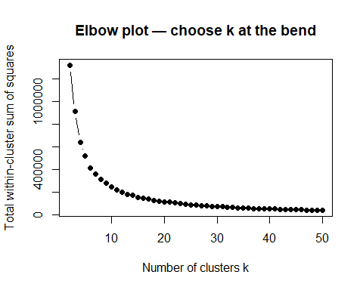
Here, compute the cluster and mediods using the number of clusters, k, from elbow plot above.
# k from elbow plot above
k <- 20 # <-- replace with your chosen k
set.seed(42)
km_result <- kmeans(umap_matrix, centers = k, nstart = 25, iter.max = 200)
umap_dt[, cluster := as.factor(km_result$cluster)]
# Find medioid per cluster (closest point to centroid)
centroids <- as.data.table(km_result$centers)
setnames(centroids, c("centroid_UMAP1", "centroid_UMAP2"))
centroids[, cluster := as.factor(1:.N)]
umap_dt[, dist_to_centroid := {
c_umap1 <- centroids[cluster == .BY$cluster, centroid_UMAP1]
c_umap2 <- centroids[cluster == .BY$cluster, centroid_UMAP2]
sqrt((UMAP1 - c_umap1)^2 + (UMAP2 - c_umap2)^2)
}, by = cluster]
medoid_reps <- umap_dt[, .SD[which.min(dist_to_centroid)], by = cluster]
cat("Medoid representatives per cluster:\n")
Medoid representatives per cluster:
print(medoid_reps[order(as.integer(cluster)), .(cluster, cichem, primary_name, UMAP1, UMAP2)])
cluster cichem
<fctr> <char>
1: 1 CICHEM000580639
2: 2 CICHEM009129990
3: 3 CICHEM014039069
4: 4 CICHEM014093470
5: 5 CICHEM008876963
6: 6 CICHEM009164427
7: 7 CICHEM001665348
8: 8 CICHEM008853285
9: 9 CICHEM009743568
10: 10 CICHEM002428951
11: 11 CICHEM008684110
12: 12 CICHEM000708370
13: 13 CICHEM000649855
14: 14 CICHEM000375279
15: 15 CICHEM008910135
16: 16 CICHEM008846578
17: 17 CICHEM000730911
18: 18 CICHEM010141703
19: 19 CICHEM000201467
20: 20 CICHEM009826124
cluster cichem
<fctr> <char>
primary_name
<char>
1: Amisulbrom
2: 1-(Furan-3-yl)-4b,7,7,14a-tetramethyl-6a,7,12b,13,14,14a-hexahydro-1H,8aH,12H-pyrano[4'',3'':2',3']furo[3',4':5,6]naphtho[2,1-c]pyran-3,5,10(4bH,6H,9H)-trione
3: Ethyl 4-[2-[3-[(dodecylamino)carbonyl]-4-hydroxy-1-naphthalenyl]diazenyl]benzoate
4: Ethyl (3S)-3-hydroxy-3-methyl-4-[[4-nitro-3-(trifluoromethyl)phenyl]amino]-4-oxobutanoate
5: Benzenesulfonic acid, 4-chloro-3-[4-[2-[2-[(2-chlorophenoxy)sulfonyl]phenyl]diazenyl]-2,5-dihydro-5-imino-3-methyl-1H-pyrazol-1-yl]-, sodium salt (1:1)
6: 4-(Cyclohexylamino)-7H-benzo[e]perimidin-7-one
7: Rupatadine
8: Carbamic acid, N-[(1S)-3-chloro-2-oxo-1-(phenylmethyl)propyl]-, phenylmethyl ester
9: 5,8-Dimethoxy-3-[(propan-2-yl)amino]-1,2,3,4-tetrahydronaphthalen-2-ol
10: Irisone B
11: Myxothiazol
12: Propanenitrile, 3-[ethyl[3-methyl-4-[[2-(methylsulfonyl)-4-nitrophenyl]azo]phenyl]amino]-
13: Ethanesulfonic acid, 2-[bis(2-hydroxyethyl)amino]-
14: Diethofencarb
15: Bisbenzimidazo[2,1-b:2',1'-i]benzo[lmn][3,8]phenanthroline-8,17-dione, potassium salt (1:2)
16: Cyclohexanamine, 2-[(4-aminocyclohexyl)methyl]-
17: 3H-Indolium, 2-[5-(1,3-dihydro-3,3-dimethyl-1-pentyl-2H-indol-2-ylidene)-1,3-pentadienyl]-3,3-dimethyl-1-pentyl-, bromide
18: Buphedrone
19: 2,2'-Dithiobisbenzothiazole
20: 17-Hydroxypregn-5-ene-3,20-dione
primary_name
<char>
UMAP1 UMAP2
<num> <num>
1: -1.4220655 0.9902832
2: 6.8270383 0.5715370
3: 0.7673622 -2.8473031
4: -5.8167567 -0.3705304
5: -6.8929281 -2.4216928
6: -6.1617994 2.3961995
7: -2.7198644 3.3701439
8: 2.8365214 0.4636896
9: 1.6922115 4.1145876
10: -0.3406281 5.6569224
11: 0.5085392 2.1779568
12: -5.8978414 -4.6322159
13: 3.6282389 -4.1725263
14: -1.4958403 -1.3305985
15: -3.5687818 0.7813735
16: 5.6237836 -1.8434174
17: -3.5023034 -4.9283051
18: 0.7782673 -0.4471755
19: -3.8086452 -1.9725000
20: 9.9266987 1.4150036
UMAP1 UMAP2
<num> <num>
#write.csv(medoid_reps, "./output/medoid_representatives_06sept2026.csv", row.names = FALSE)
table(umap_dt$sector)
Agricultural Only Consumer Only Food Only
1132 5382 464
Industrial Only Multiple Inventories Pharmaceutical Only
64136 14090 3608
Unknown
11628
This figure visualizes the UMAP embedding of the screening candidates, colored by sector, with medoid representatives marked with a star (★) and labeled.
fig_mediod <- ggplot() +
# --- All compounds, colored by sector ---
geom_point(
data = umap_dt,
aes(x = UMAP1, y = UMAP2, color = sector),
alpha = 0.6, size = 0.3
) +
# --- Medoid points ---
geom_point(
data = medoid_reps,
aes(x = UMAP1, y = UMAP2),
color = "black", shape = 8, size = 3
) +
# Medoid labels with repel
geom_label_repel(
data = medoid_reps,
aes(x = UMAP1, y = UMAP2, label = cluster),
color = "black",
fontface = "bold",
size = 3,
box.padding = 0.4,
point.padding = 0.3,
segment.color = "grey40",
segment.size = 0.3,
fill = "white",
label.size = 0.2, # border thickness
max.overlaps = Inf
) +
scale_color_manual(values = c(
"Consumer Only" = "#000095",
"Food Only" = "#00689C",
"Industrial Only" = "#E5DDCA",
"Agricultural Only" = "#00A451",
"Multiple Inventories" = '#BCE4F7',
"Pharmaceutical Only" = "#CA0123",
"Unknown" = "#FF9D55"
)) +
guides(
color = guide_legend(override.aes = list(size = 4, alpha = 1))
) +
theme_minimal() +
labs(
title = "",
subtitle = paste0("k = ", k, " clusters, medoids marked with ★"),
x = "UMAP 1",
y = "UMAP 2",
color = "Sector"
)
fig_mediod
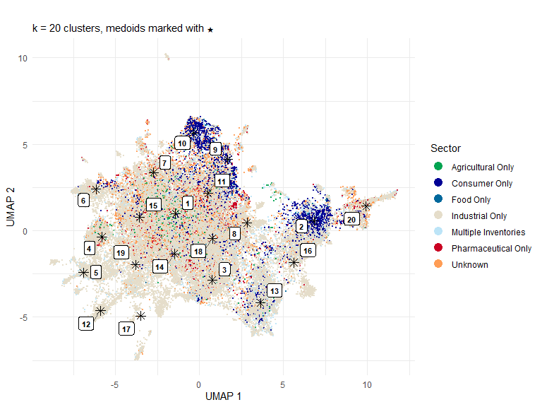
# save to ./output as tif at 300 dpi
tiff("./output/fig7_supplemental_umap_mediods_06sept2026.tif", width = 8, height = 6, units = "in", res = 300)
grid.draw(fig_mediod)
dev.off()
Here we create a view of what the size and shape of the UMAP clusters are for picking the screening candidate subset.
fig_umap_clusters <- ggplot() +
geom_point(
data = umap_dt,
aes(x = UMAP1, y = UMAP2, color = cluster),
alpha = 0.5, size = 0.6
) +
# geom_text(
# data = medoid_reps,
# aes(x = UMAP1, y = UMAP2, label = cluster),
# color = "black", fontface = "bold", size = 3, vjust = -1
# ) +
geom_label_repel(
data = medoid_reps,
aes(x = UMAP1, y = UMAP2, label = cluster),
color = "black",
fontface = "bold",
size = 3,
box.padding = 0.4,
point.padding = 0.3,
segment.color = "grey40",
segment.size = 0.3,
fill = "white",
label.size = 0.2, # border thickness
max.overlaps = Inf
)+
guides(color = guide_legend(override.aes = list(size = 5, alpha = 1))) +
theme_minimal() +
labs(
title = "UMAP colored by k-means cluster (k=20)",
x = "UMAP 1",
y = "UMAP 2",
color = "Cluster"
)
fig_umap_clusters
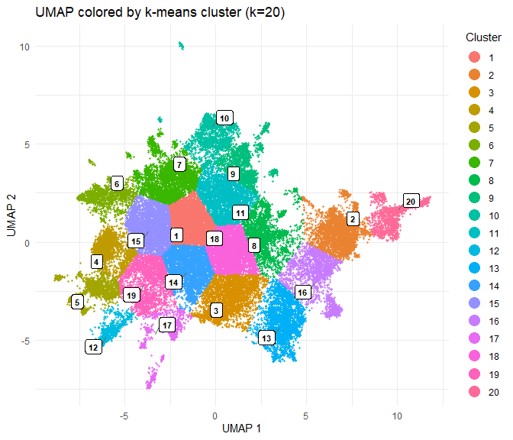
tiff("./output/fig_supplemental_umap_clusters_06sept2026.tif", width = 8, height = 6, units = "in", res = 300)
grid.draw(fig_umap_clusters)
dev.off()
Pick more compounds per cluster to get to first 500 ROCKS chemicals, confirm uniqueness.
# Deduplicate umap_dt by cichem first
umap_dt_unique <- unique(umap_dt, by = "cichem")
cat("Unique compounds:", nrow(umap_dt_unique), "\n")
Unique compounds: 50220
# Select 25 per cluster (500 total)
compounds_per_cluster <- ceiling(500 / k) # = 25
diverse_selection <- umap_dt_unique[, {
.SD[order(dist_to_centroid)][1:min(.N, compounds_per_cluster)]
}, by = cluster]
# Verify uniqueness
cat("Total compounds selected:", nrow(diverse_selection), "\n")
Total compounds selected: 500
cat("Unique cichems:", uniqueN(diverse_selection$cichem), "\n")
Unique cichems: 500
cat("Compounds per cluster:\n")
Compounds per cluster:
print(diverse_selection[, .N, by = cluster][order(as.integer(cluster))])
cluster N
<fctr> <int>
1: 1 25
2: 2 25
3: 3 25
4: 4 25
5: 5 25
6: 6 25
7: 7 25
8: 8 25
9: 9 25
10: 10 25
11: 11 25
12: 12 25
13: 13 25
14: 14 25
15: 15 25
16: 16 25
17: 17 25
18: 18 25
19: 19 25
20: 20 25
cluster N
<fctr> <int>
# Flag any duplicates
dups <- diverse_selection[duplicated(cichem)]
if (nrow(dups) > 0) {
cat("WARNING:", nrow(dups), "duplicate cichems found:\n")
print(dups)
} else {
cat("All cichems are unique.\n")
}
All cichems are unique.
# Save
fwrite(diverse_selection[, .(cluster, cichem, primary_name, sector,
UMAP1, UMAP2, dist_to_centroid)],
"./output/diverse_ROCKS_endocrine_screening_selection_500_06sept2026.csv")

Now overlay theoretical subset on ROCKS embeddings
I want to see the screenable universe and medioid representatives in the context of the entire ROCKS chemical inventory. I will overlay the 500 selected compounds and the medoid representatives on the densMAP embedding of the entire ROCKS chemical collection.
#load densUMAP embeddings for all of ROCKS
#rocks_embed <- fread('./source/fingerprints_07022026.csv')
#rocks_embed <- fread('./source/chemical_fingerprint_densmap_8.5.2026.csv')
rocks_embed <- fread('../data/raw/chemical_fingerprint_densmap_8.18.2026.csv')
cichem_to_cicomp <- unique(rocks_chemistry[, .(cichem, cicomp_id = cicomp)])
screening_with_cicomp <- merge(
umap_dt_unique[, .(cichem, cluster, dist_to_centroid, sector)], # deduplicated
cichem_to_cicomp,
by = "cichem"
)
cat("Screening candidates with cicomp_id:", nrow(screening_with_cicomp), "\n")
Screening candidates with cicomp_id: 50220
#Join onto densMAP coordinates
screening_densmap <- merge(
screening_with_cicomp,
rocks_embed[, .(cicomp, densmap_1, densmap_2)],
by.x = "cicomp_id",
by.y = "cicomp"
)
cat("Screening candidates found in densMAP:", nrow(screening_densmap), "\n")
Screening candidates found in densMAP: 50220
# --- Find which cichem are dropping out ---
missing_cicomp <- screening_with_cicomp[!cicomp_id %in% rocks_embed$cicomp]
cat("Missing from densMAP:", nrow(missing_cicomp), "\n")
Missing from densMAP: 0
cat("Unique cichem missing:", uniqueN(missing_cicomp$cichem), "\n")
Unique cichem missing: 0
# Are they missing from rocks_embed entirely, or is it a cicomp_id mismatch?
cat("Total unique cicomp_id in rocks_embed:", uniqueN(rocks_embed$cicomp), "\n")
Total unique cicomp_id in rocks_embed: 167950
cat("Sample missing cicomp_ids:\n")
Sample missing cicomp_ids:
print(head(missing_cicomp$cicomp_id, 20))
character(0)
cat("rocks_embed cicomp_id class:", class(rocks_embed$cicomp), "\n")
rocks_embed cicomp_id class: character
cat("Sample rocks_embed cicomp_ids:\n")
Sample rocks_embed cicomp_ids:
print(head(rocks_embed$cicomp, 5))
[1] "CICOMP000361246" "CICOMP000302463" "CICOMP001103704" "CICOMP008206971"
[5] "CICOMP000702225"
# Double-check with exact string match
test <- intersect(screening_with_cicomp$cicomp_id, rocks_embed$cicomp)
cat("Exact matches:", length(test), "\n")
Exact matches: 50220
#Flag 500 diverse picks and medoids ---
screening_densmap[, selected_500 := cichem %in% diverse_selection$cichem]
screening_densmap[, is_medoid := cichem %in% medoid_reps$cichem]
cat("500 diverse picks matched:", sum(screening_densmap$selected_500), "\n")
500 diverse picks matched: 500
cat("Medoids matched:", sum(screening_densmap$is_medoid), "\n")
Medoids matched: 20
Add sector to all of rocks_embed.
# add sector to rocks_embed
rocks_embed_sector <- merge(
rocks_embed,
combined_toxcast_summary[, .(
cichem = cichem_id, sector = sector_class
)],
by = "cichem", all.x = TRUE
)
medoid_densmap <- screening_densmap[is_medoid == TRUE]
fig_densmap_candidates <- ggplot() +
# --- Layer 1: full 168k background ---
geom_point(
data = rocks_embed_sector,
aes(x = densmap_1, y = densmap_2, color=sector),
alpha = 0.15, size = 0.2
) +
# --- Layer 2: all screenable compounds, colored by sector ---
geom_point(
data = screening_densmap,
aes(x = densmap_1, y = densmap_2, color=sector),
alpha = 0.4, size = 0.4
) +
# --- Layer 3: 500 diverse picks ---
geom_point(
data = screening_densmap[selected_500 == TRUE],
aes(x = densmap_1, y = densmap_2, fill="500 diverse picks"),
#color = "black",
shape = 24, size = 2.5, stroke = 0
) +
# --- Layer 4: medoid stars ---
geom_point(
data = medoid_densmap,
aes(x = densmap_1, y = densmap_2),
color = "black", shape = 8, size = 3
) +
# --- Layer 5: medoid labels ---
geom_label_repel(
data = medoid_densmap,
aes(x = densmap_1, y = densmap_2, label = cluster),
color = "black",
fontface = "bold",
size = 3,
box.padding = 0.4,
point.padding = 0.3,
segment.color = "grey40",
segment.size = 0.3,
fill = "white",
label.size = 0.2,
max.overlaps = Inf
) +
scale_color_manual(values = c(
"Consumer Only" = "#000095",
"Food Only" = "#00689C",
"Industrial Only" = "#E5DDCA",
"Agricultural Only" = "#00A451",
"Multiple Inventories" = '#BCE4F7',
"Pharmaceutical Only" = "#CA0123",
"Unknown" = "#FF9D55"
))+
scale_fill_manual(
name = "Selection",
values = c("500 diverse picks" = "#0A32FF")
) +
guides(
color = guide_legend(override.aes = list(size = 4, alpha = 1)),
fill = guide_legend(override.aes = list(size = 4, shape = 24, fill="#0A32FF"))
) +
# --- Expand the plot area to spread things out ---
#coord_cartesian(expand = TRUE) +
coord_cartesian(xlim = c(-8, 18), ylim = c(-1, 20)) +
theme_minimal() +
theme(
panel.grid.minor = element_blank(),
plot.margin = margin(20, 20, 20, 20)
) +
labs(
#title = "Screening candidates on full ROCKS densMAP embedding",
x = "densMAP 1",
y = "densMAP 2",
color = "Sector"
)
fig_densmap_candidates
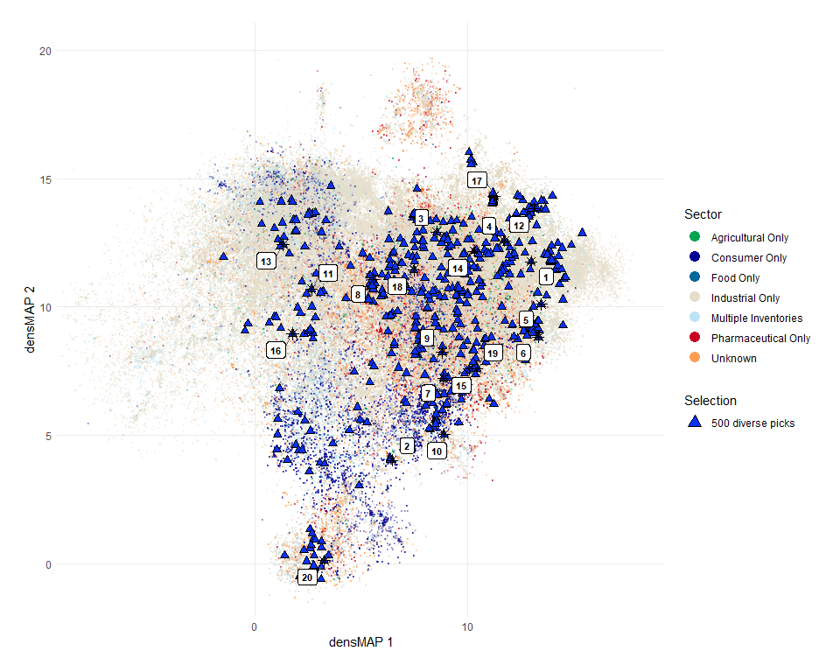
Important to verify the coordinates needed for the densMAP, so here we check where the data actually are on the densMAP coordinates.
# First check where the bulk of the data actually sits
quantile(rocks_embed$densmap_1, c(0.001, 0.999))
0.1% 99.9%
-7.918678 16.766528
quantile(rocks_embed$densmap_2, c(0.001, 0.999))
0.1% 99.9%
-0.4502431 18.4497708
Create 3 panel figure.
fig_combined <- grid.arrange(
arrangeGrob(fig_property_coverage, top = textGrob("A", x = 0, hjust = -0.5, gp = gpar(fontsize = 16, fontface = "bold"))),
arrangeGrob(fig_upset, top = textGrob("B", x = 0, hjust = -0.5, gp = gpar(fontsize = 16, fontface = "bold"))),
arrangeGrob(fig_densmap_candidates, top = textGrob("C", x = 0, hjust = -0.5, gp = gpar(fontsize = 16, fontface = "bold"))),
layout_matrix = rbind(c(1, 2),
c(3, 3)),
widths = c(1, 1),
heights = c(1, 1)
)
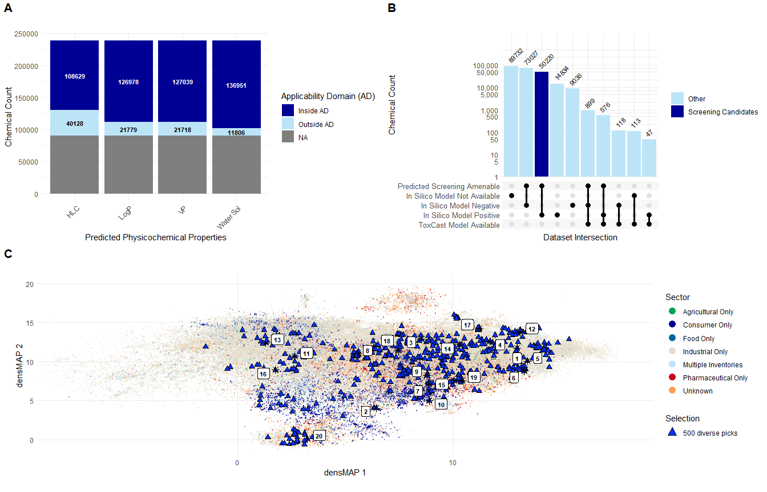
fig_combined
TableGrob (2 x 2) "arrange": 3 grobs
z cells name grob
1 1 (1-1,1-1) arrange gtable[arrange]
2 2 (1-1,2-2) arrange gtable[arrange]
3 3 (2-2,1-2) arrange gtable[arrange]
# save to ./output as tif at 300 dpi
tiff("./output/fig7_allpanels_06sept2026.tif", width = 12, height = 9, units = "in", res = 300)
grid.draw(fig_combined)
dev.off()

Evaluate ER and AR activity and predictions
Using in silico predictions (CERAPP and COMPARA) and in vitro model predictions (ToxCast ER and AR pathway models), characterize the potential estrogenicity and androgenicity of the ROCKS chemical inventory v1.0. This is a deeper dive into the endocrine activity of the ROCKS chemical inventory, and will help to identify chemicals that may be of concern for further testing.
# --- Collapse split rows into one row per (cichem_id, model) ---
# In the raw data, each mode's prediction lives on its own row with the other
# modes as NA. This coalesces the single real value per mode into one row.
# (Verified: at most one non-NA value per mode per group, so no information is lost.)
collapse_mode <- function(x) {
if (all(is.na(x))) NA_integer_ # genuinely no prediction -> NA
else as.integer(any(x == 1, na.rm = TRUE)) # recovers the single real value
}
endo_unique <- combined_endo_summary_classy[
model %in% c("CERAPP", "COMPARA"),
.(
binding = collapse_mode(binding),
agonist = collapse_mode(agonist),
antagonist = collapse_mode(antagonist),
is_qsar_ready = first(is_qsar_ready),
discard_error = first(discard_error),
dtxsid = first(dtxsid),
kingdom = first(kingdom),
superclass = first(superclass),
class = first(class),
subclass = first(subclass)
),
by = .(cichem_id, model)
]
# --- Reshape the collapsed data to long format for plotting ---
cerapp_compara_long <- melt.data.table(
endo_unique,
id.vars = c("cichem_id", "dtxsid", "model", "is_qsar_ready", "discard_error"),
measure.vars = c("binding", "agonist", "antagonist"),
variable.name = "Mode",
value.name = "Prediction"
)
# --- Factor the Prediction values (NA -> "No Prediction" category) ---
cerapp_compara_long[, Prediction := factor(Prediction, levels = c("0", "1"), labels = c("0", "1"))]
cerapp_compara_long[is.na(Prediction), Prediction := "NA"]
cerapp_compara_long[, Prediction := factor(Prediction, levels = c("NA", "0", "1"))]
cerapp_compara_long$label_color <- ifelse(cerapp_compara_long$Prediction == "1", "white", "black")

What is the coverage of the ROCKS chemical inventory with in silico predictions?
Create grouped bar chart for coverage with CERAPP and COMPARA.
# create grouped bar chart of results
fig_in_silico_endo_coverage <- ggplot(
cerapp_compara_long,
aes(
x = model,
fill = Prediction
)
) +
geom_bar(position = "stack") +
facet_wrap(~ Mode) +
labs(
title = "",
x = "Model",
y = "Chemical Count"
) +
theme_minimal() +
# write colors using ULRI colors
scale_fill_manual(values = c( "NA" = "grey", "0" = ULcolors[7], "1" = ULcolors[2]),
labels = c('No Prediction', 'Inactive','Active'),
name = "Prediction")+
#label the count of each piece of the bar, and change color of text to white for pieces of the bar where Prediction is 1, and black for pieces of the bar where Prediction is 0 and NA
geom_text(
stat = "count",
position = position_stack(vjust = 0.5),
aes(label = ..count..,
color = Prediction),
size = 3,
fontface = 'bold',
)+
scale_color_manual(values = c("0" = "black", "1" = "white", "NA" = "black"), guide = "none")
fig_in_silico_endo_coverage
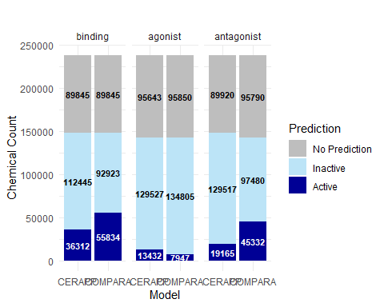

What is the coverage of the ROCKS chemical inventory with ToxCast ER and AR models?
toxcast_long <- melt.data.table(
combined_toxcast_summary,
id.vars = c("cichem_id", "dtxsid", "model"),
measure.vars = c("agonist", "antagonist"),
variable.name = "Mode",
value.name = "AUC"
)
toxcast_long <- toxcast_long[!is.na(dtxsid)]
# remove rows for model='ToxCast_ER_2017' and Mode = "antagonist"
toxcast_long <- toxcast_long[!(model == "ToxCast_ER_2017" & Mode == "antagonist")]
# now, make a column of Prediction based on whether AUC is > 0.1 (active), AUC is <= 0.1 and > 0.001 (equivocal), AUC is < 0.001 (inactive), or NA (no prediction).
toxcast_long[, Prediction := fifelse(is.na(AUC), "NA",
fifelse(AUC > 0.1, "Active",
fifelse(AUC <= 0.1 & AUC > 0.001, "Equivocal",
"Inactive")))]
# order Prediction so that Active, Inactive, Equivocal, and then NA appear from bottom to top in the stacked bar chart
toxcast_long[, Prediction := factor(Prediction, levels = c("Inactive", "Equivocal", "Active"))]
# create grouped bar chart of results
fig_toxcast_endo_coverage <- ggplot(
toxcast_long[Prediction %in% c('Active','Equivocal','Inactive')],
aes(
x = model,
fill = Prediction
)
) +
geom_bar(position = "stack") +
facet_wrap(~ Mode, scales="free_x") +
labs(
title = "",
x = "Model",
y = "Chemical Count"
) +
theme_minimal() +
# write colors using ULRI colors
scale_fill_manual(values = c("Inactive" = ULcolors[7], "Equivocal" = ULcolors[13], "Active" = ULcolors[2]),
labels = c('Inactive','Equivocal', 'Active'),
name = "Prediction")+
#label the count of each piece of the bar, and change color of text to white for pieces of the bar where Prediction is Active, and black for pieces of the bar where Prediction is Inactive, Equivocal, or NA
geom_text(
stat = "count",
position = position_stack(vjust = 0.5),
aes(label = ..count..,
color = Prediction),
size = 3,
fontface = 'bold',
)+
scale_color_manual(values = c("Inactive" = "black", "Equivocal" = "black", "Active" = "white", "NA" = "black"), guide = "none")
fig_toxcast_endo_coverage
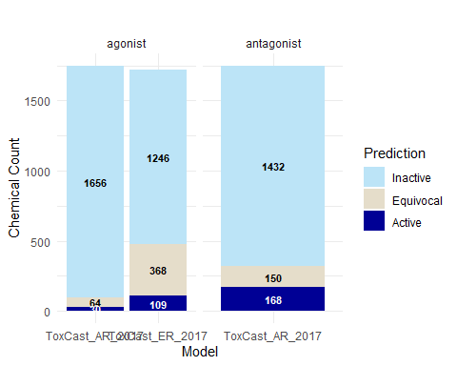
Arrange the two stacked bar plots into panel A and panel B for publication quality.
grid.arrange(
arrangeGrob(fig_in_silico_endo_coverage, top = textGrob("A", x = 0, hjust = -0.5, gp = gpar(fontsize = 16, fontface = "bold"))),
arrangeGrob(fig_toxcast_endo_coverage, top = textGrob("B", x = 0, hjust = -0.5, gp = gpar(fontsize = 16, fontface = "bold"))),
ncol = 1
)
png("./output/fig_supplement_barchart_endo_coverage.png", width = 8, height = 8, units = "in", res = 300)
grid.arrange(
arrangeGrob(fig_in_silico_endo_coverage, top = textGrob("A", x = 0, hjust = -0.5, gp = gpar(fontsize = 16, fontface = "bold"))),
arrangeGrob(fig_toxcast_endo_coverage, top = textGrob("B", x = 0, hjust = -0.5, gp = gpar(fontsize = 16, fontface = "bold"))),
ncol = 1
)
dev.off()

Understanding the structurable entities in ROCKS chemical inventory
Now I want to create two heatmaps: (1) percent of each ClassyFire Class that has been tested (2) percent of each ClassyFire Class that is positive in the CERAPP and COMPARA models for agonist, antagonist, or binding (combined modes)
First, let’s compute counts and percents of predicted and positives.
# Update heatmap_data
heatmap_data <- combined_endo_summary_classy[
model %in% c('CERAPP','COMPARA') &
!is.na(superclass) & superclass != "", # catch both NA and empty-string blanks
.(
any_positive = as.integer(any(c(agonist, antagonist, binding) == 1, na.rm = TRUE)),
any_predicted = as.integer(any(!is.na(c(agonist, antagonist, binding))))
),
by = .(cichem_id, superclass, model)
]
# Calculate both metrics
heatmap_summary <- heatmap_data[, .(
n_chemicals = .N,
percent_positive = (sum(any_positive)/.N) * 100,
percent_predicted = (sum(any_predicted)/.N) * 100,
count_positive = sum(any_positive),
count_predicted = sum(any_predicted)
), by = .(superclass, model)]
# Reshape to long format
heatmap_counts_long <- melt.data.table(
heatmap_summary,
id.vars = c("superclass", "model", "n_chemicals"),
measure.vars = c("count_positive", "count_predicted"),
variable.name = "metric",
value.name = "count"
)
# Reshape to long format for plotting percentages
heatmap_summary_long <- melt.data.table(
heatmap_summary,
id.vars = c("superclass", "model", "n_chemicals"),
measure.vars = c("percent_positive", "percent_predicted"),
variable.name = "metric",
value.name = "percent"
)
# Create n for heatmap
n_classes_counts <- n_distinct(heatmap_counts_long[!is.na(superclass), superclass])
n_classes_p <- n_distinct(heatmap_summary_long[!is.na(superclass), superclass])
# For percentage heatmap
heatmap_summary_long[, superclass := factor(superclass,
levels = heatmap_summary_long[metric == "percent_positive"][order(-percent), unique(superclass)])]
# For counts heatmap
heatmap_counts_long[, superclass := factor(superclass,
levels = heatmap_counts_long[metric == "count_positive"][order(-count), unique(superclass)])]
fig <- ggplot(heatmap_summary_long[!is.na(superclass)], aes(x = model, y = superclass, fill = percent)) +
geom_tile(color = "white", linewidth = 0.5) +
geom_text(aes(label = round(percent, 1), color = ifelse(percent > 50, "white", "black")), size = 4) +
scale_fill_gradient(low = "white", high = ULcolors[2], limits = c(0, 100), name = "%") +
scale_color_identity() +
facet_wrap(~ metric, labeller = labeller(metric = c(percent_positive = "% Positive", percent_predicted = "% Predicted"))) +
labs(
title = "Chemical Predictions by Superclass and Model",
x = "Model",
y = "Chemical Superclass"
) +
theme_minimal() +
theme(
axis.text.x = element_text(angle = 45, hjust = 1, size = 12),
axis.text.y = element_text(size = 12),
plot.title = element_text(hjust = 0.5, size = 14),
aspect.ratio = 4
)
fig
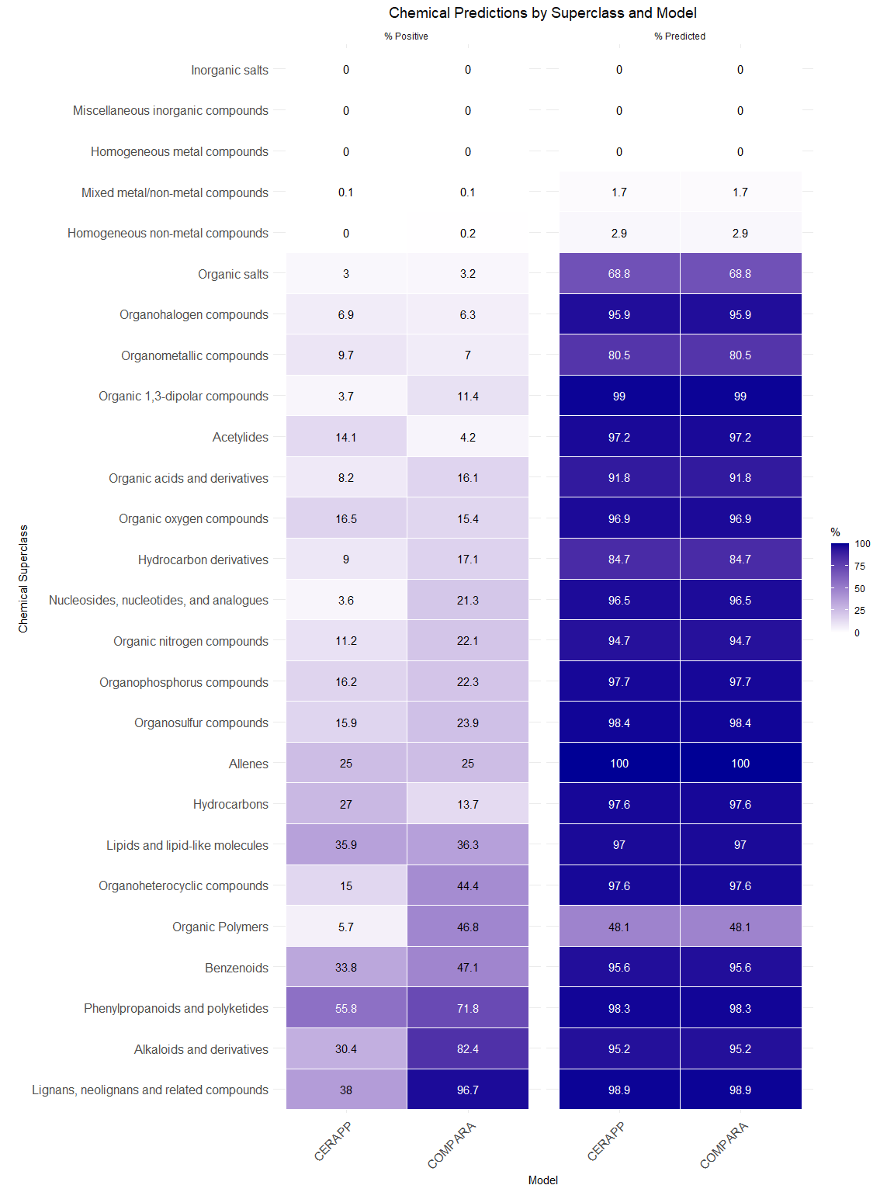
fig_counts <- ggplot(heatmap_counts_long[!is.na(superclass)], aes(x = model, y = superclass, fill = count)) +
geom_tile(color = "white", linewidth = 0.5) +
geom_text(aes(label = count, color = ifelse(count > max(count)/2, "white", "black")), size = 4) +
scale_fill_gradient(low = "white", high = ULcolors[2], name = "Count") +
scale_color_identity() +
facet_wrap(~ metric, labeller = labeller(metric = c(count_positive = "Count Positive", count_predicted = "Count Predicted"))) +
labs(
title = "Chemical Prediction Counts by Superclass and Model",
x = "Model",
y = "Chemical Superclass"
) +
theme_minimal() +
theme(
axis.text.x = element_text(angle = 45, hjust = 1, size = 12),
axis.text.y = element_text(size = 10),
plot.title = element_text(hjust = 0.5, size = 14),
aspect.ratio = 4
)
fig_counts
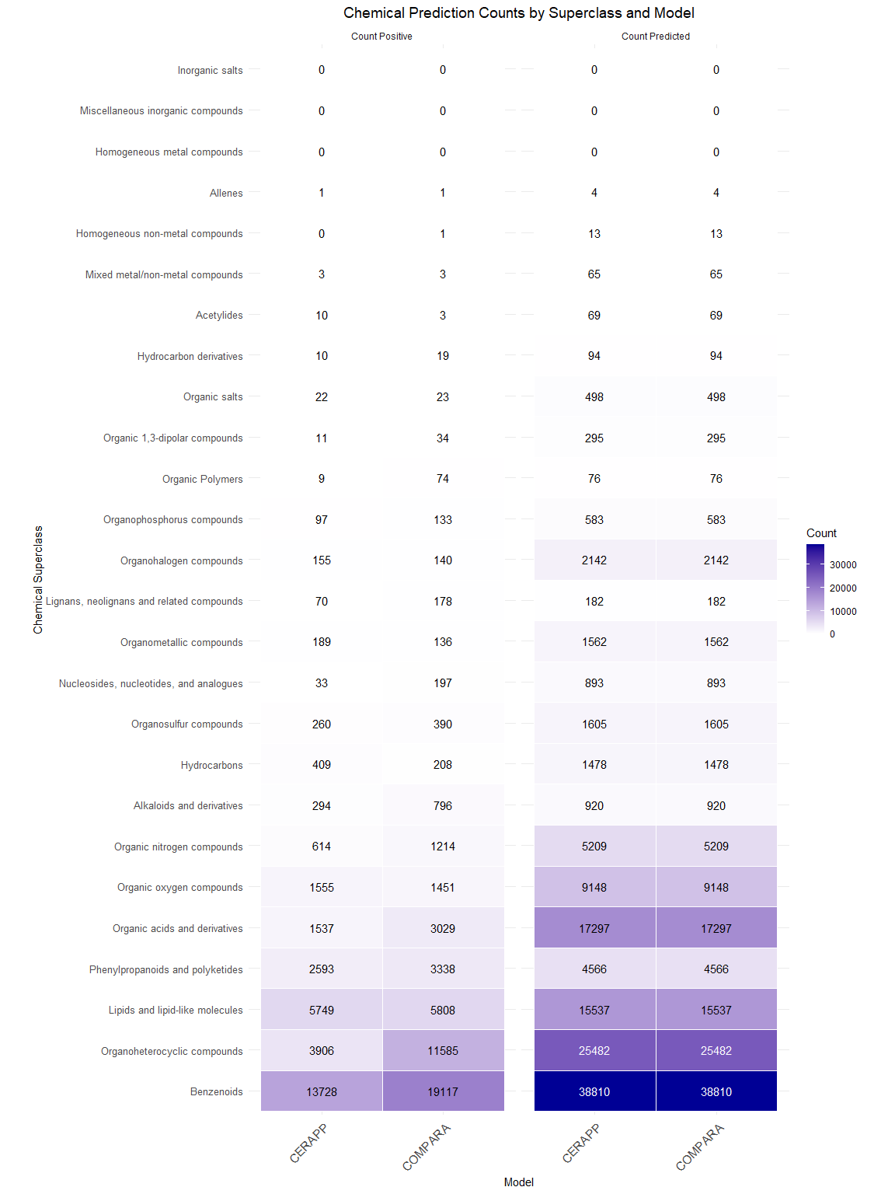
# Save percentage heatmap
ggsave("./output/supplement_classyfire_heatmap_percentage.png", fig, width = 12, height = 20, dpi = 300)
# Save counts heatmap
ggsave("./output/supplement_classyfire_heatmap_counts.png", fig_counts, width = 12, height = 20, dpi = 300)

