UltraCanvas Document Support
This sample file is an OpenDocument Text document written by the UltraCanvas framework itself. It demonstrates the formatting the document pipeline round-trips between .odt, .docx and Markdown.

Inline formatting
Text can be bold, italic, both, struck through or inline code, and link to the UltraCanvas repository.

Lists
- Feature-complete ODT reader and writer
- DOCX reader and writer
  - shared UCRichDocument model
  - signature-based format detection
- Open a document
- Edit it as Markdown
- Save it back to .odt or .docx

Table
Format | Read | Write
ODT | yes | yes
DOCX | yes | yes
DOC (legacy) | text only | no

Image
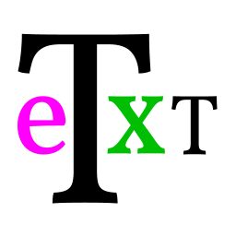
Embedded pictures travel inside the package (Pictures/) and are extracted for display when the document is opened.

Code
UCRichDocument doc;
UCWordDocumentIO::Load("document.odt", doc, error);

Formulas survive as inline math text, e.g. $E=mc^2$ and $frac{a}{b}$.

