WHAT IS C# ?

C# (pronounced "C-sharp") is the Swiss Army knife of programming languages—powerful, sleek, and versatile. Created by Microsoft, it’s the go-to language for crafting everything from breathtaking games to enterprise-grade software. Whether you're designing the next killer app or building a system that powers the world, C# has your back.

**Why is C# So Cool?**

1. **Game Dev Royalty** 🎮  
   Love gaming? C# is the lifeblood of Unity, one of the most popular game engines out there. From indie masterpieces to blockbuster titles, it’s the language behind the magic.
2. **Build Anything, Anywhere 🌍  
   Web apps? Check. Mobile apps? Absolutely. Cloud-based super-systems? Done. C# thrives on versatility, running on Windows, macOS, Linux, and even your phone.
3. **Easy on the Brain, Tough in Action 🧠💥  
   C# balances simplicity with sheer power. Its clean syntax makes it easy to pick up, but it packs the punch to tackle the most complex projects.
4. **Future-Proof** 🚀  
   Part of Microsoft’s ever-evolving .NET platform, C# is constantly updated to stay cutting-edge. With its huge ecosystem, you’ll always have tools to supercharge your creativity.

**Key Features:**

* **Object-Oriented Excellence** 🛠  
  Break your program into sleek, reusable blocks of code, just like Lego bricks.
* **Cross-Platform Power** 🌐  
  Build apps that run anywhere, thanks to .NET.
* **Memory? Handled.** 🧹  
  Forget worrying about memory leaks—C#’s garbage collector does the cleanup for you.
* **Asynchronous Wizardry** ⚡  
  Handle real-time tasks effortlessly with async/await, making apps smoother than ever.

SO WHERE DO WE BEGIN

Well to start off our code editor of choice is going to be Microsoft’s visual studio 2022

<https://visualstudio.microsoft.com/vs/community/>

once you have installed it

What we are going to install is the .Net development kit

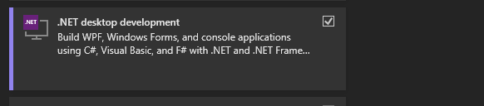

Make sure that is installed once done we are now ready to start our first program

Open visual studio 2022 and click on Create new project

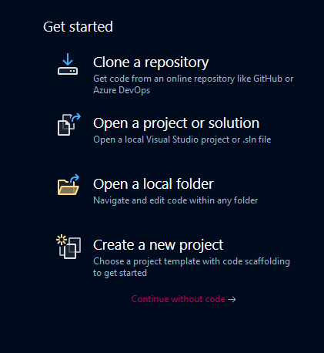

Right after that we are going to make a .dot net Console application

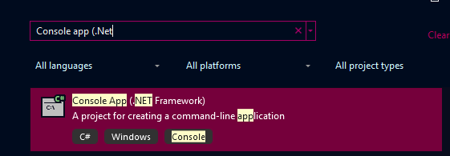

Click on it and name your project ,Now for this example we will call it Hello world

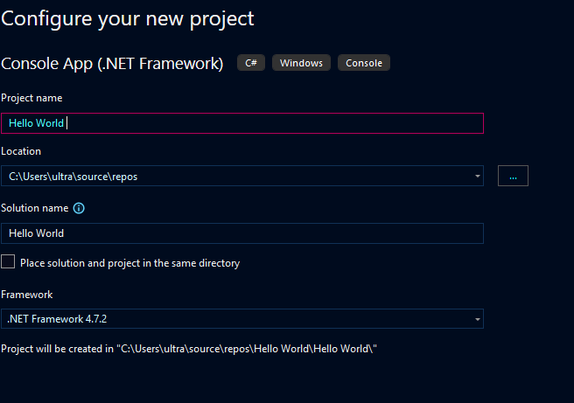

Click on create on the bottom right Now we are ready to start coding

And you will be greeted by this screen

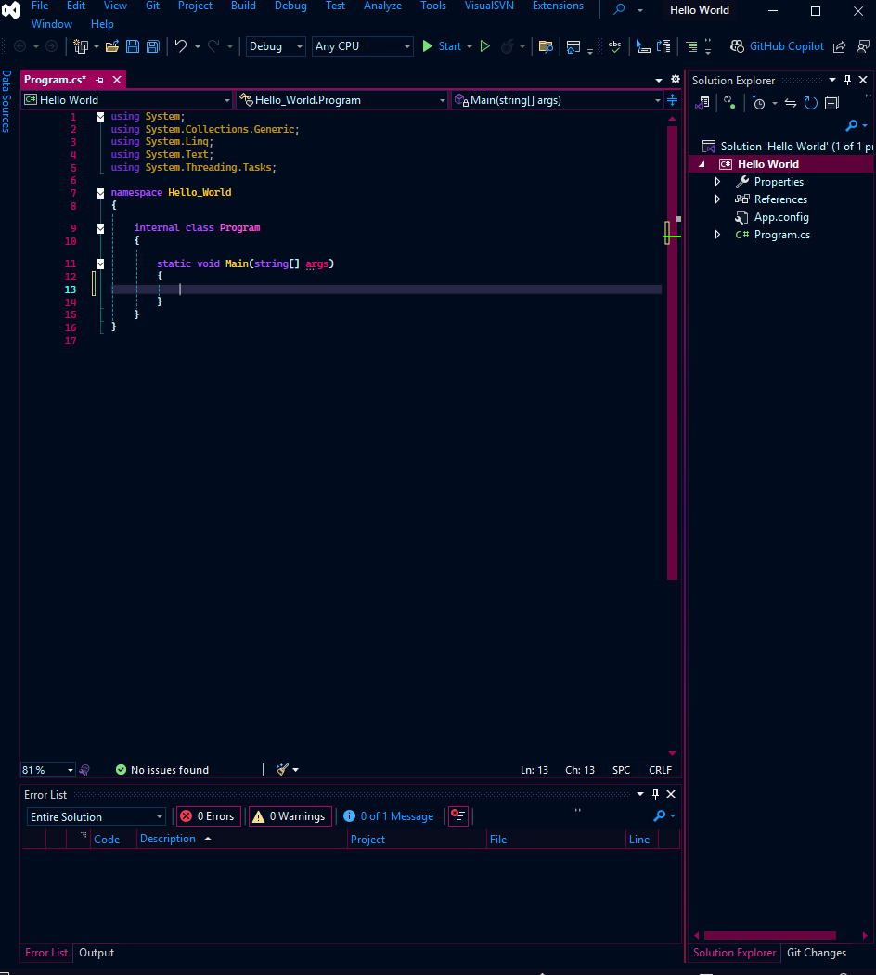

The green part is what we are going to use to write the code the rest will be discussed later as we progress

Now to print something in C#

We use Console.Write() or Console.WriteLine()

And we write whatever we want to print in some colons inside the brackets

Like this

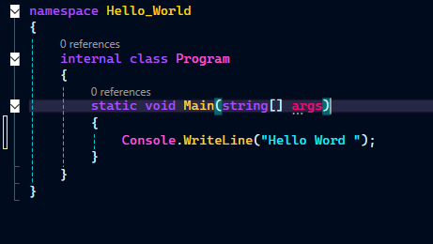

Now to run this we click on the play button uptop

But if we click on it it seems like nothing happed but something did it was just too fast to see now

-The computer printed something and closed the window right after

So how can we hold the window to see the output

We are going to Use the Console.ReadLine();

What this does is to Real a line in the console so now the window wont close unless he user types something and clicks enters

Now lets update and run it again

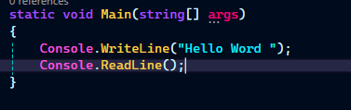

Now we can see the output

Okay

So What exactly does writeline,write and readline do ?

**1. WriteLine**

The **WriteLine** method outputs text to the console, followed by a **newline**. After executing, the cursor moves to the next line, so subsequent output appears on a new line

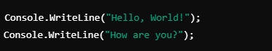

Output ?

**2. Write**

The **Write** method outputs text to the console **without adding a newline**. The cursor stays on the same line, so subsequent output appears right after the previous one.

Output ?

**3. ReadLine**

The **ReadLine** method is used to **read input** from the user. It waits for the user to type something and press **Enter**, then returns the input as a string.

Okay more info on Next chapter [Variables]