**SELECTION SORT ALGORITHM**

Selection sort is a sorting algorithm that divides the array into a sorted and unsorted part. It repeatedly finds the smallest (or largest) element from the unsorted part and moves it to the sorted part.

So how do we do that well we assume that the first element is sorted

In this case let it be compare =0;

Now we take that element and compare it to all the other elements in the array if there is an element which is less than our compare then we swap them

In this example we are going to use orange to represent the unsorted part and the light blue to represent the unsorted part

So we have 2 as our compare after finding an element less than to in this case 1 we swap them now what happens to our sorted and unsorted part well now we move on the nest unsorted element in this case that is compare =1

And we compare to see if there is any element less than it in the array

|  |  |  |  |  |  |
| --- | --- | --- | --- | --- | --- |
| 2 | 6 | 5 | 1 | 7 | 4 |

|  |  |  |  |  |  |
| --- | --- | --- | --- | --- | --- |
| 1 | 6 | 5 | 2 | 7 | 4 |

Iteration no 2nd iteration (We se that the smallest element less than 6 is to so we swap them

|  |  |  |  |  |  |
| --- | --- | --- | --- | --- | --- |
| 1 | 6 | 5 | 2 | 7 | 4 |

|  |  |  |  |  |  |
| --- | --- | --- | --- | --- | --- |
| 1 | 2 | 5 | 6 | 7 | 4 |

Now our compare =2

3rd iteration From this we can see that the smallest element less than 5 is 4 so we swap them

|  |  |  |  |  |  |
| --- | --- | --- | --- | --- | --- |
| 1 | 2 | 5 | 6 | 7 | 4 |

|  |  |  |  |  |  |
| --- | --- | --- | --- | --- | --- |
| 1 | 2 | 4 | 6 | 7 | 5 |

4th iteration

Compare =3

So now we swap 6 and 5

|  |  |  |  |  |  |
| --- | --- | --- | --- | --- | --- |
| 1 | 2 | 4 | 6 | 7 | 5 |

|  |  |  |  |  |  |
| --- | --- | --- | --- | --- | --- |
| 1 | 2 | 4 | 5 | 7 | 6 |

5th iteration

Compare =4

So now we swap 7 and 6

|  |  |  |  |  |  |
| --- | --- | --- | --- | --- | --- |
| 1 | 2 | 4 | 5 | 7 | 6 |

|  |  |  |  |  |  |
| --- | --- | --- | --- | --- | --- |
| 1 | 2 | 4 | 5 | 6 | 7 |

Now everything is now sorted ,So how do we put it into code ?

Selection Sort in Code

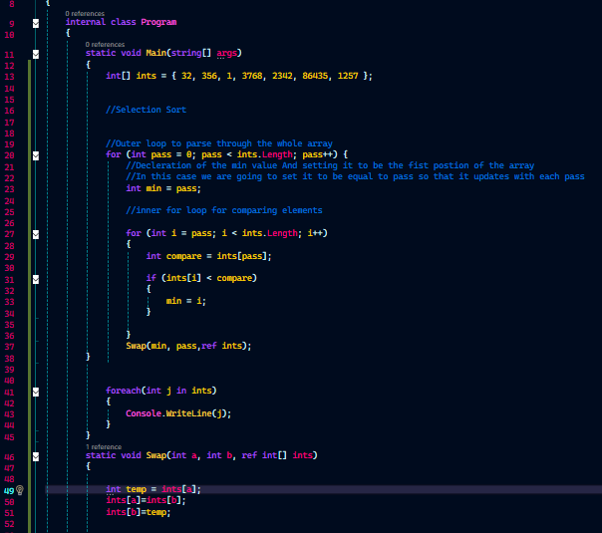

Code contains comments to help with understanding