**CSS Flexbox**

Float and flexbox both are amazing tools through this we can be able to manage the layouts.

Flexbox is very simpler than float

When we give the display property to flex then it tells that it is from another system and we can’t use property like inline ,block, inline-block and none.

As we know that every element has some display property like div element has block property , span ha inline property

So, if we use display as flex then it will embed In a container and make all of the elements property to flex and we can’t be able to get the display property like inline , block etc

Its size will be dependent on the content size.

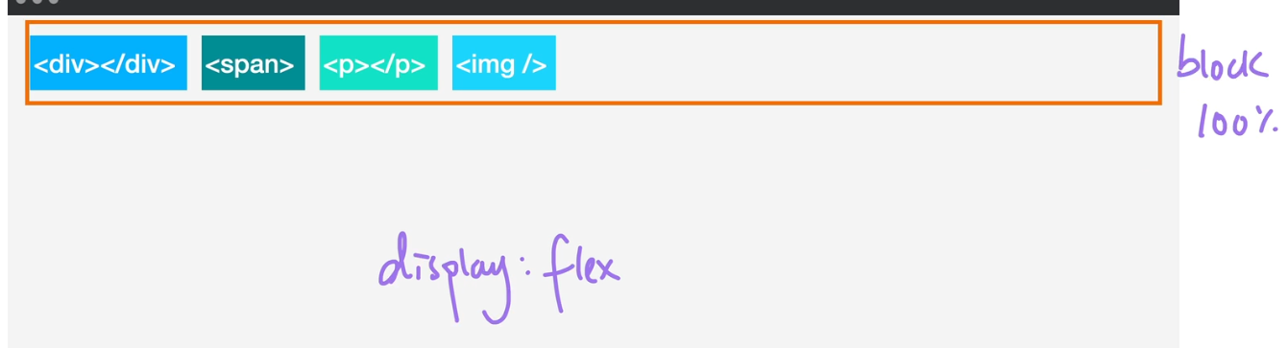

As flex box container occupies 100 % width , to avoid this we use inline flex display property

Due to which that container will have the functionality of in line. It will take that much space of the container only till my content is fitting in it.

**Flex direction:-**

Flex direction means the direction of the axis of the flex or the boxes which are present in the container :-

There are two types of axes:-

1. **Main axis:-**Main axis is the axis which is used to set the direction of the flex boxes like if my flex direction is row then my main axis will be horizontal and if my main axis direction is column then my main axis direction will be Horizontal .
2. **Cross axis:-**cross axis is the axis which is perpendicular to the main axis .

**Flex basis** is used to increase the height or width in terms of axis direction.

**Flex layout:- In flex layout there are many properties like:-**

* **ORDER:-**order property is a property tha is used for arrangement of items .

Flex box container.

* A screen shot of a computer

  Description automatically generated**Flex-wrap:-**It tells that how all the children (items) should behave ,

If this situation comes then we can use flex -wrap in flex container CSS part. So it push the elements to the next line.

So, when my screen resolution is decreased then it wraps all the elements to the next line.

This property is set on the parent container that is the flex container .

* **Justify-content:-**This flex property is also set on the parent flex container. This property

Acts like a alignment – left alignment and right alignment and centre alignment of the flex items .

So, in this there are two values

**Flex-start:-**

**Flex-end:-**

**Flex-centre:-**

**Space-between:-**In space between the first and the last element is been in totally touched .

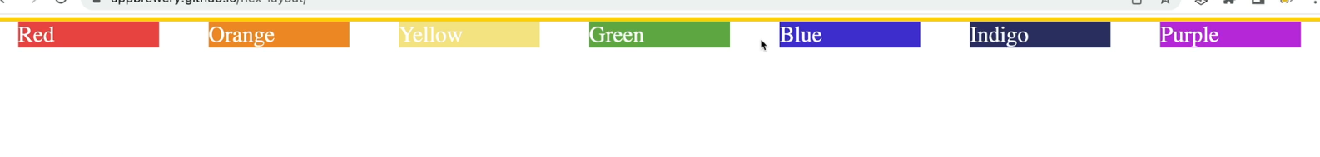**Space-around:-**In space around all the first and last element is been not been touched .

**Space-evenly:-**In space evenlyall the elements is been distributed evenly.



**G.K**

**Vh:-viewport height**

**Our screen has 100 vh.**

**Difference between align items and justify content ?**

That align items is used in cross axis whereas justify content is used in main axis.

**align-item:-**This is another flex property which is used to align the flex items for cross axis .

It has same values like in justify content

* **Flex-start:-**

* **Flex-end:-**

* A screenshot of a computer

  Description automatically generated**Flex:-centre:-**

And has some values like baseline ,stretch.

**We can also align our items individually in a container like**

So, in this the items which we need to align individual then we will use this align self-property to the individual own CSS elements.

Important thing I got to know that when my flex direction was row then justify-content was used in horizontal where as when my flex -direction is column then my justify -content will be column and align items will be doing process of rows.

Another property which is the combination of flex wrap and flex direction which is **flex-flow**

**To wrap row then use row wrap;**

**To wrap column then use column wrap;**

Resources:-

<https://css-tricks.com/snippets/css/a-guide-to-flexbox/>

Align content:-this is used when flex wrap is used, and it does same process as align items.

Max-width:- It tells that how much element can grow according to this width

Min width :- It tells that how much element can shrink according to the width.

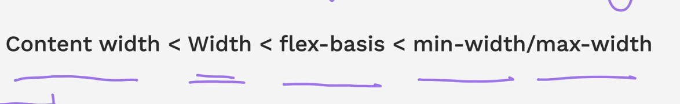**Flex sizing :-This is the hierarchy of the flex sizing.**

**For example I have created a container and It consist of items like some paragraph elememts.**

**When I shrink the window then automatically my container and the elements present inside it will shrink up to it reaches the minimum width.**

**So this is the default behaviour of flex shrinking.**

**So , now I have given the width of every items as 100px so my total width container will be approx more than 400 px considering the gap sizes.**

**So in this my minimum width will be the 100px and maximum width will be that approx. 400 px .**

**If we give the flex basis then It will ignore the width which we have given in previous.**

**Minimum width is determined by the longest word in that text.**

**Now we will use flex grow and shrink**

**We can turn on the grow and shrink by 1 and turn off by 0**

**🡪This is the shortcut way for giving the flex sizing.**

**]**