Grid

Grid is a very important topic for constructing the layouts. This tool is used for creating the two-dimensional layout.

Difference between flex and Grid is that flex is used for one dimensional layout where as grid is used for two dimensional layout.

In flex we can arrange the items linearly whereas in grid we can arrange the items in horizontally as well as vertically .

In flex box there is no perfect alignment , whereas in grid there is a perfect alignment.

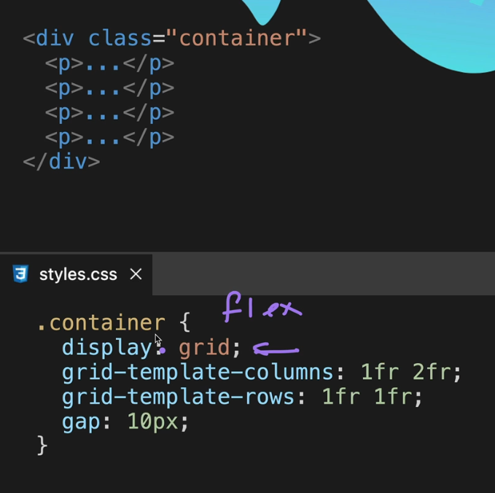

Instead of having the grid-template-rows and grid-template-columns we can have the grid template only for example :-

But if we give the sizes by pixels or rem then the sizes are fixed means that when we shrink these items will not shrink .

But if we give the sizes by fr then these are not fixed.

So, these fr will give responsiveness where as px and rems will not. But if we want to give fixed sizes as well as the responsiveness then we can use the auto keyword.

So, in grid template -columns the first width will be 200 px after then it will take the size according to the screen and it will be responsiveness.

But this doesn’t work in cases for rows as in rows the first row will be 100 px but the second row will occupy the height according to the content fit in it .

Through this we can limit the size of the items by giving the minimum and the maximum width .with this we can give the items the sizes of max and min and we can make the responsiveness of the website.

As you can see after shrinking till 400 px there is no responsivness . this is due to the min max size .

As earlier we had created the chess board tand in that there were 8 columns and eight rows so to have equal sizing we have given 1 fr to each , so we hgave 1 fr 16 times total , to avoid there is a function called as repeat.

In this for example if I have given 2 rows and 1 column and there are four items then in first two row the size will be according to the size mentioned in the code , but the next two items will be having the size according to the content present in it , so I want to give the size of the them then I can use grid-auto-row .

Now we will learn about how to grid the items in the layout .

Grid will occupy the width 100 % by default but it height is determined by the content present in it .

So, if we want to make our container to full size in height then we will give the container by giving the property oh height to 100 vh;

Grid template rows and grid template columns are basically the tracks

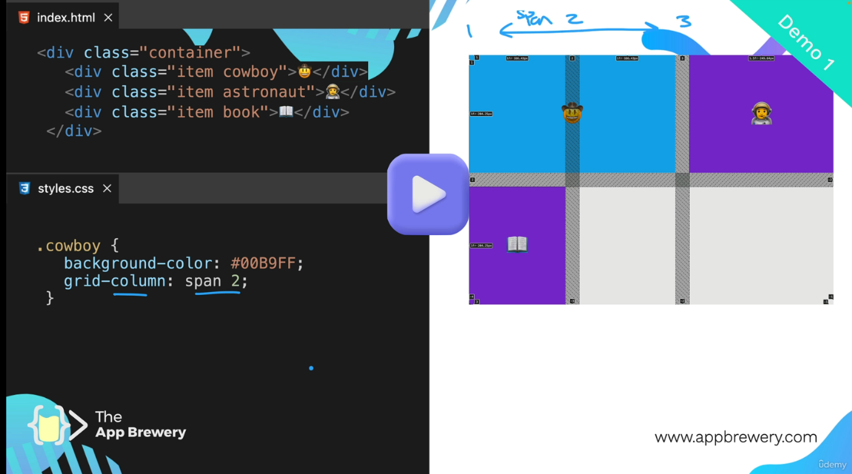

We can also span the columns and rows by giving the span value in grid column and grid rows .

That grid column property consists of two property

In grid-column-start we can the line number where to start and grid -column-end to where to end.



All these boxes in red shows the lines no (grid line no) .

We can also reverse the items.

Same for grid -row property.



For example if I have three items in that I have spanned the two columns for first items and I want to spanned the two columns for second item in second row but the second item is placed in first row to bring it down we will use order property , it will basically order the element to the bottom most and last element just like in flex box .and then we can spanned the column to 2.

But we can also give the location of the items by giving the grid -column-start, grid-column-end,grid-row-start,grid-row-end.

Another shortcut property to give the location of the items in the grid layout is:-

