Bootstrap

It is an external framework which consists of pre-made CSS files , With the help of pre-made CS S files we can save lot of our time and also it make our website more responsive as well as beautiful.

Now let’s understand the most powerful Bootstrap Layout.

So the 12 column system consists of div(container)🡪 div(row)🡪 items which are arranged in columns.

Bootstrap container is responsive on every device, given for this much size the container width will be this pixel , automatically.

We can assign the columns with different names, and we can assign them with the different sizes.

These are the breakout points where we can use in column classes .

For example :-

If I five col-sm-2 it indicates that my width of the

Column will be between 576 px and 768px , so it

Will show resolution for that range only.

So with the help of boostraps we are able to cover the resolution and responsivness and there is no need of mediaqueries.

<https://appbrewery.github.io/bootstrap-layout/> visit this website for practise.

Now we will understand the powerful feature of bootstraps.

With the help of bootstrap components we can make our webistes very quickly.

We can also use many bootstrap icons from boostrap documentation.

We can also set the dark theme to our website with the help of this bootstrap property 🡪 data-bs-theme=”dark”.

Example:-

For web designing there are some points where we should remember

1:- color palette :- choosing right color palette in our website will make user more engage.

2:-typgography:- choosing right font can also make impression on users.

Keep only wo fonts , and try to go with that fonts which have similar moods.

3:-User Interface Design:-

We can make webistes by removig our alignment.

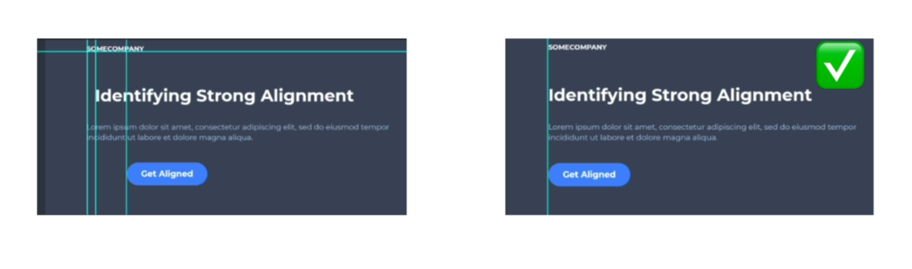

Injecting some white space make our website more professional.

Think about the audience, Think that what will they like.

* Hierarchy
* Layout
* Alignment
* White space

**UX design :-**

* **Simplicity:-**
* **Consistency:-**

**Most of the users try to read or look in F based pattern so make design which are according to F**

**Layout.**

ANOTHER PATTERN IS THE **Z-LAYOUT**

