**Document Object Model**

* We should always write script element at the last section of body element.

Dom is represented using this tree model.

In DOM the object has properties and methods with these we can manipulate our objects.

We can manipulate the properties using dot notation

set property:-

Get property:-

Methods:-

Difference between methods and function is that method is associated with the objects where as functions are just bunch of codes that are not assciciated with It.

**Document.queryselector(“”):-** this can select selector and combination of selector , classes and id .This is the best method, and we can directly manipulate the properties.

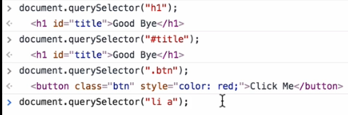

**Document.queryselectorAll(“”):**-this will select all the elements which is mentioned inside the quotation.this will give an array , for example if I want to give hover properties in nav bar headinings then I will use this property because It will give elements in the forms of array and after that we can give properties through for loop.

**Document.getElementsByTagName(“”**):this will select the html tag elements and return in the form of array.

So when we try to manipulate the items properties in an array then we will need to give position of items , it cannot directly manipulate the element.

**Document.getElementsByClassName(“”):-** this will select the particular class which is mentioned inside this.This is also returns and array , so we cannot directly set the property.

**Document.getElementById(“”):-**This will select that id which is unique through the html document and will select only one. In this we can directly manipulate the property.



In CSS we have properties like border-color , background-size etc , we have – properties where as in JavaScript when we write properties then we will need to give in camel case example :- Font-size is in css then in JS it would be FontSize.

And also, the value in css is not enclosed in “”(string), where as in javascript we need to give values in “”(string).

We can also add classes by JavaScript by using

Document.querySelector(“”).classList().add(“”);

In add parentheses add the name of the class then it will automatically add the class name.



Simply we can remove also

Last is the toggle method ,in this it will check whether my class is added or not , if yes then it will remove it and if not then it will add it .

**.Inner html:-**Inner html basically gives all the contents which is present inside that selector

.**text-content:-**Text content gives only the text content not the tag.

Example:-

We can also write whole html element also inside this inner html .

Now manipulating the html attributes.

**.attribute:-**This will give all the attributes which are been present inside the element.

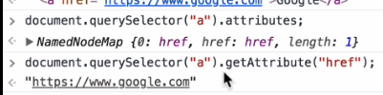

We can also set attribute value:-

In AddEventListner we try to add the function names without adding any paranthsesis , if we try not to give paranethesis then it will directly triiger the function and will execute the code without any event is happened.

Now writing in the form of anonymous function

Add event listener is taking two inputs first input is the what event it should listen to eg(onclick,click…)and second input is the function what should it do after that event has happened.

In chrome developer tools we can Debug the code by typing debugger; in console and press sfift enter and write the functions to be debug and then press enter then it will open the debugger mode.



Constructor Function :- constructor function is a function which is used for taking the inputs and this are the inputs which are been provided when we create an new objects from this constructor function.

Inside the constructor function we match the inputs with the property. Constructor function name starts with an capitalization.

We can also give functions inside the input also .

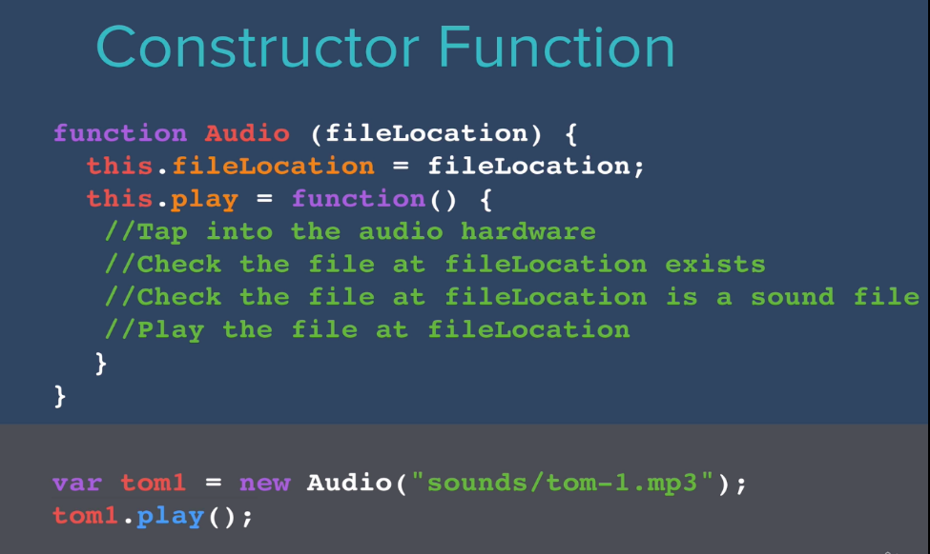There are some predefined constructor functions like audio constructor function.