Node JS

As earlier we were able to tun the JavaScript code in browser ,but now we will run by using the computer (command line prompt).

I have written this code in vs code , now I can be able to tun this js code in terminal by using this command.

Node Repl stands for :-

R:- Read

E:- Evaluation

P:- Print

L:-Loop

It basically makes the code to be run in byte size of chunks .As we were able to run this in browser.

This property is also in node Repl we can access this by using node.

There are some commands :-

Just like in python we can import the libraries and modules, now we can do same in javscript

In order to require the packages and libraries we will use the this By using the require keyword.



There are some errors when we use the packages and libraries so we need to use that version which is given the error so by comments we can do this .

we can manipulate, create the files using the node.

Npm :- Node package manager . It is the worlds largest collection of packages.

First we will initialise the npm.

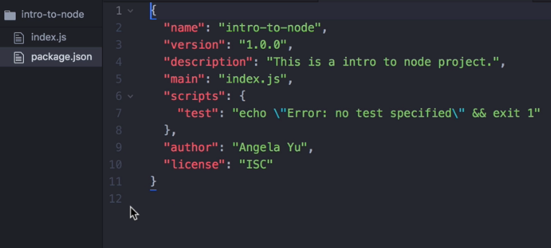After initialising It will take description from the user .

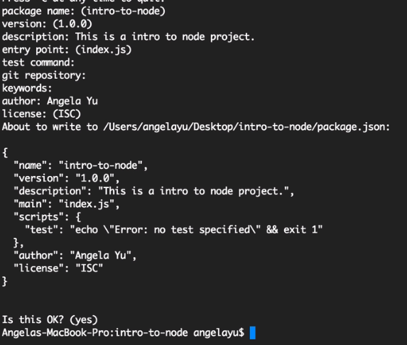

So the external packages can be installed using this command.

So all the external packages will be installed inside the

Dependencies.