**API/APPLICATION PROGRAMMING INTERFACE**

Application Programming Interface (API) is a set of commands, functions, protocols, and objects

that programmers can use to create software or interact with an external system.

There are four important points for API:-

Endpoint:-There might be some endpoint to access the external

System such as API URL.

Paths:-with the help pf paths we can be able to narrow down

The piece of data from the external server

Parameters:-Parameter is also the same.

Authentication:-To access this we need a api key with the hep of that key we can access the data from the external server and this key keeps the tack of the data.



This is by postman , very amazing tool , easily we can change the parameters and change the paths also .

Data comes in JSON format.

We can make get request to external server with many methods but we are going to use with the native https module , which is by default installed , so we are going to use that .

[**https://developer.mozilla.org/en-US/docs/Web/HTTP/Status**](https://developer.mozilla.org/en-US/docs/Web/HTTP/Status) **:- https response status codes.**

If YOUR URL IS WRONG THEN IT WILL MOSTLY GIVE THE **404** ERROR , AND IF AUTHENTICATION IS WRONG MEANS APPID THEN IT WILL GIVE **401** ERROR etc

As the status code is 200 , then we can get data form the response , so to get this data we can do this by this method

As the data which will be getting in hexadecimal , binary format or another format so we will convert in to JSON format by JSON.parser () method.



The above data is in hexadecimal format so we can convert this in to JSON format by that parser method



WE CAN CONVERT THE JSON FORMAT DATA TO STRING , WHICH USES MINIMUM SPACE , THIS CAN ALSO BE DONE BY STRINGIGY METHOD



So now how can we get the piece of the data

By going line by line Or we can use the JSON viewer pro extension.



After accessing the data we can copy

The path of that item which we want

To have

Eg is above

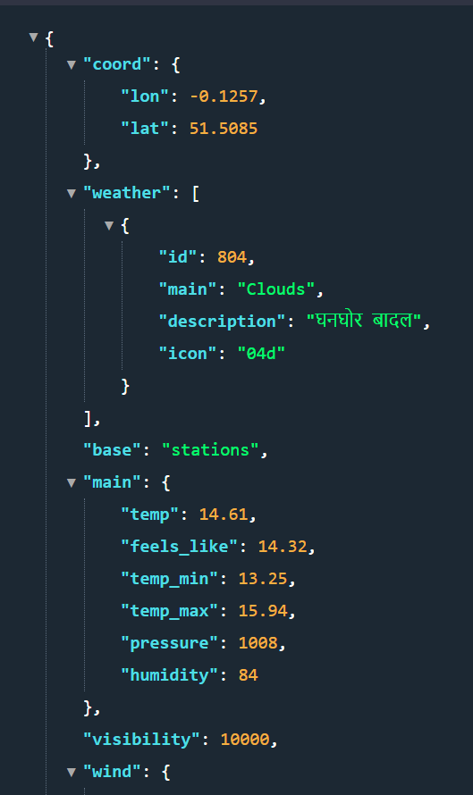

We can’t send more than one :- res.send() but we can use multiple res.write() and then after that we can send

