**GitHub**

Git log :- In git log we can see the overall commits

Git diff :- With the help of git diff we can check the difference between the commits between current and previous ones.

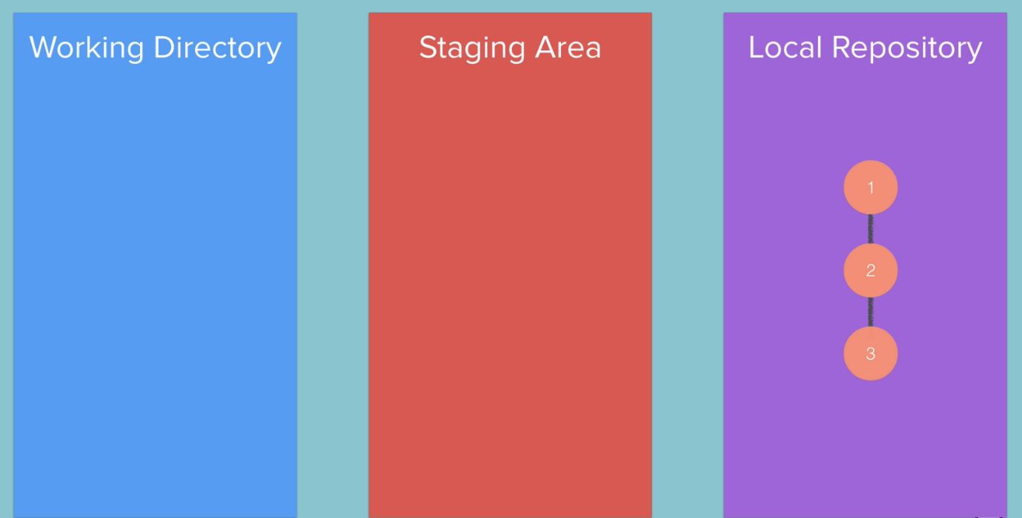

After that we can upload this repository on GitHub.Using git push -u origin main /master.

With the help of .gitignore we can ignore some files before staging area , by just adding the name.

In a case I have done the staging and I want to make one file to come in to unstage area again then we can do this by

Git rm –cached -r<file name>.This command will specifically stage to the unstage area.

For all files then git rm –cached -r . This command will unstage all the files from staging area.

