**KPI Requirements**

SELECT SUM(total_price) AS total_revenue

FROM pizza_sales;



SELECT SUM(total_price)/COUNT(DISTINCT order_id) AS average_order_value

FROM pizza_sales



SELECT SUM(quantity) AS total_pizzas_sold

FROM pizza_sales



SELECT COUNT(DISTINCT order_id) AS total_orders

FROM pizza_sales



SELECT CAST(SUM(quantity) AS DECIMAL(10,2)) / CAST(COUNT(DISTINCT order_id) AS DECIMAL(10,2)) AS average_pizzas_per_order

FROM pizza_sales



**Charts Requirements**

SELECT DATENAME(DW, order_date) AS order_day, COUNT(DISTINCT order_id) AS total_orders

FROM pizza_sales

GROUP BY DATENAME(DW, order_date)

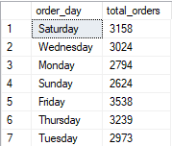

SELECT DATENAME(MONTH, order_date) AS month_name, COUNT(DISTINCT order_id) AS total_orders

FROM pizza_sales

GROUP BY DATENAME(MONTH, order_date)

ORDER BY total_orders DESC

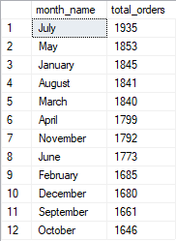

SELECT pizza_category, SUM(total_price) * 100 / (SELECT SUM(total_price) FROM pizza_sales) AS total_sales

FROM pizza_sales

GROUP BY pizza_category

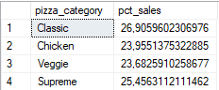

SELECT pizza_size, SUM(total_price) AS total_sales, CAST(SUM(total_price) * 100 / (SELECT SUM(total_price) FROM pizza_sales) AS DECIMAL(10,2)) AS pct_sales

FROM pizza_sales

GROUP BY pizza_size

ORDER BY pct_sales DESC

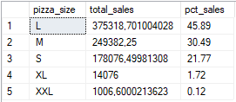

SELECT TOP 5 pizza_name, SUM(total_price) AS total_sales

FROM pizza_sales

GROUP BY pizza_name

ORDER BY SUM(total_price) DESC

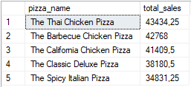

SELECT TOP 5 pizza_name, SUM(total_price) AS total_sales

FROM pizza_sales

GROUP BY pizza_name

ORDER BY SUM(total_price) ASC

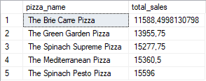

SELECT TOP 5 pizza_name, SUM(quantity) AS

total_quantity

FROM pizza_sales

GROUP BY pizza_name

ORDER BY total_quantity DESC

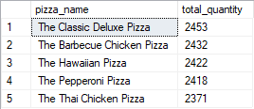

SELECT TOP 5 pizza_name, SUM(quantity) AS total_quantity

FROM pizza_sales

GROUP BY pizza_name

ORDER BY total_quantity ASC

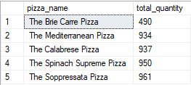

SELECT TOP 5 pizza_name, COUNT(DISTINCT order_id) AS total_orders

FROM pizza_sales

GROUP BY pizza_name

ORDER BY SUM(total_price) DESC

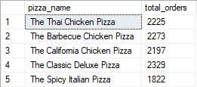

SELECT TOP 5 pizza_name, COUNT(DISTINCT order_id) AS total_orders

FROM pizza_sales

GROUP BY pizza_name

ORDER BY SUM(total_price) ASC

