16-02-2025 Morning: Quickly explored the dataset, converted the text in csv to columns and transformed data to a table. Format-wise, I centered the cell contents of the table and resized the columns to fit contents

**16-02-2025 Afternoon:** Identified the following needed data cleaning steps after exploring the dataset:

* Standardize date format to be as follows: dd-mm-yyyy
  + After failing several times to standardize the date format using the “Format cells” options, I searched through the internet and found the solution to the date format, which is through the “Text to Columns” function outlined in this [video](https://www.youtube.com/watch?v=52ujKMkEAtU) and the steps below:
    - Select the “date” column
    - Click on “Text to Columns” in the “Data” ribbon
    - Click “Next” for the first 2 steps
    - On the third steps, select “Date” and, from the dropdown, select “MDY” format. Then click “Finish”.
    - The dates will now be displayed in a correct and unified format. We can verify that by checking the filtering options, which should look like this: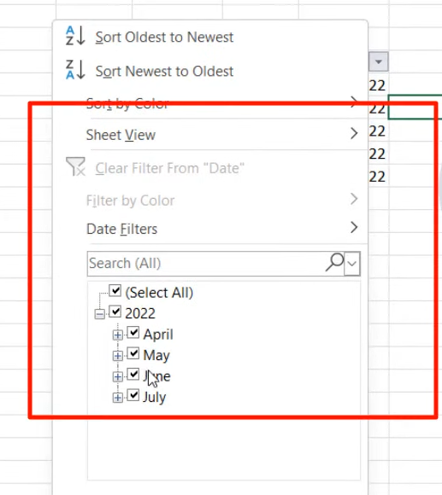
* 107 empty rows in the transaction_type column. Still did not decide how to approach the missing values
* Check for duplicate values – no duplicate values found

17-02-2025 Morning: Saved file as Excel Workbook for ease of editing and manipulation compared to CSV.

Reviewed the project description to identify next steps.

Moving to SQL and imported csv after the carried out edits. Used MS SQL Server.

There are null values in the transaction_type column. In this case I will replace the null values with “Other” which refers to any payment method that is not Cash or Online, such as a gift card or a credit card.

To save the changes, I used the UPDATE statement

19-02-2025 Evening: Wrote SQL Queries suggested in Project outline document as well as created a summary of sales through pivot tables and a chart in Excel.

Wrote first part of project README file

Created additional pivot tables and visualizations in Excel for the following questions:

* Analyzing sales trends over time.
* Understanding customer preferences for different items.
* Evaluating the impact of payment methods on revenue.
* Investigating the performance of staff members based on gender.
* Exploring the popularity of items at different times of the day.

20-02-2025 Morning: Completed project README file and uploaded project to GitHub