VITAMIN DEFICIENCY DETECTION SYSTEM
MAJOR PROJECT
BACHELOR OF TECHNOLOGY
IN
INFORMATION TECHNOLOGY
BY
M. Umarani (22568T1831)
B. Roshini Patel (22568T1804)
M. Snehalatha (22568T1832)
Shireen (22568T1839)
N. Nandini (22568T1834)
Under the guidance of
Smt. K. VANISREE
Department of CSE

Submitted to
DEPARMENT OF INFORMATION TECHNOLOGY
UNIVERSITY COLLEGE OF ENGINEERING & TECHNOLOGY FOR WOMEN
KAKATIYA UNIVERSITY CAMPUS, VIDYARANYAPURI, HANAMKONDA.
WARANGAL- 506001, INDIA
APRIL 2026

UNIVERSITY COLLEGE OF ENGINEERING & TECHNOLOGY FOR WOMEN
KAKATIYA UNIVERSITY CAMPUS, VIDYARANYAPURI, HANAMKONDA.



CERTIFICATE
This is to certify that M. UMARANI (22568T1831), B. ROSHINI PATEL (22568T1804), M. SNEHALATHA (22568T1832), SHIREEN (22568T1839), N. NANDINI (22568T1834) of B. TECH(IT) VIII semester have satisfactorily completed. The dissertation of my project work entitled with “VITAMIN DEFICIENCY DETECTION SYSTEM” towards the partial fulfillment for the award of degree of BACHELOR OF TECHNOLOGY in INFORMATION TECHNOLOGY to the KAKATIYA UNIVERSITY, it is a record of work carried out during the academic year 2025-2026 under our guidance and supervision.

Guide Department HOD
(Smt. K. VANISREE) (Smt. J. DEEPTHI)

External Examiner
(Mr. N. RAMANA)

Academic Coordinator Principal
(Mr. M. VENUGOPAL REDDY) (Prof. Dr. K. BIKSHALU)
DECLARATION
We declare that this written submission represents our ideas to our own words and where other’s ideas or words have been included, we have adequately cited and referenced the original sources. We declare that the work presented in the project report is original and carried out in the development of Information Technology, University College of Engineering &Technology for Women, Hanamkonda, Telangana and have not been submitted elsewhere for any graduate and part of in full.

M. Umarani (22568T1831)
B. Roshini Patel (22568T1804)
M. Snehalatha (22568T1832)
Shireen (22568T1839)
N. Nandini (22568T1834)

ACKNOWLEDGEMENT
It plunges us in taking privilege in expressing our heartfelt gratitude to all who have helped, encouraged and in foreseeing successful completion of our project. Ecstasies to work under gregarious guidance and Head of Department of Information Technology, Mr. N. RAMANA, to whom we are extremely in debt for his valuable and timely suggestions. We are honoured and privileged to thank Smt. K. Vanisree, our guide for this project, for her support, motivation, regular guidance. It was a pleasure for us to receive valuable suggestions from and we would like to endow our thanks for the motivating guidance during our project work from our academic coordinator Mr. M. Venugopal Reddy and principal of the college Dr. K. Bikshalu. Finally, we would like to thank our families from the bottom of our hearts for their kind cooperation in helping us to complete our project work in time
ABSTRACT
The Vitamin Deficiency Detection System is a web application that identifies potential vitamin deficiencies using machine learning. The project’s main goal is to raise awareness about vitamin deficiencies based on symptoms and basic health information provided by the user.
In this system, users enter their symptoms and general health details through a simple, easy-to-use interface. The entered data is analyzed using a trained Random Forest machine learning model, which predicts potential vitamin deficiencies.
After making predictions, the system displays the identified deficiency along with a risk level to show the severity. It also offers basic health suggestions, including dietary recommendations and lifestyle tips, and advises users to see a doctor if needed.
The application stores prediction results in a database for future reference. Moreover, the system has a feature that allows users to generate and download a PDF report with their details.
This project shows how machine learning and web technologies can work together to create a simple, efficient, and user-friendly system that aids in early detection and awareness of vitamin deficiencies.

INDEX

1.INTRODUCTION

Vitamin deficiency is a common problem faced by individuals belonging to different age groups. Lack of essential vitamins in one’s diet may result in a variety of health problems, and individuals often do not realize they are suffering from a vitamin deficiency until they are in a critical condition, as proper medical testing can be time-consuming and costly, and such facilities may not be easily accessible.
With the advancement in technology, machine learning has been able to play a vital role in analyzing such problems and providing early predictions regarding them. Using symptoms and basic health conditions, a machine learning model can help predict possible vitamin deficiencies and provide suggestions for prevention.
The Vitamin Deficiency Detection System has been developed with the aim of providing a solution to this problem, and the system allows users to fill in their symptoms and basic health conditions through a web-based interface. The machine learning model analyzes the provided data and predicts possible vitamin deficiencies, and based on this, basic health recommendations are provided to users.
The main aim of this project is to develop a system that can be easily used by individuals and help them detect and become aware of vitamin deficiencies in a timely manner, thus helping them understand their health conditions and seek proper medical guidance if needed.

  - Scope
The scope of the Vitamin Deficiency Detection System is to offer a simple and user-friendly platform to detect potential vitamin deficiencies at an early stage. This system is designed to allow ordinary users to perform a preliminary health assessment based on symptoms and general health information, without the need to acquire medical knowledge.
This system is designed to detect common vitamin deficiencies and offer basic health advice to raise awareness and promote health prevention. Moreover, the system enables the storage of the results and the generation of reports for later use.
However, the project can be further enhanced by adding more types of vitamin deficiencies and increasing the accuracy of the prediction by using a large dataset and implementing more sophisticated machine learning algorithms in the future.
Moreover, the system can be further enhanced to allow the system to be used in clinics and rural health centers and telemedicine facilities, making the system a more scalable platform to promote health prevention and awareness of nutritional health.

  - Objective
The major objectives of the Vitamin Deficiency Detection System are as follows:

- To develop a web application for detecting possible vitamin deficiency.
- To collect the symptoms and basic health details of the users through a simple interface.
- To use machine learning methods, such as Random Forest, for predicting possible vitamin deficiency.
- To give suggestions for diet and lifestyle based on the prediction results.
- To store the details and results for future use.
- To produce a PDF file containing the details and results for future use.
- To spread awareness among people regarding vitamin-related health problems.

2. LITERATURE SURVEY
Machine learning methods have been used in healthcare to predict and identify diseases. Bhimavarapu et al. (2025) proposed a machine learning model to predict vitamin D deficiency using non-invasive methods. They wanted to reduce the dependency on blood tests to identify vitamin D deficiency by using machine learning methods to analyze the health data. They were able to accurately identify the deficiency using machine learning methods. This research paper proves the use of machine learning to predict vitamin deficiencies in healthcare.
The study by Guo et al. (2024) proposed a machine learning-based system to predict vitamin D deficiency using simple interview-based health data. They used a large dataset containing more than 62,000 participants and used machine learning algorithms to identify the deficiency. They were able to accurately predict the deficiency using machine learning methods. This research paper proves the use of machine learning to predict vitamin deficiencies.
Alloubani et al. (2024) used machine learning algorithms like Random Forest for the prediction of vitamin deficiency by considering various parameters from the health domain and environmental domain. It has shown the efficiency of the Random Forest algorithm in providing accurate prediction results. This research article proves the efficiency of the Random Forest algorithm in developing the proposed Vitamin Deficiency Detection System.
Breiman (2001) proposed the Random Forest algorithm, which uses multiple decision tree algorithms for accurate prediction. This algorithm has shown high efficiency in classification and prediction problems. This algorithm will be used in the proposed Vitamin Deficiency Detection System.
Researchers have proposed various disease prediction systems based on machine learning algorithms. These prediction systems are based on the symptoms provided by the user. This helps in detecting various diseases in the early stages. It also helps in providing preventive measures for the diseases. This has shown the efficiency of machine learning algorithms in developing various disease prediction systems.
From the above research articles, it has shown that machine learning algorithms like Random Forest can be used for the prediction of vitamin deficiency. This proposed system is based on the machine learning algorithm for developing an efficient Vitamin Deficiency Detection System.
3.SYSTEM ANALYSIS
3.1 EXISTING SYSTEM
Currently, vitamin deficiency detection takes place through conventional medical practices. People facing vitamin deficiency symptoms consult doctors, who then diagnose the problem after examining their symptoms, medical history, and living habits. Doctors prescribe blood tests, which help confirm vitamin deficiencies like Vitamin D, Vitamin B12, and Iron deficiency.
Although this method delivers accurate results, there are some disadvantages, including time consumption, cost, and accessibility. Moreover, some people do not seek medical help during the beginning stages of vitamin deficiency symptoms, which leads to further complications.
Additionally, there exist various online websites that offer information about vitamin deficiency symptoms. These websites, however, do not offer personalized predictions or analysis. Hence, there does not exist a quick and automated solution for vitamin deficiency detection and awareness.
Disadvantages of Existing System:
- Visiting doctors is required for diagnosis
- Laboratory tests are expensive
- Time consumption in diagnosis
- Not accessible in rural areas
- Lack of awareness and early detection
- No personalized predictions based on symptoms
- Only general information is given on vitamin deficiency symptoms
- No automated or intelligent detection system

3.2 PROPOSED SYSTEM
The proposed Vitamin Deficiency Detection System will be a web application that will help users identify vitamin deficiencies in an efficient manner. The system will allow users to register and then log in, after which users will be prompted to enter their symptoms and other health-related information, which will be taken through an interactive interface.
The data will be processed, and a Random Forest algorithm will be used to predict vitamin deficiencies. After predicting, users will be shown results indicating the type of deficiency, confidence level, risk level, and nutrition level.
The system will also provide users with dietary and lifestyle recommendations depending on the deficiency. Moreover, users will be advised to consult a doctor if the risk level is high.
The results will be stored in a database, and users will be able to generate a PDF report using the proposed system. The proposed system will be a quick and digital solution for users to be aware of vitamin deficiencies.
Advantages of Proposed System:
- Provides early detection of vitamin deficiencies
- User-friendly and easy-to-use interface
- Quick and automated prediction system
- Reduces dependency on manual diagnosis for initial screening
- Provides personalized recommendations
- Stores user data for future reference
- Generates downloadable PDF reports
- Accessible from anywhere through web application
- Helps increase awareness about vitamin deficiencies
- Cost-effective compared to traditional diagnosis.

4. PROJECT ANALYSIS
4.1 General
The Vitamin Deficiency Detection System is a web-based application designed to identify potential vitamin deficiencies using machine learning techniques. The system allows users to enter their symptoms and basic health information. Based on the provided input, the system analyses the data using a trained Random Forest model and predicts possible vitamin deficiencies.
The application provides users with prediction results along with risk level, basic explanation, and dietary recommendations. It also advises users to consult a healthcare professional when necessary. Additionally, the system stores prediction results for future reference and allows users to generate downloadable reports.
The project integrates web technologies and machine learning to provide a simple and efficient solution for early detection and awareness of vitamin deficiencies.
4.2 Problem Definition
Vitamin deficiencies have emerged as one of the significant health issues due to improper dietary habits, lifestyle changes, and lack of knowledge. Many people are facing problems with symptoms like lack of energy, immunity, and concentration. However, they are unaware that these problems are due to vitamin deficiencies. Therefore, vitamin deficiencies are going unnoticed until they lead to serious health problems.
The traditional method of detecting vitamin deficiencies is consulting doctors and undergoing medical tests. Although this method is reliable, it is time-consuming, costly, and not accessible to everyone. Moreover, people are neglecting symptoms due to lack of knowledge. Therefore, an effective and convenient method is needed to assist individuals in detecting vitamin deficiencies at an early stage. The proposed system will address this problem by developing a web-based application using machine learning techniques to predict vitamin deficiencies.
4.3 Methodologies
The methodology of the Vitamin Deficiency Detection System describes the workflow of the system in identifying possible vitamin deficiency issues using machine learning technology. The system allows users to input the symptoms they are experiencing, along with other general health information, through the system’s online interface. The input data will then be processed and analyzed using the Random Forest algorithm to determine possible vitamin deficiency issues.
Finally, the system will show the results, including the deficiency type, risk level, and general health suggestions, which will be stored in the database for future use. The results can also be converted to a PDF document, which can be downloaded.
This methodology can be an effective approach in the early detection and awareness of vitamin deficiency issues.
4.4 Algorithm

5.SYSTEM REQUIREMENTS
5.1 Hardware Requirements
Processor : intel i5 core or higher
RAM : 8 GB or more
Speed : 2.5 GHz or higher
5.2 Software Requirements
Frontend Technologies : HTML, CSS, JavaScript
Backend Technologies : Python (Flask)
Database : MongoDB
Machine Learning Library : Scikit-learn
Operating System : Windows 10 or above
Development Tool : Visual Studio Code
5.3 Functional Requirements
The Vitamin Deficiency Detection System shall have the following functional requirements to work effectively and efficiently for the prediction of vitamin deficiencies:
- User Registration and Login: The system shall allow users to register and login with valid user credentials.
- User Authentication: The system shall authenticate users before providing access to prediction.
- Health Data Input: The system shall allow users to enter their symptoms and basic health information such as age, gender, and dietary habits.
- Input Validation: The system shall validate user inputs to ensure accuracy and precision.
- Prediction Processing: The system shall process user inputs using a Random Forest machine learning model for prediction.
- Result Display: The system shall display the predicted vitamin deficiency along with the risk level.
- Recommendation System: The system shall offer dietary recommendations and lifestyle recommendations based on prediction.
- Report Generation: The system shall generate a report based on user information and prediction.
- Report Download: The system shall allow users to download the generated report.
- Data Storage: The system shall store user information and prediction results for future reference.
- User Interface: The system shall have an easy-to-use interface for user convenience.
5.4 Non-Functional Requirements
The Vitamin Deficiency Detection System has to fulfill the following non-functional requirements to make sure that the system performs efficiently and effectively:
- Performance: The system has to perform the prediction result in a short period of time and perform efficiently in handling many users.
- Usability: The system has to be simple and easy to use, and users without technical knowledge can understand how to use the system.
- Accuracy: The system has to perform accurate prediction using the machine learning model and dataset.
- Security: The system has to perform secure access and prevent unauthorized access to users.
- Scalability: The system has to perform enhancements such as additional vitamin deficiencies and a large number of users.
- Reliability: The system has to perform without system failures and has to handle unexpected errors.
- Maintainability: The system has to perform easily and has to be modified and updated for future improvements.
- Compatibility: The system has to be compatible with different devices such as desktop, laptops, and mobile devices.
- Availability: The system has to be accessible to users at any time through the web interface.
- Data Privacy: The system has to perform confidentiality in terms of users’ health information and data.

6. SYSTEM DESIGN
6.1 ER Diagram
6.2 Dataflow Diagram

6.3 UML Diagram
6.3.1 Use case Diagram
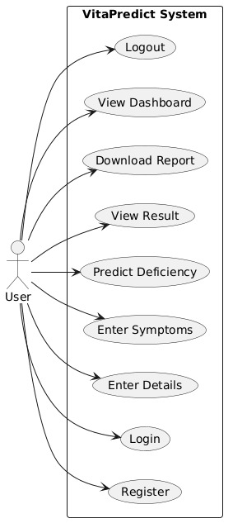
Use Case Diagram Description:
The Use Case Diagram of the VitaPredict System shows the interaction between the user and the system. The user is the main actor of the system. The user will interact with the system to perform different operations. The user will be able to register themselves with the system, log in to the system, provide details, and ask for vitamin deficiency prediction. The system will process the details and show the result to the user. Then, the user will be able to view the result, download the report, and view the dashboard. Finally, the user will be able to log out of the system. This is the Use Case Diagram of the Vitamin Deficiency Detection System.
6.3.2 Class Diagram
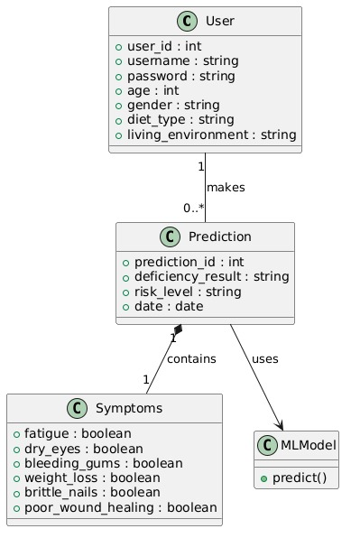
Class Diagram Description
The Class Diagram of the VitaPredict System shows the structure of the system and the relationships between the various components of the system. In the Class Diagram of the system, the User class holds the details of the user, including the username, age, gender, and diet. The user enters the symptoms of the problem he/she is facing, and these are held in the system in the Symptoms class.
The prediction results of the problem are held in the Prediction class, which uses the ML Model class to generate the prediction results using the prediction function implemented in the system with the help of the Random Forest algorithm.
From the Class Diagram of the system, we can see the relationships between the classes of the system and the functionality of the system. From the Class Diagram of the system, we can see the relationships between the classes of the system and the functionality of the system.

7. IMPLEMENTATION

8. RESULT
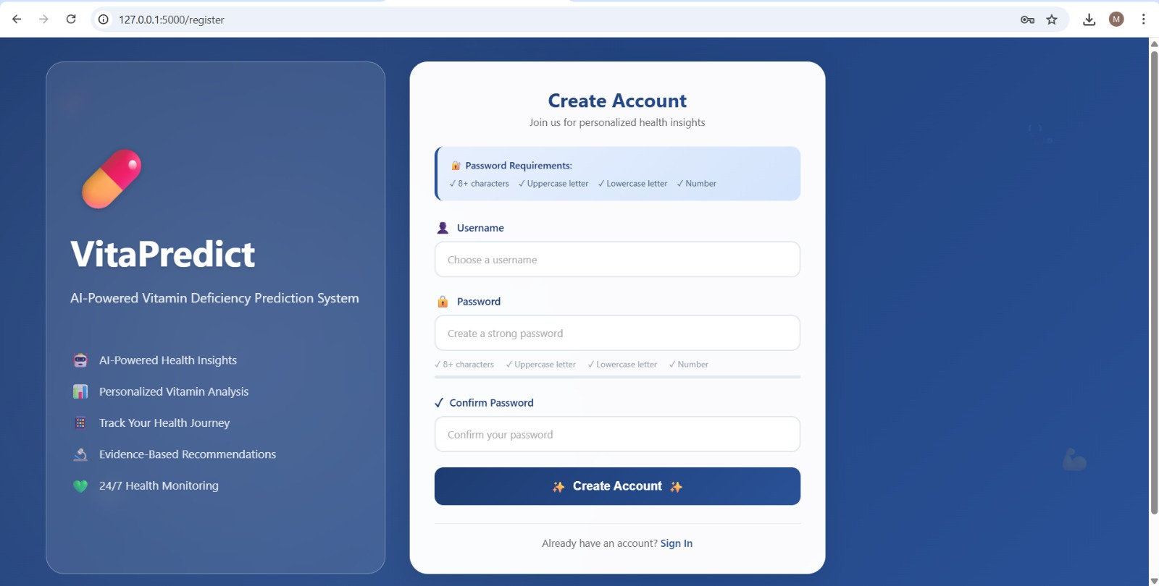

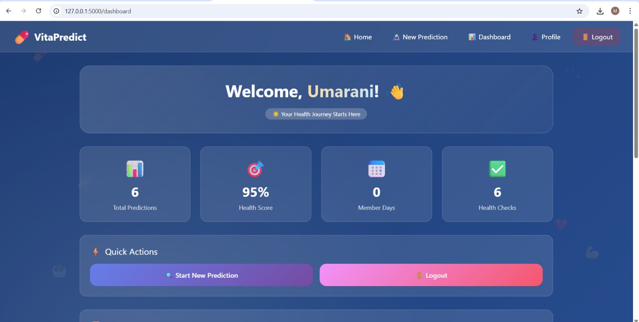
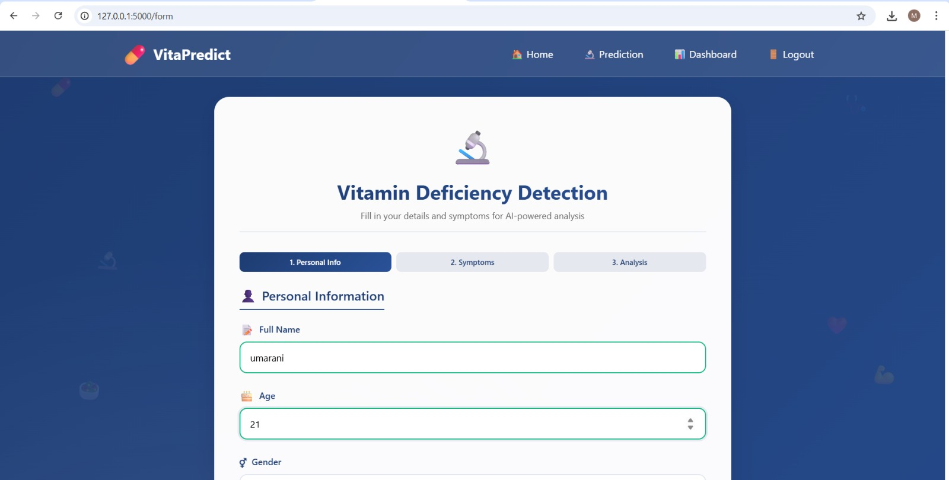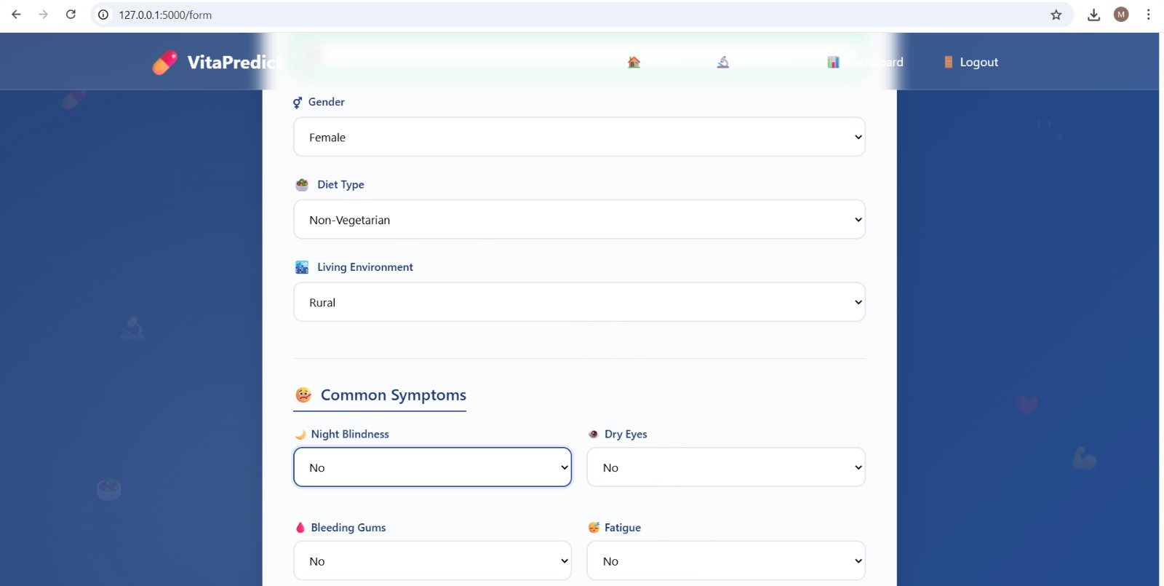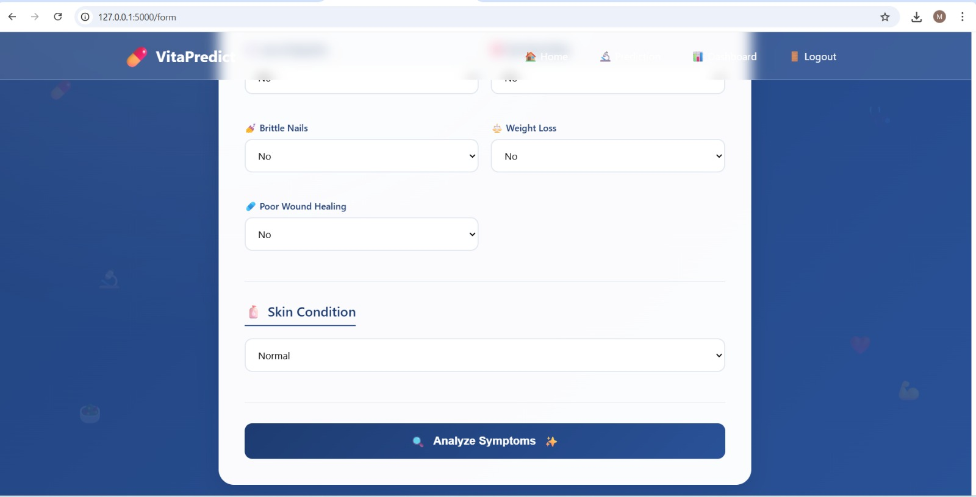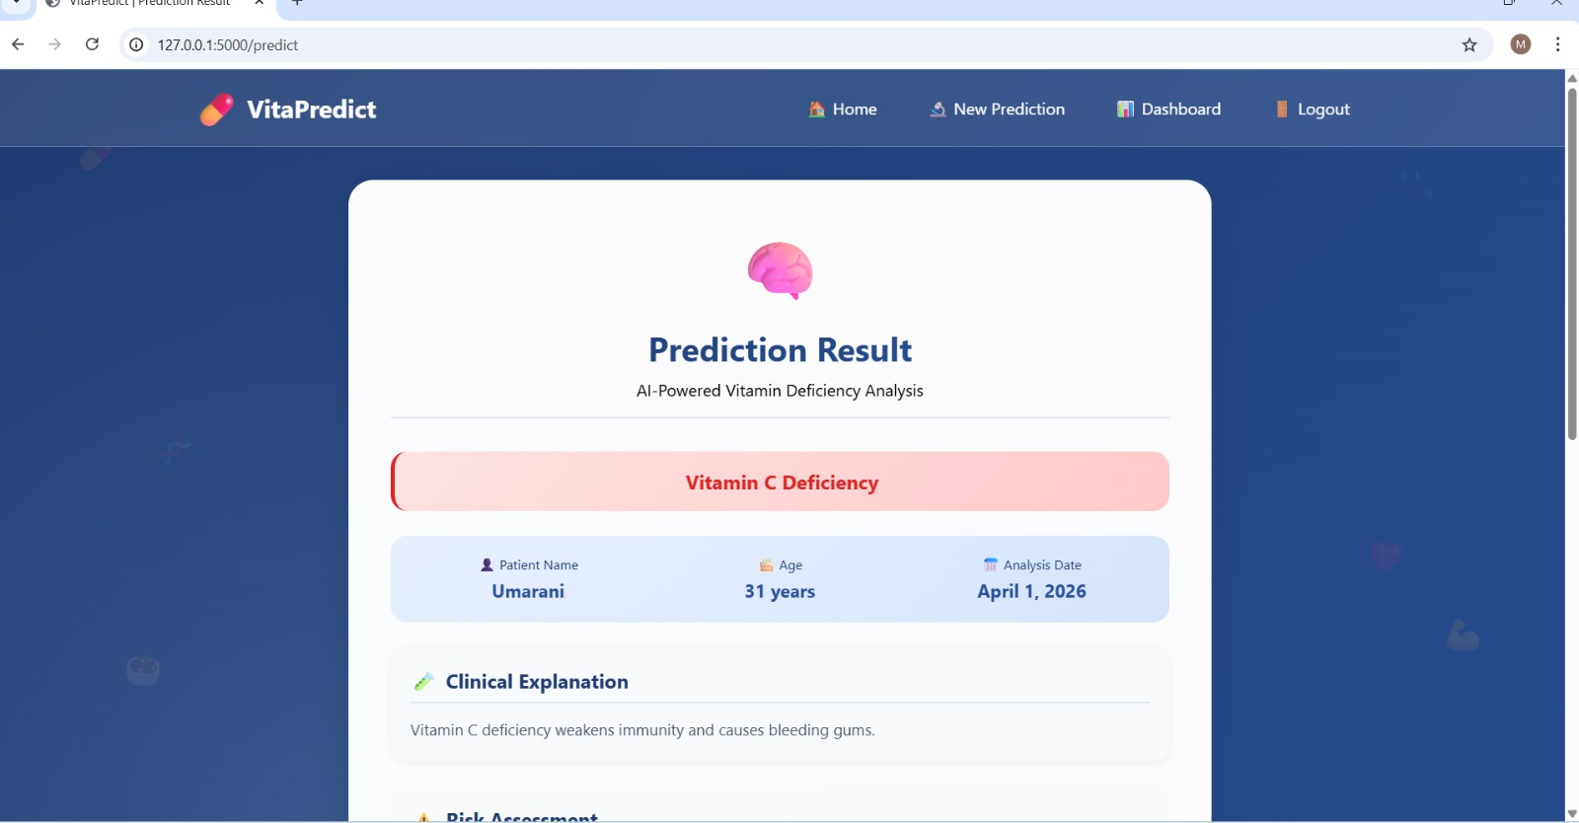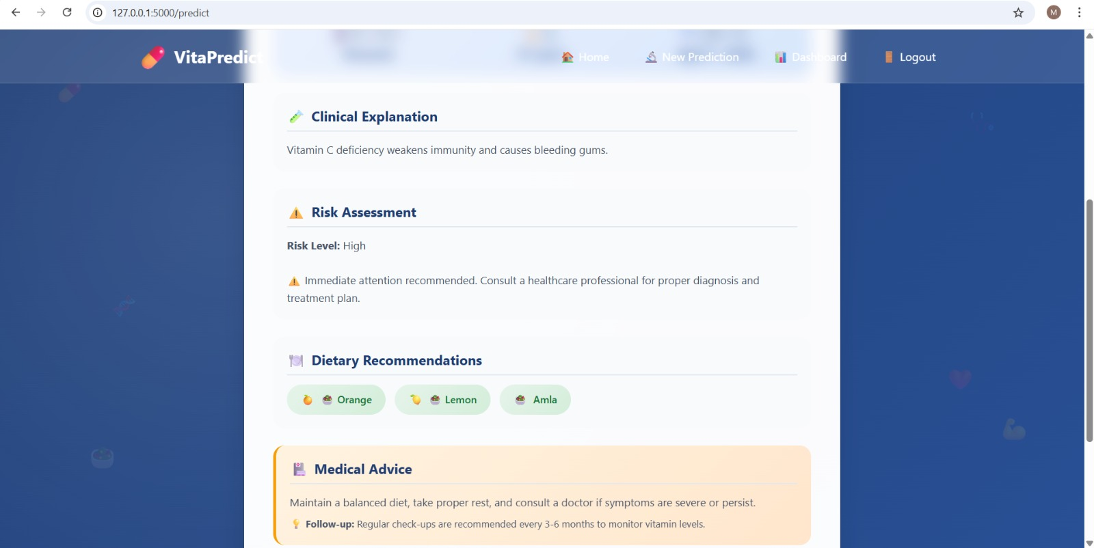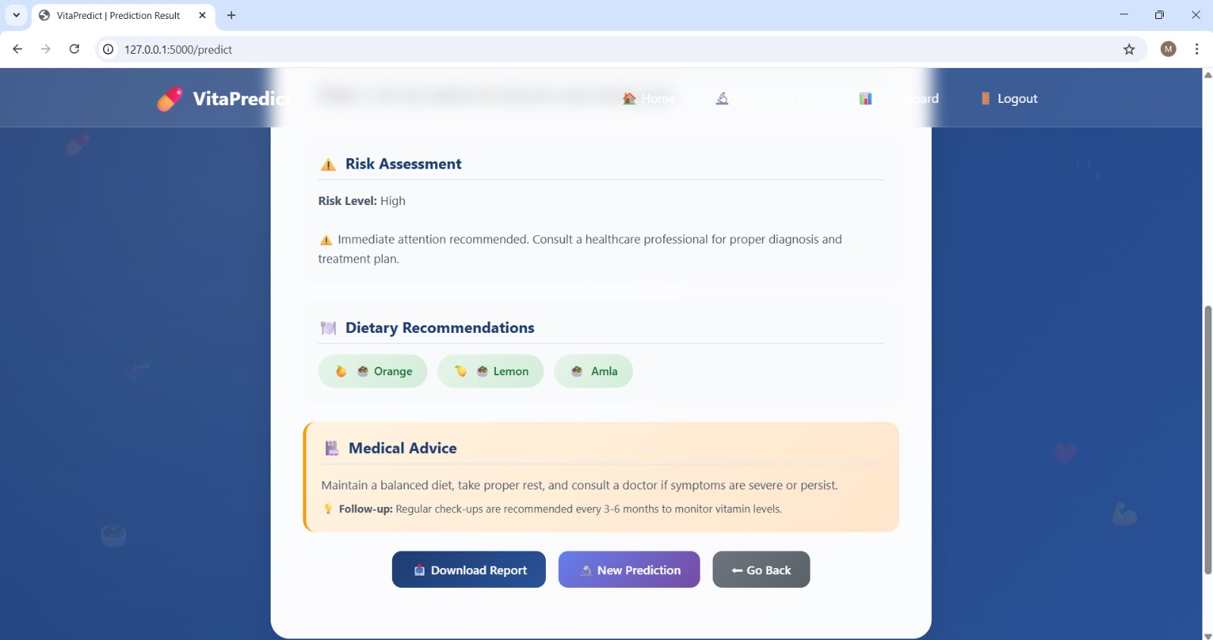
9.CONCLUSION
The Vitamin Deficiency Detection System, VitaPredict, is an effective example of how machine learning can be utilized in solving problems in the healthcare domain. The system helps predict possible vitamin deficiencies based on user-input data regarding symptoms and basic personal information. By utilizing the Random Forest algorithm, it is able to generate reliable predictions for user health conditions.
The application provides a user-friendly interface for users to input their information regarding symptoms and health conditions. The system generates results based on user input, including predicted vitamin deficiencies and basic health recommendations. It helps users become more aware of their health conditions and promotes early preventive measures for maintaining good health.
One of the major advantages of this system is its ability to generate results without the need for medical tests. It helps reduce manual screening and provides useful guidance for users. The combination of web technology and machine learning makes it easier for the system to operate smoothly.
In conclusion, it can be stated that the system effectively fulfills its purpose of providing an efficient and simple means for early detection of vitamin deficiencies. The project can be further enhanced by providing more data for better prediction accuracy and considering other health parameters in the future.

10.REFERENCES
- Machine Learning-Driven Prediction of Vitamin D Deficiency Severity with Hybrid Optimization: Usharani Bhimavarapu, Gopi Battineni, Nalini Chintalapudi
- Machine learning-based prediction of vitamin D deficiency: NHANES 2001-2018: Jiale Guo, Qionghan He, Yehai Li
- Breiman, L. Random Forests. Machine Learning 45, 5–32 (2001).
- Predicting vitamin D deficiency using optimized random forest classifier: Aladeen Alloubani, Belal Abuhaija, M. Almatari, Ghaith Jaradat, Baha Ihnaini
- SmartCare: A Symptoms Based Disease Prediction Model Using Machine Learning Approach: Stepheny Lucas, Mitali Desai, Amisha Khot, Sincee Harriet, Nilambari Narkar

