ONLLINE WALLET MANAGEMENT SYSTEM

Team Members

Umang Agarwal

Utkarsh

INTRODUCTION

This project is aimed at developing an online Wallet Management System. This is a web-based application that can be accessed over the web. This user can Show payment wallet account balance, Transfer funds from one account to another, adding amount to the payment wallet account, Create payment wallet account. This is an integrated system that contains both the user component, and the Admin component. There are features like report generators etc. in this system.

## Functional components of the project

**Admin Operation**

Admin can only approve account.

**User Operation**

User can Show payment wallet account balance, Transfer funds from one account to another, adding amount to the payment wallet account, Create payment wallet account. Status should be approved by Admin.

USE CASE VIEW

CLASS DIAGRAM

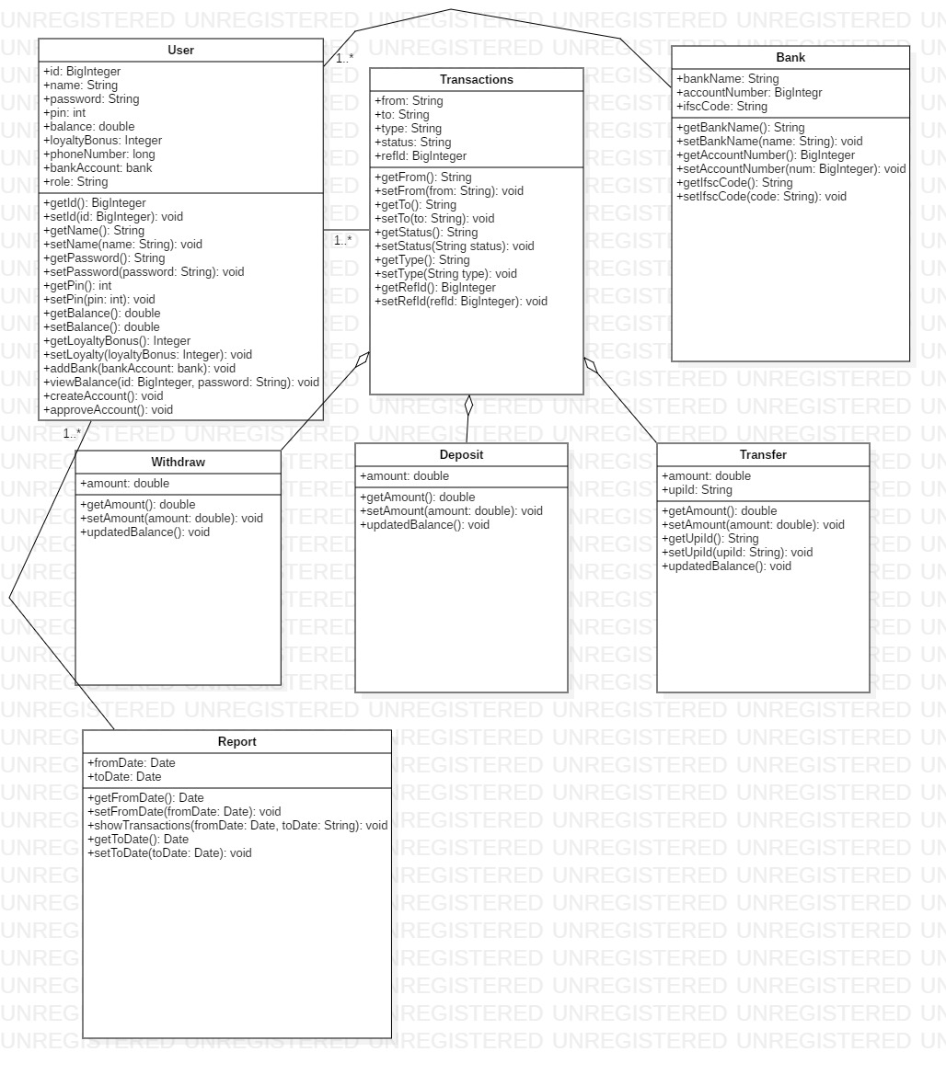

CLASSES AND METHODS

The mobile wallet consists of the following classes:-

1. User – This class stores the details of user who can be customer or administrator.

Attribures –

id : BigInteger

name : String

password : String

pin : Integer

balance : Double

loyaltyBonus : int

phoneNumber : Integer

bankAccount : bank

role : String

Methods:

viewBalance(id : BigInteger, password : String) : void

Users can view their wallet balance by using their credentials.

addBank(bankAccount : bank) : void

Users can add new bank accounts or update existing ones using

this method.

createAccount () : void

This method is used for the creation of new user account.

approveAccount():void

This method is used by the admin to approve a newly created account.

1. Transactions – This class contains the details of transactions.

Attributes:

from : String

to : String

type : String

status : String

refId : BigInteger

1. Bank- This class is used to use new bank accounts by user.

Attributes :

bankName : String

accountNumber : BigInteger

ifscCode : String

1. Withdraw – Object of this class is invoked if transaction type is withdrawal.

Attributes:

amount : Double

Methods:

updatedBalance():void – This method is used to display the updated balance.

1. Deposit : Object of this class is invoked if transaction is of type deposit.

Attributes :

amount : Double;

Methods:

updatedBalance():void – This method is used to display the updated balance.

1. Transfer : Object of this class is invoked when the transaction type is transfer of funds from one account to another.

Attributes :

amount : Double

upiId : String

Methods:

updatedBalance():void – This method is used to display the updated balance.

1. Report : This class is used to get an account statement.

Attributes :

fromDate : Date

toDate : String

Methods:

showTransactions(in fromDate:Date, in toDate:String): void – This method is used to show all the transactions in the specified time period.