# Lab 02

Publishing Ports in Docker

<https://docs.docker.com/get-started/docker-concepts/running-containers/publishing-ports/#use-the-docker-cli>

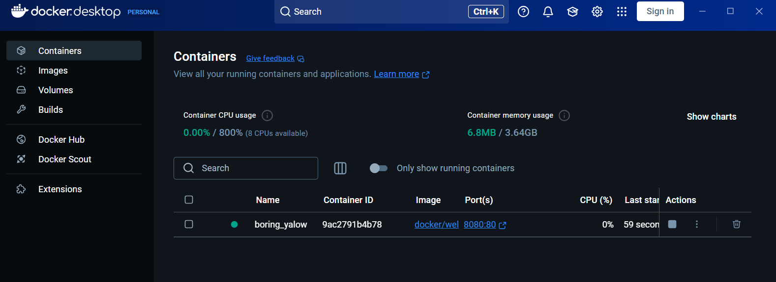

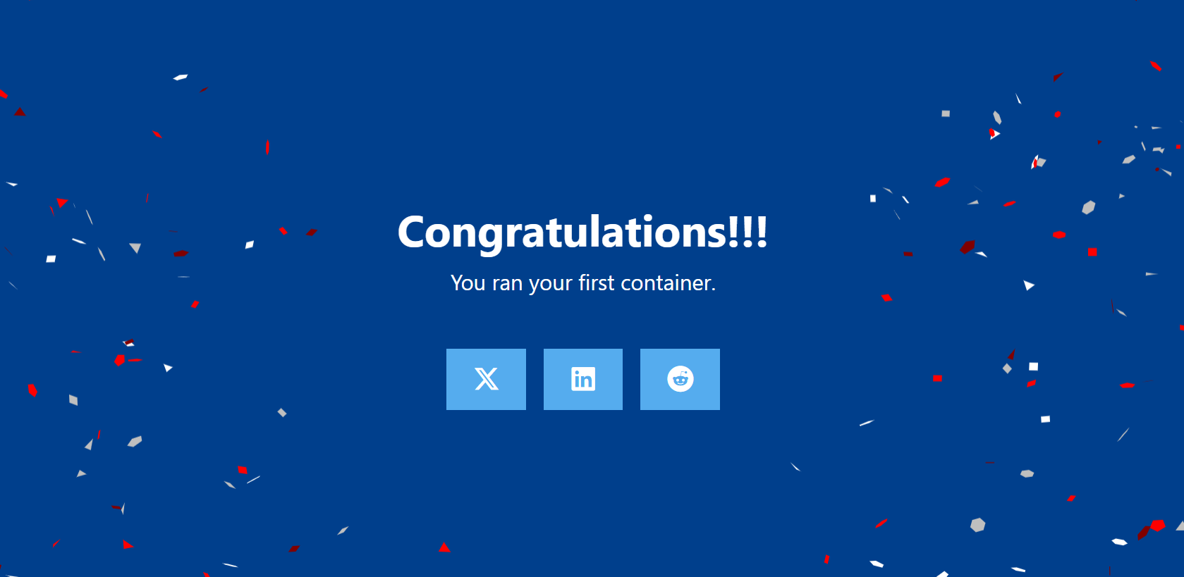

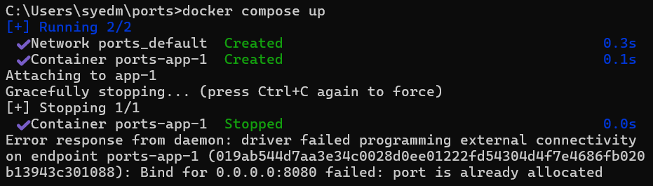

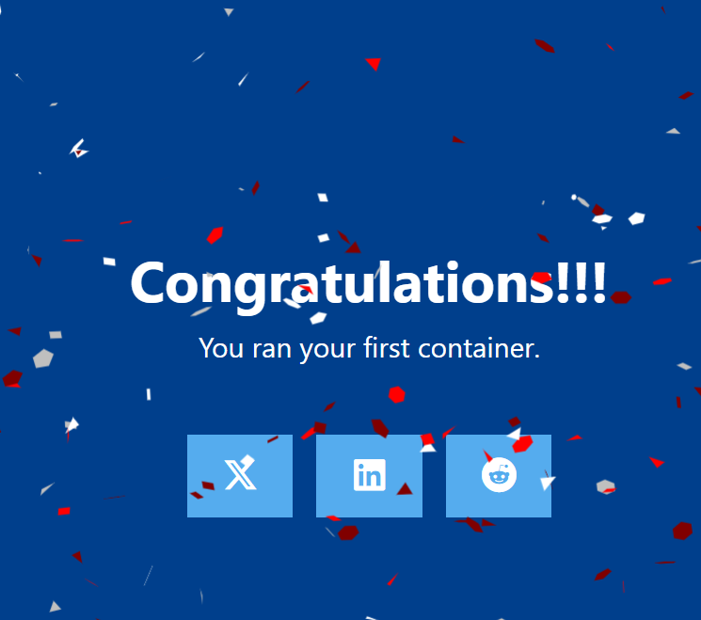

Overriding container defaults

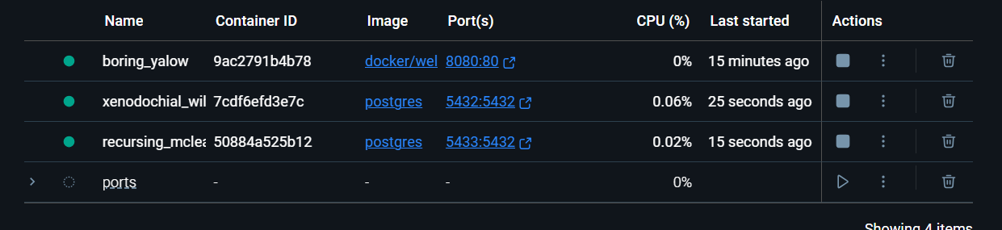

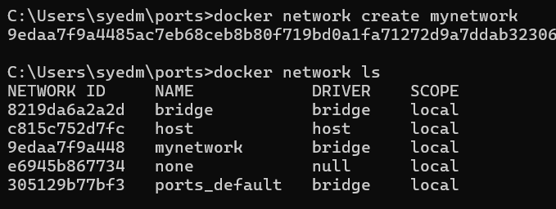

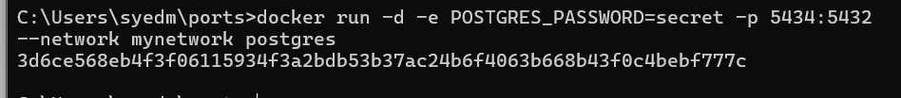



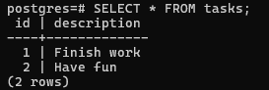

Persisting Container Data



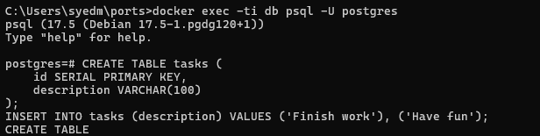



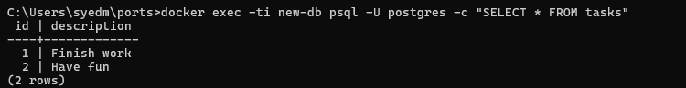

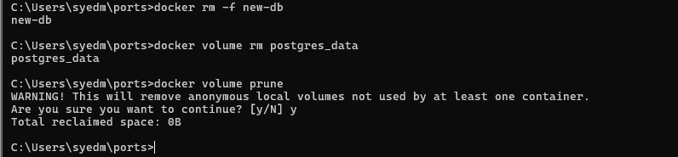

Sharing local files with containers.

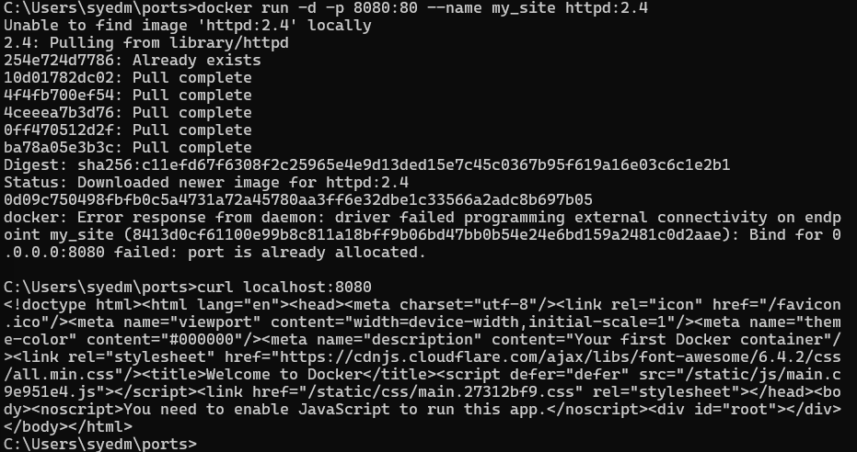

Verified step 3 on tutorial.

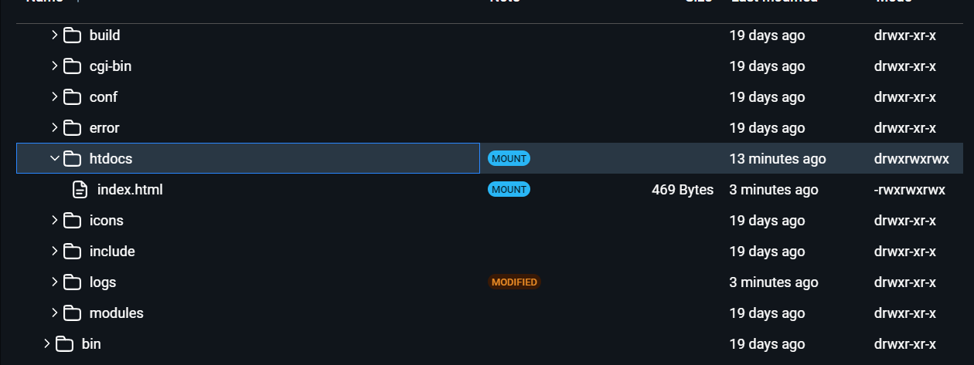

Files successfully mounted.

Multi-Container Application

Steps 1-2 of Build the Images

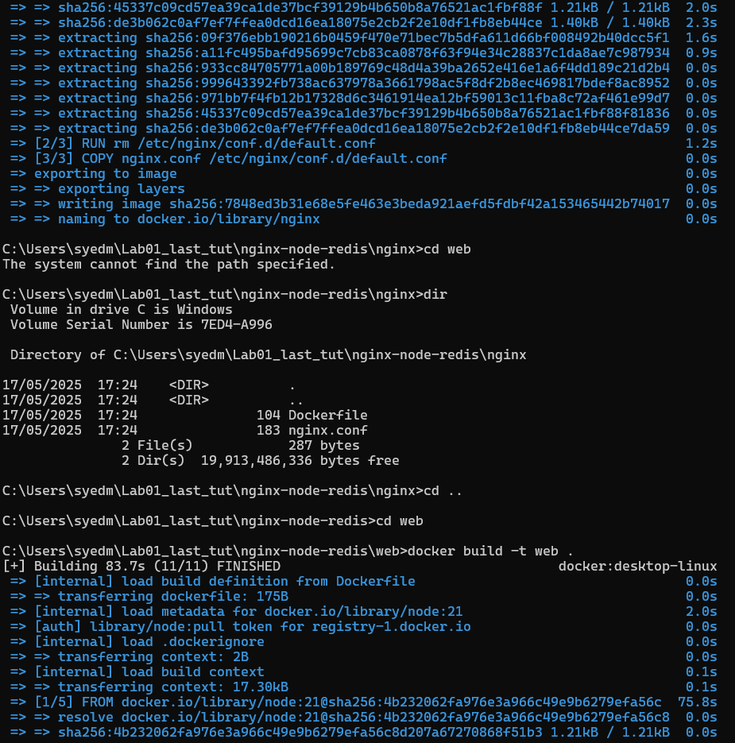

Result for remaining steps in tutorial

