Lab 03

1. MiniKube Setup

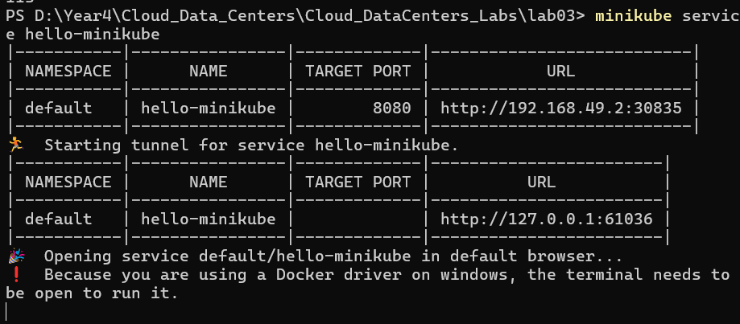

1. Hello MiniKube completed

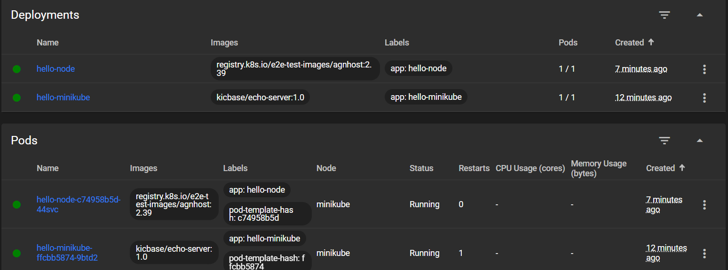

1. Using kubectl to Create a Deployment

