(Student) - Syed Muhammad Umar
south east technological university
tutor - tim casey
Functional Specification

Contents
Introduction 3
Main Functions 3
System Layout 6
ER-Diagram 7
Tables 8
Screens 11
Login Page 11
Change Password 12
Home Page 13
Employees 14
Add Employee Record 15
Edit View Employee 16
Delete Employee 17
Orders 18
Place Order 19
Edit/View Order 20
Cancel Order 21
Sales 22
Add Sales 23
View Sales 24
Refund 25
Delivery 26
Add Delivery 27
View Delivery 28
Reports 29
End Of Day 30
Summary By Date 31
Pay-out 32
Fuel 33
View Fuel Level 34
Order Fuel 35
Drive Off 36
Add Drive Off 37
View Drive Off 38
Delete Drive Off 39
Interview 40

Introduction

A Functional specification for Pak Oil located in Tullow Street, Carlow and requested by the owner Mr Steve Smith. This specification contains the main functions of the original system. All the functionalities have been described with the help of Chart, ER diagram, Database and Graphics screenshots.

Main Functions
- Add, edit and remove all the employee’s data.
- Place, view and cancel all the orders made by the manager.
- Add, View and print receipt of any sale made by an employee.
- Add and view all the deliveries.
- Add, Edit and remove all the drive offs.
- View and print all the sales reports of any particular date or time.
Business Overview
Pak Oil as the name suggest is a Fuel station located in Tullow Street, Carlow. It is own by Mr Steve Smith since 2002. As discussed with Mr Smith he wants to expand his fuel station with a retail shop beside his pump. In this regard he wants a software to make all the work fast, simple and easy to manage.
Currently the petrol station runs 24 hours with the help of 6 employees. As the station will be expanded there will be need for more staff and according to the owners, shop will also be running 24 hours. At the moment owner keeps all the records of employees with them, in office, in form of a file containing hard copy of all the necessary employment documents, which is a tedious way to manage and difficult to take care of all sensitive information of the employees.
According to Mr Smith, he is dealing with only one supplier, who supplies fuel to the company every week and all the order placement is done on phone and payment to supplier through cash which means there is no record keeping of all the stuff bought every week. Although the current order system is operating well, with multiple suppliers the job will be more difficult. As the owner himself will have to make all the orders and keep track of everything which is time consuming and making a simple job difficult.
There is no formal record of all the orders delivered. Suppliers provide a computerized invoice which contains all the products in form of hard copy which again is kept by the owner in form of a file in his office. This practice can also affect the records as it will not be easy to view any particular invoice in case it’s needed.
There is no option for card payment. Pump provides an ATM machine but still the business has been seriously affected by this practice, as people find it frustrating to use ATM machines for small payments and it is not secure as well, especially during night shifts.
The site has various security cameras, and the purpose of those cameras is to keep people away of doing an illegal activity which includes drive offs, which is most common of all the activities. In case of any drive off the manager, who has access to all the cameras look at the footage and try to get the registration number of the particular vehicle and send all the necessary information to Police.
Station has computerized tills, but they are limited to fuel sales. For the retail shop the garage needs a new computerized system to make sales and keep record of everything including fuel.
The manager keep track of fuel level in fuel tanks and report to the owner in case the fuel level is low, with retail shop it will be difficult for a manager to keep track of a large number of products which require any sort of assistance which let the manger know in case a product is running low in stock.

System Layout
login
Employees
Add Employee
Edit/View Employee
Delete Employee
Order
Place Order
Edit/View Order
Cancel Order
Sales
Add Sales
Edit/View Sales
Refund
Deliveries
Add Delivery
View Delivery
Reports
End Of Day
Summary by Date
Pay out
Fuel
View Fuel level
Order Fuel
Drive Off
Add drive off
Edit/View Drive off
Delete Drive off
Change Password
Home

ER-Diagram
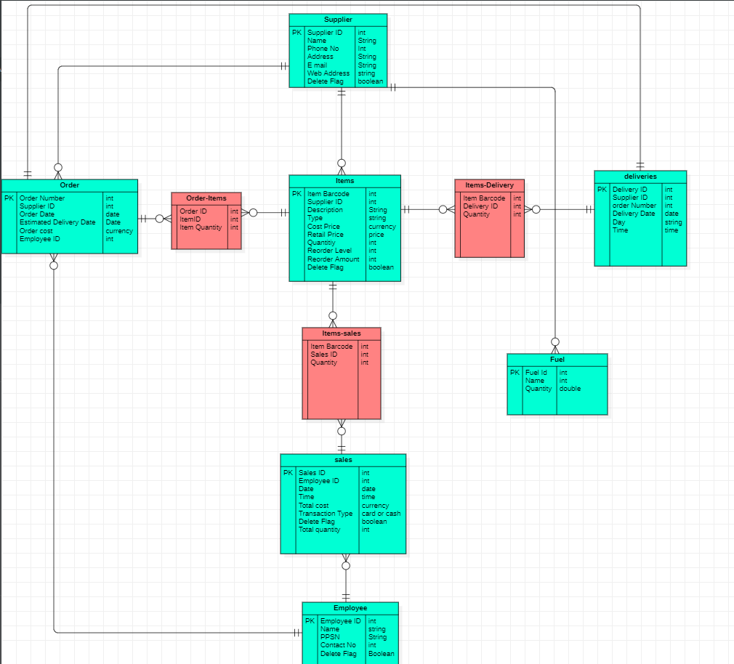

Tables
Order Table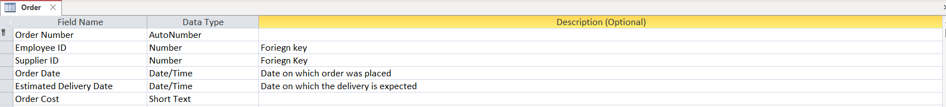
Order-Item Table
Item Table
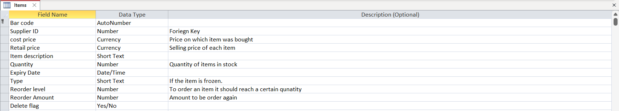
Sales Table
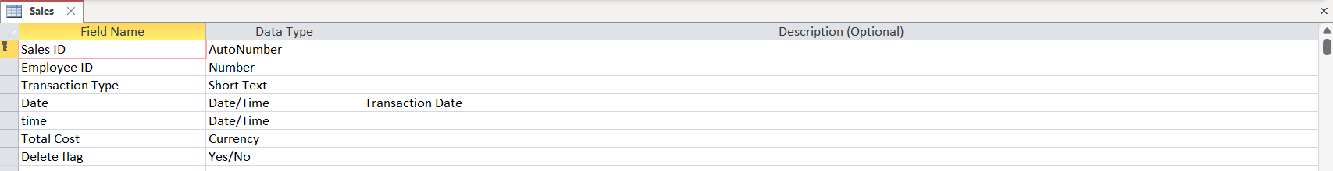
Item-Sales Table

Deliveries Table
Delivery-Item Table

Fuel Table
Employee Table
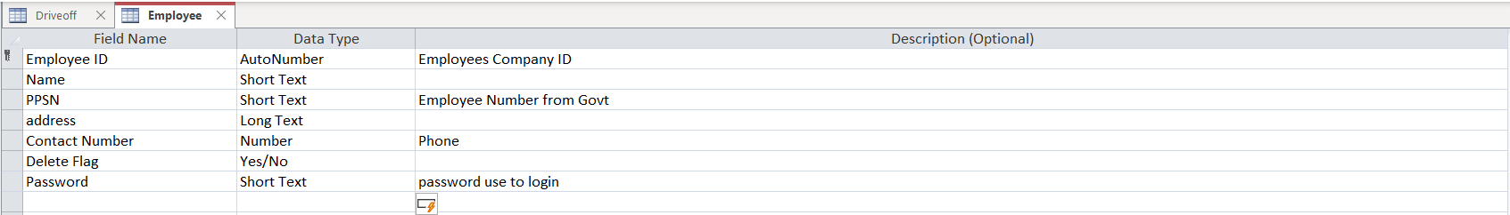
Supplier Table
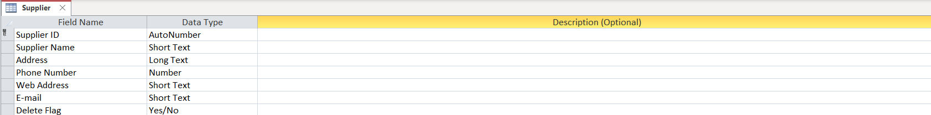

Drive-Off Table
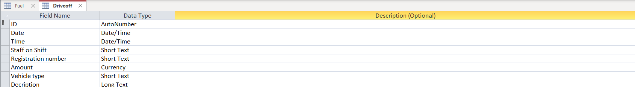

Screens

Login Page

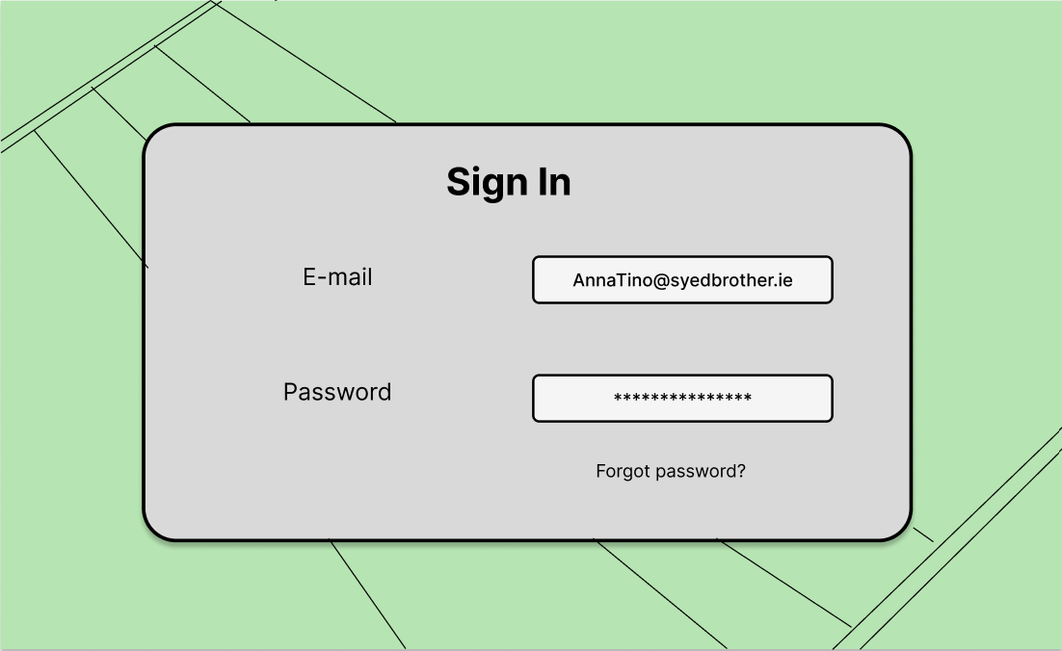
Enter
Screen Access: Login Screen
Purpose: Allow user to login.
Table Processing: Employee Table queried.

Change Password

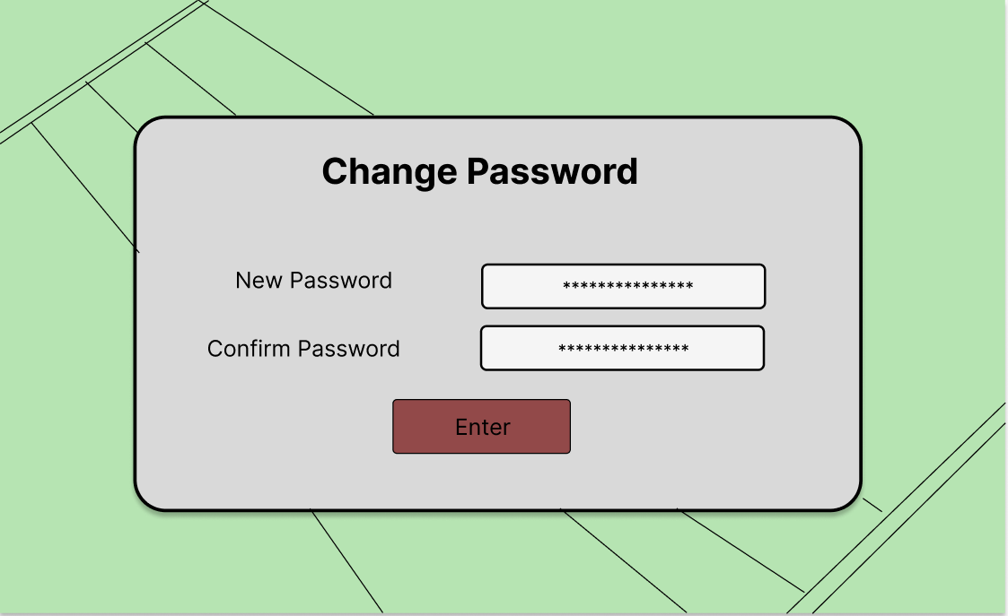

Screen Access: login Screen Change Password.
Purpose: Allow user to change Password.
Table Processing: Employee Table is updated.

Home Page

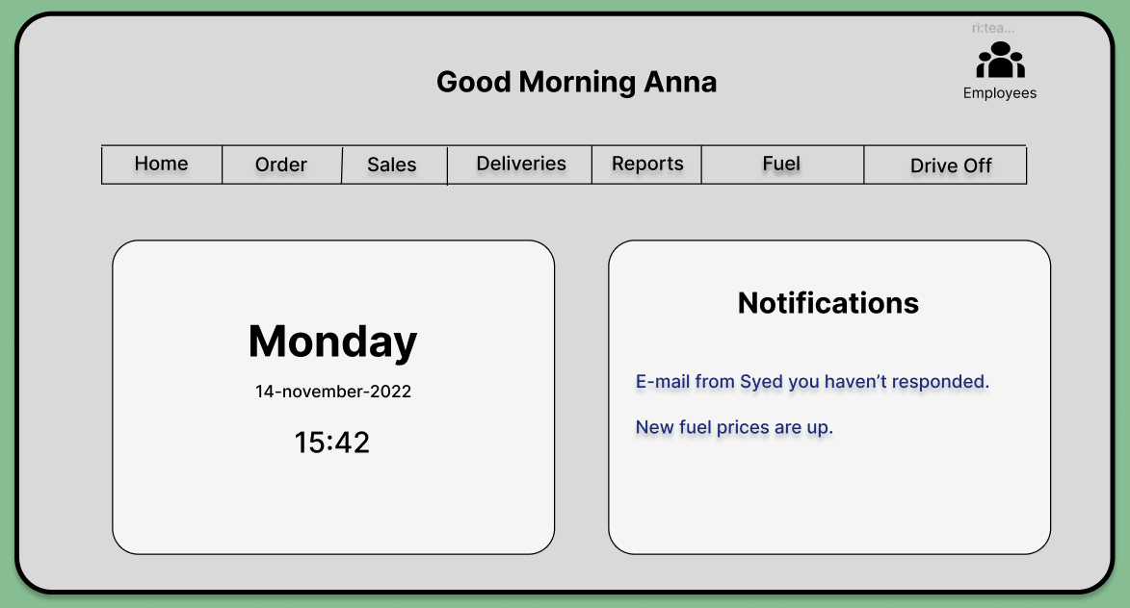

Screen Access: login Screen Home Screen.
Purpose: Home Screen.
Table Processing: Employee table queried.

Employees
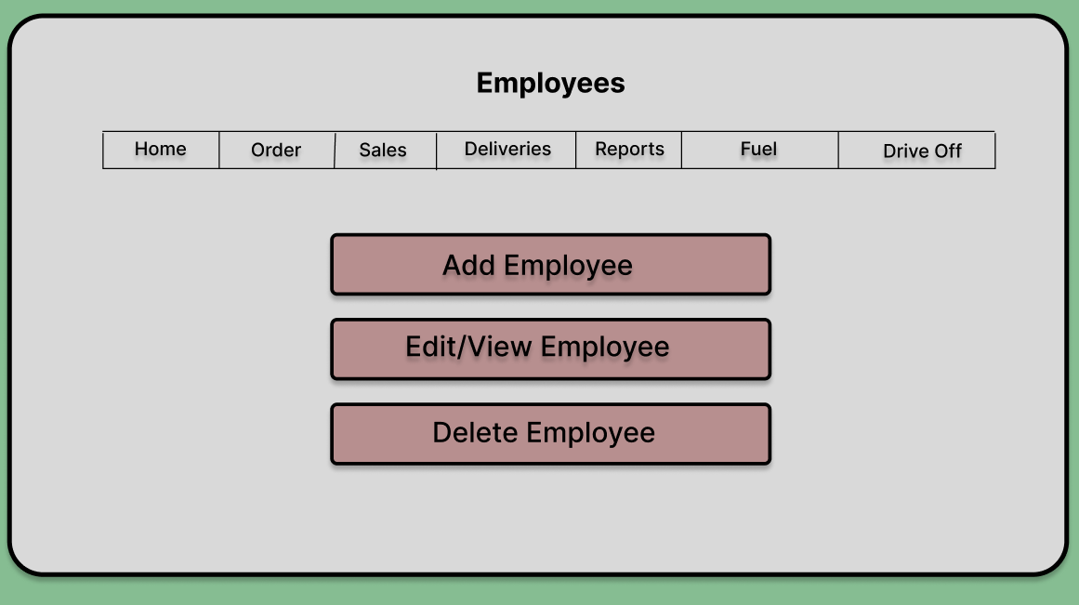

Screen Access: login Screen Home Employees.
Purpose: View User all the tasks available.
Table Processing: N/A.

Add Employee Record

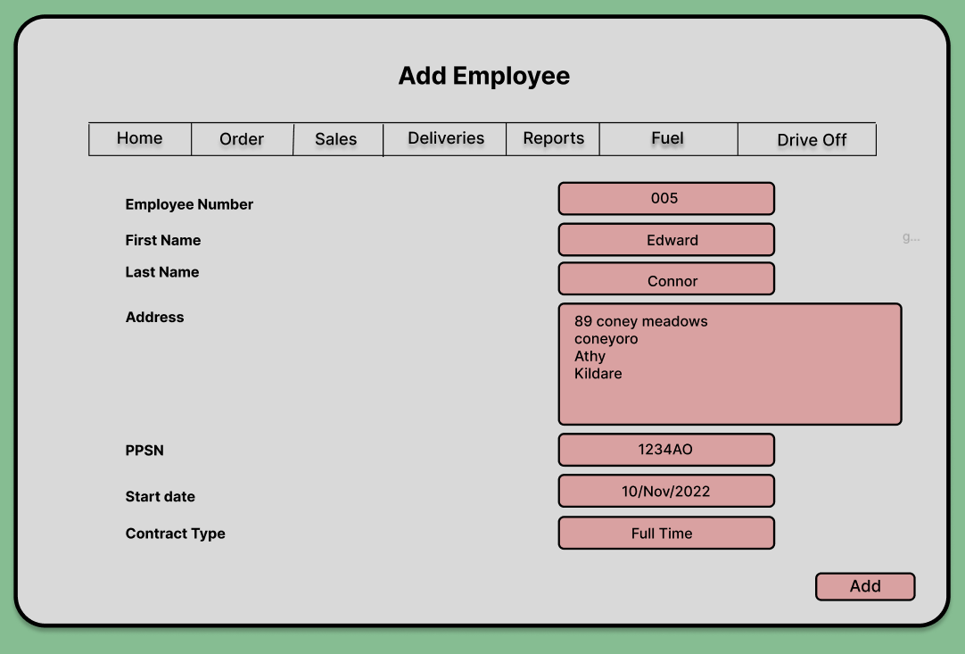
Screen Access: login Screen Home Employees Add Employee.
Purpose: Allow user to add Employees.
Table Processing: New record added to Employee Table.

Edit View Employee

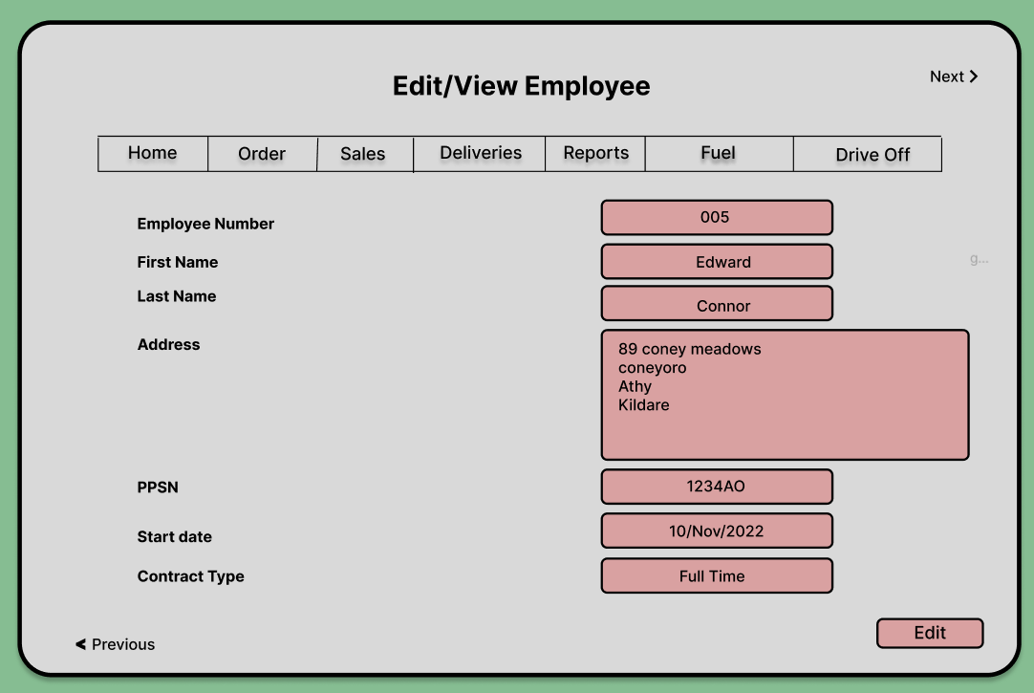
Screen Access: login Screen Home Employees Edit/view Employee.
Purpose: Allow user to view or edit data related to all Employees by searching their name or id.
Table Processing: Employee Table queried or updated.

Delete Employee

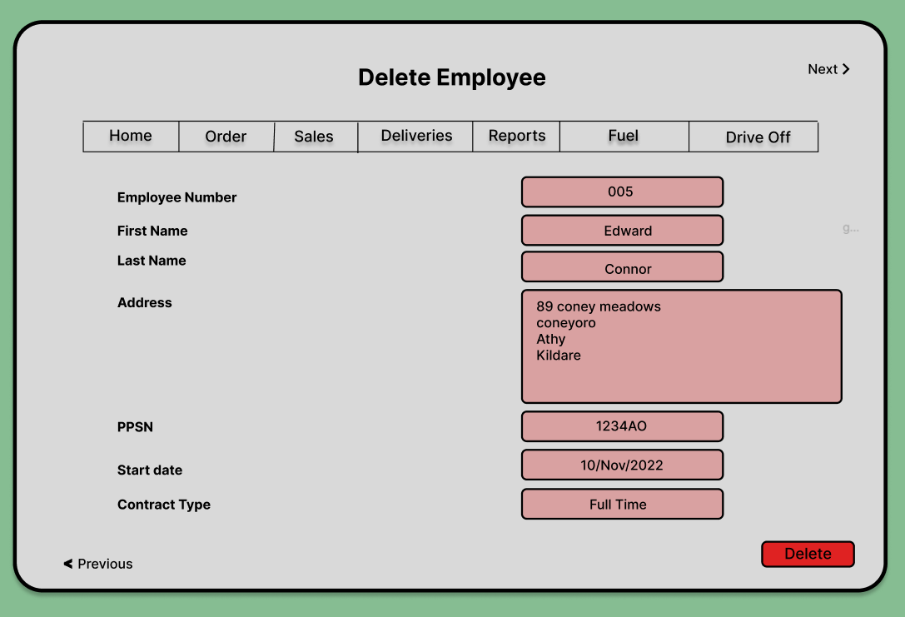
Screen Access: login Screen Home Employees Delete Employee.
Purpose: Allow user to delete Employee’s data by searching their name or id.
Table Processing: Employee Table will be updated.

Orders

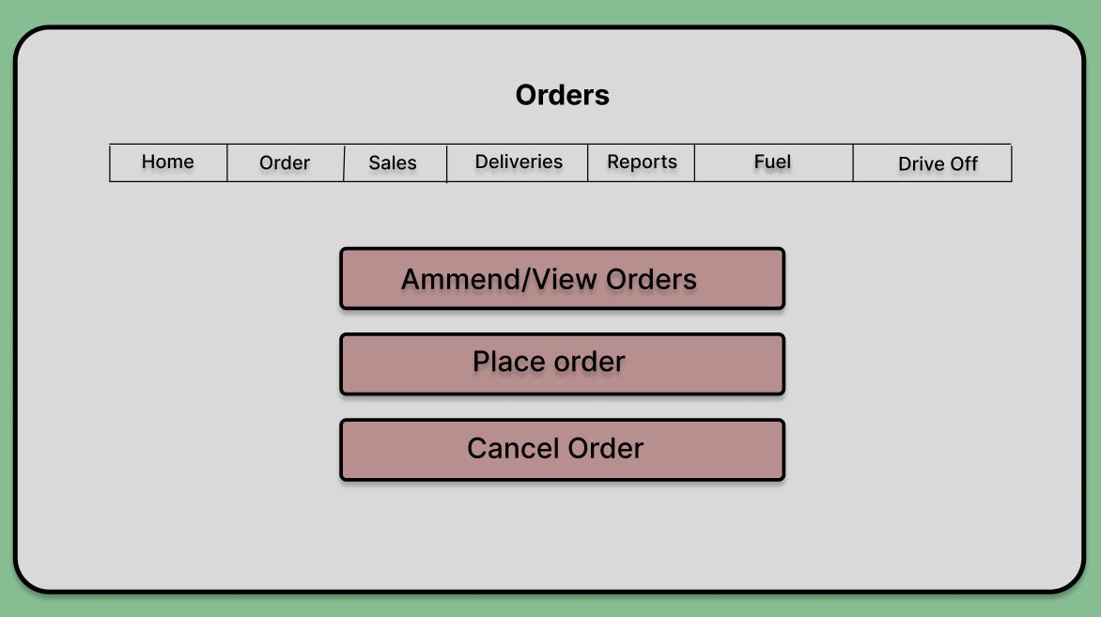

Screen Access: login Screen Home Order
Purpose: Allow user to view all the tasks related to the orders.
Table Processing: N/A.

Place Order

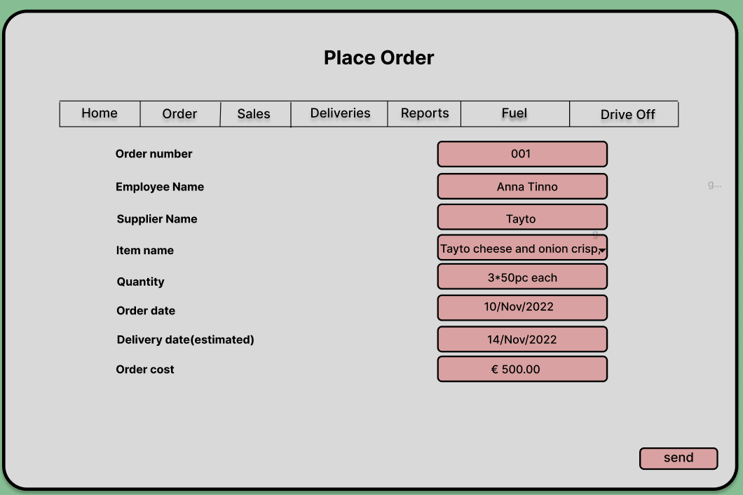
Screen Access: login Screen Home Order Place order
Purpose: Allow user to place orders.
Table Processing: Order table, Supplier table, Item table new record added.

Edit/View Order

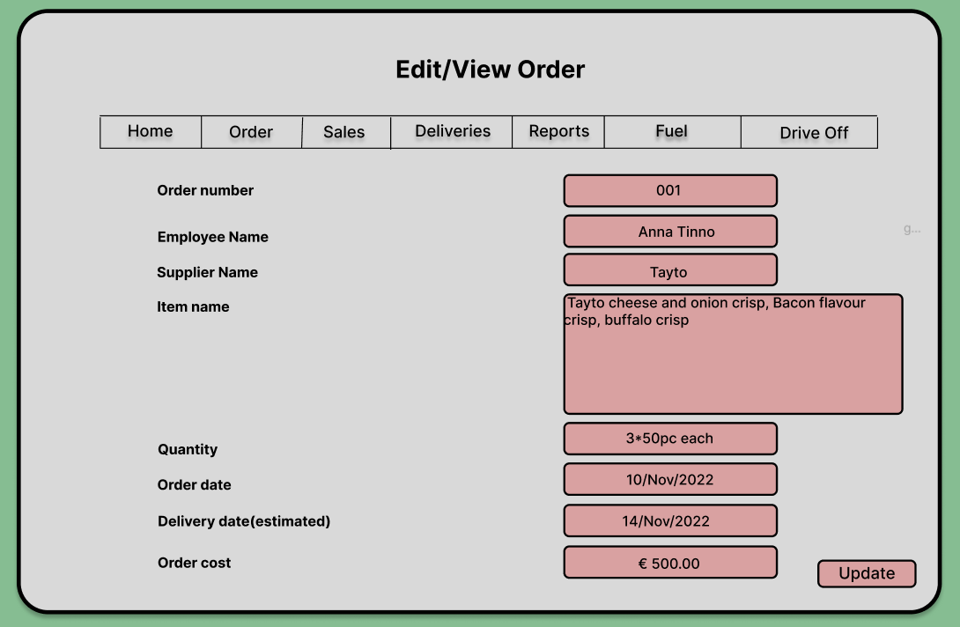
Screen Access: login Screen Home Order Edit/View order
Purpose: Allow user to edit or view placed orders by searching the suppliers name.
Table Processing: Order table and Item table updated, Employee table and Supplier table queried.

Cancel Order

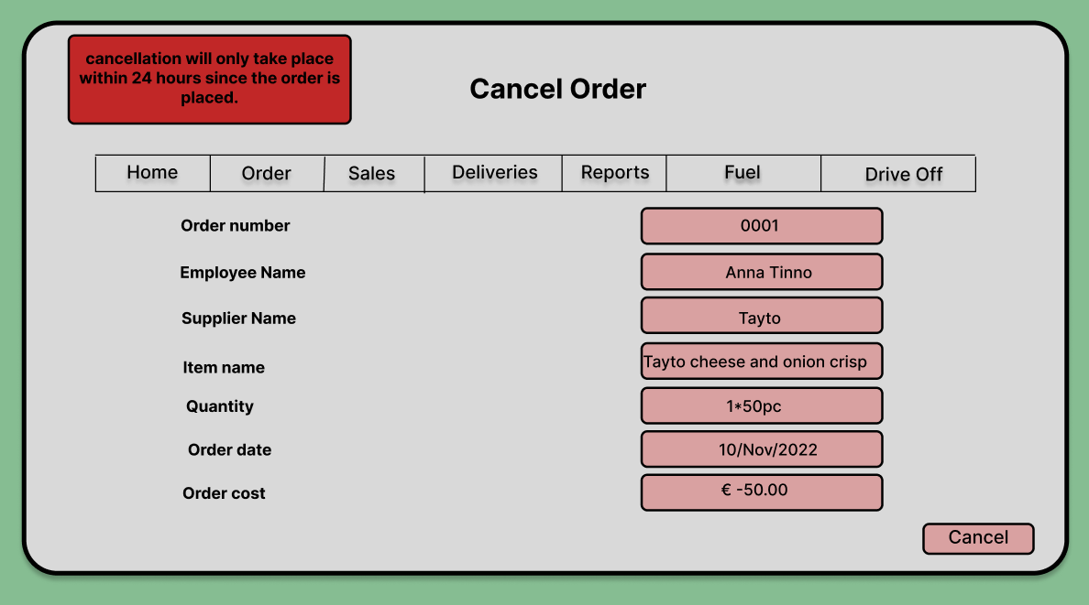

Screen Access: login Screen Home Order Delete order
Purpose: Allow user to delete placed order. If the condition is met.
Table Processing: Order table and Item table is updated, Employee table and supplier table is updated.

Sales

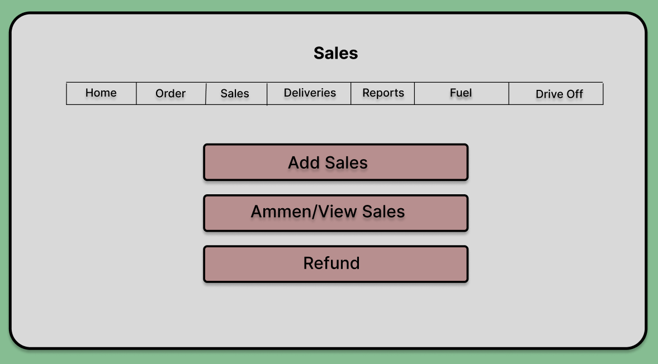
Screen Access: login Screen Home Sales
Purpose: Allow user to do tasks related to sales.
Table Processing: N/A.

Add Sales

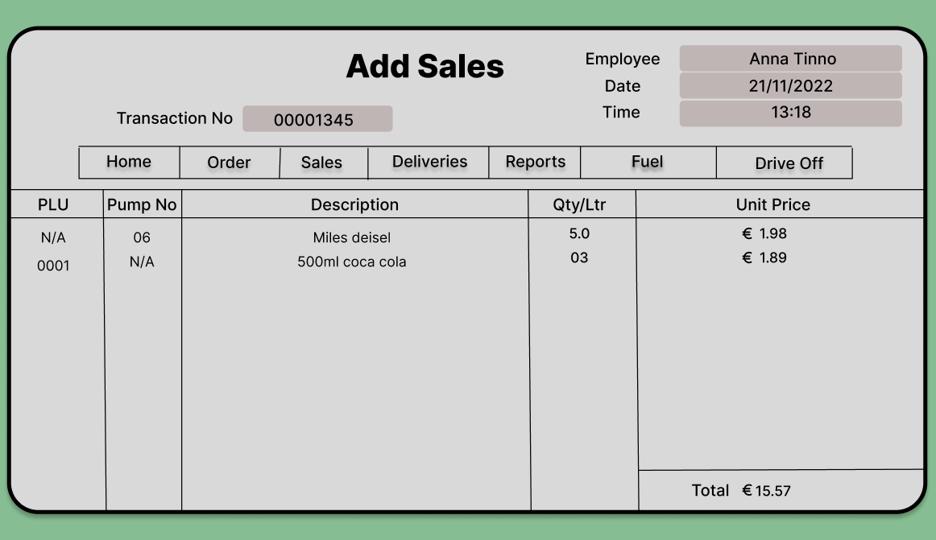
Screen Access: login Screen Home Sales Add Sales
Purpose: Allow user to add sales.
Table Processing: Sales table and Items table is updated, Employee table is queried.

View Sales

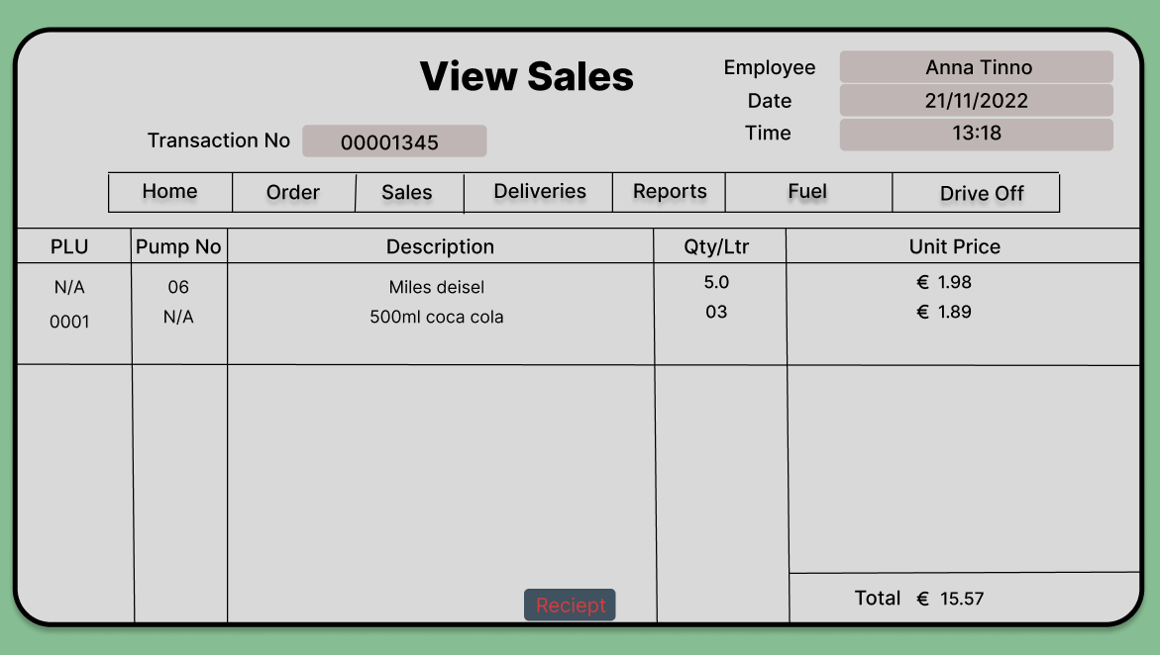
Screen Access: login Screen Home Sales View Sales
Purpose: Allow user to view sales and print receipt for a particular date or time.
Table Processing: Sales table, Items table and Employee table queried.

Refund

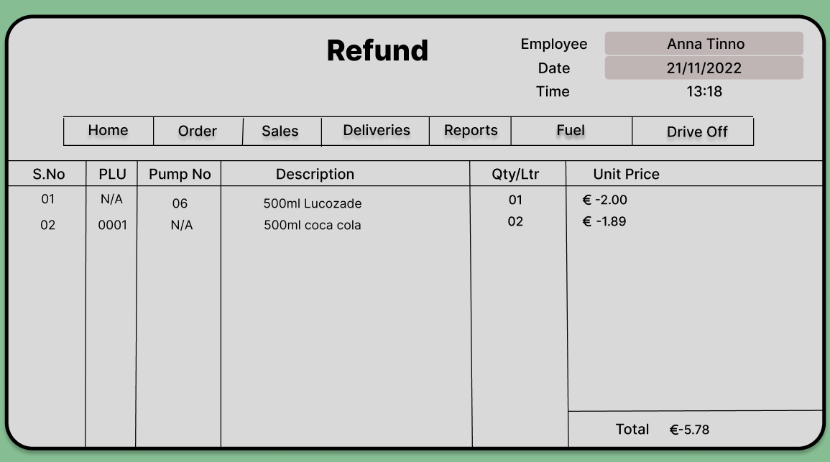
Screen Access: login Screen Home Sales Refund.
Purpose: Allow user to perform refunds by re scanning the bought items.
Table Processing: Sales table and Items table updated, Employee table is queried.

Delivery

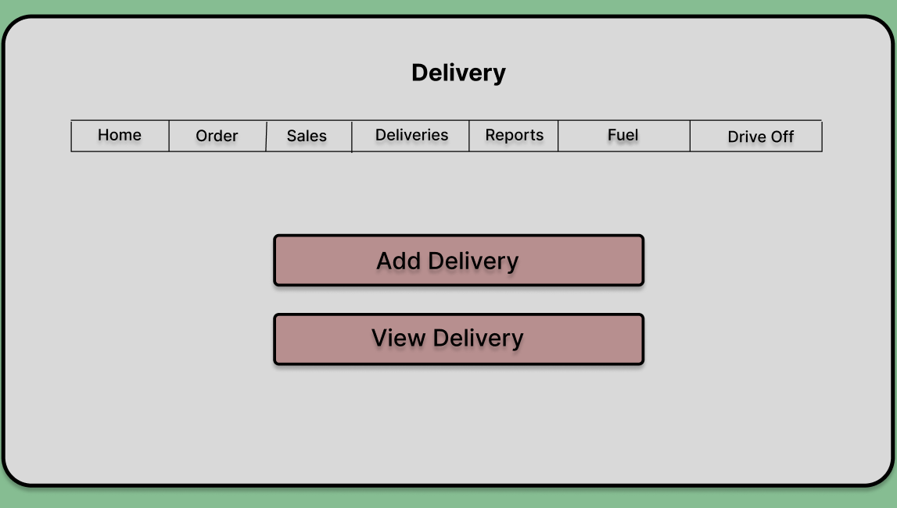
Screen Access: login Screen Home Delivery
Purpose: Allow user to perform tasks related to delivery.
Table Processing: N/A

Add Delivery

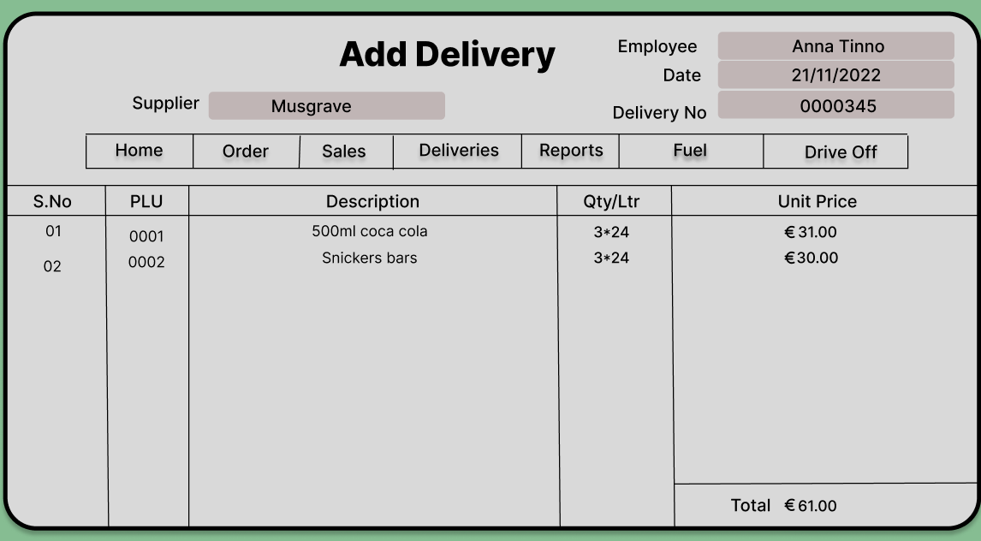
Screen Access: login Screen Home Sales Add Delivery.
Purpose: Allow user to add items delivered.
Table Processing: Delivery table is updated Item table, supplier table, and Employee table is queried.

View Delivery

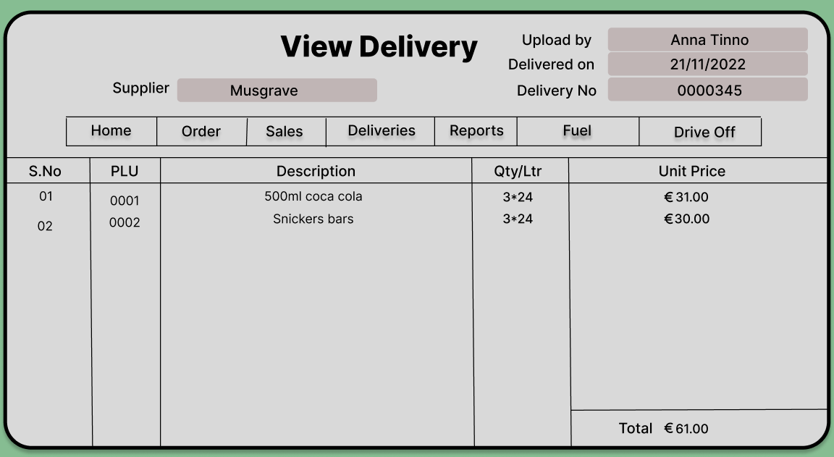
Screen Access: login Screen Home Sales View Delivery.
Purpose: Allow user to view items delivered by inserting the date.
Table Processing: Delivery table, Item table and Employee table queried.

Reports

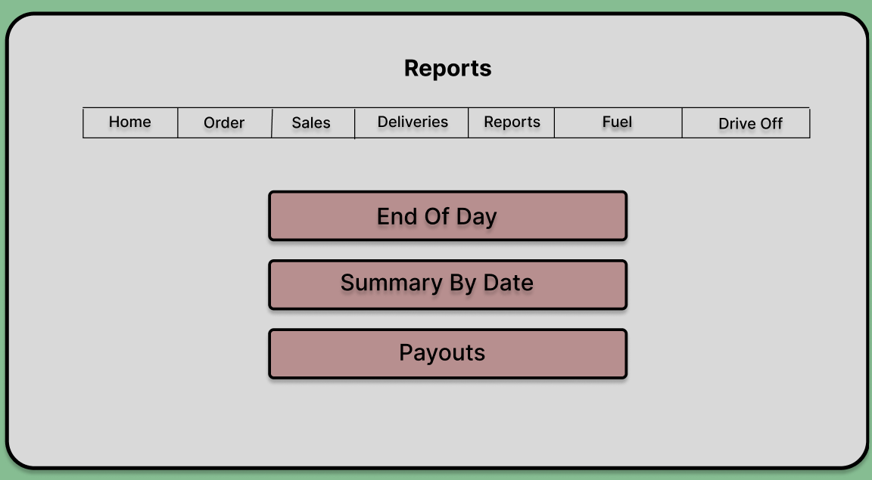
Screen Access: login Screen Home Reports
Purpose: Allow user to perform tasks related to reports.
Table Processing: N/A.

End Of Day

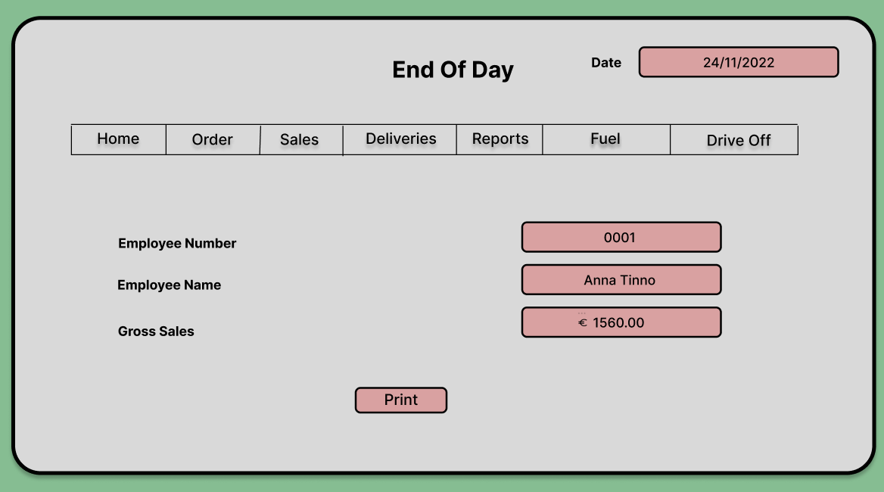
Screen Access: login Screen Home Reports End of day.
Purpose: Allow user to print all the sales report of the day after each day.
Table Processing: Item table and Sales table queried.

Summary By Date

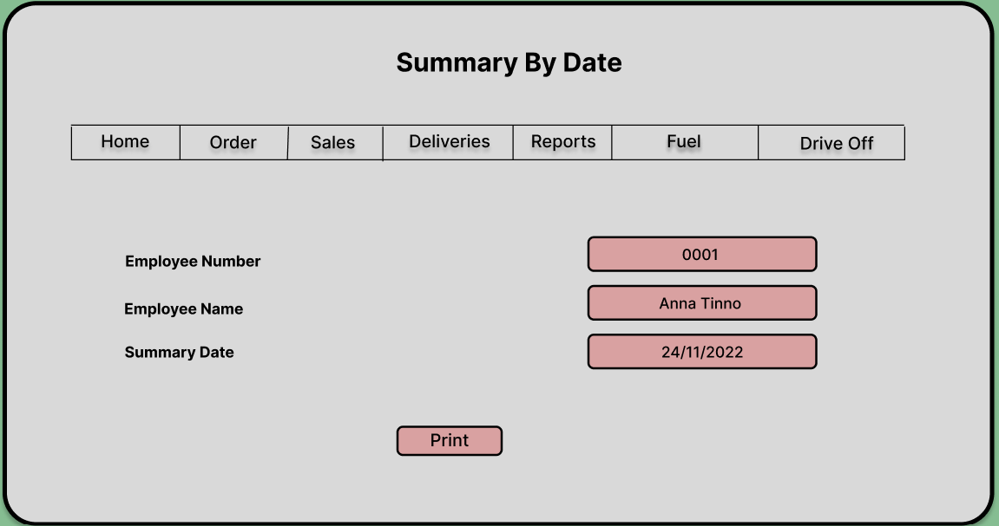
Screen Access: login Screen Home Reports Summary by date.
Purpose: Allow user to print the sales report of a particular day by inserting date.
Table Processing: Item table and Sales table queried.

Pay-out

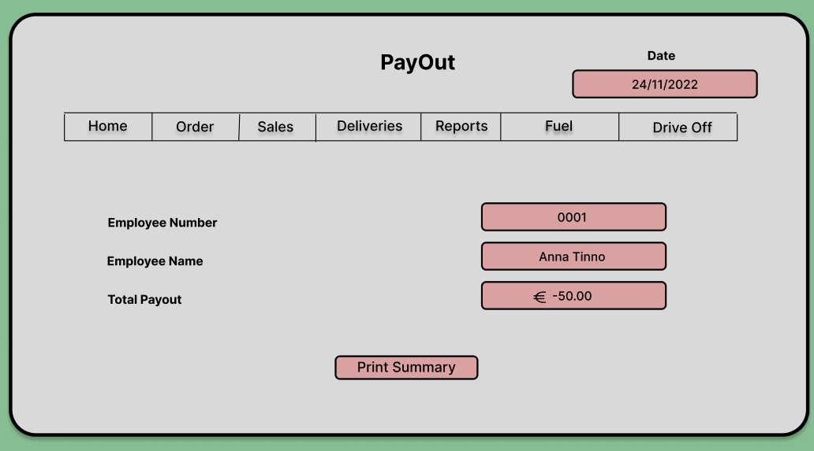
Screen Access: login Screen Home Reports End of day.
Purpose: Allow user to print all the refunds report including lotto wins and credits.
Table Processing: Item table and Sales table queried.

Fuel

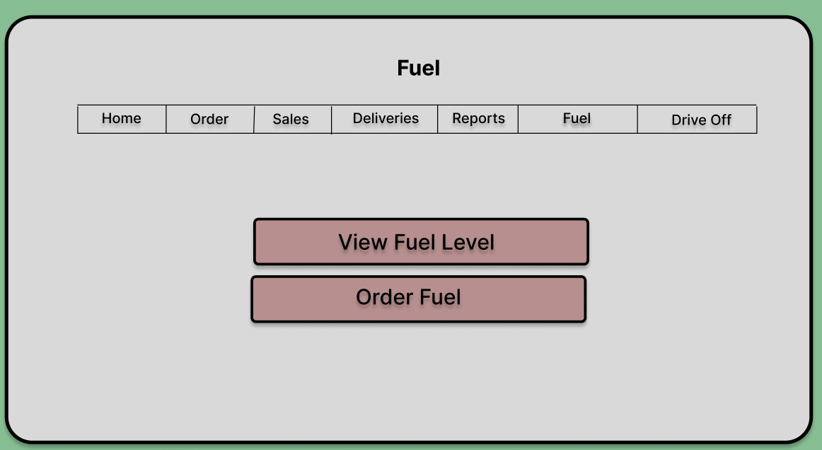
Screen Access: login Screen Home Fuel.
Purpose: Allow user to perform task related to fuel.
Table Processing: N/A.

View Fuel Level
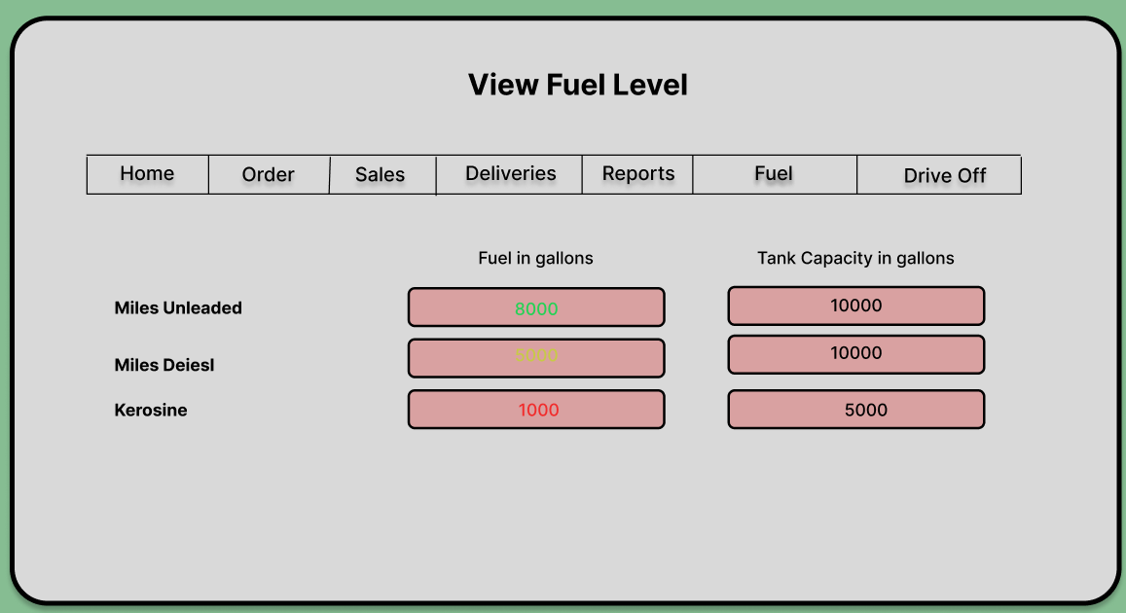

Screen Access: login Screen Home Fuel View Fuel Level.
Purpose: Allow user to View fuel level in underground tanks.
Table Processing: Fuel table queried.

Order Fuel

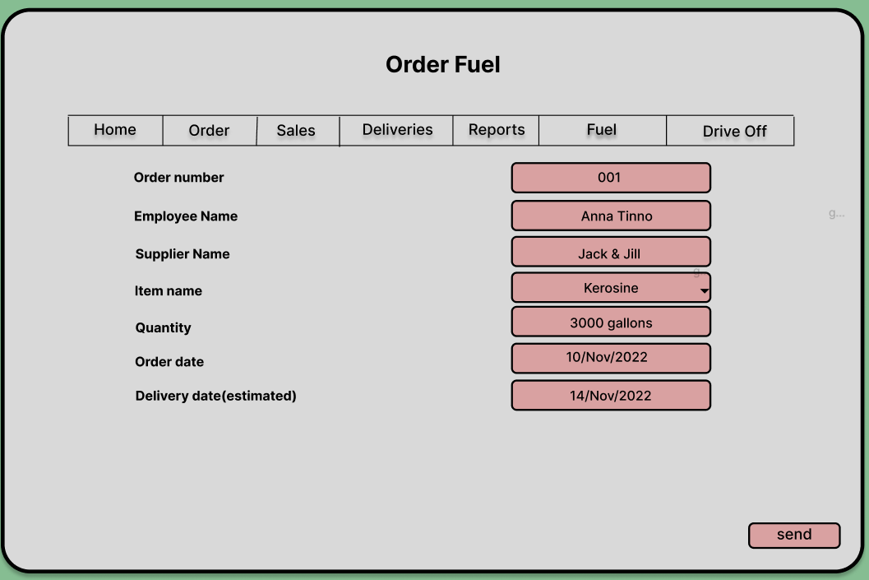
Screen Access: login Screen Home Fuel Order Fuel.
Purpose: Allow user to Order fuel.
Table Processing: Supplier table, Employee table and Fuel table updated. , Order table is updated.

Drive Off

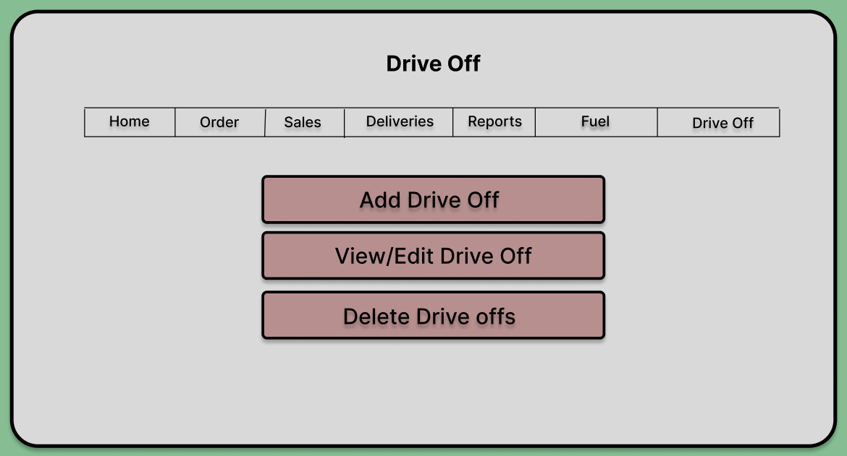
Screen Access: login Screen Home Drive Off.
Purpose: Allow user to perform task related to drive offs.
Table Processing: N/A

Add Drive Off

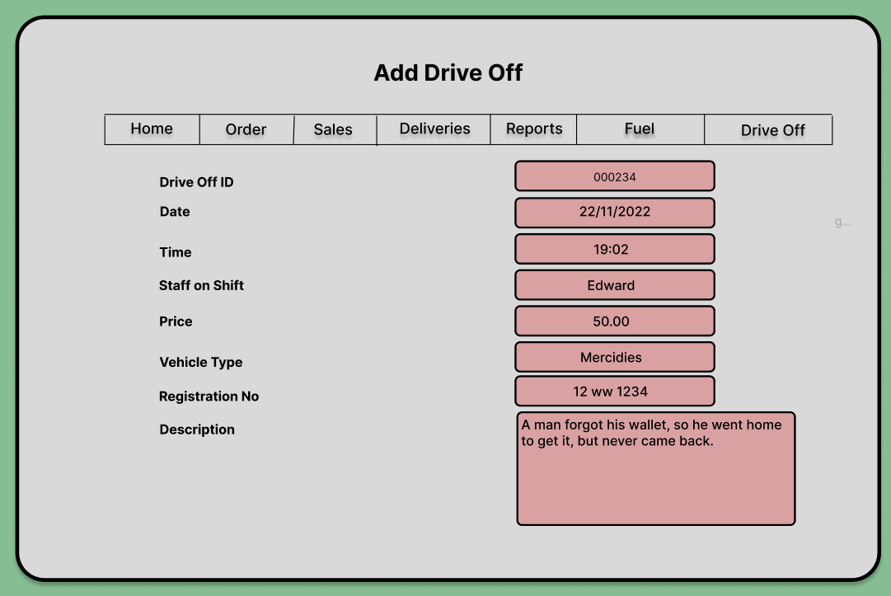
Screen Access: login Screen Home Fuel Add drive off.
Purpose: Allow user to add drive offs.
Table Processing: Drive off table is updated, Employee table is queried.

View Drive Off

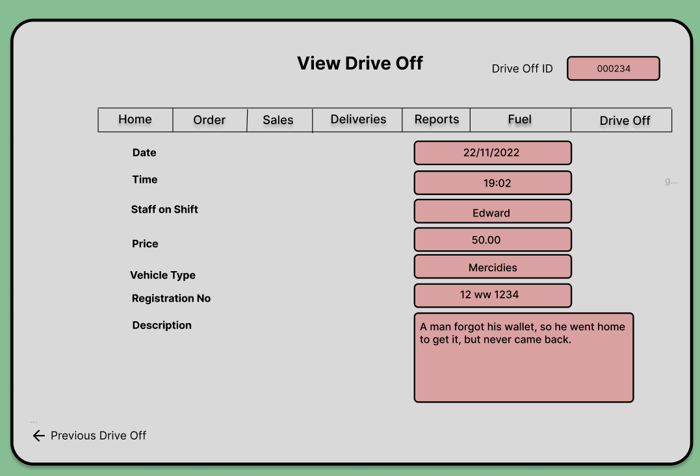
Screen Access: login Screen Home Fuel View Drive offs.
Purpose: Allow user to view drive offs by inserting date and time.
Table Processing: Drive off table, and Employee table queried.

Delete Drive Off

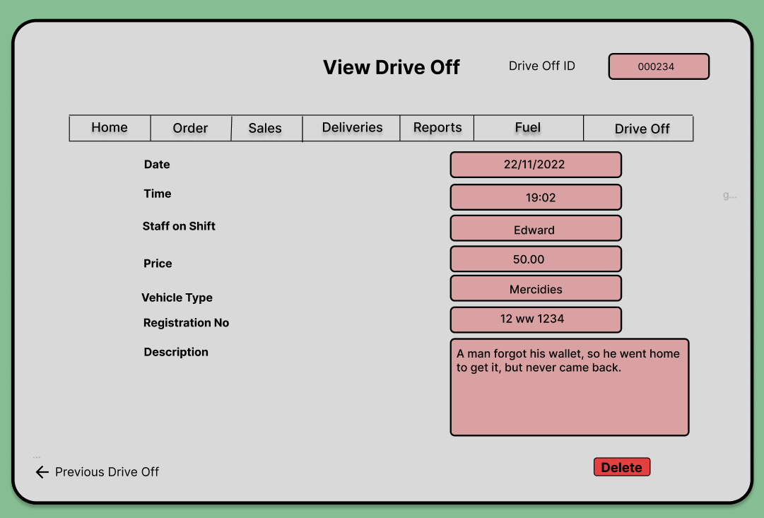
Screen Access: login Screen Home Fuel View Fuel Level.
Purpose: Allow user to Delete drive offs.
Table Processing: Drive off table updated, Employee table is queried.
Appendices
This is an interview took place with Mr. Steve Smith on 20 October 2022. In this interview we discussed about the new software for his shop and all the difficulties he faces with the current system.

Interview
Q. How long have you been using the current System?
I bought this station in 2002 and this system was working even before I bought, since then and before now I never felt that I need a new system.
Q. Why you need a new system?
I am at the moment planning to expand my business by adding a retail shop with it, as I have observed it is a good profitable business. That’s why I am looking for a completely new system.
Q. What do you expect from this system?
The main thing I consider about my business is that it should be reliable and for a reliable business you need a system which never let you down. I want a system which is safe, reliable, with less mechanical flaws, and most importantly it should be easy to use.
Q. As the database is concerned how do you keep record of everything?
At the moment my all data is paper based which is very hard to organise and time consuming. I want this system to store all my data in a database which is easy to access, secure and more reliable.

