**System Design**

**Document**

*Piece of Eden Rentals*

**Client**

John Winder

**Team 4**

Stephen Masterson

Rachel Cohen

Nicholas Keckeisen

Eric Forte

Matthew Walker

3/5/2016

*Piece of Eden Rentals*

System Design Document

**Table of Contents**

1. Introduction

1.1 Purpose of This Document

1.2 References

1. System Architecture

2.1 Architectural Design

2.2 Decomposition Description

1. Persistent Data Design

3.1 Database Descriptions

1. Requirements Matrix
2. Appendix A – Agreement Between Customer and Contractor
3. Appendix B – Team Review Sign-off
4. Appendix C – Document Contributions

**1. Introduction**

***1.1 Purpose of This Document***

The purpose of this document is to describe the design of the Piece of Eden Rentals

application. Key topics covered in this document include the high level system

architecture, lower level class designs, and the persistent data design Piece of Eden Rentals.

***1.2 References***

Throughout this document references will be made to: (none at this time)

**2. System Architecture**

***2.1 Architectural Design***

The Piece of Eden Rentals application will be built using the Amazon Web Services framework (AWS). The core components will be build using the Django framework and a MongoDB database within AWS.

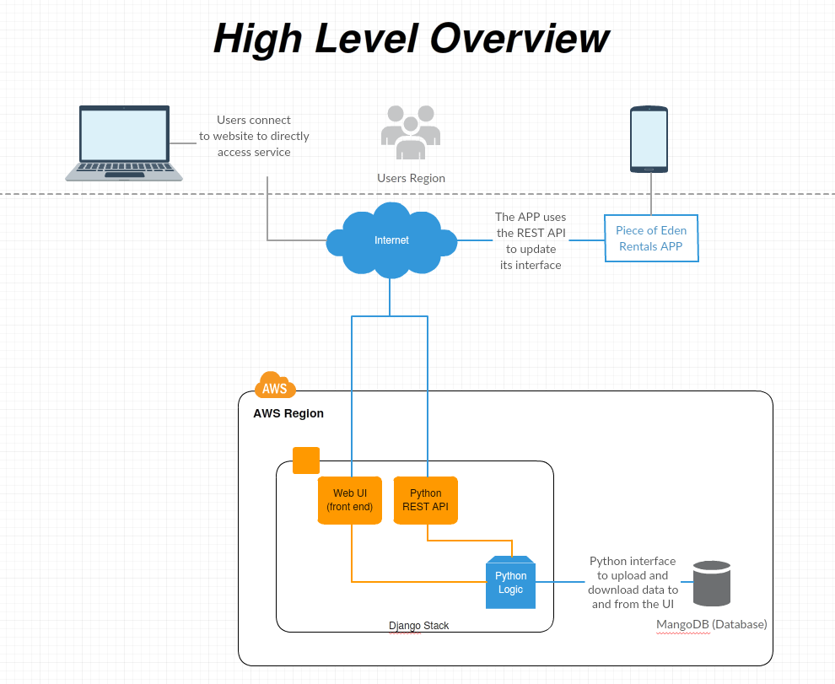

Figure 1.1

As shown in figure 1.1, users can either connect to the Piece of Eden Rental service directly through the web interface (PieceOfEdenRentals.com) or on a mobile device through the APP. The APP uses a Python REST API integrated into the Django framework to communicate with the database to obtain new information to display in its UI. The web application uses a direct connection to the database through the Django python interface. The database will be described in more detail later in this document.

***2.2 Decomposition Description***

The front end web UI will be separated into 4 main pages, a homepage, a user page, a rental page, and a contact page. Greater detail as to the design of these pages is on the User Interface Design document; however, the UI will utilize a hybrid of object-oriented and procedural architecture. Each property itself will be a python object that gets stored in the database with specific variables such as location of the house, picture links, rating of the house,etc… Each specific page displaying a house will be procedurally generated from the ID of the house the user requested. The generic page will act like a container that gets filled with the responses from the database as to the specific house the user selected.

The REST API will work with the Piece of Eden Rentals APP similarly, as the API will serve the requested user information to the APP which will display it in a mobile friendly view similar to the original web application. However, the APP can not work on its own and must have access to the API in order to function properly.

The Python backend will maintain the logic to properly assign the procedurally generated elements of the application to the specific variables that should contain the information to display it properly. Furthermore, it will update the information in the database as necessary using the Django MongoDB Engine’s direct integration tools.

**3. Persistent Data Design**

***3.1 Database Descriptions***

The database itself is separated into two parts, a property database which is publically viewable, and a user database which has security restrictions. The user database information will not be available unless the user is logged in. Furthermore, the user’s themselves are only able to edit their own information. However, the admin user can edit both the user and the property database.

**4. Requirements Matrix**

Please refer to the System Requirements Specification for details regarding the

corresponding use cases.

**5. Appendix A – Agreement Between Customer and**

**Contractor**

The customer agrees to a *Luxury Rental Network* system with searching, browsing and

detailed meta-data capabilities. See System Requirements Specification for more

information. Additional features will be provided in further development spirals.

When and if future changes to this document occur a drafted new document will be

created. Both a hard and electronic copy of both versions will be presented to the client for

review. Upon approval, the draft will be finalized and signed off by both parties.

**Client**

Name _________________________________________ Date

___________________

Print

Name _________________________________________ Date

___________________

Signature

**Team**

Name _________________________________________ Date

___________________

Print

Name _________________________________________ Date

___________________

Signature

Name _________________________________________ Date

___________________

Print

Name _________________________________________ Date

___________________

Signature

Name _________________________________________ Date

___________________

Print

Name _________________________________________ Date

___________________

Signature

Name _________________________________________ Date

___________________

Print

Name _________________________________________ Date

___________________

Signature

Name _________________________________________ Date

___________________

Print

Name _________________________________________ Date

___________________

Signature

Name _________________________________________ Date

___________________

Print

Name _________________________________________ Date

___________________

Signature

**6. Appendix B – Team Review Sign-off**

This document has been collaboratively written by all members the team.

Additionally, all team members have reviewed this document and agree on both

the content and the format. Any disagreements or concerns are addressed in

team comments below.

**Team**

Name _________________________________________ Date

___________________

Print

Name _________________________________________ Date

___________________

Signature

Comments

______________________________________________________________

______________________________________________________________________

__

Name _________________________________________ Date

___________________

Print

Name _________________________________________ Date

___________________

Signature

Comments

______________________________________________________________

______________________________________________________________________

__

Name _________________________________________ Date

___________________

Print

Name _________________________________________ Date

___________________

Signature

Comments

______________________________________________________________

______________________________________________________________________

__

Name _________________________________________ Date

___________________

Print

Name _________________________________________ Date

___________________

Signature

Comments

______________________________________________________________

______________________________________________________________________

__

Name _________________________________________ Date

___________________

Print

Name _________________________________________ Date

___________________

Signature

Comments

______________________________________________________________

______________________________________________________________________

__

Name _________________________________________ Date

___________________

Print

Name _________________________________________ Date

___________________

Signature

Comments

______________________________________________________________

______________________________________________________________________

__

**7. Appendix C – Document Contributions**

Eric Forte took the lead on the writing of this document