**Testing Report**

*Piece of Eden Rentals*

**Client**

John Winder

**Team 3**

Eric Forte

Rachel Cohen

Stephen Masterson

Matt Walker

Nick Keckeisen

4/13/16

*Piece of Eden Rentals*

Testing Report

**Table of Contents**

1. Introduction

1.1 Purpose of this document

1.2 References

1. Testing Process

2.1 Description

2.2 Testing Sessions

1. Test Results

3.1 Testing Suite

3.2 Test Results

1. Appendix A - Team Review Sign-off
2. Appendix B - Document Contributions
3. **Introduction**

Testing is an integral part of the development process, and is a vital requirement for delivering a consistent and accurate web application

**1.1 Purpose of this Document**

This document is intended for system administrators, integration teams, quality assurance teams, and any other use who is interested in reviewing the testing procedure used for the development of the Piece of Eden web application. This report defines and analyzes the testing process that our team used.

**1.2 References**

Use Cases from the System Requirements Specifications (SRS) documentation.

1. **Testing Process**

**2.1 Description**

Use Cases described in SRS document dictate each spiral’s testing procedures. The development process was driven by the use cases we had defined in Spiral 1, and satisfying those conditions was a major goal accomplished during this Spiral.

Further testing not described in the document also took place. This included basic testing of functional requirements in the midst of the development and code writing process.

* 1. **Testing Sessions**

|  |  |  |  |  |  |
| --- | --- | --- | --- | --- | --- |
| **Date** | **Location** | **Time Started** | **Time Ended** | **Performed By** | **Use Cases** |
| 4/10/2016 | Home | 3:20pm | 4:00pm | Matt W. | Creating/Displaying Data |
| 4/11/2016 | RLC | 6:30pm | 7:00pm | Nick K. | Visit Webpage |
| 4/11/2016 | Home | 7:00pm | 7:30pm | Rachel C. | Visit Webpage |
| 4/11/2016 | Home | 7:00pm | 7:30pm | Rachel C. | Visit User Page |
| 4/12/2016 | RLC | 5:00pm | 6:00pm | Eric F. | Register Property |
| 4/12/2016 | Home | 5:00pm | 6:00pm | Stephen M. | Register User Account |
| 4/13/2016 | RLC | 11:00pm | 12:00pm | Eric F. | Renting a Property |
| 4/13/2016 | RLC | 7:00pm | 7:30pm | Rachel C. | Register Property |
| 4/14/2016 | Home | 9:00am | 9:30am | Rachel C. | Renting a Property |
| 4/14/2016 | Home | 9:30am | 10:00am | Nick K. | Renting a property |

**2.2 Impressions of the Process**

Testing focused on whether or not the use cases were satisfied to a point where our customer would be happy with them. Keeping in mind that this is Spiral 2, we were making sure that the core functionality was there, aside from having other small things perfected. Through the use of test conditions derived from the use cases (can be seen in the SRS), the requirements were tested accurately. The use cases were helpful in creating a guide of the necessary steps that were required for the system to perform in the way we had intended.

As a process, software testing is important to identify defects and errors that could’ve been made during the development process. It is essential since it makes sure of the customer’s reliability and their overall satisfaction with the functionality and appearance of the application. In this spiral, we focused on ensuring the functionality, so that we would not run into any failures in future development phases.

1. **Test Results**

Testing results are outlined below.

**3.1 Testing Suite**

**Use Case 1: Register a Property**

Purpose: To allow the user to register a rentable property.

Valid Situation: Register a property with a name, price, location, and owner.

Invalid Situation: The items do not appear in the property database.

**Use Case 2: Click on Property Pin**

Purpose: To click on a pin on the Google Map to view a property at a given location.

Valid Situation: Click on a pin and see the image of the house, availability windows, and a rating.

Invalid Situation: Clicking on pin returns no results.

**Use Case 3: Rate Property**

Purpose: To give a rating to a property to let other users know about prior rental experiences.

Valid Situation: Rate a property up or down.

Invalid Situation: Rating does not register with the database.

**Use Case 4: Login to user account**

Purpose: To allow a user to log into the system.

Valid Situation: Log in to existing user account. Can only be accessed with the correct password.

Invalid Situation: Database does not verify the account.

**Use Case 5: Rent a Property**

Purpose: To allow a user to rent a property for a window of time.

Valid Situation: Rent a property for a certain time window and have it appear in the calendar.

Invalid Situation: Database does not verify changes for that property. The property does not register as “rentable” for other users.

**Use Case 6: Select User Avatar**

Purpose: Allow a user to have a personal image associated with their account.

Valid Situation: Upload an image as an avatar.

Invalid Situation: The image has not changed and is not viewable to other users.

**Use Case 7: Visit User Page**

Purpose: Allow a user to have a page with their account and rental information.

Valid Situation: Connect to user’s page and view their information.

Invalid Situation: Information in database and webpage is not synced or viewable on the application.

**Use Case 8: Visit the Homepage**

Purpose: To have a landing/welcome page for the application that allows the user to navigate to different parts of the site.

Valid Situation: User is able to visit the application homepage.

Invalid Situation: User gets an error when trying to visit the application homepage.

**Use Case 9: Register New User Account**

Purpose: To allow users to create accounts on the system.

Valid Situation: User enters name and password and is able to register a new account in the system.

Invalid Situation: Database cannot verify if user already exists.

* 1. **Test Results**

**Use Case 1: Register a Property**

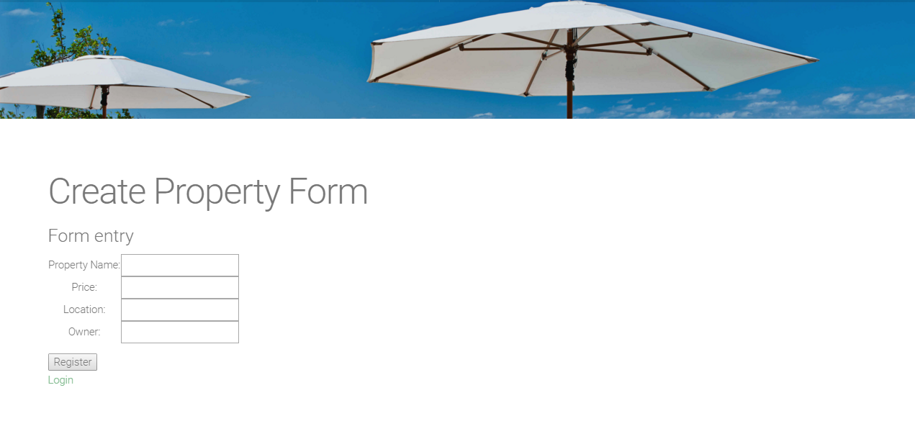

**Use Case 2: Click on Property Pin**

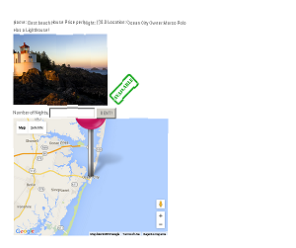

**Use Case 4: Login to user account**

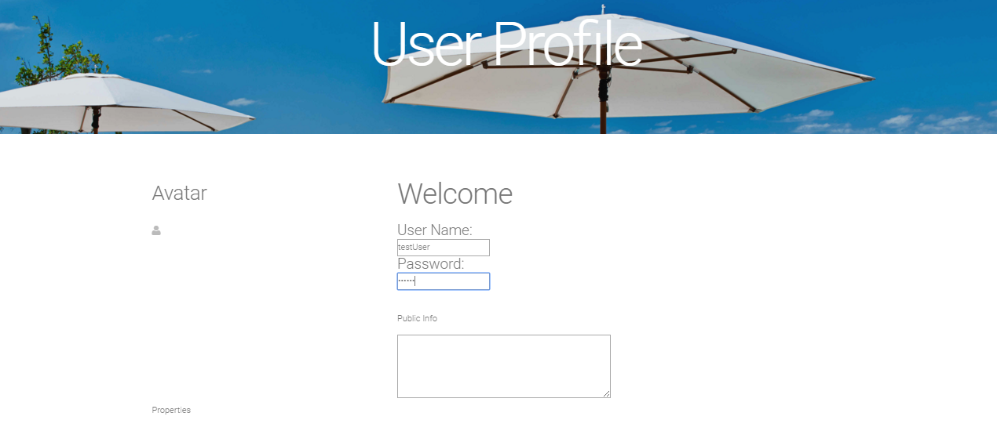

**Use Case 5: Rent a Property**

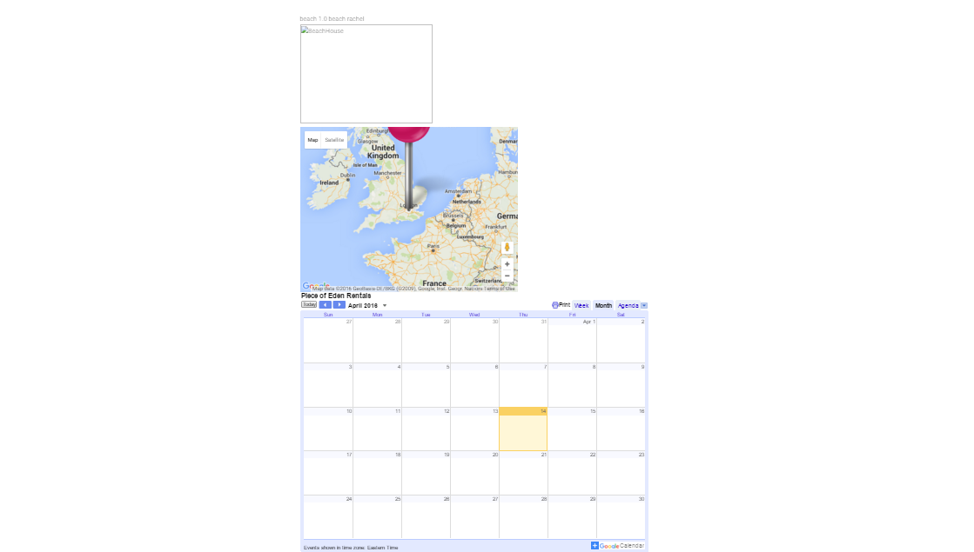

**Use Case 6: Select User Avatar**

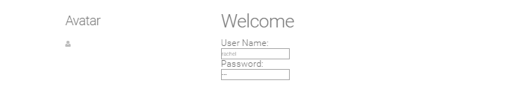

**Use Case 7: Visit User Page**

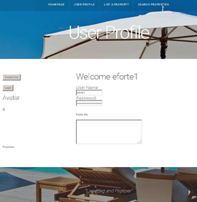

**Use Case 8: Visit the Homepage**

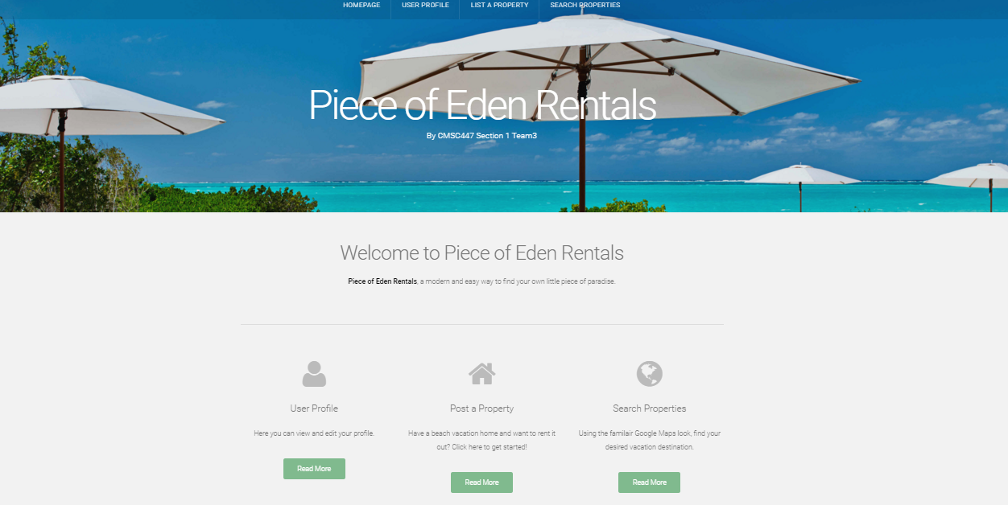

**Use Case 9: Register New User Account**

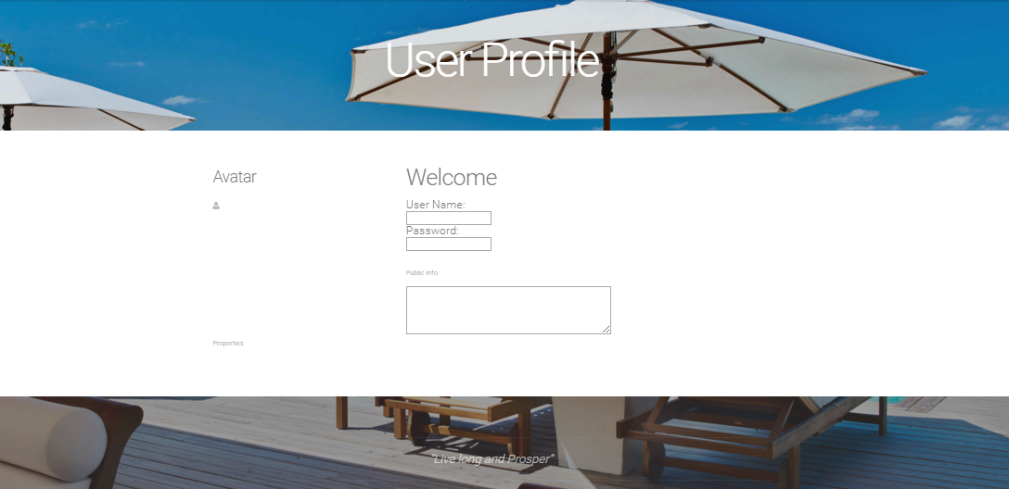

1. **Appendix A - Team Review Sign-off**

**Client**

Name _______________________________________________

Date ___________________

Print

Name _______________________________________________

Date___________________

Signature

**Team**

Name _______________________________________________

Date ___________________

Print

Name _______________________________________________

Date___________________

Signature

Name _______________________________________________

Date ___________________

Print

Name _______________________________________________

Date___________________

Signature

Name _______________________________________________

Date ___________________

Print

Name _______________________________________________

Date___________________

Signature

Name _______________________________________________

Date ___________________

Print

Name _______________________________________________

Date___________________

Signature

Name _______________________________________________

Date ___________________

Print

Name _______________________________________________

Date___________________

Signature

1. **Appendix B - Document Contributions**

Nick Keckeisen created this *document for Spiral 1.

Rachel Cohen updated the document for Spiral 2.