**User Interface Design**

**Document**

*Piece of Eden Rentals*

**Client**

John Winder

**Team 4**

Stephen Masterson

Rachel Cohen

Nicholas Keckeisen

Eric Forte

Matthew Walker

4/28/2016

*Piece of Eden Rentals*

User Interface Design Document

**Table of Contents**

1. Introduction

1.1 Purpose of This Document

1.2 References

2. User Interface Standards

3. User Interface Walkthrough

3.1 Piece of Eden Rentals Navigation Diagram

3.2 Piece of Eden Rentals Walkthrough

3.2.1 Searching

3.2.2 Profile

4. Data Validation

4.1 Data Validation Table

5. Appendix A – Agreement Between Customer and Contractor

6. Appendix B – Team Review Sign-off

7. Appendix C – Document Contributions

**1. Introduction**

**1.1 Purpose of This Document**

The purpose of this document is to show the user how to navigate and interact

with the Piece of Eden Rentals web application. Images will show how Piece of Eden Rentals is interconnected and will display the different pages within the application,

highlighting important features to familiarize users with all that Piece of Eden Rentals has to offer.

**1.2 References**

**1.** Piece of Eden Rentals System Requirements

**2. User Interface Standards**

This section contains an overview of the design standards used in the Piece of Eden Rentals web application. As seen in Figure 1.0 below, there are two aspects to the

Piece of Eden Rentals layout that are consistent throughout the application. First, the

Piece of Eden Rentals Logo will appear in the URL title bar of every page. Second, the Menu Bar, which allows navigation through the main sub pages, will always

appear at the top of each web page. The Menu Bar contains four buttons users can choose from. First, the Home Button navigates to the Home Page (Figure 1.0). The Home page is the initial landing site for the user and guides them as to different paths they can take on the site. The user can also click on the rentals tab bringing forth the Rentals Screen (Figure 2.0) for featured properties. If the user clicks to apply filters or directly search for a property, the user will be taken to a modified version of the search page (Figure 2.1) or the property information page (Figure 2.2). The User tab takes users to the user page (Figure 3.0). This page allows the user to create a user account or edit their information if their account does not already exist.

***Figure 1.0 – Home Page***

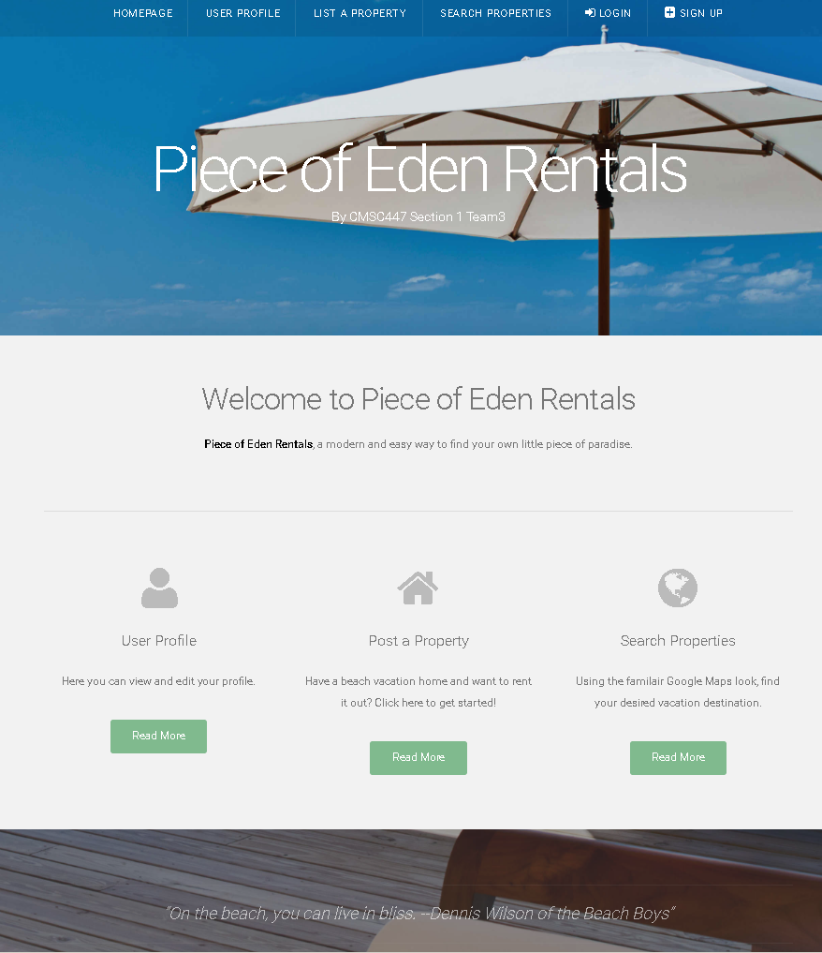

**3. User Interface Walkthrough**

**3.1 Piece of Eden Rentals Navigation Diagram**

The following navigation diagram or sitemap explains possible user flow through the

system. Note this is just suggested flow for users and this may not match all use cases. However, the majority of the functionality of this application is achievable through this progression.

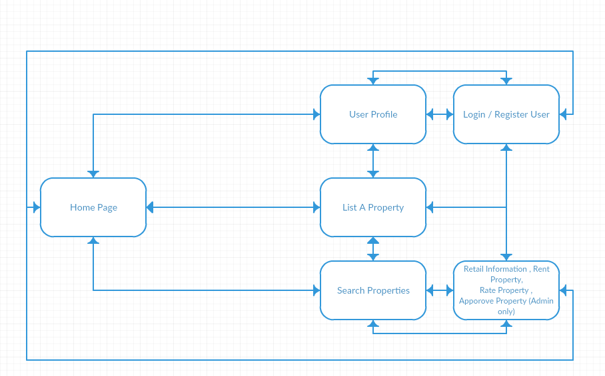

**3.2 Piece of Eden Rentals Walkthrough**

**3.2.1 Searching**

The first page, or home page, the user will see is the Home Page (Figure 1.0).

This page contains the User Interface Standards, mentioned earlier in Section 2,

as well as a Sign in or Sign up button. On this page the user can enter their information and sign in if they wish to have a personalized experience and the ability to rent properties, or they can search for properties to rent. To search for a property, the user will click on the Search Page (Figure 2.0 / 2.1). The search page has since been combined with the featured properties page since the last spiral however, both figure number will be used to reference this new page to maintain formatting for reference to the first iteration document. The results are organized in the order of either recently added or highest related properties. On the results page, the user may click on the property to view its rental information on the rental information page (Figure 2.2). Registered users will only be able to see properties that have been approved by an administrator. If the user is an administrator, they can see approved and unapproved properties, allowing the admin to manage available properties.

**3.2.2 Property Info**

This page, the rental information page (Figure 2.2), contains the majority of the functionality and user interaction of the application. The general information about a property is displayed here, such as pictures, title, owner, rating, etc… Also if the user has rented the property before the user will be allowed to rate the property by selecting a start rating from the interface. Below this is the rent property form where the user can select a start date on the input calendar and end date on the second input calendar. After submitting the rental times, a rent slot object will appear on the availability calendar on the bottom of the page with the current user’s username as a title. If the user is an admin user then a button will appear to either approve the property for rental, adding it to the list of rentable properties or undo the approval and remove the property from the list.

**3.2.3 Profile**

Clicking the User Button, from the Menu Bar, will navigate to the User’s Profile

Page (Figure 3.0). The User Page contains the User Interface Standards

mentioned earlier in Section 2. This page contains user information such as username, public info text, properties owned, and properties rented/renting. This information is available to the admin user and to other users who try to view the profile. Since the Menu Bar is on every page throughout the Piece of Eden Rentals web application, the user may view any other pages at any time simply by clicking on each respective button.

**3.2.4 Create a Property**

Registered users have the ability to click on the “list a property” button on the menu tab which will navigate them to the Create a Property Screen (Figure 4). Non-registered users may access this page, but they cannot go through with registering a property. From this screen a user may enter information about the property he or she wishes to list such as name, price per night, pictures, etc... Also, there is a Google Maps window where one can get the coordinates of any location on the map to register the property’s location. If a visitor to the site is not logged in as a user the button will produce a prompt asking the user to login before creating a property, as they do not have permission to create a property otherwise. Furthermore, a property created will not appear in the listed property section unless approved by an administrator.

***Figure 2.0 /2.1 - Rentals / Search Page***

Title of property (link to access Property Info Page), and Property information

Property Search by property name

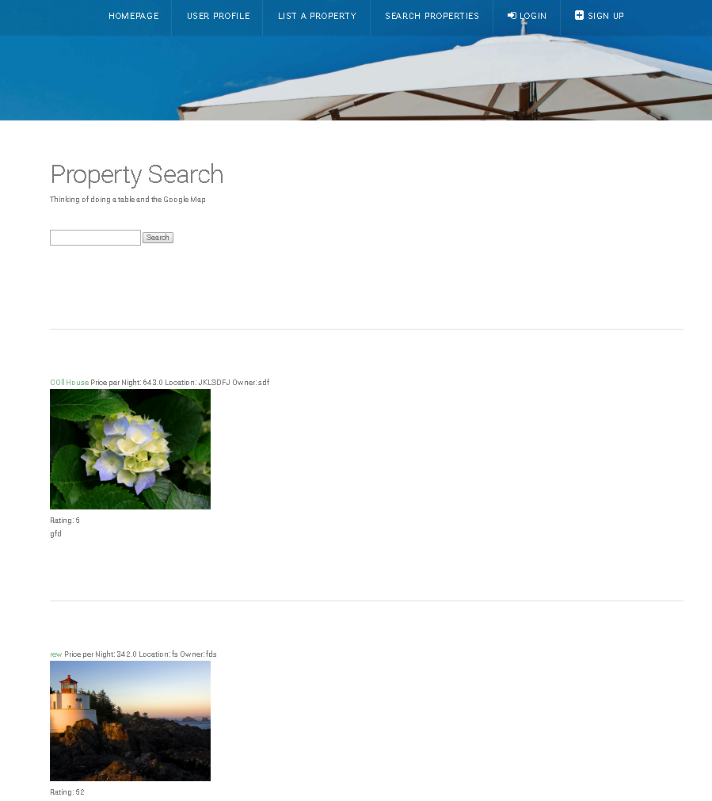

***Figure 2.2 - Rental Information Page***

Rating input field, only available if the user had rented or Is currently renting the property.

Approve/Un-Approve button only available to admin users

Rental date submission form. Upon clicking on the input boxes will bring up input calendars for the start and the end date inputs respectively.

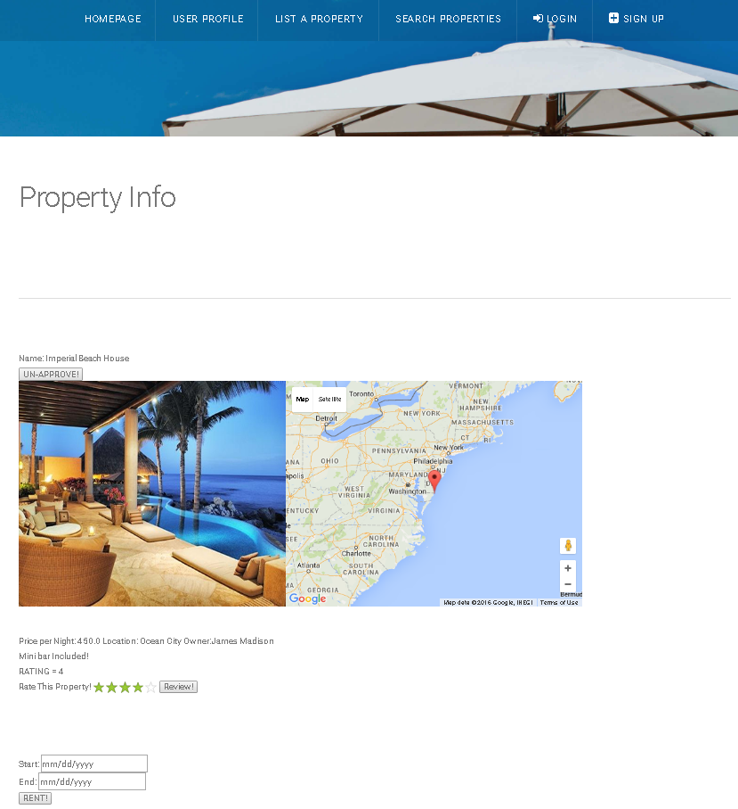

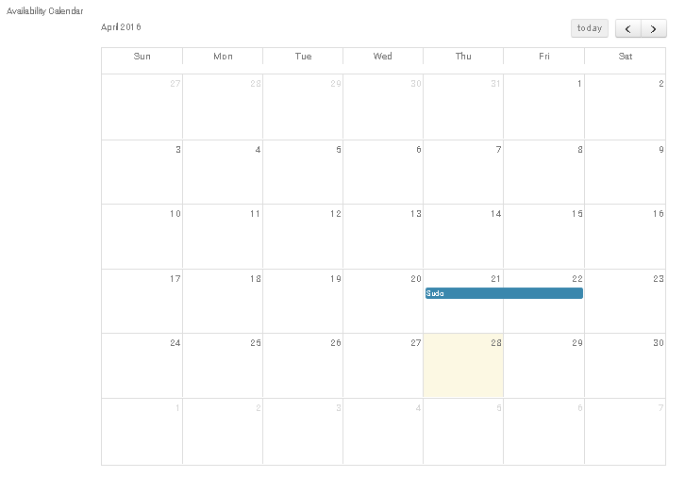

Rent Slot Object which shows the user “Sudo” had rented the property on these dates. The highlighted date is the current date.

***Figure 3.0 - User Page***

List of properties rented

List of properties owned

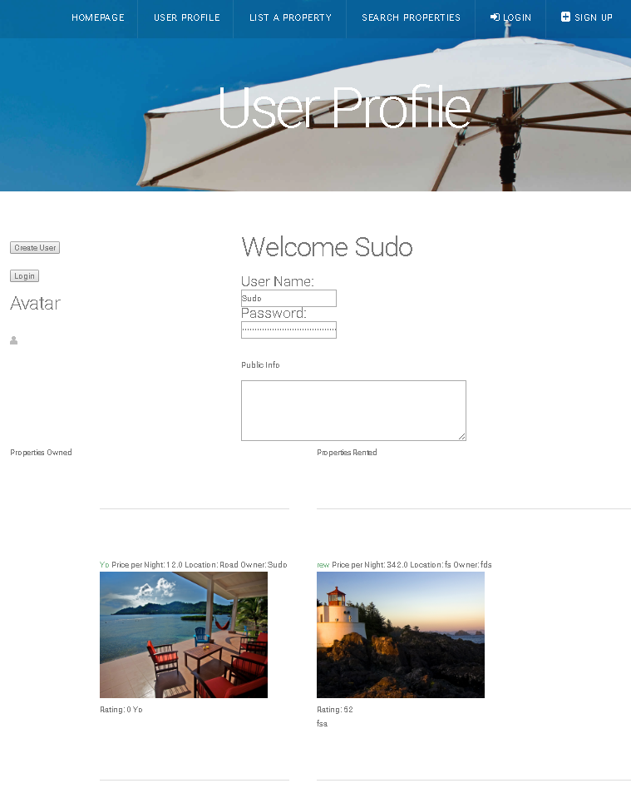

***Figure 4 – Create Property Form***

The Latitude and Longitude input fields update dynamically by placing/moving a marker on the Google Maps window.

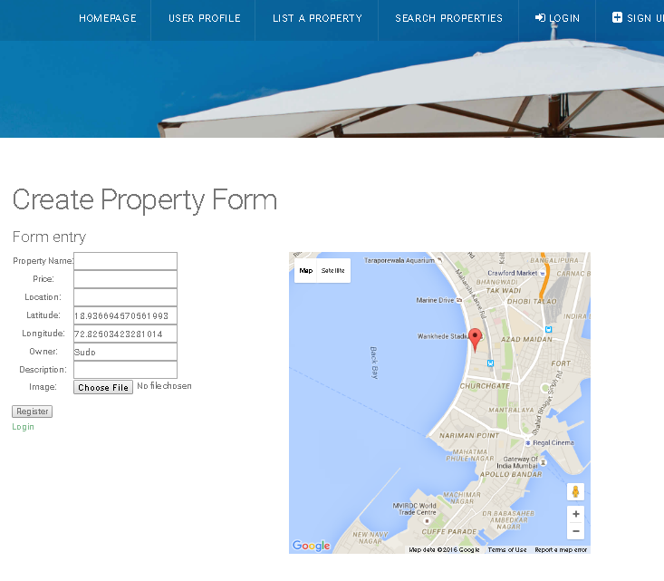

**4. Data Validation**

There are multiple data entry points into the Piece of Eden Rentals. They include: User names, profile pictures, user information, and reviewing property. Please refer to the table below for further information regarding allowable inputs, their limits, and allowable formats. In addition, all text that is entered is escaped for security. An important note is for the Latitude and Longitude input which can be entered manually or by clicking on the Google Maps window.

**4.1 Data Validation Table**

**User Creation Form:**

|  |  |  |
| --- | --- | --- |
| **Entry Location** | **Data Type** | **Limits** |
| Username | Char Field | Length 30 |
| Email Address | Char Field | Length 30 |
| Password | Char Field (hashed) | Length 30 |

**List Property Form**

|  |  |  |
| --- | --- | --- |
| **Entry Location** | **Data Type** | **Limits** |
| Property Name | Char Field | Length 30 |
| Price | Float | Valid Float |
| Location | Char Field (hashed) | Length 50 |
| Owner | Char Field | Length 30 |
| Description | Char Feild | Length 256 |
| Image | .jpg | Valid .jpg |
| Latitude | Float | Valid float |
| Longitude | Float | Valid float |

**5. Appendix A – Agreement Between Customer**

**and Contractor**

The customer agrees to a *Luxury Rental Network* system with searching, browsing and

detailed meta-data capabilities. See System Requirements Specification for more

information. Additional features will be provided in further development spirals.

When and if future changes to this document occur a drafted new document will be

created. Both a hard and electronic copy of both versions will be presented to the client for

review. Upon approval, the draft will be finalized and signed off by both parties.

**Client**

Name _________________________________________ Date

___________________

Print

Name _________________________________________ Date

___________________

Signature

**Team**

Name _________________________________________ Date

___________________

Print

Name _________________________________________ Date

___________________

Signature

Name _________________________________________ Date

___________________

Print

Name _________________________________________ Date

___________________

Signature

Name _________________________________________ Date

___________________

Print

Name _________________________________________ Date

___________________

Signature

Name _________________________________________ Date

___________________

Print

Name _________________________________________ Date

___________________

Signature

Name _________________________________________ Date

___________________

Print

Name _________________________________________ Date

___________________

Signature

Name _________________________________________ Date

___________________

Print

Name _________________________________________ Date

___________________

Signature

**6. Appendix B – Team Review Sign-off**

This document has been collaboratively written by all members the team. Additionally,

all team members have reviewed this document and agree on both the content and the

format. Any disagreements or concerns are addressed in team comments below.

**Team**

Name _________________________________________ Date

___________________

Print

Name _________________________________________ Date

___________________

Signature

Comments

______________________________________________________________

______________________________________________________________________

__

Name _________________________________________ Date

___________________

Print

Name _________________________________________ Date

___________________

Signature

Comments

______________________________________________________________

______________________________________________________________________

__

Name _________________________________________ Date

___________________

Print

Name _________________________________________ Date

___________________

Signature

Comments

______________________________________________________________

______________________________________________________________________

__

Name _________________________________________ Date

___________________

Print

Name _________________________________________ Date

___________________

Signature

Comments

______________________________________________________________

______________________________________________________________________

__

Name _________________________________________ Date

___________________

Print

Name _________________________________________ Date

___________________

Signature

Comments

______________________________________________________________

______________________________________________________________________

__

Name _________________________________________ Date

___________________

Print

Name _________________________________________ Date

___________________

Signature

Comments

______________________________________________________________

______________________________________________________________________

__

**7. Appendix C – Document Contributions**

Eric Forte is the owner of this document, and as of this version, is the sole contributor.