**User Interface Design**

**Document**

*Piece of Eden Rentals*

**Client**

John Winder

**Team 4**

Stephen Masterson

Rachel Cohen

Nicholas Keckeisen

Eric Forte

Matthew Walker

3/5/2016

*Piece of Eden Rentals*

User Interface Design Document

**Table of Contents**

1. Introduction

1.1 Purpose of This Document

1.2 References

2. User Interface Standards

3. User Interface Walkthrough

3.1 Piece of Eden Rentals Navigation Diagram

3.2 Piece of Eden Rentals Walkthrough

3.2.1 Searching

3.2.2 Profile

4. Data Validation

4.1 Data Validation Table

5. Appendix A – Agreement Between Customer and Contractor

6. Appendix B – Team Review Sign-off

7. Appendix C – Document Contributions

**1. Introduction**

**1.1 Purpose of This Document**

The purpose of this document is to show the user how to navigate and interact

with the Piece of Eden Rentals web application. Images will show how Piece of Eden Rentals is interconnected and will display the different pages within the application,

highlighting important features to familiarize users with all that Piece of Eden Rentals has to offer.

**1.2 References**

**1.** Piece of Eden Rentals System Requirements

**2. User Interface Standards**

This section contains an overview of the design standards used in the Piece of Eden Rentals web application. As seen in Figure 1.0 below, there are two aspects to the

Piece of Eden Rentals layout that are consistent throughout the application. First, the

Piece of Eden Rentals Logo will appear in the top center of every page. Second, the Menu Bar, which allows navigation through the main sub pages, will always

appear just under the Piece of Eden Rentals Logo.The Menu Bar contains four buttons users can choose from. First, the Home Button navigates to the Home Page (Figure 1.0). The Home page allows the user to login search for recently added properties, highest rated properties, or to pick a property at random. The user can also click on the rentals tab bringing forth the Rentals Screen (Figure 2.0) for featured properties. If the user clicks on either the Recently Added or Highest Rated buttons the user will be taken to the appropriate search page (Figure 2.1) more in-depth search capabilities. The User tab takes users to the user page (Figure 3.0). This page allows the user to create a user account or edit their information if their account does not already exist.

***Figure 1.0***

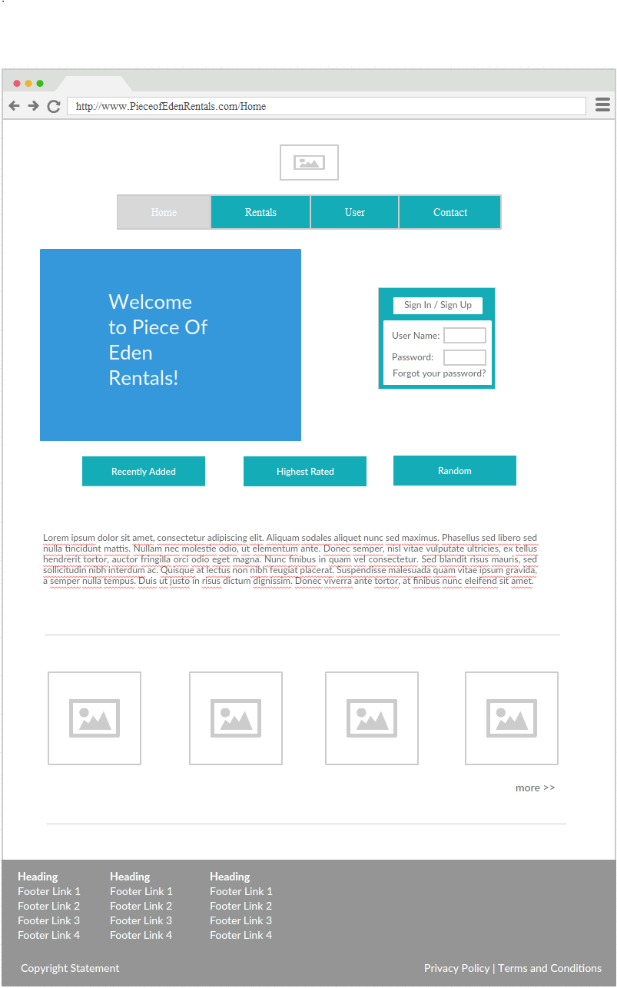

**3. User Interface Walkthrough**

**3.1 Piece of Eden Rentals Navigation Diagram**

The following navigation diagram or sitemap explains possible user flow through the

system. (Under Construction)

**3.2 Piece of Eden Rentals Walkthrough**

**3.2.1 Searching**

The first page, or home page, the user will see is the Home Page (Figure 1.0).

This page contains the User Interface Standards, mentioned earlier in Section 2,

as well as a Sign in or Sign up button. On this page the user can enter their information and sign in if they wish to have a personalized experience, or they can search for properties to rent. The results of the search are displayed on a Search Page (Figure 2.1). The results are organized in the order of either recently added or highest related properties. On the results page, the user may click on the property to view its rental information on the rental information page(Figure 2.2).

**3.2.2 Profile**

Clicking the User Button, from the Menu Bar, will navigate to the User’s Profile

Page (Figure 3.0). The User Page contains the User Interface Standards

mentioned earlier in Section 2. This information is available to the admin user and to other users who try to view the profile, usually when looking at the user’s reviews. Since the Menu Bar is on every page throughout the Piece of Eden Rentals web application, the user may view any other pages at any time simply by clicking on each respective button.

***Figure 2.0 - Rentals***

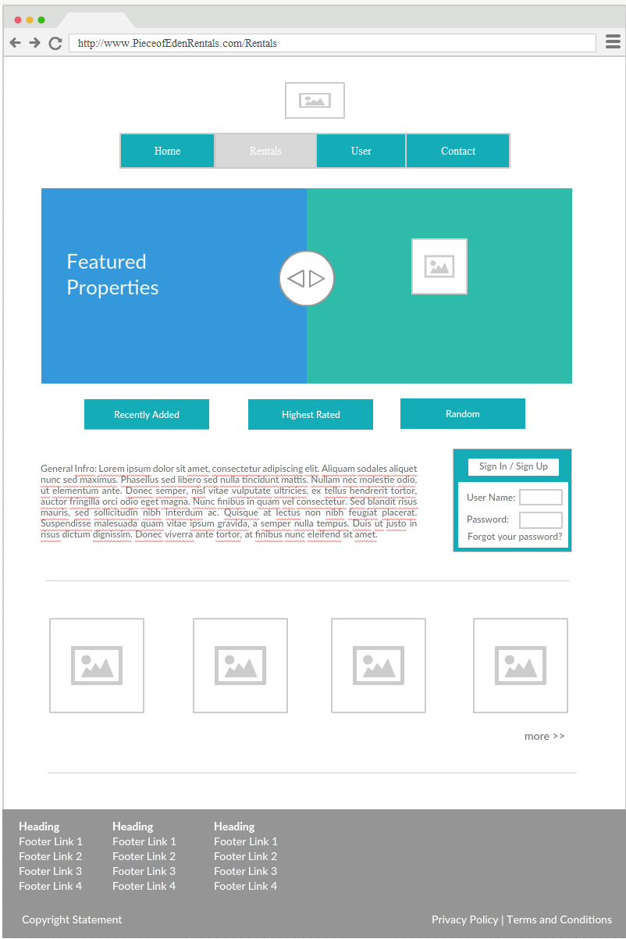

***Figure 2.1- Search Page***

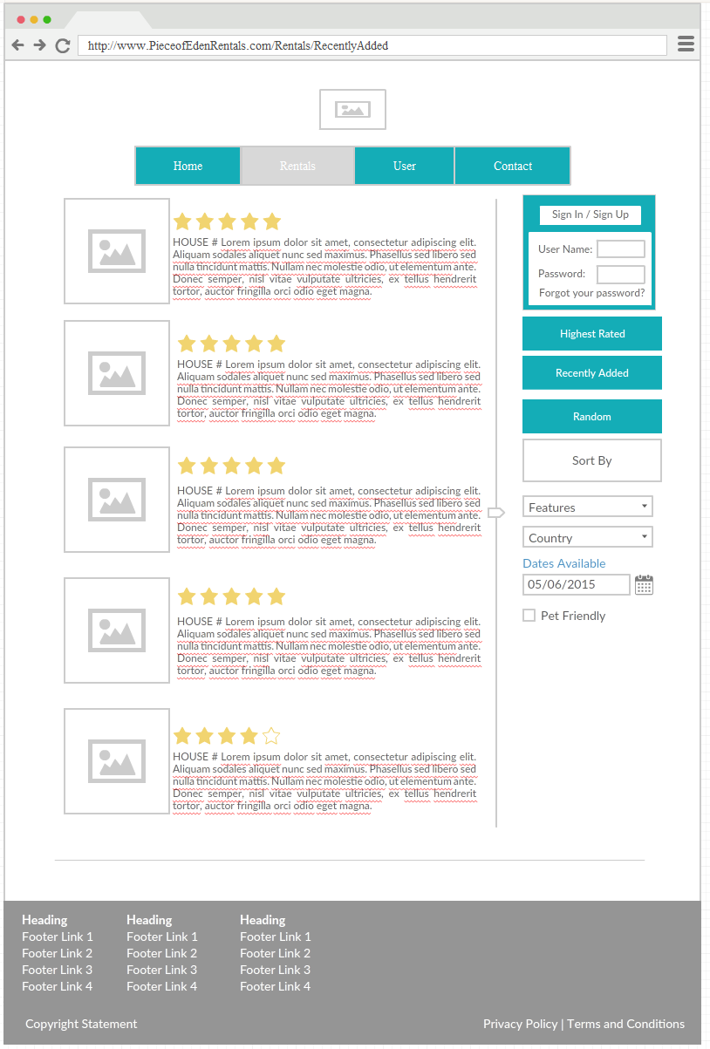

***Figure 2.2 - Rental Information Page***

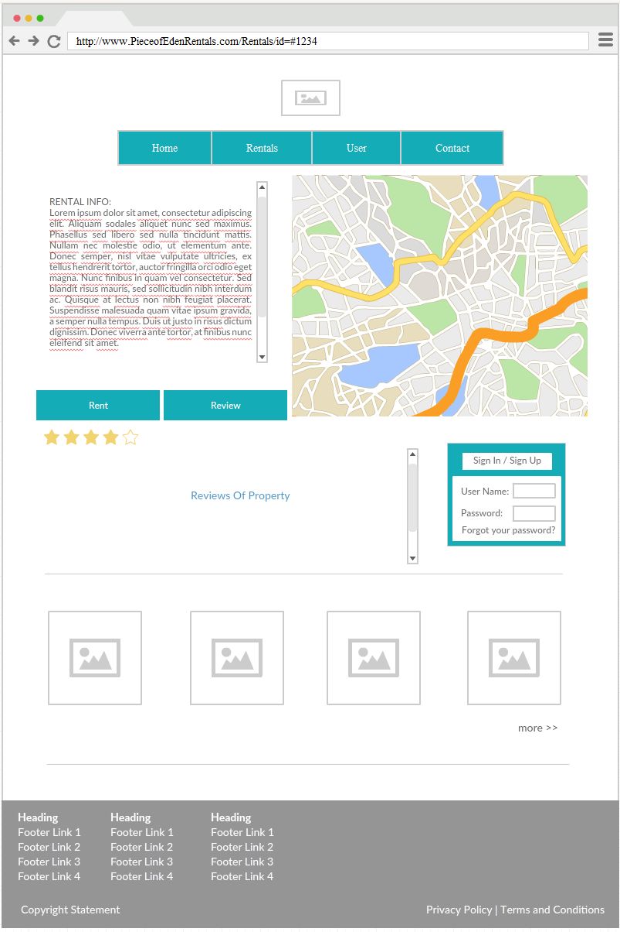

***Figure 3.0 - User Page***

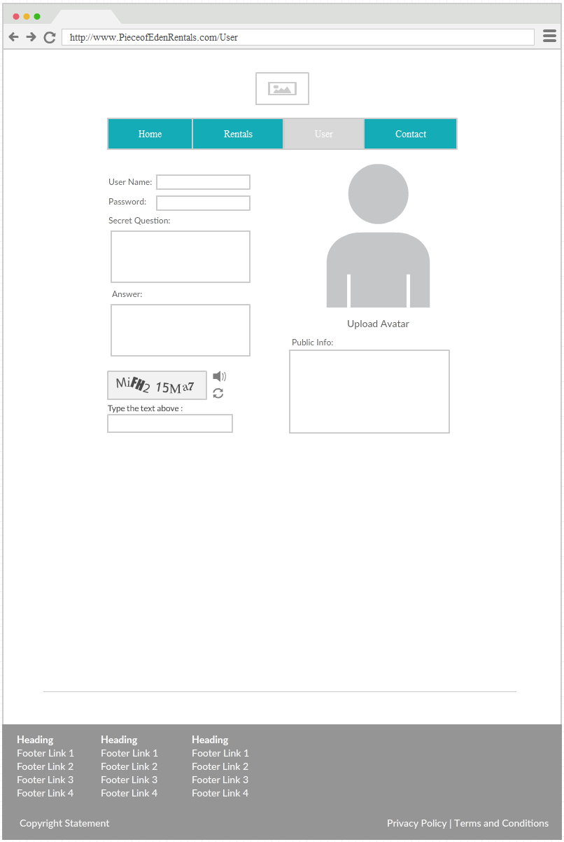

**4. Data Validation**

There are multiple data entry points into the Piece of Eden Rentals. They include: User names, profile pictures, user information, and reviewing property. Please refer to the table below for further information regarding allowable inputs, their limits, and allowable formats. In addition all text that is entered is escaped for security.

**4.1 Data Validation Table**

**(UNDER CONSTRUCTION)**

**5. Appendix A – Agreement Between Customer**

**and Contractor**

The customer agrees to a *Luxury Rental Network* system with searching, browsing and

detailed meta-data capabilities. See System Requirements Specification for more

information. Additional features will be provided in further development spirals.

When and if future changes to this document occur a drafted new document will be

created. Both a hard and electronic copy of both versions will be presented to the client for

review. Upon approval, the draft will be finalized and signed off by both parties.

**Client**

Name _________________________________________ Date

___________________

Print

Name _________________________________________ Date

___________________

Signature

**Team**

Name _________________________________________ Date

___________________

Print

Name _________________________________________ Date

___________________

Signature

Name _________________________________________ Date

___________________

Print

Name _________________________________________ Date

___________________

Signature

Name _________________________________________ Date

___________________

Print

Name _________________________________________ Date

___________________

Signature

Name _________________________________________ Date

___________________

Print

Name _________________________________________ Date

___________________

Signature

Name _________________________________________ Date

___________________

Print

Name _________________________________________ Date

___________________

Signature

Name _________________________________________ Date

___________________

Print

Name _________________________________________ Date

___________________

Signature

**6. Appendix B – Team Review Sign-off**

This document has been collaboratively written by all members the team. Additionally,

all team members have reviewed this document and agree on both the content and the

format. Any disagreements or concerns are addressed in team comments below.

**Team**

Name _________________________________________ Date

___________________

Print

Name _________________________________________ Date

___________________

Signature

Comments

______________________________________________________________

______________________________________________________________________

__

Name _________________________________________ Date

___________________

Print

Name _________________________________________ Date

___________________

Signature

Comments

______________________________________________________________

______________________________________________________________________

__

Name _________________________________________ Date

___________________

Print

Name _________________________________________ Date

___________________

Signature

Comments

______________________________________________________________

______________________________________________________________________

__

Name _________________________________________ Date

___________________

Print

Name _________________________________________ Date

___________________

Signature

Comments

______________________________________________________________

______________________________________________________________________

__

Name _________________________________________ Date

___________________

Print

Name _________________________________________ Date

___________________

Signature

Comments

______________________________________________________________

______________________________________________________________________

__

Name _________________________________________ Date

___________________

Print

Name _________________________________________ Date

___________________

Signature

Comments

______________________________________________________________

______________________________________________________________________

__

**7. Appendix C – Document Contributions**

Eric Forte is the owner of this document, and as of this version, is the sole contributor.