System Design
Document

Piece of Eden Rentals
Client
John Winder

Team 4
Stephen Masterson
Rachel Cohen
Nicholas Keckeisen
Eric Forte
Matthew Walker

4/13/2016

Piece of Eden Rentals
System Design Document

Table of Contents

- Introduction

1.1 Purpose of This Document
1.2 References

- System Architecture

2.1 Architectural Design
2.2 Decomposition Description

- Persistent Data Design

3.1 Database Descriptions

- Requirements Matrix

- Appendix A – Agreement Between Customer and Contractor

- Appendix B – Team Review Sign-off

- Appendix C – Document Contributions

1. Introduction

1.1 Purpose of This Document
The purpose of this document is to describe the design of the Piece of Eden Rentals
application. Key topics covered in this document include the high level system
architecture, lower level class designs, and the persistent data design Piece of Eden Rentals.

1.2 References
Throughout this document references will be made to: (none at this time)

2. System Architecture

2.1 Architectural Design

The Piece of Eden Rentals application will be built and finally deployed using the Amazon Web Services framework (AWS). The core components are built using the Django framework and a SQLlite database within AWS or any other deployment platform. Initially the product was going to be built with Mongo DB, but in effort to improve useability for our customer we changed to SQLlite to make deployment an easier process.

Figure 1.1
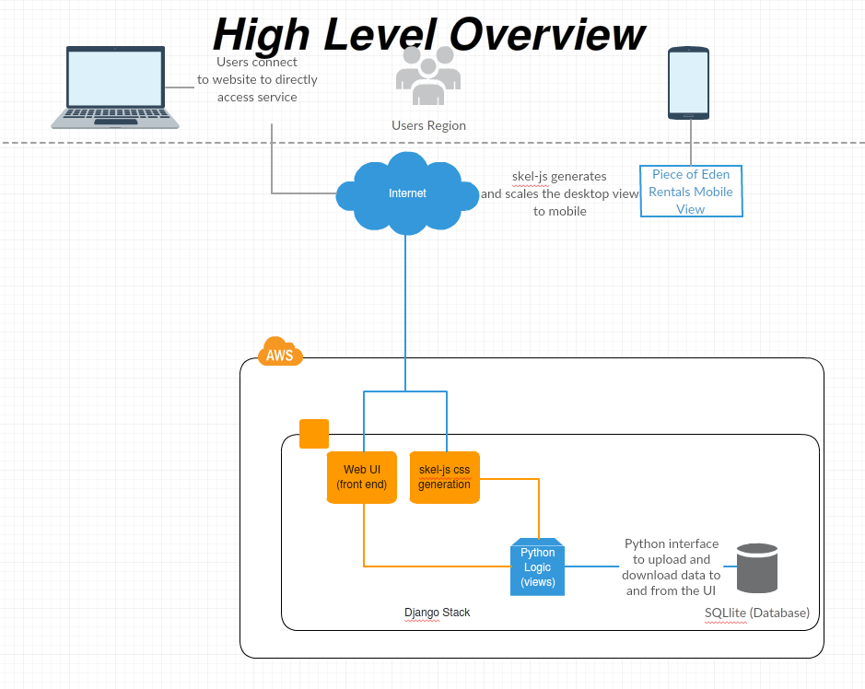
As shown in figure 1.1, users can connect to the Piece of Eden Rental service directly through the web interface on either a desktop web interface, or a mobile friendly interface, both at PieceOfEdenRentals.com. Initially, The APP was going to use a Python REST API integrated into the Django framework to communicate with the database to obtain new information to display in its UI. However, this feature was dropped and moved to a stretch goal as the customer would rather have the development team spend time on making the product easier to deploy and the UI more appealing. Also, by using the skel-js library a mobile view can be generated dynamically from existing desktop views. The web application uses a direct connection to the database through the Django python interface. The database is also integrated directly with the Django python interface and both interactions are described in the figure below.

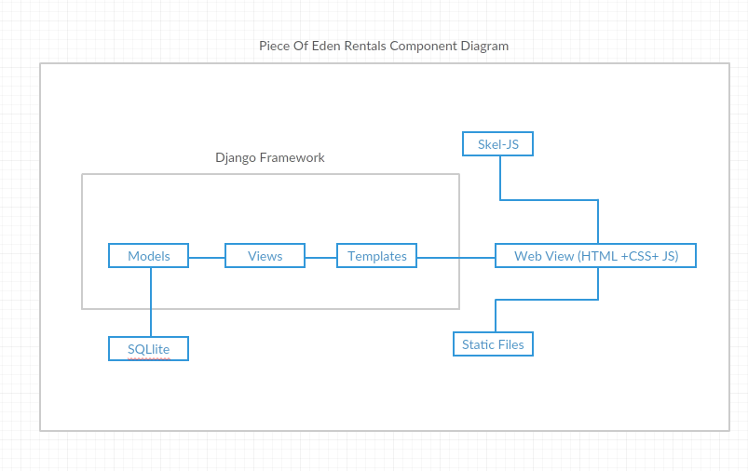
Django Stack Component Diagram (figure 1.2)

The Django stack uses core components such as Models, Views, and Templates which follows a Model View Controller architecture(MVC). The model layer is used for managing the database, consisting of various classes the correspond to tables in the SQLlite database. These models are used to handle both user data and property data providing flexibility in their access. The views layer is used to manage, abstract, and display standard(HTML,CSS, PHP, and JS) web templates which make up the template layer. The views act as the controller in Django’s MVC as they manage the data flow to and from the user. Additionally, they contain python logic that can manipulate Templates or Models dynamically per user request. What is displayed to the user is the content fetched from the Models and put into templates that are then modified as the situation demands. This allows for features such as browsing, viewing details about a property, and other which will be more fully described later in the document.

2.2 Decomposition Description

The front end web UI will be separated into 4 main pages, a homepage, a user page, a rental submission page, and a rental browsing page. Greater detail as to the design of these pages is on the User Interface Design document; however, the UI will utilize a hybrid of object-oriented and procedural architecture. Each property itself is a python object that gets stored in the database with specific variables such as location of the house, picture links, rating of the house,etc… Each specific page displaying a house will be procedurally generated from the ID of the house the user requested. The generic page will act like a container that gets filled with the responses from the database as to the specific house the user selected. This work flow is shown below:

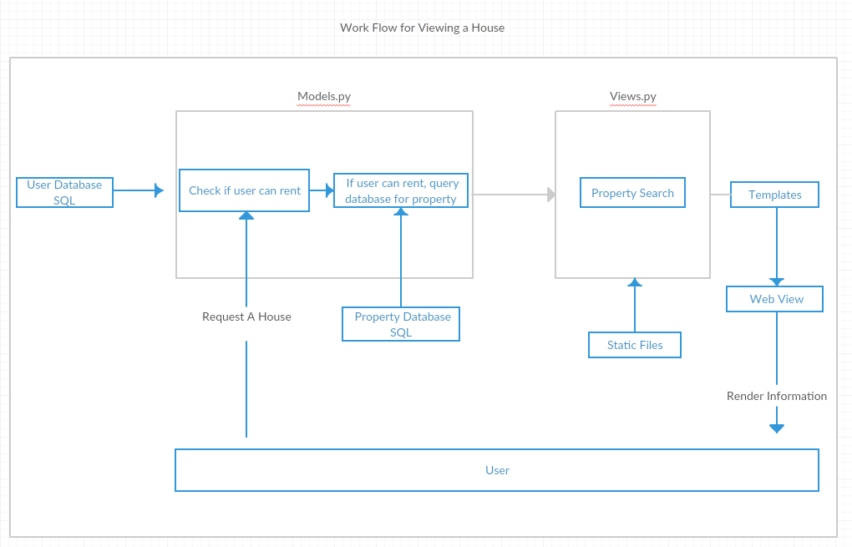

The models in the application are python classes which are used to generate and manage the SQL database tables. All property fields are publicly accessible; however, user data is only available to other users or the administrator. The main fields within

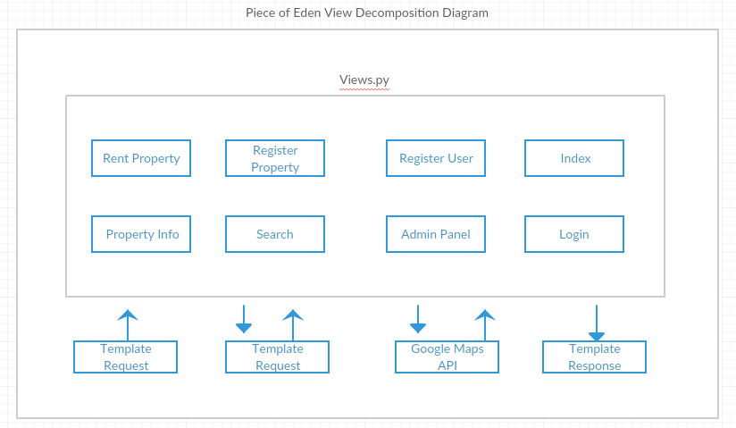

(TALK ABOUT HOW VIEWS WORK)

The Python backend will maintain the logic to properly assign the procedurally generated elements of the application to the specific variables that should contain the information to display it properly. Furthermore, it will update the information in the database as necessary using the Django MongoDB Engine’s direct integration tools.

3. Persistent Data Design
3.1 Database Descriptions
The database itself is separated into two parts, a property database which is publicly viewable, and a user database which has security restrictions. The user database information will not be available unless the user is logged in. Furthermore, the user’s themselves are only able to edit their own information. However, the admin user can edit both the user and the property database. An entry-relationship schema is used for both databases and both are run using SQLlite.

Entry and modification of the database is directly done through python scripting. Django has built in functions for using model abstraction classes to generate the database tables. Access to these tables is then handled through python classes which have specific access abilities to each table. Modifying and reading specific tables requires a unique token to be passed to each user of the site in order to prevent cross site and/or unwanted data manipulation. Furthermore, the python classes allow for direct input validation in an environment where incoming arbitrary data or code does not have the ability to be executed or inserted unless proven valid. Through this the data integrity is maintained throughout the site. The schema diagrams for the user and property database are shown bellow.
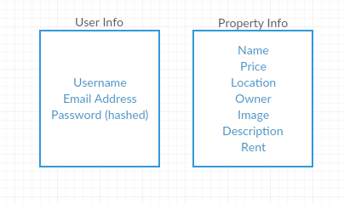

4. Requirements Matrix
Please refer to the System Requirements Specification for details regarding the
corresponding use cases.
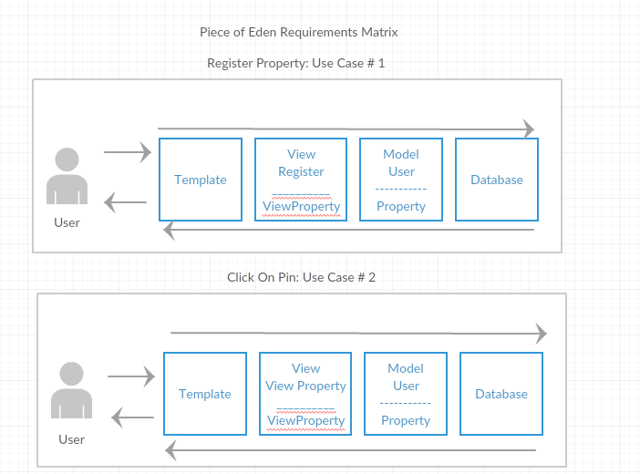
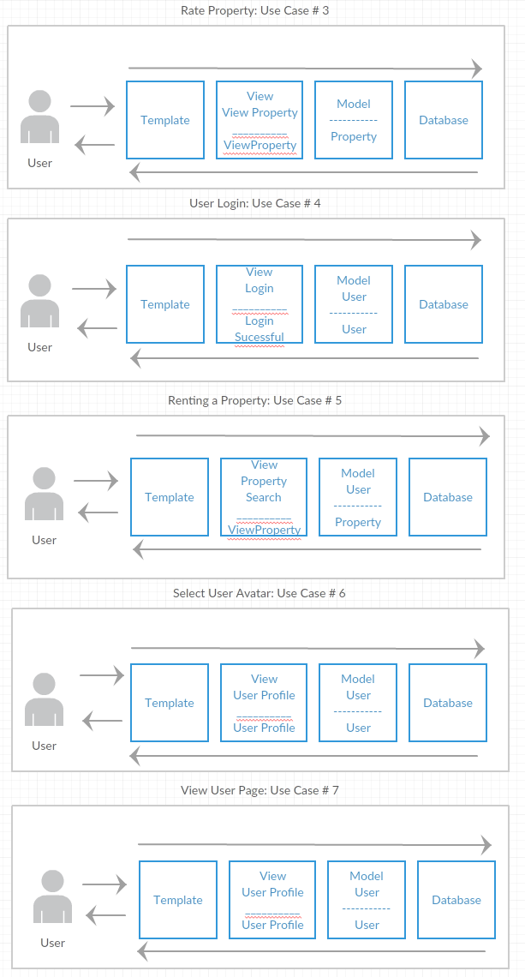

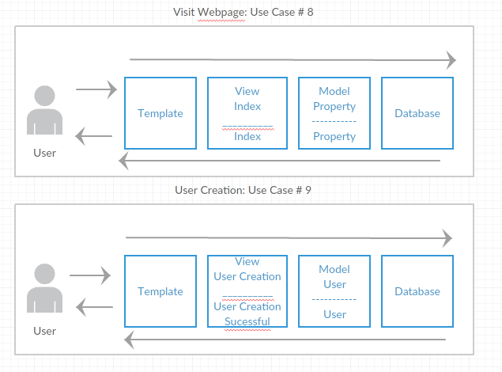

5. Appendix A – Agreement Between Customer and
Contractor
The customer agrees to a Luxury Rental Network system with searching, browsing and
detailed meta-data capabilities. See System Requirements Specification for more
information. Additional features will be provided in further development spirals.
When and if future changes to this document occur a drafted new document will be
created. Both a hard and electronic copy of both versions will be presented to the client for
review. Upon approval, the draft will be finalized and signed off by both parties.

Client
Name _________________________________________ Date
___________________
Print
Name _________________________________________ Date
___________________
Signature
Team
Name _________________________________________ Date
___________________
Print
Name _________________________________________ Date
___________________
Signature
Name _________________________________________ Date
___________________
Print
Name _________________________________________ Date
___________________
Signature
Name _________________________________________ Date
___________________
Print
Name _________________________________________ Date
___________________
Signature
Name _________________________________________ Date
___________________
Print
Name _________________________________________ Date
___________________
Signature
Name _________________________________________ Date
___________________
Print
Name _________________________________________ Date
___________________
Signature
Name _________________________________________ Date
___________________
Print
Name _________________________________________ Date
___________________

Signature
6. Appendix B – Team Review Sign-off
This document has been collaboratively written by all members the team.
Additionally, all team members have reviewed this document and agree on both
the content and the format. Any disagreements or concerns are addressed in
team comments below.
Team
Name _________________________________________ Date
___________________
Print
Name _________________________________________ Date
___________________
Signature

Comments
______________________________________________________________
______________________________________________________________________
__
Name _________________________________________ Date
___________________
Print
Name _________________________________________ Date
___________________
Signature
Comments
______________________________________________________________
______________________________________________________________________
__
Name _________________________________________ Date
___________________
Print
Name _________________________________________ Date
___________________
Signature
Comments
______________________________________________________________
______________________________________________________________________
__
Name _________________________________________ Date
___________________
Print
Name _________________________________________ Date
___________________
Signature
Comments
______________________________________________________________
______________________________________________________________________
__
Name _________________________________________ Date
___________________
Print
Name _________________________________________ Date
___________________
Signature
Comments
______________________________________________________________
______________________________________________________________________
__
Name _________________________________________ Date
___________________
Print
Name _________________________________________ Date
___________________
Signature
Comments
______________________________________________________________
______________________________________________________________________
__

7. Appendix C – Document Contributions
Eric Forte is the owner of this document and, as of this version, is the sole contributor.

