User Interface Design
Document

Piece of Eden Rentals
Client
John Winder

Team 4
Stephen Masterson
Rachel Cohen
Nicholas Keckeisen
Eric Forte
Matthew Walker

3/5/2016

Piece of Eden Rentals
User Interface Design Document

Table of Contents
- Introduction
1.1 Purpose of This Document
1.2 References

2. User Interface Standards

3. User Interface Walkthrough
3.1 Piece of Eden Rentals Navigation Diagram
3.2 Piece of Eden Rentals Walkthrough
3.2.1 Searching
3.2.2 Profile

4. Data Validation
4.1 Data Validation Table

5. Appendix A – Agreement Between Customer and Contractor

6. Appendix B – Team Review Sign-off

7. Appendix C – Document Contributions

1. Introduction
1.1 Purpose of This Document
The purpose of this document is to show the user how to navigate and interact
with the Piece of Eden Rentals web application. Images will show how Piece of Eden Rentals is interconnected and will display the different pages within the application,
highlighting important features to familiarize users with all that Piece of Eden Rentals has to offer.
1.2 References
1. Piece of Eden Rentals System Requirements

2. User Interface Standards
This section contains an overview of the design standards used in the Piece of Eden Rentals web application. As seen in Figure 1.0 below, there are two aspects to the
Piece of Eden Rentals layout that are consistent throughout the application. First, the
Piece of Eden Rentals Logo will appear in the top center of every page. Second, the Menu Bar, which allows navigation through the main sub pages, will always
appear just under the Piece of Eden Rentals Logo.The Menu Bar contains four buttons users can choose from. First, the Home Button navigates to the Home Page (Figure 1.0). The Home page allows the user to login search for recently added properties, highest rated properties, or to pick a property at random. The user can also click on the rentals tab bringing forth the Rentals Screen (Figure 2.0) for featured properties. If the user clicks on either the Recently Added or Highest Rated buttons the user will be taken to the appropriate search page (Figure 2.1) more in-depth search capabilities. The User tab takes users to the user page (Figure 3.0). This page allows the user to create a user account or edit their information if their account does not already exist.

Figure 1.0 – Home Page
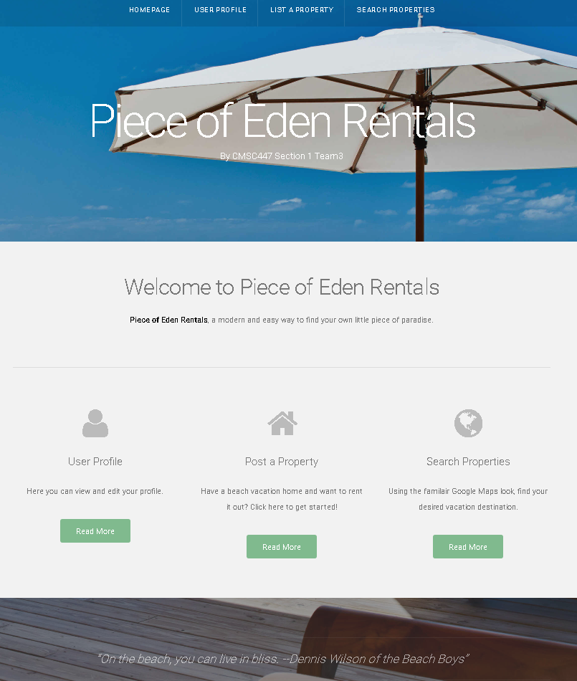
c

3. User Interface Walkthrough
3.1 Piece of Eden Rentals Navigation Diagram
The following navigation diagram or sitemap explains possible user flow through the
system. Note this is just suggested flow for users and this may not match all use cases. However, the majority of the functionality of this application is achievable through this progression.
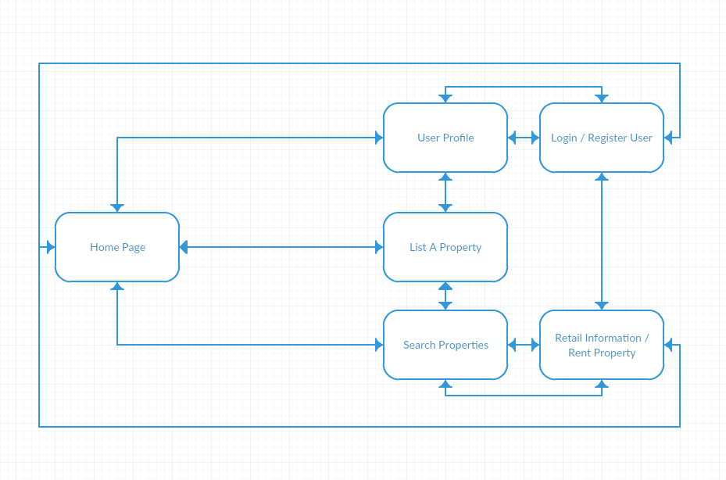

3.2 Piece of Eden Rentals Walkthrough
3.2.1 Searching
The first page, or home page, the user will see is the Home Page (Figure 1.0).
This page contains the User Interface Standards, mentioned earlier in Section 2,
as well as a Sign in or Sign up button. On this page the user can enter their information and sign in if they wish to have a personalized experience, or they can search for properties to rent. The results of the search are displayed on a Search Page (Figure 2.0 / 2.1). The search page has since been combined with the featured properties page since the last spiral however, both figure number will be used to reference this new page to maintain formatting for reference to the first iteration document. The results are organized in the order of either recently added or highest related properties. On the results page, the user may click on the property to view its rental information on the rental information page(Figure 2.2).
3.2.2 Profile
Clicking the User Button, from the Menu Bar, will navigate to the User’s Profile
Page (Figure 3.0). The User Page contains the User Interface Standards
mentioned earlier in Section 2. This information is available to the admin user and to other users who try to view the profile, usually when looking at the user’s reviews. Since the Menu Bar is on every page throughout the Piece of Eden Rentals web application, the user may view any other pages at any time simply by clicking on each respective button.
3.2.3 Create a Property
Registtered users have the ability to click on the “list a property” button on the menu tab which will navigate them to the Create a Property Screen (Figure 4). From this screen a user may enter information about the property he or she wishes to list such as name, price per night, pictures, etc... If a visitor to the site is not logged in as a user the button will produce a prompt asking the user to login before creating a property, as they do not have permission to create a property otherwise.

Figure 2.0 /2.1 - Rentals / Search Page

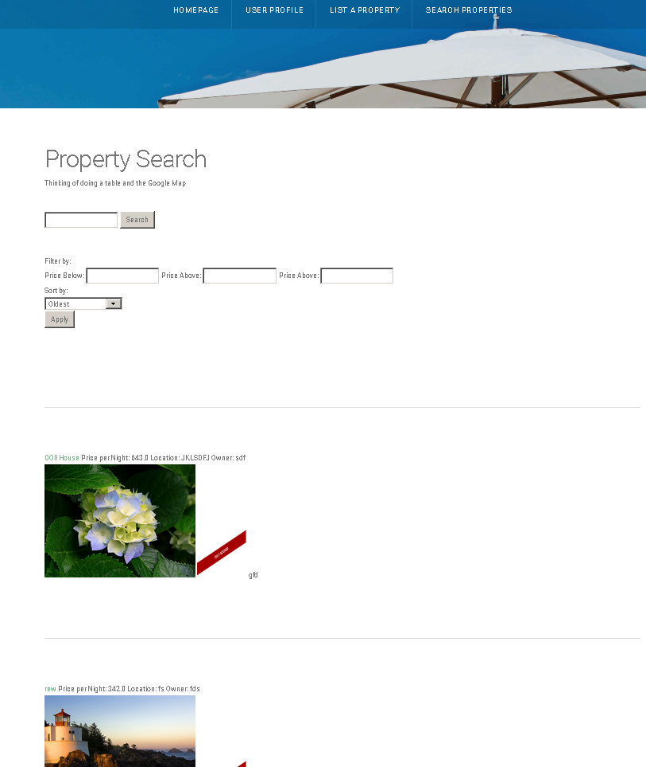

Figure 2.2 - Rental Information Page

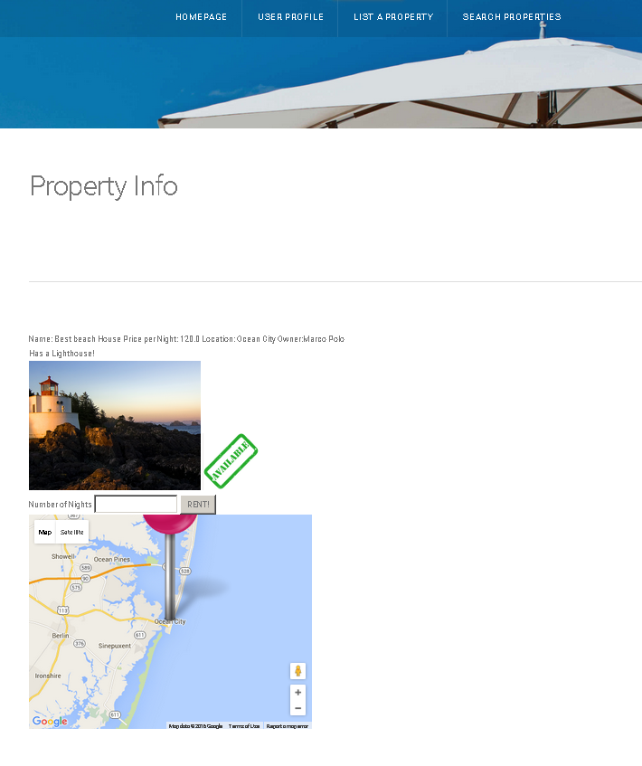

Figure 3.0 - User Page

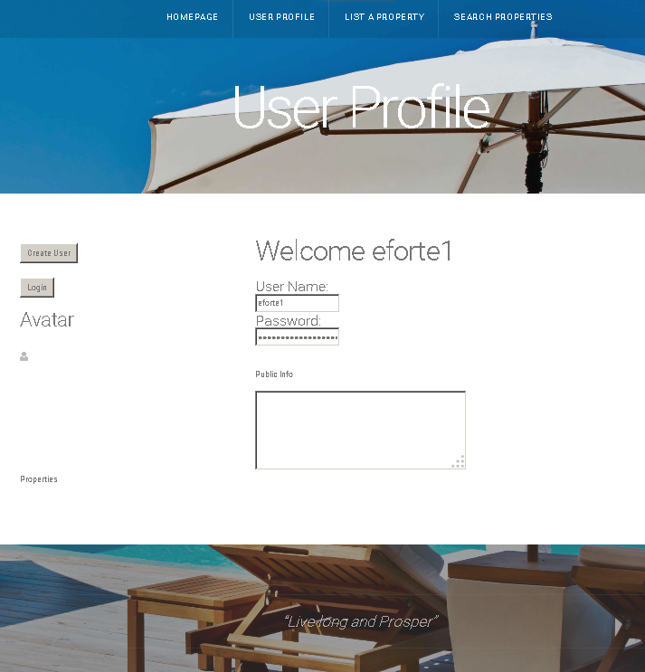

Figure 4 – Create Property Form
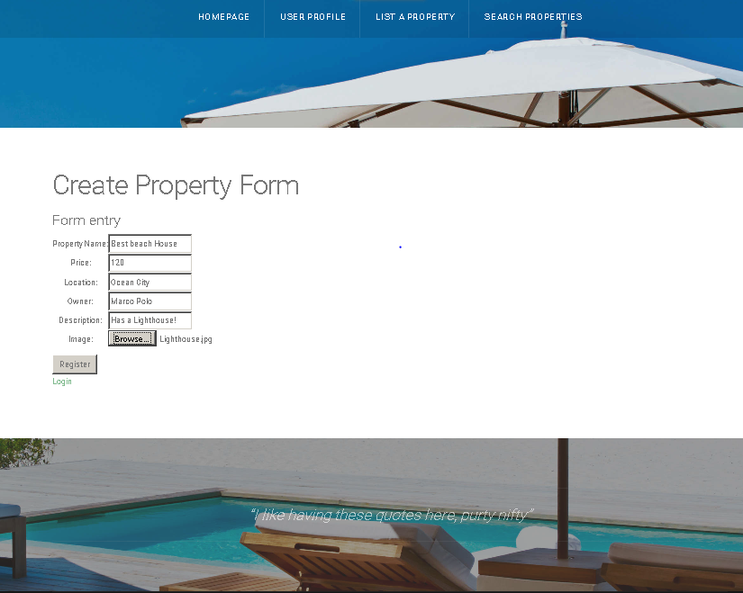

4. Data Validation
There are multiple data entry points into the Piece of Eden Rentals. They include: User names, profile pictures, user information, and reviewing property. Please refer to the table below for further information regarding allowable inputs, their limits, and allowable formats. In addition, all text that is entered is escaped for security.

4.1 Data Validation Table
User Creation Form:

Entry Location | Data Type | Limits
Username | Char Field | Length 30
Email Address | Char Field | Length 30
Password | Char Field (hashed) | Length 30

List Property Form

Entry Location | Data Type | Limits
Property Name | Char Field | Length 30
Price | Float | Valid Float
Location | Char Field (hashed) | Length 50
Owner | Char Field | Length 30
Description | Char Feild | Length 256
Image | .jpg | Valid .jpg
Rent | Integer | Valid Int

5. Appendix A – Agreement Between Customer
and Contractor
The customer agrees to a Luxury Rental Network system with searching, browsing and
detailed meta-data capabilities. See System Requirements Specification for more
information. Additional features will be provided in further development spirals.
When and if future changes to this document occur a drafted new document will be
created. Both a hard and electronic copy of both versions will be presented to the client for
review. Upon approval, the draft will be finalized and signed off by both parties.
Client
Name _________________________________________ Date
___________________
Print
Name _________________________________________ Date
___________________
Signature
Team
Name _________________________________________ Date
___________________
Print
Name _________________________________________ Date
___________________
Signature
Name _________________________________________ Date
___________________
Print
Name _________________________________________ Date
___________________
Signature
Name _________________________________________ Date
___________________
Print
Name _________________________________________ Date
___________________
Signature
Name _________________________________________ Date
___________________
Print
Name _________________________________________ Date
___________________
Signature
Name _________________________________________ Date
___________________
Print
Name _________________________________________ Date
___________________
Signature
Name _________________________________________ Date
___________________
Print
Name _________________________________________ Date
___________________
Signature
6. Appendix B – Team Review Sign-off
This document has been collaboratively written by all members the team. Additionally,
all team members have reviewed this document and agree on both the content and the
format. Any disagreements or concerns are addressed in team comments below.
Team
Name _________________________________________ Date
___________________
Print
Name _________________________________________ Date
___________________
Signature
Comments
______________________________________________________________
______________________________________________________________________
__
Name _________________________________________ Date
___________________
Print
Name _________________________________________ Date
___________________
Signature
Comments
______________________________________________________________
______________________________________________________________________
__
Name _________________________________________ Date
___________________
Print
Name _________________________________________ Date
___________________
Signature
Comments
______________________________________________________________
______________________________________________________________________
__
Name _________________________________________ Date
___________________
Print
Name _________________________________________ Date
___________________
Signature
Comments
______________________________________________________________
______________________________________________________________________
__
Name _________________________________________ Date
___________________
Print
Name _________________________________________ Date
___________________
Signature
Comments
______________________________________________________________
______________________________________________________________________
__
Name _________________________________________ Date
___________________
Print
Name _________________________________________ Date
___________________
Signature
Comments
______________________________________________________________
______________________________________________________________________
__
7. Appendix C – Document Contributions
Eric Forte is the owner of this document, and as of this version, is the sole contributor.

