User Interface Design Document

UMBC Market

**Client**

Abhay Kashyap

**Team 4**

Cory Ferrier

Sam Leung

Seth Jenkins

Wesley Chiou

Zachary Robinson

UMBC Market

User Interface Design Document

#### **Table of Contents**

1. Introduction - Page 3
   1. Document Purpose
   2. References
2. User Interface Standards - Page 4
3. User Interface Walkthrough - Page 4
   1. Navigation Diagram
   2. Walkthrough
      1. Main Page
      2. View Offer Page
      3. Account Page
4. Data Validation - Page 8

Appendix A **-** Agreement Between Customer and Contractor - Page 9

Appendix B – Peer Review Sign-off - Page 11

Appendix C – Document Contributions - Page 13

## **1. Introduction**.

1.1 Purpose of This Document

The purpose of this document is to show the user how to navigate and interact with the UMBC Market web application. Images will show how UMBC Market is interconnected and will display the different pages within the application, highlighting important features to familiarize users with all that UMBC Market has to offer.

1.2 References

* UMBC Market Systems Requirements Specifications

1.3 Intended Audience

This document is intended for use by the development team in meeting UI standards and for the clients reference.

1. **User Interface Standards**

This section contains an overview of the design standards used in the UMBC Market web application. As displayed in figures 1.0 and 1.1, there are 4 aspects to the UMBC Market layout that remain consistent throughout the application. First, the UMBC Market logo will appear in the upper left corner of every page. Second, a help and FAQ button will appear in the upper right corner of every page. A search bar will always appear at the top of the screen. The currently logged in user will be greeted just below the help and FAQ button along with the account settings button and sign-out button. If the user has not logged in yet, then this greeting and the 2 buttons will be replaced with a username and password.

**Figure 1.0(Main Page,not logged in) Figure 1.1(Main Page, logged in)**

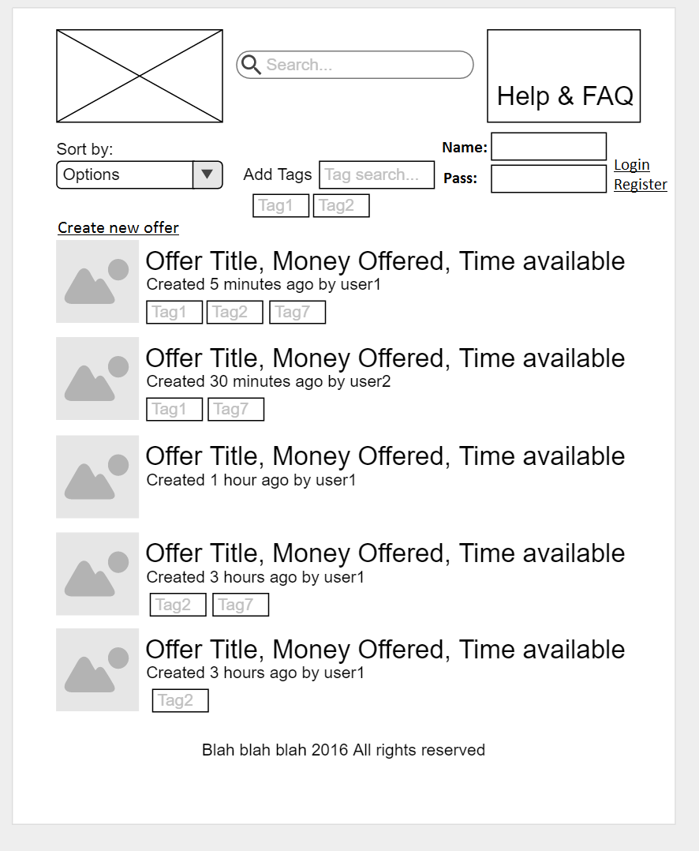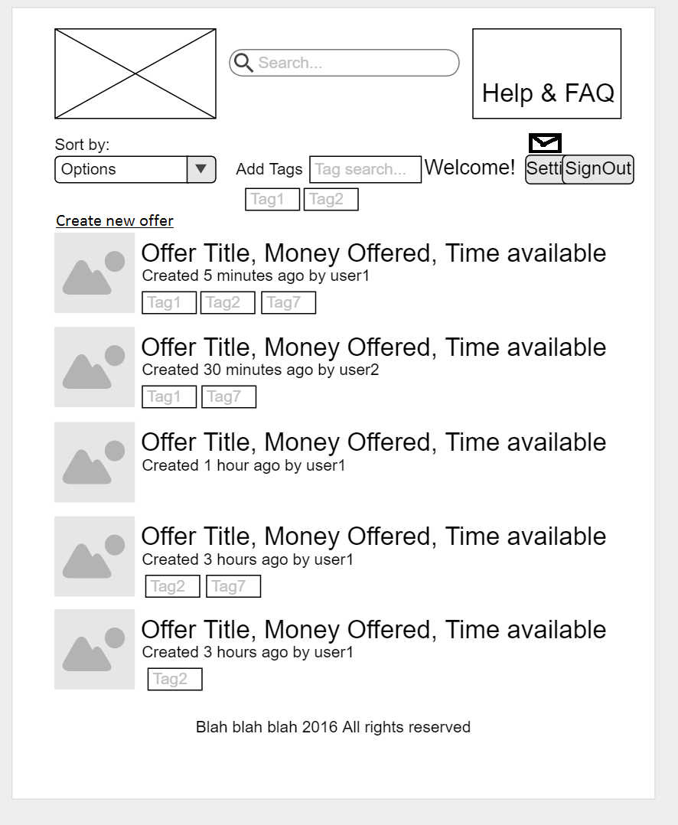

1. **User Interface Walkthrough**

The following section explains the user interface of the Application and how pages are used, navigated, and connected to one another.

**3.1 UMBC Market Navigation Diagram**

The following navigation diagram or sitemap explains possible user flow through the system.

Navigation Diagram.png

**3.2 UMBC Market Walkthrough**

**3.2.1 Main Page**

The first page, or home page, the user will see is the Main Page (Figure 1.0). This page contains the User Interface Standards, mentioned earlier in Section 2, as well as a Search Bar, and Search Button. Below the search bar and applied tags are the most recent postings. On this page the user can enter a user, item or service into the Search Box, click the Search Button, on the right, or hit the return key, to begin a search. The results of the search are displayed below, replacing the most recent postings with offers that coincide with the search string and applied tags. The results can be organized based on time, user and title which the user can determine using drop down menu below the UMBC Market icon. The user may click on either the title of an offer, to navigate to the View Offer Page (Figure 2.0),or the username of the user who submitted the offer, to navigate to the New Message Page(Figure 2.1). In addition to searching by text, the user can further narrow down the search by using tags. Tags can be added using the tag search bar which will attempt to auto-fill the string via a dropdown menu with completed suggestions. Any tags which are applied will be displayed below the tag search bar. Currently applied tags can be removed by clicking on them. The user can create new offers by clicking on the “Create New Offer” button. The button will lead them to the Create New Offer Page(Figure 2.2) where there are title, starting offer and description fields to fill out before the user can submit the new offer. The user can optionally upload a thumbnail image to their offer along with additional images. Tags can be added in a similar fashion as the search tags. An envelope icon above the Settings button will take the user to the View Messages Page(Figure 2.3). The icon will have an exclamation point on top of the icon if there are outstanding unread messages. If the user has not logged in yet, they can create an account by clicking on the Register button which will display a modal in which the user can fill out their username, password and email.

**3.2.2 View Offer Page**

The View Offer Page will display the offer as it appeared on the Main Page along with the starting offer, the description and any additional pictures that the submitter has uploaded. The user can respond to the offer by clicking on the Respond to Offer button which will take the user to the New Message Page with the submitter of the offer as the recipient of the new message. The search order drop down menu will be replaced with a return button which will take the user back to the Main Page. A Report Button is available if the submitter is offering illicit services or items or is using defamatory language.

**3.2.3 Account Page**

Clicking the Settings button will take the user to the Account Page(Figure 3.0). The user can change their password by clicking Change Password, access their message box by clicking Messaging, change their notifications by clicking Notification Settings, change their privacy settings by clicking Privacy Settings, and can report a user by clicking Report Misconduct. The user’s currently active offers will be displayed below the account options with X’s on the left of the offer which will remove the offer from the database. Clicking on Messaging will take the user to the View Messages Page where their outgoing and incoming messages can be viewed, responded to and deleted. Clicking on the title to a message will take the user to the New Message Page with the sender as the recipient of the new message.

**Figure 2.0 (View Offer Page) Figure 2.1 (New Message Page)**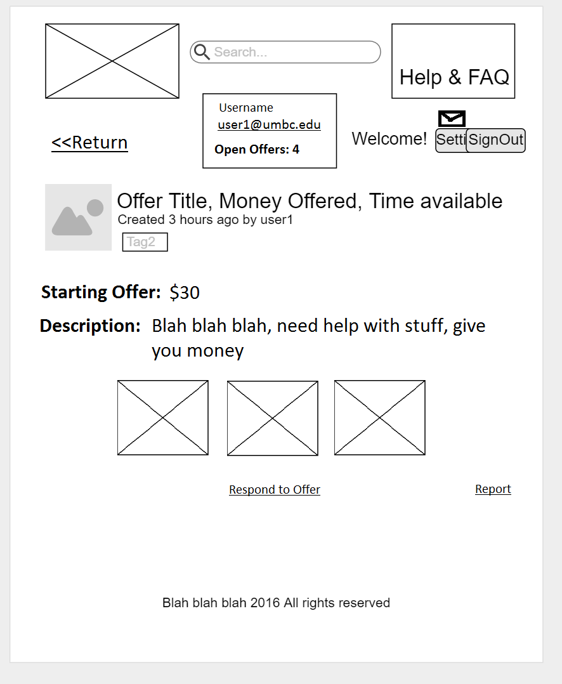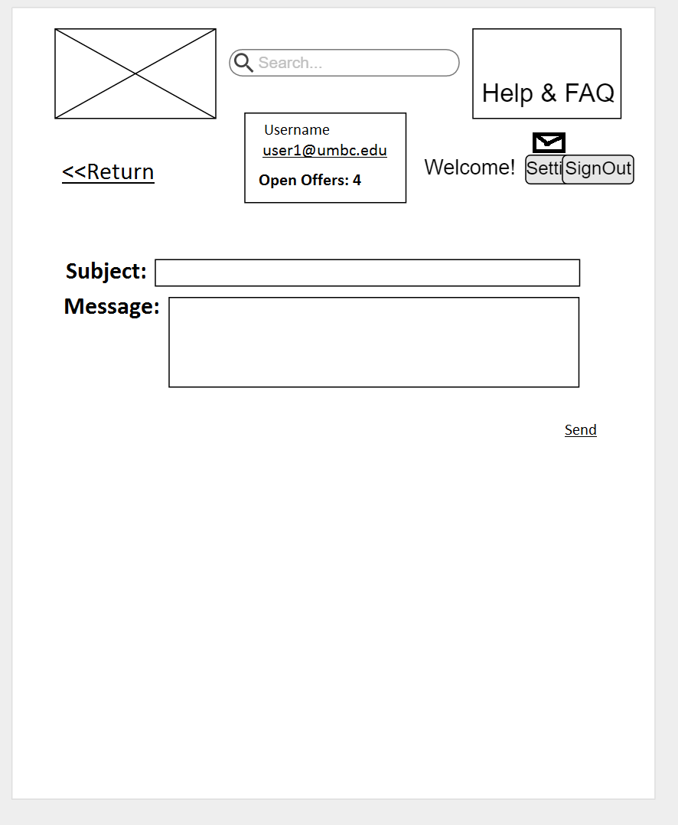

**Figure 2.2(Create Offer Page) Figure 2.3 (View Messages Page)**

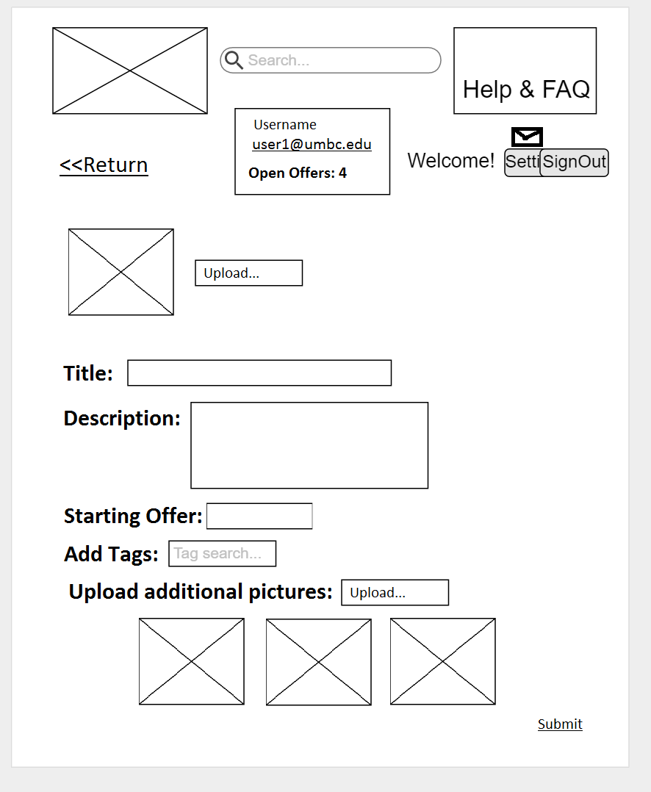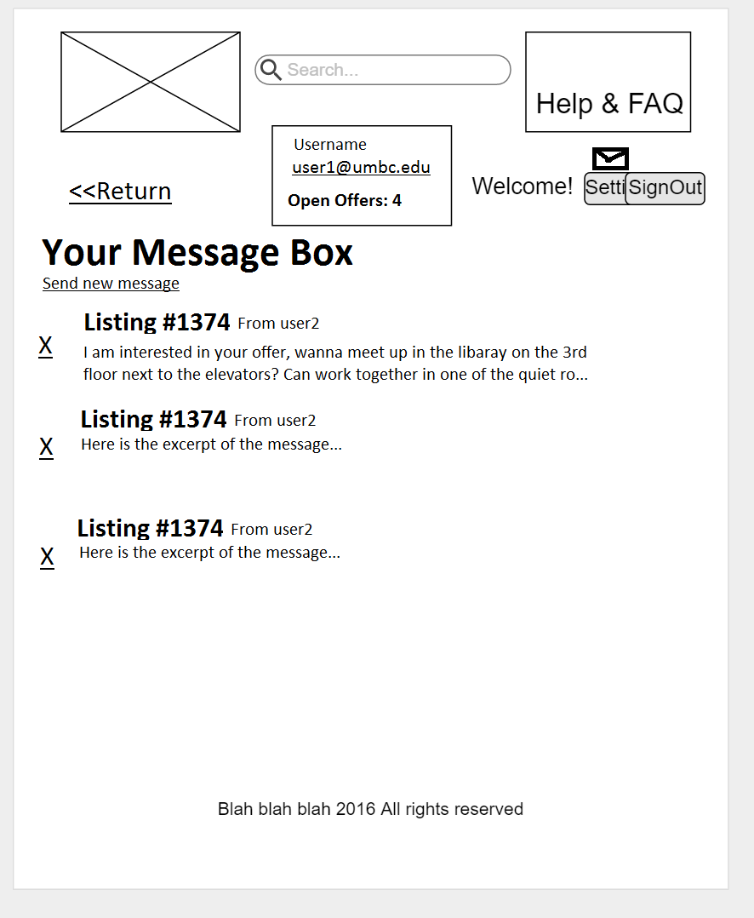

**Figure 3.0(Account Page)**

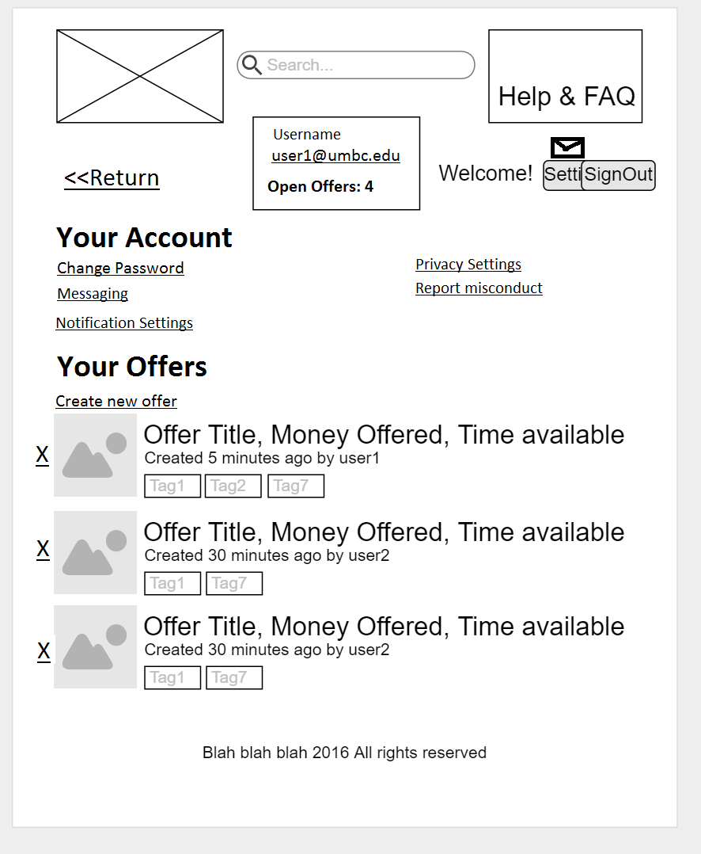

1. **Data Validation**

The following table describes the possible inputs that the Application accepts and their associated restrictions.

|  |  |  |  |  |  |
| --- | --- | --- | --- | --- | --- |
| **Item** | **Description** | **Type** | **Format** | **Limit** | **Figure** |
| Search Entry | Used to refine displayed listings | String | N/A | 2 - 50 characters | All |
| Name | Log-in username | String | N/A | 2 - 20 characters | 1.0 |
| Password | Log-in password | String | N/A | 8 - 20 characters | 1.0 |
| Email | Account Email | String | Email | 7 - 50 Chars | N/A |
| Add Tags | Used to view a category of listings | String | N/A | 2 - 20 characters | 1.0, 1.1, 2.2 |
| Subject  (Optional) | Subject for a message | String | N/A | 0 - 100 characters | 2.1 |
| Message | Body of a message | String | N/A | 1 - 1000 characters | 2.1 |
| Title | Title for a new offer | String | N/A | 2 - 50 characters | 2.2 |
| Description | Description of a new offer | String | N/A | 1 - 500 characters | 2.2 |
| Starting Offer | Initial bargaining point for a new offer | Float | xxx.xx | 0 - 999.99 | 2.2 |
| Images (Optional) | Images to be displayed under the listing | Image | JPEG  PNG | 10MB per image  Maximum 5 images | 2.2 |

# Appendix A - Agreement Between Client and Contractor

The client and contracted team members have come to an agreement on the scope and functionality of the UMBC Market Application to be created. The scope and functionality is detailed clearly through the provided use cases in section two of this document.

If future changes to this document are required, any modifications made will be reviewed by the client and each team member. The client and each team member will then again sign and date the document indicating their approval. When all parties have verified and signed the modified document, the modified document will then become the active working document for the application and the prior instance is deemed void.

**Client**

Name(print): __________________________________________ Date: ____________

Signature: ___________________________________________

Comments: ______________________________________________________________________________________________________________________________________________________________________________________________________________________________________________________________________________________________________________________________________________________________

**Team**

Name(print): Cory Ferrier Date: 10/31/2016

Signature: Cory Ferrier

Name(print): Zachary Robinson Date: 11/2/2016

Signature: Zachary Robinson

Name(print): Sam Leung Date: 11/2/2016

Signature: ___________________________________________

Name(print): Wesley Chiou Date: 11/2/2016

Signature: Wesley Chiou

Name(print): __________________________________________ Date: ____________

Signature: ___________________________________________

# Appendix B - Team Review Sign-off

Each team member has reviewed this document and approves of its content and format. Any minor points of contention are addressed in the comments below.

**Team**

Name(print): Cory Ferrier Date: 10/31/2016

Signature: Cory Ferrier

Comments: ____________________________________________________________________________________________________________________________________________

______________________________________________________________________

Name(print): Zachary Robinson Date: 11/2/2016

Signature: Zachary Robinson

Comments: ____________________________________________________________________________________________________________________________________________

______________________________________________________________________

Name(print): Sam Leung Date: 11/2/2016

Signature: Sam Leung

Comments: ____________________________________________________________________________________________________________________________________________

______________________________________________________________________

Name(print): __________________________________________ Date: ____________

Signature: ___________________________________________

Comments: ____________________________________________________________________________________________________________________________________________

______________________________________________________________________

Name(print): __________________________________________ Date: ____________

Signature: ___________________________________________

Comments: ____________________________________________________________________________________________________________________________________________

______________________________________________________________________

# Appendix C - Document Contributions

Zachary Robinson drafted and edited section 4, the Data Validation Section. He additionally reviewed and made edits to the other sections of the document.

Wesley Chiou contributed to sections 1-3, created UI figures referenced by sections 2 and 3. Made edits to those sections following client feedback.

Cory Ferrier made changes to the Data Validation Section, added to the Introduction Section, and improved the table of contents.

Sam Leung reviewed the document for any errors, fixed minor formatting errors within the document, and modified the table of contents.