CMSC 447: Software Engineering I

**UMBC ParkingPal**

**User Interface Design Document**

Customer:

Katherine Gibson

Team: UMBC Construction Workers

Abbie Minor

Constantin Koehler

Braxton Dubin

Naomi Schumacher

Sarah Kirby

UMBC ParkingPal

User Interface Design Document

**Table of Contents**

**1. Introduction****3**

1.1 Purpose of This Document 3

1.2 References 3

**2. User Interface Standards****3**

**3. User Interface Walkthrough****6**

**4. Data Validation****11**

**Appendix A – Agreement Between Customer and Contractor****13**

**Appendix B – Team Review Sign-off****14**

**Appendix C – Document Contributions****15**

# 

# 

# 1. Introduction

## 1.1 Purpose of This Document

The purpose of this document is to clearly define user interface standards, the user interface walkthrough, data validation, and report formats for UMBC ParkingPal. This document is important to the customer because it details the general physical layout and functionality of the webapp. For the development team, it outlines a plan and gives a sense of direction for the design of the web application.

## 1.2 References

The UMBC ParkingPal System Requirements Specification

# 2. User Interface Standards

This section provides an overview of the design standards the team plans to implement. There are multiple aspects of the layouts that will remain consistent from page to page. They are the UMBC ParkingPal logo on the left hand corner and the tabs located under the logo. The logo will be clickable and redirect the user to the homepage. The tabs make it easy for the user to navigate to the most frequently used subpages of the website. Figure A below shows how the homepage will look when the user first navigates to the application. In addition to the two features mentioned, there is a login/register button in the center of the page, directly after the Terms of Service. Prompting the user to log in or register before they proceed further into the site ensures that they are a valid participant on the site (a member of the UMBC community), have agreed to the site terms and conditions, and have agreed to the UMBC parking policies (linked to in the terms and conditions of the site).

*Figure A: Basic layout for the homepage before the user is logged in or registered.*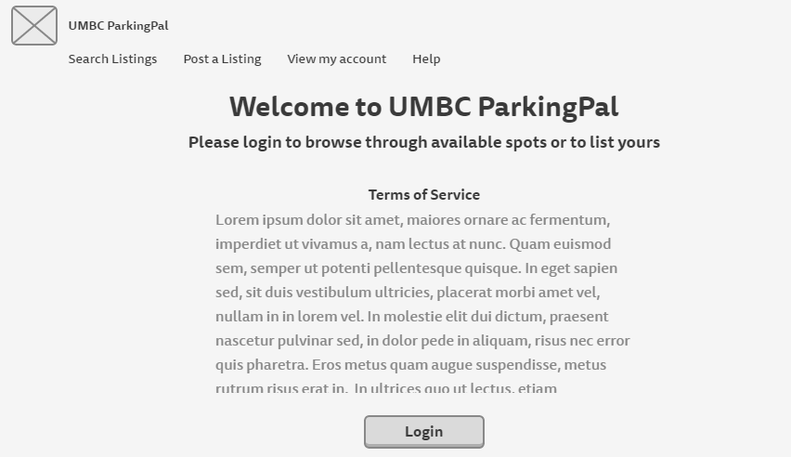

For registration, the user is directed to a page where they must fill out information regarding their permit type, car make, model, color, year, license plate, and phone number. If the user violates any of the data validations listed in Section 4, they will receive an error message stating their mistake and will be prompted to re-enter their information. Registration requires acknowledgement and acceptance of the terms of service.

Once registered and logged in, the user’s homepage will appear as in Figure B. The user’s active purchases and active listings are generated in a custom homepage. If the user has none, it will prompt them to either browse available spots or list a spot. There is also a “Logout” button in the top right corner to terminate the session.

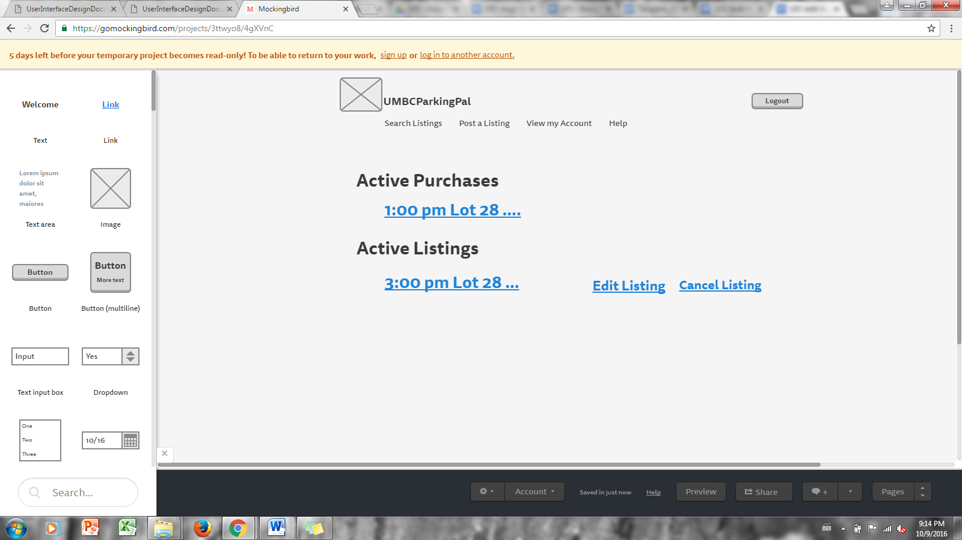

*Figure B: Basic layout for the homepage after the user is logged in.*

If the user selects “Search Listings,” they are redirected to a page where they see a map of the campus parking lots and dropdowns across the top. The user can either click on a location on the map or select a parking lot from the dropdown. The user also has a show all listings view, which will show all listings including time, price, location, and seller rating.

Once a spot is selected, the user is directed to a purchasing page where they can pay through PayPal or Venmo. After the purchase is confirmed, more details as to the exact location and the seller’s car information are given. A confirmation email will be sent to both users stating that the transaction has taken place. After the purchase and exchange of spots, the user is prompted to leave a 0-5 star review of their experience with that particular seller.

For listing a space, the seller clicks the “Post a Listing” button. A listing post page is activated similar to the buyer page with maps and dropdowns. The seller narrows down the location of their car, then they are able to specify a price and time of departure. If the user incorrectly enters any of this information, they will receive an error with their mistake and will be directed back to the previous screen to correct the information.The seller also has the ability to edit their listing or cancel it as long as it has not been purchased yet. The screen for editing is the same as for listing with the fields populated with the current values. To cancel, the user can either scroll to the bottom of the edit screen or cancel through the shortcut on the homepage once their spot is listed. If the spot has already been purchased, the seller will receive an error message stating that they cannot cancel the listing due to this reason.

If the user selects “View my Account,” they are able to edit their account details such as permit type, car make, model, color, license plate, and phone number. The “Help” tab links the user to a help page with basic instructions on how to use the tool.

# 3. User Interface Walkthrough

The table below shows all the different pages available for this webapp. The pages listed under the navigation column are the pages that are directly connected to the listed page via hyperlink or other redirects.

Note: Unless marked with an asterisk below, all pages will be able to navigate to the following pages due to the navigation bar at the top of the page:

* Search Listings
* Post a Listing
* Account Settings
* Help/FAQ

|  |  |  |
| --- | --- | --- |
| Screen | Page Description | Navigation |
| A | Welcome Screen | * * * UMBC Login Page -> C *(if user does not already have an account)* * UMBC Login Page -> B *(if user has logged in before)* |
| B | Home Page | * Active Purchase * Active Listing * Edit Listing -> Confirmation Page -> B *(if user already has a listing up)* * Cancel Listing -> Confirmation Page -> B *(if user already has a listing up)* |
| C | Registering an Account | * * * B |
| D | Search for Listings (Map) | * H |
| E | Parking Spot List | * Paypal Login Page -> Transaction Confirmation Page *(user can rate transaction here)* -> B |
| F | Post a Listing | * Listing Confirmation Page -> B |
| G1 | Account Settings | * N/A |
| H | FAQs | * N/A |

* Unable to navigate to the pages listed above in the note.

Below are all of the frameworks for each page listed above. Please note that confirmation pages and pages that are not explicitly created by us (Paypal login, UMBC login, etc) will not be shown here.

# 

*Figure C: This is the page that will be shown when the user logs into the webapp for the first time using their myUMBC login. The user is able to fill out the rest of their details to continue registration.*

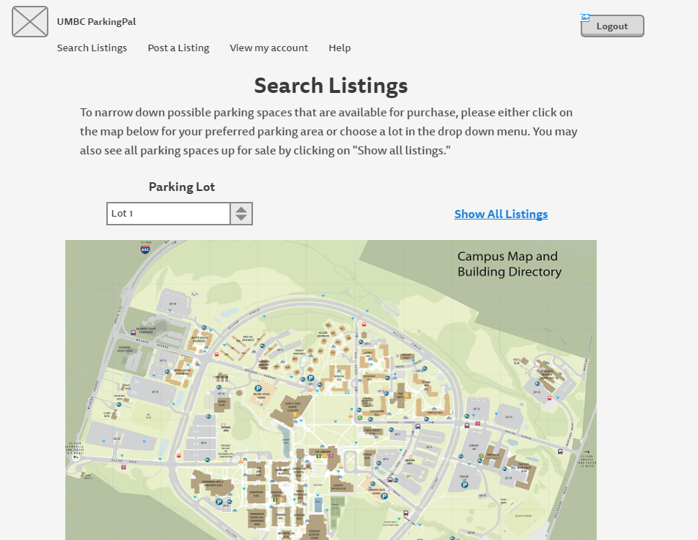

*Figure D: Above is the main navigation page when searching for a listing. The user will be able to specify which area they would prefer to park by either locating a specific parking lot under the dropdown menu or clicking on the map for a general area of where’d they’d like to park. The user may also look at all listings available via “Show All Listings.”*

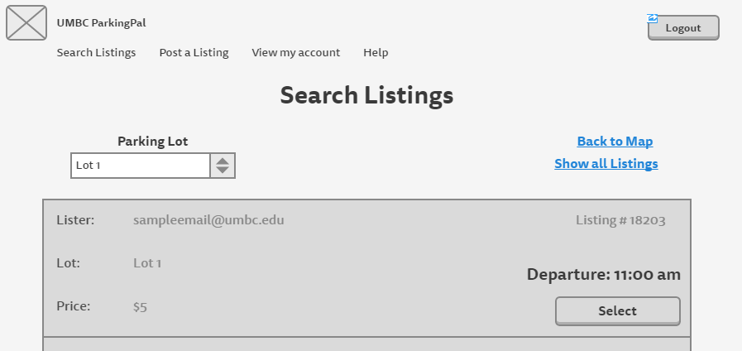

*Figure E: Above is the page that comes up after the user specifies which area they’d like to park in from figure D. All spots that fall into the chosen category will be shown here.*

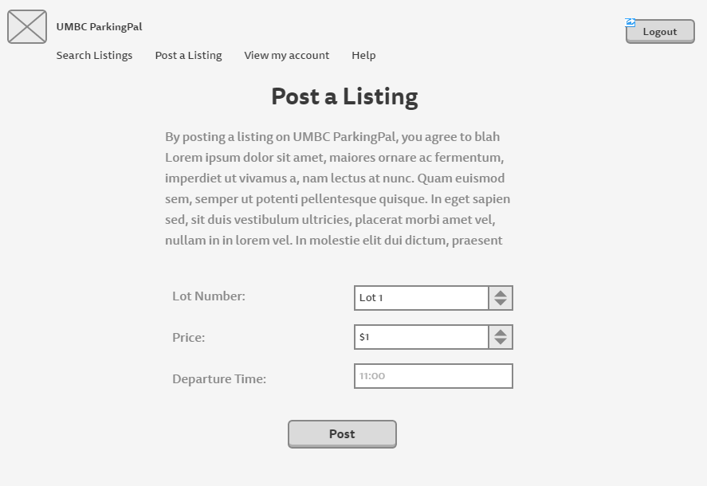

*Figure F: Above is the page for listing a parking spot for sale. There will be a blurb at the top of the page stating all of the statements the user must agree to to post a listing on UMBC ParkingPal.*

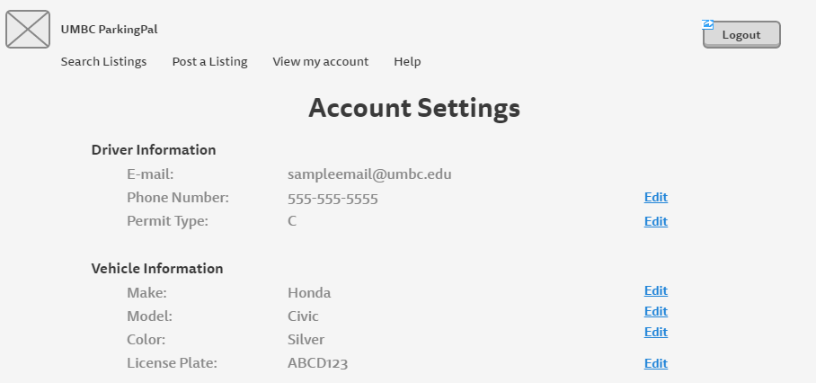

*Figure G1: Above is the page that comes up after clicking on “View my account” in the navigation bar. Here, the user is able to change any information about the driver or the vehicle.*

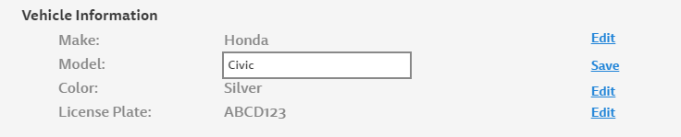

*Figure G2: This just shows what will happen when “Edit” is clicked on in figure G1.*

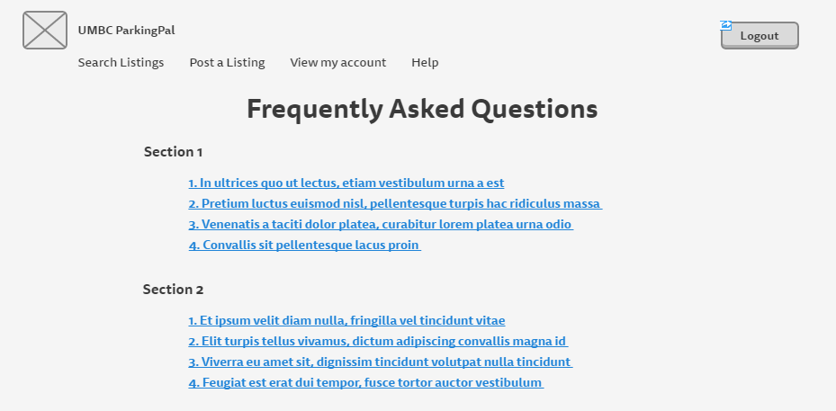

Fi*gure H: Above is the page that comes up when the user clicks on “Help” in the navigation bar. Here, they are able to search for any possible questions they may have about the webapp. Clicking on the hyperlinks will take them to the corresponding answer down lower on the page.*

Fi*gure I: Above is the page where the seller consents to sending their parking information to the buyer.*

# 4. Data Validation

There are multiple data entry points in UMBC ParkingPal. Data entry points include registering as a new user, registering or updating car info and contact info, searching for a spot, listing a spot, and leaving a review. Please refer to the table below for information regarding inputs types and limits. In addition all text that is entered is escaped for security.

|  |  |  |  |
| --- | --- | --- | --- |
| **Screen Name** | **Data Label** | **Type** | **Limits** |
| User Information | Permit Type | Char | Limited by dropdown |
|  | Car Make | String | 20 Char limit, A-z, a-z, 0-9 |
|  | Car Model | String | 20 Char limit, A-z, a-z, 0-9 |
|  | Car Color | String | 20 Char limit, A-z, a-z |
|  | License Plate | String | 8 Char limit, A-Z, 0-9, - only. Hyphens and spaces included in char count. |
|  | Phone Number | String | 10 Char limit, 0-9 only |
| Search for a Spot | Lot Number | Int | Limited by dropdown |
| Listing a Spot | Lot Number | Int | Limited by dropdown |
|  | Hour leaving | Int | Must be 1-12, am/pm specified by dropdown. Will be converted to military time. |
|  | Minute leaving | Int | Must be 0-59 |
|  | Price | Int | Limited by dropdown |
| Confirm Exchange | Rating | Int | 0-5, limited by dropdown |

# 

# 

# Appendix A – Agreement Between Customer and Contractor

By signing this document all members of the team agree to complete the project with the design specified.

If future changes need to be made to the design, the team members agree to consult with the customer and vice versa. If an agreement is made, it must be made in writing and the design documents must be updated with the changes.

Abbie Minor ____________________________ Date: __________

Constantin Koehler ____________________________ Date: __________

Braxton Dubin ____________________________ Date: __________

Naomi Schumacher ____________________________ Date: __________

Sarah Kirby ____________________________ Date: __________

Katherine Gibson ____________________________ Date: __________

(Customer)

Customer Comments:

# Appendix B – Team Review Sign-off

All members of the team have reviewed this document and agree on its content and format. They agree to follow the interface design specified for UMBC ParkingPal. They agree to discuss possible areas for change with other team members and follow the guidelines for making changes to the document. The comment areas below are to be used to state any minor points regarding the document that members may not agree with.

Abbie Minor ____________________________ Date: __________

Comments:

Constantin Koehler ____________________________ Date: __________

Comments:

Braxton Dubin ____________________________ Date: __________

Comments:

Naomi Schumacher ____________________________ Date: __________

Comments:

Sarah Kirby ____________________________ Date: __________

Comments:

# Appendix C – Document Contributions

This section identifies how each member contributed to the creation of this document. The percentages listed are an estimate of the percentage of work each person contributed.

Abbie Minor: 25%

Contribution: User Interface Standards, Table of Contents

Constantin Koehler: 0%

Contribution: None

Braxton Dubin: 25%

Contribution: Initial User Interface Design

Naomi Schumacher: 25%

Contribution: Appendices, User Interface Walkthrough, proofreading

Sarah Kirby: 25%

Contribution: Data Validation, Document template