
Statistical Analysis Plan

DP4 (WP1): Demonstrating solutions for studying intermittent medication exposures in diseases with episodic manifestations during pregnancy: application to medication for migraine in pregnancy
- Medication safety study

This study will be conducted within the ConcePTION project of the Innovative Medicines Initiative under grant agreement No 821520

Title | Demonstrating solutions for studying intermittent medication exposures in diseases with episodic manifestations during pregnancy: application to medication for migraine in pregnancy
Protocol version identifier | 1.0
Date of last version of protocol | 30/09/2021
EU PAS register number | EUPAS43409
Active substance | Primary exposure: Triptans (ATC: N02CC)  Co-medications: analgesics; preventive anti-migraine therapy; antiemetics
Medicinal product | Sumatriptan (ATC: N02CC01), Naratriptan (ATC: N02CC02), Zolmitriptan (ATC: N02CC03), Rizatriptan (ATC: N02CC04), Almotriptan (ATC: N02CC05), Eletriptan (ATC: N02CC06), Frovatriptan (ATC: N02CC07)
Research question and objectives | This study is based on electronic health care registry data from 7 health care data bases in 7 European countries between 2005 and 2019/most recent data available.  Medication safety study: To study the association between prenatal exposure to triptans and adverse maternal and pregnancy outcomes. The potential impact of exposure misclassification on exposure-outcome associations will be assessed under a range of scenarios. Results from across data sources will be combined using meta-analytic techniques.
Country(-ies) of study | Norway (Nationwide), Finland (Nationwide), France (Haute-Garonne), Italy (Emilia Romagna, Tuscany), Spain (Valencian Region), UK (Wales for SAIL), and Sweden (Nationwide) pending on results from the Data characterization (WP7).
Author(s) | Dr. Angela Lupattelli and Prof. Hedvig Nordeng  PharmacoEpidemiology and Drug Safety Research Group, Faculty of Mathematics and Natural Sciences, University of Oslo, Norway.  Post box 1068 Blindern, 0316 OSLO  Telephone : +47 450 33 984​  E-mail: angela.lupattelli@farmasi.uio.no; h.m.e.nordeng@farmasi.uio.no;

Reviewers of the document
Name | Institution | Role
Joan Morris | St George’s University of London, UK. Statistician | Statistical expert
Marte-Helene Bjørk | Haukeland University Hospital and Department of Clinical Medicine, University of Bergen, Norway, Medical expert | Clinical expert
Ditte Mølgaard-Nielsen | Novo Nordisk A/S | WP7
Ema Alsina  Vjola Hoxhaj | University Medical Center Utrecht, UMCU, Utrecht, The Netherlands | R programmer
Anja Geldhof | Janssen | WP1 lead
Marianne Cunnington | GSK (CPRD) | WP7 lead
Anna-Belle Beau, Marie Beslay, Christine Damase-Michel | Centre Hospitalier Universitaire, Toulouse, FRANCE | DAP
Amanda Julie Neville, Elisa Ballardini | Epidemiology and Clinical Research Center, University of Ferrara, and Emilia Romagna Region, ITALY | DAP
Rosa Gini, Giuseppe Roberto, Giulia Yeraci | Agenzia Regionale di Sanita, ARS, ITALY | DAP
Clara Cavero-Carbonell, Laia Barrachina-Bonet | Rare Disease Research Unit, FISABIO: The Foundation for the Promotion of Health and Biomedical Research of Valencian Region, SPAIN | DAP
Maarit K Leinonen | Finnish Institute for Health and Welfare, Information Services Department, Helsinki, FINLAND | DAP
 | Sweden (uncertain) | DAP

Document history:
Protocol approved by the IMI ConcePTION management team: 27.09.2021.
The related protocol has been uploaded to the EU PASS register: 01.10.2021.
SAP approved by all DAPs: Jan 2023
Amendments and Updates
SAP amendments following first approval: xxx

Number | Date (DDMMMYY) | Section of the SAP | Amendment or update | Reason
1
2
….

Introduction
This is the statistical analytical plan (SAP) of the ConcePTION demonstration project aiming at providing guidance on how to study intermittent medication exposures in diseases with episodic manifestation during pregnancy. The project is organized in two parts:
- Part 1. Medication Utilisation study and Event/Outcome Definition
- Part 2. Medication Safety study
This SAP relates to Part 2 only.
The background and rationale for this SAP is outlined in more detail in the corresponding protocol. In brief, knowledge about benefits and harms related to pharmacological treatment of diseases with episodic manifestations has been inadequate for years due to the difficulties and lack of harmonization in assessing intermittent medication use in pregnancy using records of medicines’ prescription or dispensing. Medication exposure will often vary over the course of pregnancy, with exposure episodes depending on a range of factors including fluctuation in disease activity, co-medication use and the women’s perception of her needs, drug risks and benefits. Failure to take into account the time-varying component of exposure and confounders may lead to biased estimates in drug in pregnancy safety studies. For instance, disease severity at start of pregnancy may be associated with drug exposure in early pregnancy, but such exposure status may in turn affect disease severity in mid-pregnancy. This may in turn predict drug exposure in mid-late pregnancy. In this example, disease severity acts as mediator at the time point of mid-pregnancy, and adjustment for it may introduce biases.
Medications to treat migraine, specifically triptans, are used as motivating example in this project. The rationale behind this choice is three-fold: (i) triptans are important rescue migraine medications in pregnancy; (ii) migraine is a relapsing-remitting pain condition; (iii) the available literature on the reproductive safety of triptans is not yet exhaustive to inform evidence-based clinical decisions. We use Part 1 of this project to inform decisions in the current Part 2 SAP; amendments to this Part 2 SAP may occur when results of Part 1 become available. Part 1 focussed on correctly defining exposure (i.e. migraine medication), the underlying disease (i.e. migraine) and selected outcomes associated with the underlying disease (i.e. preeclampsia and gestational diabetes).
To emulate the design of a hypothetical randomized drug trial, the project includes pregnancies within women having an underlying indication for treatment with triptans prior to pregnancy start.¹ Health outcomes of interest will then be measured among triptan continuers in pregnancy, and compared to triptan discontinuers before pregnancy, and non-medicated with migraine. To generalize further the findings, an additional population comparison group (no triptan, no migraine) is evaluated. The stricter target trial approach comparing pregnancies initiating triptan in pregnancy with pregnancies with new onset migraine is difficult to apply due to data type available in the project, and also because migraine without aura seldom starts for the first time in pregnancy, and will thus not be applied.²

Objectives
Primary objectives of the Medication Safety Study
In a population of pregnancies with prescribed/filled prescriptions for triptan prescription in 12 months (or at least 3/2.5 months) prior to pregnancy start (depending on data source), the primary objectives are:
- To investigate whether triptan continuation in first trimester or within the first 20 weeks of gestation is associated with an increased risk for maternal gestational diabetes mellitus or preeclampsia, respectively, relative to triptan discontinuation before pregnancy.
- To determine the association between triptan continuation into the first trimester of pregnancy and congenital anomalies in the offspring, relative to triptan discontinuation before pregnancy.
- To determine the association of triptan continuation in pregnancy with preterm birth, low birth weight, small for gestational age, and non-live birth, relative to triptan discontinuation before pregnancy.
- To determine the association of continued time-varying triptan exposure in pregnancy with preterm birth, low birth weight, or small for gestational age, relative to non-exposure to triptan in the time window in pregnancy.
- To quantify the influence of triptan exposure misclassification on the investigated association measures using probabilistic bias analysis (PBA) as instructed by Lash (unadjusted PBA).^{3,4}
Substance level analyses for the individual triptans will also be performed, when study power is sufficient.
The secondary objectives of the Medication Safety Study are:
- To investigate whether extended use of continued triptan in early/mid-pregnancy is associated with an increased risk for maternal preeclampsia and gestational diabetes mellitus, relative to (i) no extended use in early/mid-pregnancy, as well as to (ii) triptan discontinuation before pregnancy.
- To determine the association between extended use of continued triptan in the first trimester of pregnancy and congenital anomalies in the offspring, relative to (i) no extended use in the first trimester, as well as to (ii) triptan discontinuation before pregnancy.
- To determine the association of extended use of continued triptan in pregnancy with preterm birth, low birth weight, small for gestational age, and non-live birth, relative to (i) no extended use during pregnancy, as well as to (ii) triptan discontinuation before pregnancy.
- To address – by design - the role of confounding by maternal migraine severity in objectives 1-3, by comparing continued triptan use in pregnancy to two additional comparators: (1) non-exposure to triptan neither before nor during pregnancy in women with migraine (=non-medicated disease comparator); (2) non-exposure to triptan neither before nor during pregnancy in women with no migraine (=population comparison).

Methods

Data sources and study period
This is a cross-country analytical study, using data from 9 or 11 data sources in 7 or 8 European countries (Germany, Finland, France, Italy, Norway, Spain, Sweden and UK) covering 5 million pregnancies across a 15-year time frame (see Table 1), all pending on results from the Data characterization (WP7). Some data sources will not provide data for the entire study period, but instead will provide data between the dates outlined in Table 1. The period in which pregnancies may be picked may be shorter than the dates in Table 1 due to additional data requirements for each pregnancy. Appendix 1 show information about the data sources in this project.
The overall period of data source coverage will run from 1 January 2004 (or later date, see Table 1) until 31 December 2019 or 30th September 2021, or at least 31 December 2018 (depending on data source). For simplicity, hereafter we will use the term “study period” to indicate the time from the earliest start date of data coverage to the latest one, as shown in Table 1.
The enrolment date into the cohort coincides with the date of last menstrual period (LMP) for each pregnancy, whenever that falls within the period from 1st January 2005 (or other dates as shown in Table 1, depending on data source) until 1st March 2019 or 1st December 2020 (or other dates as shown in Table 1, depending on data source). The rationale for this is two-fold: (a) to ensure that all pregnancies have at least one-year look-back time on prescription history (entire year 2004), or less depending on data source; and (b) to ensure that pregnancies with LMP date in the year 2019 will have the chance of being observed for the full pregnancy length. For simplicity, hereafter we will use the term “enrolment period” to indicate the time from the first LMP date to last LMP date, as shown in Table 1.
Table 1 – Start and end dates of the data source coverage, and enrolment period in each data source
Data source | Catchment area | Start - end date of the data source coverage | Start enrolment period: first LMP date | End enrolment period: last LMP date
Finland | Nation-wide | 01/01/2004 to 31/12/2018 | 01/01/2005 | 01/03/2018*
France | Haute-Garonne | 01/01/2004 to 31/12/2019 | 01/01/2005 | 01/03/2019
Italy | Emilia Romagna | 01/01/2004 to 31/12/2019 | 01/01/2005 | 01/03/2019
Norway | Nation-wide | 01/01/2008 to 31/12/2019 | 01/01/2009 | 01/03/2019
Spain | Valencian Region | 01/01/2010 to 31/12/2019 | 01/01/2011 | 01/03/2019
UK | Wales | 01/01/2004 to 31/12/2020 | 01/01/2005 | 01/03/2020
Sweden | Nation-wide | ** | ** | **
*For children born in 2018 the Malformation Register captures malformations until 2019, i.e. when the child is of 1 year of age.
**Preliminary dates for data coverage not provided by the DAP / possible DAP UK-CPRD, Sweden and the UK-Scotland. Data sources included in the project pending on results from the Data characterization (WP7).

Source population
The source population will include pregnancies with LMP date observed in one of the participating data sources during the enrolment period (see Table 1), having prescription record coverage from 12 months, or at least the 2.5 months before pregnancy through end of pregnancy. The unit of analysis in this study is the pregnancy. Pregnancies, along with the best estimates for their start and end dates within each data source, are identified using the algorithms developed by WP7 within the ConcePTION pipeline (Task 7.7); please refer to the corresponding SAP for information on how start of pregnancy / LMP date is estimated.

Pregnancy cohort
The overall pregnancy cohort will contain all pregnancies in which the mother has met the below inclusion/exclusion criteria, as also depicted in Figure 1:
Inclusion criteria
- Having 12 months of prescription data prior to LMP date, or at least 2.5 months if 12 are not available (depending on data source; see Table 2)
- Pregnancies with LMP date between the pre-defined “enrolment period” described in section 2.2 and Table 1
- Known pregnancy outcome
- Prescription data throughout their pregnancy
- Singleton pregnancy
- Age at pregnancy start (LMP) between 15 and 49 years

- Additional inclusion criteria that apply to specific objectives:
In the analyses examining associations for continued time-varying triptan exposure, we will apply the additional inclusion criteria of having migraine at baseline, defined as having filled/prescribed/dispensed at least one triptan prescription in the 12 or at least 2.5 months prior to LMP (depending on data source). See definition of exposure to triptan before LMP in section 2.4.

Exclusion criteria
- Records with missing pregnancy ID, as these are not linkable across registries within the same data source
- Pregnancies with missing or unrealistic gestational age (i.e. gestation week > 44 weeks), missing LMP and/or date of delivery, according to the level checks and pregnancy algorithm in the ConcePTION Data characterization task (7.6/7.7)
- Pregnancies with missing data on the sufficient set of confounders (complete case analyses, see section 2.7 for the list of confounders considered as sufficient set)
- Pregnancies within women possibly initiating a triptan during pregnancy, i.e. with no prior history of triptan exposure before LMP, but having filled/prescribed at least once a triptan during pregnancy**
- Pregnancies within women with a new onset diagnosis of migraine during pregnancy, i.e. with no prior history of migraine before LMP, but having received a diagnosis in pregnancy.**
**This exclusion criterion is set so that all pregnancies have comparable history prior to cohort enrolment. Because of the fluctuating nature of migraine, we may be unable to capture a fair comparator for triptan initiators in pregnancy in this safety study.

- Additional exclusion criteria that apply to specific objectives:
(a) In the analyses examining the risk of congenital anomalies, we will further exclude offspring with Down syndrome or genetic/chromosomal anomalies, as recommended by EUROCAT (Guide 1.4: Instruction for registration of congenital anomalies: JRC-EUROCAT-Full-Guide-1.4-version-15-Nov-2019.pdf (europa.eu))
(b) In the analyses examining the risk for preterm birth, low birth weight, and small for gestational age, we will exclude non-live births.
Whether the pregnancy requires 3, 2.5 or 12 months of available prescription data prior to cohort entry depends on the information their data source is providing to ConcePTION, but 12 months is prioritized. Table 2 outlines how many months prior to LMP date are available for each data source.

Table 2: Availability of prescription data around pregnancy by data source
Data Source | 12 months prior to LMP | 2.5 or 3 months prior to LMP
Finland | ☐ | ☒
France (Haute Garonne) | ☐ | ☒
Germany | ☒ | ☒
Italy (Emilia Romagna) | ☒ | ☒
Italy (Tuscany) | ☒ | ☒
Norway | ☒ | ☒
Spain (Valencian Region) | ☒ | ☒
UK (Wales) | ☒ | ☒
UK (CPRD) | ☒ | ☒

Figure 1. Description of inclusion and exclusion criteria for the pregnancy cohort and time of enrolment / cohort entry using Norway data source as example* (www.repeatinitiative.org/projects.html)

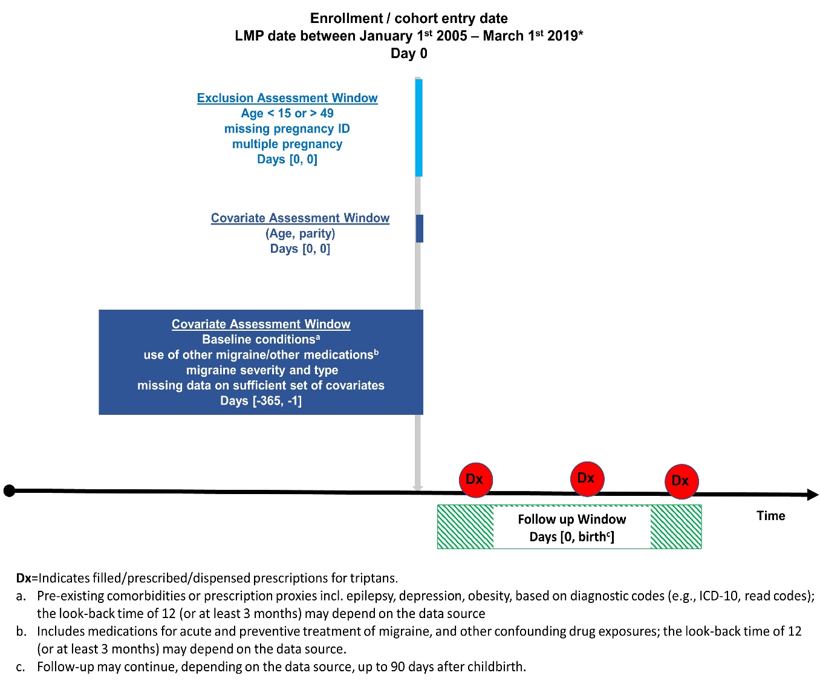

*Please note that additional inclusion/exclusion criteria apply for specific analyses (see above in section 2.3), but these are not depicted in Figure 1.

Triptan exposure
The primary exposure is triptans (ATC-code N02CC). We define triptan exposure as a maternal record for a prescription (prescribed, dispensed or reimbursed; hereafter, “prescribed/dispensed”) for a drug belonging to the class with 4th level ATC-code N02CC, and by individual substance (5th ATC-code listed below), during the relevant windows of exposure. Please refer to the SAP for identification of pregnancy developed by WP7 for information on how start of pregnancy / LMP date is estimated.
The ATC-code of the individual triptans are:
- N02CC01 sumatriptan
- N02CC02 naratriptan
- N02CC03 zolmitriptan
- N02CC04 rizatriptan
- N02CC05 almotriptan
- N02CC06 eletriptan
- N02CC07 frovatriptan

The primary windows of exposure to triptans are defined as ≥1 prescribed/dispensed triptan prescription in the period between LMP and date of delivery, or the windows of interest (see Table 3). We define a pregnancy as exposed in the corresponding window if the date when a triptan prescription was prescribed/dispensed falls within the corresponding window as defined in Table 3. The primary exposure definition does not take into account whether the number of defined daily doses (DDDs) or units prescribed/dispensed overlaps with the next time window. This is considered in the sensitivity analysis, as described in 2.7. The rationale behind this choice is the intermittent nature of the disease and its treatment with triptans.
The primary triptan exposure classifications - for the primary objectives - include:
  - Ever in pregnancy, i.e. at any time and/or at any intensity;
  - By timing, i.e. in 1st, 2nd, 3rd trimester, or in gestation week 0-20;
The secondary triptan exposure classifications - for the secondary objectives - include:
  - By intensity, i.e. extended use of triptans ever in pregnancy, in first trimester, and in week 0-20.
Primary triptan exposure classifications
We defined relevant windows of triptan exposure in pregnancy based on etiological plausibility and timing of onset of the outcome, as described in Table 3. This table also indicates how the starting and ending points for the different exposure definitions are calculated, and for which health outcomes the definitions apply.
Table 3 – Definitions of windows of triptan exposure for the primary objectives *
Windows of exposure | Starting point of the exposure window | Ending point of the exposure window | Outcome investigated**
Ever in pregnancy | LMP date | Delivery date | Preterm birth, low birth weight, and small for gestational age
First trimester | LMP date | LMP date + 97 days* | Congenital anomalies in the offspring, non-live birth, preterm birth, low birth weight, small for gestational age, gestational diabetes mellitus
Second trimester | LMP date + 98 days | LMP date + 195 days* | Preterm birth, low birth weight, small for gestational age
Third trimester | LMP date + 196 days | Delivery date | Preterm birth, low birth weight, small for gestational age
Gestation week 0-20 | LMP date | LMP date + 140 days* | Preeclampsia
LMP=Last menstrual period. The time spans for the trimesters are according to the ACOG definition.
*If a pregnancy ends in a miscarriage or stillbirth and therefore does not reach the second or third trimester, the corresponding date of delivery will apply. **For the outcomes preterm birth, low birth weight, small for gestational age, the window of exposure has to proceed the outcome onset, and so the exposure window may be shifted accordingly.
Secondary triptan exposure classifications
Table 4 shows prescription information available in each data source, including dosage units and/or DDDs. Extended use of triptans (i.e. headache medication overuse, defined as yes vs. no) is defined as >15 DDD (depending on data source) prescribed/dispensed per any 1 month (1 month = 30 days). This definition applies only to triptan-exposed pregnancies. The 1 month period starts from the day in which the triptan is prescribed/dispensed. In case of multiple prescriptions in pregnancy, the 1 month's period starts from the first of every day of prescribed/filled triptans in pregnancy. For instance, if a pregnancy has one filled triptan in day 5 of gestation with 6 dosage units dispensed, and a next filled/prescribed triptan at day 21 with 12 dosage units dispensed, the pregnancy is classified as exposed to extended use of triptan (6+12=18 dosage units within 1 month spanning from day 5 to day 35 in gestation).
Table 4 – Prescription information available in each data source
Data Source | Rx by health care sector covered | Prescription information available
Finland | Primary care | Dispensation date + number of packages
France (Haute Garonne) | Primary care | Dispensation date + product name (standardized box/unit sizes) + number dispensed packages (since 01.01.2012)
Germany | Primary care | Dispensation date + DDD/Number of units/treatment length
Italy (Emilia Romagna) | Primary care | Dispensation date + number DDDs dispensed
Italy (Tuscany) | Primary care | Dispensation date + number DDDs dispensed + number of tablets dispensed
Norway | Primary care | Dispensation date + number DDDs dispensed + number of tablets dispensed
Spain (Valencian Region) | Primary care | Dispensation/prescription date + product name (standardized box/unit sizes) or DDD (if mapped)
UK (Wales) | Primary care | Dispensation date + number DDDs dispensed
UK (CPRD) | Primary care | *
Sweden | Primary care | Dispensation date + number DDDs dispensed
*Information not provided by the possible DAP.

We consider a triptan-exposed pregnancy to have extended use of triptan (yes versus no) whenever the prescribed/dispensed DDD per any 1 month (with starting point as described above) is larger than 15. The operational definition of extended use of triptans applies to the entire pregnancy length, i.e., if whenever a pregnancy fulfils the criteria of extended triptan use in the window LMP-delivery, as well as to the first trimester (i.e., whenever a pregnancy fulfils the criteria of extended triptan use in the window LMP date + 97 days), and gestation week 0-20 (i.e., whenever a pregnancy fulfils the criteria of extended triptan use in the window LMP date + 140 days).
Triptan exposure classifications before pregnancy start
To identify history of triptan use in the 12 or at least 3 or 2.5 months period prior to LMP date, we will define triptan exposure prior to LMP as ≥ 1 prescribed/dispensed triptan prescription in the following time windows (depending on data source):
- Starting point of the exposure window: LMP date - 365 days (12 months), or LMP date - 90 days (3 months) for the Finnish data source, or LMP date – 75 days (2.5 months) for EFEMERIS
- Ending point of the exposure window: LMP date - 1 day

For simplicity, we will hereafter use the term “before pregnancy” to refer to this definition.

Defining exposure and comparison groups
To address the role of confounding by maternal migraine, we will define the following mutually-exclusive exposure groups:
- Continued triptan into pregnancy: having prescribed/dispensed prescription for triptans both before pregnancy AND ever/at any time during pregnancy; within this group, we will further identify continuers by timing (e.g., until the second trimester) and with extended use of triptans, based on the prescribing/dispensation date and characteristics (see 3.4).
- Discontinued triptan before pregnancy: having prescribed/dispensed prescription for triptans only before pregnancy AND NOT during pregnancy;
- Unexposed, migraine comparison group: having no prescribed/dispensed prescription for triptans neither before nor during pregnancy, but having a record for migraine diagnosis at baseline, i.e. in the 12 or at least 2.5 months prior to LMP date.
- Unexposed, population comparison group: having no prescribed/dispensed prescription for triptans neither before nor during pregnancy, and no record for migraine diagnosis at baseline, i.e. in the 12 or at least 2.5 months prior to LMP date.
Depending on the availability of primary and/or secondary care data, data sources may not contribute with all comparison groups, but only with a) and b).
Primary analysis
The primary analysis will compare group a vs b, i.e. “Continued triptan into pregnancy” to “Discontinued triptan before pregnancy”. Continued triptan is modelled as exposure ever in pregnancy, in first trimester, in gestation week 0-20, or as time-varying by trimesters, depending on the outcome of interest (see Table 3).
Secondary analysis
The secondary analyses will individually compare group a vs c and d, i.e. “Continued triptan into pregnancy” vs “Unexposed, migraine comparison group” and “Unexposed, population comparison group”. Continued triptan is modelled as exposure ever in pregnancy, in first trimester, or in gestation week 0-20, depending on the outcome of interest (see Table 3). No comparison with the population group is done for time-varying triptan exposure because this would violate the positivity assumption of the marginal structural model.
Within pregnancies with continued triptan in pregnancy, the secondary analyses will compare those with extended use of triptans ever in pregnancy, as well as in the first trimester or during week 0-20, with those exposed pregnancies having no extended use of triptans. In addition, extended users of triptans are compared to triptan discontinuation before pregnancy.
Substance level analyses for the individual triptans will also be performed, if sufficient power.

Outcomes
The outcomes of interest in this project may be based on (a) the case/event definition as agreed upon in ConcePTION in the Harmonization document (in task 1.5) and task 1.2; or (b) on the operational definition using algorithms using diagnostic codes, procedures, prescriptions developed in ConcePTION WP1 and/or WP7 (Pregnancy algorithm). Appendices 2-3 shows how information about these outcomes is ascertained in each data source.

Maternal outcomes
The study investigates two maternal adverse outcomes: gestational diabetes mellitus (GDM) and preeclampsia. These are defined according to the operational definition developed in Task 1.3.5 embedded in Task 1.5.4 and thereby the results of this task.
GDM
We will identify GDM according to the operational definitions developed in ConcePTION Subtaks 1.3.5. Task 1.3.5 has proposed eight algorithms for identification of GDM. This safety study will use the best performing algorithm in the respective data sources (i.e., the ones suiting the data structure of most data sources) as identified in Task 1.3.5. Because the operational definition of GDM is any outcome occurrence from start of second trimester, only triptan exposure in the first trimester time window is investigated (see Table 3).
Preeclampsia
We will identify preeclampsia according to the operational definitions developed in ConcePTION Subtaks 1.3.5. Here, five algorithms have been proposed for identification of preeclampsia. This safety study will use the best performing algorithm (i.e., the ones suiting the data structure of most data sources) as identified in Task 1.3.5. Because preeclampsia is defined as developing after 20 weeks’ gestation, we consider only triptan exposure in weeks 0-20 of gestation (week 20 included) (see Table 3). Pregnancy outcomes
Major congenital anomalies (MCA)
The definition of MCA is based on the case/event definition as agreed upon in ConcePTION in the harmonization document and task 1.2 – see Annex 6 of task 1.2 for diagnostic codes. All congenital anomalies will be classified and analysed according to the EUROCAT Classification (EUROCAT Subgroups of Congenital Anomalies). This includes diagnosis in the Q chapter of ICD-10 (and equivalent ICD-9 codes), but excludes a recognized list of minor anomalies, if isolated, as specified by EUROCAT. Congenital anomalies are considered in both live and non-live births (e.g. TOPFA, stillbirths), if available in the data source. If a registry of congenital anomalies is not available in the data source, diagnostic codes from specialist and/or primary care until age 1 year are used, using the ICD-10 codes described above.
Analyses on organ class level are conducted if there is a sufficient statistical power (80%) to detect at least a 50% increase in the risk of the outcome in question; when statistical power is not sufficient, only descriptive results are provided. Power analysis is done when the result of the Drug Utilization Study Part I are available.
The following selected EUROCAT subgroups are used: Nervous system malformations; Congenital heart defects; Respiratory malformations; Oro-facial clefts; Digestive system malformations; Abdominal wall defects; Urinary defects; Genital malformations; Limb malformations. ICD-10 Codes for these subgroups are found here: https://eu-rd-platform.jrc.ec.europa.eu/sites/default/files/JRC-EUROCAT-Full-Guide-1.4-version-15-Nov-2019.pdf
Rarer congenital anomalies (e.g. ear, face and neck malformations, or eye malformations) are not examined.
Other adverse pregnancy outcomes
These include a range of key outcomes routinely recorded in medical charts at birth and notifiable by law to national or regional birth registries in the data sources. They will be defined according to the case/event definition as agreed upon in ConcePTION in the harmonization document, task 1.2 and task 7.6/7.7 (Pregnancy algorithm). Code list for the other adverse pregnancy outcomes listed below have been made as part of the task 7.6 (Appendix 3).
For this study, we will include:
- Preterm birth
The definition is birth occurring at less than 37 completed weeks (less than 259 days) of gestation. Only live births are included in this analysis. In this study, preterm birth is defined as both a binary (yes/no) as well as numeric (days of gestational length) outcome. Gestational length is estimated from the best clinical estimation of gestational age at birth, primarily based on ultrasound. By design, pregnancies with missing or unrealistic gestational age are excluded in the study, according to Pregnancy algorithm (task 7.7).
In case the gestational age is not available in the data source, ICD codes are used (ICD-10 codes O60 and sub-digits, P07.2, P07.3).
- Low birth weight
Low birth weight is defined according to the case/event definition as agreed upon in ConcePTION in the harmonization document and task 1.2. The definition is body weight of the newborn at birth of less than 2,500 grams (up to and including 2,499 g). Only live births are included in this analysis. In this study, low birth weight is defined as binary measure (yes/no). In addition, birth weight in grams is examined as numeric outcome. In case the data source has no information on birth weight, ICD codes are used (ICD-10 codes P07.0, P07.1).
- Small-for-gestational age
Small-for-gestational age is defined as an observed weight of a live born infant or size of a foetus lower than expected, usually below the 10th percentile, on the basis of gestational age. In this study, small for gestational age is defined as binary measure (yes/no). ICD codes will be used (ICD-10 codes P05.0, P05.1, P05.9) unless the data sources has a specific SGA variable. The priority will be to calculate the 10th percentile based on birth weight, gestational age and sex of the offspring is these variables are available in the data source.
- Non-live birth
Non-live birth is classified as event of death prior to complete expulsion or extraction from the mother of a foetus, irrespective of the duration of pregnancy. Early foetal death (before 22 completed weeks of gestation) is known as miscarriage, whereas late foetal death (after 22 completed weeks of gestation) is known as stillbirth. These outcomes, i.e. miscarriage and stillbirth, are defined as binary (yes/no) measures. Information on non-live births is routinely collected in the birth registries in some data sources; if not, diagnosis codes (ICD-10 codes O02, O03, O06, P95) are used to identify these events. The study is not able to capture non-live births events occurring very early in pregnancy (e.g., < week 12) in some data sources.

Sufficient set of confounders
Confounders of the association between triptan exposure and maternal and pregnancy outcomes are identified through literature review and selected through iterative use of directed acyclic graphs (dagitty.net, see Appendices 4-5) and availability across data sources. Table 5 shows which factors are considered as sufficient set of confounders for the analyses, and whether they are handled as time-fixed or time-varying confounders or both, depending on the outcome of interest. These confounders are described in the sections 3.7.1-3.7.4 below. To visualize the time-varying nature of exposure and confounders, see Appendix 6 for a simplified directed acyclic graph. Variables will depend on availability by the data source. Confront Appendix 6 for the description of the confounders available in each data source and their definitions.
Table 5: Confounding factors for the maternal and pregnancy outcomes
Confounder | Time-fixed, time point of measurement |  | Time-varying, time point of measurement
 | 1 year or 2.5/3 months < cohort entry | At cohort entry | First trimester | Second trimester
Migraine-related factors
Acute migraine co-medications (i.e., analgesics, NSAIDs, antinauseants) | ☒ |  | ☒ | ☒
Migraine preventive treatment | ☒ |  | ☒ | ☒
Migraine severity at baseline** | ☒
Health-related factors
Other psychotropic medication (i.e., antidepressants, antiepileptics, antipsychotics, mood stabilizers, z-hypnotics, benzodiazepines, ADHD drugs)* | ☒ |  | ☒ | ☒
Maternal chronic disorders (i.e., depression, epilepsy)* | ☒
Pregnancy-related and sociodemographic factors
Folic acid prior to/during first trimester of pregnancy |  | ☒
Parity |  | ☒
Year of LMP |  | ☒
Maternal age |  | ☒
Maternal occupation/employment/education/social economic status*** |  | ☒
Smoking status before pregnancy | ☒
Obesity or BMI≥30 | ☒
History of prior births with congenital anomalies |  | ☒
Reproductive history (previous abortions, stillbirths) |  | ☒

*See Table 7 for ATC codes. **as defined based on the Migraine algorithm. ***as operationalized in the WP7 data characterization.
Confounding by migraine severity at baseline is addressed by stratification, see later section. To capture the time-varying status of relevant co-medications during pregnancy, the assessment of these specific covariates will be done at two time points in pregnancy; by design, all pregnancies evaluate for the time-varying analyses have triptan exposure before pregnancy, to meet the positivity assumption. The measurement points of the time-varying confounders is described in more details in section 2.7.
To make the baseline period prior to pregnancy more comparable between pregnancies – as the look-back time varies by data source – we will include as confounding factor (yes / no) triptan prescriptions filled/dispensed in the one month prior to pregnancy start. This factor is relevant only for the comparison between continued versus discontinued triptan, and the extended versus no extended use of triptan.

Migraine related factors
Medications
Proxy of mild or more severe migraine include use of co-medication for migraine. These includes the groups listed in Table 6, along with ATC codes. These are grouped into (i) acute use and (ii) preventive treatments. The definition of the exposure window for these medications operationally coincides with the main exposure definition applied to triptans. In brief, a pregnancy is defined as exposed to a migraine drug X, whenever the prescription is prescribed/dispensed within the relevant window of exposure irrespective of dispensed drug supply. Migraine co-medications are used as time-varying confounders in the timing analysis. The rationale for this is that these co-medications are, depending on time of measurement, both confounders and intermediates. For instance, use of acute migraine medication in early pregnancy can affect use of triptans in mid-gestation, and such exposure status in turn determines use of acute migraine medications in the third trimester, as shown in prior research.^{5,6} This is why these factors are handled as time-varying, as described in section 3.3 below. Standard adjustment for these factors would lead to biased estimates.⁷⁻¹⁰

Table 6: Medication for acute and preventive treatment of migraine
Co-medication | ATC code
Other acute migraine medication
Analgesics
Acetaminophen* | N02BE01
Codeine and paracetamol | N02AJ06
NSAIDs*
Ibuprofen | M01AE01
Diclofenac | M01AB05
Naproxen | M01AE02
Ketoprofen | M01AE03
Tolfenamic acid | M01AG02
Antinauseants*
Metoclopramide | A03FA01
Doxylamine | R06AA09
Meclozine | R06AE05
Prochlorperazine | N05AB04
Promethazine | R06AD02
Serotonin (5HT3) antagonists | A04AA
Preventive treatment – continuous use
Metoprolol | C07AB02
Propranolol | C07AA05
Amitriptyline | N06AA09
Candesartan | C09CA06
Topiramate | N03AX11
Valproic acid | N03AG01
Botulinum toxin | M03AX01
Pizotifen | N02CX01
Clonidine | N02CX02
Lisinopril | C09AA03
Verapamil | C08DA01
Calcitonin gene-related peptide (CGRP) antagonists | N02CD
Oxetorone | N02CX06
Flunarizine | N07CA03
Ergotamine combined with caffeine | N02CA52
Dihydroergotamine | N02CA01

*Depending on dose, these other medications are available over-the-counter. The study will therefore be able to consider time-varying confounding by analgesics, anti-inflammatory and antinauseant drugs at higher dosage, which require a prescription.
Migraine diagnosis
Maternal migraine-related factors include proxy of migraine severity at the time prior to cohort entry and during different trimester in pregnancy. Migraine severity in the 12 months period before pregnancy is defined based on the output of Task 1.5.4. As this information may not be available to all data sources, especially if primary health care records are not captured, we will use proxies of migraine severity before pregnancy (see end of section 2.7 above); in specific, we will include as confounding factor (yes / no) triptan prescriptions filled/dispensed in the one month prior to pregnancy start.
Migraine type in the 12 months period before pregnancy is defined as any recorded diagnostic codes (ICD-9/10: 346.9, G43 and subclasses; ICPC-1 or 2: N89; Read codes: F26); see Table 7 below for the applied coding system in each data source. One pregnancy can have multiple migraine types diagnosis registered; yet, a hierarchy of migraine types cannot necessarily inform the level of migraine severity; thus, we will count the number of different migraine diagnosis types registered before and during pregnancy for descriptive purposes. Depending on statistical power, we will stratify the association measure by most common migraine type at baseline.
Table 7. Health care sectors covered and coding system used to detect Migraine diagnosis per data source
Data source | Migraine diagnoses in Primary care | Migraine diagnoses in hospital
Finland | GP and specialist: ICD-10 or ICPC-2 codes since 2011 and more complete 2013 onwards | ICD-10 codes
France (Haute Garonne) | no | ICD-10 codes
Germany | GP and specialist | ICD-10 codes
Italy (Tuscany) | no | ICD-10 codes
Italy (Emilia-Romagna) | no | ICD-10 codes
Norway | GP and specialist: ICD-10 and ICPC codes | ICD-10 codes
Spain (Valencian Region)
UK
UK-CPRD | GP: READ codes | no
Sweden

Health-related factors
Medications
Other medications include those listed in Table 7, along with ATC codes. The definition of the exposure window for these medications operationally coincides with the main exposure definition applied to triptans. In brief, a pregnancy is defined as exposed to a migraine drug X, whenever the prescription is prescribed/dispensed within the relevant window of exposure irrespective of dispensed drug supply. These other medications are treated as time-varying confounders in the timing analysis.
Table 7: Other medication use
Medication | ATC code
Antidepressants | N06A
Antiepileptics | N03A
Antipsychotics | N05A
z-Hypnotics | N05CF
Benzodiazepines | N05CD, N05BA

Co-morbidities
Pre-existing comorbidities, that is depression and epilepsy, are measured via diagnostic codes (e.g., ICD-10, read codes) registered in the 12 month period prior to LMP, depending on the data source (similar to the Migraine diagnosis – see table x). We will use the definitions of morbidities from the DP2. Not all data sources will be able to provide this information.

Pregnancy-related and sociodemographic characteristics
Maternal characteristics include sociodemographic, life-style and reproductive characteristics (see Appendix 7 for the description of the confounders available in each data source and their definitions):
- Calendar year of LMP (5-year intervals) –The intervals of interest for this project are 2005-2009, 2010-2014, 2015-2019. Each interval will begin on the 1st of Jan of the start year and end on the 31st of Dec of the end year
- Maternal age at pregnancy start, grouped as follows: 15-24, 25-39 and 40-49 years
- Parity at pregnancy start, defined as the number of times the mother has given birth to a foetus with a gestational age of 24 (or 22 depending on data source) weeks or more, regardless of whether the child was born alive or was stillborn - the categories are 0, 1, > 1
- Folic acid, defined as any folic acid intake from one month before and/or during the first trimester of pregnancy, categorized as yes/no
- Obesity (measured by BMI in the 12 months period before pregnancy and where BMI≥30 is classified as obese, and/or diagnostic codes categorized as yes/no).

Analyses

Comparisons of continued triptan in pregnancy versus (a) discontinued before pregnancy and (b) unexposed, migraine comparison group
The positivity assumption of causal inference methods used in this study (i.e., propensity score stratification, and marginal structural model) implies that all observations in the cohort are at risk of receiving triptan. Hence, in this main analysis, we compare the risk for adverse maternal and pregnancy outcomes in the continued triptan exposure group, with that of (a) discontinued triptan exposure before pregnancy, and (b) of the unexposed, migraine comparison group.
The description of the analyses below is divided by outcomes of interest, and in relation to whether the analysis examines time-fixed (i.e., “ever in pregnancy exposure”, “extended use of triptans”) or time-varying exposure effects.

Analysis for time-fixed triptan exposure effects
To estimate associations with continued triptan exposure in gestation (i.e., at any time/intensity in pregnancy, by trimester, in week 0-20), we fit crude and weighted analyses using inverse probability of treatment weighting (IPTW), based on the propensity score.^{11,12} Logistic regression models are first fit to estimate the probability of the following exposure statuses (i) ‘continued triptan, ever in pregnancy’, (ii) ‘continued triptan in week 0-20’, (iii) ‘continued triptan in first trimester’, relative to the discontinued triptan group, as well as the unexposed, migraine comparison group, given the set of confounders in section 3.7.
To estimate associations for extended use of triptan in pregnancy, by week 0-20, or in first trimester, we fit crude and weighted analyses using inverse probability of treatment weighting (IPTW), based on the propensity score.^{11,12} Logistic regression models are first fit to estimate the probability of the following exposure statuses (i) ‘continued triptan in pregnancy as extended use’ in the window of interest (ever in pregnancy, week 0-20, first trimester), relative to continued triptan in pregnancy with no extended use, as well as the discontinued triptan group, given the set of confounders in section 3.7. No comparison is done with the unexposed, migraine comparison group, as intensity-based analyses may produce very unstable IPTW.¹³
Next, to estimate mean differences in birthweight or gestational length, crude and weighted generalized linear models with robust standard errors are fit. To estimate the risk ratio (RR) for GDM, preeclampsia, MCA, prematurity, low birth weight, and small for gestational age, a negative binomial regression model, crude and weighted, is then fit using robust standard errors.
Stratification of effect estimates by migraine severity group at baseline (defined in the migraine-event protocol) and the type of migraine (with or without aura) at baseline, will be conducted to investigate any effect modification. This set of analysis will be done in those data sources having stratification variables available. Data are presented crude and weighted RR, and as crude and weighted mean differences with 95% CI. Effect estimates will also be presented in terms of excess risk and number needed to harm (NNH) whenever the magnitude of the effect and the results of sensitivity analysis point towards a possible triptan effect on the explored outcomes.

Analysis for time-varying triptan exposure effects
To estimate time-varying effects of continued triptan exposure in pregnancy, we fit marginal structural models (MSM)^{14,15} with three time points to account for i) time-varying triptan exposure; ii) time-varying confounders (i.e, acute migraine medications, migraine preventative treatment, use of other psychotropic) which are affected by prior triptan treatment in pregnancy, as shown and illustrated in Appendix 3. We estimate the probability of triptan exposure using a pooled logistic regression in which the outcome is current treatment with a triptan in (i) first, (ii) second, or (iii) third trimester, and covariates are maternal baseline factors, time-varying and time-fixed confounders. We then derive stabilized IPTW for each pregnancy at each time point. Generalized linear and marginal structural models with a modified Poisson distribution are then fit applying the IPTW and with robust standard errors. The latter outcome model is used to estimate the RR for prematurity, low birth weight, and small for gestational age, while the former is fit to estimate mean differences in the numeric outcomes birthweight or gestational length.
Stratification of effect estimates by migraine severity group at baseline (defined in the migraine-event protocol) and the type of migraine (with or without aura) at baseline, will be conducted to investigate any effect modification. Data are presented crude and weighted RR, and as crude and weighted mean differences with 95% CI. Effect estimates will also be presented in terms of excess risk and number needed to harm (NNH) whenever the magnitude of the effect and the results of sensitivity analysis point towards a possible triptan effect on the explored outcomes.

Comparisons of continued triptan in pregnancy versus unexposed, no migraine population group
The population comparison group with no migraine is not “at risk” of receiving triptan treatment in pregnancy. In this scenario, the PS method’s assumption of positivity does not hold. For the comparison between ‘continued triptan exposed, ever in pregnancy’ and the ‘unexposed, no-migraine group’, we use propensity scores with standardized mortality/morbidity ratio weights (SMR), instead of IPTWs as in the main analysis. This approach has been recommended by Stürmer et al.¹⁶ The outcome model is then fit as described in section 4.2 above. This analysis is limited to the exposure windows ‘continued triptan, ever in pregnancy’, ‘continued triptan in week 0-20’, and ‘continued triptan in first trimester’; no analysis by timing or intensity is done in the secondary analysis.
Data are presented as crude and weighted RR, and as crude and weighted mean differences with 95% CI. Effect estimates will also be presented in terms of excess risk and number needed to harm (NNH) whenever the magnitude of the effect and the results of sensitivity analysis point towards a possible triptan effect on the explored outcomes.
To demonstrate this approach, we will select three outcomes and perform the analysis in selected DAPs and for selected outcomes: preeclampsia, GDM, and MCA.

Analyses for non-live birth outcomes
To avoid immortal time bias when studying triptan exposure effects on risk of non-live birth outcome (i.e. miscarriage, stillbirth), it is crucial to model triptan exposure as time-dependent within the Cox proportional hazard framework.¹⁷ We fit crude and weighted analyses using IPTW, based on the time-dependent propensity score.¹⁸ A Cox proportional hazard regression model is first fit to estimate the probability of triptan continuation in first trimester, using the date of first prescription dispensed/prescribed in the time window, relative to the discontinued triptan group, as well as the unexposed, migraine comparison group, given the set of confounders in section 3.7. To estimate the hazard ratio (HR) for non-live birth, the extended Cox proportional hazard regression models with continued triptan in first trimester as time-dependent variable, is then fit as crude and weighted, using robust standard errors. The time scale in this analysis is number of days since LMP. The assumption of proportional hazard will be verified. Data are presented crude and weighted HR with 95% CI.

Probabilistic bias analysis for exposure misclassification
Probabilistic bias analysis¹⁹ for exposure misclassification are conducted for the various primary exposure definitions, using parameters on sensitivity and specificity of relevance for the data source. In Norway, for instance, parameters published by Harris et al.⁵ will be used. Based on this, we define several scenarios for the parameters of sensitivity and specificity (e.g. optimistic, realistic and pessimistic) with sensitivity ranging from 0.30 to 0.70, and specificity ranging from 0.70 to 0.95. The probabilistic bias analyses are conducted in DAPs where database-specific parameters are available. This is because specificity/sensitivity parameters may be country-specific. The excel sheets published by Lash are used for these analyses.¹⁹

Sensitivity analyses
Several sensitivity analyses will be performed to assess the robustness of results, and at the same time, to demonstrate the feasibility of the CONCEPTION analytical pipeline. These analyses will be conducted in relation to the primary analysis described in section 2.5.
- Restriction to term pregnancies when examining prematurity, low birth weight, and small for gestational age;
- Restriction to live-births to understand the impact of non-live birth bias on the effect estimates for preeclampsia, GDM, and all pregnancy outcomes;
- Restriction to pregnancies filling at least 2 prescriptions for triptans, ever in pregnancy as well as in the window of interest (i.e., trimesters) when examining time-varying effects;
- Re-define the exposure definition for triptans, allowing prescription filled/prescribed in the 30 days prior to LMP with dispensed dosage units overlapping the LMP date to count as exposed;
- Exclusion of pregnancies within women exposed to strong teratogenic drugs in first trimester (see Appendix 8 for the list of these drugs), as defined in prior work;^{20,21} this analysis applies to MCA outcome;
- Exclusion of pregnancies within women with pre-gestational diabetes (type I or II), identified as described in Task 1.3.5/1.5.4, when studying GDM;
- Exclusion of pregnancies within women with pre-existing hypertension, defined as (a) filled/prescribed/dispensed prescription for antihypertensive drugs (ATC C02), and/or (b) any hypertensive disease diagnosis (ICD-10: I10-I15) in the 12 or 2.5/3 months prior to LMP, when studying preeclampsia.
- Restriction to only one random pregnancy per woman when studying all outcomes;
- Redefinition of equal look-back time across data sources, which is 2.5 months before LMP, when defining migraine at baseline.
- Sensitivity analyses including pregnancies with unknown pregnancy outcome or with unknown birth or start date (that is observations where gestational age is imputed), using the Pregnancy Algorithm (Task 7.7).
- Probabilistic bias analysis for outcome misclassification,¹⁹ in specific preeclampsia and GDM, using parameters on sensitivity and specificity published in the literature (see the Sap for Task 1.3.5)*
- Probabilistic bias analysis for unmeasured confounding using the e-value, as well as probabilistic bias analysis for unmeasured confounding by migraine severity, BMI at LMP, alcohol use at baseline. Different scenarios with varying strength of the association confounder-exposure and confounder-outcome will be applied, ranging from small-moderate to larger effect size (relative risk range: 1.2, 1.5, 1.8, 2.0, 2.3).^{3,22}

Additional sensitivity analysis will be conducted, which are inherent the secondary analysis:
- Re-definition of extended use of triptans based on >15 dosage unit (rather than DDD) within the 1 month period (30 days) ever in pregnancy.
- Exclusion of data sources lacking information on migraine diagnosis in primary care, in relation to the comparison of continued triptan in pregnancy relative to unexposed with migraine.

Handling of missing data
Observations with missing data on the sufficient set of confounders are excluded from the study cohort (see exclusion and inclusion criteria). However, to understand the possible bias introduced by the complete case approach on the effect estimates, we will first explore and show descriptively the patterns of missingness at the phase of cohort selection. For each confounder, the extent of missingness will be tabulated by outcome and exposure group, by data source.
Furthermore, in the Norwegian data sources, we will conduct multiple imputation by chained equation for missing data in covariates, in addition to a complete case approach. By comparing the effect estimates in the complete case versus multiple imputed approach in one data source, we will appraise, at least to some extent, the impact of missing data on our results. The imputation model will include exposure and outcome variables, as well as auxiliary variables. We will impute 10 datasets.^{23,24}

Meta-analysis of effect estimates
For the meta-analysis of effects, effect estimates will be pooled using the random-effects model. The meta-analysis on aggregate data will allow for adjustment for country-optimized covariates. To combine aggregated results from across countries accurately, suitable meta-analytic techniques for sparse data may be needed.
The results of this project are presented as shown in the Table shells 1-9 and Figures 1-2. Many results will be plotted in additional figures.

Power calculation
The nine contributing data sources capture approximately 5 million pregnancies, depending on the in- and exclusion criteria that will differ according to the objectives. Based on recent research in Norway,⁶ we expect that 0.6-0.8% of pregnant women at population level continue triptan in pregnancy, while 2.3% discontinue. Thus, we estimate - conservatively - to include at least 30,000 pregnancies with continued triptan use in pregnancy, 115 000 discontinuers before pregnancy, and about 350 000 with no triptan exposure but migraine. Triptan exposure in first, second and third trimester is estimate to be 0.6%, 0.2% and 0.1%, respectively;²⁵ thus, we conservatively estimate to include at least 30,000 pregnancies with triptan exposure in first trimester, 10,000 and 5,000 with exposure in second and third trimester.
Power calculations showed that we can expect to be able to detect at least a 20% increased risk in cardiac anomalies (baseline prevalence: 1%) and 15% increased risk for any major congenital anomaly (baseline prevalence: 2.3%) for continued triptan use in first trimester, relative to discontinuation. For the more common outcomes of prematurity (baseline prevalence: 10%), low birth weight (baseline prevalence: 5-7%) and small-for-gestational-age (baseline prevalence: 10%), we are able to rule out at least 10-15% increased risk in the models assessing time-varying exposure effects in second and third trimester where the prevalence of triptan exposure is lowest.

 | Appendix 1: Overview of data sources and estimates of number of pregnancies and type of data
Country |  | Name Data source | Births per year (1000) | Pregnancies (2005-2019) (1000) | Type of data source | Registries used | Diagnoses recordings | Prescriptions | Birth registry data
Finland |  | Finish registries | 60 | 900 | Record linkage | Care Register for Health Care (HILMO)  Register of Primary Health Care visits (Avohilmo)  Medical Birth Register  Register of Congenital Malformations | GP, Hospital | Dispensings in  community pharmacies | Yes
France |  | EFEMERIS | 10 | 140 | Cohort | EFEMERIS | Hospital | Dispensings in  community pharmacies | Yes
Germany |  | GePaRD | 100 | 1,500 | Health insurance | GePaRD | GP, Specialist | Dispensings in  community pharmacies | Yes
Italy |  | ARS | 25 | 5 | Record linkage | Inhabitant registry  Drug dispensations from community pharmacies and from hospital pharmacies Hospital discharge records Emergency admissions  Outpatient services  Birth registry  Congenital anomaly register | Hospital | Dispensings in  community pharmacies | Yes
Italy |  | IMER, Healthcare administrative | 35 | * | Record linkage | Inhabitant registry  Drug dispensations from community pharmacies and from hospital pharmacies Hospital discharge records Emergency admissions  Outpatient services  Birth registry  IMER Registry of Congenital anomalies | Hospital | Dispensings in  community pharmacies | Yes
Norway |  | Norwegian registries | 55 | 605 | Record linkage | The Norwegian Prescription Database (NorPD)  The Medical Birth Registry of Norway (MBRN)  KUHR  The Norwegian Patient Registry (NPR) | Secondary care, specialist, GP | Dispensings in  community pharmacies | Yes
Spain-Valencian Region |  | Rare Diseases Research Unit from FISABIO | 50 | 605  (2007-2019) | Record linkage | Prescription  Dispensations dataset  Hospital discharge records  Mortality registry  Congenital anomalies registry  Birth registry  Spontaneous abortions | GP, specialist  Hospital | Dispensing and prescriptions (linked) | Yes
UK |  | CPRD | * | * | Record linkage | * | GP | Primary care prescribing for ~75% population | No
Wales, UK |  | SAIL | 25 | 400 | Record linkage databank | SAIL | GP, Hospital | Primary care prescribing for ~75% population | Yes
Sweden |  | Swedish registries | 100 | * | Record linkage | The Swedish Prescription Database, The Medical Birth Registry of Sweden,  The Swedish Patient Registry | Specialist  Hospital | Dispensings in  community pharmacies | Yes

*Preliminary counts / data not provided by the DAP.
Appendix 2a-2g: Availability of outcome data by data source, information on how this data is captured in source data, and where in the ConcePTION CDM this information should be extracted from (event, survey)
a. Preeclampsia
 | Available  (yes/no) | Event ascertainment  (eg diagnosis, birth record) | Data bank used by each data source to identify the event | CDM extraction (event/survey)
Preeclampsia
Finland
France (Haute Garonne)
Germany |  |  | Use of outpatient diagnoses alone usually leads to overestimation. For chronic diseases we therefore use a combination of in- and outpatient diagnoses
Italy (Emilia Romagna)
Italy (Tuscany) |  |  | Hospital discharge records, emergency admissions, exemptions from copayment
Norway | Y | Birth record and diagnosis | Norwegian Patient Registry (NPR); Norwegian Primary care registry (KUHR); Medical Birth registry (MBRN) | Event and survey
Spain (Valencian Region) |  |  | Ambulatory Electronic Health Records (AEHR) includes primary (PCV) and specialist care (CEX) and active diagnoses (DIAGNOSTICS); Accident & Emergency Department record (AED); Hospital admission (MBDS)
UK (Wales) |  |  | Primary care (GP) database, Hospital admissions (PEDW). Maternity Indicators Dataset (MIDS)
UK (CPRD)
Sweden |  |  | Swedish patient registry  Swedish pregnancy register

b. Gestational diabetes mellitus
 | Available  (yes/no) | Event ascertainment  (eg diagnosis, birth record) | Data bank used by each data source to identify the event | CDM extraction (event/survey)
Gestational diabetes mellitus
Finland
France (Haute Garonne)
Germany |  |  | Use of outpatient diagnoses alone usually leads to overestimation. For chronic diseases we therefore use a combination of in- and outpatient diagnoses, dispensings and procedures.
Italy (Emilia Romagna)
Italy (Tuscany) |  |  | Hospital discharge records, emergency admissions, exemptions from copayment, dispensings of medicines from community or hospital pharmacies for outpatient use
Norway | Y | Diagnosis and birth record | Norwegian Patient Registry (NPR); Norwegian Primary care registry (KUHR); Medical Birth registry (MBRN); Norwegian Prescription Database (NorPD) | Event and survey
Spain (Valencian Region) |  |  | Ambulatory Electronic Health Records (AEHR) includes primary (PCV) and specialist care (CEX) and active diagnoses (DIAGNOSTICS); Accident & Emergency Department record (AED); Hospital admission (MBDS); Electronic pharmaceutical records (GAIA)
UK (Wales) |  |  | Primary care (GP) database, Hospital admissions (PEDW). Maternity Indicators Dataset (MIDS)
UK (CPRD)
Sweden |  |  | Swedish patient registry  Swedish pregnancy register  Swedish prescribed drug register

c. Congenital anomalies
 | Available  (yes/no) | Event ascertainment  (eg diagnosis, birth record) | Data bank used by each data source to identify the event | CDM extraction (event/survey)
Congenital anomalies
Finland
France (Haute Garonne)
Germany |  |  | Use of outpatient diagnoses alone usually leads to overestimation. For chronic diseases we therefore use a combination of in- and outpatient diagnoses
Italy (Emilia Romagna)
Italy (Tuscany) |  |  | Hospital discharge records, emergency admissions, exemptions from copayment
Norway | Y | Birth record | Medical Birth registry (MBRN); | survey
Spain (Valencian Region) |  |  | Ambulatory Electronic Health Records (AEHR) includes primary (PCV) and specialist care (CEX) and active diagnoses (DIAGNOSTICS); Hospital admission (MBDS);
UK (Wales) |  |  | Primary care (GP) database, Hospital admissions (PEDW). Maternity Indicators Dataset (MIDS)
UK (CPRD)
Sweden |  |  | Swedish patient registry  Swedish pregnancy register

d. Preterm birth
 | Available  (yes/no) | Event ascertainment  (eg diagnosis, birth record) | Data bank used by each data source to identify the event | CDM extraction (event/survey)
Prematurity
Finland
France (Haute Garonne)
Germany
Italy (Emilia Romagna)
Italy (Tuscany)
Norway | Y | Birth record | Medical Birth registry (MBRN); | survey
Spain (Valencian Region)
UK (Wales)
UK (CPRD)
Sweden

e. Low birth weight
 | Available  (yes/no) | Event ascertainment  (eg diagnosis, birth record) | Data bank used by each data source to identify the event | CDM extraction (event/survey)
Low birth weight
Finland
France (Haute Garonne)
Germany
Italy (Emilia Romagna)
Italy (Tuscany)
Norway | Y | Birth record | Medical Birth registry (MBRN); | survey
Spain (Valencian Region)
UK (Wales)
UK (CPRD)
Sweden

f. Small for gestational age
 | Available  (yes/no) | Event ascertainment  (eg diagnosis, birth record) | Data bank used by each data source to identify the event | CDM extraction (event/survey)
Prematurity
Finland
France (Haute Garonne)
Germany
Italy (Emilia Romagna)
Italy (Tuscany)
Norway | Y | Birth record | Medical Birth registry (MBRN); | survey
Spain (Valencian Region)
UK (Wales)
UK (CPRD)
Sweden

g. Non-live birth
 | Available  (yes/no) | Event ascertainment  (eg diagnosis, birth record) | Data bank used by each data source to identify the event | CDM extraction (event/survey)
Non-live birth
Finland
France (Haute Garonne)
Germany
Italy (Emilia Romagna)
Italy (Tuscany)
Norway | Y | Birth record | Medical Birth registry (MBRN); | survey
Spain (Valencian Region)
UK (Wales)
UK (CPRD)
Sweden

Appendix 3: Relevant ConcePTION code lists for the project
* Preeclampsia
* Gestational diabetes
* Preterm birth
* Low birth weight
* Small for gestational age
* Non-live birth (Stillbirth, spontaneous abortion, Termination of pregnancy for fetal anomaly (TOPFA))
* Major congenital anomalies including: abdominal wall, cardiovascular/heart, chromosomal, digestive, ear/face/neck, eye, genital, limb, nervous system, orofacial clefts, other, respiratory, urinary congenital anomalies

Appendix 4: Possible directed acyclic graph for the pregnancy outcomes
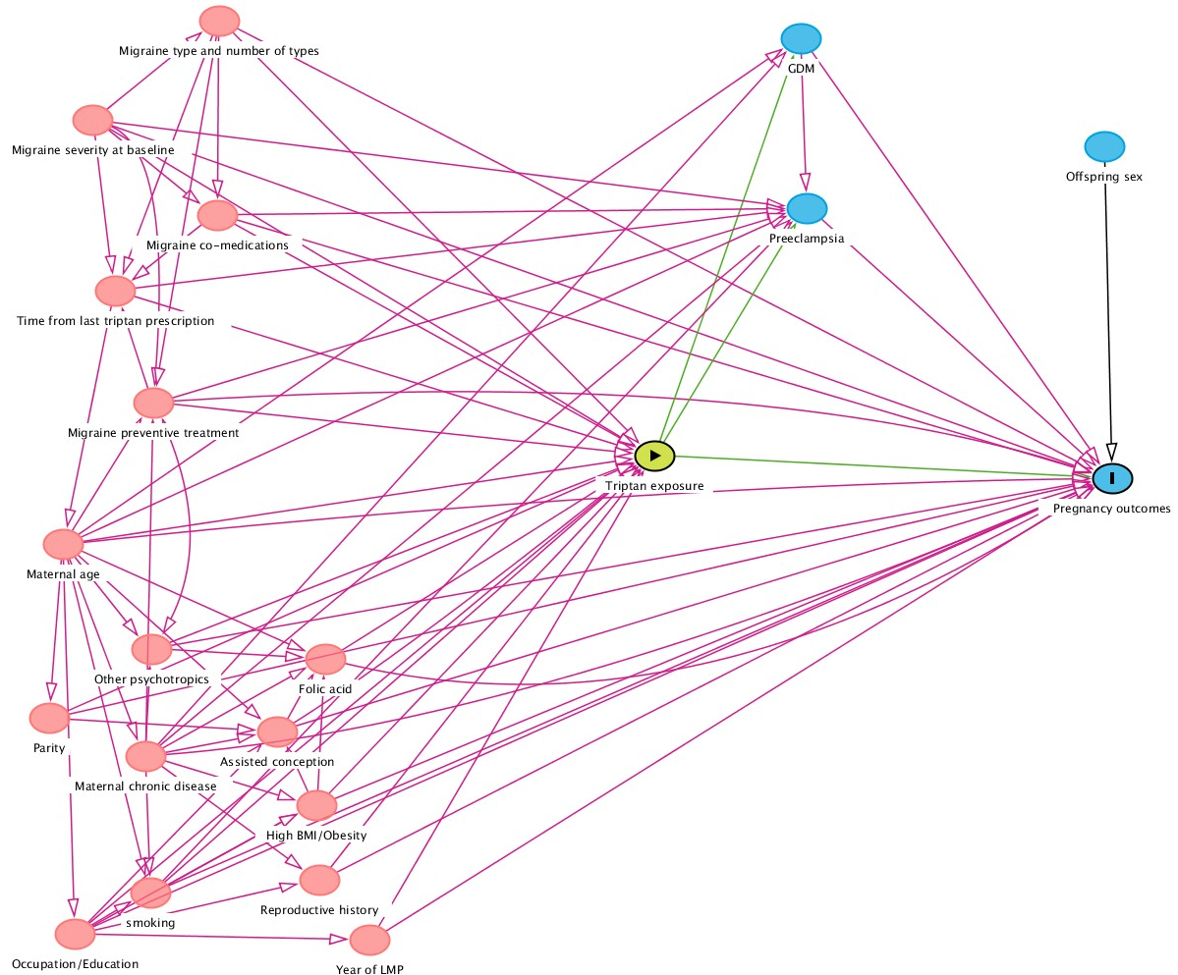
Abbreviations:
GDM=gestational diabetes mellitus; BMI=body mass index; LMP=Last menstrual period.

Appendix 5: Possible directed acyclic graph for the maternal outcomes
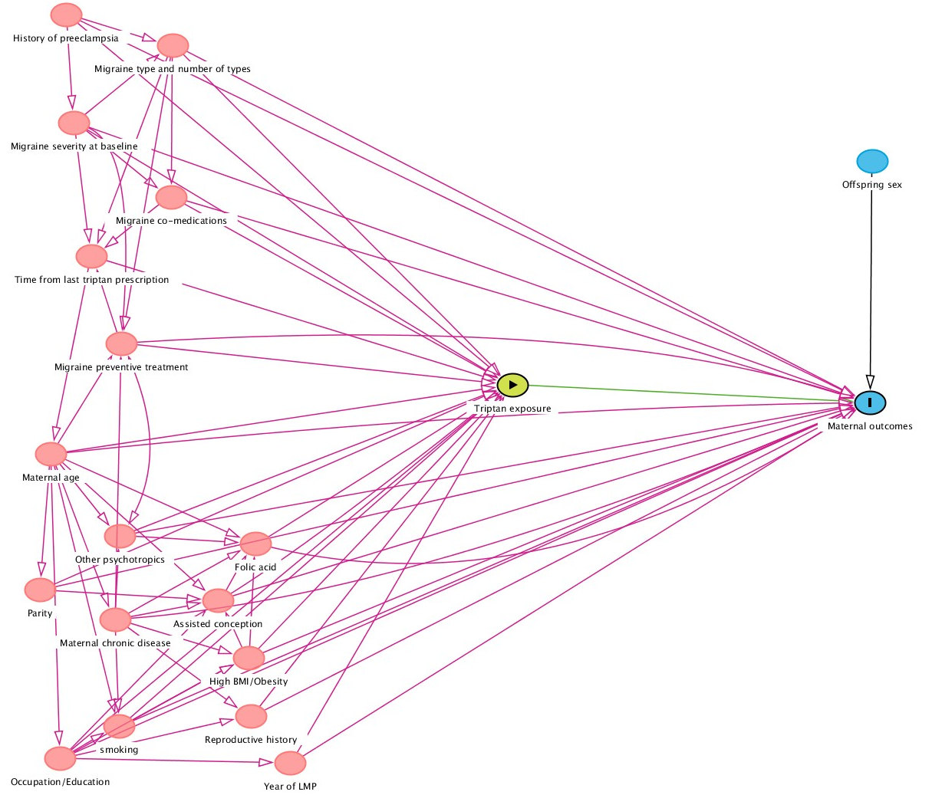
Abbreviations:
BMI=body mass index; LMP=Last menstrual period.

Appendix 6: Simplified directed acyclic graph for the time-varying analysis
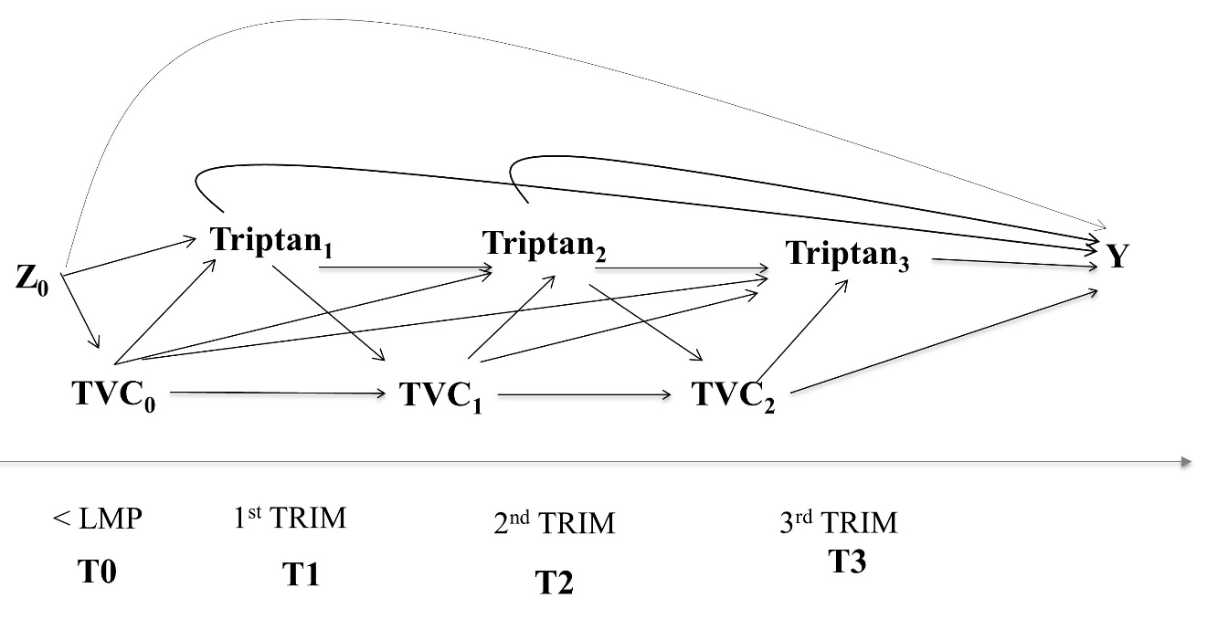
Z indicates time-fixed, baseline factors. TVC indicates time-varying confounders at the time < LMP (time 0), first trimester (T1), and second trimester (T2). Y indicates the pregnancy outcomes.
The variables triptan 1-3 indicates triptan exposure status at each trimester. There is no baseline triptan exposure before pregnancy because the comparison groups – by design – account for that baseline exposure.

Appendix 7: Availability of the confounders in each data source (panel A) and definitions (panels B-E)
A) Availability of the confounders in each data source
Data source | Maternal age at pregnancy start | Parity at pregnancy start | Year of birth | Folic acid before / during trimester | Smoking before / during  pregnancy | Comorbidities | Employment/education/  social economic status | Obesity or BMI≥30 | Comedication
Finland | Y | Y | Y | ? | Y | Y | Y | Y | Y
France (Haute Garonne) | Y | Y | Y | ? | Y | Y | N | N | Y
Germany | ? | ? | Y | ? | ? | ? | ? | ? | Y
Italy (Emilia Romagna) | Y | Y | Y | ? | Y | Y | N | Y | Y
Italy (Tuscany) | Y | Y | Y | ? | Y | Y | N | Y | Y
Norway | Y | Y | Y | Y | Y | Y | Y | Y | Y
Spain (Valencian Region) | Y | Y | Y | ? | Y | Y | ? | Y | Y
UK (Wales) | Y | Y | Y | ? | Y | Y | Y | Y | Y
UK (CPRD) | ? | ? | ? | ? | ? | ? | ? | ? | ?
*Maternal age, parity and year of birth are defined in section 2.7.3 and they are extracted from birth registries across data sources.

B) Definition of folic acid 1 month before and/or during first trimester of pregnancy in each data source (only data source reporting availability of the variable are listed)
Data source | Definition and CDM extraction (event/survey)
Finland | Yes / No, extracted from the Medical Birth registry using data from SURVEY table
France (Haute Garonne) | ?
Germany | ?
Italy (Emilia Romagna) | ?
Italy (Tuscany) | ?
Norway  UiO | Yes / No, extracted from the Medical Birth registry using data from SURVEY table
Spain (Valencian Region) | ?
Sweden  Karolinska Institutet | Yes / No, extracted from the Medical Birth registry using data from SURVEY table
UK (Wales) | ?
UK (CPRD) | ?

C) Definition of smoking before (or if not available) during pregnancy in each data source (only data source reporting availability of the variable are listed)
Data source | Definition and CDM extraction (event/survey)
Finland | Yes / No, extracted from the Medical Birth registry using data from SURVEY table
France (Haute Garonne) | ?
Germany | ?
Italy (Emilia Romagna) | ?
Italy (Tuscany) | ?
Norway  UiO | Yes / No, extracted from the Medical Birth registry using data from SURVEY table
Spain (Valencian Region) | ?
Sweden  Karolinska Institutet | Yes / No, extracted from the Medical Birth registry using data from SURVEY table
UK (Wales) | ?
UK (CPRD) | ?

D) Definition of obesity or BMI≥30 in each data source (only data source reporting availability of the variable are listed)
Data source | Definition and CDM extraction (event/survey)
Finland | Obesity is identified as a BMI ≥ 30 kg/m² at the start of pregnancy, extracted from the Medical Birth registry using data from SURVEY table
Spain (Valencian Region) | Obesity is identified as an obesity diagnosis (ICD9: 278 codes; ICD10: E65, E66 codes) from one year before the estimated LMP using data from EVENTS table.
Norway  UiO | Obesity is identified as a BMI ≥ 30 kg/m² at the start of pregnancy, extracted from the Medical Birth registry (MBRN) using data from SURVEY table.
Sweden  Karolinska Institutet | Obesity is identified as a BMI ≥ 30 kg/m² at the start of pregnancy, extracted from the Swedish pregnancy register using data from EVENTS table
Italy (Emilia Romagna) | Obesity is identified from diagnostic codes retrieved during 365 days before estimated pregnancy start using data from EVENTS table. Due to the nature of the ARS data source, this is expected to be severely underestimated.
Italy (Tuscany) | Obesity is identified from diagnostic codes retrieved during 365 days before estimated pregnancy start using data from EVENTS table. Due to the nature of the ARS data source, this is expected to be severely underestimated.
UK (Wales) | Maternity Indicators Dataset (MIDS) using data from SURVEY table. Height and weight are entered at initial antenatal visit.

E) Employment/education/social economic status (only data source reporting availability of the variable are listed)
Data source | Definition and CDM extraction (event/survey)
Finland | ?
Norway  UiO | Defined as employed or unemployed, extracted from the Medical Birth registry (MBRN) using data from SURVEY table.
UK (Wales) | ?
Spain (Valencian Region) | ?
UK (CPRD) | ?

Appendix 8: Proven teratogenic drugs – congenital malformations^{20,21}
Medication | Physical affects
Oral retinoid
Acitretin | Multiple malformations including central nervous system abnormalities, orofacial clefts, cardiovascular, skeletal, limb and ear. Facial dysmorphia.
Alitretinoin
Bexarotene
Isotretinoin
Tretinoin
Antiepileptic/ anticonvulsants
Carbamazepine | Variable by individual medication type but include cardiovascular (phenobarbital, primidone, valproate), neural tube (valproate, carbamazepine), skeletal (valproate), orofacial cleft (topiramate, valproate) and limb (valproate). Facial dysmorphia (phenytoin, carbamazepine, valproate). Growth disruption (topiramate).
Phenytoin
Fosphenytoin
Primidone
Topiramate
Valproate
Phenobarbital
Antithyroid
Carbimazole | Multiple malformation including skin defects including aplasia cutis, choanal atresia, esophageal atresia, other malformations of the gastrointestinal tract. Facial dysmorphia.
Methimazole
Anticoagulant
Coumarin | Multiple malformations including nasal hypoplasia, stippled epiphyses, skeletal and digital. Growth disruption. Facial dysmorphia.
Phenindione
Warfarin
Acenocoumarol
Immunosuppressive
Mycophenolate | Multiple malformations including orofacial cleft, microtia, external auditory canal atresia, micrognathia, cardiovascular, oesophageal atresia.
Methotrexate  Aminopterin | Multiple malformations including skeletal, cardiovascular, urogenital, holoprosencephaly. Growth disruption.

References
1. Hernan MA, et al. Using Big Data to Emulate a Target Trial When a Randomized Trial Is Not Available. Am J Epidemiol. 2016.
2. Schnitzer ME, et al. A potential outcomes approach to defining and estimating gestational age-specific exposure effects during pregnancy. Stat Methods Med Res. 2022.
3. Lash TL, et al. Applying Quantitative Bias Analysis to Epidemiologic Data. Springer New York; 2009.
4. Lash TL, et al. Good practices for quantitative bias analysis. Int J Epidemiol. 2014.
5. Harris GE, et al. Modeling exposures of medications used episodically during pregnancy: Triptans as a motivating example. Pharmacoepidemiol Drug Saf. 2020.
6. Tauqeer F, et al. Perinatal use of triptans and other drugs for migraine-A nationwide drug utilization study. PLoS One. 2021.
7. Wood ME, et al. Prenatal triptan exposure and parent-reported early childhood neurodevelopmental outcomes: an application of propensity score calibration to adjust for unmeasured confounding by migraine severity. Pharmacoepidemiol Drug Saf. 2015.
8. Wood ME, et al. Making fair comparisons in pregnancy medication safety studies: An overview of advanced methods for confounding control. Pharmacoepidemiol Drug Saf. 2018.
9. Wood ME, et al. Longitudinal changes in neurodevelopmental outcomes between 18 and 36 months in children with prenatal triptan exposure: findings from the Norwegian Mother and Child Cohort Study. BMJ open. 2016.
10. Wood ME, et al. Prenatal Triptan Exposure and Internalising and Externalising Behaviour Problems in 3-Year-Old Children: Results from the Norwegian Mother and Child Cohort Study. Paediatr Perinat Epidemiol. 2015.
11. Austin PC. The use of propensity score methods with survival or time-to-event outcomes: reporting measures of effect similar to those used in randomized experiments. Stat Med. 2014.
12. Garrido MM, et al. Methods for Constructing and Assessing Propensity Scores. Health Serv Res. 2014.
13. Lupattelli A, et al. Association of Maternal Use of Benzodiazepines and Z-Hypnotics During Pregnancy With Motor and Communication Skills and Attention-Deficit/Hyperactivity Disorder Symptoms in Preschoolers. JAMA Netw Open. 2019.
14. Hernan MA, et al. Marginal structural models to estimate the causal effect of zidovudine on the survival of HIV-positive men. Epidemiology. 2000.
15. Robins JM, et al. Marginal structural models and causal inference in epidemiology. Epidemiology. 2000.
16. Stürmer T, et al. Propensity scores for confounder adjustment when assessing the effects of medical interventions using nonexperimental study designs. J Intern Med. 2014.
17. Wood ME, et al. Longitudinal Methods for Modeling Exposures in Pharmacoepidemiologic Studies in Pregnancy. Epidemiol Rev. 2021.
18. Xu R, et al. Time-dependent propensity score for assessing the effect of vaccine exposure on pregnancy outcomes through pregnancy exposure cohort studies. Int J Environ Res Public Health. 2014.
19. Lash TL. The Harm Done to Reproducibility by the Culture of Null Hypothesis Significance Testing. Am J Epidemiol. 2017.
20. Gomes JDA, et al. Genetic Susceptibility to Drug Teratogenicity: A Systematic Literature Review. Front Genet. 2021.
21. Gerba CP. Chapter 28 - Environmental Toxicology. In: Brusseau ML, Pepper IL, Gerba CP, eds. Environmental and Pollution Science (Third Edition). Academic Press; 2019:511-540.
22. Ding P, et al. Sensitivity Analysis Without Assumptions. Epidemiology. 2016.
23. Azur MJ, et al. Multiple Imputation by Chained Equations: What is it and how does it work? Int J Methods Psychiatr Res. 2011.
24. Sterne JA, et al. Multiple imputation for missing data in epidemiological and clinical research: potential and pitfalls. BMJ. 2009.
25. Nezvalová-Henriksen K, et al. Triptan safety during pregnancy: a Norwegian population registry study. Eur J Epidemiol. 2013.

Figure 1: Data flow to achieve the final pregnancy cohort

Table shell 1. Baseline characteristics of the study population according to triptan prenatal exposure (N=xxx)
Baseline maternal characteristics | Total study population | Continued triptan into pregnancy | Discontinued triptan before pregnancy | Unexposed, migraine comparison group | Unexposed, population comparison group
 | N= | N= | N= | N= | N=
 | n (%) | n (%) | n (%) | n (%) | n (%)
Calendar year of LMP
2005-2009
2010-2014
2015-2019
Maternal age at start of pregnancy
15-24 years
25-39 years
40-49 years
Parity at start of pregnancy
0
1
>1
Any folic acid intake before and/or during first trimester of pregnancy
No
Yes
Obesity within 12 months before pregnancy (BMI≥30)
No
Yes
Depression within 12 months before pregnancy
No
Yes
Epilepsy within 12 months before pregnancy
No
Yes
Migraine severity in the 12 months before pregnancy*
Mild
Moderate
Severe
Migraine type in the 12 months before pregnancy**
Migraine without aura
Migraine with aura
Migraine status migrainosus
Complicated migraine
Other migraine
(Ophthalmoplegic/Retinal)
Migraine unspecified
Use of other acute migraine drugs in the 12 (or 3) months before pregnancy
Analgesics (yes)
NSAIDs (yes)
Antinauseants (yes)
Use of migraine preventive drugs in the 12 (or 3) months before pregnancy (yes)***
Use of antidepressants in the 12 (or 3) months before pregnancy (yes)
Use of antiepileptics in the 12 (or 3) months before pregnancy (yes)
Use of antipsychotics in the 12 (or 3) months before pregnancy (yes)
Use of z-hypnotics in the 12 (or 3) months before pregnancy (yes)
Use of benzodiazepines in the 12 (or 3) months before pregnancy (yes)
Use of ADHD drugs in the 12 (or 3) months before pregnancy (yes)
*Very severe migraine cannot be computed at baseline. The severity groups are mutually-exclusive. **Migraine type groups are not mutually-exclusive.***These are grouped as total preventive migraine drugs, due to low prevalence of use.

Figure 2: Standardized mean difference in the distribution of the confounding factors before and after weighting
Panel a) Continued triptan in pregnancy vs Discontinued triptan before pregnancy
Panel b) Continued triptan in pregnancy vs Unexposed, migraine comparison group
Panel c) Continued triptan in pregnancy vs Unexposed, population comparison group

Table shell 2. Triptan utilisation parameter before and during pregnancy (N=xxx)
Parameters during the individual windows of exposure | Discontinued triptan before pregnancy | Continued triptan into pregnancy
Any time in the 0-12 (or 3) months < LMP
Extended use of triptans, n (%)
Prescriptions filled, median (IQR), min-max
Ever in pregnancy
Extended use of triptans*, n (%) | -
Prescriptions filled, median (IQR), min-max | -
1 trimester | -
Extended use of triptans*, n (%) | -
Prescriptions filled, median (IQR), min-max | -
2 trimester | -
Extended use of triptans*, n (%) | -
Prescriptions filled, median (IQR), min-max | -
3 trimester | -
Extended use of triptans*, n (%) | -
Prescriptions filled, median (IQR), min-max | -
Gestation week 0-20 | -
Extended use of triptans*, n (%) | -
Prescriptions filled, median (IQR), min-max | -
*Extended use of triptan is defined as >15 DDDs prescribed/dispensed per any 1 month (1 month = 30 days).

Table shell 3. Distribution of time-varying confounders by triptan prenatal exposure (N=xxx) *
Use of other medications | Discontinued triptan before pregnancy | Continued triptan into pregnancy
 | N= | N=
 | n (%) | n (%)
Use of other medications in first trimester of pregnancy
Analgesics (yes)
NSAIDs (yes)
Antinauseants (yes)
Migraine preventive drugs (yes)**
Antidepressants (yes)
Antiepileptics (yes)
Z-hypnotics (yes)
Antipsychotics (yes)
Benzodiazepines (yes)
ADHD drugs (yes)
Use of other medications in second trimester of pregnancy
Analgesics (yes)
NSAIDs (yes)
Antinauseants (yes)
Migraine preventive drugs (yes)**
Antidepressants (yes)
Antiepileptics (yes)
Z-hypnotics (yes)
Antipsychotics (yes)
Benzodiazepines (yes)
Use of other medications in third trimester of pregnancy
Analgesics (yes)
NSAIDs (yes)
Antinauseants (yes)
Migraine preventive drugs (yes)**
Antidepressants (yes)
Antiepileptics (yes)
Z-hypnotics (yes)
Antipsychotics (yes)
Benzodiazepines (yes)
*The unexposed, population comparison group and unexposed, with migraine are not shown in this table, as time-varying analyses are done only in relation to continued / discontinued triptan. **These are grouped as total preventive migraine drugs, due to low prevalence of use.
Table shell 4. Association between continued triptan exposure and maternal outcomes (N=xxx) *
 | Total  N=xxx | with outcome  N=xxx (%) | Crude RR with 95% CI | Weighted RR with 95% CI | Crude RR with 95% CI | Weighted RR with 95% CI | Crude RR with 95% CI | Weighted RR with 95% CI
Preeclampsia
Unexposed, population comparison group |  |  | 1 | 1
Unexposed, migraine comparison group |  |  | xxxx | xxx | 1 | 1
Discontinued triptan before pregnancy |  |  |  |  | xxxx | xxxx | 1 | 1
Continued triptan into week 0-20 of pregnancy |  |  |  |  |  |  | xxx | xxx
Gestational diabetes mellitus
Unexposed, population comparison group |  |  | 1 | 1
Unexposed, migraine comparison group |  |  | xxxx | xxx | 1 | 1
Discontinued triptan before pregnancy |  |  |  |  | xxxx | xxxx | 1 | 1
Continued triptan into week 0-20 of pregnancy |  |  |  |  |  |  | xxx | xxx
*Point estimates for the above associations, stratified by migraine severity and migraine type at baseline, will be plotted in two figures.
Table shell 5. Association between continued triptan exposure and congenital anomalies in the offspring (N=xxx) **
 | Total  N=xxx | with any MCA  N=xxx (%) | Crude RR with 95% CI | Weighted RR with 95% CI | Crude RR with 95% CI | Weighted RR with 95% CI | Crude RR with 95% CI | Weighted RR with 95% CI
Unexposed, population comparison group |  |  | 1 | 1
Unexposed, migraine comparison group |  |  |  |  | 1 | 1
Discontinued triptan before pregnancy |  |  |  |  |  |  | 1 | 1
Continued triptan into first trimester of pregnancy
*we will make one such table for each organ specific MCA
**Point estimates for the above associations, stratified by migraine severity and migraine type at baseline, will be plotted in two figures.

Table shell 6. Association between continued triptan exposure and pregnancy binary outcomes (N=xxx) *
 | Total  N=xxx | with outcome  N=xxx (%) | Crude RR with 95% CI | Weighted RR with 95% CI | Crude RR with 95% CI | Weighted RR with 95% CI | Crude RR with 95% CI | Weighted RR with 95% CI
Premature birth
Unexposed, population comparison group |  |  | 1 | 1
Unexposed, migraine comparison group |  |  |  |  | 1 | 1
Discontinued triptan before pregnancy |  |  |  |  |  |  | 1 | 1
Continued triptan ever in pregnancy
Small for gestational age
Unexposed, population comparison group |  |  | 1 | 1
Unexposed, migraine comparison group |  |  |  |  | 1 | 1
Discontinued triptan before pregnancy |  |  |  |  |  |  | 1 | 1
Continued triptan ever in pregnancy
Low birth weight
Unexposed, population comparison group |  |  | 1 | 1
Unexposed, migraine comparison group |  |  |  |  | 1 | 1
Discontinued triptan before pregnancy |  |  |  |  |  |  | 1 | 1
Continued triptan ever in pregnancy
Non-live birth
Unexposed, population comparison group |  |  | 1 | 1
Unexposed, migraine comparison group |  |  |  |  | 1 | 1
Discontinued triptan before pregnancy |  |  |  |  |  |  | 1 | 1
Continued triptan in first trimester of pregnancy
*Point estimates for the above associations, stratified by migraine severity and migraine type at baseline, will be plotted in two figures.
Table shell 7. Association between continued triptan exposure and pregnancy continuous outcomes (N=xxx) *
 | Total  N=xxx | Mean gestation and SD | Crude mean difference with 95% CI | Weighted mean difference with 95% CI | Crude mean difference with 95% CI | Weighted mean difference with 95% CI | Crude mean difference with 95% CI | Weighted mean difference with 95% CI
Gestational age (in days)
Unexposed, population comparison group |  |  | 1 | 1
Unexposed, migraine comparison group |  |  |  |  | 1 | 1
Discontinued triptan before pregnancy |  |  |  |  |  |  | 1 | 1
Continued triptan ever in pregnancy
Birth weight (in grams)
Unexposed, population comparison group |  |  | 1 | 1
Unexposed, migraine comparison group |  |  |  |  | 1 | 1
Discontinued triptan before pregnancy |  |  |  |  |  |  | 1 | 1
Continued triptan ever in pregnancy
*Point estimates for the above associations, stratified by migraine severity and migraine type at baseline, will be plotted in two figures.
Table shell 8. Association between continued triptan exposure and pregnancy binary outcomes in the time-varying analyses (N=xxx) *
 | Total  N=xxx | with the outcome  N=xxx (%) | Crude RR with 95% CI | Weighted RR with 95% CI
Premature birth
Discontinued triptan before pregnancy |  |  | 1 | 1
Continued triptan in first trimester of pregnancy
Continued triptan in second trimester of pregnancy
Continued triptan in third trimester of pregnancy
Small for gestational age
Discontinued triptan before pregnancy |  |  | 1 | 1
Continued triptan in first trimester of pregnancy
Continued triptan in second trimester of pregnancy
Continued triptan in third trimester of pregnancy
Low birth weight
Discontinued triptan before pregnancy |  |  | 1 | 1
Continued triptan in first trimester of pregnancy
Continued triptan in second trimester of pregnancy
Continued triptan in third trimester of pregnancy
*Point estimates for the above associations, stratified by migraine severity and migraine type at baseline, will be plotted in two figures.

Table shell 9. Association between extended use of continued triptan in pregnancy with maternal and pregnancy outcomes (N=xxx) *
 | Total  N=xxx | with the outcome  N=xxx (%) | Crude RR with 95% CI | Weighted RR with 95% CI | Crude RR with 95% CI | Weighted RR with 95% CI
Premature birth
Discontinued triptan before pregnancy |  |  | 1 | 1
No extended use of continued triptan in pregnancy |  |  |  |  | 1 | 1
Extended use of continued triptan in pregnancy
Small for gestational age
Discontinued triptan before pregnancy |  |  | 1 | 1
No extended use of continued triptan in pregnancy |  |  |  |  | 1 | 1
Extended use of continued triptan in pregnancy
Low birth weight
Discontinued triptan before pregnancy |  |  | 1 | 1
No extended use of continued triptan in pregnancy |  |  |  |  | 1 | 1
Extended use of continued triptan in pregnancy
Major congenital anomalies
Discontinued triptan before pregnancy |  |  | 1 | 1
No extended use of continued triptan in first trimester of pregnancy |  |  |  |  | 1 | 1
Extended use of continued triptan in first trimester of pregnancy
Non-live birth
Discontinued triptan before pregnancy |  |  | 1 | 1
No extended use of continued triptan in first trimester of pregnancy |  |  |  |  | 1 | 1
Extended use of continued triptan in first trimester of pregnancy
Preeclampsia
Discontinued triptan before pregnancy |  |  | 1 | 1
No extended use of continued triptan in week 0-20 of pregnancy |  |  |  |  | 1 | 1
Extended use of continued triptan in week 0-20 of pregnancy
Gestational diabetes mellitus
Discontinued triptan before pregnancy |  |  | 1 | 1
No extended use of continued triptan in first trimester of pregnancy |  |  |  |  | 1 | 1
Extended use of continued triptan in first trimester of pregnancy
*Point estimates for the above associations, stratified by migraine severity and migraine type at baseline, will be plotted in two figures.
Figure 3: Plot of association measures between continued triptan in pregnancy versus discontinued triptan before pregnancy and all investigated outcomes, stratified by migraine severity at baseline

Figure 4: Plot of association measures between continued triptan in pregnancy versus unexposed with migraine and all investigated outcomes, stratified by migraine severity at baseline

Figure 5: illustration of effect estimates shift when applying probabilistic bias analyses for exposure misclassification
Table shells for the various sensitivity analyses will have same structure as the ones outlined above.

