Milestones and Medicare Outcomes Analyses Summary

8/31/2020

Table of Contents

1. Cohort Description 2

2. Milestone ratings 3

2.1 Overall mean 3

Descriptive table 3

Odds ratios and predicted values for all outcomes 3

model summary for any complication 4

2.2 Professional ratings 5

Descriptive table 5

Odds ratios and predicted values for all outcomes 5

model summary for any complication 6

2.3 Operative ratings 7

Descriptive table 7

Odds ratios and predicted values for all outcomes 7

model summary for any complication 8

2.4 Leadership ratings 9

Descriptive table 9

Odds ratios and predicted values for all outcomes 9

model summary for any complication 10

## 1. Cohort Description

Milestones vs Medicare outcomes cohort details

* Medicare cases: inpatient from 2015-2017
* Milestone graduates:2015-2017
* Procedure: Partial Colectomy
* Practice months after graduation: 24 months

**Overall Cohort**

|  |  |
| --- | --- |
| n_case | 2368 |
| n_surgeon | 520 |
| n_hosp | 507 |
| n_patient | 2320 |
| severe_complication_rate | 14% |
| any_complication_rate | 26% |
| death_rate | 10% |
| readmit_rate | 33% |
| reop_rate | 4% |

**case level characteristics**

|  |  |
| --- | --- |
| **Characteristic** | **N = 2368** |
| flg_male | 1011 (43%) |
| age_at_admit | 75 (70, 82) |
| race_white | 2101 (89%) |
| AHRQ_score | 10 (3, 20) |
| flg_admit_emerg | 1179 (50%) |
| hosp_beds_2grp | 815 (35%) |
| colectomy_type |  |
| lap | 949 (40%) |
| open | 1419 (60%) |

Note: - hosp_beds_2grp :(0.<349, 1: >=350)

[AHRQ_score](https://pubmed.ncbi.nlm.nih.gov/28498196/): patient comorbidity scores

## 2. Milestone ratings

### 2.1 Overall mean

#### Descriptive table

|  |  |  |  |
| --- | --- | --- | --- |
| **Characteristic** | **mean<8**, N = 394 | **mean>=8**, N = 1974 | **p-value** |
| flg_male | 179 (45%) | 832 (42%) | 0.3 |
| age_at_admit | 75 (70, 82) | 75 (70, 82) | 0.9 |
| race_white | 340 (86%) | 1761 (89%) | 0.11 |
| AHRQ_score | 11 (3, 20) | 10 (2, 20) | 0.2 |
| flg_admit_emerg | 206 (53%) | 973 (50%) | 0.3 |
| hosp_beds_2grp | 99 (25%) | 716 (37%) | <0.001 |
| colectomy_type |  |  | 0.2 |
| lap | 146 (37%) | 803 (41%) |  |
| open | 248 (63%) | 1171 (59%) |  |

#### Odds ratios and predicted values for all outcomes

#### model summary for any complication

|  |  |  |  |  |
| --- | --- | --- | --- | --- |
| Fixed Effects | OR | OR_lower | OR_upper | p_value |
| mean_ge_8 | 0.81 | 0.61 | 1.08 | 0.15 |
| flg_male | 0.92 | 0.74 | 1.13 | 0.42 |
| age_at_admit_scale | 0.97 | 0.88 | 1.08 | 0.61 |
| race_white | 0.77 | 0.51 | 1.15 | 0.20 |
| race_hisp_other | 0.98 | 0.53 | 1.82 | 0.95 |
| flg_admit_emerg | 2.04 | 1.58 | 2.65 | 0.00 |
| AHRQ_score_scale | 2.01 | 1.80 | 2.25 | 0.00 |
| ses_2grp | 0.92 | 0.73 | 1.16 | 0.50 |
| facility_clm_yr | 0.98 | 0.83 | 1.15 | 0.77 |
| flg_multi_surgeon | 0.70 | 0.54 | 0.91 | 0.01 |
| flg_assistant_surgeon | 1.10 | 0.83 | 1.46 | 0.52 |
| hosp_beds_2grp | 1.25 | 0.99 | 1.58 | 0.06 |
| val_hosp_mcday2inptday_ratio | 0.81 | 0.27 | 2.42 | 0.70 |
| val_hosp_rn2bed_ratio | 1.03 | 0.89 | 1.19 | 0.70 |

|  |  |  |  |  |
| --- | --- | --- | --- | --- |
| Random Effects | effect | variance | sd | var_prop |
| id_physician_npi | Intercept | 0.06 | 0.24 | 28% |
| cpt_cd | Intercept | 0.15 | 0.39 | 72% |

### 2.2 Professional ratings

Professional rating mean values are from comp5_PR_Q1, comp5_PR_Q2, comp5_PR_Q3

#### Descriptive table

|  |  |  |  |
| --- | --- | --- | --- |
| **Characteristic** | **mean<8**, N = 379 | **mean>=8**, N = 1989 | **p-value** |
| flg_male | 164 (43%) | 847 (43%) | 0.8 |
| age_at_admit | 75 (70, 82) | 75 (70, 82) | >0.9 |
| race_white | 332 (88%) | 1769 (89%) | 0.5 |
| AHRQ_score | 12 (4, 21) | 10 (2, 20) | 0.049 |
| flg_admit_emerg | 198 (53%) | 981 (50%) | 0.3 |
| hosp_beds_2grp | 93 (25%) | 722 (37%) | <0.001 |
| colectomy_type |  |  | 0.3 |
| lap | 142 (37%) | 807 (41%) |  |
| open | 237 (63%) | 1182 (59%) |  |

#### Odds ratios and predicted values for all outcomes

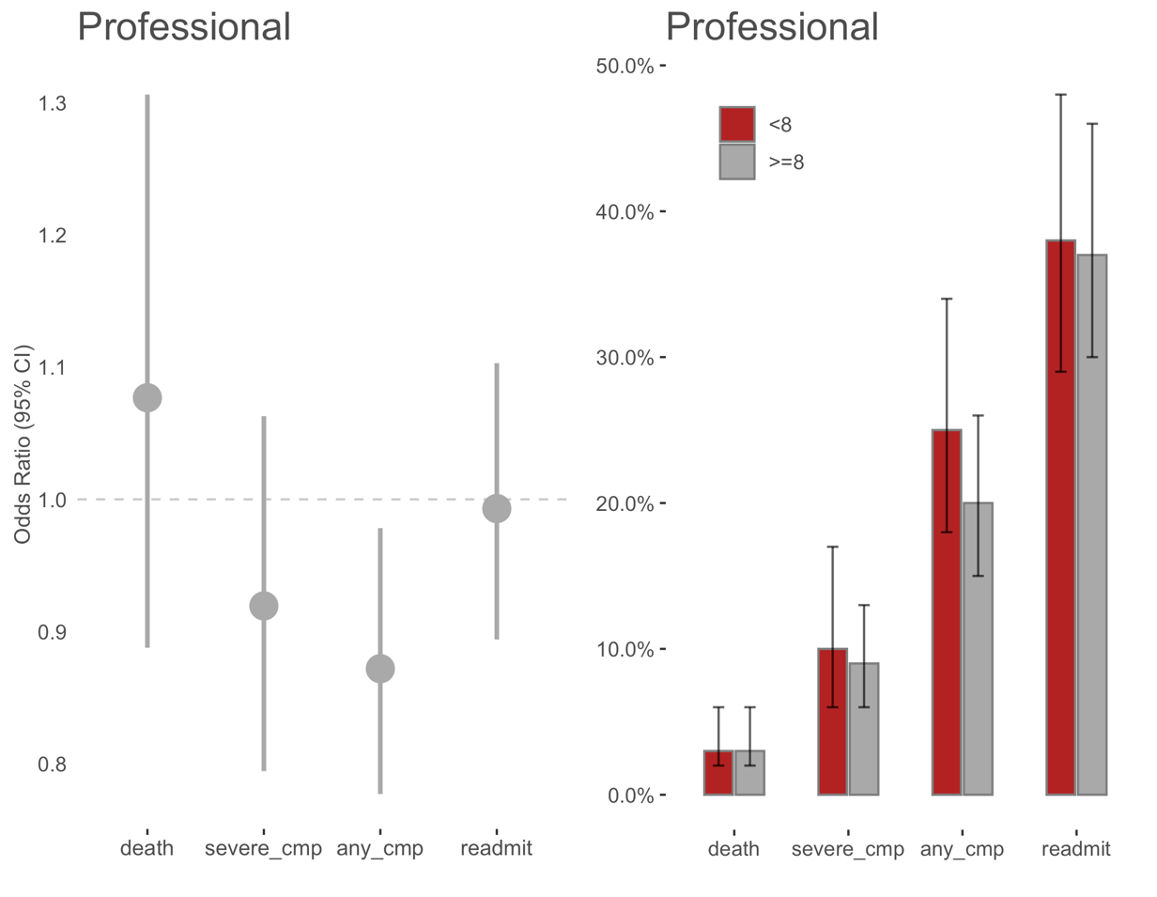

#### model summary for any complication

|  |  |  |  |  |
| --- | --- | --- | --- | --- |
| Fixed Effects | OR | OR_lower | OR_upper | p_value |
| prof_rating_ge8 | 0.72 | 0.54 | 0.96 | 0.02 |
| flg_male | 0.92 | 0.75 | 1.15 | 0.48 |
| age_at_admit_scale | 0.97 | 0.88 | 1.08 | 0.62 |
| race_white | 0.77 | 0.51 | 1.15 | 0.20 |
| race_hisp_other | 0.99 | 0.53 | 1.84 | 0.96 |
| flg_admit_emerg | 2.02 | 1.56 | 2.62 | 0.00 |
| AHRQ_score_scale | 2.00 | 1.79 | 2.24 | 0.00 |
| ses_2grp | 0.93 | 0.74 | 1.17 | 0.53 |
| facility_clm_yr | 0.98 | 0.83 | 1.16 | 0.81 |
| flg_multi_surgeon | 0.70 | 0.54 | 0.91 | 0.01 |
| flg_assistant_surgeon | 1.10 | 0.82 | 1.46 | 0.53 |
| hosp_beds_2grp | 1.27 | 1.01 | 1.60 | 0.04 |
| val_hosp_mcday2inptday_ratio | 0.79 | 0.27 | 2.38 | 0.68 |
| val_hosp_rn2bed_ratio | 1.02 | 0.88 | 1.18 | 0.84 |

|  |  |  |  |  |
| --- | --- | --- | --- | --- |
| Random Effects | effect | variance | sd | var_prop |
| id_physician_npi | Intercept | 0.05 | 0.23 | 25% |
| cpt_cd | Intercept | 0.16 | 0.40 | 75% |

### 

### 2.3 Operative ratings

Operative ratings mean values are from PC3, MK2, ICS3.

#### Descriptive table

|  |  |  |  |
| --- | --- | --- | --- |
| **Characteristic** | **mean<8**, N = 385 | **mean>=8**, N = 1983 | **p-value** |
| flg_male | 165 (43%) | 846 (43%) | >0.9 |
| age_at_admit | 76 (70, 82) | 75 (70, 82) | 0.5 |
| race_white | 330 (86%) | 1771 (89%) | 0.051 |
| AHRQ_score | 11 (2, 21) | 10 (3, 20) | 0.4 |
| flg_admit_emerg | 205 (54%) | 974 (49%) | 0.14 |
| hosp_beds_2grp | 108 (28%) | 707 (36%) | 0.004 |
| colectomy_type |  |  | 0.056 |
| lap | 137 (36%) | 812 (41%) |  |
| open | 248 (64%) | 1171 (59%) |  |

#### Odds ratios and predicted values for all outcomes

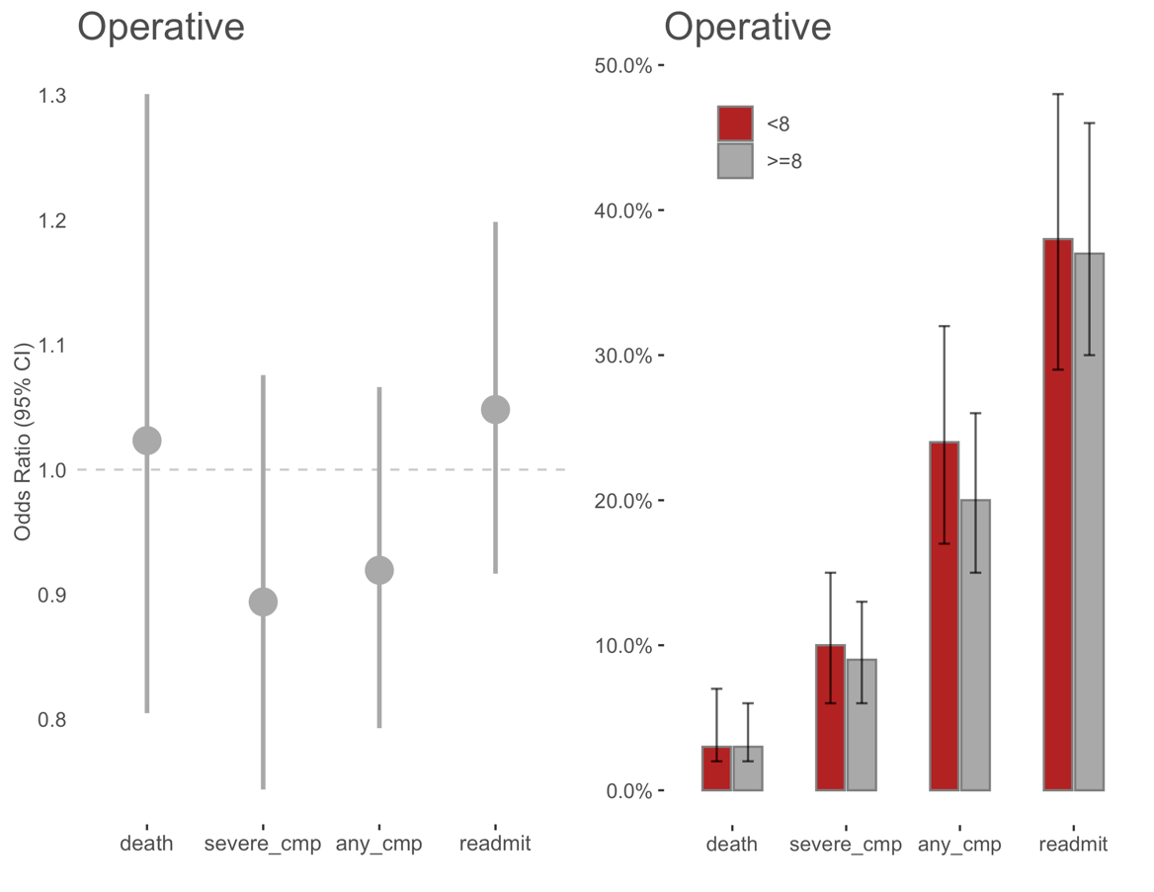

#### model summary for any complication

|  |  |  |  |  |
| --- | --- | --- | --- | --- |
| Fixed Effects | OR | OR_lower | OR_upper | p_value |
| operative_rating_ge8 | 0.81 | 0.61 | 1.08 | 0.15 |
| flg_male | 0.93 | 0.75 | 1.15 | 0.49 |
| age_at_admit_scale | 0.97 | 0.88 | 1.08 | 0.59 |
| race_white | 0.77 | 0.51 | 1.15 | 0.21 |
| race_hisp_other | 0.99 | 0.53 | 1.85 | 0.97 |
| flg_admit_emerg | 2.01 | 1.55 | 2.61 | 0.00 |
| AHRQ_score_scale | 2.01 | 1.80 | 2.25 | 0.00 |
| ses_2grp | 0.93 | 0.74 | 1.17 | 0.55 |
| facility_clm_yr | 0.98 | 0.83 | 1.15 | 0.79 |
| flg_multi_surgeon | 0.70 | 0.54 | 0.91 | 0.01 |
| flg_assistant_surgeon | 1.09 | 0.82 | 1.45 | 0.57 |
| hosp_beds_2grp | 1.25 | 0.99 | 1.58 | 0.06 |
| val_hosp_mcday2inptday_ratio | 0.80 | 0.27 | 2.40 | 0.69 |
| val_hosp_rn2bed_ratio | 1.02 | 0.88 | 1.19 | 0.77 |

|  |  |  |  |  |
| --- | --- | --- | --- | --- |
| Random Effects | effect | variance | sd | var_prop |
| id_physician_npi | Intercept | 0.06 | 0.24 | 28% |
| cpt_cd | Intercept | 0.16 | 0.40 | 72% |

### 2.4 Leadership ratings

leadership ratings mean values are from comp5_PR_Q1, comp6_ICS_Q1, comp6_ICS_Q2, comp3_SBP_Q.

#### Descriptive table

|  |  |  |  |
| --- | --- | --- | --- |
| **Characteristic** | **mean<8**, N = 297 | **mean>=8**, N = 2071 | **p-value** |
| flg_male | 132 (44%) | 879 (42%) | 0.6 |
| age_at_admit | 76 (70, 82) | 75 (70, 82) | 0.9 |
| race_white | 264 (89%) | 1837 (89%) | >0.9 |
| AHRQ_score | 10 (2, 20) | 10 (3, 20) | 0.7 |
| flg_admit_emerg | 150 (51%) | 1029 (50%) | 0.8 |
| hosp_beds_2grp | 67 (23%) | 748 (36%) | <0.001 |
| colectomy_type |  |  | >0.9 |
| lap | 119 (40%) | 830 (40%) |  |
| open | 178 (60%) | 1241 (60%) |  |

#### Odds ratios and predicted values for all outcomes

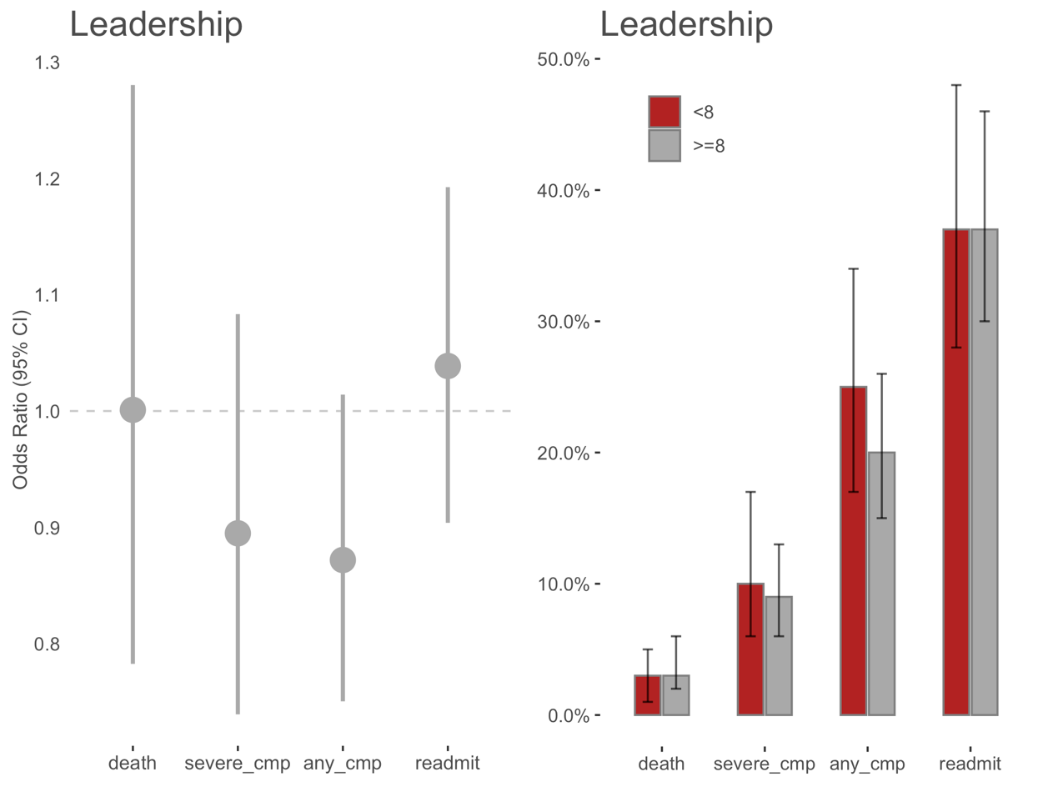

#### model summary for any complication

|  |  |  |  |  |
| --- | --- | --- | --- | --- |
| Fixed Effects | OR | OR_lower | OR_upper | p_value |
| leadership_rating_ge8 | 0.76 | 0.55 | 1.05 | 0.10 |
| flg_male | 0.93 | 0.75 | 1.15 | 0.48 |
| age_at_admit_scale | 0.97 | 0.88 | 1.08 | 0.60 |
| race_white | 0.76 | 0.51 | 1.14 | 0.19 |
| race_hisp_other | 0.98 | 0.52 | 1.83 | 0.95 |
| flg_admit_emerg | 2.02 | 1.56 | 2.61 | 0.00 |
| AHRQ_score_scale | 2.02 | 1.80 | 2.25 | 0.00 |
| ses_2grp | 0.92 | 0.73 | 1.16 | 0.50 |
| facility_clm_yr | 0.98 | 0.83 | 1.16 | 0.84 |
| flg_multi_surgeon | 0.71 | 0.55 | 0.92 | 0.01 |
| flg_assistant_surgeon | 1.09 | 0.82 | 1.45 | 0.55 |
| hosp_beds_2grp | 1.26 | 1.00 | 1.60 | 0.05 |
| val_hosp_mcday2inptday_ratio | 0.80 | 0.27 | 2.39 | 0.68 |
| val_hosp_rn2bed_ratio | 1.02 | 0.88 | 1.18 | 0.84 |

|  |  |  |  |  |
| --- | --- | --- | --- | --- |
| Random Effects | effect | variance | sd | var_prop |
| id_physician_npi | Intercept | 0.06 | 0.25 | 27% |
| cpt_cd | Intercept | 0.16 | 0.40 | 73% |