

ELECTRICAL AND ELECTRONICS ENGINEERING

ee463 statıc power conversıon



January 27, 2018

Ü. MERT ÇAĞLAR

METU-EEE

Table of Contents

1) INTRODUCTION 2

I. Introduction to Power Electronics 2

II. Introduction to Project 2

2) DESCRIPTION 2

I. Problem Description 2

II. Possible Solutions 2

III. Solution Approach 2

3) SIMULATIONS 2

I. AC-DC Diode Bridge Converter 2

II. DC-DC Buck Converter 2

III. Overall System Design 2

IV. Heat dissipation and Heatsinks 2

4) EXPERIMENTAL RESULTS 2

5) DEMONSTRATION 2

6) REFERENCES 2

7) APPENDICES 2

1. INTRODUCTION
   1. Introduction to Power Electronics

Power electronics are a relatively new electronic development area. Basic electronics include inductors capacitors and various transistors; however, these electronics are widely used under 5-20Volts and never exceed 1-2 Amperes of current drawn.

Contemporary advancements in power electronics area enabled usage of high voltage rating electronic components. MOSFETs that can withstand hundreds of volts and Amperes, Capacitors that are bigger than commercial automobiles are a few examples of power electronics area.

A professional interest in power electronics area is the concept of converters. These converters can be categorized but not limited to AC-DC converters and DC-DC converters, also there are filter elements and gate drive elements that accompany power electronics. Filter elements are much like in circuits and systems theory but with larger capacitor and inductor components and much less stages (generally only one stage).

* 1. Introduction to Project

Gate drives are much complicated in power electronics, now we are combining relatively very high voltages and currents and very low voltages and currents. Gate drives such as optocoupler, Arduino microprocessor unit and such require 5-10 V to operate and draw 20-30 mA, while these components operate at these ratings power electronics and motors in the scope of this project are rated with 400-600Volts and 10-20Amperes. Even a fraction of these ratings will cause volatile destruction on drive elements.

1. DESCRIPTION
   1. Problem Description

We are tasked to operate a DC motor with following ratings:

The aforementioned DC motor is to be operated with the following grid:

The grid and DC motor will be connected through our power electronic project.

* 1. Possible Solutions
     1. 3-Phase Thyristor Rectifier

Three phase thyristor rectifier requires a zero-crossing detection device and phase lag gate signals. Overall circuit simulation is shown below.

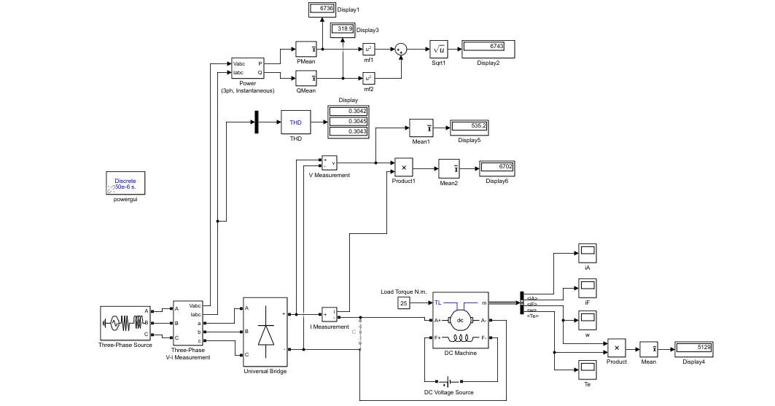

**Figure 1:** Three phase thyristor rectifier circuit.

Since we have decided not to use it only motor current and motor speeds are represented in following figure 2&3 under constant torque which is 25 N/m. Firing angle is set to zero.

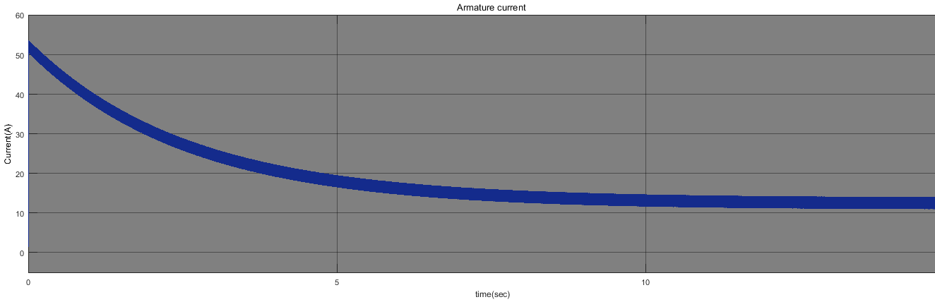

**Figure 2:** Armature current motor driven by 3 phase full controlled rectifier.

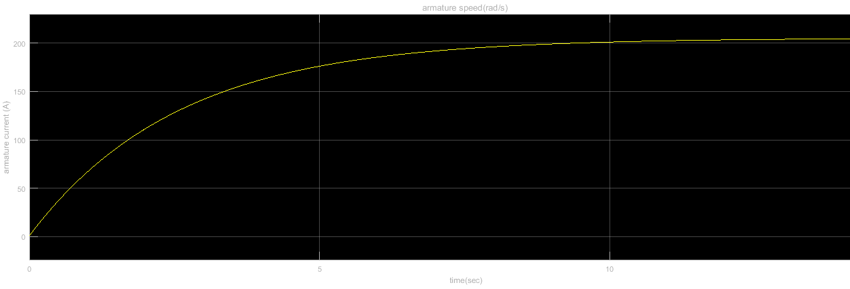

**Figure 3:** Armature speed of motor driven by 3 phase full controlled rectifier.

Input line THD is 0.30 and output of the rectifier circuit is 535 V which can be seen on the figure 1.

* + 1. 1-Phase Thyristor Rectifier

One phase thyristor rectifier gives comparably low voltage to three phase, this will create extensive load to DC-DC converter side, also one phase thyristor bridge requires 4 thyristors while three phase requires just 2 more (6 total). Overall circuit is very similar to 3-phase case. The schematic is in the figure 4. Firing angle is set to 0.

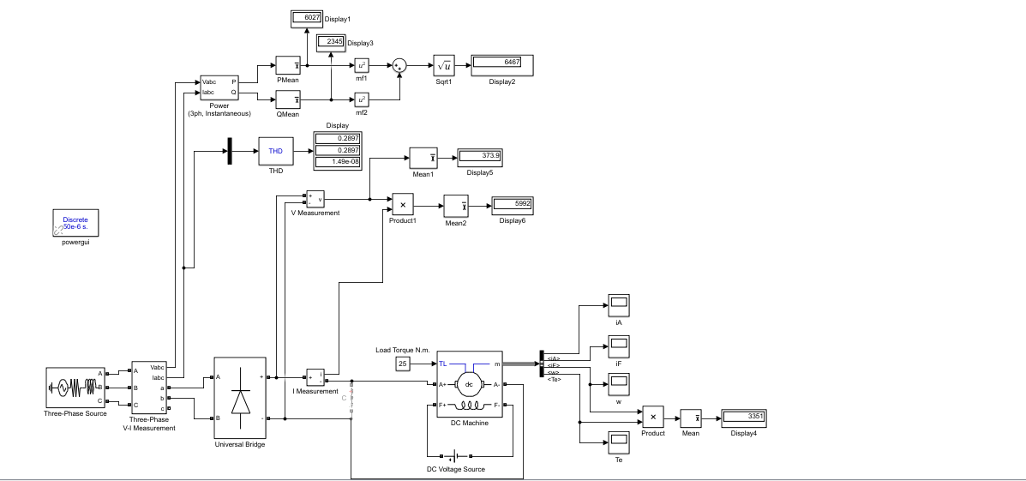

**Figure 4:** 1-ph full controlled rectifier circuit.

Again since we have decided not to use this configuration only armature current and speed are represented in the following figure 5 & 6.

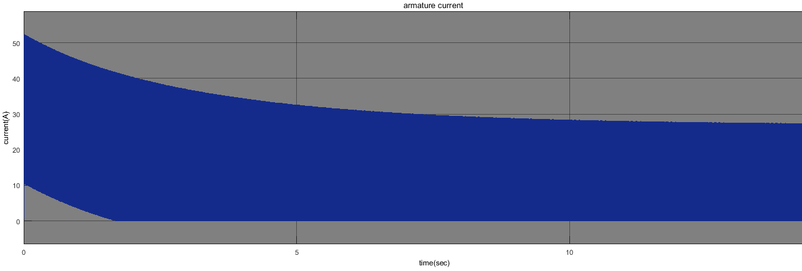

**Figure 5:** Armature current of motor driven by 1-ph full controlled rectifier circuit.

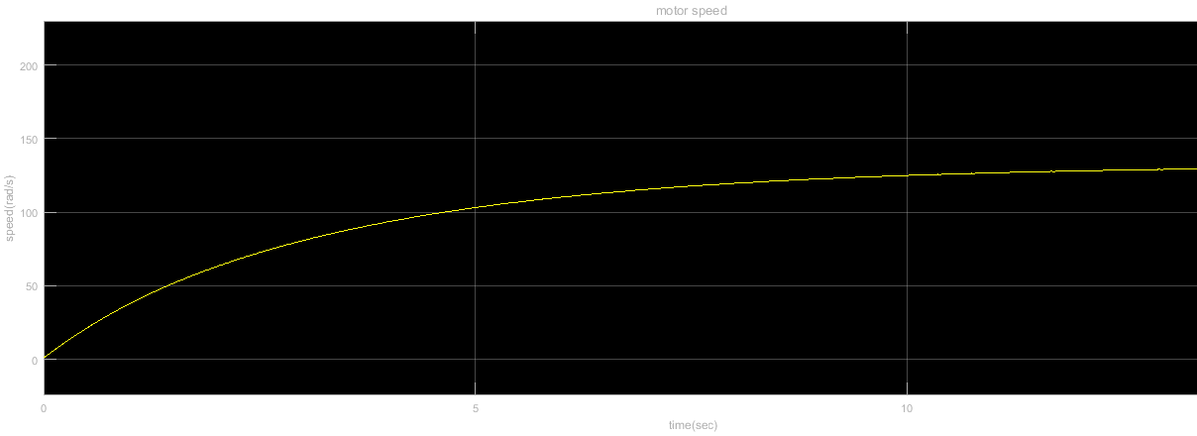

**Figure 6:** Speed of the motor driven by 1-ph full controlled rectifier circuit.

Input current THD is better in this case which is 0.28 and output voltage of the rectifier circuit is 373V. They can be seen figure 4.

* + 1. Diode Rectifier + Buck Converter

Diode rectifier is uncontrolled AC-DC converter, its output has high ripple but 6 pack diode rectifier is a robust design alternative. After diode rectifier there needs to be a controlled buck converter that will decrease the Vdc.

* 1. Solution Approach

We aim to accomplish the given task with Diode bridge rectifier and Buck converter. Main reason is that implementation of the trigger circuits of the three phase rectifiers are rather harder than trigger circuit of the buck converters which needs simple duty cycle. Second reason is that we planned to design a speed control system under various loads and duty cycle is more convenient to manipulate in a feedback controller system.

1. SIMULATIONS
   1. AC-DC Diode Bridge Converter

An AC-DC converter topology given in figure 7.

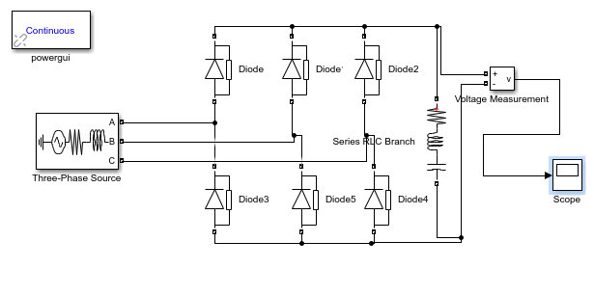

**Figure7:** AC-DC converter

Output voltage waveform is given in figure 8.

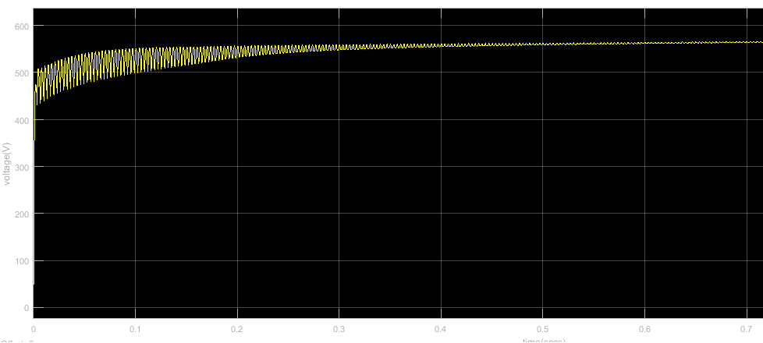

**Figure 8:** Output Voltage Waveform of AC-DC converter

* 1. DC-DC Buck Converter

Buck converter is represented in figure 9.

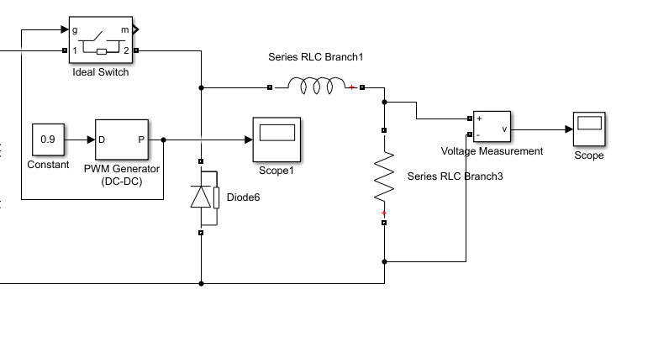

**Figure 9:** Buck converter.

Corresponding output voltages with %90 and %10 duty cycles are in figure 10 and 11 respectively.

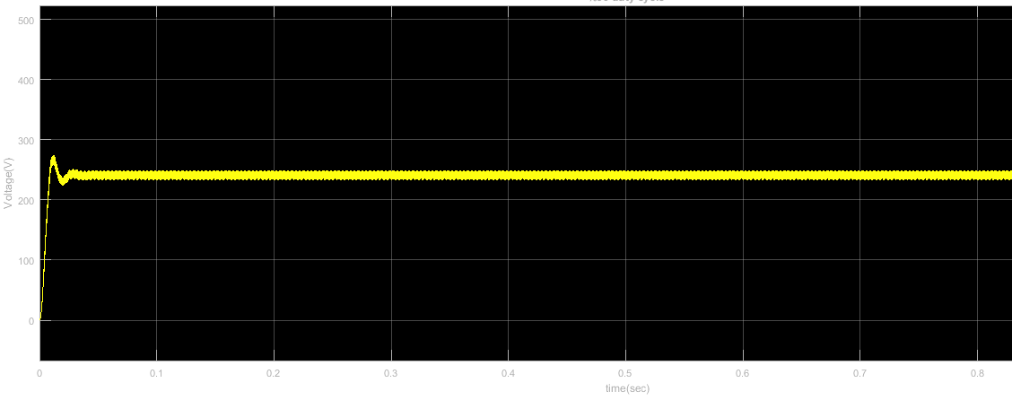

**Figure 10:** %90 duty cycle.

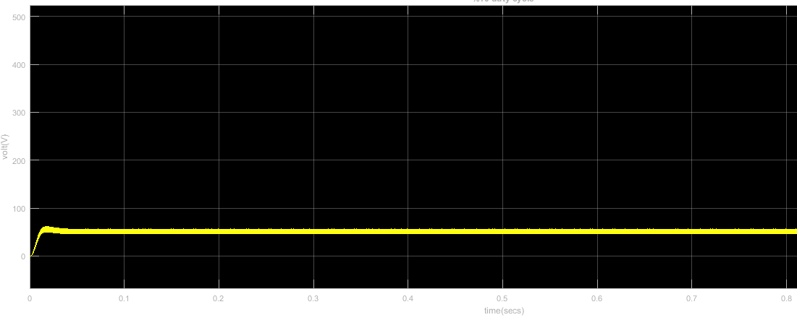

**Figure 11:** %10 duty cycle.

* 1. Overall System Design

As an initial speed of the motor, we adjusted 150 rad/s in the simulations because of some restrictions in simulink software and we connected 25 N/m constant torque on the motor. Our overall circuit is represented in figure 12. Results are obtained with duty cycle %90.

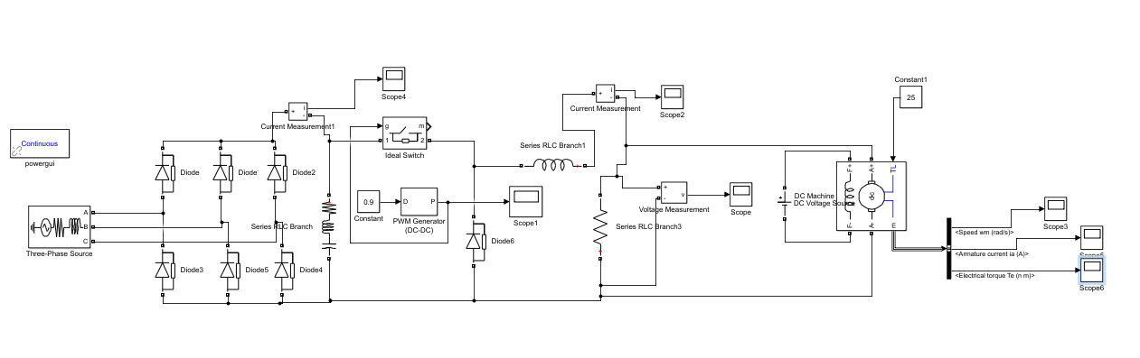

**Figure 12:** Overall circuit

Output current of the rectifier circuit is shown below in figure 13.

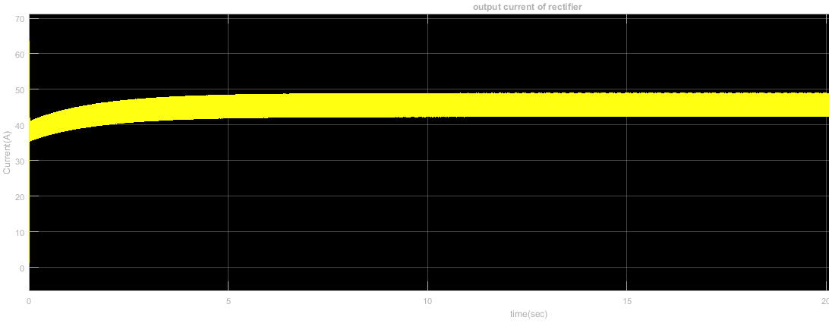

**Figure 13.** Output current of rectifier circuit.

Output voltage and current of buck converter are shown in figure 14 & 15 respectively.

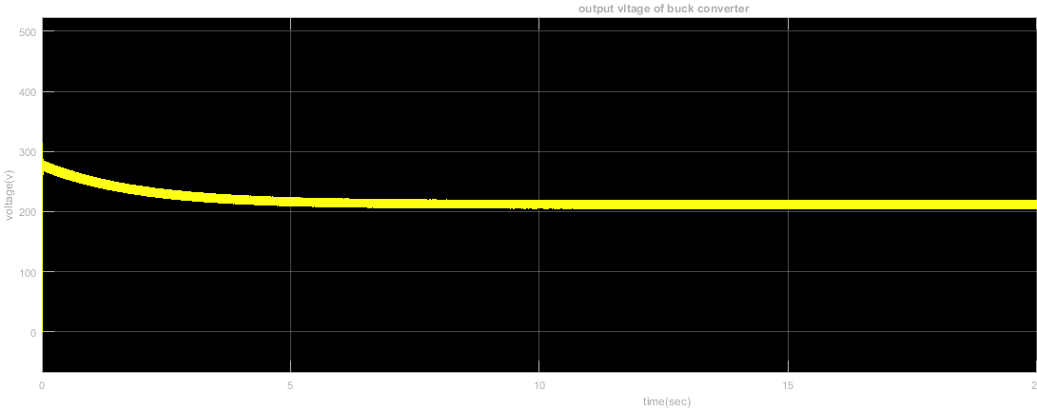

**Figure 14:** Output current of buck converter.

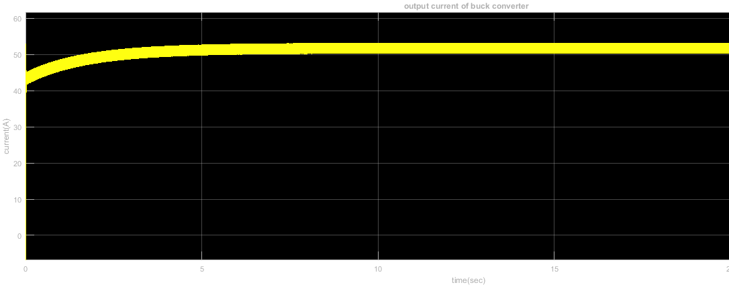

**Figure 15**: Output voltage of buck converter.

Motor measurements are figure 16 & 17.

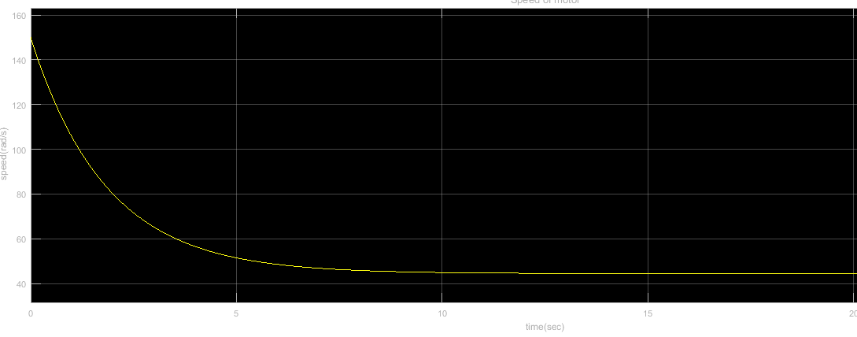

**Figure 16:** Speed of the motor.

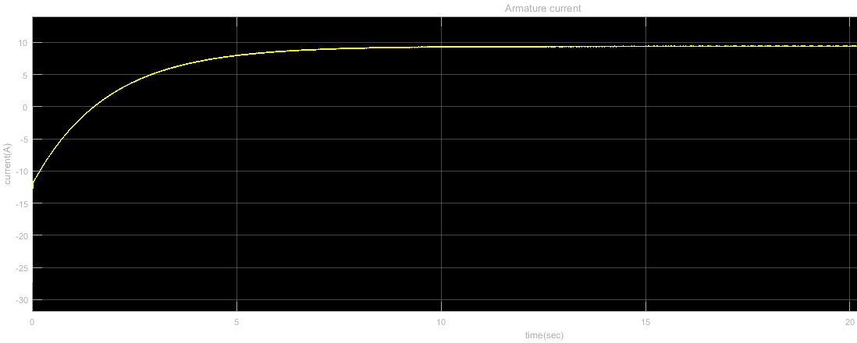

**Figure 17:** Armature current of the motor

In steady state operation, armature current of the motor is approximately 10 A, in the demonstration, we measured it as 12 A. Therefore, our torque constant is approximately equal to the real case in the simulation. Our final speed is almost equal to 40 rad/s. It corresponds to 381 RPM. Armature current and motor speed with duty cycle 30% is shown in figure 18 & 19 respectively.

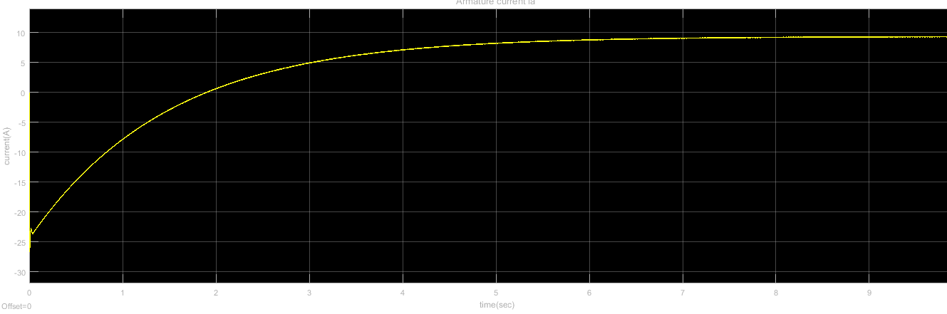

**Figure 18:** Motor armature current with %30 duty cycle.

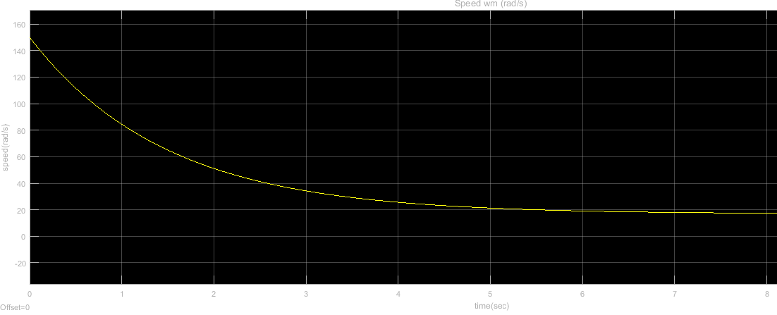

**Figure 19:** Motor speed with %30 duty cycle

* 1. Heat dissipation and Heatsinks
  2. Filtering Elements and Protection

In case of any fault, high voltage may damage the low voltage euipments and some of these equipments are rather expensive. Therefore, we used TLP250 model optocoupler in order to separate the high voltage and low voltage circuits from each other.

We used simple capacitive filter after AC-DC converter in order to suppress the sudden changes on the voltage value due to voltage drops on the grid line.

1. EXPERIMENTAL RESULTS
2. EXPANDITURES

We have used 150 TL to design, test and implement this project. The following table contains the main expenditures:

|  |  |
| --- | --- |
| Part | Cost |
| SKBPC3504 Diode Bridge | 1x55₺ |
| IXYS DSEI 30 Fast Diode | 2x8₺ |
| Vishay IRFP460 MOSFET | 2x12₺ |
| 4 Heatsinks | 40₺ |
| Other | 5₺ |
| **Total** | **140₺** |

1. DEMONSTRATION
2. REFERENCES
3. APPENDICES