

**COMSATS University Islamabad**

**Mid Project Report (Lab)**

Web Technologies

**Submitted By:**

|  |  |  |
| --- | --- | --- |
| Usama Muhammad Channar | FA19-BCS-083 | BCS-5B |

**Submitted To:**

Mr. Wassem Abbas

**Dated: 03-12-2021**

**Q1 and Q2:**

**Code:**

<!DOCTYPE html>

<html lang="en">

<head>

<meta name="viewport" content="width = device-width, initial-scale = 1.0, maximum-scale = 1.0, user-scalable = no">

<title>

fa19-bcs-083

</title>

<link rel="stylesheet" href="https://stackpath.bootstrapcdn.com/bootstrap/4.4.1/css/bootstrap.min.css"

integrity="sha384-Vkoo8x4CGsO3+Hhxv8T/Q5PaXtkKtu6ug5TOeNV6gBiFeWPGFN9MuhOf23Q9Ifjh" crossorigin="anonymous">

</head>

<body style="background-color: aqua;">

<div class="student" style="margin-top: 5rem;">

<h1 class="text-center mb-5 font-weight-bold">Student Details</h1>

<div class=" d-flex flex-column form align-items-center">

<form>

<div class="form-row">

<div class="form-group col-md-6">

<label for="name" class="font-weight-bold">Name</label>

<input type="text" class="form-control" id="name" placeholder="Name">

</div>

<div class="form-group col-md-6">

<label for="age" class="font-weight-bold">Age</label>

<input type="text" class="form-control" id="age" placeholder="Age">

</div>

</div>

<div class="form-row">

<div class="form-group col-md-6">

<label for="gender" class="font-weight-bold">Gender</label>

<input type="text" class="form-control" id="gender" placeholder="Male,Female">

</div>

<div class="form-group col-md-6">

<label for="img" class="font-weight-bold">Photograph</label>

<input type="file" class="form-control" id="img" accept="image/*" onchange="loadFile(event)">

</div>

</div>

<div class="form-row">

<div class="form-group col-md-4">

<label for="dob" class="font-weight-bold">Date of Birth</label>

<input type="date" class="form-control" id="dob">

</div>

<div class="form-group col-md-4">

<label for="pob" class="font-weight-bold">Place of Birth</label>

<input type="text" class="form-control" id="pob" placeholder="City Name">

</div>

<div class="form-group col-md-4">

<label for="photo" class="font-weight-bold">Photograph</label>

<input type="file" class="form-control" id="photo" accept="image/*" onchange="looadFile(event)">

</div>

</div>

<h4 class="font-weight-bold">Matric</h4>

<div class="form-row">

<div class="form-group col-md-6">

<label for="matm" class="font-weight-bold">Marks</label>

<input type="text" class="form-control" id="matm">

</div>

<div class="form-group col-md-6">

<label for="matp" class="font-weight-bold">Percentage</label>

<input type="text" class="form-control" id="matp">

</div>

</div>

<h4 class="font-weight-bold">FSC</h4>

<div class="form-row">

<div class="form-group col-md-6">

<label for="fscm" class="font-weight-bold">Marks</label>

<input type="text" class="form-control" id="fscm">

</div>

<div class="form-group col-md-6">

<label for="fscp" class="font-weight-bold">Percentage</label>

<input type="text" class="form-control" id="fscp">

</div>

</div>

<button type="button" onclick="create()" id="submit" class="btn btn-primary">Submit</button>

</form>

</div>

<p class="text-center mt-3">**************************************************************************</p>

<div class="show d-flex flex-column mt-3 align-items-center">

<h3 class="font-weight-bold ml-3 mt-5 text-center">

Student Data

</h3>

<p class="ml-3 mt-3 col-md-4">

<strong>Name:</strong> <span id="outname"></span>.

<strong>Age:</strong> <span id="outage"></span>.

<strong>Gender:</strong> <span id="outgender"></span>.

<strong>Image:</strong> <img id='output' style="height:100px; width:100px;"><br>

<strong>Date of Birth:</strong> <span id="outdob"></span>.

<strong>Place of Birth:</strong> <span id="outpob"></span>.

<strong>Photograph:</strong> <img id='outputt' style="height:100px; width:100px;"><br>

<strong style="font-size:x-large;">Matric</strong><br>

<strong>Marks:</strong> <span id="outmatm"></span>.

<strong>Percentage:</strong> <span id="outmatp"></span>.<br>

<strong style="font-size:x-large;">FSC</strong><br>

<strong>Marks:</strong> <span id="outfscm"></span>.

<strong>Percentage.</strong> <span id="outfscp"></span>.<br>

</p>

<table class="table col-md-6">

<thead>

<tr>

<th>#</th>

<th>Percentage</th>

<th>Result</th>

</tr>

</thead>

<tbody>

<tr>

<td>Matric</td>

<td><span id="mattp"></span></td>

<td><span id="matr"></span></td>

</tr>

<tr>

<td>FSC</td>

<td><span id="fsctp"></span></td>

<td><span id="fscr"></span></td>

</tr>

</tbody>

</table>

</div>

<div class="col text-center mt-3 mb-4">

<button class="btn btn-primary" type="button"><a href="experience.html" style="color: white;">Experience

</a></button>

</div>

</div>

<script>

var loadFile = function (event) {

var image = document.getElementById('output');

image.src = URL.createObjectURL(event.target.files[0]);

};

var looadFile = function (event) {

var image = document.getElementById('outputt');

image.src = URL.createObjectURL(event.target.files[0]);

};

function create() {

var input1 = document.getElementById('name').value;

var input2 = document.getElementById("age").value;

var input3 = document.getElementById("gender").value;

var input5 = document.getElementById("dob").value;

var input6 = document.getElementById("pob").value;

var input7 = document.getElementById("matm").value;

var input8 = document.getElementById("matp").value;

var input9 = document.getElementById("fscm").value;

var input10 = document.getElementById("fscp").value;

document.getElementById("mattp").innerHTML = input8;

document.getElementById("outname").innerHTML = input1;

document.getElementById("outage").innerHTML = input2;

document.getElementById("outgender").innerHTML = input3;

document.getElementById("outdob").innerHTML = input5;

document.getElementById("outpob").innerHTML = input6;

document.getElementById("outmatm").innerHTML = input7;

document.getElementById("outmatp").innerHTML = input8;

document.getElementById("outfscm").innerHTML = input9;

document.getElementById("outfscp").innerHTML = input10;

document.getElementById("fsctp").innerHTML = input10;

if (input8 >= 90) {

var exc = "Excellent";

document.getElementById("matr").innerHTML = exc;

} else if (input8 > 80 && input8 < 90) {

var exc = "Very Good";

document.getElementById("matr").innerHTML = exc;

} else if (input8 > 75 && input8 < 80) {

var exc = "Good";

document.getElementById("matr").innerHTML = exc;

} else if (input8 > 60 && input8 < 75) {

var exc = "First Class";

document.getElementById("matr").innerHTML = exc;

} else if (input8 > 50 && input8 < 60) {

var exc = "Second Class";

document.getElementById("matr").innerHTML = exc;

} else if (input8 > 40 && input8 < 50) {

var exc = "Third Class";

document.getElementById("matr").innerHTML = exc;

} else if (input8 < 40) {

var exc = "Fail";

document.getElementById("matr").innerHTML = exc;

}

if (input10 >= 90) {

var exc = "Excellent";

document.getElementById("fscr").innerHTML = exc;

} else if (input10 > 80 && input10 < 90) {

var exc = "Very Good";

document.getElementById("fscr").innerHTML = exc;

} else if (input10 > 75 && input10 < 80) {

var exc = "Good";

document.getElementById("fscr").innerHTML = exc;

} else if (input10 > 60 && input10 < 75) {

var exc = "First Class";

document.getElementById("fscr").innerHTML = exc;

} else if (input10 > 50 && input10 < 60) {

var exc = "Second Class";

document.getElementById("fscr").innerHTML = exc;

} else if (input10 > 40 && input10 < 50) {

var exc = "Third Class";

document.getElementById("fscr").innerHTML = exc;

} else if (input10 < 40) {

var exc = "Fail";

document.getElementById("fscr").innerHTML = exc;

}

console.log(input1);

};

</script>

</body>

</html>

**Screen Shots:**

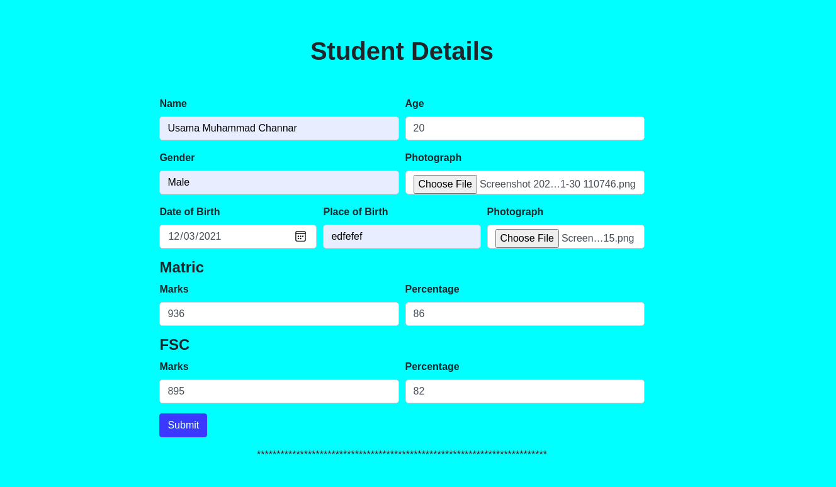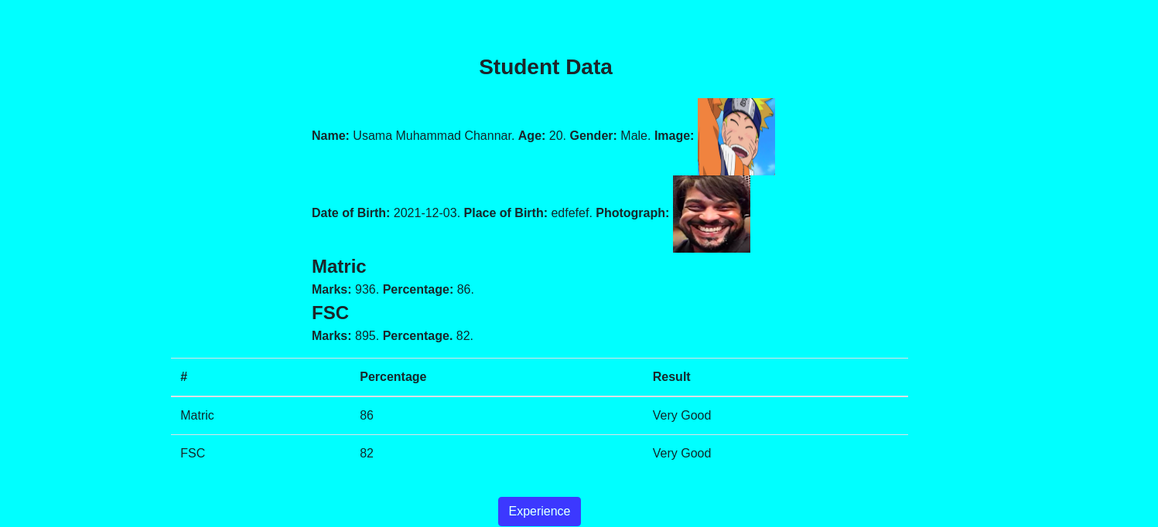

**Q3:**

**Code:**

Experience.html:

<!DOCTYPE html>

<html lang="en">

<head>

<title>

Fa19-bcs-083

</title>

<meta name="viewport" content="width = device-width, initial-scale = 1.0, maximum-scale = 1.0, user-scalable = no">

<link rel="stylesheet" href="https://stackpath.bootstrapcdn.com/bootstrap/4.4.1/css/bootstrap.min.css"

integrity="sha384-Vkoo8x4CGsO3+Hhxv8T/Q5PaXtkKtu6ug5TOeNV6gBiFeWPGFN9MuhOf23Q9Ifjh" crossorigin="anonymous">

<script src="https://ajax.googleapis.com/ajax/libs/jquery/3.5.1/jquery.min.js"></script>

<style>

@import url('https://fonts.googleapis.com/css2?family=Poppins:wght@800&family=Titillium+Web:wght@200;400&display=swap');

</style>

<link rel="stylesheet" href="experience.css">

</head>

<body style="background-color: aqua;">

<h2 class="text-center mb-5 mt-4 font-weight-bold" style="font-family: 'Poppins', sans-serif;">Comsats University

Islamabad

</h2>

<div class="d-flex flex-row justify-content-around align-items-center mb-4" style="background-color:black;">

<button class="btn btn-primary" type="button"><a href="index.html" style="color: white;">Home

</a></button>

<button type="button" onclick="createp()" id="submit" class="btn btn-primary mb-1 ml-1">Positive

Reviews</button>

<button type="button" onclick="createn()" id="submit" class="btn btn-primary mb-1 ml-1">Negative

Reviews</button>

<button type="button" onclick="createc()" id="submit" class="btn btn-primary mb-1 ml-1">Extra Curricular

activities</button>

<button type="button" onclick="createcn()" id="submit" class="btn btn-primary mb-1 ml-1">Contact Us</button>

</div>

<div id="pr">

<h2 style="font-family: 'Poppins', sans-serif;" class="m-5">Positive Reviews</h2>

<div class="expp">

<h2 id="oneh"><strong>1</strong></h2>

<p id="one" style="font-family: 'Titillium Web', sans-serif;">

I would describe the COMSATS University as exciting and dynamic. The best thing about being a student

here

is COMSATS provides the opportunity to meet excellent professors and build a network while studying in

the

heart of Pakistan. I keep a great memory of the classes, of the atmosphere among students and

interaction

with teachers. I would recommend to any student looking for a good academic curriculum. To any new

student

coming to the University, I would say this: Throw yourself at every opportunity that comes your way.

</p>

</div>

<div class="exppp">

<h2 id="twoh"><strong>2</strong></h2>

<p id="two" style="font-family: 'Titillium Web', sans-serif;">

I would describe the COMSATS University as exciting and dynamic. The best thing about being a student

here

is COMSATS provides the opportunity to meet excellent professors and build a network while studying in

the

heart of Pakistan. I keep a great memory of the classes, of the atmosphere among students and

interaction

with teachers. I would recommend to any student looking for a good academic curriculum. To any new

student

coming to the University, I would say this: Throw yourself at every opportunity that comes your way.

</p>

</div>

</div>

<div id="nr">

<h2 style="font-family: 'Poppins', sans-serif;" class="m-5">Negative Reviews</h2>

<div class="expp">

<h2 id="oneh"><strong>1</strong></h2>

<p id="one" style="font-family: 'Titillium Web', sans-serif;">

I would describe the COMSATS University as exciting and dynamic. The best thing about being a student

here

is COMSATS provides the opportunity to meet excellent professors and build a network while studying in

the

heart of Pakistan. I keep a great memory of the classes, of the atmosphere among students and

interaction

with teachers. I would recommend to any student looking for a good academic curriculum. To any new

student

coming to the University, I would say this: Throw yourself at every opportunity that comes your way.

</p>

</div>

<div class="exppp">

<h2 id="twoh"><strong>2</strong></h2>

<p id="two" style="font-family: 'Titillium Web', sans-serif;">

I would describe the COMSATS University as exciting and dynamic. The best thing about being a student

here

is COMSATS provides the opportunity to meet excellent professors and build a network while studying in

the

heart of Pakistan. I keep a great memory of the classes, of the atmosphere among students and

interaction

with teachers. I would recommend to any student looking for a good academic curriculum. To any new

student

coming to the University, I would say this: Throw yourself at every opportunity that comes your way.

</p>

</div>

</div>

<div id="cr">

<h2 style="font-family: 'Poppins', sans-serif;" class="m-5">Extra Curricular

activities</h2>

<div class="cr1">

<img src="c1.png" style="height:175px; width:200px;" class="p-2">

<p id="crp" style="font-family: 'Titillium Web', sans-serif;">

I would describe the COMSATS University as exciting and dynamic. The best thing about being a student

here

is COMSATS provides the opportunity to meet excellent professors and build a network while studying in

the

heart of Pakistan. I keep a great memory of the classes, of the atmosphere among students and

interaction

with teachers. I would recommend to any student looking for a good academic curriculum. To any new

student

coming to the University, I would say this: Throw yourself at every opportunity that comes your way.

</p>

</div>

<div class="cr2">

<img src="c2.jpg" style="height:175px; width:200px;" class="p-2">

<p id="crp" style="font-family: 'Titillium Web', sans-serif;">

I would describe the COMSATS University as exciting and dynamic. The best thing about being a student

here

is COMSATS provides the opportunity to meet excellent professors and build a network while studying in

the

heart of Pakistan. I keep a great memory of the classes, of the atmosphere among students and

interaction

with teachers. I would recommend to any student looking for a good academic curriculum. To any new

student

coming to the University, I would say this: Throw yourself at every opportunity that comes your way.

</p>

</div>

<div class="cr1">

<img src="c3.png" style="height:175px; width:200px;" class="p-2">

<p id="crp" style="font-family: 'Titillium Web', sans-serif;">

I would describe the COMSATS University as exciting and dynamic. The best thing about being a student

here

is COMSATS provides the opportunity to meet excellent professors and build a network while studying in

the

heart of Pakistan. I keep a great memory of the classes, of the atmosphere among students and

interaction

with teachers. I would recommend to any student looking for a good academic curriculum. To any new

student

coming to the University, I would say this: Throw yourself at every opportunity that comes your way.

</p>

</div>

</div>

<div id="cnr">

<p id="contact" class="text-center"

style="font-size:x-large; font-family: 'Titillium Web', sans-serif; border:solid;"><strong>Usama Muahmmad

Channar</strong><br><strong>Fa19-bcs-083</strong></p>

</div>

<script>

$("#pr").hide();

function createp() {

$("#pr").slideToggle(2000);

};

$("#nr").hide();

function createn() {

$("#nr").slideToggle(2000);

};

$("#cr").hide();

function createc() {

$("#cr").slideToggle(2000);

}

$("#cnr").hide();

function createcn() {

$("#cnr").slideToggle(2000);

}

</script>

</body>

</html>

Experience.css:

body {

display: flex;

flex-direction: column;

}

.expp {

display: flex;

flex-direction: row;

margin-left: 50rem;

margin-right: 20rem;

margin-bottom: 2rem;

border: solid;

}

#one {

padding: 0.5rem;

}

.exppp {

display: flex;

flex-direction: row;

margin-left: 20rem;

margin-right: 50rem;

margin-bottom: 2rem;

border: solid;

}

#two {

padding: 0.5rem;

}

.cr1 {

display: flex;

flex-direction: row;

margin-left: 50rem;

margin-right: 20rem;

margin-bottom: 2rem;

border: solid;

}

#crp {

padding: 0.5rem;

}

.cr2 {

display: flex;

flex-direction: row;

margin-left: 20rem;

margin-right: 50rem;

margin-bottom: 2rem;

border: solid;

}

**Screen Shots:**



