Global monthly continental discharge data set 1900-2023.
- Dai and Trenberth (2017) data set as ds551.0 in the NCAR Data Archive was taken as a base. (https://rda.ucar.edu/datasets/ds551.0/). It covers the years 1900-2018.
- The rivers which have annual mean discharge more 0.1 Sv and all Arctic Ocean rivers were replaced by newer observations up to the 07/2023. The new Arctic Ocean data were taken from the Woodwell Climate Research Center, Arctic Great Rivers Observatory (https://arcticgreatrivers.org/), all other from the Global Runoff Data Centre (https://portal.grdc.bafg.de/applications/public.html) Marked as new on the Figure.1. Most observed year is 1957. ~750 rivers in July.
Figure.1
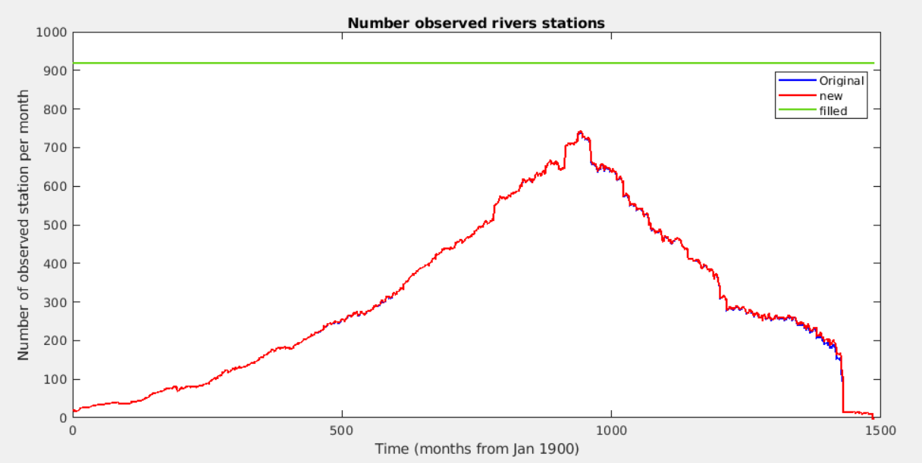
- The gaps in each individual river observations were filled by climatology calculated from 1900-2023 years. (Climatology 1980-2023 is very similar) This data is marked as filled on Figure.1. Changes in the Global Continental River Discharge are shown on the Figure.2.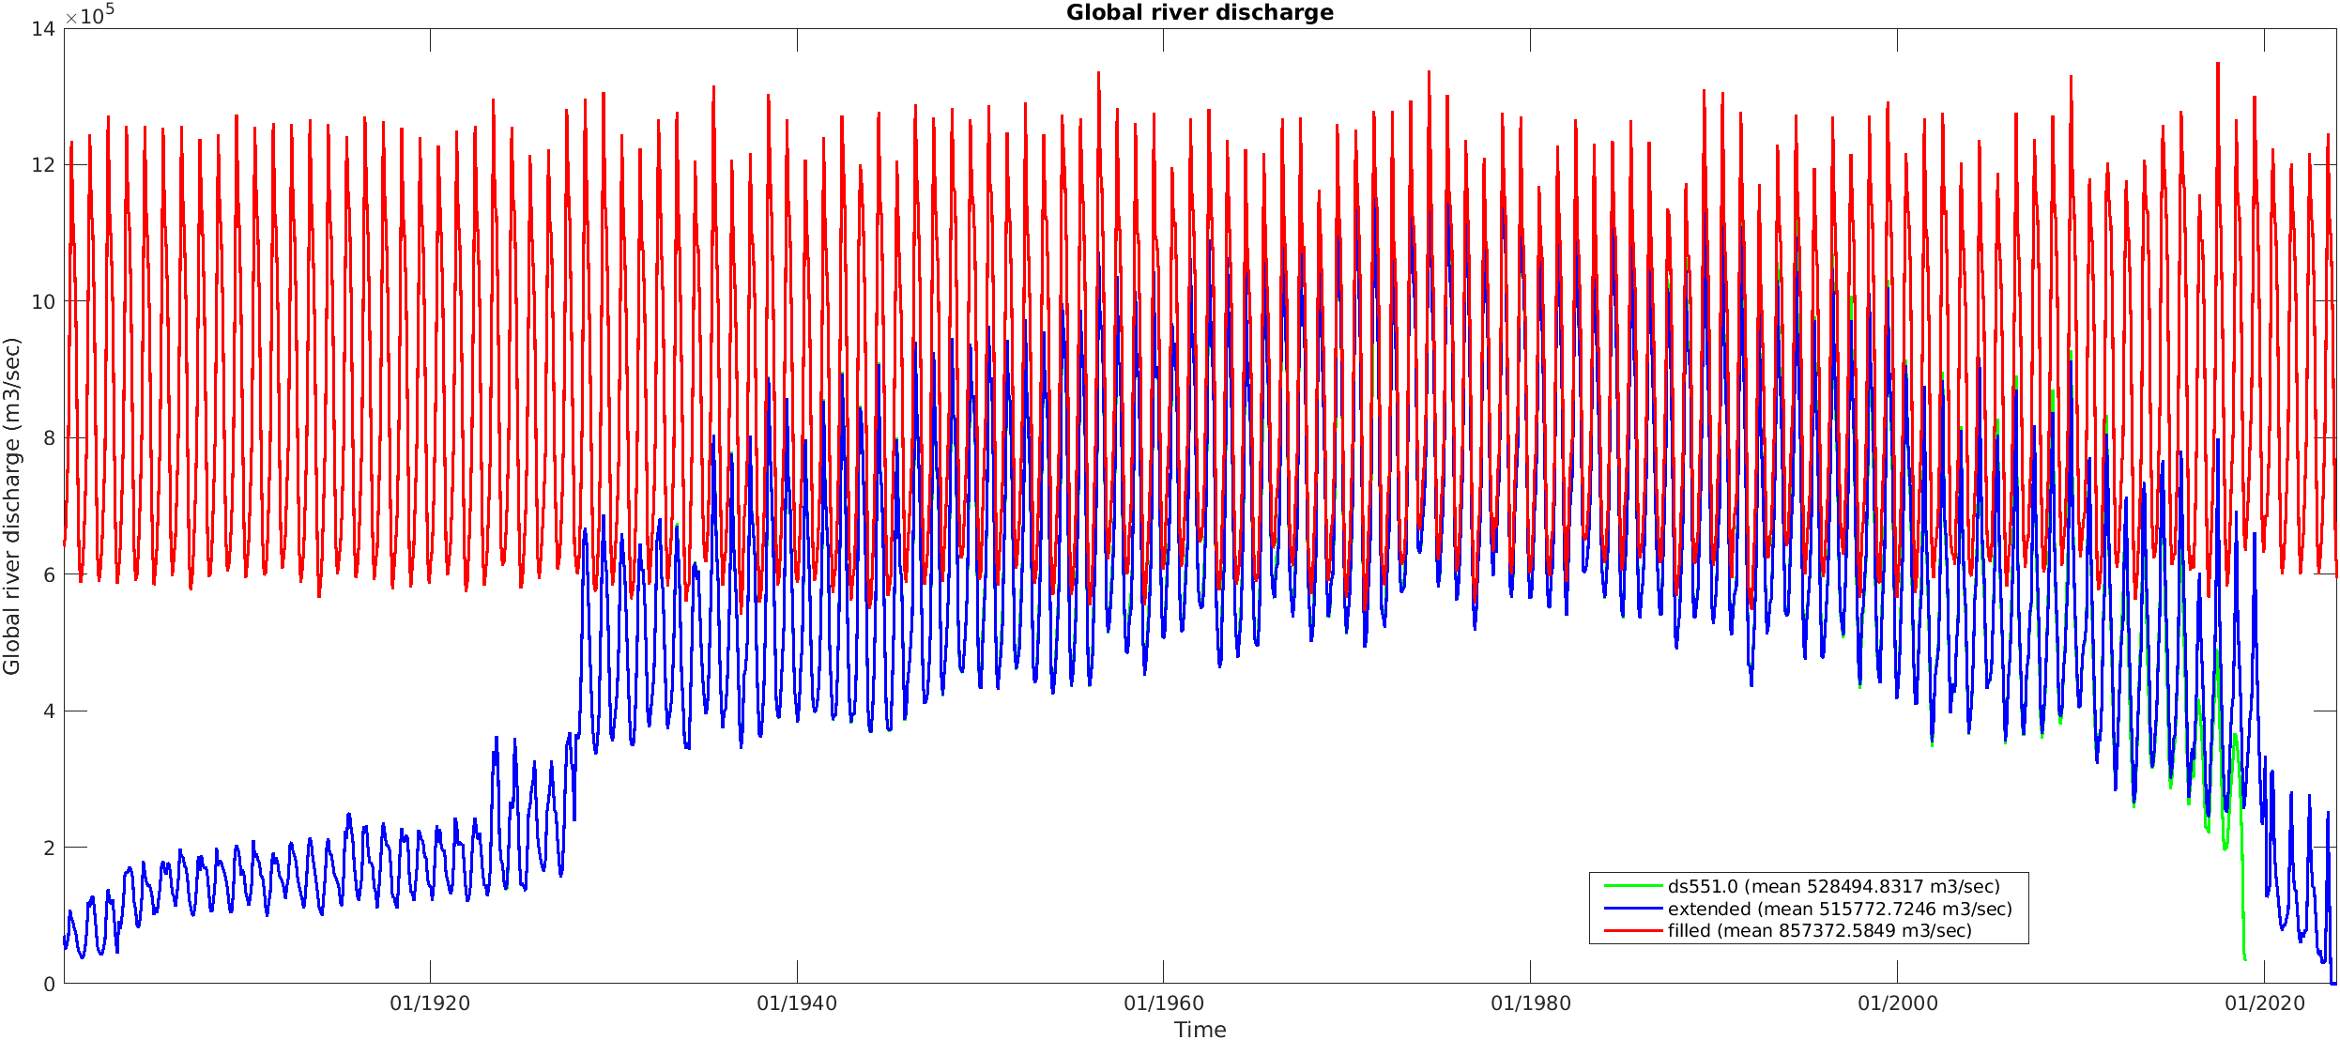
- The annual mean inflation coefficients for ungauged sources for each ocean basin were taken from the Dai and Trenberth (2002). All data were multiplied by appropriate coefficient. Exception were four strongest rivers Amazon, Congo, Orinoco, and Mississippi. Inflation of these river’s discharge has a result in unrealistic low salinity plums in Atlantic Ocean. Global and each ocean basin continental discharges 1980-2023 are show on the Figure.3.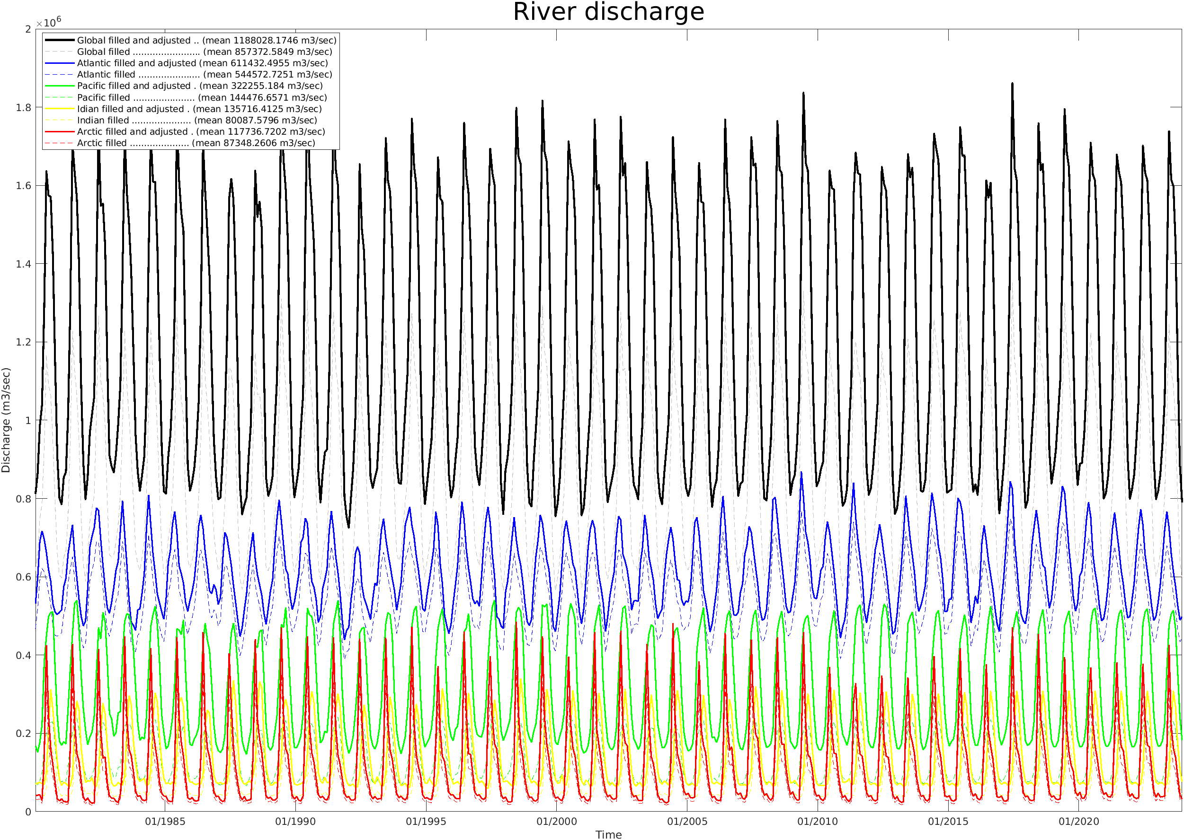
- The discharge data (years 1980-2023) were gridded to the 0.5⁰x0.5⁰ global grid.
- Greenland discharge data (1987-2019) from Mankoff et al (2019) were filled by climatology and added to the final data set (/aosc/iceland2/chepurin/RIVERS/DATA/gridded_discharge_720x360x528.nc).
- Final 0.5⁰x0.5⁰ data set were interpolated to the original SODA4 grid.

