# jQuery + AJAX Worksheet

## Pre-Requisites:

* Completed code for course searching

## Helpful Tools:

* <https://umd.io/courses/>

## Exercise:

1. Display the pre-requisites required for each course in bullet point format underneath the respective course description

## Before:

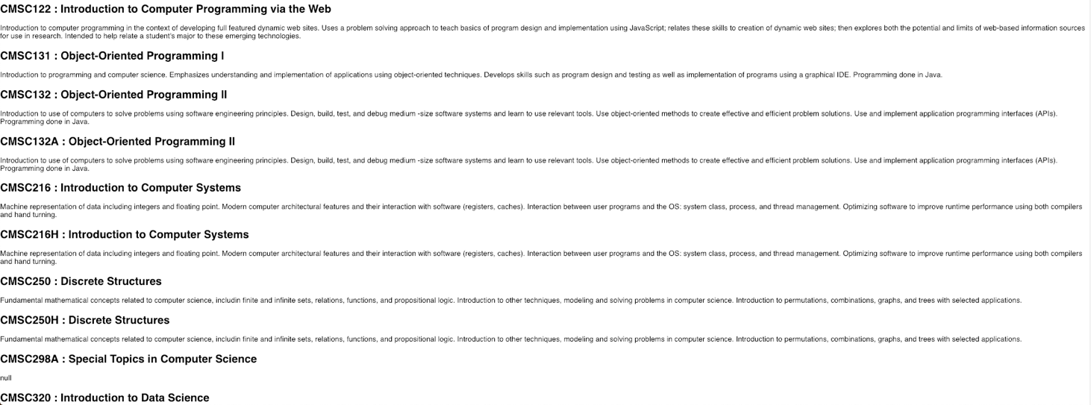

## After:

