ENPM661 - Spring 2025

Project 02

Implementation of the BFS (and Dijkstra) Algorithm for a Point Robot

Note: This is an individual project

## Points/Weightage: 10

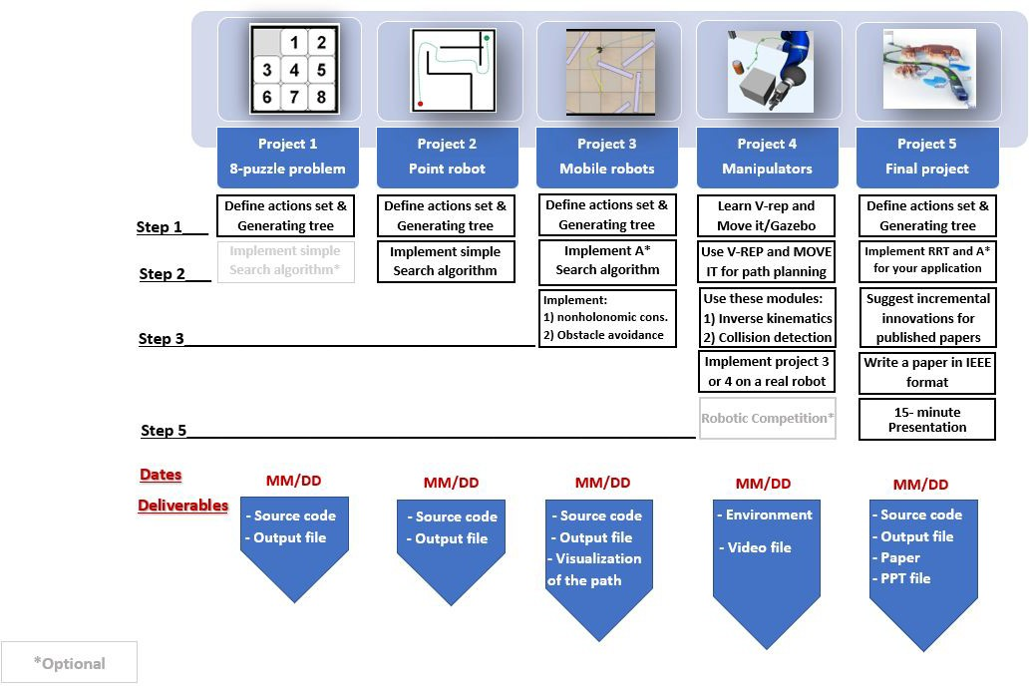

Ignore the node (do nothing!)

and

**BFS’s Pseudocode  
(Forward search)**

Create two empty lists named OpenList and ClosedList Get the initial (Xi) and goal node (Xg) from the user OpenList.put(Xi)

While (OpenList not EMPTY) and (Not reached the goal) do x OpenList.get()

Add x to ClosedList if x = Xg

Run backtrack function return SUCCESS

else

forall u ∈ U(x)

x’ f(x,u) # Generating each valid action

if (x’ ∉ ClosedList) and (NOT in the obstacle space) if (x’ ∉ OpenList) or (CostToCome(x’) = ∞)

Parent(x’) x

CostToCome(x’) CostToCome(x) + L(x,u) # L(x,u) is the cost of the action

Cost(x’) CostToCome(x’) OpenList.put(x’)

return FAILURE

else

If Cost(x’) > CostToCome(x) + L(x,u) Parent(x’) x

CostToCome(x’) CostToCome(x) + L(x,u) Cost(x’) CostToCome(x’)

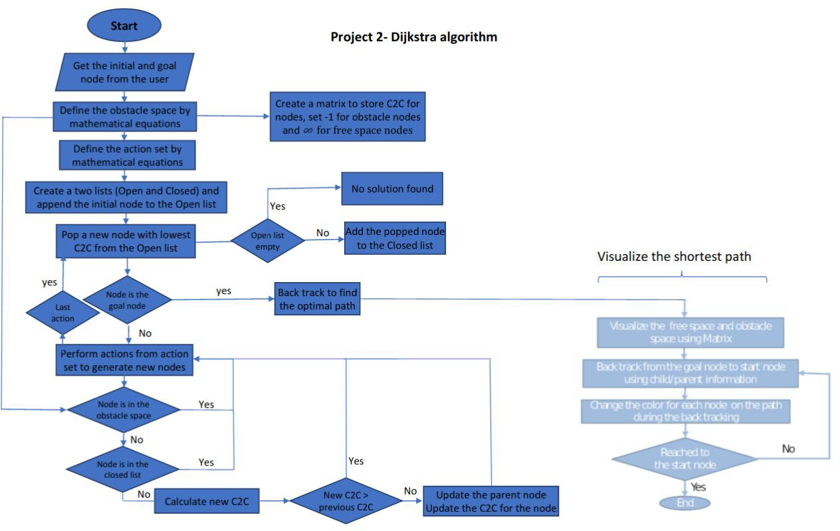

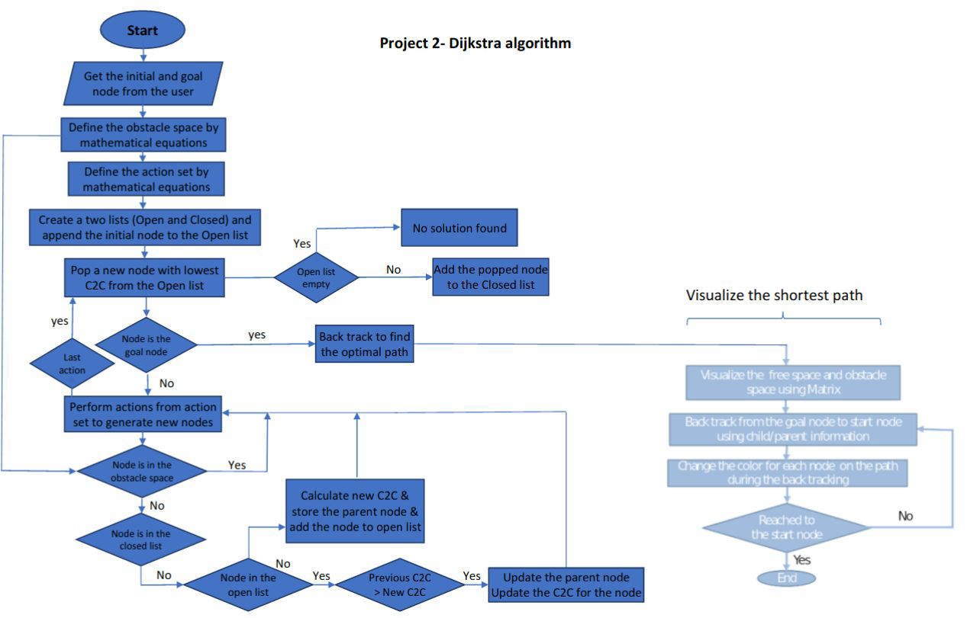

* The robot is assumed to be a point robot (size/radius of the robot = 0)
* 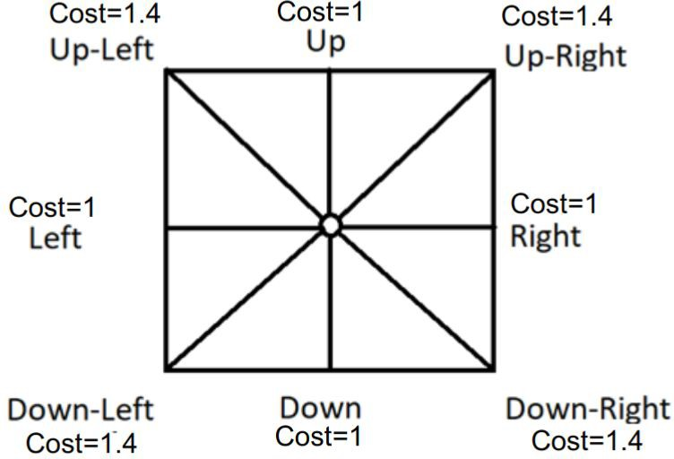The robot has a clearance of 2 mm (described in the next page).
* The workspace is an 8-connected space
  + The robot can move UP, DOWN, LEFT, RIGHT [Cost: 1.0]
  + It can also move diagonally between UP-LEFT, UP-RIGHT, DOWN-LEFT, and DOWN-RIGHT [Cost: 1.0 for BFS; Cost: 1.4 for Dijkestra]

**Actions Set = {(1,0), (-1,0), (0,1), (0,-1), (1,1), (-1,1), (1,-1), (-1,-1)}**

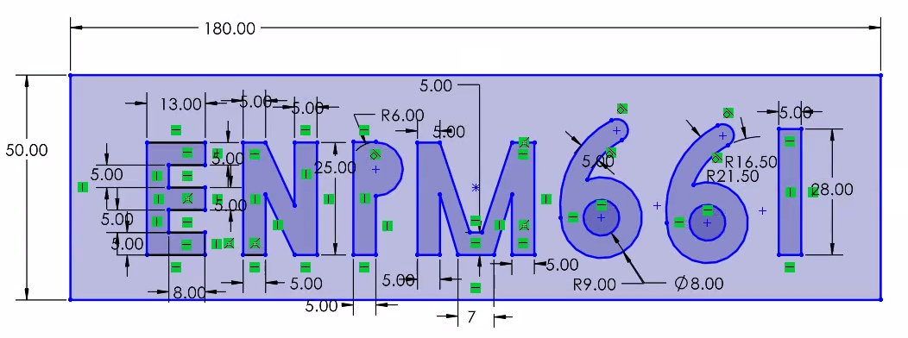

Free space

y

Origin

x

* The above map represents the space for clearance = 0 mm. For a clearance of 2 mm, the obstacles (including the walls) should be bloated by 2 mm distance on each side.
* Space inside the texts are obstacles
* Check the feasibility of all inputs/outputs
  + If the start and/or goal nodes are in the obstacle space, the user should be informed by a message and **they should input the nodes again** until valid values are entered.
  + The user input start and goal coordinates should be w.r.t. the origin shown in the previous page.
* Implement Dijkstra’s Algorithm to find a path between the start and end point on a given map for a point robot (**radius = 0; clearance = 2 mm**).
* Your code must output an **animation of optimal path generation between start and goal point** on the map. You need to **show both the node exploration as well as the optimal path generated**.
  + Sample videos from previous years: [[Link](https://umd.instructure.com/files/77271087/download?download_frd=1)], [[Link](https://umd.instructure.com/files/77304307/download?download_frd=1)]
* Some useful tools for drawing shapes on a canvas (map generation/visualization):
  + OpenCV
    - <https://pyimagesearch.com/2021/01/27/drawing-with-opencv/>
    - [https://medium.com/analytics-vidhya/opencv-tutorial-drawing-shapes-and-te xts-5cba52c76cd0](https://medium.com/analytics-vidhya/opencv-tutorial-drawing-shapes-and-texts-5cba52c76cd0)
  + Pygame
    - <https://www.geeksforgeeks.org/how-to-draw-rectangle-in-pygame/>
    - [https://medium.com/theta-hat/using-pygame-to-draw-grided-canvas-ba7e7e 409373](https://medium.com/theta-hat/using-pygame-to-draw-grided-canvas-ba7e7e409373)
    - <https://ryanstutorials.net/pygame-tutorial/pygame-shapes.php>
  + Matplotlib
    - <https://nickcharlton.net/posts/drawing-animating-shapes-matplotlib.html>
    - <https://www.askpython.com/python/examples/draw-shapes-using-opencv>
  + Tkinter
    - [https://stackoverflow.com/questions/25701347/how-to-draw-a-line-on-a-can vas](https://stackoverflow.com/questions/25701347/how-to-draw-a-line-on-a-canvas)
    - <https://pythonbasics.org/tkinter-canvas/>

# Step 01: Define the Actions in a Mathematical Format

* You can use the same data structure from Project 01 to store the node information.
* Write 8 functions, one for each action. The output of each function is the state of a new node after taking the associated action. The names of these functions can be as per your wish as long they achieve the intended result.

**Actions Set = {(1,0), (-1,0), (0,1), (0,-1), (1,1), (-1,1), (1,-1), (-1,-1)}**

# Step 02: Find the Mathematical Representation of Free Space

* Use **Half planes and semi-algebraic models** to represent the obstacles in the map.
  + Refer [Session 03](https://umd.instructure.com/files/77137530/download?download_frd=1)
  + The equations must account for the 2 mm clearance of the robot.
* Using OpenCV/Matplotlib/Pygame/Tkinter (or any other graphical plotting library of your choice), create an empty canvas of size height=50 mm and width=180 mm.
  + With the above equations, assign a different color for all the pixels within obstacles and walls. You may choose to represent the clearance pixels around the obstacle with another color.
  + IMPORTANT: While creating the map/canvas, pay attention to the coordinate system representation of the corresponding library.
    - For example: In OpenCV, the image origin is at the top left corner. Refer: [[Link](https://pyimagesearch.com/2021/01/20/opencv-getting-and-setting-pixels/)]

# Step 03: Generate the Graph and Check for Goal Node in each Iteration

* Generate the graph using the action set for an 8-connected space, similar to as done in Project 01.
* Before saving the nodes, check for the nodes that are within the obstacle space and ignore them.
  + To verify if a specific coordinate (node) is in the obstacle space, simply check its pixel color value in the created map.
* Once the goal node is popped, stop the search and backtrack to find the path.
  + Write a function that compares the current node with the goal node and return TRUE if they are equal.
    - While generating each new node this function should be called
  + Write a function, when once the goal node is reached, using the child and parent relationship, backtracks from the goal node to start node and outputs all the intermediate nodes in the reversed order (start to goal).
* Show optimal path generation animation between start and goal point using a simple graphical interface. You need to show both the node exploration as well as the optimal path generated.

## Note: The visualization of (exploration and optimal path) should start only after the exploration is complete and optimal path is found.

* + - To save the visualization animation as a video:
      * OpenCV:
        + <https://theailearner.com/2018/10/15/creating-video-from-images-using-opencv-python/>
        + <https://www.geeksforgeeks.org/saving-a-video-using-opencv/>
      * Matplotlib:
        + <https://matplotlib.org/stable/gallery/animation/dynamic_image.html>
        + <https://holypython.com/how-to-save-matplotlib-animations-the-ultimate-guide/>
      * Pygame
        + <https://pypi.org/project/vidmaker/>
      * Tkinter
        + <https://www.quickprogrammingtips.com/python/how-to-create-canvas-animation-using-tkinter.html>
      * Alternatively, you may run the code + visualization, screen record the animation and save it as a .mp4 file.

# Project 02: Deliverables

* README file (.md or .txt)
  + Must describe how to run the code and give inputs (start and goal coordinates)
  + Must mention the libraries/dependencies used (for ex: numpy, matplotlib, etc)
* Source Code (.py)
  + Filename: **BFS_firstname_lastname.py (and dijkstra_firstname_lastname.py)**
  + Code should accept start and goal coordinates as a user input
    - Values should be w.r.t the map origin frame
  + GitHub Repository Link containing the code(s)
    - Simple Tutorial: <https://www.youtube.com/watch?v=iv8rSLsi1xo>
* Animation Video (.mp4)
  + Recording of the Node exploration and Optimal path
  + Start and Goal coordinates can be random
  + Submit all the files by dragging and dropping in the ELMS portal.

Do not zip the files

# Additional information + Tips

* When defining the obstacle space, use any graphing tool (like desmos) to visualize and check the validity of your equations.
  + <https://www.desmos.com/calculator>
* It is important to keep your code modular so that it can be reused for the upcoming projects.
* Use the [time](https://www.programiz.com/python-programming/examples/elapsed-time) library to print the runtime of your algorithm.