# Martials Arts Web Application

## User Manual

**CMSC 495 #6380**

**10/11/20**

**Group #5**

**Members:**

**Nicholas Crown**

**Tiago Feitosa**

**David Roberts**

**Contents**

Martials Arts Web Application 1

User Manual 1

**Revision History** 3

1 – Requirements 4

2 – Installation 4

Create an AWS Account 4

Create Cloud9 IDE Environment 4

Install Python 4

Create RDS Database 5

Starting the server 5

3 – Operation 5

1. Logging in to your account 5

2. Check the calendar 6

3. Changing months in the calendar 7

4. Creating student accounts 8

5. Creating instructor accounts 12

6. Modifying accounts 14

7. Deleting accounts 16

8. Creating new classes 17

9. Modifying classes 20

10. Deleting classes 21

11. Taking attendance 21

12. Logging out of the system. 23

# **Revision History**

|  |  |  |  |
| --- | --- | --- | --- |
| **Version** | **Date** | **Reviser** | **Changes made** |
| 1.0 | 10/11/20 |  | Initial creation of document, including title page, table of contents page, and revision history table. |
| 1.0 | 10/11/20 | Tiago Feitosa | Wrote the Manual User |
|  |  |  |  |

# 1 – Requirements

The Martial Arts Web application requires a computer to run with the following minimum hardware requirements:

* **Processor:** 1 gigahertz (GHz) or faster processor or SoC
* **RAM:** 1 gigabyte (GB) for 32-bit or 2 GB for 64-bit
* **Hard disk space:** 16 GB for 32-bit OS or 20 GB for 64-bit OS
* **Graphics card:** DirectX 9 or later with WDDM 1.0 driver
* **Display Monitor:** 800 x 600 pixels resolution or better

The application requires an operating system with a browser to operate. One of the following browsers are required:

* **Google Chrome:** Latest three major versions
* **Mozilla Firefox:** Latest three major versions
* **Microsoft Edge:** Latest three major versions
* **Microsoft Internet Explorer 11**

# 2 – Installation

## Create an AWS Account

1. Create an account with AWS Amazon services. Go to <https://aws.amazon.com/console/>
2. Sign in with your new credentials.
3. On the left top corner of the page, click on the AWS logo to access your dashboard and services.

## Create Cloud9 IDE Environment

1. In the AWS dashboard, type in the Find Services search bar Cloud9 and hit enter.
2. In the Cloud9 Management page, click on the Create environment button.
3. Give the service a name and Description of your server. Click on the Next step button.
4. Leave all default values. Click on the Next step button.
5. Click on the Create environment button.
6. In the management page, click on Open IDE.
7. On the left side of the console, there is a folder with the name of your newly created Cloud9 IDE environment.
8. Select the folder of your web application in your computer folder.
9. Drag it and drop it inside your Cloud9 IDE environment folder.

## Install Python

1. In your Cloud9 environment, open your IDE.
2. Right-click on your environment folder and select Open Terminal Here.
3. Copy and paste the following command line to install the Python language on your server in order to run your files:

apt-get install python3.7

1. Install Flask dependencies with the following line:

pip install flask

1. Install Passlib dependencies for password authentication with the following line:

pip install passlib

## Create RDS Database

1. In the AWS dashboard, type in the Find Services search bar RDS and hit enter.
2. Click on Create Database button.
3. Select Easy Create.
4. Select MySQL Database.
5. Select a username and master password.
6. Click on Create Database.
7. Go back to your Cloud9 environment and open your IDE.
8. Right-click on your environment folder and select Open Terminal Here.
9. In the command line, copy and paste the following line with your database URL:

mysql -h <database url> -u admin -p

1. Type in your master password.
2. You are now connected to your RDS Database console.
3. In your environment folders, double-click on file DatabaseConfiguration.sql to open it.
4. Copy all the scripts of the file.
5. Paste it on the Database console and hit enter. That will create the tables of your database.

## Starting the server

1. Browse through your web application files and double click on file application.py to open it.
2. On the console menu, click on the Run button to run the application.

# 3 – Operation

## Logging in to your account

1. Enter the address for the Martial Arts website on your browser.
2. Enter your **Username** and **Password** in the following areas.

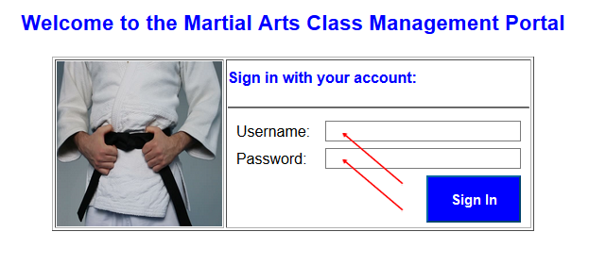

1. Click the **Sign In** button.

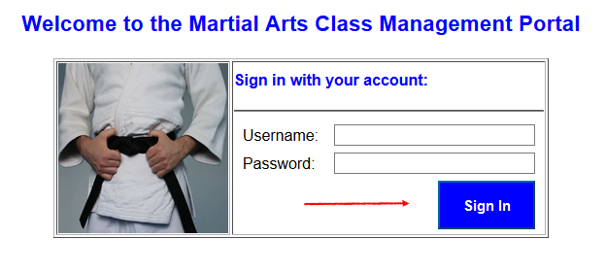

## Check the calendar

To check or refresh your calendar, anywhere in the website:

Click on the **Calendar** button on the menu.

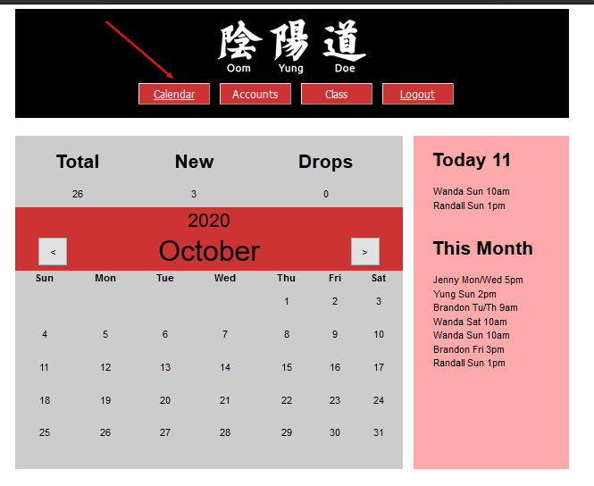

## Changing months in the calendar

In the calendar view, click on the arrows to change to past and next months.

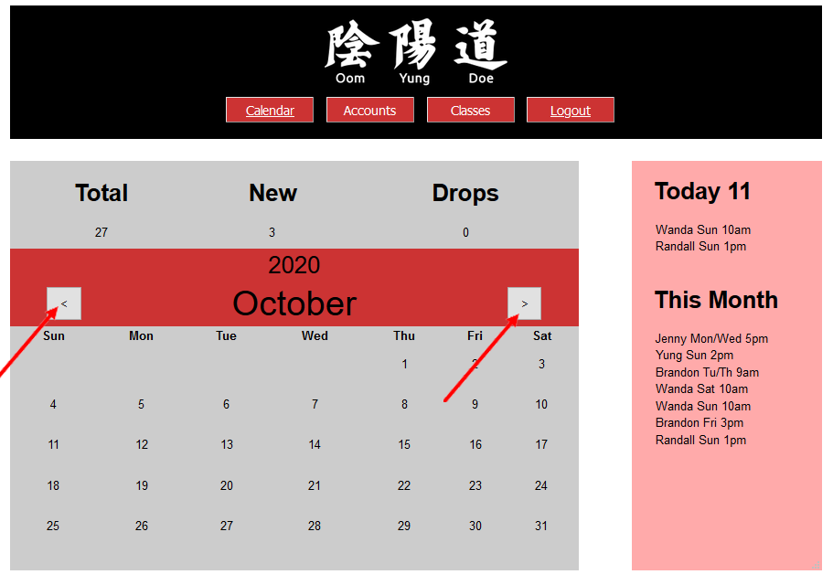

## Creating student accounts

1. Hover the mouse over the **Accounts** button on the menu. That should drop down two more buttons.

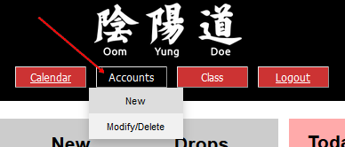

1. Click on the **New** button.

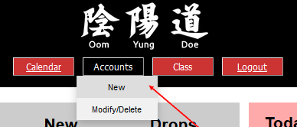

1. Fill in the **text fields**.

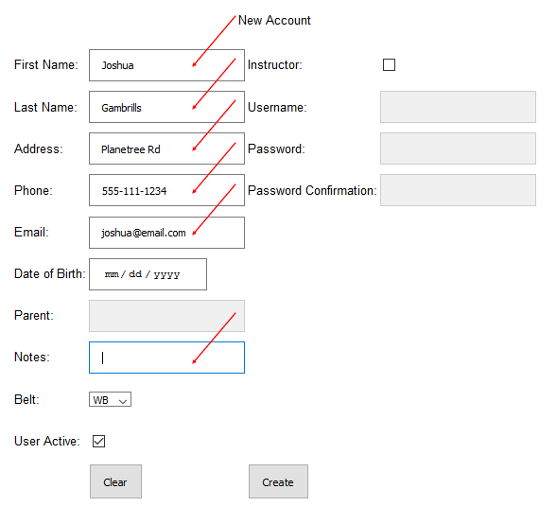

1. Click on the **Date of Birth** box. Click on the **Month** and **Year**.

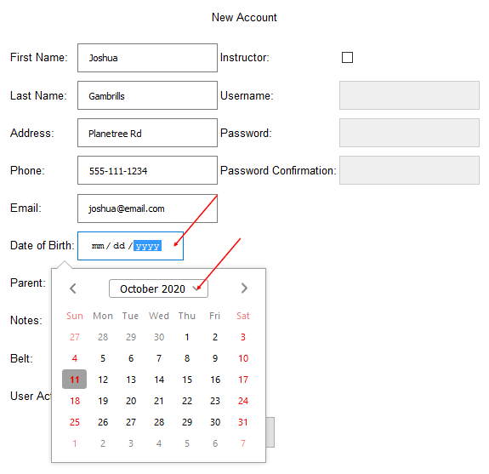

1. Select **month** and **year**. Click on the **top button** again to confirm.

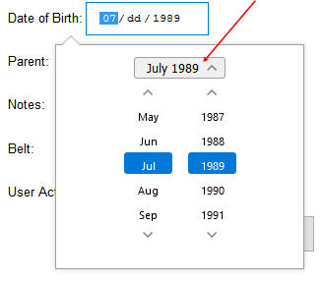

1. Select the day in the mini calendar.

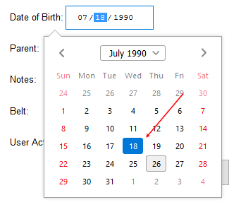

1. Click on the **Belt** box. Select the student current belt level.

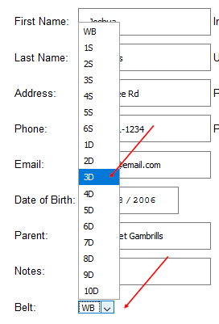

1. If Student is less than 18 years old, fill in **Parent** Contact.

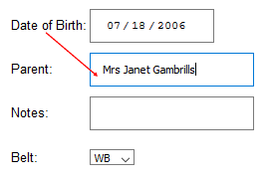

1. Click the **Create** button to complete student account creation.

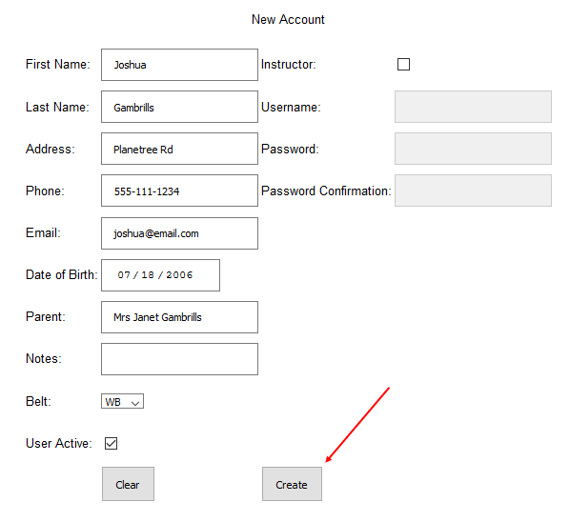

Note: The following fields are required to create an account:

* First Name
* Last Name
* Address
* Phone
* Date of Birth

## Creating instructor accounts

1. Repeat steps **a** through **g** of Creating Students Account in 4.
2. Click on the **Instructor** tick box on the right column of the form.

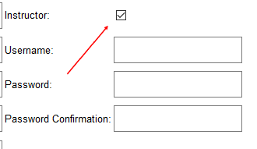

1. Fill in **Username** and **Password** fields.

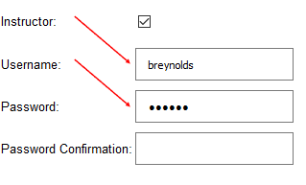

1. Repeat Password on **Password Confirmation** field.
2. If passwords match, click on **Create** to complete instructor account creation.

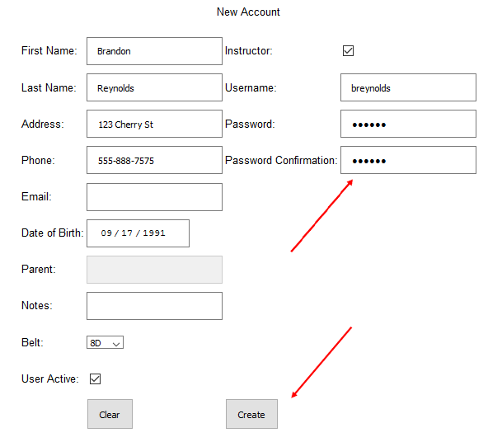

## Modifying accounts

1. Hover the mouse over the **Accounts** button on the menu.
2. Click on the **Modify/Delete** button.

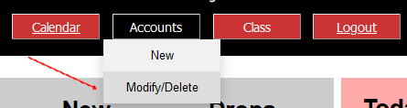

1. Click on the **drop down** box of accounts.

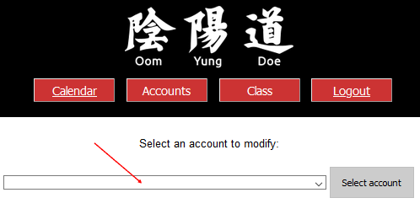

1. Select the desired **Account**.

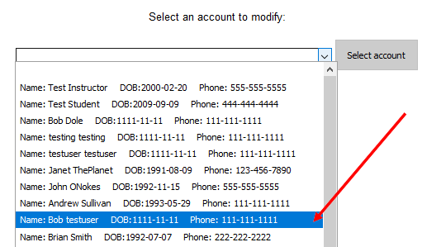

1. Click on **Select Account** button to the right.

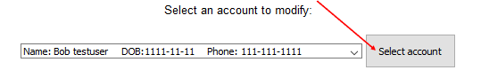

1. Repeat any desired steps of Creating Student and Creating Instructor Account.
2. Click on the Modify Account button on the bottom of the form.

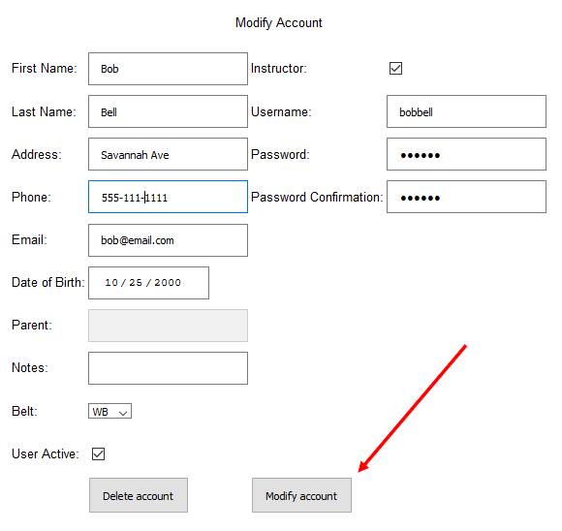

## Deleting accounts

1. Repeat steps **a** through **e** of Modifying Accounts in 6.
2. Click on the Delete account button on the bottom of the form.

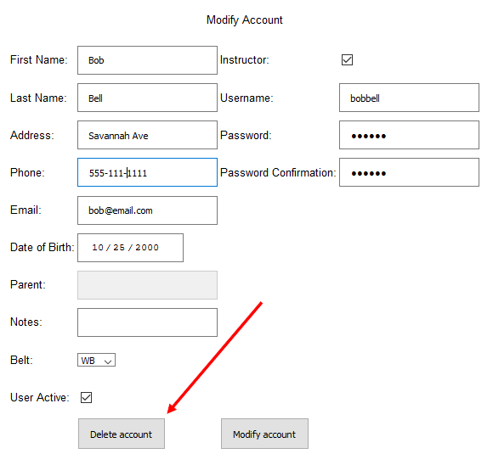

## Creating new classes

1. Hover the mouse over the **Classes** button.

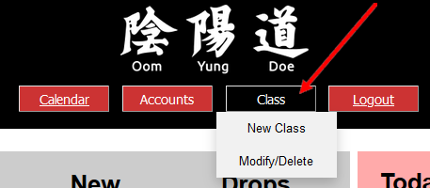

1. Click on the **New Class** button.

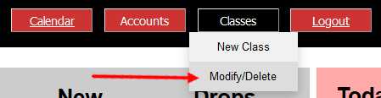

1. Type in a **name** for the class in the Class name field.

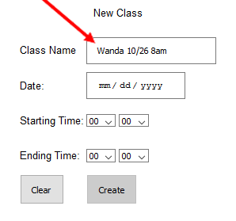

1. Select a **date** for the class. Follow instructions in 4.d, 4.e and 4.f of this manual.

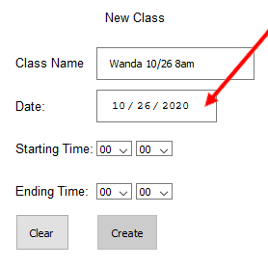

1. Select **hour** for Starting time.

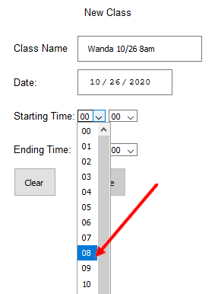

1. Select **minutes** for Starting time.

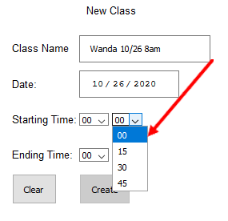

1. Repeat e and f for **Ending Time**.
2. Click on the **Create** button to complete class creation.

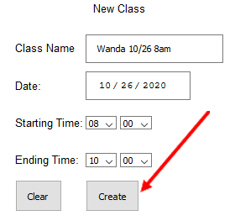

Note: All fields are required to create a new class.

## Modifying classes

1. Hover the mouse over the **Classes** button on the menu.
2. Click on the **Modify/Delete** button.

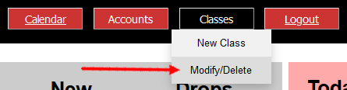

1. Click on the **dropdown** box with the list of classes.

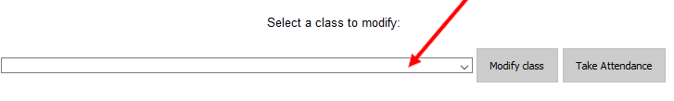

1. Select the desired **class**.

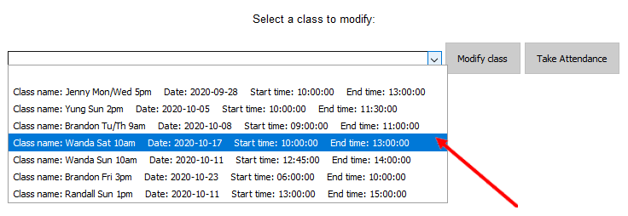

1. Follow steps **c** through **g** of item 8 of this manual to make modifications.

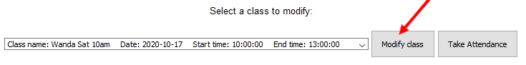

1. Click on the **Modify Class** button on the bottom of the form.

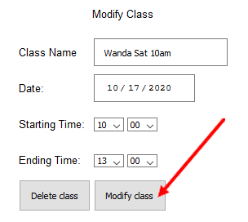

## Deleting classes

1. Repeat steps **a** through **e** of item 9 of this manual.
2. Click on the **Delete Class** button at the bottom of the form.

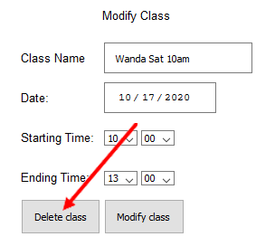

## Taking attendance

1. Repeat steps **a** through **d** of item 9 of this manual to select a class.
2. Click on the **Take Attendance** button to the right of the class list.

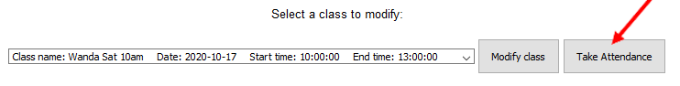

1. Left click with the mouse on a student to **highlight** it in blue.

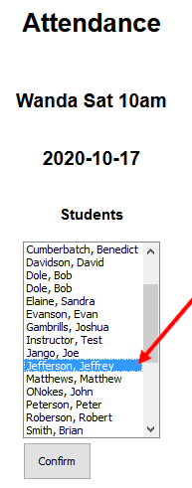

1. Hold the **CTRL button** on the keyboard and **left click** with the mouse to select multiple students.

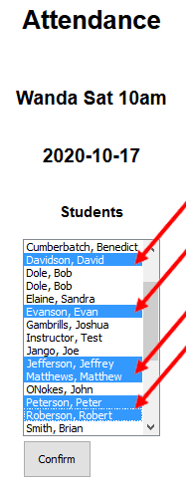

1. Click on the **Confirm** button to complete attendance list.

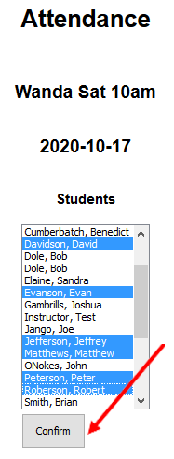

## Logging out of the system.

Anywhere in the website, click on the Logout button on the menu to log out of the website.

