Phase 2 Source:
AI/LLM Inventory Management System

UMGC 495: Computer Science Capstone | Summer 2026 | 22 June 2026

Team Members
Dan Nunes
Robert Lee
Adan Medina
Spencer Renfro
Arth Naileshbhai Thakkar
Jose Jovenal Escandor

1. Project Setup
This Phase II submission re-examines and finalizes the development environment established in Phase I. All coding tools, source libraries, and dependencies have been verified as operational across both repositories. The containerized local environment, CI/CD pipeline, and shared contracts package are in full use by the team.

1.1 Coding Tools / IDE
- IDE: Visual Studio Code
- Node.js (v22 or higher) and npm
- TypeScript (backend and frontend client)
- Docker / Docker Compose (containerized full-stack dev environment)
- ESLint + Prettier (enforced in both repositories via CI)
- Prisma ORM (database schema, migrations, and type-safe query generation)
- GitHub Actions (CI/CD pipeline: lint, test, build + automated Claude code review on every PR)

1.2 Libraries and Packages Installed
Our dependencies are declared in the package.json files and installed with npm. The core technologies are:

Layer | Technology / Packages
Frontend | React, Vite, React Router, Material UI (MUI), TanStack Query, react-hook-form, Firebase Auth, Zod
Backend | Node.js, Express.js, Prisma ORM, Firebase Admin, AWS Bedrock SDK, Zod, Swagger UI
Database | PostgreSQL
Shared Contracts | @umgccapstone/contracts (shared types, Zod schemas, enums, derive functions)
AI / LLM | AWS Bedrock (cross-region inference profile, with rule-based fallback)
Testing | Vitest + React Testing Library (frontend), Jest + supertest (backend)

Each repository is cloned separately, and dependencies are installed with:
npm install (run inside the frontend repository)
npm install (run inside the backend repository)
The full list of dependencies and their versions is maintained in each repository's README and package.json files.

1.3 Version Control Integration
- We use Git for version control, hosted on GitHub. The frontend and backend live in separate repositories, and in each we manage issues, pull requests, and code reviews.
- Frontend repository URL: https://github.com/UMGCCAPSTONE/AI_Inventory_Frontend.git
- Backend repository URL: https://github.com/UMGCCAPSTONE/AI_Inventory_Backend.git
- Production branch: main | Integration branch: dev | Access: Private
- Branching convention: feature/T_X_short-name off dev. PRs target dev for integration review; dev merges into main for production releases. No direct commits to main or dev.
- All changes go through pull request review. The CI pipeline (lint, test, build via GitHub Actions) must pass before any merge.
- Automated code review via the @claude GitHub Actions workflow runs on every PR. Team members can invoke @claude in PR comments to get an inline review.
- Shared types and schemas are distributed as the @umgccapstone/contracts package, published to GitHub Packages. Both repos pin the same version to keep the contract in sync.
- The commit history in each repository reflects incremental, ticket-driven work from all six team members.

1.4 Organized Project Structure (Separated Configuration Files)
Each repository maintains its own structure, keeping application code separate from configuration files (.env.example, CI workflows, Docker files, .gitignore).

Backend repository
ai-inventory-backend/
src/
app.ts Express app factory (middleware, routes, docs)
server.ts Entry point - boots the API
routes/ inventory, suppliers, dashboard, health, api (auth router)
lib/ db, prisma, firebase, http, errors, inventory-dto,
dashboard-dto, inventory-watermark
middleware/ requireAuth (Firebase token verification)
docs/ openapi.ts, swagger.ts (live Swagger UI)
__tests__/ Jest + supertest test suite (9 test files)
prisma/
schema.prisma 7 models: UserProfile, Supplier, InventoryItem, MenuItem,
MenuItemIngredient, Recommendation, InventoryMutation
migrations/ Applied Prisma migrations
seed.ts Demo seed data
packages/contracts/ @umgccapstone/contracts - shared types, schemas, derive
.github/workflows/ CI/CD + automated Claude PR review
docker-compose.dev.yml Full-stack local dev env (API + Postgres, health-checked)
Dockerfile Multi-stage container image
.env.example Environment variable template
.gitignore Excludes node_modules, dist, .env, generated client
README.md

Frontend repository
ai-inventory-frontend/
client/
src/
components/ DashboardHeader, InventoryDataGrid, InventoryFormModal,
StatCard, SupplierDirectory, TodayDashboard, Toaster, states/
pages/ DashboardPage, InventoryPage, LoginPage,
MenuBuilderPage, ReportsPage, SuppliersPage
hooks/ useDashboard, useInventory, useInventoryMutations, useSuppliers
services/ apiClient, inventory, suppliers, dashboard, health,
config, queryKeys, invalidation
types/ api.ts, dashboard.ts
context/ AuthContext (Firebase session)
styles/ theme.ts (MUI theme)
vite.config.ts Vite + Vitest config
Dockerfile Multi-stage build (dev Vite + nginx prod)
nginx.conf.template SPA serving + /api reverse proxy (same-origin, no CORS)
.github/workflows/ CI/CD pipeline + ADR shared-copy drift check
.env.example Environment variable template
.gitignore Excludes node_modules, dist, .env.local
README.md
Secrets (API keys, database credentials, Firebase config) are excluded from both repositories and supplied via local .env / .env.local files or GitHub Actions Secrets.

2. Core Functionality
This section covers the production-level features implemented in Phase II. Authentication, inventory management, the dashboard, and supplier management are complete and tested. AI recommendation generation and the reports module are in active development on their respective feature branches.

2.1 Implementation of Features (from Project Requirements)
The Must-Have MVP features from our project design, with their current Phase II status:

Feature | Requirement | Phase II Status
Authentication | Firebase ID token verification, protected /api routes, dev passthrough, production fail-fast guard | Complete
Inventory Management | Add, view, edit, delete items; search, category filter, sort, pagination; low-stock / expiring-soon / at-risk derived flags; 409 conflict guard on delete when active menu items reference the ingredient | Complete
Dashboard | Total items, low-stock count, expiring-soon count, at-risk inventory value, last-updated timestamp; deletion watermark for accurate freshness after hard-deletes | Complete
Supplier Management | List, view, create, update suppliers; optional contact fields (email, phone, delivery cadence); SetNull on delete so linked inventory items are preserved | Complete
AI Recommendations | AWS Bedrock client configured with cross-region inference profile; recommendation generation endpoints in progress | In Progress
Fallback Recommendations | Rule-based recommendation logic implemented in @umgccapstone/contracts derive.ts; wired to the preview endpoint stub | In Progress
Menu Builder | Frontend page scaffolded with routing; MenuItem and MenuItemIngredient schema complete in Prisma; ingredient-link conflict guard (409 ITEM_IN_USE) enforced on inventory delete | In Progress
Reports / KPI Cards | Feature branch feature/t10a-reports-kpi-cards opened; backend KPI aggregation endpoint planned | In Progress

2.2 Choice of Efficient Algorithms
Our core calculations use deterministic logic in the @umgccapstone/contracts package (derive.ts), shared by both repositories. Keeping derive logic in one place ensures the frontend and backend report identical values and that the formulas are independently testable.

Function | Logic | Status
isLowStock(quantity, parLevel) | Returns true when quantity is at or below par level. O(1) per item. | Complete
isExpiringSoon(expirationDate, now) | Returns true when a perishable item expires within 7 days. Null date (non-perishable) always returns false. O(1). | Complete
isUrgentlyExpiring(expirationDate, now) | Returns true when expiration is within 48 hours. O(1). | Complete
isAtRisk(item, now) | True when isLowStock OR isExpiringSoon. O(1). | Complete
itemAtRiskValue(item, now) | Returns quantity multiplied by unit cost when the item is at risk; 0 otherwise. O(1). | Complete
summarizeInventory(items, now) | Aggregates totalItems, lowStockCount, expiringSoonCount, atRiskValue in a single O(n) pass. Each at-risk item's value is counted once (not double-counted). | Complete
convertQuantity(amount, from, to) | Converts between supported units (e.g., lb to oz, kg to g). O(1). | Complete
filterByStatus(items, status) | In-memory post-SQL filter by derived status (low_stock / expiring_soon / ok). Applied after Prisma retrieval. | Complete
sortInventory(items, sort, order) | In-memory sort by any DTO field, null-safe (null expiration dates always sort last regardless of direction). | Complete
Deletion watermark (InventoryMutation) | Dashboard lastUpdatedAt = max(newest item updatedAt, lastMutatedAt watermark). Written on DELETE so a hard-delete does not make the timestamp jump backward. | Complete
AI recommendation workflow | Calls AWS Bedrock first; falls back to rule-based logic (derive.ts) when the service is unavailable. Bedrock client uses cross-region inference profile for higher availability. | In Progress

2.3 Modular Components / Minimal Duplication
Code is organized into reusable modules on both sides, with shared logic extracted to @umgccapstone/contracts to prevent duplication between repositories.

Backend layers:
- Routes (src/routes/): HTTP handling only - parse, validate, delegate, respond. No business logic.
- Library (src/lib/): Pure data transforms (inventory-dto, dashboard-dto), DB helpers, error classes. No Express imports - trivially unit-testable.
- Middleware (src/middleware/requireAuth.ts): Single cross-cutting concern; all /api routes inherit it automatically via the auth-guarded router.
- Shared contracts (packages/contracts/): Types, Zod schemas, enums, and derive functions published to GitHub Packages. Single source of truth for the data contract - types are never duplicated across repos.

Frontend layers:
- apiClient (services/apiClient.ts): The only place fetch is called for API data. Attaches Firebase bearer token, unwraps the response envelope, throws typed ApiError on errors.
- Hooks (hooks/): TanStack Query hooks, one per screen seam. No component owns raw fetch logic. Query keys declared once in services/queryKeys.ts.
- Components: Single-responsibility functional React components. Business logic lives in hooks/services/utils - never inlined into JSX.
- Four-state rendering: every data screen renders loading, empty, error, and success states explicitly.

3. Documentation
Our documentation covers consistent code formatting, clear in-code comments, Architecture Decision Records (ADRs), live API documentation, and a README in each repository that describes the project, its dependencies and versions, and how to run the tests.

3.1 Consistent Code Formatting
Both repositories enforce consistent formatting automatically:
- Backend: ESLint (@typescript-eslint/eslint-plugin) + Prettier. Configured in .eslintrc and .prettierrc. Run with npm run lint and npm run format.
- Frontend: ESLint with eslint-plugin-react-hooks and eslint-plugin-react-refresh. Run with npm run lint.
- CI pipeline runs npm run lint on every pull request - formatting or lint violations block merge. This ensures every merged commit meets the same standard regardless of local IDE setup.

3.2 Clear and Concise Comments
Comments explain the non-obvious "why," not the "what" (which is covered by well-named identifiers):
- Prisma schema: Each non-obvious model field carries a comment (e.g., the SetNull strategy for supplierId, the InventoryMutation singleton watermark design, the Recommendation.ingredientsUsed frozen content snapshot).
- Route files (e.g., inventory.ts): JSDoc explains the tradeoff behind in-memory vs. SQL filtering at single-tenant MVP scale.
- requireAuth middleware: Documents the dev passthrough behavior (FIREBASE_PROJECT_ID unset) and the production fail-fast guard.
- inventory-dto.ts: Documents the key-presence (not truthiness) approach for PATCH inputs, enabling expirationDate: null to write null correctly.
- Architecture Decision Records (docs/adr/): MADR-format ADRs in both repos record every significant design decision (e.g., ADR 0001: no hard deletes for menu items; ADR 0004: server-computed derived fields; ADR 0013: deletion watermark). Shared ADRs live in @umgccapstone/contracts and are synced into both repos.
- CLAUDE.md in each repo: High-level architecture guide for contributors.

3.3 README, Dependencies, Versions, and Unit Test Cases
- Each repository (frontend and backend) has its own README.md.
- Each README covers: project overview, tech stack, prerequisites (Node 22 or higher, Docker), install and run steps (native dev and containerized), environment variable setup, scripts table, project structure, and team roster.
- Backend README lists all production and development dependencies with version ranges as declared in package.json.
- Frontend README lists client/ dependencies and explains the GitHub Packages auth flow required for @umgccapstone/contracts.
- Test commands are documented: npm test (watch) / npm run test:run (CI single run) / npm run test:coverage (HTML report).
- The backend also exposes live interactive API documentation at http://localhost:3000/docs (Swagger UI, generated from the Zod schemas). The raw OpenAPI 3 spec is available at /openapi.json.

Frontend README:
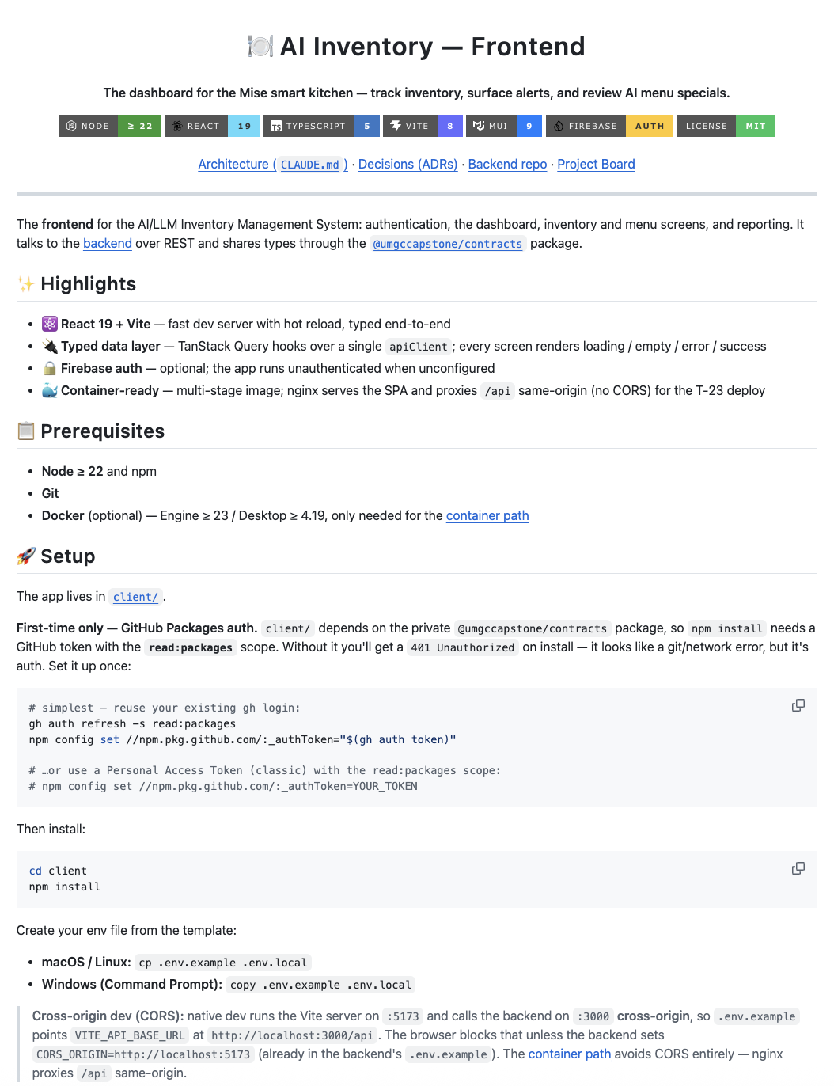
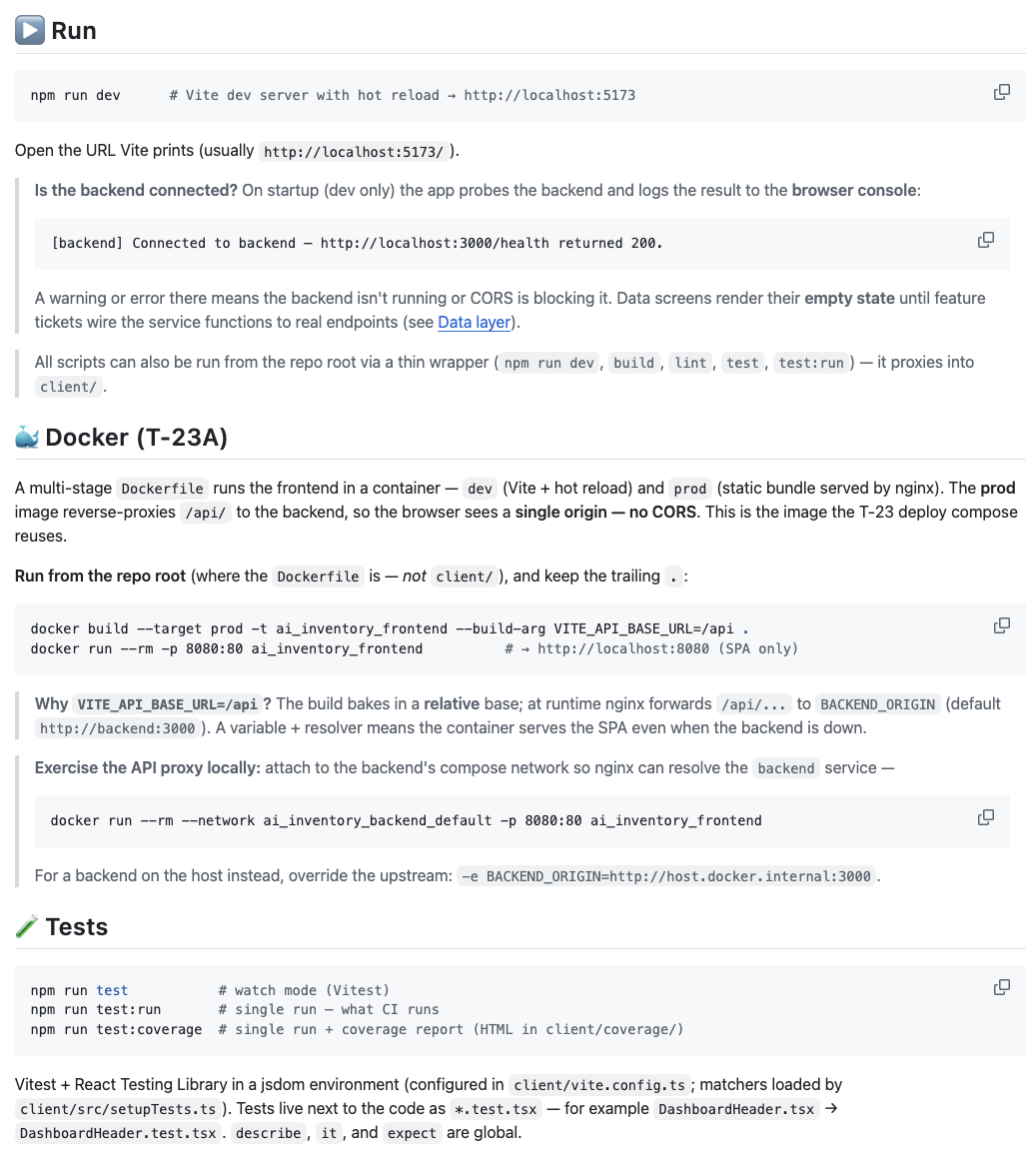
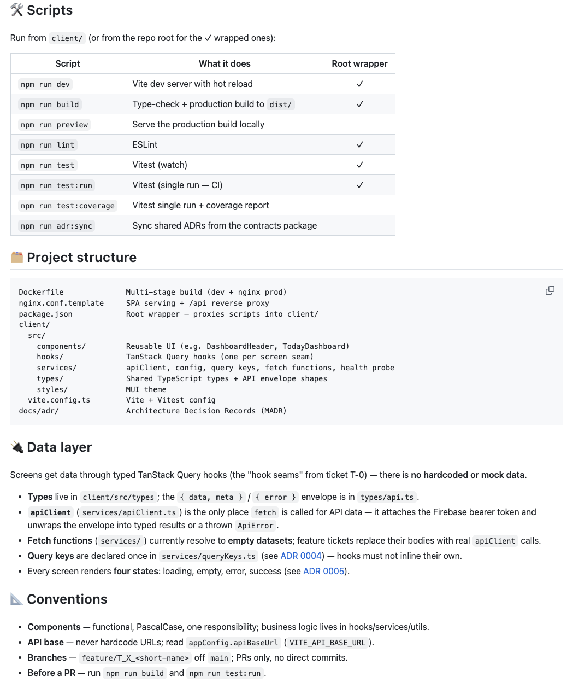
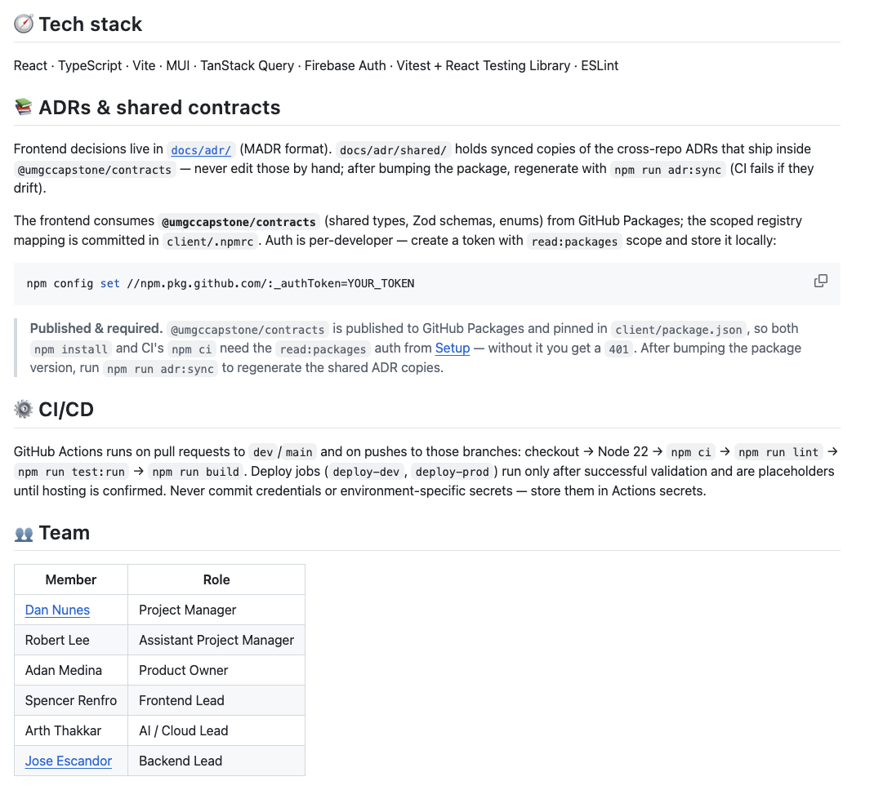

Backend README:
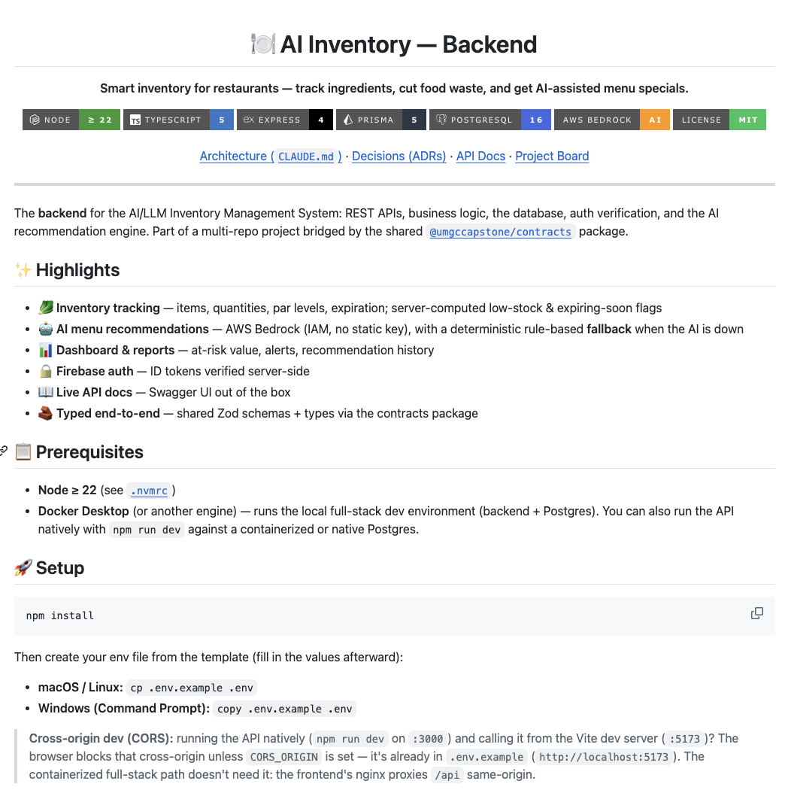
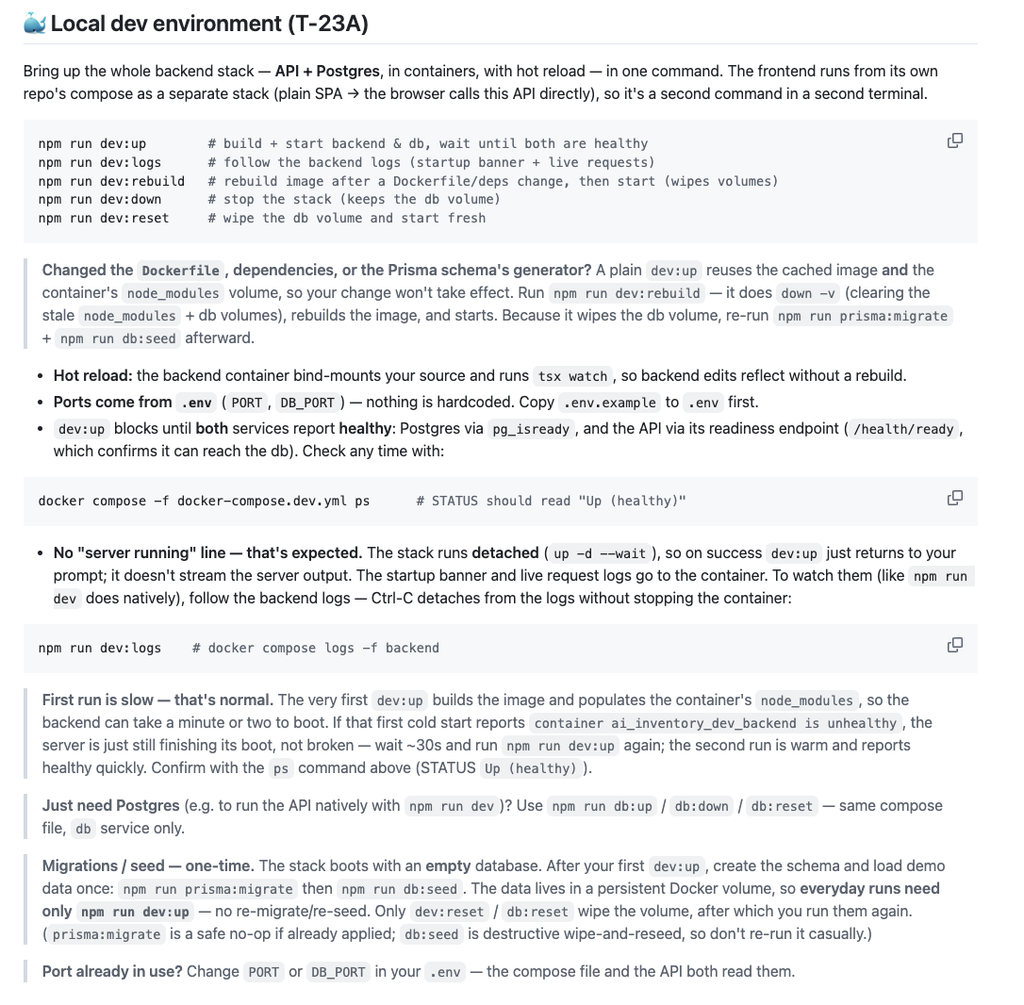
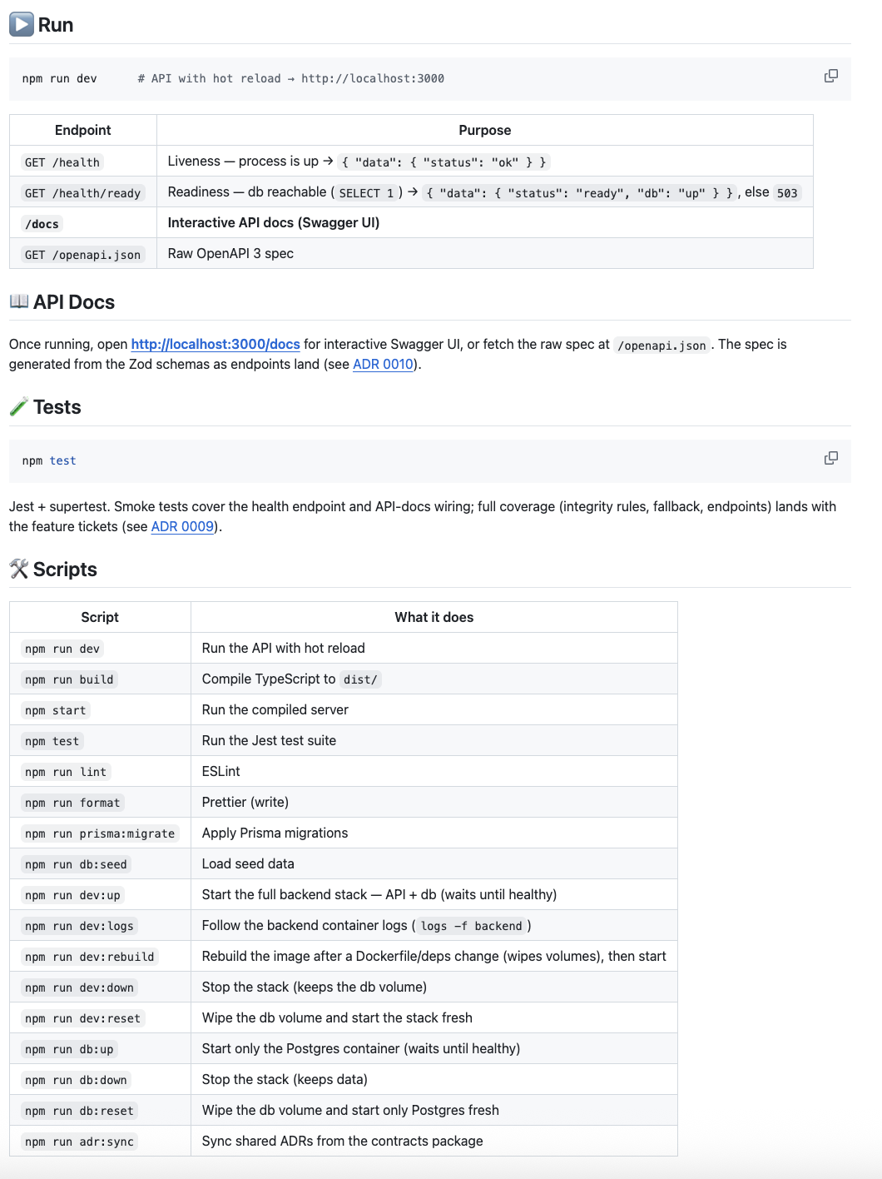
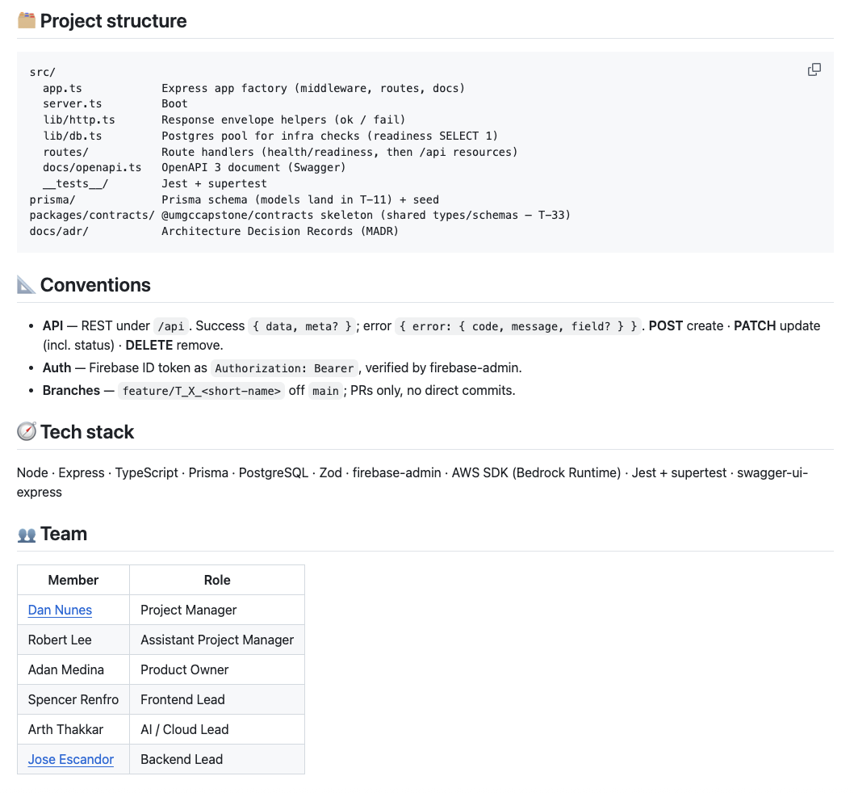

3.4 Frontend UI
The frontend is a React 19 single-page application built with Vite and styled with Material UI (MUI). Pages implemented:
- Login Page: Google Sign-In via Firebase Auth. Disables the sign-in button when Firebase is not configured.
- Inventory Page: Four KPI stat cards (Total Items, Expiring Soon, At-Risk Value, Below Par) sourced from GET /api/dashboard/summary. MUI X DataGrid for the item list with search, category filter, and sort. Add/Edit/Delete modals with react-hook-form + Zod validation, server-error field mapping, and name-confirmation on delete.
- Suppliers Page: Supplier directory with create/edit capability (SupplierDirectory component).
- Dashboard Page: Scaffolded; summary cards and AI recommendation preview cards in progress.
- Menu Builder Page: Scaffolded; ingredient-link conflict (409 ITEM_IN_USE) already handled end-to-end through the inventory delete flow.
- Reports Page: Scaffolded; feature branch feature/t10a-reports-kpi-cards opened.

Frontend Mockup UI:

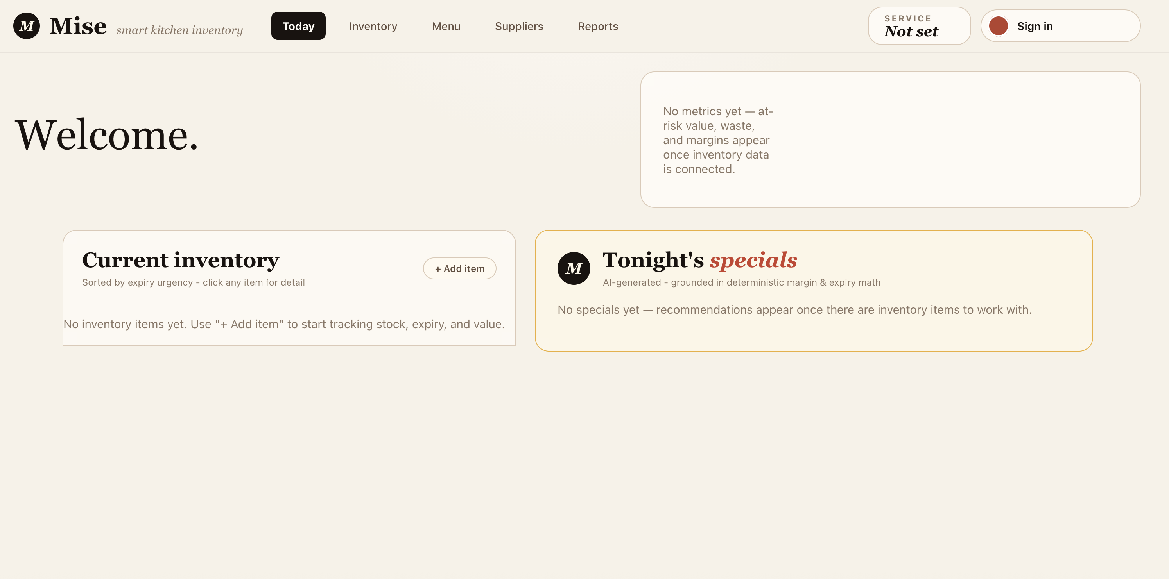

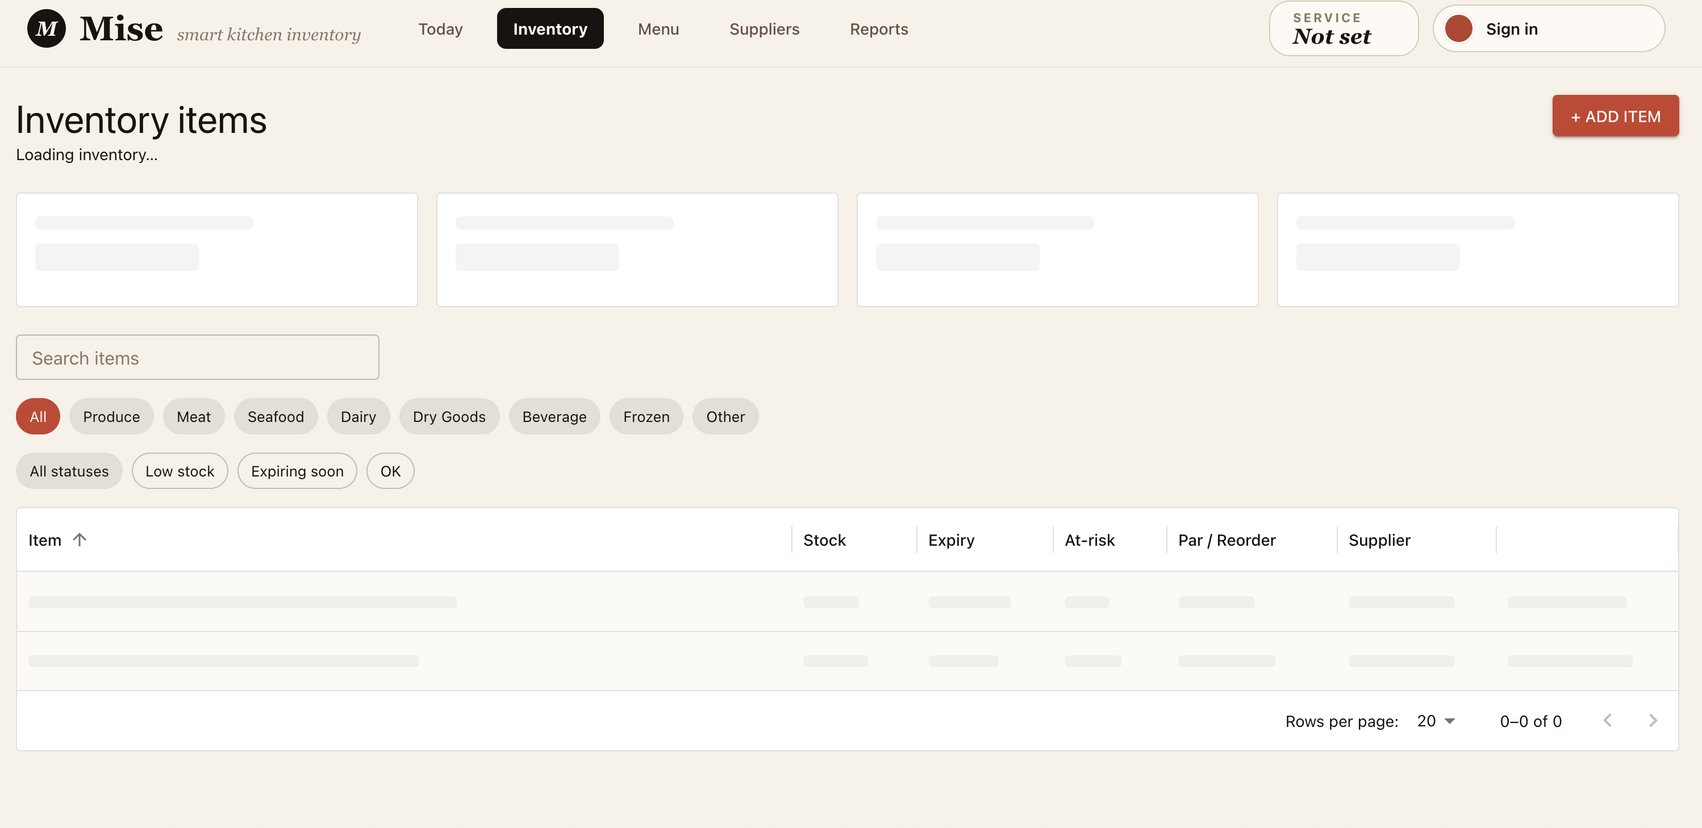
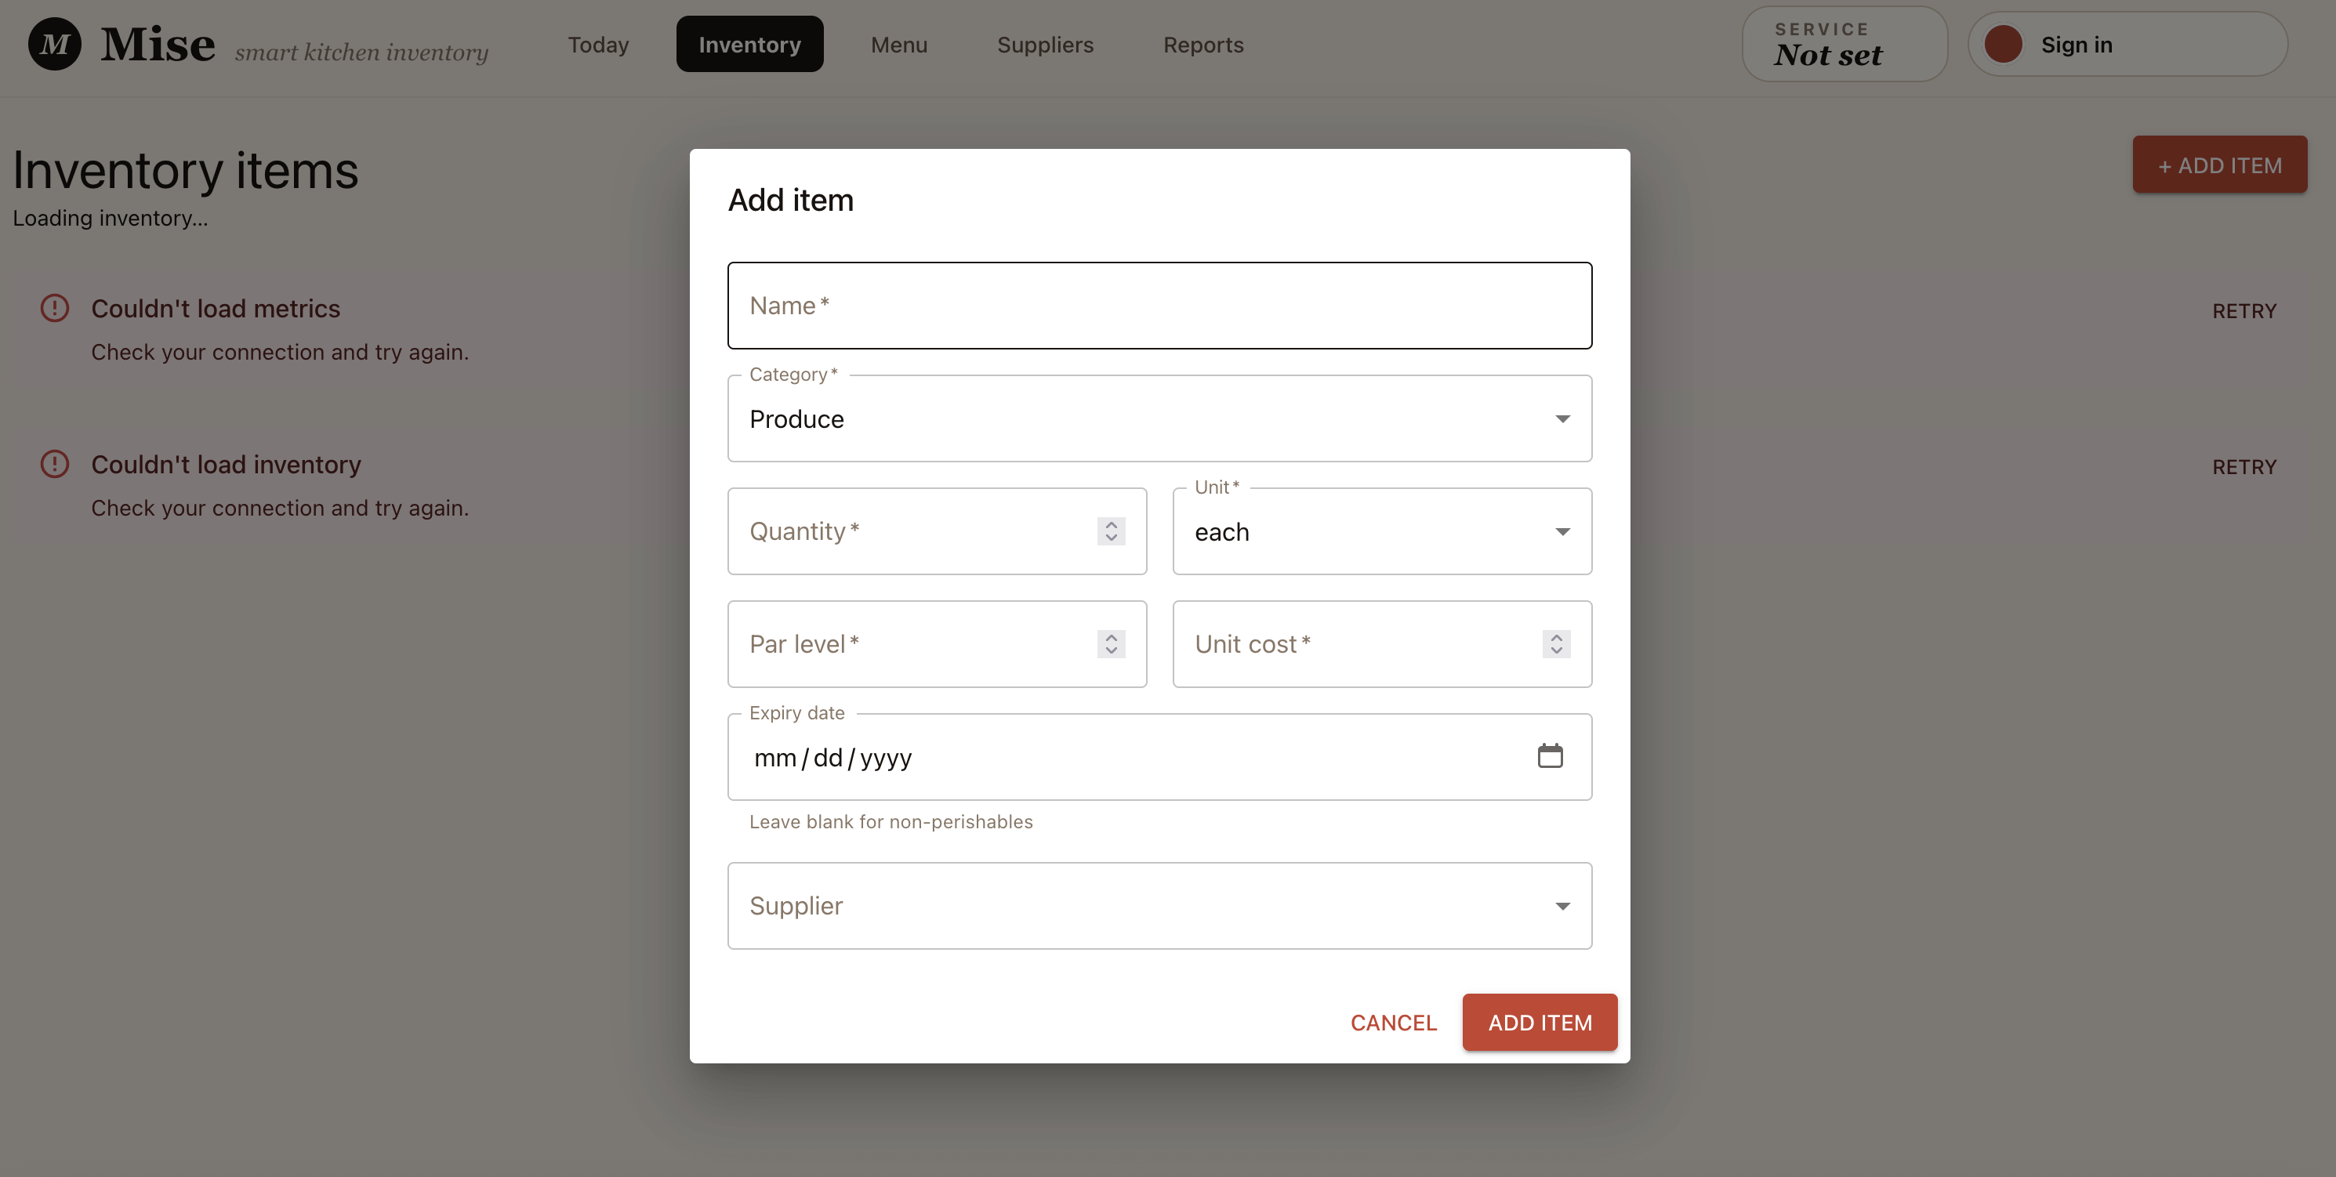

4. Unit Testing
We use Vitest for the frontend and Jest for the backend. Every test listed below is a real, passing test tied to a feature implemented in Phase II. Upcoming features have placeholder test files (describe.skip / it.todo) that are promoted to full tests as the corresponding ticket merges.

4.1 Testing Frameworks
- Backend: Jest + supertest (integration-style HTTP tests against the Express app; Prisma is mocked at the module level). TypeScript transpiled via ts-jest.
- Frontend: Vitest + React Testing Library in a jsdom environment. Test files live next to the code (*.test.tsx / *.test.ts). Matchers loaded by client/src/setupTests.ts.
Tests are run with npm test (watch mode) or npm run test:run (single run - what CI runs) inside each repository.

4.2 Tests Covering Major Functionality
Each row below is a passing unit test for a completed feature. Placeholder (skipped) tests for in-progress features are not listed here - they exist in upcoming-features.test.ts and DashboardPage.test.tsx and will be promoted as tickets merge.

Backend Tests:
Test ID | What It Verifies | Result
TC-BE-01 | GET /health returns 200 with { data: { status: "ok" } } | Pass
TC-BE-02 | /api routes return 401 with error envelope when Authorization header is missing | Pass
TC-BE-03 | /api routes return 401 for a malformed Bearer token | Pass
TC-BE-04 | Valid Firebase token is verified; request passes through to the route | Pass
TC-BE-05 | Dev passthrough: requests without a token are allowed when FIREBASE_PROJECT_ID is unset | Pass
TC-BE-06 | Prod fail-fast: createApp() throws when NODE_ENV=production and FIREBASE_PROJECT_ID is unset | Pass
TC-BE-07 | requireAuth attaches uid and email to req.user on a verified token | Pass
TC-BE-08 | GET /api/inventory returns paginated list with data and meta envelope | Pass
TC-BE-09 | GET /api/inventory passes search and category into the Prisma where clause | Pass
TC-BE-10 | GET /api/inventory filters by derived status (low_stock / ok) in memory | Pass
TC-BE-11 | GET /api/inventory filters by expiring_soon using the server clock | Pass
TC-BE-12 | GET /api/inventory sorts by name descending | Pass
TC-BE-13 | GET /api/inventory rejects invalid query params (page=0) with 400 VALIDATION_ERROR | Pass
TC-BE-14 | GET /api/inventory/:id returns item with derived fields (isLowStock, isExpiringSoon, atRiskValue) | Pass
TC-BE-15 | GET /api/inventory/:id returns 404 NOT_FOUND when item does not exist | Pass
TC-BE-16 | POST /api/inventory creates an item and returns 201 with the full DTO | Pass
TC-BE-17 | POST /api/inventory rejects missing name with 400 and field="name" | Pass
TC-BE-18 | POST /api/inventory rejects negative quantity with 400 and field="quantity" | Pass
TC-BE-19 | POST /api/inventory rejects an invalid expiration date with 400 | Pass
TC-BE-20 | POST /api/inventory rejects an unknown request key (strict schema) with 400 | Pass
TC-BE-21 | PATCH /api/inventory/:id partially updates an item | Pass
TC-BE-22 | PATCH /api/inventory/:id correctly sets expirationDate: null (key presence, not truthiness) | Pass
TC-BE-23 | PATCH /api/inventory/:id returns 404 when the item does not exist (Prisma P2025) | Pass
TC-BE-24 | DELETE /api/inventory/:id deletes an unlinked item and returns its id | Pass
TC-BE-25 | DELETE /api/inventory/:id deletes when only archived dishes reference it | Pass
TC-BE-26 | DELETE /api/inventory/:id returns 409 ITEM_IN_USE naming the active dishes | Pass
TC-BE-27 | DELETE /api/inventory/:id returns 404 when the item does not exist | Pass
TC-BE-28 | GET /api/dashboard/summary returns DashboardSummary shape with correct counts and values | Pass
TC-BE-29 | GET /api/dashboard/summary returns all-zero counts for empty inventory | Pass
TC-BE-30 | GET /api/dashboard/summary: lastUpdatedAt is the newest item updatedAt (no deletions) | Pass
TC-BE-31 | GET /api/dashboard/summary: a newer deletion watermark wins over surviving items | Pass
TC-BE-32 | GET /api/dashboard/summary: emptied-by-delete inventory reports the deletion timestamp | Pass
TC-BE-33 | GET /api/dashboard/alerts returns only at-risk items, sorted by at-risk value desc with name tiebreak | Pass
TC-BE-34 | GET /api/dashboard/alerts returns empty array when no items are at risk | Pass
TC-BE-35 | GET /api/dashboard/alerts returns empty array for empty inventory | Pass
TC-BE-36 | GET /api/dashboard/recommendations/preview returns empty list (stubbed) | Pass
TC-BE-37 | GET /api/dashboard/* returns 401 UNAUTHORIZED without a Bearer token | Pass
TC-BE-38 | isLowStock: returns true when quantity is at or below par level | Pass
TC-BE-39 | isExpiringSoon: identifies items expiring within the 7-day window; null date is false | Pass
TC-BE-40 | isUrgentlyExpiring: identifies items expiring within 48 hours | Pass
TC-BE-41 | itemAtRiskValue: calculates money at risk if an at-risk item is lost | Pass
TC-BE-42 | convertQuantity: correctly converts units (lb to oz) | Pass
TC-BE-43 | isAtRisk: true when low-stock OR expiring soon; false when healthy | Pass
TC-BE-44 | summarizeInventory: aggregates counts and at-risk value in one pass | Pass
TC-BE-45 | summarizeInventory: counts an item once when both low-stock and expiring (no double-count) | Pass
TC-BE-46 | summarizeInventory: returns all-zero counts for empty inventory; no totalSkus key | Pass
TC-BE-47 | GET /api/suppliers returns supplier list in the success envelope | Pass
TC-BE-48 | GET /api/suppliers returns empty array when no suppliers exist | Pass
TC-BE-49 | GET /api/suppliers omits null optional fields from the DTO | Pass
TC-BE-50 | GET /api/suppliers includes optional fields when present | Pass
TC-BE-51 | GET /api/suppliers/:id returns the supplier in the success envelope | Pass
TC-BE-52 | GET /api/suppliers/:id returns 404 NOT_FOUND when supplier does not exist | Pass
TC-BE-53 | POST /api/suppliers creates a supplier and returns 201 | Pass
TC-BE-54 | POST /api/suppliers creates a supplier with all optional fields | Pass
TC-BE-55 | POST /api/suppliers rejects missing name with 400 and field="name" | Pass
TC-BE-56 | POST /api/suppliers rejects an invalid email with 400 | Pass
TC-BE-57 | POST /api/suppliers rejects unknown keys (strict schema) with 400 | Pass
TC-BE-58 | PATCH /api/suppliers/:id updates a supplier (partial) | Pass
TC-BE-59 | PATCH /api/suppliers/:id returns 404 when supplier does not exist (Prisma P2025) | Pass
TC-BE-60 | PATCH /api/suppliers/:id rejects an invalid email with 400 | Pass
TC-BE-61 | Unknown route returns 404 NOT_FOUND with error envelope | Pass
TC-BE-62 | GET /openapi.json serves the OpenAPI 3.0.3 spec with /health path | Pass
TC-BE-63 | GET /docs/ serves Swagger UI HTML | Pass

Frontend Tests:
Test ID | What It Verifies | Result
TC-FE-01 | DashboardHeader renders without crashing (renders an h1 heading) | Pass
TC-FE-02 | InventoryPage renders the heading and four KPI cards from the dashboard summary API | Pass
TC-FE-03 | InventoryPage shows the loading state while the summary is fetching | Pass
TC-FE-04 | InventoryPage shows the error state when the summary request fails | Pass
TC-FE-05 | InventoryPage opens the add-item form when "+ Add Item" is clicked | Pass
TC-FE-06 | InventoryPage fires createInventoryItem with the correct payload on submit | Pass
TC-FE-07 | InventoryPage shows a validation error and does not submit when required fields are empty | Pass
TC-FE-08 | InventoryPage opens the edit form pre-filled with the item's data, including supplier | Pass
TC-FE-09 | InventoryPage fires updateInventoryItem with updated fields on edit submit | Pass
TC-FE-10 | InventoryPage maps a server 400 with a field error onto the correct input | Pass
TC-FE-11 | InventoryPage deletes an item after the user confirms by typing the item name | Pass
TC-FE-12 | InventoryPage keeps the item open and shows dishes on a 409 ITEM_IN_USE response | Pass
TC-FE-13 | LoginPage renders the sign-in heading and Google Sign-In button | Pass
TC-FE-14 | LoginPage calls signInWithGoogle when the button is clicked | Pass
TC-FE-15 | LoginPage shows an error alert when sign-in throws | Pass
TC-FE-16 | LoginPage disables the sign-in button when Firebase is not configured | Pass
TC-FE-17 | apiClient.get() unwraps the data envelope into the typed result | Pass
TC-FE-18 | apiClient.list() keeps the data and meta envelope (for paginated responses) | Pass
TC-FE-19 | apiClient throws a typed ApiError built from a non-ok error body | Pass
TC-FE-20 | apiClient throws UNKNOWN_ERROR on a non-ok response with no error body | Pass
TC-FE-21 | apiClient invokes onUnauthorized callback on a 401 response | Pass
TC-FE-22 | apiClient throws CONFIG_ERROR (and skips fetch) when no base URL is configured | Pass
TC-FE-23 | apiClient attaches the Firebase bearer token as Authorization: Bearer when available | Pass

4.3 Clear Documentation of Test Cases
Each test case above lists its ID, what it verifies, and its result. The same test cases are described in each repository's README.md under the Testing section.

Test commands:
- npm run test:run - single run (CI mode); what GitHub Actions executes on every PR
- npm test - watch mode for local development
- npm run test:coverage - generates an HTML coverage report in client/coverage/ (frontend) or coverage/ (backend)

Placeholder test coverage: src/__tests__/upcoming-features.test.ts (backend) and DashboardPage.test.tsx (frontend) contain describe.skip / it.todo blocks for features not yet complete (AI recommendation generation, Reports/KPI). These files are part of the test suite but contribute zero passing tests - they exist to hold the spec until the corresponding ticket merges, at which point they are promoted to full tests and the skip is removed.

5. Team Collaboration and Implementation
Phase II development has been driven by ticket-based collaboration across all six team members, with GitHub as the central coordination platform.

Pull request workflow and code review:
- All changes are delivered through pull requests targeting the dev integration branch. No team member commits directly to dev or main.
- Every PR is peer-reviewed before merge. The automated @claude GitHub Actions workflow provides a first-pass structural and correctness review on every PR; team members then follow up with human review and approval.
- The CI pipeline (lint, test, build) must pass before a PR can be merged. This enforces consistent formatting and a green test suite as the baseline for every integration.
- Completed PRs in this phase include: T-12B (contracts 0.4.0 - dashboard lastUpdatedAt + ITEM_IN_USE details), T-13 (dashboard API endpoints), T-14 (supplier API endpoints), T-20C (unit test coverage - derive + placeholder specs), T-25 (Bedrock cross-region model ID), and T-5A (backend auth middleware).

Code quality and consistency:
- ESLint and Prettier enforce a shared style across all contributions. Violations block merge via CI.
- Architecture Decision Records (ADRs) in docs/adr/ provide a written rationale for every significant design choice (14+ ADRs across the backend, frontend, and shared contracts). This prevents the same design questions from being re-litigated in each PR.
- The shared @umgccapstone/contracts package (published to GitHub Packages at version 0.4.0) is the single source of truth for types, Zod schemas, enums, and derive functions. Both repos pin the same version, so no PR can silently diverge the contract on one side.
- The dev branch is used for integration; main is production-only and is updated only after dev is verified. This branching model was established in a backend ADR and is documented in both READMEs.

Testing and finalization:
- 63 backend tests (Jest + supertest) and 23 frontend tests (Vitest + React Testing Library) are passing on the dev branch.
- Test files for in-progress features use describe.skip / it.todo to hold the spec. They are promoted to full tests when the feature merges, keeping the test runner output honest about what is and is not yet covered.
- The team has followed a policy of writing tests with the feature, not after - each feature PR includes its own test file or extends an existing one.
- Known in-progress items (AI recommendation generation, Reports/KPI endpoints) are tracked as open GitHub issues with T-number tickets, acceptance-criteria checkboxes, and feature branches. These will be completed in Phase III.

