Phase 1 Source:
AI/LLM Inventory Management System

UMGC 495: Computer Science Capstone | Summer 2026 | 09 June 2026

Team Members
- Dan Nunes
- Robert Lee
- Adan Medina
- Spencer Renfro
- Arth Naileshbhai Thakkar
- Jose Jovenal Escandor

1. Project Setup
This Phase I submission establishes the foundation of our AI/LLM Inventory Management System. In this section we describe the development tools we use, the libraries and packages we installed, how we integrated version control, and how we organized the repository so that configuration is kept separate from application code.

1.1 Coding Tools / IDE
• IDE: Visual Studio Cod
• Node.js version: v26.0.0 | npm version: 11.12.1
• PostgreSQL version: 18.4
• Docker / Docker Compose version: 4.77.0

1.2 Libraries and Packages Installed
Our dependencies are declared in the package.json files and installed with npm. The core technologies are:
Layer | Technology / Packages
Frontend | React (JavaScript), Vite, React Router
Backend | Node.js, Express.js
Database | PostgreSQL
AI / LLM | Structured prompt workflow via AWS Bedrock
Testing | Vitest (frontend), Jest (backend)
Each repository is cloned separately, and dependencies are installed with:
npm install (run inside the frontend repository)
npm install (run inside the backend repository)
The full list of dependencies and their versions is maintained in each repository's README and package.json files.

1.3 Version Control Integration
• We use Git for version control, hosted on GitHub. The frontend and backend live in separate repositories, and in each we manage issues, pull requests, and code reviews.
• Frontend repository URL: https://github.com/UMGCCAPSTONE/AI_Inventory_Frontend.git
• Backend repository URL: https://github.com/UMGCCAPSTONE/AI_Inventory_Backend.git
• Default branch (both repos): main | Access: Private
• The commit history in each repository reflects incremental work from multiple team members.

1.4 Organized Project Structure (Separated Configuration Files)
Because the frontend and backend are maintained as separate repositories, each one has its own structure that keeps application code separate from configuration files such as the environment template, CI workflow, and .gitignore.
Frontend repository
ai-inventory-frontend/
src/ components, pages, routing
tests/ Vitest unit tests
.github/workflows/ CI workflow (YAML)
package.json
.env.example environment variable template
.gitignore excludes node_modules, build output, .env
README.md

Backend repository
ai-inventory-backend/
src/ Express APIs, business logic, AI workflow
tests/ Jest unit tests
db/ schema, migrations, seed data
.github/workflows/ CI workflow (YAML)
Dockerfile container build config
package.json
.env.example environment variable template
.gitignore excludes node_modules, build output, .env
README.md

The Docker Compose file that orchestrates the frontend, backend, and database lives in [which repository, or a separate deployment location]. Secrets such as API keys and database credentials are kept out of both repositories and are supplied through environment variables in local .env files.

2. Core Functionality
This section covers the features from our project requirements, the algorithm and logic choices behind them, and how our code is organized. Because this is Phase I, the application is not yet feature-complete. Some features are working, some are in progress, and others are planned for a later phase. The status of each is noted below.

2.1 Implementation of Features (from Project Requirements)
The Must-Have MVP features from our project design, with their current status:
Feature | Requirement | Phase I status
Authentication | Login / sign-up, session validation, protected routes. | [status]
Inventory Management | Add, view, edit, delete items; validate required fields, no negative quantity, valid expiration date. | [status]
Dashboard | Total items, low-stock count, expiring items, at-risk inventory value. | [status]
AI Recommendations | Menu suggestion from inventory, expiration, cost, and sales data, with a short explanation. | [status]
Fallback Recommendations | Rule-based recommendation when the AI/LLM service is unavailable. | [status]

2.2 Choice of Efficient Algorithms
Our core calculations — expiration urgency, low-stock detection, and at-risk inventory value — use deterministic logic so that these results stay predictable and explainable rather than depending on the AI. The recommendation flow is designed to call the AI/LLM service first and fall back to rule-based logic when that service is unavailable, so the feature remains reliable.
Status of this logic in Phase I: [which of the above is built, in progress, or not yet started]

2.3 Modular Components / Minimal Duplication
Our code is organized into reusable modules: React components on the frontend, and separate route, controller, and service layers on the backend, with shared utilities to reduce duplication.
Screenshots of the features working so far: [dashboard, inventory page, AI recommendation, fallback recommendation]

3. Documentation
Our documentation covers consistent code formatting, clear in-code comments, and a README that describes the project, its dependencies and versions, and our unit test cases.

3.1 Consistent Code Formatting
We use [ESLint / Prettier] to keep code formatting consistent across the team.

3.2 Clear and Concise Comments
Comments throughout the code explain the parts that are not self-evident, such as validation rules, how the AI prompt is assembled, and how the fallback logic is triggered.

3.3 README, Dependencies, Versions, and Unit Test Cases
• Each repository (frontend and backend) has its own README.md.
• Each README describes the project, prerequisites, install and run steps, environment variables, and how to run the tests.
• Each README lists that repository's dependencies and their versions.
• The unit test cases are documented in the corresponding repository's README.

Frontend README example:
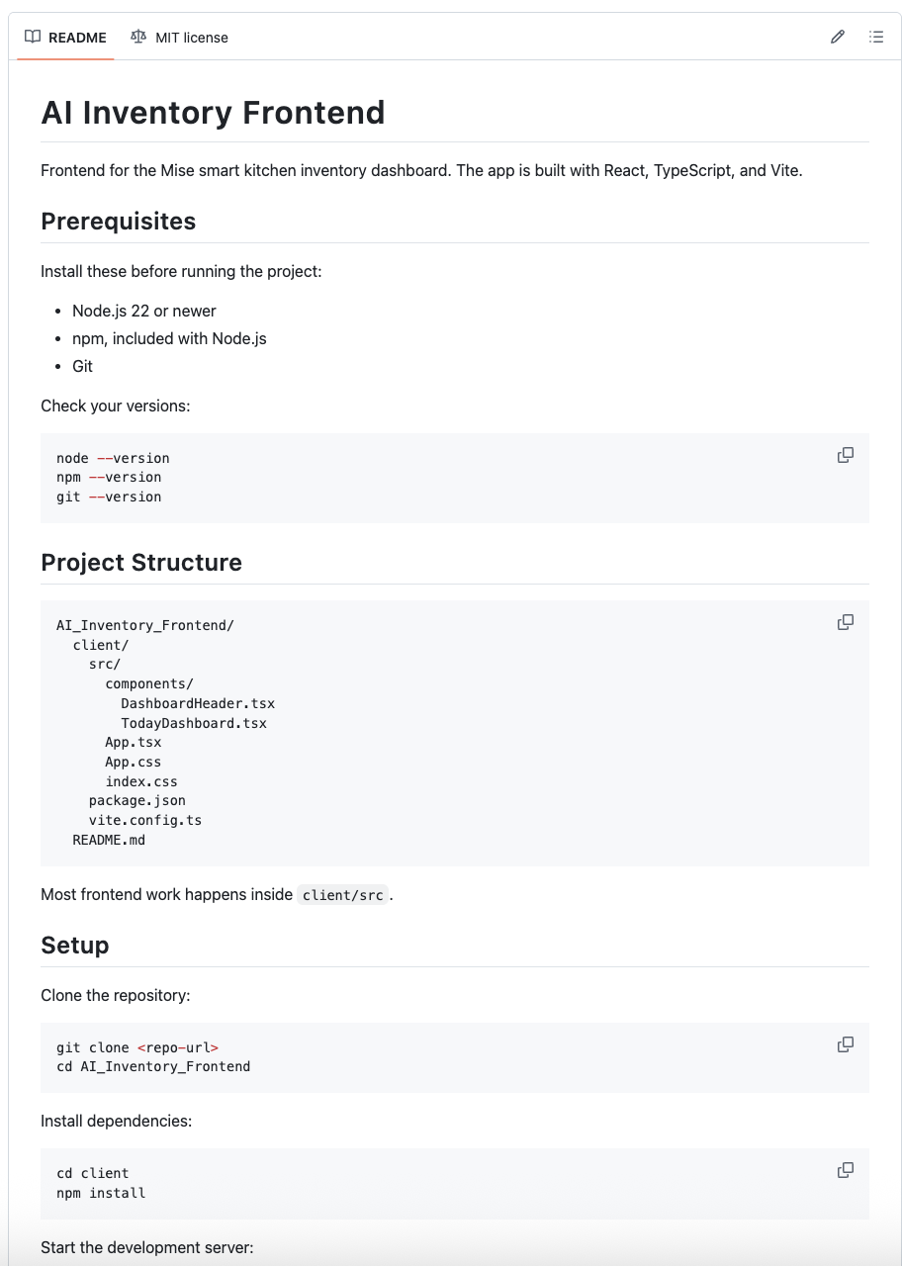

3.4 Frontend UI Mockup
• Example:
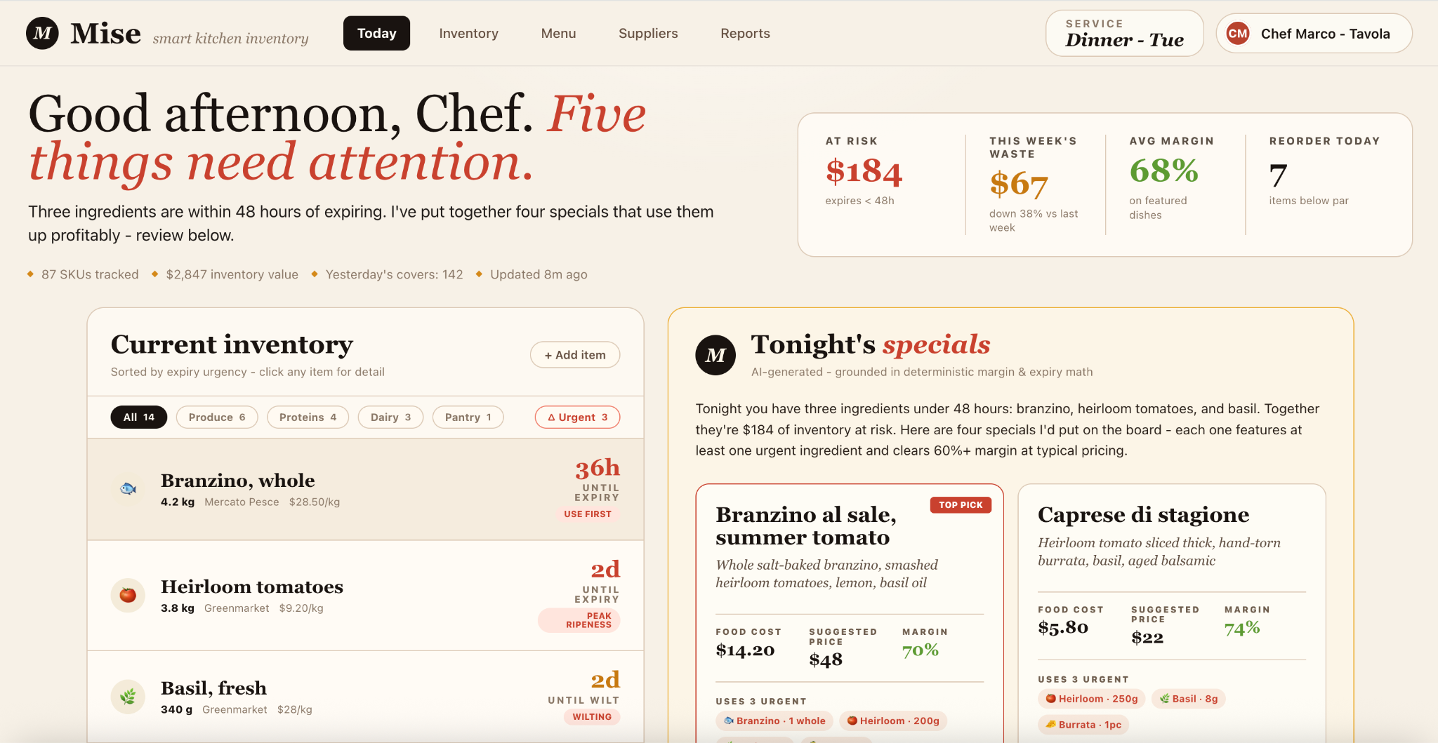

4. Unit Testing
We use Vitest for the frontend and Jest for the backend. We document only the unit tests we have actually written, which cover the components built in Phase I. Features that are still in progress are not yet tested and will be covered as they are completed in a later phase.

4.1 Testing Frameworks
• Frontend: Vitest
• Backend: Jest
Tests are run with npm test inside each repository.

4.2 Tests Covering Major Functionality
Each row below is a unit test we have written for a component that exists in this submission. If a feature is not yet built, it has no test and is not listed here.

Backend Tests:
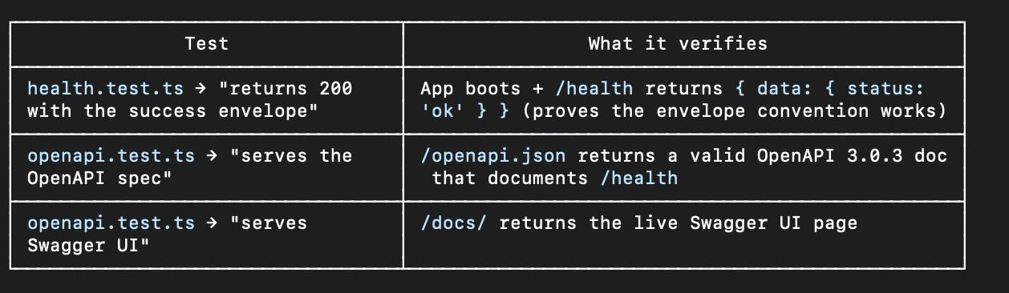

Test ID | What it Verifies | Result
TC-01 | User can view the inventory dashboard and all inventory items load correctly. | Pass if dashboard displays inventory data without errors.
TC-02 | User can add a new inventory item with valid information. | Pass if item is saved and appears in inventory list.
TC-03 | System prevents inventory items from being saved with missing required fields. | Pass if validation message is displayed and item is not saved.
TC-04 | System prevents negative inventory quantities from being entered. | Pass if validation error is displayed.
TC-05 | System correctly highlights items approaching expiration. | Pass if items within expiration threshold are marked as urgent.
TC-06 | Dashboard metrics display accurate inventory statistics and alerts. | Pass if displayed values match database records.
TC-07 | User can filter inventory by category (Produce, Proteins, Dairy, etc.). | Pass if only selected category items are displayed.
TC-08 | AI recommendation engine generates menu suggestions using available inventory data. | Pass if at least one valid recommendation is generated.
TC-09 | AI recommendation includes an explanation showing why the recommendation was selected. | Pass if explanation references inventory, expiration, cost, or margin data.
TC-10 | Rule-based fallback recommendations are generated when the AI service is unavailable. | Pass if recommendation is displayed without AI connection.
TC-11 | Backend API correctly retrieves inventory records from the database. | Pass if API returns expected inventory data.
TC-12 | Backend API correctly stores inventory updates in the database. | Pass if changes persist after save operation.
TC-13 | Application loads successfully in the deployed cloud environment. | Pass if application is accessible and operational.
TC-14 | End-to-end workflow from inventory review to menu recommendation functions correctly. | Pass if user completes workflow without critical errors.
TC-15 | User Guide instructions allow a first-time user to complete common tasks. | Pass if test user completes tasks without developer assistance.

4.3 Clear Documentation of Test Cases
Each test case above lists its ID, what it verifies, and its result, and the same cases are documented in the README.
Test run output: [terminal output screenshot or coverage summary]

