User's Guide
Mise
AI / LLM Inventory Management System

UMGC 495: Computer Science Capstone | Summer 2026
30 June 2026

Dan Nunes · Robert Lee · Adan Medina
Spencer Renfro · Arth Thakkar · Jose Escandor

Contents
1. Introduction
2. System Overview
3. System Features
4. Getting Started
4.1 System Requirements
4.2 Backend Setup
4.3 Frontend Setup
4.4 Starting the Full Stack
5. Application Walkthrough
5.1 Signing In
5.2 Dashboard
5.3 Inventory Management
5.4 Adding an Inventory Item
5.5 Editing an Inventory Item
5.6 Deleting an Inventory Item
5.7 Exporting Inventory to CSV
5.8 Suppliers
5.9 Menu Builder & AI Recommendations
5.10 Reports
6. Troubleshooting
7. Exiting the Application

1. Introduction
Mise is an AI-powered inventory management system designed for restaurants and small food businesses. The application helps kitchen managers reduce food waste, monitor ingredient levels, track expiration dates, and surface AI-assisted menu specials - all from a single web-based dashboard.
The live application is available at: https://umgccapstone.online/
This guide provides step-by-step instructions for installing, launching, and using all features of the Mise system. Each section describes a specific area of the application, explains what each button does, and includes guidance for common tasks such as adding inventory items and reviewing AI recommendations.
Note: Mise is a full-stack web application. Both the backend API and the frontend dashboard must be running simultaneously for full functionality. Section 4 covers setup for both.

2. System Overview
Mise is built as a two-repository system:
- Backend - A Node.js/Express REST API backed by PostgreSQL (via Prisma ORM). It handles inventory data, AI recommendation generation through AWS Bedrock, Firebase authentication verification, and all business logic.
- Frontend - A React 19 single-page application built with Vite and styled with Material UI (MUI). It communicates with the backend over REST and presents the dashboard, inventory screens, supplier directory, menu builder, and reports.
A shared package, @umgccapstone/contracts, defines all TypeScript types and validation schemas used by both sides, ensuring the frontend can never send data the backend would reject.
Note: Live API documentation is available at http://localhost:3000/docs (Swagger UI) while the backend is running.

3. System Features
- AI Menu Recommendations - Anthropic Claude (claude-sonnet-4-6) analyzes current inventory (prioritizing expiring and low-stock items) and suggests dishes that use at-risk ingredients - reducing waste while keeping the menu fresh. (prioritizing expiring and low-stock items) and suggests special menu items. A deterministic rule-based engine serves as a fallback if the AI is unavailable.
- Inventory CRUD - Create, read, update, and delete ingredient records with name, category, quantity, unit, par level, unit cost, expiration date, and supplier.
- Automated Alerts - The system automatically flags items that are below par level or expiring within 7 days without any manual threshold configuration.
- Dashboard Summary - Four KPI cards (Total Items, Expiring Soon, At-Risk Value, Below Par) update in real time from the server so figures are never stale or recomputed client-side.
- Supplier Directory - Maintain a list of ingredient suppliers with create and edit capability.
- Menu Builder - Link AI-generated menu specials to available ingredients and check live availability based on on-hand stock.
- Reports - Analytics and reporting for inventory health and performance.
- CSV Export - Download the full inventory as a CSV file for offline analysis.
- Firebase Authentication - Secure Google Sign-In for access control. Authentication can be disabled locally for development.
- Container-Ready - The full stack (frontend + backend + database) can be run with a single Docker Compose command.

4. Getting Started

4.1 System Requirements
Requirement | Minimum Version | Notes
Node.js | ≥ 22 | Includes npm. Verify with node --version.
Docker Desktop | ≥ 4.19 / Engine ≥ 23 | Required for the local PostgreSQL database.
GitHub CLI (gh) | Any recent | Required for GitHub Packages authentication. Install from cli.github.com.
Git | Any recent | Required to clone the repositories.
Web Browser | Current version | Chrome, Firefox, Edge, or Safari.
Operating System | macOS, Windows 10+, or Linux | Windows users should use PowerShell, not Command Prompt.

Note: GitHub Packages Token: The frontend uses a private shared package (@umgccapstone/contracts). You must authenticate with GitHub Packages once per machine before npm install will succeed. This is covered in Section 4.3.

4.2 Backend Setup
The backend must be running before the frontend can display live data.

Step 1 - Clone the backend repository
git clone https://github.com/UMGCCAPSTONE/AI_Inventory_Backend.git
cd AI_Inventory_Backend

Step 2 - Install dependencies
npm install

Step 3 - Create your local environment file
# macOS / Linux
cp .env.example .env
# Windows (PowerShell)
Copy-Item .env.example .env
Note: The defaults in .env.example work as-is for local development. Authentication is disabled by default (no FIREBASE_PROJECT_ID set), so you can call endpoints without a token.

Step 4 - Start the PostgreSQL database
npm run db:up
This starts a Postgres 16 container using Docker. Wait until the terminal reports the container is healthy before continuing.

Step 5 - Apply the database schema
npm run prisma:migrate
This is a safe no-op if migrations have already been applied.

Step 6 - Load the demo data
npm run db:seed
Note: Warning: db:seed is destructive - it wipes existing data and reseeds from scratch. Only run this on a fresh setup or when you want to reset to the demo dataset.

Step 7 - Start the API server
npm run dev
The API starts at http://localhost:3000. Verify it is running by visiting http://localhost:3000/health in your browser - you should see { "data": { "status": "ok" } }.
Interactive API documentation is available at http://localhost:3000/docs.

4.3 Frontend Setup

Step 1 - Clone the frontend repository
git clone https://github.com/UMGCCAPSTONE/AI_Inventory_Frontend.git
cd AI_Inventory_Frontend/client
Note: The React app lives in the client/ subfolder.

Step 2 - Authenticate with GitHub Packages (first time only)
The frontend depends on the private @umgccapstone/contracts package. Without a token, npm install will fail with 401 Unauthorized.
Option A - Use the GitHub CLI (recommended):
# macOS / Linux
gh auth refresh -s read:packages
npm config set //npm.pkg.github.com/:_authToken="$(gh auth token)"
# Windows (PowerShell)
gh auth refresh -s read:packages
npm config set //npm.pkg.github.com/:_authToken=(gh auth token)
Option B - Paste the token manually:
gh auth token
# Copy the printed value, then:
npm config set //npm.pkg.github.com/:_authToken=PASTE_TOKEN_HERE
Note: No gh CLI? Create a Personal Access Token (classic) at github.com/settings/tokens with the read:packages scope and use that value instead.

Step 3 - Install dependencies
npm install

Step 4 - Create your local environment file
# macOS / Linux
cp .env.example .env.local
# Windows (PowerShell)
Copy-Item .env.example .env.local

Step 5 - Start the development server
npm run dev
Open the URL printed in the terminal - usually http://localhost:5173.

4.4 Starting the Full Stack
To confirm both services are connected, open the browser console (press F12, then click the Console tab) after loading the frontend. You should see:
[backend] Connected to backend - http://localhost:3000/health returned 200.
A warning here means the backend is not running or a CORS issue is blocking the connection. The screens will still load but show empty data - this is expected behavior, not a bug.

5. Application Walkthrough

5.1 Signing In
Mise uses Google Sign-In, powered by Firebase Authentication, to verify user identity. Firebase Authentication is a third-party service provided by Google. Before signing in, a Firebase project must be configured for this deployment and the FIREBASE_PROJECT_ID environment variable must be set on the backend. Contact your system administrator if you are setting up the application for the first time. Once Firebase is configured, all users sign in with a Google account - no separate username or password is required.
When you first navigate to http://localhost:5173, you will see the Mise login page. If Firebase authentication has not been configured, the Sign In button will be disabled and the page will display a note that authentication is not set up for this environment.

To sign in:
- Click the "Sign in with Google" button.
- A Google authentication popup will appear. Select or enter your Google account credentials.
- After successful authentication, you will be redirected to the Dashboard.

Note: If the login page displays "Authentication is not configured in this environment," the Firebase project ID has not been set in .env.local. In a local development environment with auth disabled, you may still access the application directly by navigating to http://localhost:5173/dashboard.

5.2 Dashboard
The Dashboard is the home screen of Mise. A time-sensitive greeting ("Good morning/afternoon/evening, Chef") appears at the top, followed by four KPI cards and a two-column layout: Alerts on the left and AI Recommendations on the right.. It provides an at-a-glance overview of your kitchen's inventory health.
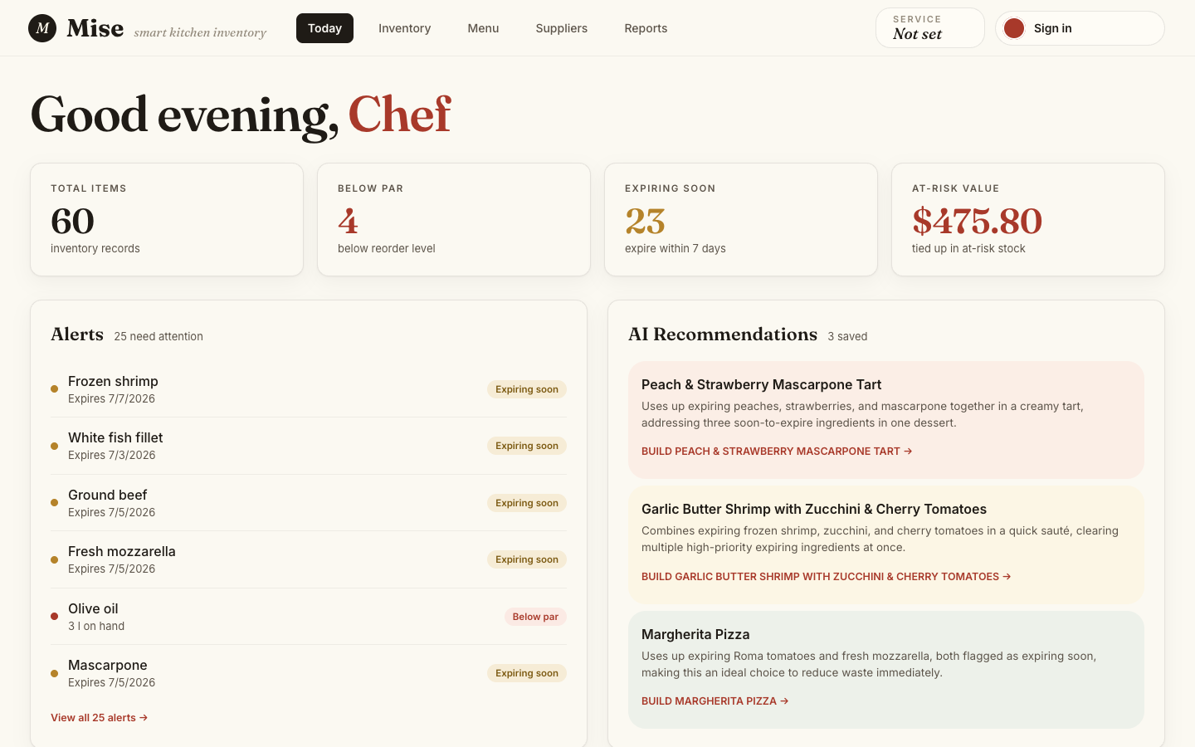

Dashboard sections:
Section | Description
Welcome Header | Displays a personalized greeting and a brief AI-generated summary of the kitchen status.
KPI Metric Cards | Four summary cards showing Total Items, Below Par count, Expiring Soon count, and At-Risk Value in dollars.
Alerts | A list of inventory items that require immediate attention - items flagged as below par level, expiring soon (within 7 days), or both. Each alert is a clickable link that navigates directly to the Inventory page.
AI Recommendations | A preview of up to three AI-generated menu specials, each showing the dish name, a brief description, and live availability status based on current stock.

KPI card color coding:
- Default (no color): The metric is healthy (e.g., zero low-stock items).
- Warning (amber): The metric needs attention (e.g., items expiring soon).
- Danger (red): The metric indicates a critical condition (e.g., items below par or high at-risk value).
Alerts section - each alert row displays:

- The ingredient name
- Its current quantity and unit
- Its expiration date (if applicable)
- A badge indicating the alert type: "Expiring & Low Stock" (red), "Below Par" (red), or "Expiring Soon" (amber)
Click any alert row to navigate directly to the Inventory page where you can update the item.
AI Recommendation cards - each card shows:
- The suggested dish name
- A brief AI-generated description
- "Available" (green) if all required ingredients are in stock, or "Not available" (amber) with the limiting ingredient noted
- A "Go to Menu Builder" button that navigates to the Menu Builder page

5.3 Inventory Management
Navigate to the Inventory page using the sidebar navigation. This page displays all ingredient records and provides tools for creating, editing, deleting, and exporting inventory data.
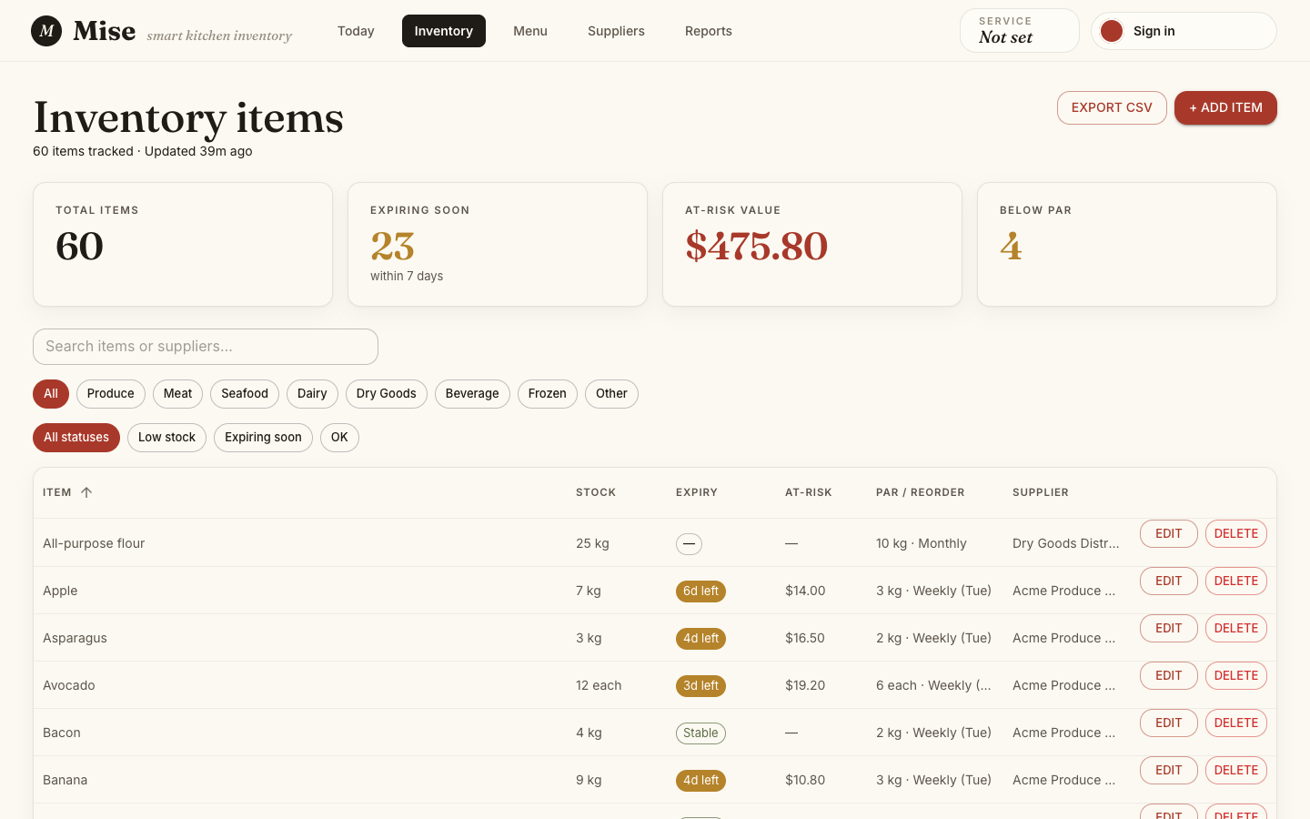

Page header buttons:
Button | Action
+ Add Item | Opens the Add Item form dialog to create a new inventory record.
Export CSV | Downloads the complete inventory (all pages) as a CSV file named with the current date.

KPI stat cards (top of page):
Card | Description
Total items | Count of all inventory records.
Expiring soon | Items with an expiration date within the next 7 days (shown in amber).
At-risk value | Total dollar value of stock that is low or expiring (shown in red when non-zero).
Below par | Items whose on-hand quantity is at or below their reorder par level (shown in amber).

Data grid - you can:
- Sort any column by clicking the column header.
- Filter items using the filter icon in the column header.
- Search across all items using the toolbar search field.
- Click the edit icon on any row to open the Edit Item form.
- Click the delete icon on any row to open the Delete confirmation dialog.

5.4 Adding an Inventory Item
1. On the Inventory page, click the "+ Add Item" button in the upper right corner.
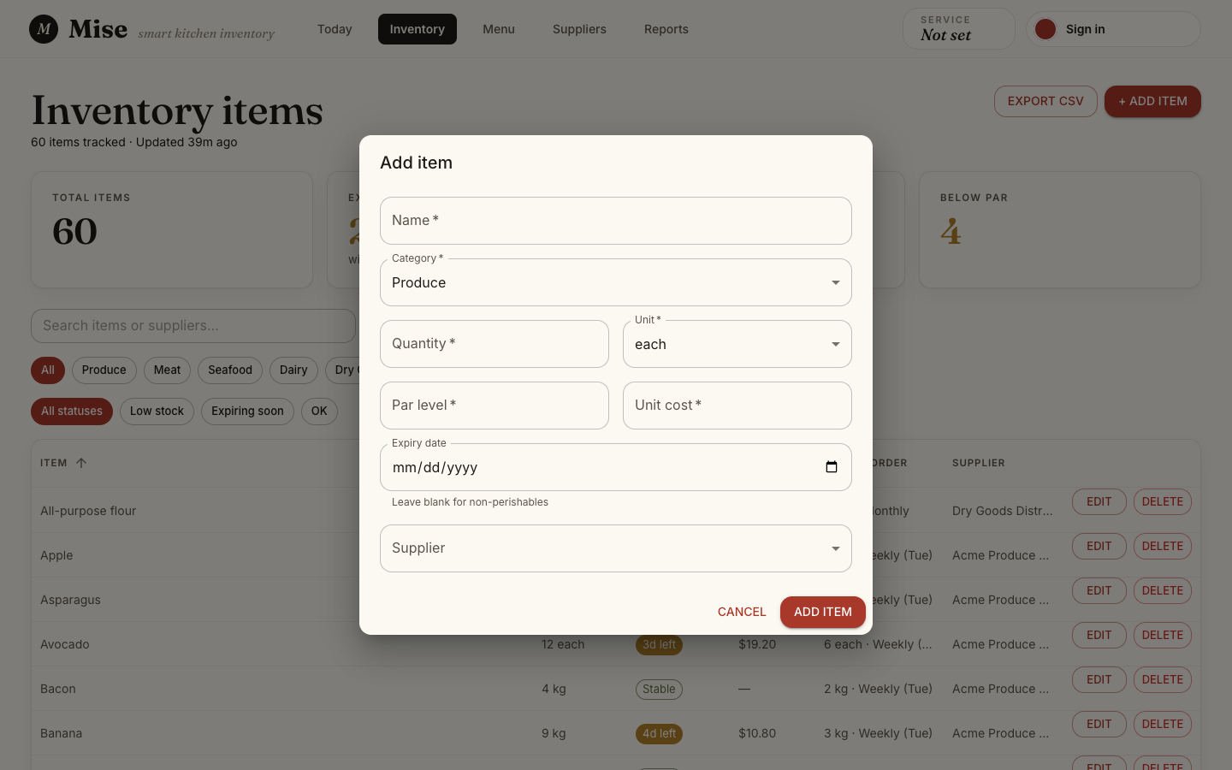
2. The Add item dialog opens.

3. Fill in the required fields:
Field | Required | Description
Name | Yes | The ingredient name (e.g., "Roma Tomatoes").
Category | Yes | Select from: Produce, Proteins, Dairy, Dry Goods, Beverages, Condiments, Frozen, Other.
Quantity | Yes | Current on-hand quantity (numeric).
Unit | Yes | Select a unit of measure: each, case, lb, oz, kg, g, ml, l, fl oz, gal.
Par level | Yes | The minimum desired quantity. The system flags the item as "Below Par" when on-hand quantity falls at or below this number.
Unit cost | Yes | Cost per unit in dollars (used to calculate at-risk value).
Expiration date | Optional | Date the ingredient expires. Leave blank if not applicable. Items within 7 days of expiration are flagged automatically.
Supplier | Optional | Select an existing supplier from the dropdown. Add suppliers first on the Suppliers page if the list is empty.

4. Click "Save" to submit the form.
- If validation passes, the item is saved and the dialog closes. A success toast notification briefly appears at the bottom of the screen.
- If a field is invalid, an inline error message appears beneath the affected field. Correct the error and resubmit.
5. The Inventory data grid and KPI cards refresh automatically to reflect the new item.

5.5 Editing an Inventory Item
1. On the Inventory page, locate the item you want to update in the data grid.
2. Click the pencil/edit icon in that item's row.
3. The Edit item dialog opens, pre-filled with the item's current values.

4. Update any fields as needed (all fields from the Add form are available in the same layout).
5. Click "Save" to submit the changes. The grid and KPI cards refresh automatically. A success toast notification confirms the update.

5.6 Deleting an Inventory Item
1. On the Inventory page, locate the item you want to remove.
2. Click the trash/delete icon in that item's row.
3. A confirmation dialog appears asking you to confirm the deletion.

4. Click "Delete" to confirm, or "Cancel" to go back without making changes.
Note: An item cannot be deleted if it is currently linked to an active (non-archived) menu item. If you attempt to delete such an item, you will see the error: ITEM_IN_USE - This ingredient is in use by one or more active menu items. Archive those menu items first, then retry the delete.

5.7 Exporting Inventory to CSV
1. On the Inventory page, click the "Export CSV" button in the upper right.
2. The button label changes to "Exporting…" while the data is being prepared.
3. A CSV file downloads automatically. The filename includes the current date (e.g., inventory-2026-06-29.csv).
4. A success toast at the bottom of the screen confirms the export and reports how many items were included.
Note: The export always includes the complete inventory, not just the current page of the grid. If there are no items yet, the file will still download but will have no data rows.

5.8 Suppliers
Navigate to the Suppliers page using the top navigation bar. The page is titled "Supplier network." and shows a two-column layout. This page maintains the directory of ingredient suppliers that can be associated with inventory items. The left column lists suppliers with search and filter tabs (All, Active, Pending order) and a Recent Orders table below. The right sidebar shows a Spend by Supplier donut chart and an Upcoming Deliveries list. Each supplier row has an EDIT button (opens the edit form) and a VIEW button (opens the delivery history for that supplier).
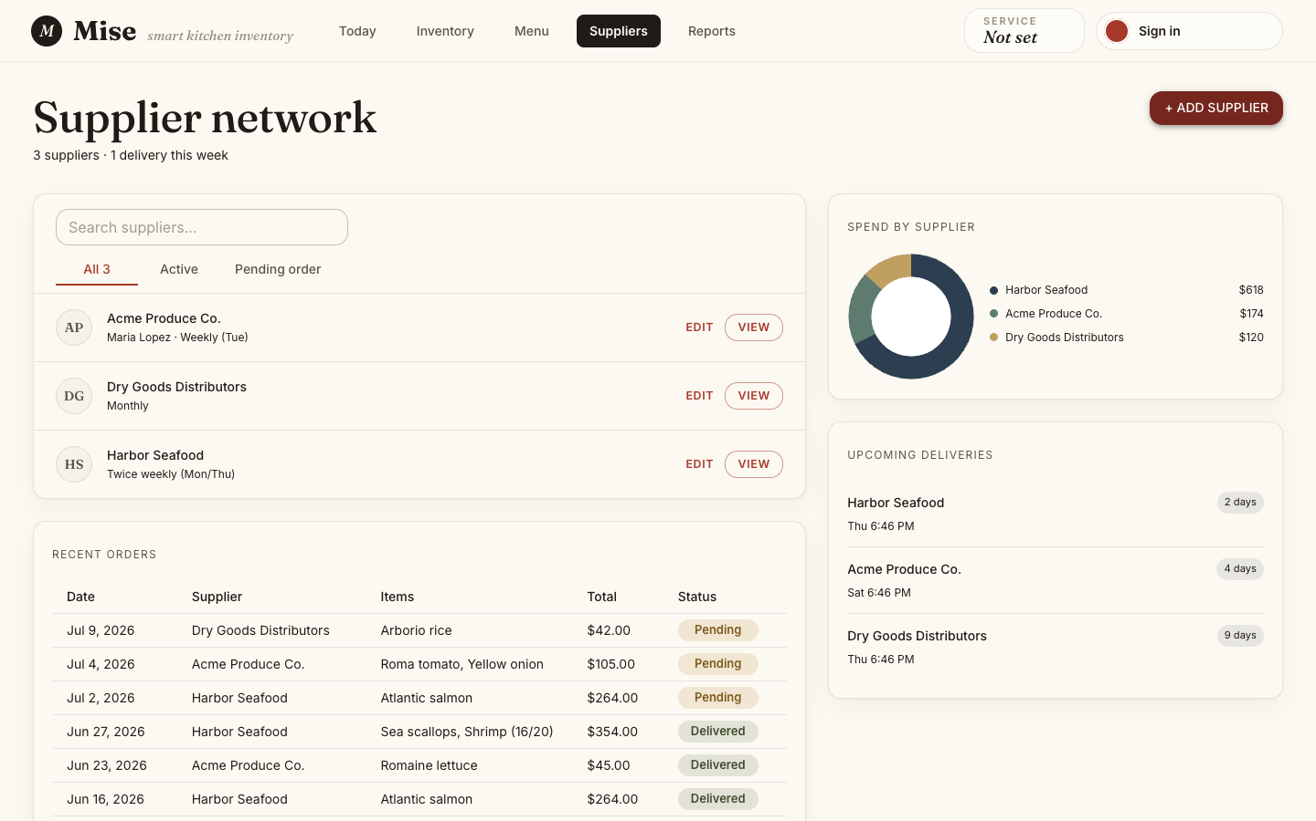

Adding a Supplier
1. Click the "Add supplier" button in the upper right corner.
2. The Add Supplier form dialog opens.

3. Fill in the supplier details:
Field | Required | Description
Name | Yes | Supplier company name.
Contact name | Optional | Primary contact person.
Phone | Optional | Contact phone number.
Email | Optional | Contact email address.
Delivery days | Optional | Days of the week the supplier delivers.

4. Click "Save" to add the supplier.
- A success toast ("Supplier added.") appears at the bottom of the screen.
- If an error occurs, the form stays open and an inline error message is displayed so you can correct and retry.

Editing a Supplier
1. In the supplier directory, click the edit icon next to the supplier you want to update.
2. The Edit Supplier form opens, pre-filled with the supplier's current information.
3. Update the desired fields and click "Save". A success toast ("Supplier updated.") confirms the change.
Note: Suppliers cannot be deleted in the current version (MVP). Contact a system administrator if a supplier record needs to be removed.

5.9 Menu Builder & AI Recommendations
Navigate to the Menu page using the top navigation bar. This page integrates AI-generated menu specials with live ingredient availability.
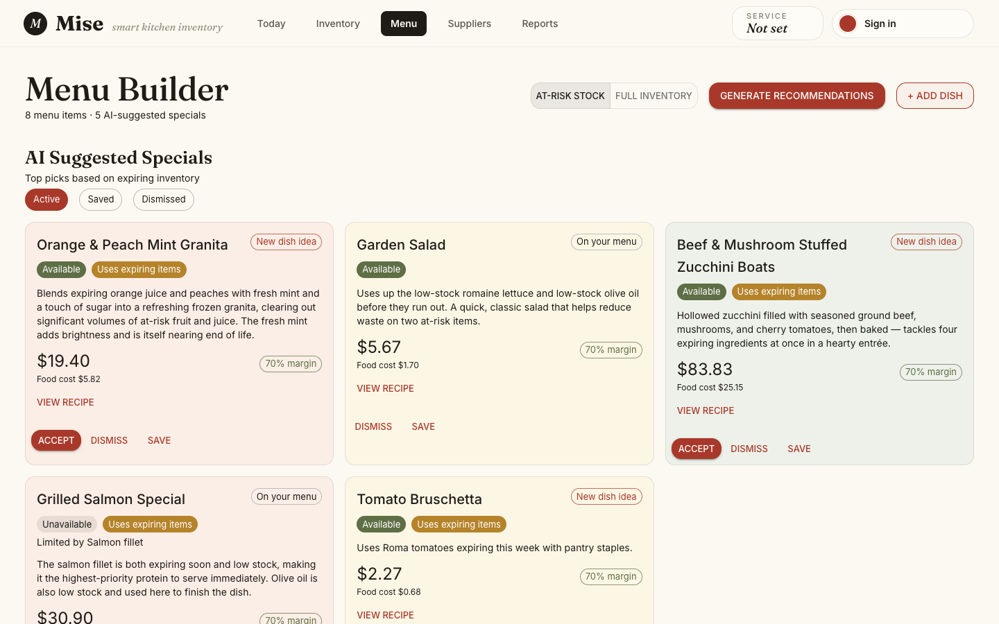

How AI Recommendations Work
The system sends the current inventory (prioritizing low-stock and expiring-soon items) to Anthropic Claude (claude-sonnet-4-6), which returns suggested menu specials designed to use ingredients before they go to waste. If Bedrock is unavailable, a rule-based fallback engine generates suggestions automatically. A scope toggle at the top of the page lets you choose between "At-Risk Stock" (default - focuses on expiring and low-stock items) and "Full Inventory" (considers everything). Each recommendation card displays the suggested dish name, an availability badge (Available / Unavailable), a "Uses expiring items" badge when applicable, a brief description, the suggested menu price, food cost, target margin, and a "View Recipe" link. Cards also show whether a dish is a "New dish idea" or already "On your menu."

Reading a Recommendation Card
Each recommendation card displays:
- Dish name - The suggested special.
- Description - A brief explanation of why this dish was recommended (ingredients driving the suggestion).
- "Available" (green) - All required ingredients are in stock at sufficient quantities.
- "Not available" (amber) - At least one required ingredient is below the needed amount. The limiting ingredient is listed below the badge.

Actions on Recommendation Cards
Button | Action
Accept | Accepts the recommendation and adds it to the active menu. Status changes from PROPOSED to ACCEPTED.
Dismiss | Dismisses the recommendation. Status changes to DISMISSED and the card is removed from the active list.
Save | Saves the recommendation for later review without accepting or dismissing it. Status changes to SAVED.
Go to Menu Builder | Navigates from the Dashboard recommendation preview to the full Menu Builder page.

5.10 Reports
Navigate to the Reports page using the top navigation bar. This page provides analytics and reporting on inventory performance.
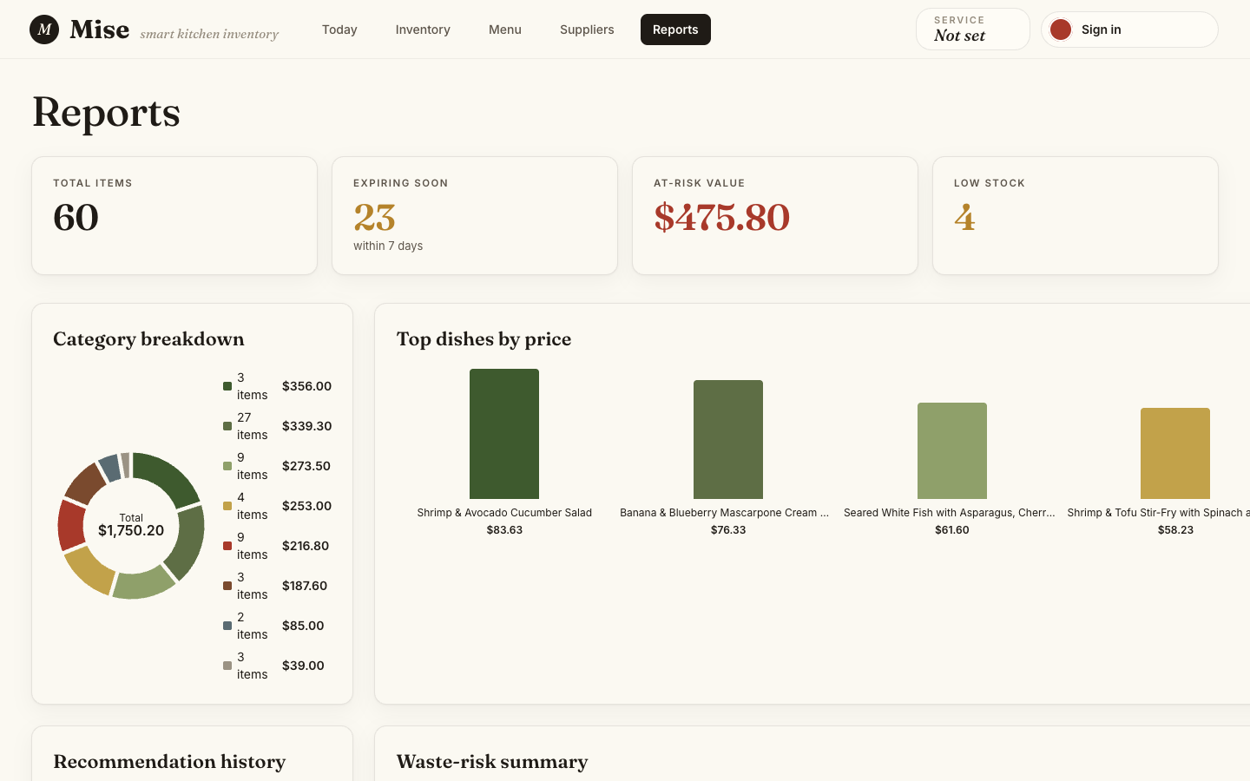

The Reports page surfaces metrics including:
- Category breakdown - a donut chart showing inventory value by category
- Top dishes by price - a bar chart of the highest-priced menu items
- Recommendation history - a log of all AI-generated specials
- Waste-risk summary - items most at risk of going to waste
Note: The Reports page is fully implemented and displays live data from the current inventory and menu.

6. Troubleshooting
Problem | Likely Cause | Solution
npm install fails with 401 Unauthorized | GitHub Packages token not set or expired | Re-run the gh auth refresh -s read:packages + npm config set commands from Section 4.3.
Backend won't start - "port already in use" | Another process is using port 3000 | Stop the conflicting process or change PORT in your .env file.
Browser console shows backend connection warning | Backend is not running | Start the backend with npm run dev in the AI_Inventory_Backend directory.
Inventory screens show empty data but no error | Backend is running but not seeded | Run npm run prisma:migrate then npm run db:seed in the backend directory.
"Sign in with Google" button is disabled | Firebase not configured in .env.local | In development without auth, navigate directly to http://localhost:5173/dashboard.
Delete fails with ITEM_IN_USE error | Item is linked to an active menu item | Archive the menu item in the Menu Builder first, then retry the delete.
Docker container shows "unhealthy" on first run | Image and node_modules are being built for the first time | Wait ~30 seconds and run npm run dev:up again. The warm run is fast.
All recommendations say "Not available" | Insufficient inventory quantities for suggested dishes | Restock the flagged limiting ingredients shown beneath the availability badge.
Data grid shows stale data after an update | Browser cache issue | Press F5 to refresh or click the retry button shown in any error state.

7. Exiting the Application
To exit the frontend development server:
In the terminal where npm run dev is running, press Ctrl + C to stop the Vite development server.
To stop the backend and database:
# Stop the database container (data is preserved in the Docker volume):
npm run db:down
# Stop and wipe all data:
npm run db:reset
If you used the full Docker stack (npm run dev:up):
npm run dev:down # stop the stack, preserve data
npm run dev:reset # stop and wipe all data
Note: Your inventory data is stored in a Docker volume and persists between restarts as long as you use db:down or dev:down. Only db:reset or dev:reset wipe the data.

8. User Testing
This user guide was reviewed by a novice user who followed the setup and walkthrough steps. Feedback from the review was used to clarify setup instructions, button names, and troubleshooting guidance.

Mise - AI/LLM Inventory Management System
UMGC 495 Capstone · Summer 2026
Dan Nunes · Robert Lee · Adan Medina · Spencer Renfro · Arth Thakkar · Jose Escandor

