Mise

Software Test Plan
AI/LLM Inventory Management System for Restaurants

CMSC 495— Computer Science Capstone
University of Maryland Global Campus
Summer 2026
Unit 5 Deliverable: Test Plan
June 16, 2026

Project Team
Team Member | Role
Dan Nunes | Project Manager
Robert Lee | Assistant Project Manager
Adan Medina | Product Owner
Spencer Renfro | Frontend Lead
Arth Thakkar | AI / Cloud Lead
Jose Escandor | Backend Lead

1. Introduction
Mise is an AI/LLM-powered inventory management system built for restaurants and small food businesses. The application helps operators reduce food waste, track ingredient inventory, surface low-stock and expiring items, and generate AI-assisted menu recommendations, with a rule-based fallback when the AI service is unavailable. The core user flow is: a restaurant manager signs in, reviews a dashboard of inventory status and urgent alerts, manages inventory items, and generates menu recommendations driven by current stock.
The system is implemented as a multi-repository, full-stack web application. A React (Vite + TypeScript) single-page frontend communicates with a Node.js/Express + TypeScript backend backed by PostgreSQL through the Prisma ORM. A versioned shared contract package (@umgccapstone/contracts) defines the TypeScript types and Zod validation schemas consumed by both repositories, keeping the API surface consistent. The AI capability is provided by AWS Bedrock, and continuous integration runs on GitHub Actions.
This document defines the test plan for Mise. It establishes the testing objectives, strategy, scope, a hierarchical catalog of test cases, the procedures and environment used to execute them, the schedule and resources allocated to testing, and the defect-management process. Because the project is mid-development, the plan also records an honest snapshot of the tests implemented to date and distinguishes them from the broader set of planned tests.

2. Testing Objectives
The objective of the testing effort is to verify that Mise meets its functional requirements and quality goals before the Phase II demonstration, and to catch regressions automatically as the codebase grows. Testing targets the following quality attributes:
Quality Attribute | Objective
Functional correctness | Each MVP feature (authentication, inventory CRUD, dashboard, supplier directory, menu/AI recommendations) behaves per its acceptance criteria, including negative and error paths.
Reliability / resilience | The AI recommendation flow degrades gracefully to the deterministic rule-based fallback when AWS Bedrock is unavailable, so the core demo always returns a recommendation.
Data integrity | Server-computed metrics (low-stock, expiring-soon, at-risk value, menu availability) are calculated correctly and consistently on the server; validation rejects malformed input.
Security | Protected API routes require a valid Firebase ID token (401 on missing/invalid); secrets are never committed to the repositories.
Performance | API endpoints respond within acceptable latency under expected load, and key pages render responsively.
Usability & accessibility | Primary pages are keyboard-navigable, expose appropriate ARIA roles, and present clear loading, empty, and error states.
Maintainability | Linting, formatting, and automated tests run as a CI gate on every pull request so defects are caught before merge.

3. Test Strategy
Testing follows a shift-left, Agile approach aligned with the project's sprints. The team operates a “you build it, you test it” model: every engineer writes and documents automated tests for the code they author, and those tests run automatically in CI on every pull request. The strategy combines multiple levels and types of testing:
Testing Type | What It Covers | Tooling
Unit testing | Pure functions and isolated logic — e.g., derived inventory metrics and fallback ranking. | Jest (backend), Vitest (frontend)
Integration / API testing | HTTP endpoints exercised end-to-end against the app, including success and error envelopes. | Jest + supertest; Postman collection
Component / UI testing | React components rendered and interacted with in a simulated DOM. | Vitest + React Testing Library + jsdom
Functionality testing | Each MVP feature validated against its acceptance criteria (happy path + negatives). | Automated suites + manual checks
Parametric (data-driven) testing | Validation logic exercised across boundary and invalid input sets (e.g., quantity, unit, par level). | Jest/Vitest parameterized cases (Zod)
Performance & stress testing | Endpoint latency under normal load and behavior under concurrent / large-seed load. | Manual timing + scripted load checks
System / end-to-end testing | Full MVP user flows across frontend, backend, database, and AI. | Manual E2E pass (ticket T-28)
Acceptance testing | Stakeholder walkthrough confirming the build satisfies user stories before sign-off. | Product Owner-led UAT
Automated tests are the primary defense and are required to pass before any branch merges to the main line. Manual exploratory and acceptance testing supplement automation for flows that are expensive to automate, particularly the AI recommendation experience and cross-cutting user journeys covered in the Sprint 3 comprehensive testing pass (ticket T-28).

4. Test Scope

4.1 In Scope
- Authentication and authorization (Google sign-in via Firebase; Bearer-token verification on the API).
- Inventory management CRUD and server-computed metrics (low-stock, expiring-soon, at-risk value).
- Dashboard summary, KPI cards, category summary, and urgent/expiring alerts.
- Supplier directory (list, search, loading/empty/error states).
- Menu builder, AI menu recommendations, and the rule-based fallback path.
- Platform endpoints and infrastructure: health check, 404 handling, OpenAPI/Swagger docs, and the CI pipeline.
- Cross-cutting concerns: input validation, API success/error envelopes, basic performance, usability, and security checks.

4.2 Out of Scope
- Sales-pattern analytics and forecasting (no sales entity exists in the MVP).
- Multi-location / multi-tenant support and live supplier ordering or order-history features.
- Advanced single sign-on and enterprise identity federation.
- Production-grade load, soak, and penetration testing, and commercial production deployment hardening.
- Autonomous AI decision-making (the AI only ranks and suggests; humans decide).

5. Test Cases
Test cases are consolidated into the table below so that each row represents one test case. The table preserves each case identifier, module, purpose, type/priority, resources, preconditions, test data, execution steps, expected result, and automation status.
Module | ID | Purpose | Type / Priority | Resources | Preconditions | Test Data | Steps | Expected Result | Automation Status
Authentication (T-5) | TC-AUTH-01 | Verify the Login page renders and triggers Google sign-in on click. | Functionality / Integration | H | Vitest + React Testing Library; useAuth mocked via vi.mock('../context') | useAuth returns { user: null, loading: false, isConfigured: true, signInWithGoogle: mock } | makeAuth() default with a mocked signInWithGoogle that resolves | 1) render(<LoginPage />). 2) Query the level-1 heading and the button named /sign in with google/i. 3) fireEvent.click the button. | getByRole('heading', { level: 1 }) and getByRole('button', { name: /sign in with google/i }) are in the document; after click, signInWithGoogle is called exactly once (toHaveBeenCalledTimes(1)). | Automated — LoginPage.test.tsx (PR #39): “renders the sign-in heading and button” + “calls signInWithGoogle when the button is clicked”.
Authentication (T-5) | TC-AUTH-02 | Verify a failed sign-in surfaces an error alert to the user. | Functionality / Negative | M | Vitest + React Testing Library; mocked useAuth | signInWithGoogle is mocked to reject | signInWithGoogle = vi.fn().mockRejectedValue(new Error('auth failed')) | 1) render(<LoginPage />). 2) fireEvent.click the /sign in with google/i button. 3) await waitFor(...). | An element with role 'alert' appears: getByRole('alert') toBeInTheDocument(). | Automated — LoginPage.test.tsx (PR #39): “shows an error alert when sign-in fails”.
Authentication (T-5) | TC-AUTH-03 | Verify sign-in is disabled when Firebase is not configured. | Functionality / Negative | M | Vitest + React Testing Library; mocked useAuth | useAuth returns isConfigured: false | makeAuth({ isConfigured: false }) | 1) render(<LoginPage />). 2) Query the /sign in with google/i button. | getByRole('button', { name: /sign in with google/i }) is disabled (toBeDisabled()). | Automated — LoginPage.test.tsx (PR #39): “disables the button when Firebase is not configured”.
Authentication (T-5) | TC-AUTH-04 | Verify protected API rejects requests without a valid token. | Integration / Security | H | Backend API, supertest/Postman | Backend running; a protected route exists | Request with no / invalid Authorization header | 1) Call a protected endpoint without a Bearer token. | API returns 401 with the error envelope {error:{code,message}}. | Automated — auth.test.ts (main): "returns 401 with error envelope when Authorization header is missing"
Authentication (T-5) | TC-AUTH-05 | Verify a valid Firebase ID token is accepted. | Integration / Security | H | Backend API, firebase-admin, test token | Backend running; firebase-admin verification active | Valid Firebase ID token as Bearer | 1) Call a protected endpoint with a valid Bearer token. | Request is authorized and returns 200 with the success envelope. | Automated — auth.test.ts (main): "passes through with a valid token and auth falls through to 404"
Inventory Management (T-12 / T-7) | TC-INV-01 | Create an inventory item via the API. | Functionality / Integration | H | Backend API + PostgreSQL (seed DB), supertest/Postman | Authenticated; DB migrated and seeded | Valid item payload (name, category, quantity, unit, parLevel, unitCost, expiration) | 1) POST /api/inventory with a valid body. 2) Read the response. | 201/200 with success envelope; item persisted and retrievable. | Automated — inventory.test.ts (main): "creates an item and returns 201"
Inventory Management (T-12 / T-7) | TC-INV-02 | List existing inventory items. | Functionality | H | Backend API + seeded DB | At least one item exists | T-32 seed dataset | 1) GET /api/inventory. | 200 with {data:[...]} containing the seeded items. | Automated — inventory.test.ts (main): "returns a page with pagination meta and the success envelope"
Inventory Management (T-12 / T-7) | TC-INV-03 | Partially update an item with PATCH. | Functionality | M | Backend API + seeded DB | Target item exists | Partial body, e.g., {quantity: 5} | 1) PATCH /api/inventory/{id} with one field. 2) Re-read item. | 200; only the supplied field changes; others unchanged. | Automated — inventory.test.ts (main): "updates an item (partial)"
Inventory Management (T-12 / T-7) | TC-INV-04 | Block deletion of an item used by an active menu item. | Integration / Negative | H | Backend API + seeded DB with a menu reference | Item referenced by a non-archived menu item | Seeded menu item depending on the target inventory item | 1) DELETE /api/inventory/{id}. | 409 Conflict with error code ITEM_IN_USE; item not deleted. | Automated — inventory.test.ts (main): "returns 409 ITEM_IN_USE naming the active dishes"
Inventory Management (T-12 / T-7) | TC-INV-05 | Validate inventory fields across boundary and invalid inputs. | Parametric / Unit (Zod) | H | Backend validation (Zod) + Jest parameterized cases | Validation schema in place | quantity ∈ {-1, 0, 10, “abc”}; unit ∈ {valid enum, invalid}; parLevel ∈ {boundary values} | 1) Submit each parameter set to the create/update validator. | Valid inputs accepted; each invalid input rejected with a field-level error. | Automated — inventory.test.ts (main): it.each — missing name, negative quantity, negative unitCost, invalid date, and bad category each return 400 VALIDATION_ERROR with the offending field name
Inventory Management (T-12 / T-7) | TC-INV-06 | Verify the low-stock derived flag. | Unit | H | Backend metric function + Jest | Metric function available | quantity vs parLevel pairs (below, equal, above) | 1) Call isLowStock(item) for each pair. | True when quantity ≤ parLevel; false otherwise. | Automated — derive.test.ts (main): "isLowStock: returns true when quantity is at or below par"
Inventory Management (T-12 / T-7) | TC-INV-07 | Verify the expiring-soon derived flag. | Unit | H | Backend metric function + Jest | EXPIRING_WINDOW_DAYS = 7 (proposed) configured | Expiration dates: today+3, today+7, today+10, already expired | 1) Call isExpiringSoon(item) for each date. | True within the window and for expired items; false beyond the window. | Automated — derive.test.ts (main): "isExpiringSoon: identifies items expiring within the 7-day window"
Inventory Management (T-12 / T-7) | TC-INV-08 | Verify at-risk value computation. | Unit | M | Backend metric function + Jest | Metric function available | Items that are low-stock and/or expiring, with quantity and unitCost | 1) Call atRiskValue(item) for at-risk and healthy items. | quantity × unitCost for at-risk items; 0 for healthy items. | Automated — derive.test.ts (main): "itemAtRiskValue: calculates money lost if an item expires"
Dashboard (T-13 / T-6 / T-10) | TC-DASH-01 | Dashboard header renders without crashing. | Functionality / Component | M | Vitest + React Testing Library; wrapped in QueryClientProvider (new QueryClient()) | Component mounted within a React Query provider | Default render (no props) | 1) render(<DashboardHeader />, { wrapper }) where wrapper provides QueryClientProvider. 2) Query getByRole('heading', { level: 1 }). | The component renders and getByRole('heading', { level: 1 }) toBeInTheDocument(). | Automated — DashboardHeader.test.tsx (main): “renders without crashing”.
Dashboard (T-13 / T-6 / T-10) | TC-DASH-02 | Summary cards reflect seeded inventory counts. | Integration | H | Backend + seeded DB + frontend | Dashboard API live; DB seeded | T-32 seed dataset with known counts | 1) Load dashboard. 2) Compare card totals to seed data. | Total items, low-stock, and expiring counts match the seed dataset. | Planned — placeholder in DashboardPage.test.tsx (main, T-20B)
Dashboard (T-13 / T-6 / T-10) | TC-DASH-03 | Urgent/expiring alerts list the correct items. | Functionality | H | Backend + seeded DB + frontend | Items with known expiry/stock present | Seed items: some expiring, some low-stock | 1) Load dashboard. 2) Inspect the alerts panel. | Only at-risk items appear, ordered by urgency. | Planned — placeholder in DashboardPage.test.tsx (main, T-20B)
Dashboard (T-13 / T-6 / T-10) | TC-DASH-04 | KPI and category summary aggregation is correct. | Integration | M | Backend dashboard read model + frontend | Dashboard API live; DB seeded | Seed items across multiple categories | 1) Load reports/KPI view. 2) Verify per-category aggregates. | Category counts/values sum to the totals; no double counting. | Planned — placeholder in DashboardPage.test.tsx (main, T-20B)
Supplier Directory (T-14 / T-9A) | TC-SUP-01 | Supplier directory lists suppliers from the API. | Functionality / Integration | H | Vitest + RTL; QueryClientProvider; fetchSuppliers mocked (vi.mock('../services/suppliers')); @mui/x-data-grid stubbed | mockFetchSuppliers.mockResolvedValue(suppliers) | Two suppliers: {id:'1', name:'Acme Produce', contactName:'Jane Doe', email:'jane@acme.test', phone:'555-0100', deliveryCadence:'Weekly'} and {id:'2', name:'Best Meats', contactName:'Sam Lee', email:'sam@best.test', phone:'555-0101', deliveryCadence:'Bi-weekly'} | 1) Render the directory. 2) await findByText('Acme Produce'). | Displays 'Acme Produce', 'Best Meats', 'Jane Doe', 'jane@acme.test · 555-0100', and 'Weekly' (each toBeInTheDocument()). | Automated — SupplierDirectory.test.tsx (PR #38): “renders the supplier list from the API”.
Supplier Directory (T-14 / T-9A) | TC-SUP-02 | Directory shows a loading state while fetching. | Usability / Component | M | Vitest + RTL; QueryClientProvider | fetchSuppliers pending (never resolves) | mockFetchSuppliers.mockReturnValue(new Promise(() => {})) | 1) Render the directory while the request is pending. | getByRole('status') toBeInTheDocument() (loading indicator shown). | Automated — SupplierDirectory.test.tsx (PR #38): “shows a loading state…”.
Supplier Directory (T-14 / T-9A) | TC-SUP-03 | Directory shows an error state on request failure. | Functionality / Negative | M | Vitest + RTL; QueryClientProvider (retry: false) | fetchSuppliers rejects | mockFetchSuppliers.mockRejectedValue(new Error('network error')) | 1) Render the directory; the request fails. 2) await findByRole('alert'). | An element with role 'alert' is displayed (toBeInTheDocument()). | Automated — SupplierDirectory.test.tsx (PR #38): “shows an error state…”.
Supplier Directory (T-14 / T-9A) | TC-SUP-04 | Directory shows an empty state when there are no suppliers. | Functionality | L | Vitest + RTL; QueryClientProvider; DataGrid noRowsOverlay stub | fetchSuppliers resolves with an empty array | mockFetchSuppliers.mockResolvedValue([]) | 1) Render the directory. 2) await findByText(/no suppliers yet/i). | The empty-state text matching /no suppliers yet/i is shown. | Automated — SupplierDirectory.test.tsx (PR #38): “shows an empty state…”.
Supplier Directory (T-14 / T-9A) | TC-SUP-05 | Search narrows the supplier list by name. | Functionality / Usability | M | Vitest + RTL; QueryClientProvider | Directory rendered with the two seeded suppliers | Type 'best' into the searchbox named /search suppliers/i | 1) await findByText('Acme Produce'). 2) fireEvent.change(getByRole('searchbox', { name: /search suppliers/i }), { target: { value: 'best' } }). | queryByText('Acme Produce') is not in the document; getByText('Best Meats') remains. | Automated — SupplierDirectory.test.tsx (PR #38): “narrows rows when searching by name”.
Supplier Directory (T-14 / T-9A) | TC-SUP-06 | Backend API returns the supplier list and an individual supplier in the success envelope. | Integration | H | Jest + supertest; Prisma mock (mockSupplier.findMany / findUnique) | App created via createApp(); mockSupplier mocks configured | Two suppliers: {id:"sup_1", name:"Fresh Farms"} and {id:"sup_2", name:"Ocean Best"}; single supplier with contactName:"Jane". Null optional fields: contactName, email, phone, deliveryCadence. | 1) GET /api/suppliers — two suppliers. 2) GET /api/suppliers (empty DB). 3) GET /api/suppliers — supplier with null optional fields. 4) GET /api/suppliers/sup_1 — single with contactName. 5) GET /api/suppliers/nope — missing id. | List: 200, body.data.length===2, ordered by name asc. Empty: 200, body.data===[ ]. Null fields: DTO omits contactName/email/phone/deliveryCadence. Single: 200, body.data.contactName==="Jane". Missing: 404 { error: { code:"NOT_FOUND", message:"Supplier not found" } }. | Automated — suppliers.test.ts (main): "returns the supplier list in the success envelope" + "returns an empty array when no suppliers exist" + "omits null optional fields from the DTO" + "returns the supplier in the success envelope" + "returns 404 when the supplier does not exist"
Supplier Directory (T-14 / T-9A) | TC-SUP-07 | Backend API creates a supplier (POST) and partially updates it (PATCH). | Integration | H | Jest + supertest; Prisma mock (mockSupplier.create / update) | App created via createApp() | POST: {name:"Green Valley"}; POST full: adds contactName, email, phone, deliveryCadence. POST invalid: {}; {name:"X", email:"not-an-email"}; {name:"X", surprise:true}. PATCH: {name:"Renamed"}; PATCH bad: {email:"bad-email"}; PATCH missing: Prisma P2025. | 1) POST name-only. 2) POST with all optional fields. 3) POST missing name. 4) POST invalid email. 5) PATCH /api/suppliers/sup_1 with {name:"Renamed"}. 6) PATCH with bad email. 7) PATCH nonexistent supplier. | POST name-only: 201, mockSupplier.create called with {name:"Green Valley"}. POST all fields: 201, create called with full payload. POST missing name: 400 VALIDATION_ERROR field:"name", create not called. POST bad email: 400 VALIDATION_ERROR field:"email". PATCH: 200, update called with {where:{id:"sup_1"}, data:{name:"Renamed"}}. PATCH bad email: 400 VALIDATION_ERROR field:"email". PATCH nonexistent: 404 NOT_FOUND. | Automated — suppliers.test.ts (main): "creates a supplier and returns 201" + "creates a supplier with all optional fields" + "rejects missing name with 400 and the offending field" + "rejects an invalid email with 400" + "updates a supplier (partial)" + "returns 404 when the supplier does not exist (Prisma P2025)"
Menu Builder & AI Recommendations (T-15 / T-16) | TC-MENU-01 | Compute menu-item availability and limiting ingredient. | Unit | H | Backend metric function + Jest | Unit normalization (mass/volume/each) available | Menu item with ingredients at varying on-hand vs required | 1) Call isAvailable() and limitingIngredient() with normalized units. | Available only when every ingredient meets the requirement; limiting ingredient is the lowest available/required ratio below 1. | Planned — placeholder in MenuBuilderPage.test.tsx (main, T-20B)
Menu Builder & AI Recommendations (T-15 / T-16) | TC-AI-01 | AI prompt builds from inventory context and parses the response. | Unit / Integration | H | Backend AI module + Jest; mock Bedrock response | Prompt template implemented (T-16) | Inventory context: low-stock and expiring items; mocked structured LLM reply | 1) Build the prompt. 2) Parse a mocked structured response. | Prompt includes the relevant inventory context; the structured response is parsed into recommendation objects. | Planned — placeholder in upcoming-features.test.ts (main, T-20C)
AI Fallback (T-17) | TC-FALL-01 | Rule-based fallback returns a recommendation when Bedrock is unavailable. | Integration / Reliability | H | Backend AI + fallback module; Bedrock disabled/mocked to fail | Fallback logic implemented (T-17) | Seeded inventory; Bedrock call forced to fail | 1) Request a recommendation with Bedrock unavailable. | A valid rule-based recommendation is returned without error. | Planned — placeholder in upcoming-features.test.ts (main, T-20C)
AI Fallback (T-17) | TC-FALL-02 | Fallback ranks items by expiring-soon and low-stock. | Unit | M | Backend fallback function + Jest | Fallback ranking implemented | Items with mixed expiry/stock states | 1) Call the fallback ranking on the item set. | Expiring-soon and low-stock items are prioritized in the output. | Planned — placeholder in upcoming-features.test.ts (main, T-20C)
Platform, API & Infrastructure | TC-SYS-01 | Health endpoint returns the success envelope. | Integration | H | Jest + supertest against request(createApp()) | App instance created via createApp() | HTTP GET /health | 1) const res = await request(createApp()).get('/health'). | res.status === 200 and res.body deep-equals { data: { status: 'ok' } }. | Automated — health.test.ts (main): “returns 200 with the success envelope”.
Platform, API & Infrastructure | TC-SYS-02 | Unknown route returns the 404 error envelope. | Integration / Negative | M | Jest + supertest against request(createApp()) | App instance created via createApp() | HTTP GET /does-not-exist | 1) const res = await request(createApp()).get('/does-not-exist'). | res.status === 404 and res.body deep-equals { error: { code: 'NOT_FOUND', message: 'Resource not found' } }. | Automated — notfound.test.ts (main): “returns 404 with the error envelope”.
Platform, API & Infrastructure | TC-SYS-03 | OpenAPI spec and Swagger UI documentation are served. | Integration | L | Jest + supertest against request(createApp()) | App instance created via createApp() | HTTP GET /openapi.json and GET /docs/ | 1) GET /openapi.json. 2) GET /docs/. | /openapi.json: res.status === 200, res.body.openapi === '3.0.3', res.body.paths has property '/health'. /docs/: res.status === 200 and res.text contains 'Swagger UI'. | Automated — openapi.test.ts (main): “serves the OpenAPI spec at /openapi.json” + “serves Swagger UI at /docs/”.
Platform, API & Infrastructure | TC-SYS-04 | CI gate runs lint, tests, and build on every pull request. | Integration / CI | H | GitHub Actions | CI workflow present (T-19, PR #30) | A pull request to dev/main | 1) Open a PR. 2) Observe the CI workflow. | Workflow runs npm run lint → npm test → npm run build; failures block merge. | Manual / planned; automation status not yet specified.
Non-Functional | TC-PERF-01 | API responds within target latency under normal load. | Performance | M | Backend + seeded DB; timing/Postman runner | API running against seed data | Repeated requests to list/read endpoints | 1) Issue N sequential requests. 2) Record p95 latency. | p95 response time is within the agreed target (e.g., < 500 ms locally). | Manual / planned; automation status not yet specified.
Non-Functional | TC-UX-01 | Key pages are keyboard-navigable and expose ARIA roles. | Usability / Accessibility | M | Frontend; manual + RTL role queries | Pages rendered | Login, dashboard, supplier directory | 1) Tab through controls. 2) Verify roles (button, alert, status, searchbox). | All interactive elements are reachable and correctly labeled. | Manual / planned; automation status not yet specified.
Non-Functional | TC-SEC-01 | Secrets are not exposed in the repositories. | Security | H | Git repositories; review | Repos configured with .gitignore and .env.example | Repository contents | 1) Inspect tracked files for secrets. 2) Confirm .env is ignored. | No secrets are committed; only .env.example placeholders are present. | Manual / planned; automation status not yet specified.
Non-Functional | TC-UAT-01 | End-to-end MVP acceptance walkthrough. | Acceptance / System | H | Full stack on EC2; Product Owner | Phase II build deployed (ticket T-28) | Demo / seed dataset | 1) Sign in. 2) Manage inventory. 3) View dashboard alerts. 4) Generate a recommendation (with fallback). 5) View reports. | All MVP user stories pass; defects are logged and triaged. | Manual / planned; automation status not yet specified.
Frontend Data Layer (T-7B) | TC-FE-01 | Frontend API client unwraps success envelopes, surfaces typed ApiErrors, triggers onUnauthorized on 401, and rejects calls when no base URL is configured. | Unit | H | Vitest; global fetch mocked via vi.stubGlobal; apiClient + setAuthHandlers from services/apiClient.ts | appConfig.apiBaseUrl = "http://api.test"; auth handlers wired via setAuthHandlers | Responses: {data:{id:"1"}} 200; {data:[1,2],meta:{total:5}} 200; {error:{code:"BAD",field:"name"}} 400; null body 500; {error:{code:"UNAUTHENTICATED"}} 401; no base URL; token "tok123" available. | 1) get() with {data} body. 2) list() with {data,meta} body. 3) get() with {error} 400 body. 4) get() with non-ok 500 / no error body. 5) get() with 401 response. 6) get() when no base URL configured. 7) get() when Firebase token is available. | get() returns unwrapped data object. list() returns full {data,meta} envelope unchanged. {error} body: throws ApiError with code="BAD", field="name", status=400. 500 no body: throws UNKNOWN_ERROR, status=500. 401: throws ApiError AND calls onUnauthorized exactly once. No URL: throws CONFIG_ERROR, fetch never called. Token: Authorization header === "Bearer tok123". | Automated — apiClient.test.ts (dev/T-7B, merged to dev branch): 7 tests covering envelope unwrapping, typed errors, 401 callback, config guard, and auth header.
Frontend Data Layer (T-7B) | TC-FE-02 | Frontend inventory service serializes query params into the /inventory URL and extracts pagination meta from the response. | Unit | H | Vitest; apiClient.list mocked | fetchInventory imported from services/inventory.ts | Full params: {search:"tomato", category:"PRODUCE", status:"low_stock", sort:"name", order:"asc", page:2, pageSize:10}; response meta: {total:42, page:2, pageSize:10}. Partial params (sort/order/page/pageSize only). No-data response: {data:undefined}. | 1) Call fetchInventory with all params; inspect URL string passed to apiClient.list. 2) Call without optional params (no search/category/status). 3) Call when API returns no data. | Full params: URL contains search=tomato, category=PRODUCE, status=low_stock, sort=name, order=asc, page=2, pageSize=10; result.total===42, result.page===2. No optional params: URL omits search, category, status; total falls back to items.length. No data: result.items===[ ], result.total===0. | Automated — services/inventory.test.ts (dev/T-7B): "serializes all params into the /inventory query string and reads meta" + "omits empty optional params and falls back to items.length when meta is absent" + "returns an empty list when the API sends no data"
Frontend Data Layer (T-7B) | TC-FE-03 | InventoryDataGrid renders inventory data, drives API params via search/filter/sort, shows empty and error states, and calls onEdit with the correct row. | Component / Functionality | H | Vitest + React Testing Library + jsdom; fetchInventory and fetchSuppliers mocked; ResizeObserver and window.matchMedia stubbed for MUI X DataGrid; QueryClientProvider (retry:false) | fetchSuppliers resolves to [ ]; fetchInventory mock configured per case | sampleItem: {id:"1", name:"Roma tomato", category:"PRODUCE", quantity:5, unit:"kg", isLowStock:false, isExpiringSoon:false, atRiskValue:0, ...} | 1) Render with one item — grid renders. 2) Empty response — empty state text. 3) Rejected fetch — error state text. 4) Type "tomato" into search box (debounced). 5) Click "Item" column header to sort. 6) Click "Produce" category chip. 7) Click "Low stock" status chip. 8) Click Edit button on the row. | Render: getByRole("grid") in document; fetchInventory called with default {sort:"name", order:"asc", page:1, pageSize:20}. Empty: findByText("No inventory items"). Error: findByText("Couldn't load inventory"). Search: fetchInventory called with {search:"tomato"}. Sort: called with {sort:"name", order:"desc"}. Category: called with {category:"PRODUCE"}. Status: called with {status:"low_stock"}. Edit: onEdit called with {id:"1", name:"Roma tomato", ...}. | Automated — InventoryDataGrid.test.tsx (dev/T-7B): 8 tests: render+default query, empty state, error state, search, sort, category filter, status filter, edit callback.

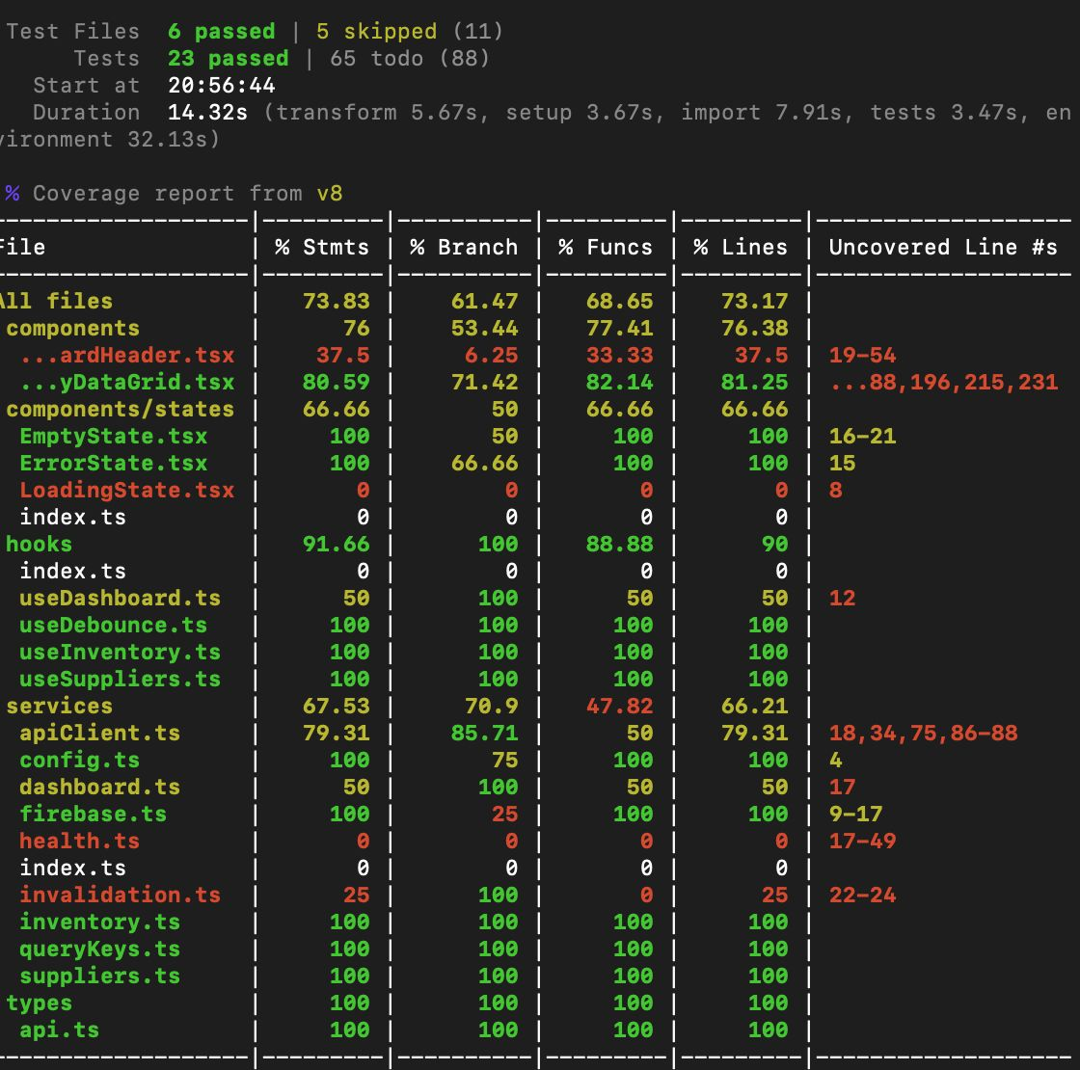
Figure 1: Frontend
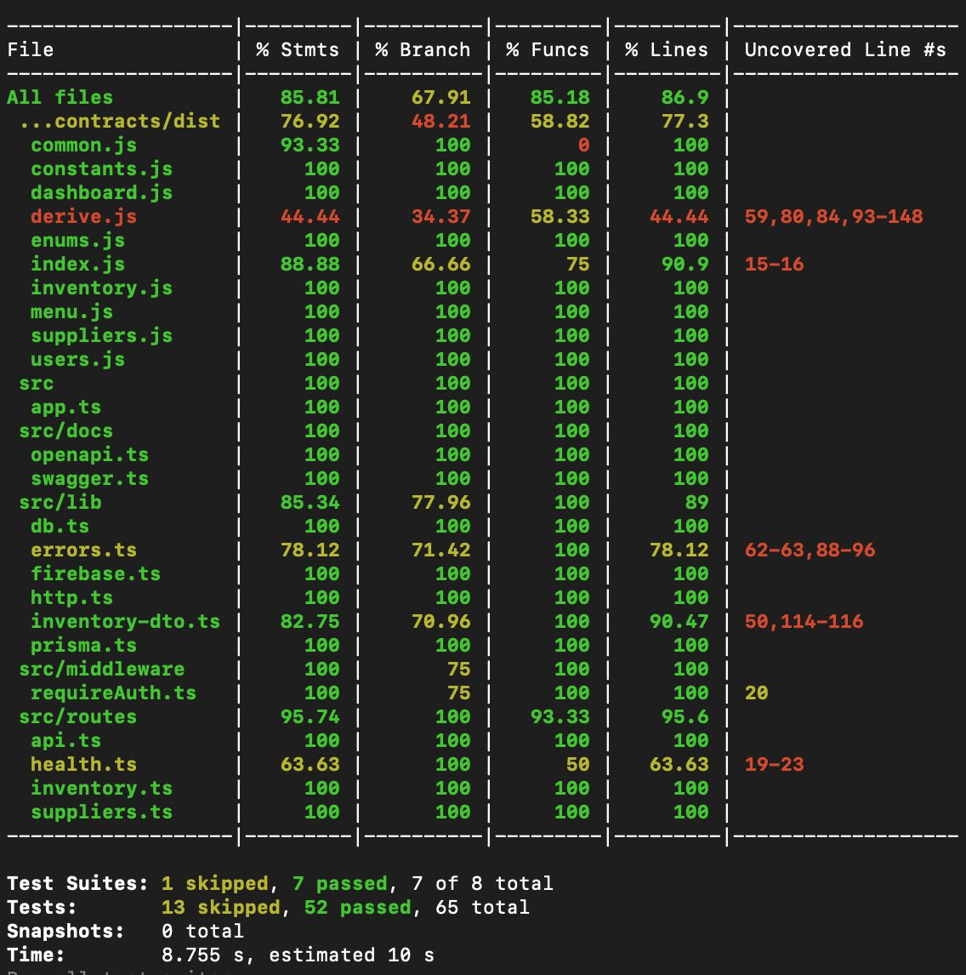
Figure 2: Backend
The detailed automated test cases for this project are maintained in the team’s GitHub repositories. These repositories contain the current frontend and backend test files, including unit tests, integration/API tests, component tests, and supporting test fixtures. The test plan summarizes the major test cases and coverage areas, while the GitHub repositories serve as the authoritative source for the implemented test code and the most up-to-date testing evidence.

6. Testing Procedures

6.1 Test Environment Configuration
- Runtime: Node.js 22 across both repositories (CI pins Node 22; the .nvmrc/engines bump to 22 is in progress).
- Database: a local PostgreSQL 16 instance started via docker-compose.dev.yml; connection configured through DATABASE_URL in .env (copied from .env.example).
- Backend: install with npm ci, generate the Prisma client, then run the API with npm run dev; tests run with npm test (Jest + ts-jest, matching src/**/__tests__/**/*.test.ts).
- Frontend: install in client/, run the dev server with npm run dev; tests run with npm test or npm run test:run (Vitest + React Testing Library + jsdom, setup in client/src/setupTests.ts).
- AI: AWS Bedrock accessed via IAM credentials (no static key); the fallback path is exercised by disabling/forcing failure of the Bedrock call.
- CI: GitHub Actions runs lint → test → build on pull requests and pushes to dev/main; failures block merge.

6.2 Test Data Preparation
The canonical T-32 seed dataset is the primary source of test data. After running Prisma migrations, the database is populated with prisma db seed, producing a known set of inventory items, suppliers, menu items, and recommendations — the same dataset used for the demo. This gives deterministic expected values for dashboard counts, alerts, and aggregations. Unit and component tests use small inline fixtures and mocks (e.g., mocked auth context, mocked suppliers service, mocked Bedrock responses) so they run without external dependencies.

6.3 Test Execution Flow
- Local: developers run the relevant suite (npm test) before pushing.
- Pull request: CI automatically runs lint, the full test suite, and the build; a green run is required to merge.
- Integration / API: endpoints are verified with supertest in automated tests and with a shared Postman collection for manual exploration.
- Manual / E2E: the Sprint 3 comprehensive pass (T-28) walks every MVP flow on the deployed stack and records results.
- Acceptance: the Product Owner validates user stories against the running build before sign-off.

7. Testing Schedule
Testing is continuous and sprint-aligned. The milestones below tie to the project's internal deadlines (set four days ahead of each official course due date).
Phase / Date | Activity | Description | Status
Sprint 1 | Test harness stand-up | Vitest + RTL frontend harness (T-20A) and Jest + supertest backend harness in place; first smoke tests passing. | Complete
Sprint 2 | Per-feature automated tests | Engineers add unit/component/API tests alongside each feature (auth, inventory, dashboard, suppliers); CI gate enforced (T-19/T-20). | In progress
Jun 17, 2026 | Test Plan deliverable | This document submitted (official course due date; internal target Jun 13). | This deliverable
Sprint 3 | Comprehensive testing (T-28) | Full manual E2E pass across UI, API, DB, and AI; performance/stress spot checks; defects logged and resolved. | Planned
Sprint 3 | Test evidence & UAT | Test results captured (screenshots / run output / summary); Product Owner acceptance before Phase II. | Planned

8. Testing Resources

8.1 Personnel & Responsibilities
Testing is a shared, whole-team responsibility: every engineer writes and documents tests for the code they build. Leads coordinate coverage and review within their domain, and the project managers own the plan, schedule, and defect process.
Member | Role | Testing Responsibility
Dan Nunes | Project Manager | Owns the test plan and schedule; coordinates the defect process and review sign-off.
Robert Lee | Assistant Project Manager | Co-owns the plan/schedule; tracks test completion and peer reviews.
Jose Escandor | Backend Lead | Coordinates Jest + supertest API coverage and the Postman collection.
Spencer Renfro | Frontend Lead | Coordinates Vitest + React Testing Library UI/component coverage.
Arth Thakkar | AI / Cloud Lead | Coordinates AI/Bedrock and fallback testing, plus CI test execution.
Adan Medina | Product Owner | Validates acceptance criteria and usability; leads UAT sign-off.
Entire team | All engineers | Author/document feature tests; participate in the Sprint 3 comprehensive pass (T-28).

8.2 Tools & Equipment
- Automated testing: Jest + ts-jest + supertest (backend); Vitest + React Testing Library + jsdom (frontend).
- API testing: Postman collection for manual/exploratory endpoint checks.
- CI/CD: GitHub Actions; version control and issue tracking on GitHub (Org Project #1).
- Runtime/infra: Node.js 22, Docker / docker-compose, PostgreSQL 16, a single AWS EC2 host, and AWS Bedrock for AI.
- Developer workstations for local development and manual testing.

8.3 Budget
Tooling cost is effectively zero: the test stack (Jest, Vitest, Testing Library, supertest, Postman, GitHub Actions) is open-source or free for this use. The only cloud costs are a single EC2 host and metered AWS Bedrock usage, both modest and covered under the project's educational allowance. The primary resource investment is team engineering time.

9. Defect Management
Defects are tracked as GitHub Issues on the organization's project board (Project #1). Each defect is reported with a clear title, steps to reproduce, expected vs. actual behavior, environment, severity, and supporting evidence (logs or screenshots).

9.1 Severity & Priority
Severity | Definition | Handling
Critical | Blocks a core MVP flow or the demo; no workaround. | Fix immediately
High | Major feature broken or incorrect data; workaround difficult. | Fix this sprint
Medium | Feature partially impaired; reasonable workaround exists. | Schedule
Low | Cosmetic or minor; minimal user impact. | Backlog

9.2 Defect Lifecycle
Report → Triage (severity/priority assigned, owner set) → Fix on a feature/fix branch → Pull request with a regression test → CI runs lint/test/build → Reviewer verifies the fix → Merge and close. Reopened defects return to triage. Because automated tests gate every merge, fixes ship with a test that guards against recurrence wherever practical.

10. Current Implementation Status
As of June 16, 2026 (post T-7B merge) the automated test suites are established and growing. The following is an accurate snapshot of tests committed or in open pull requests; the remaining cases in Section 5 are planned and will be added alongside their features.
Area | Test File(s) | Framework | Status
Backend — Platform | health.test.ts, notfound.test.ts, openapi.test.ts | Jest + supertest | Committed (main)
Backend — Auth | auth.test.ts (7 tests) | Jest + supertest | Committed (main)
Backend — Inventory | inventory.test.ts (18 tests) | Jest + supertest | Committed (main)
Backend — Suppliers | suppliers.test.ts (14 tests) | Jest + supertest | Committed (main)
Backend — Derived math | derive.test.ts (5 tests) | Jest (contracts pkg) | Committed (main)
Frontend — Dashboard | DashboardHeader.test.tsx (1 test) | Vitest + RTL | Committed (main)
Frontend — Inventory | InventoryDataGrid.test.tsx (8 tests), services/inventory.test.ts (3 tests) | Vitest + RTL | Committed (dev/T-7B)
Frontend — Services | apiClient.test.ts (7 tests), services/suppliers.test.ts (2 tests), types/api.test.ts (2 tests) | Vitest | Committed (dev/T-7B)
Frontend — Auth UI | LoginPage.test.tsx (4 tests) | Vitest + RTL | Open PR #39 (T-5)
Frontend — Supplier UI | SupplierDirectory.test.tsx (6 tests) | Vitest + RTL | Open PR #38 (T-9A)
Planned — Dashboard | DashboardPage.test.tsx (placeholders, T-6A/B/C) | Vitest + RTL | Planned — Sprint 2
Planned — Menu / AI | MenuBuilderPage.test.tsx, upcoming-features.test.ts (placeholders, T-8/16/17) | Vitest / Jest | Planned — Sprint 2/3
Manual / E2E | T-28 comprehensive testing pass | Manual + Postman | Planned — Sprint 3
Not yet automated (planned): Dashboard API and page (T-6A/B/C — placeholders in DashboardPage.test.tsx), Menu Builder and recommendations (T-8A/B — placeholders in MenuBuilderPage.test.tsx), AI prompt construction and Bedrock response parsing (T-16 — placeholder in upcoming-features.test.ts), fallback ranking logic (T-17 — placeholder in upcoming-features.test.ts), and end-to-end flows (T-28, manual Sprint 3 pass).

11. References
- Mise Project Documentation repository — README, Sprint 1–2 Assignment Plan, and github_tickets.md (UMGCCAPSTONE, 2026).
- Mise Course Deliverables repository — deliverable schedule and technology stack (UMGCCAPSTONE, 2026).
- AI_Inventory_Backend CLAUDE.md — backend architecture, conventions, and domain model (UMGCCAPSTONE, 2026).
- IEEE Std 829-2008, IEEE Standard for Software and System Test Documentation. IEEE.
- International Software Testing Qualifications Board (ISTQB), Standard Glossary of Terms Used in Software Testing.
- Jest documentation. https://jestjs.io/
- Vitest documentation. https://vitest.dev/
- Testing Library (React) documentation. https://testing-library.com/
- Postman documentation. https://learning.postman.com/
- AWS Bedrock documentation. https://docs.aws.amazon.com/bedrock/
- UMGCCAPSTONE. (2026). Repositories. GitHub. Retrieved June 16, 2026, from https://github.com/orgs/UMGCCAPSTONE/repositories

