Mise
An AI/LLM-Powered Inventory Management System for Restaurants

Final Report
CMSC 495: Computer Science Capstone | University of Maryland Global Campus
Summer 2026 | 03 July 2026

Project Team
Dan Nunes
Robert Lee
Adan Medina
Spencer Renfro
Arth Naileshbhai Thakkar
Jose Jovenal Escandor

1. Introduction
Mise is an AI/LLM-powered inventory management system built for restaurants and small food businesses. It helps a kitchen manager track ingredient stock, catch items before they run low or expire, and turn that at-risk inventory into concrete menu ideas through an AI recommendation engine with a deterministic rule-based fallback. The name comes from "mise en place," the kitchen practice of having every ingredient prepared and in its place before service begins; the system's goal is the same discipline applied to inventory data.
The project was developed over Summer 2026 by a six-person team in CMSC 495, the Computer Science Capstone course at the University of Maryland Global Campus, as the culmination of the program's software engineering and applied AI coursework. It began as a Project Plan and Project Design in late May 2026, moved through a Phase I and Phase II source submission, a Test Plan, and a User Guide, and arrives at this Final Report as a working, deployed, continuously tested full-stack application rather than a paper design.

1.1 Background and Motivation
Independent restaurants and small food businesses run on thin margins, and food cost is one of the few levers an operator controls day to day. Ingredients that expire unused, over-ordering driven by guesswork, and menu planning that ignores what is actually on the shelf are all avoidable sources of waste. Many of these businesses still track inventory on paper, in spreadsheets, or by memory, which makes it hard to see an expiring case of cream or a nearly depleted box of chicken thighs before it becomes a loss. At the same time, enterprise inventory suites built for large multi-location chains are often more system than a single-location restaurant needs, both in cost and in operational complexity.
The motivation behind Mise is to close that gap with a focused tool: a dashboard that surfaces low-stock and expiring items automatically, and an AI layer that turns those at-risk ingredients into a usable menu suggestion, priced and explained, instead of just a warning the manager still has to act on unaided. Deterministic logic, not the AI, computes the numbers that matter (what is low, what is expiring, what it is worth); the AI's job is creative, not arithmetic, and the system always has a rule-based answer ready if the AI service is slow, unavailable, or returns something it cannot validate.

1.2 Related and Similar Work
AI-assisted food waste reduction is an active area of both industry practice and academic research. Clark et al. (2025) surveyed AI-driven food waste management strategies used across the hospitality industry and found that computer vision, sensor data, and machine learning are already used commercially to identify, categorize, and quantify waste and to generate reduction recommendations, though most deployed systems still target large-scale hospitality operations rather than small independent restaurants. Vukolić et al. (2025) reach a similar conclusion from the hospitality-management side in the Journal of Tourism Futures, describing measurable food-cost and waste reductions where AI has been adopted for kitchen inventory decisions, while noting that adoption among small operators lags well behind large chains because of cost and integration complexity.
On the demand-forecasting side, Hossain and Parvin (2025) compared statistical and machine learning models for predicting restaurant demand in Bangladesh and found that even modest, well-scoped models meaningfully improve inventory decisions in a restaurant setting, which supports Mise's design choice to prioritize a small set of deterministic, explainable metrics (low-stock, expiring-soon, at-risk value) over a heavier forecasting model that the MVP does not have the sales history to train. More directly relevant to Mise's own architecture, Quan and Liu (2024) describe InvAgent, a large language model based multi-agent system for supply chain inventory management, and report that an LLM-driven agent can make adaptive, interpretable inventory decisions without the extensive historical training data that classical forecasting requires. This is the same bet Mise makes at a much smaller scale: an LLM (Anthropic's Claude) reasons over the current inventory snapshot and produces an interpretable, explained suggestion rather than a black-box forecast, with rule-based logic standing in whenever the model is unavailable or its output cannot be trusted.
Commercially, Mise sits alongside established restaurant back-of-house platforms such as MarketMan and Toast's xtraCHEF. Clow's (2026) independent comparison of the two describes MarketMan as built around ingredient-level counting, recipe costing, and multi-location vendor management, and xtraCHEF as focused on invoice automation and food-cost reporting tied to point-of-sale data, with neither product built primarily around AI-generated menu recommendations. Mise does not attempt to match either product's depth in vendor invoicing or multi-location analytics; its contribution as a capstone prototype is narrower and specific: pairing simple, explainable inventory math with an AI recommendation step aimed squarely at reducing waste on a single-location scale, an angle that the reviewed commercial tools address only indirectly.

1.3 Report Scope
This report is the final, consolidated deliverable for the project. It restates the problem and requirements established in the Project Plan and Project Design, describes the system as it is actually implemented today rather than as it was originally scoped, summarizes the testing performed against it, documents where the design changed from its original plan and why, and reflects on the team's process and results. Section-level detail that is available in the team's other deliverables (the full Test Plan, the User Guide, and the GitHub repositories) is summarized here and referenced rather than reproduced in full, with the complete system requirements and a condensed user guide included as appendices.

2. Process Overview
The team followed an Agile/Scrum process rather than a waterfall sequence, chosen at the Project Design stage because the system's riskiest component (the AI recommendation workflow) could not be fully specified up front and needed to be built, tried against real seed data, and refined over several iterations. That choice held up well in practice: the AI integration changed providers mid-project (Section 6.1), the pricing model for a recommendation was revised twice after the frontend surfaced a gap (Section 6.3), and neither change required renegotiating the project schedule because the team's sprint cadence already assumed the design would move.

2.1 Roles
- Dan Nunes, Project Manager: owned the schedule, sprint milestones, and delivery coordination across both repositories.
- Robert Lee, Assistant Project Manager: co-owned the test plan and schedule, tracked ticket completion, and coordinated documentation across the four project repositories.
- Adan Medina, Product Owner: defined MVP scope, prioritized tickets, and validated completed work against user stories and acceptance criteria.
- Jose Jovenal Escandor, Backend Lead: owned the Express/Prisma API, the database schema, and backend testing, and was the primary author of the shared contracts package.
- Spencer Renfro, Frontend Lead: owned the React/MUI user interface, page-level workflows, and frontend testing.
- Arth Naileshbhai Thakkar, AI/Cloud Lead: owned the AI integration, CI/CD pipeline, Docker/EC2 deployment, and cloud configuration.
In practice all six members wrote code, tests, and documentation across both repositories; the roles above describe primary ownership and accountability, not an exclusive division of labor. GitHub's commit history for both repositories shows contributions from all six team members across the life of the project, and the ticket board attributes each merged pull request to the engineer who implemented it and to the reviewer(s) who approved it.

2.2 Tools and Artifacts
Work was coordinated entirely through GitHub: three private repositories under the UMGCCAPSTONE organization (AI_Inventory_Backend, AI_Inventory_Frontend, and Documentations, plus the CourseDeliverables repository for course submissions), a shared GitHub Project board for ticket tracking, GitHub Issues for T-numbered tickets with checkbox acceptance criteria, and pull requests for all code review. Across the two application repositories the team opened 75 issues (64 closed as of this report) and merged 75 pull requests, none of them committed directly to the dev or main branches.
- Version control and workflow: feature branches named feature/T_X_short-name off dev; PRs target dev for review, and dev merges into main only after verification. GitHub Actions runs lint, test, and build on every PR and blocks merges on failure; an automated @claude review runs on every PR as a first pass before human review.
- Shared contract package: @umgccapstone/contracts, a versioned npm package (GitHub Packages) of TypeScript types, Zod validation schemas, and the derive.ts metric functions, consumed by both the frontend and backend so the two codebases cannot silently disagree about a data shape or a business rule.
- Architecture Decision Records (ADRs): over 30 MADR-format ADRs across the two repositories (17 in the backend, 9 in the frontend, plus 5 shared ADRs synced between them) record the reasoning behind every significant design decision, several of which are discussed in Section 6.
- Local and deployed environments: Docker Compose for a containerized local stack (API, frontend, PostgreSQL), and a single AWS EC2 host running the same Docker Compose stack in production, deployed automatically by GitHub Actions on merges to main.
- Testing and code quality: Jest and supertest (backend), Vitest and React Testing Library (frontend), ESLint and Prettier enforced in CI on both repositories.

2.3 Individual Contributions Summary
Each engineer authored the tests for the code they wrote, in keeping with the team's "you build it, you test it" policy recorded in the Test Plan. The Backend Lead built the Prisma schema, the inventory, dashboard, supplier, and menu/recommendation APIs, and the contracts package; the Frontend Lead built the dashboard, inventory, supplier, menu builder, and reports pages and their component tests; the AI/Cloud Lead built the CI/CD pipeline, the Docker and EC2 deployment path, and the Bedrock-to-Anthropic AI migration described in Section 6.1; the Product Owner defined and validated acceptance criteria and led usability sign-off; and the Project Manager and Assistant Project Manager maintained the schedule, the test plan, and cross-repository documentation while also contributing feature and fix pull requests directly. This shared-ownership model is also why the Discussion (Section 8) frames outcomes as team results rather than crediting a single role for the project's completed scope.

3. Requirements Specification
The requirements below were established in the Project Design document and have not changed in substance since; what changed over the project's life is which requirements were complete at each phase, tracked in Section 7. The full requirements catalog, including page-level field requirements and user stories, is included as Appendix A.

3.1 Business Requirements
- Help restaurants and small food businesses track inventory more accurately.
- Reduce food waste by identifying ingredients that are close to expiration.
- Support menu planning through AI-assisted recommendations.
- Provide useful inventory insights that help managers make better operational decisions.

3.2 Functional Requirements
- Allow users to add, view, edit, and delete inventory items with required fields (name, category, quantity, unit, par level, unit cost, expiration date).
- Display low-stock and expiring items on a dashboard, computed server-side.
- Generate AI-assisted menu recommendations from available ingredients, expiration dates, and cost, each with a short explanation.
- Provide a rule-based fallback recommendation whenever the AI/LLM service is unavailable or its output cannot be validated.
- Maintain a supplier directory linked to inventory items.
- Provide inventory and recommendation reports (category breakdown, top dishes, waste-risk summary, recommendation history).
- Support CSV export of the full inventory.
- Authenticate users via Google Sign-In and protect all API routes.

3.3 Non-Functional Requirements
- Provide a simple, responsive interface usable on common desktop and mobile browsers.
- Protect credentials, API keys, and inventory data; require a valid bearer token on protected routes.
- Keep derived metrics (low-stock, expiring-soon, at-risk value) consistent between frontend and backend by computing them once, server-side.
- Degrade gracefully: the system must still return a usable recommendation when the AI service fails, times out, or returns invalid output.
- Be maintainable by the development team: enforced linting and formatting, a CI gate on every merge, and ADRs recording design rationale.
- Support the addition of inventory items, recipes, and suppliers without requiring a schema redesign.

4. Project Design
Mise is a multi-repository, full-stack web application. A React single-page frontend communicates over REST with a Node.js/Express backend, which persists data in PostgreSQL through the Prisma ORM and calls the Anthropic API for AI-generated menu recommendations. A versioned shared package, @umgccapstone/contracts, defines the TypeScript types, Zod validation schemas, and the pure derive.ts metric functions used by both repositories, so the two codebases share one definition of what a valid inventory item is and how a metric like at-risk value is computed.
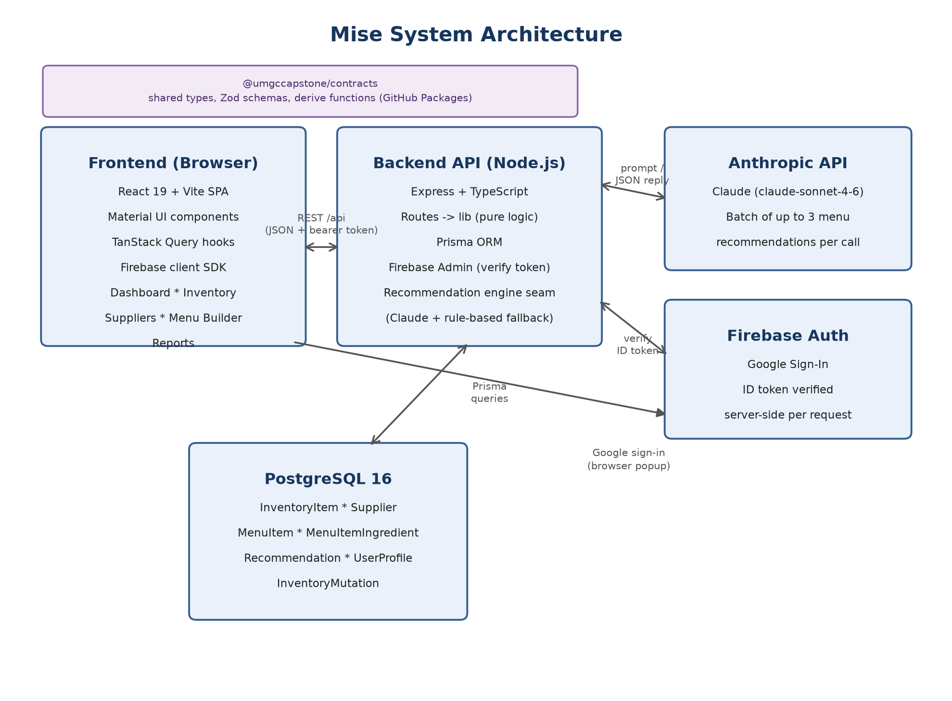
Figure 1. Mise system architecture: frontend, backend, database, AI, and auth components.

4.1 Technology Stack
Layer | Technology
Frontend | React 19, Vite, TypeScript, Material UI (MUI) and MUI X DataGrid, TanStack Query, react-hook-form, Zod, Firebase Auth client
Backend | Node.js, Express, TypeScript, Prisma ORM, Zod, firebase-admin, Anthropic SDK, Swagger UI / OpenAPI 3
Database | PostgreSQL 16
Shared contracts | @umgccapstone/contracts: types, Zod schemas, enums, and derive functions, published to GitHub Packages
AI / LLM | Anthropic API, model claude-sonnet-4-6, with a deterministic rule-based fallback engine
Testing | Jest + supertest (backend), Vitest + React Testing Library (frontend)
DevOps | Docker / Docker Compose, a single AWS EC2 host, GitHub Actions CI/CD

4.2 Data Model
The backend's Prisma schema defines seven models: InventoryItem, Supplier, MenuItem, MenuItemIngredient, Recommendation, InventoryMutation, and UserProfile. Enumerations (Category, Unit, RecommendationStatus, MenuItemStatus, UserRole) are declared once in the contracts package and consumed by both repositories through Zod. Several derived fields (whether an item is low-stock, whether it is expiring soon, its at-risk dollar value, whether a menu item is currently makeable) are computed only on the server; the frontend renders whatever the API returns and never recomputes these values itself, which keeps the dashboard, the inventory grid, and the AI recommendation pricing from ever disagreeing about the same number.

4.3 API Design
The backend exposes a REST API under /api. Every response follows one of two envelopes: { data, meta } on success or { error: { code, message, field } } on failure, so the frontend's API client has one place to unwrap a response and one place to throw a typed error. Authentication is a Firebase ID token sent as a Bearer header and verified server-side by firebase-admin; requests without a valid token receive 401. Interactive API documentation is generated from the same Zod schemas and served through Swagger UI at /docs, with the raw OpenAPI 3 specification at /openapi.json.

4.4 What the System Does and How It Is Used
A restaurant manager signs in with a Google account (or, in a login-less demo configuration, is taken directly to the dashboard). The Dashboard is the home screen: a personalized greeting, four KPI cards (Total Items, Below Par, Expiring Soon, At-Risk Value), an alerts list of items needing attention, and a preview of up to three AI-generated menu recommendations. From there the manager can:
- Manage inventory: add, edit, delete, search, filter, sort, and paginate ingredient records on the Inventory page, with validation preventing negative quantities, invalid dates, or missing required fields, and a 409 conflict if a delete would remove an ingredient still used by an active menu item.
- Review suppliers: maintain a supplier directory with contact information, delivery cadence, a read-only delivery ledger, and spend-by-supplier reporting.
- Generate menu recommendations: on the Menu Builder page, request up to three AI-generated specials scoped to at-risk stock or the full inventory. Each recommendation card shows the dish name, an explanation, an availability badge, suggested price, food cost, and margin, and can be accepted onto the menu, dismissed, or saved for later.
- Review reports: view a category breakdown, top dishes by price, recommendation history, and a waste-risk summary.
- Export data: download the complete inventory as a CSV file for offline analysis.
Behind the scenes, generating a recommendation calls a single engine seam that tries the Anthropic API first. If the call fails, times out, or returns output that does not validate against the expected schema, the same seam falls through to a rule-based engine that ranks candidates by expiring-soon and low-stock status using only deterministic logic in derive.ts, so the feature always returns a usable answer. A batch of up to three distinct recommendations is generated and persisted per request, deduplicated against dishes already proposed, accepted, or saved so the same suggestion is never repeated in a batch.
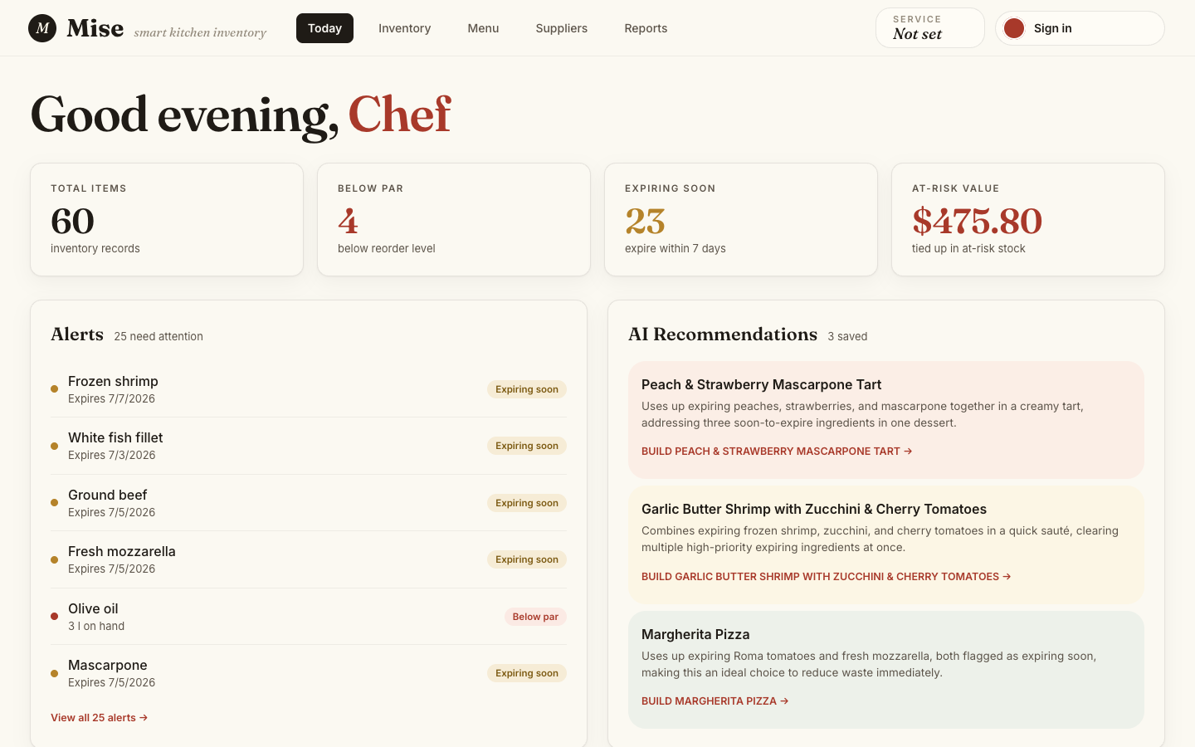
Figure 2. The Dashboard, showing KPI cards, expiration/low-stock alerts, and AI-generated recommendation previews.
A complete, step-by-step walkthrough of every page, with additional screenshots of the running application, is provided in Appendix B (condensed from the team's User Guide).

5. Project Evaluation

5.1 Testing Strategy
Testing followed a shift-left, "you build it, you test it" model: every engineer wrote and documented automated tests for the code they authored, and those tests ran automatically in CI on every pull request. The Test Plan (submitted as a separate deliverable and summarized here) defines seven levels of testing used across the project:
Testing Type | Tooling | What It Covers
Unit testing | Jest (backend), Vitest (frontend) | Pure functions and isolated logic, e.g., derived inventory metrics and fallback ranking
Integration / API testing | Jest + supertest; Postman | HTTP endpoints exercised end-to-end, including success and error envelopes
Component / UI testing | Vitest + React Testing Library | React components rendered and interacted with in a simulated DOM
Functionality testing | Automated suites + manual checks | Each MVP feature validated against its acceptance criteria
Parametric testing | Jest/Vitest parameterized cases (Zod) | Validation logic across boundary and invalid input sets
Performance / stress | Manual timing + scripted checks | Endpoint latency under normal and concurrent load
System / acceptance | Manual E2E pass; Product Owner UAT | Full MVP user flows across frontend, backend, database, and AI

5.2 Test Results
As of this report, both automated suites pass in full. The table below was produced by re-running each suite against the current dev branch while preparing this report.
Suite | Test Files | Tests Passing
Backend (Jest + supertest) | 16 | 172
Frontend (Vitest + RTL) | 16 | 168
Total | 32 | 340

This is substantial growth from the Phase II submission, which reported 63 backend and 23 frontend passing tests; the increase reflects both new features (suppliers delivery ledger, reports, the AI recommendation engine, portion guarding) and the team's policy of writing tests alongside each feature rather than after it. The one skipped backend suite (upcoming-features.test.ts) and the ten skipped/todo cases hold specs for stretch items that remain open at the time of this report (Section 8.3); they are intentionally excluded from the passing count rather than deleted, so the gap between planned and implemented coverage stays visible in the test run itself.
Backend coverage spans authentication (token verification, dev passthrough, production fail-fast), inventory CRUD and validation, dashboard aggregation, supplier CRUD, the AI recommendation engine and its Anthropic client, the portion-guard clamp, the rule-based fallback, menu availability, reports, and platform concerns (health check, 404 handling, OpenAPI/Swagger). Frontend coverage spans every page (Dashboard, Inventory, Suppliers, Menu Builder, Reports, Login), the shared API client, and the CSV export utility. The CI pipeline on both repositories runs lint, the full test suite, and a build on every pull request, and blocks merges on any failure, so this passing state is also the state required to reach the dev and main branches.

5.3 Validation
The Project Design defined success criteria centered on task-based usability testing: restaurant-manager volunteers locating inventory status and expiration alerts, adding an item, generating and reading an AI recommendation, and completing these tasks without developer assistance, with a target of 90% task completion and an average satisfaction score of 4 out of 5. The User Guide records that a novice user reviewed the setup and walkthrough steps, and that feedback from that review was used to clarify setup instructions, button names, and troubleshooting guidance before the guide was finalized. The Sprint 3 comprehensive manual pass (ticket T-28) exercises the full MVP flow, sign-in, inventory management, dashboard alerts, recommendation generation with fallback, and reports, on the deployed EC2 environment, and remains the team's acceptance gate before treating a feature as demo-ready.

6. Design and Alternate Designs
The team recorded every significant design decision as an Architecture Decision Record (ADR) at the time it was made, including decisions that were later revisited. The four cases below are drawn directly from that record and are the clearest examples of the design changing in response to implementation experience or testing, rather than being fully specified up front.

6.1 AI Provider: AWS Bedrock to the Anthropic API
The original AI design decision (ADR 0007, June 8, 2026) chose AWS Bedrock, authenticated through IAM, specifically to avoid managing a static API key: an EC2 instance role in production and AWS SSO for local development. This fit the project's AWS-centered deployment plan from the Project Plan. During implementation, the team replaced this with a direct integration against the Anthropic API using an API key (commit 4dc1bda, "replace AWS Bedrock with the Anthropic API"). The recommendation engine module that calls the model is still named bedrock-engine.ts in the codebase, a naming artifact of the migration, though its implementation now calls Anthropic's SDK directly. The engine-seam design from ADR 0007 (a single function the route calls without caring which engine answered) meant this provider swap did not require changing the route, the persistence layer, or the rule-based fallback; only the engine implementation itself changed. This is a case where the interface-first design absorbed a significant underlying change with no ripple effect elsewhere in the system.

6.2 Recommendation Pricing: From No Pricing to a Clamped, Serving-Based Model
ADR 0015 (June 28, 2026) added food cost, suggested price, and margin to each recommendation card, computed server-side with a food-cost-percentage method (a 30% target food cost, chosen by the Product Owner). Testing the fallback path against real seed data surfaced a problem the initial design had not anticipated: the rule-based baseline's "use up these at-risk ingredients" suggestion is not a real recipe, so pricing it against the entire on-hand quantity of an ingredient could price a single dish at roughly $178. The design was revised (amendment, July 1, 2026) to price the fallback baseline at a nominal single-serving quantity per unit dimension instead of the full on-hand stock. A second gap appeared once the AI path was tested: a prompt can ask the model for single-serving quantities, but a prompt is only best-effort, and an occasional hallucinated quantity could still distort a price. The team's response (July 2, 2026, reviewed in pull request #72) added an explicit servings parameter to the generate request, defaulted to one serving, and a deterministic portion-guard module that clamps any AI-emitted ingredient quantity to a plausible single-serving range per inventory category before it is priced or persisted. The guard clamps rather than rejects an out-of-range value, so one implausible quantity does not discard an otherwise-good recommendation.

6.3 Auth Opt-Out for the Public Demo
The team's shared ADR mandates Firebase bearer authentication on every protected route, and the backend deliberately fails to start in production if that authentication is not configured, a safeguard against accidentally shipping an unauthenticated production API. Once the project needed a public, login-less demo (so a reviewer or grader could open the live site without a Google account), that safeguard conflicted directly with the demo requirement. Rather than disabling the guard by editing code or misconfiguring NODE_ENV, the team added a single explicit AUTH_DISABLED environment flag (ADR 0016, June 29, 2026) that makes both the backend's auth check and the frontend's login wall skip authentication together, logging a visible warning when active. This design was revisited twice more after deployment: once when removing the EC2 firewall made a login-less API world-writable (auth was turned back on, June 30), and again when the flag was found to only cover the backend, leaving the frontend's login wall up even with the API open (fixed by threading the same flag into the frontend build as VITE_AUTH_DISABLED, July 2). Each revisit is recorded as a dated amendment to the same ADR rather than a new, disconnected decision, which keeps the full history of why the flag exists and how its scope grew in one place.

6.4 Batch Recommendations
The recommendation engine originally returned one suggestion per request. Once the Menu Builder mockup (ticket T-8) showed three specials side by side, and the frontend's data layer already expected an array response, the team changed the engine interface to return up to three distinct recommendations per call (ADR 0017, June 29, 2026), enforced by a single deduplication wrapper placed around whichever engine, AI or rule-based, answers the request. The batch is capped but never padded: if the current inventory only supports one genuine suggestion, the engine returns one rather than fabricating filler to reach three. This is another case where a UI requirement discovered after the initial backend design forced a contract change, and the team's engine-seam pattern from Section 6.1 kept that change confined to one wrapper instead of every call site.

7. Development History
The project ran on an internal schedule set roughly four days ahead of each official course due date, so the team always had slack before a graded deadline. The table below is reconstructed from the repositories' commit history and the team's submitted deliverables.
Date | Milestone
21 May 2026 | Backend and frontend repositories created; initial project scaffolding
26 May 2026 | Project Plan submitted: scope, roles, risk plan, technology stack
02 Jun 2026 | Project Design submitted: requirements, page-level scope, Agile justification
08 to 09 Jun 2026 | Core backend/frontend scaffolding; ADR 0007 (AI provider: Bedrock); Phase I Source submitted
10 to 16 Jun 2026 | Inventory, dashboard, and supplier APIs and UI; test harnesses stood up (T-20A/B); Test Plan submitted (63 backend / 23 frontend tests passing at the time)
17 to 22 Jun 2026 | Contracts package hardened; auth middleware; Phase II Source submitted (auth, inventory, dashboard, and suppliers complete; AI, menu builder, and reports in progress)
28 to 29 Jun 2026 | AI provider migrated to the Anthropic API (issue #66); recommendation pricing (ADR 0015) and batch generation (ADR 0017) added; supplier delivery ledger and spend reporting added
29 to 30 Jun 2026 | User Guide submitted; AUTH_DISABLED demo toggle added and revisited (ADR 0016) after the public site went live at umgccapstone.online
01 to 02 Jul 2026 | Reports page KPI/category/trend work (T-72); mobile-responsive layout fixes; explicit servings and the portion-guard clamp added to recommendation pricing (PR #72)
03 Jul 2026 | Final Report prepared against the current dev branch: 340 automated tests passing, 75 pull requests merged across both repositories

Across the life of the project the team opened 75 GitHub issues (37 backend, 38 frontend) and merged 75 pull requests (36 backend, 39 frontend); 64 of the 75 issues are closed as of this report, with the remainder tracking the stretch items discussed in Section 8.3.

8. Discussion

8.1 Lessons Learned
- An interface-first design pays off when the riskiest part of the system is the least certain part. Isolating the AI call behind one engine seam (Section 6.1) meant swapping the entire AI provider mid-project touched one file's implementation, not the route, the persistence layer, or the fallback logic.
- A shared contracts package prevents an entire category of integration bug. Because both repositories import the same types, Zod schemas, and derive functions from @umgccapstone/contracts, the frontend and backend cannot silently disagree about a field name or a business rule; version bumps to the package made every such change visible and reviewable instead of discovered at runtime.
- Writing an ADR at the moment of decision, not after the fact, made revisiting a decision cheap. The AUTH_DISABLED history (Section 6.3) is legible as three dated amendments to one document; without that habit, the same history would likely have been three separate, disconnected fixes with no record of why the flag existed in the first place.
- Clamp, do not reject, when a model's output is only probably right. The portion-guard design (Section 6.2) treats an implausible AI-generated quantity as a value to correct, not a batch to throw away, which kept the feature usable without needing the model to be perfect.
- Coordinating six people across time zones and course loads worked because the tools did the coordinating. GitHub Issues, PR review, and a shared project board meant progress did not depend on everyone being in the same meeting at the same time.

8.2 Design Strengths
- A clear split between deterministic and AI-driven logic: every number that determines whether an ingredient is low-stock, expiring, or at risk, and every dollar figure derived from it, is computed by plain, unit-tested functions in derive.ts, never by the AI. The AI's role is limited to the part it is actually good at: proposing a plausible, explained dish.
- A rule-based fallback that is a first-class code path, not an afterthought: the fallback engine is exercised by its own tests and is the answer the system gives whenever the AI is slow, unavailable, or returns something that fails validation, so a demo or a real service outage never leaves the recommendation feature with nothing to show.
- A CI gate that actually gates: lint, test, and build must pass before a pull request can merge into dev or main on either repository, which is why the 340 tests reported in Section 5.2 reflect the state of the branch, not a snapshot that has since drifted.
- Server-computed, single-source-of-truth derived fields: the frontend never recomputes a metric the backend already computed, which removed an entire class of dashboard-vs-detail-page inconsistency bugs before they could occur.

8.3 Limitations
- The system is single-tenant: it assumes one restaurant's data per deployment, with no multi-location or multi-tenant support, by original MVP design.
- There is no sales-history entity, so recommendations rank by expiration and stock level only, not by past sales performance; the demand-forecasting research reviewed in Section 1.2 suggests this would be a natural next enhancement once real sales data exists.
- A handful of stretch-scope tickets remain open at the time of this report: custom ingredient categories (backend and frontend), a per-row CSV import validator, protected-route hardening on the frontend router (T-5B), and two reports endpoints for recommendation-impact and inventory-trend analytics. None of these block the MVP acceptance criteria in the Project Design.
- The public demo's login-less mode (Section 6.3), while explicit and reversible, leaves the demo API world-writable whenever it is enabled; this is an accepted, documented tradeoff for a grading/demo audience and not a configuration suitable for real restaurant data.
- Supplier records cannot be deleted in the current version, an intentional MVP restriction (ADR 0003) rather than an oversight, but one that would need addressing before real-world use.

8.4 Suggestions for Future Improvement
- Add a sales or order-history entity and use it to weight recommendations, closing the gap identified in Section 8.3 and bringing the system closer to the forecasting-augmented designs reviewed in Section 1.2.
- Extend the AUTH_DISABLED pattern's reasoning to a genuine multi-tenant data model, so the system could serve more than one restaurant per deployment.
- Promote the remaining placeholder test specs (Section 5.2) to full tests as their tickets close, keeping the test suite's skip count trending toward zero.
- Add supplier deletion with referential-integrity handling, and CSV import to match the existing CSV export.
- Consider a lightweight caching or rate-limit layer in front of the Anthropic API call, since recommendation generation is currently synchronous and uncached per request.

9. Conclusion
Mise met its MVP goal and, on several features, went beyond it. Every must-have feature from the Project Design (authentication, inventory management, the dashboard, AI-assisted recommendations with a rule-based fallback) is implemented and tested, and two features originally scoped as should-have or stretch (the supplier delivery ledger and spend reporting, and the fully built-out Reports page) were completed as well. The system runs as a deployed, publicly reachable application, not only as a local demo, and its 340 automated tests pass on the branch this report was written against. Where the original design proved wrong or incomplete, most visibly the AI provider choice, the recommendation pricing model, and the authentication toggle needed for a public demo, the team's engine-seam architecture and its ADR discipline let those corrections happen without destabilizing the rest of the system. The result is a small, honestly scoped tool that does what the Project Plan set out to do: turn at-risk inventory into a usable, explained menu suggestion, with a human always making the final call.

10. Acknowledgement
The team thanks the CMSC 495 course instructor for guidance across each phase of this project, and acknowledges the open-source and hosted-service communities behind React, Node.js, Express, Prisma, PostgreSQL, Firebase, Docker, and the Anthropic API, whose documentation and tooling this project relied on throughout.

11. References
Amazon Web Services, Inc. (n.d.). Amazon Web Services (AWS). https://aws.amazon.com/
Anthropic. (n.d.). Claude documentation. https://docs.anthropic.com/
Clark, Q. M., Kanavikar, D. B., Clark, J., & Donnelly, P. J. (2025). Exploring the potential of AI-driven food waste management strategies used in the hospitality industry for application in household settings. Frontiers in Artificial Intelligence, 7, Article 1429477. https://doi.org/10.3389/frai.2024.1429477
Clow, B. (2026, May 10). MarketMan vs xtraCHEF by Toast (2026): The honest comparison. Restaurant Inventory Tools. https://restaurantinventorytools.com/marketman-vs-xtrachef-by-toast-2026/
Docker, Inc. (n.d.). Docker documentation. https://docs.docker.com/
GitHub, Inc. (n.d.). GitHub. https://github.com/
Google. (n.d.). Firebase documentation. https://firebase.google.com/docs
Hossain, M. S., & Parvin, F. (2025). A comparative study of various statistical and machine learning models for predicting restaurant demand in Bangladesh. PLoS One. https://doi.org/10.1371/journal.pone.0325449
IEEE. (2008). IEEE Std 829-2008: IEEE standard for software and system test documentation. Institute of Electrical and Electronics Engineers.
International Software Testing Qualifications Board. (n.d.). Standard glossary of terms used in software testing. https://www.istqb.org/
Jest. (n.d.). Jest documentation. https://jestjs.io/
Material UI. (n.d.). MUI documentation. https://mui.com/
Meta Platforms, Inc. (n.d.). React. https://react.dev/
OpenJS Foundation. (n.d.). Express: Node.js web application framework. https://expressjs.com/
OpenJS Foundation. (n.d.). Node.js. https://nodejs.org/
Postman, Inc. (n.d.). Postman documentation. https://learning.postman.com/
PostgreSQL Global Development Group. (n.d.). PostgreSQL. https://www.postgresql.org/
Prisma. (n.d.). Prisma documentation. https://www.prisma.io/docs
Quan, Y., & Liu, Z. (2024). InvAgent: A large language model based multi-agent system for inventory management in supply chains (arXiv:2407.11384). arXiv. https://arxiv.org/abs/2407.11384
Testing Library. (n.d.). React Testing Library documentation. https://testing-library.com/
UMGCCAPSTONE. (2026). Repositories. GitHub. https://github.com/orgs/UMGCCAPSTONE/repositories
Vitest. (n.d.). Vitest documentation. https://vitest.dev/
Vukolić, D., Gajić, T., Cabral, Ó., Veljović, S., & Knežević, S. (2025). Revolutionizing the hospitality industry: The impact of AI technologies on efficient food management and reduction of food waste. Journal of Tourism Futures. https://doi.org/10.1108/JTF-02-2025-0033

Appendix A: System Specification

A.1 Software and Version Requirements
Component | Minimum Version | Notes
Node.js | 22 or higher | Includes npm; verify with node --version
Docker Desktop | 4.19 (Engine 23) | Required for the local PostgreSQL container and the full containerized stack
PostgreSQL | 16 | Runs inside Docker via docker-compose.dev.yml; no separate install needed
GitHub CLI (gh) | Any recent | Required to authenticate against the private @umgccapstone/contracts package
Git | Any recent | Required to clone the repositories
Web browser | Current version | Chrome, Firefox, Edge, or Safari
Operating system | macOS, Windows 10+, or Linux | Windows users should use PowerShell rather than Command Prompt

A.2 Recommended Development Hardware
Mise has no unusual hardware requirements; it runs comfortably on typical developer laptops. The figures below reflect running the full local stack (frontend dev server, backend dev server, and a Dockerized PostgreSQL instance) at once, which is the heaviest local configuration.
Resource | Recommended Minimum
CPU | Dual-core 64-bit processor (quad-core or better recommended for Docker)
Memory | 8 GB RAM (16 GB recommended when running Docker Desktop and both dev servers together)
Disk space | About 2 GB free for cloned repositories, node_modules, and Docker images/volumes
Network | Internet access for GitHub Packages authentication and the Anthropic API

Production hosting runs on a single AWS EC2 instance sized for a Docker Compose stack of three services (frontend, backend, PostgreSQL); this is adequate for the project's single-tenant, demo-scale traffic and is not intended to represent production sizing for real multi-restaurant use.

A.3 MVP Page Scope
Page | Feature | Priority
Login / Sign Up | Basic login and sign-up via Google; advanced SSO not required for MVP | Must Have
Dashboard | Inventory summary, low-stock alerts, expiring items, at-risk value, AI recommendation preview | Must Have
Inventory Management | Add, view, edit, delete inventory items | Must Have
Menu Builder / AI Recommendations | AI-assisted menu recommendations from inventory, expiration, and cost | Must Have
Fallback Recommendations | Rule-based recommendation if the AI/LLM service is unavailable | Must Have
Supplier Directory | Basic supplier information linked to inventory items | Should Have
Reports / Analytics | Basic inventory summaries, waste-risk information, recommendation impact | Should Have
CSV Export | Inventory data export | Nice to Have
Advanced Charts | Simple charts as time allows | Nice to Have

Out of scope for the MVP: full supplier order-history workflow, supplier spend analytics beyond the basic ledger later added in issue #66, delivery scheduling, advanced menu management, advanced SSO, live supplier ordering, real-time supplier integrations, advanced financial/accounting integrations, multi-location management, fully autonomous AI decision-making, and commercial production deployment.

A.4 User Stories and Acceptance Criteria
Feature | User Story | Acceptance Criteria
Dashboard | As a restaurant manager, I want to quickly see urgent inventory issues so I know what needs attention first. | Dashboard displays total inventory, low-stock items, expiring items, and at-risk inventory value.
Inventory Management | As a restaurant manager, I want to add and update inventory items so records stay accurate. | User can add, view, edit, and delete inventory items with required fields.
Expiration Alerts | As a restaurant manager, I want to see ingredients close to expiring so I can reduce waste. | Items close to expiration are clearly marked or highlighted.
AI Recommendations | As a restaurant manager, I want menu suggestions based on available ingredients so I can use inventory before it expires. | System generates a menu recommendation using inventory data and provides a short explanation.
Fallback Recommendations | As a restaurant manager, I want a suggestion even if the AI service fails. | If the AI/LLM service is unavailable, the system provides a rule-based recommendation.
Supplier Directory | As a restaurant manager, I want supplier information connected to inventory so I know where items come from. | User can view and manage basic supplier records.
Reports | As a restaurant manager, I want basic inventory reports so I can understand stock value, waste risk, and recommendation impact. | Reports show inventory value, expiring-item counts, waste-risk information, and recommendation history.

Appendix B: User Guide
This appendix condenses the team's full User Guide deliverable into the core walkthrough. The live application is available at https://umgccapstone.online/.

B.1 Getting Started
Mise is a two-repository system. The backend (Node.js/Express, PostgreSQL via Prisma) must be running before the frontend (React/Vite) can display live data. Both repositories include a .env.example file; copy it to .env (backend) or .env.local (frontend) before starting. The typical local startup sequence is:
- Backend: npm install, then npm run db:up (starts PostgreSQL in Docker), npm run prisma:migrate, npm run db:seed, and npm run dev (starts the API at http://localhost:3000; verify at /health).
- Frontend: authenticate once with the GitHub CLI for the private contracts package (gh auth refresh -s read:packages), then npm install and npm run dev inside client/ (usually opens at http://localhost:5173).
Interactive API documentation is available at http://localhost:3000/docs (Swagger UI) while the backend is running.

B.2 Signing In
Mise uses Google Sign-In through Firebase Authentication. Click "Sign in with Google," choose a Google account in the popup, and the app redirects to the Dashboard. In a local environment with authentication disabled, a note appears on the login page and the Dashboard can be reached directly.

B.3 Dashboard
The Dashboard is the home screen: a time-of-day greeting, four KPI cards (Total Items, Below Par, Expiring Soon, At-Risk Value), an Alerts list of items needing attention, and a preview of up to three AI-generated menu recommendations. Each alert links directly to the Inventory page; each recommendation card shows an availability badge and a "Go to Menu Builder" button.

B.4 Inventory Management
The Inventory page lists every ingredient record with search, category filters, status filters, and sortable columns. "+ Add Item" opens a form requiring name, category, quantity, unit, par level, and unit cost, with an optional expiration date and supplier. Editing reopens the same form pre-filled; deleting requires typing the item's name to confirm, and is blocked with an ITEM_IN_USE error if the ingredient is linked to an active menu item. "Export CSV" downloads the complete inventory regardless of the page currently shown on screen.
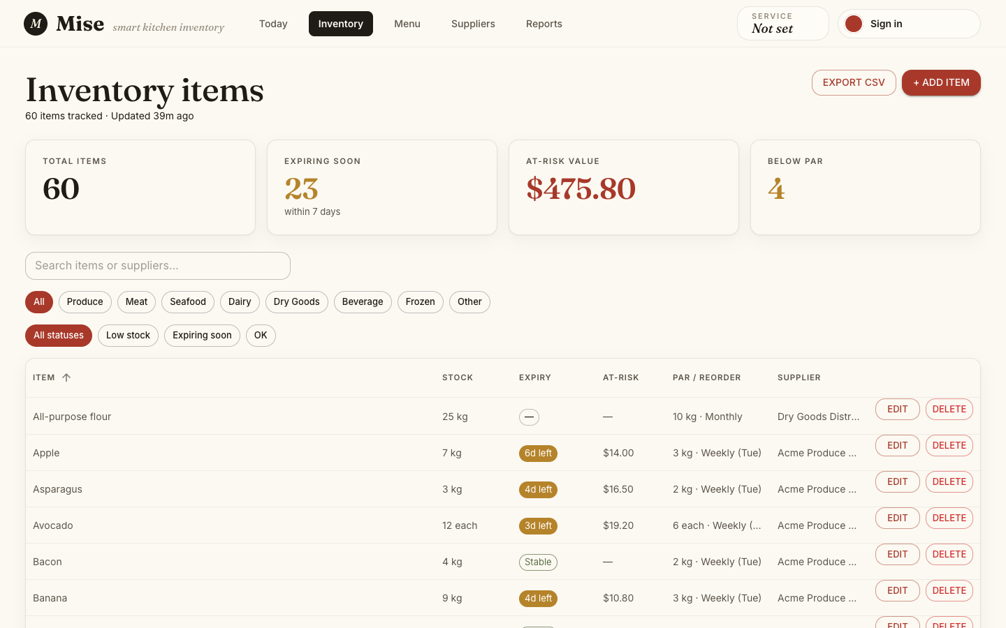
Figure 3. The Inventory page, with KPI cards, category/status filters, and the item data grid.

B.5 Suppliers
The Suppliers page maintains a directory of ingredient suppliers, each with optional contact name, phone, email, and delivery days, plus a read-only delivery history and a spend-by-supplier summary. Suppliers can be added and edited but not deleted in the current version; a supplier removal request should go to a system administrator.

B.6 Menu Builder and AI Recommendations
The Menu page combines AI-generated menu specials with live ingredient availability. A scope toggle switches between "At-Risk Stock" (the default, focused on expiring and low-stock ingredients) and "Full Inventory." Each recommendation card shows the dish name, an explanation, an availability badge, suggested price, food cost, and margin, and can be accepted onto the menu, dismissed, or saved for later.
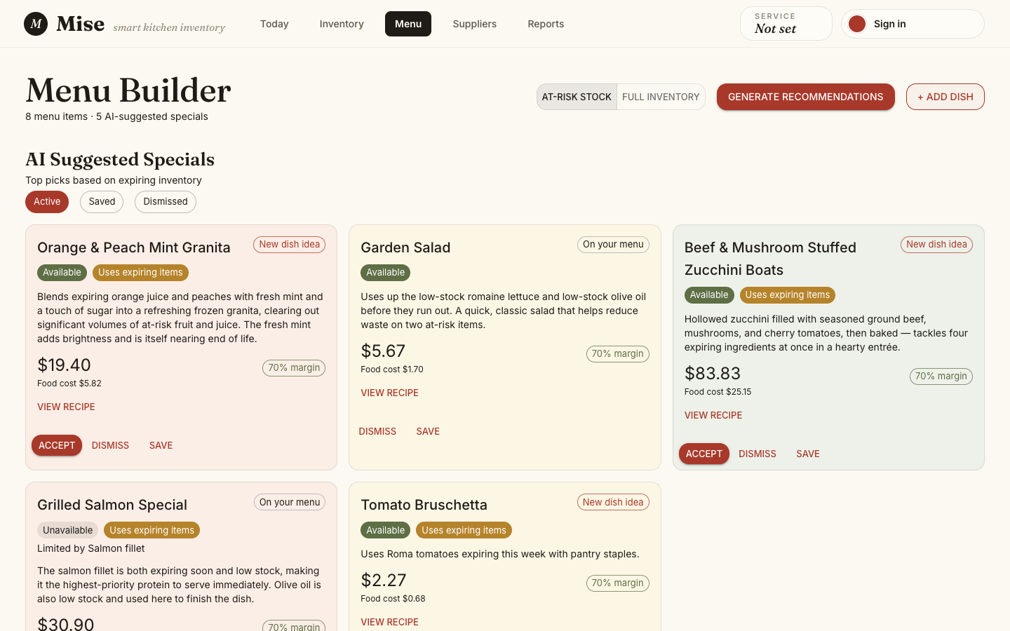
Figure 4. The Menu Builder page, showing AI-suggested specials with availability, price, and margin.

B.7 Reports
The Reports page shows a category breakdown of inventory value, the top dishes by price, recommendation history, and a waste-risk summary.
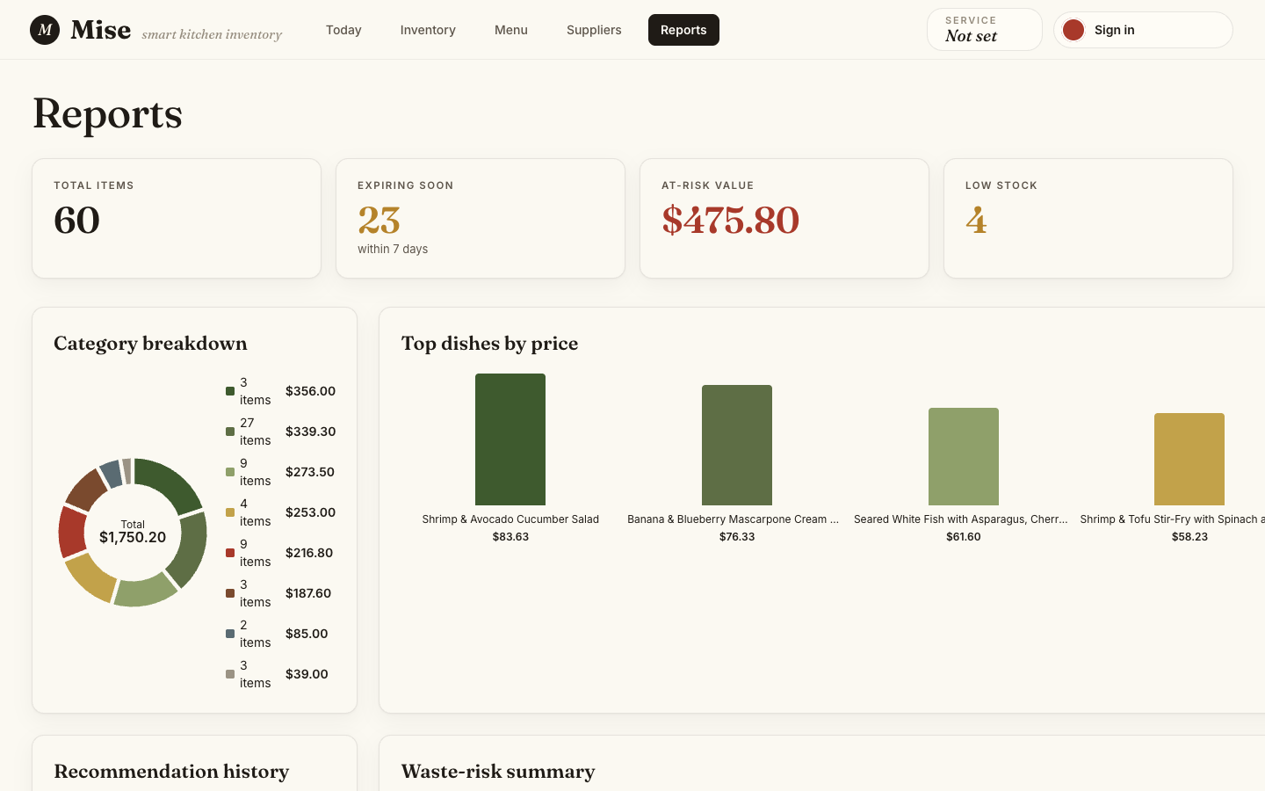
Figure 5. The Reports page, showing category breakdown and top-dish analytics.

B.8 Troubleshooting
Problem | Likely Cause | Solution
npm install fails with 401 | GitHub Packages token not set or expired | Re-run gh auth refresh -s read:packages and the npm config command
Backend will not start | Port already in use | Stop the conflicting process or change PORT in .env
Screens show empty data, no error | Backend running but not seeded | Run npm run prisma:migrate then npm run db:seed
"Sign in with Google" disabled | Firebase not configured locally | Navigate directly to /dashboard in a no-auth local setup
Delete fails with ITEM_IN_USE | Item linked to an active menu item | Archive the menu item first, then retry the delete
All recommendations "Not available" | Insufficient inventory for suggested dishes | Restock the limiting ingredient shown on the card

Appendix C: Architecture Decision Record Index
The ADRs below are the ones referenced directly in this report (Section 6). The full set, over 30 records across both repositories, is maintained in docs/adr/ in each repository.
ADR | Title | Repository
0003 | No supplier delete in MVP | Backend
0005 | Rule-based fallback ranking | Backend
0007 | AI via AWS Bedrock using IAM auth (superseded in practice by the Anthropic API migration, issue #66) | Backend
0015 | Recommendation pricing: food-cost-percentage method | Backend
0016 | Production auth opt-out via AUTH_DISABLED | Backend
0017 | Batch recommendation generation | Backend
Shared 0003 | Firebase bearer auth | Shared (both)
Shared 0004 | Server-computed derived fields | Shared (both)

