C.V. RAMAN GLOBAL UNIVERSITY
BHUBANESWAR, ODISHA-752054
DEPARTMENT OF COMPUTER SCIENCE & ENGINEERING



MACHINE LEARNING LABORATORY
RECORD

INDEX PAGE
SL. NO. | EXPERIMENTS/TOPICS | PAGE NO. | DATE OF EXPERIMENT | DATE OF SUBMISSION | FACULTY  SIGN. | REMARKS
1
2
3
4
5
6
7
8
9
10

EXPERIMENT - 1
Problem 1.1: Getting familiar with python syntax and introduction to python open source libraries for formation Retrieval ( Scipy, Numpy, Matplotlib, pandas, Sklearn )
Downloading, installing and getting started with Python Anaconda.
Solution 1.1:
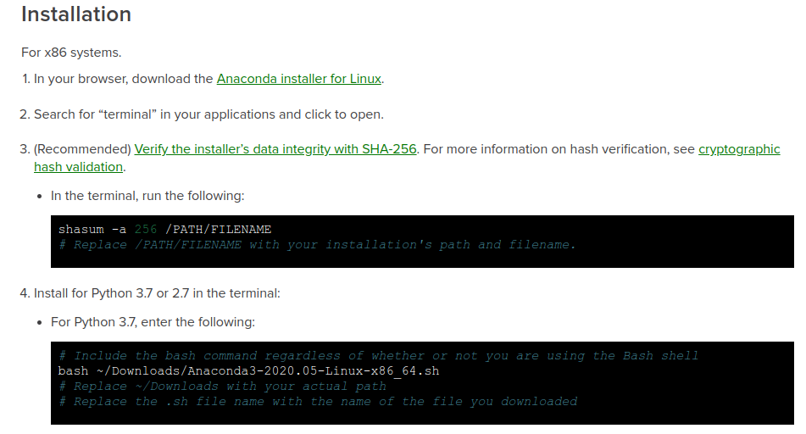
Problem 1.2: WAP to display about yourself (Name, branch, roll no, semester, department, college name) where you show different types of comment line including the new line.
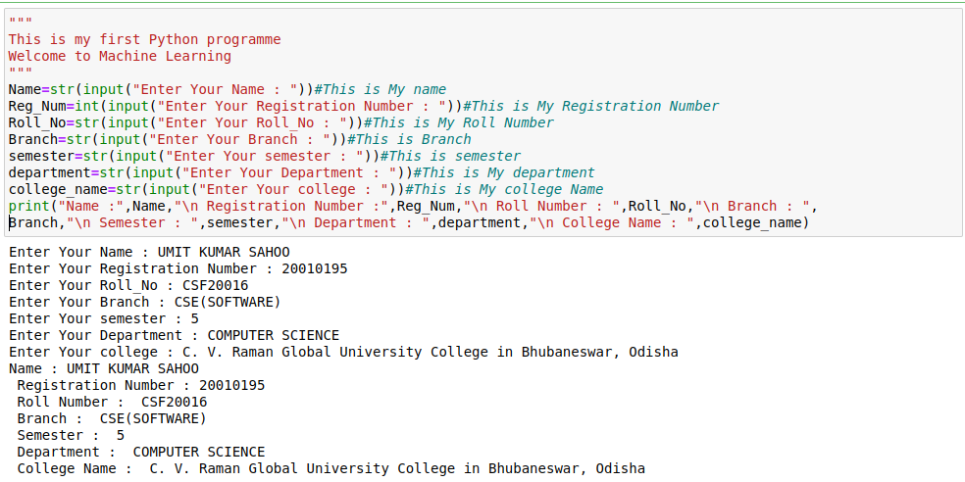
Solution 1.2:
Problem 1.3 WAP to convert the value from Celsius to Fahrenheit.
Solution 1.3:
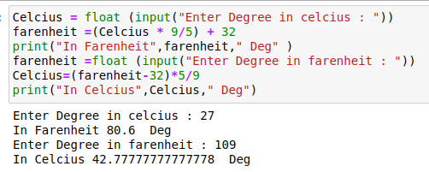
Problem 1.4: WAP to display swapping two numbers.
Solution 1.4:
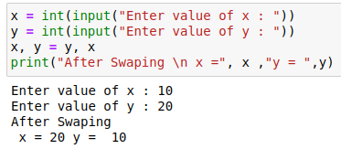
Problem 1.5: WAP to display the working of different python operators on two numbers.
Solution 1.5:
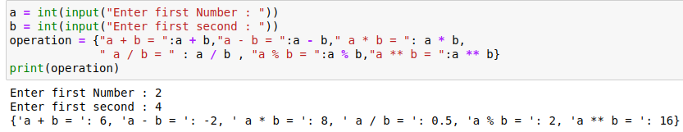
Submitted by
Student Name:
Reg No :
Branch & Semester :

EXPERIMNENT - 2
Problem 2.1: Loading and Understanding datasets (Pima Indian diabetes, Iris) using pandas.
Solution 2.1:
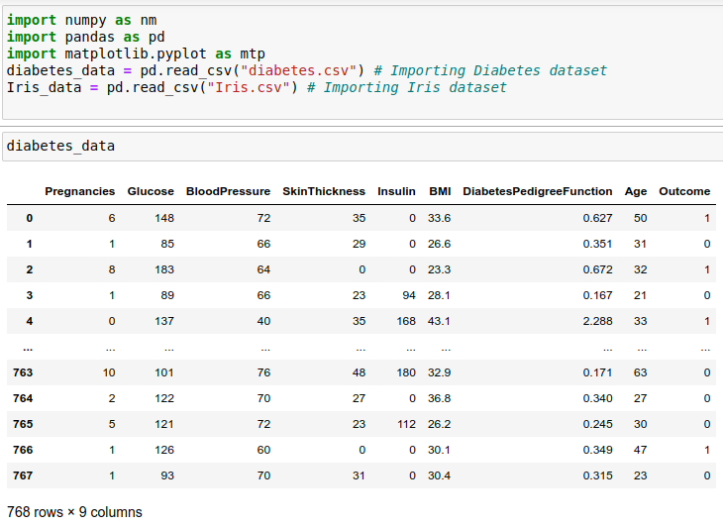
Problem 2.2:Find out Statistical summary of data (Mean Median, Mode, Variance, Co-variance, and Correlation) and Implementation of various classification algorithms on above mentioned dataset
Solution 2.2:
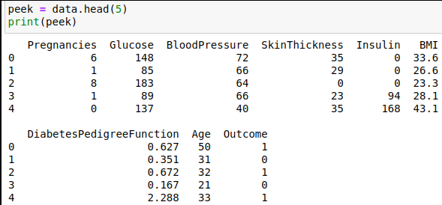

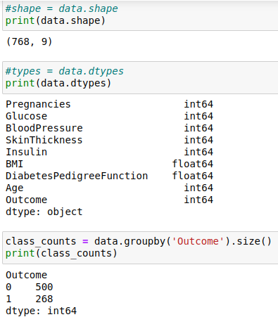

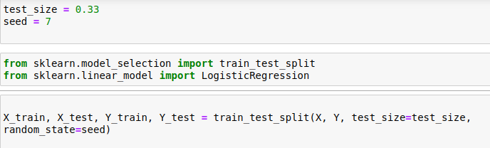

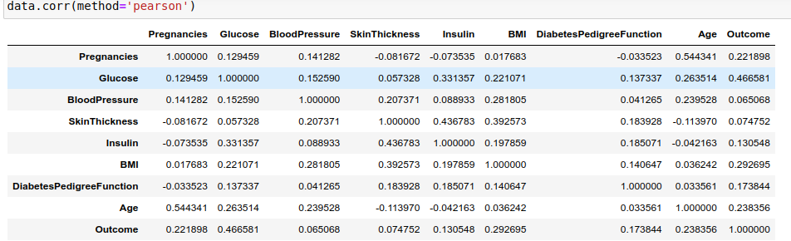
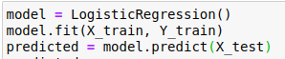
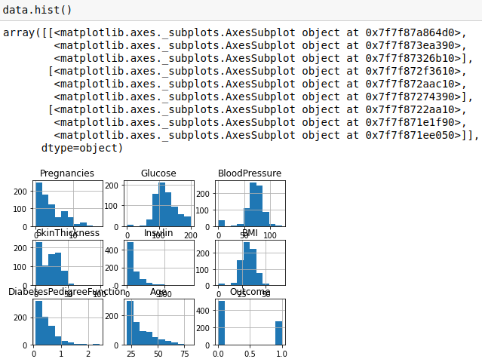

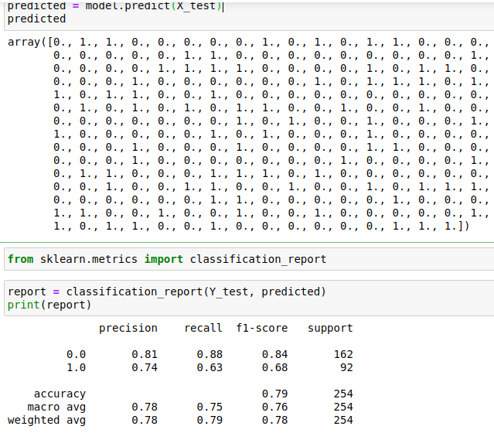
Submitted by
Student Name:
Reg No :
Branch & Semester :
EXPERIMNENT - 3
Problem 3 : Load dataset (Pima indian diabetes and iris) to python environmental dataset, make the confusion matrix for both dataset and compare classification performance of all the well known algorithms
Solution 3 :
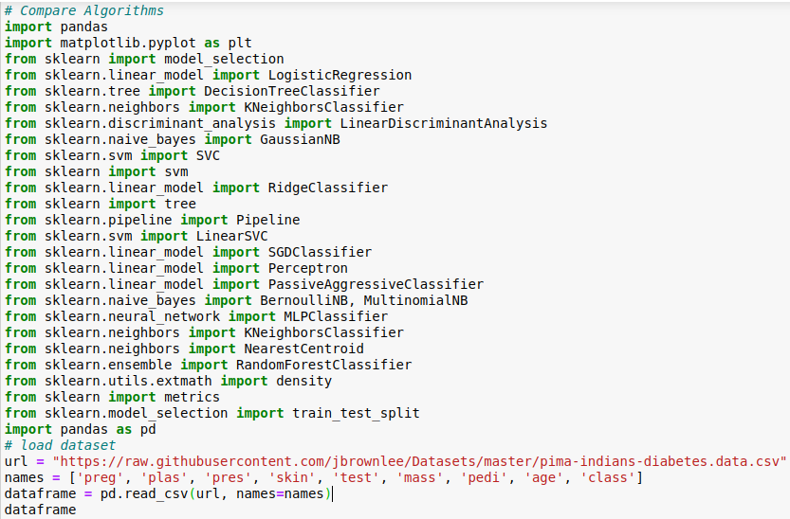
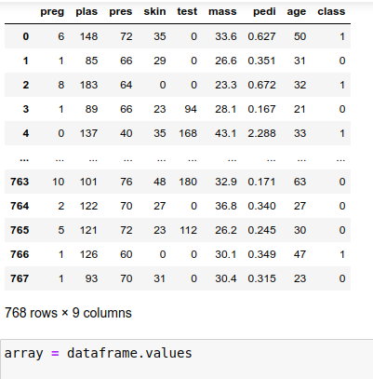
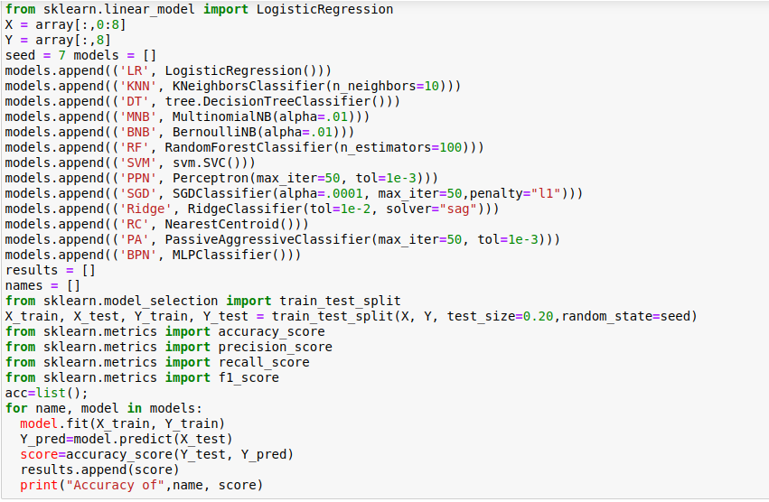
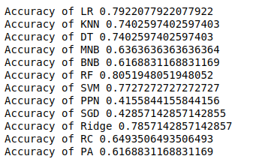

Submitted by
Student Name:
Reg No :
Branch & Semester :

