Resource:

TV SHOWS ,STREAMING SERVICE AND NETWORK

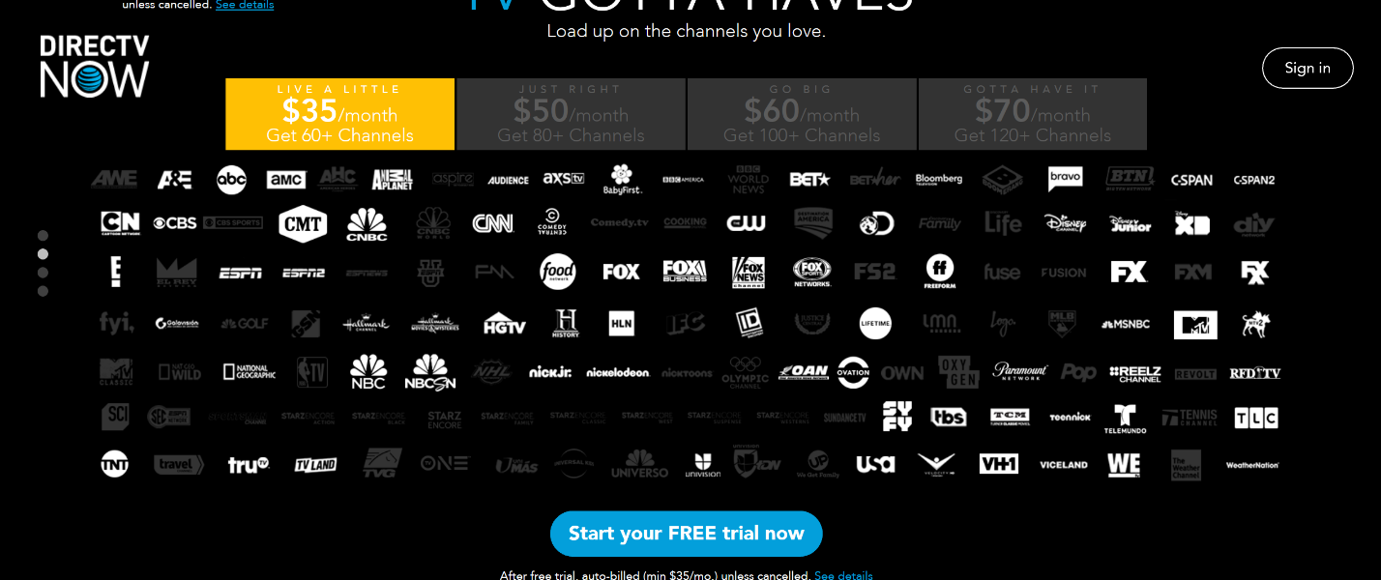

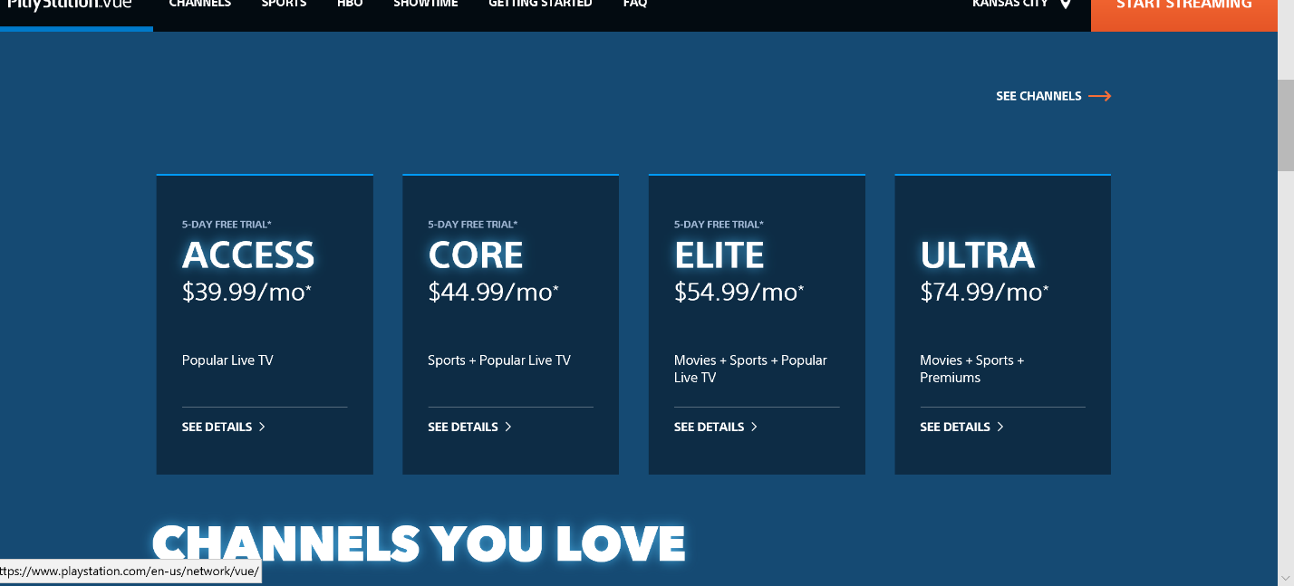

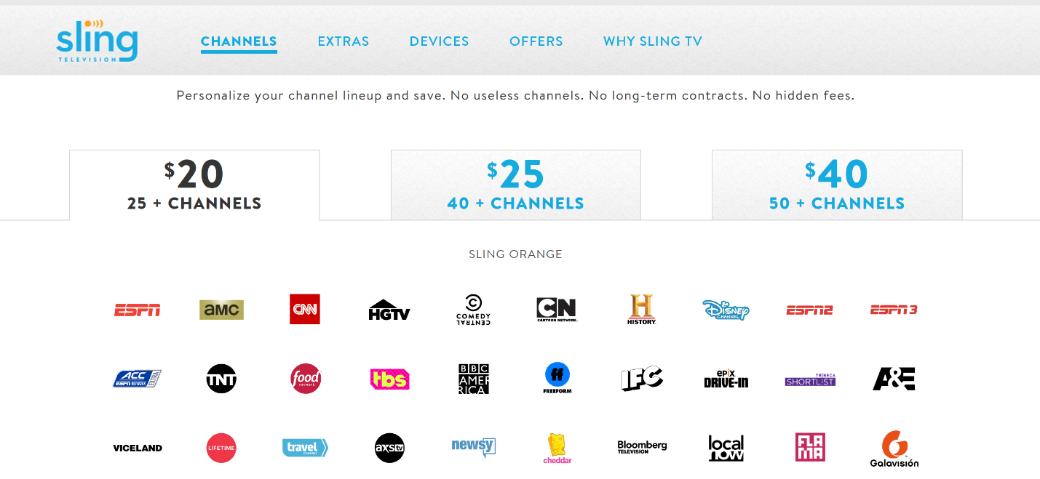

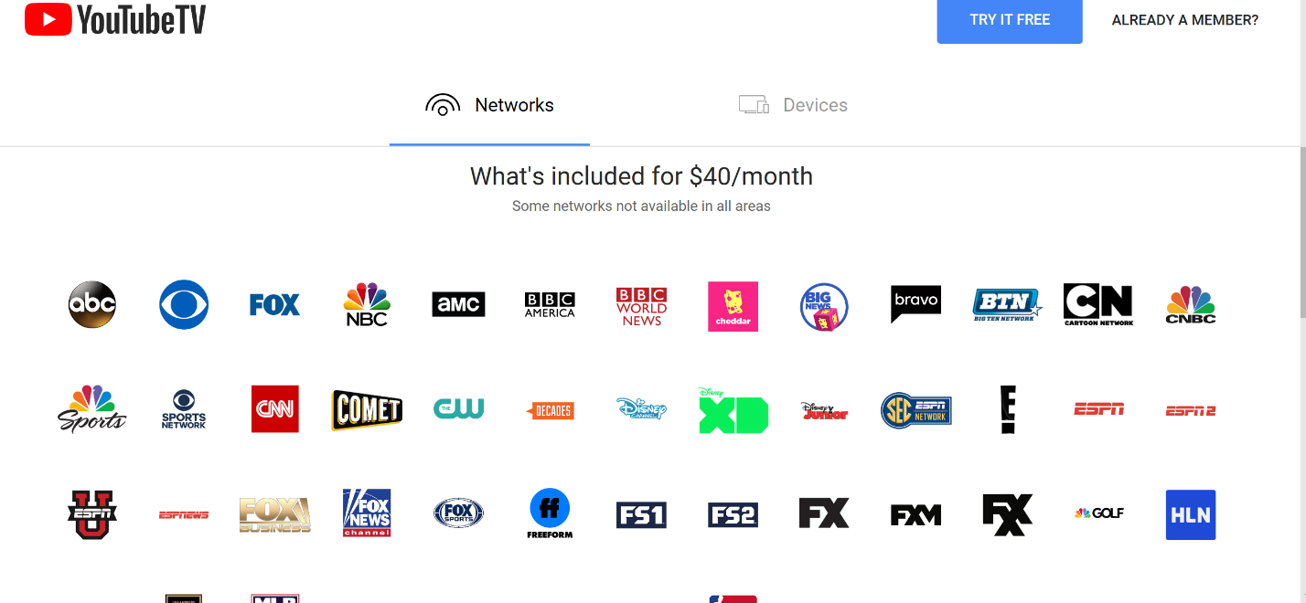

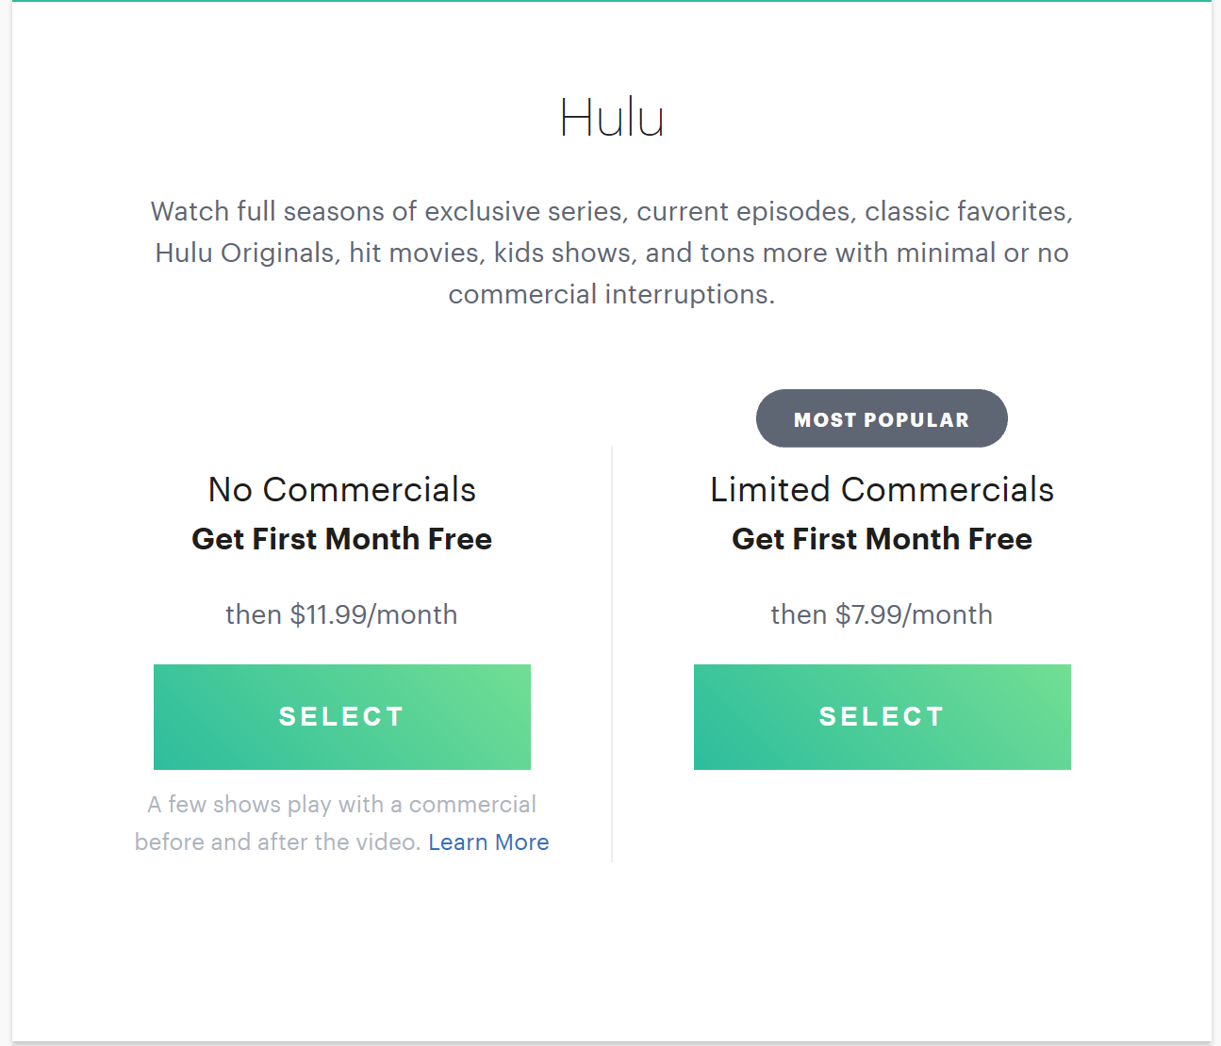

TV SHOWS WITH STREAMING SERVICE:

<https://reelgood.com/tv/source/hulu>

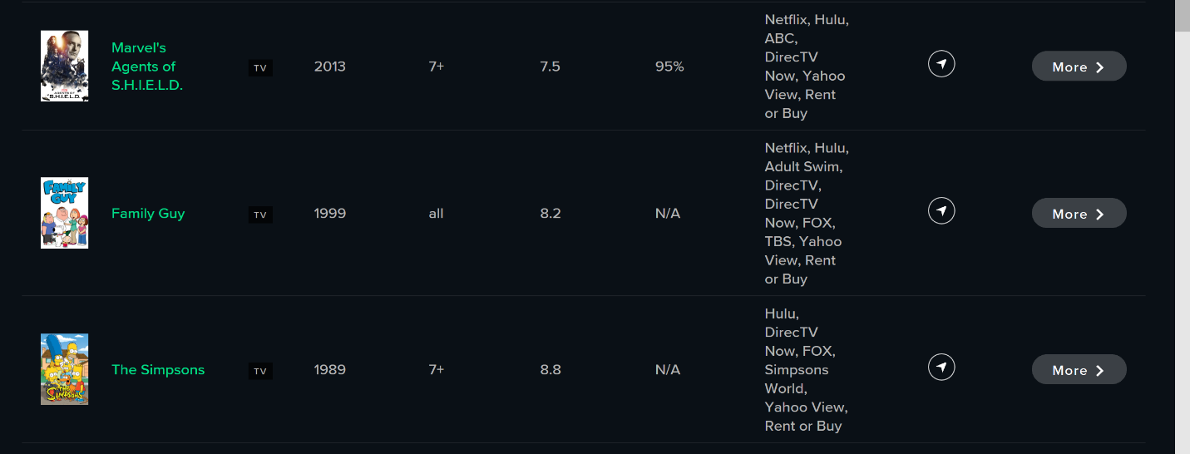

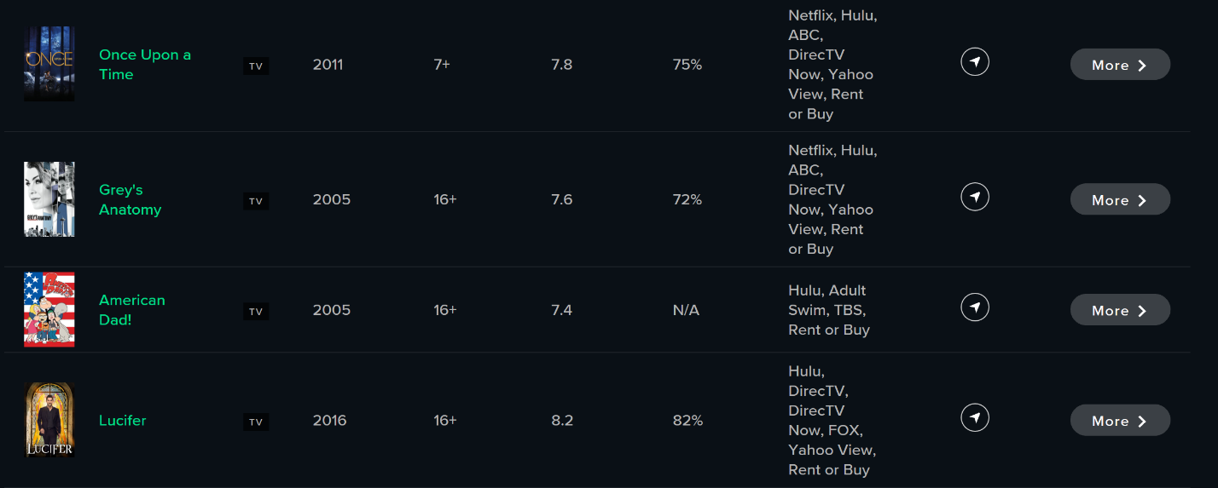

TV SHOWS:

Family guy—cartoon network—youtube,amazon,hulu$1.99

Grey’s Anatomy—lifetime,ABC—hulu subscription

American Dad—cartoon network,TBS—youtube$1.99

Lucifer—FOX—hulu subsciption

Once upon a time—ABC—hulu subscription

The good place-NBC---youtube$1.99

Queer eye--[Bravo](https://www.google.com/search?q=Bravo&stick=H4sIAAAAAAAAAOPgE-LUz9U3MKwyLylRgjKTi8q0JLOTrfRLyoAovqAoP70oMdcqL7WkPL8oGwDqKSbmMwAAAA&sa=X&ved=0ahUKEwicmviw89HaAhVLSK0KHZRJCwwQmxMI9QEoATAi)---Amazon$1.99

High Maintenance—HBO—youtube$0.99,google play$0.99,amazon$1.99

Atlanta—FX—YOUTUBE$1.99,AMAZON$1.99,HULU Subscription

The good wife—CBS—YOUTUBE$1.99,AMAZON$1.99,HULU SUbcription